# **PF Lab Assignment**

## Flowchart

start

end

Print correct input

Print wrong input

If something is string

Input something

no yes



delivery

sorting

start

Is the delivery urgent?

Input item

Is the receiving item fragile?

no no

sorting

yes

yes

delivery

a

exit

c

exit

b

no

Until noitemsleft

a

Print deliver this item as soon as possible

c

Print handle this item carefully

b

exit

exit

yes

exit

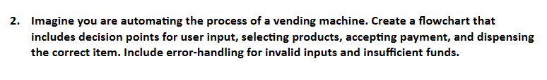

Input

start

payment

Input choose a product

Input

Input amount

no

If amount sufficient

Print insufficient funds

payment

Until nocustomersleft

If product available

no no

exit

yes

Provide the item to the user

yes yes

end

exit

## Pseudocode

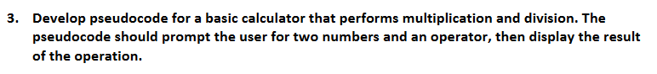

Start

Input num_1, num_2, operator

Multiplication = num_1 * num_2

Division = num_1 / num_2

If the operator is * then

Print Multiplication

Elseif the operator is / then

If num_2==0 then print division not possible

Print Division

End



Start

Set num1, num2, and num3

If num1<num2 and num1<num3 THEN

Print “num1 is the smallest”

ELSE IF num2<num1 and num2<num3 THEN

Print “num2 is the smallest”

ELSE

Print “num 3 is the smallest”

END

# Algorithm



START

INPUT a number

IF the number is divided by any number other than 1 and itself

THEN it’s not a prime number

ELSE it’s prime

END



START

INPUT a number

Divide the number by 7

IF remainder is 0, print Sunday

ELSEIF remainder is 1, print Monday

ELSEIF remainder is 2, print Tuesday

ELSEIF remainder is 3, print Wednesday

ELSEIF remainder is 4, print Thursday

ELSEIF remainder is 5, print Friday

ELSE print Saturday

END



START  
INPUT any two numbers

a = first number, b = second number

make sure that a > b, if not then swap them

r is remainder

a % b = r

now a = b, b = r

repeat till remainder becomes 0

b will be the GCD

EXIT