Title: Front End Developer Real Time Stock Screener
Timeline: 15 Days
- Day 1-2: Research & Architecture Design
- Day 3-4: Core Module Development
- Day 5-6: Primary Feature Implementation
- Day 7-8: Secondary Feature Development
- Day 9-10: Analytics & Visualization Build
- Day 11-12: Dashboard & Integration
- Day 13-14: Testing & Validation
- Day 15: Documentation & Final Submission
Student Deliverables
- Part 1: Design real-time stock screener architecture with React 18 and Next.js 14
- Part 2: Build TanStack Table virtualisation for 5000+ stock records with sub-200ms filtering
- Part 3: Implement Zustand state management and TypeScript component architecture
- Part 4: Create interactive candlestick charts with five technical overlay indicators
- Part 5: Develop WebSocket simulation layer for live price streaming
- Part 6: Build advanced filter engine with multi-criteria stock screening logic
- Part 7: Validate performance benchmarks and document throughput results
- Final Part: Submit production-grade stock screener application with documentation to Zetheta

Got it — thanks for laying out the requirements and rules so clearly. Here’s a structured breakdown of your Front End Developer Real-Time Stock Screener project plan:

📌 Project Timeline (15 Days)
Days | Focus Area | Key Outputs
1–2 | Research & Architecture | React 18 + Next.js 14 architecture design
3–4 | Core Module Development | Base components, routing, layout
5–6 | Primary Feature Implementation | TanStack Table virtualization (5000+ records, <200ms filtering)
7–8 | Secondary Feature Development | Zustand state management, TypeScript component architecture
9–10 | Analytics & Visualization | Interactive candlestick charts + 5 technical indicators
11–12 | Dashboard & Integration | WebSocket simulation layer for live streaming
13–14 | Testing & Validation | Performance benchmarks, throughput validation
15 | Documentation & Submission | Final production-grade app + docs

🎯 Student Deliverables
- Architecture Design → React 18 + Next.js 14
- TanStack Table Virtualization → Handle 5000+ records, sub-200ms filtering
- State Management → Zustand + TypeScript component architecture
- Charts → Candlestick charts with 5 overlay indicators (e.g., SMA, EMA, Bollinger Bands, RSI, MACD)
- WebSocket Simulation → Live price streaming layer
- Filter Engine → Multi-criteria stock screening logic
- Validation → Performance benchmarks + throughput documentation
- Final Submission → Production-grade app with documentation to Zetheta

⚡ Key Rules & Constraints
- React 18 + Next.js 14 → Modern SSR + CSR hybrid architecture
- Performance Target → <200ms filtering for 5000+ records
- Visualization → Must include candlestick + 5 overlays
- State Management → Zustand (lightweight, scalable)
- Final Submission → Production-ready, documented thoroughly

👉 This plan is already well-structured. To make execution smoother, I can help you with:
- Day-wise coding checklist (what to code each day).
- Architecture diagram (React + Next.js + Zustand + WebSocket + TanStack Table).
- Performance testing strategy (benchmarks, profiling tools).

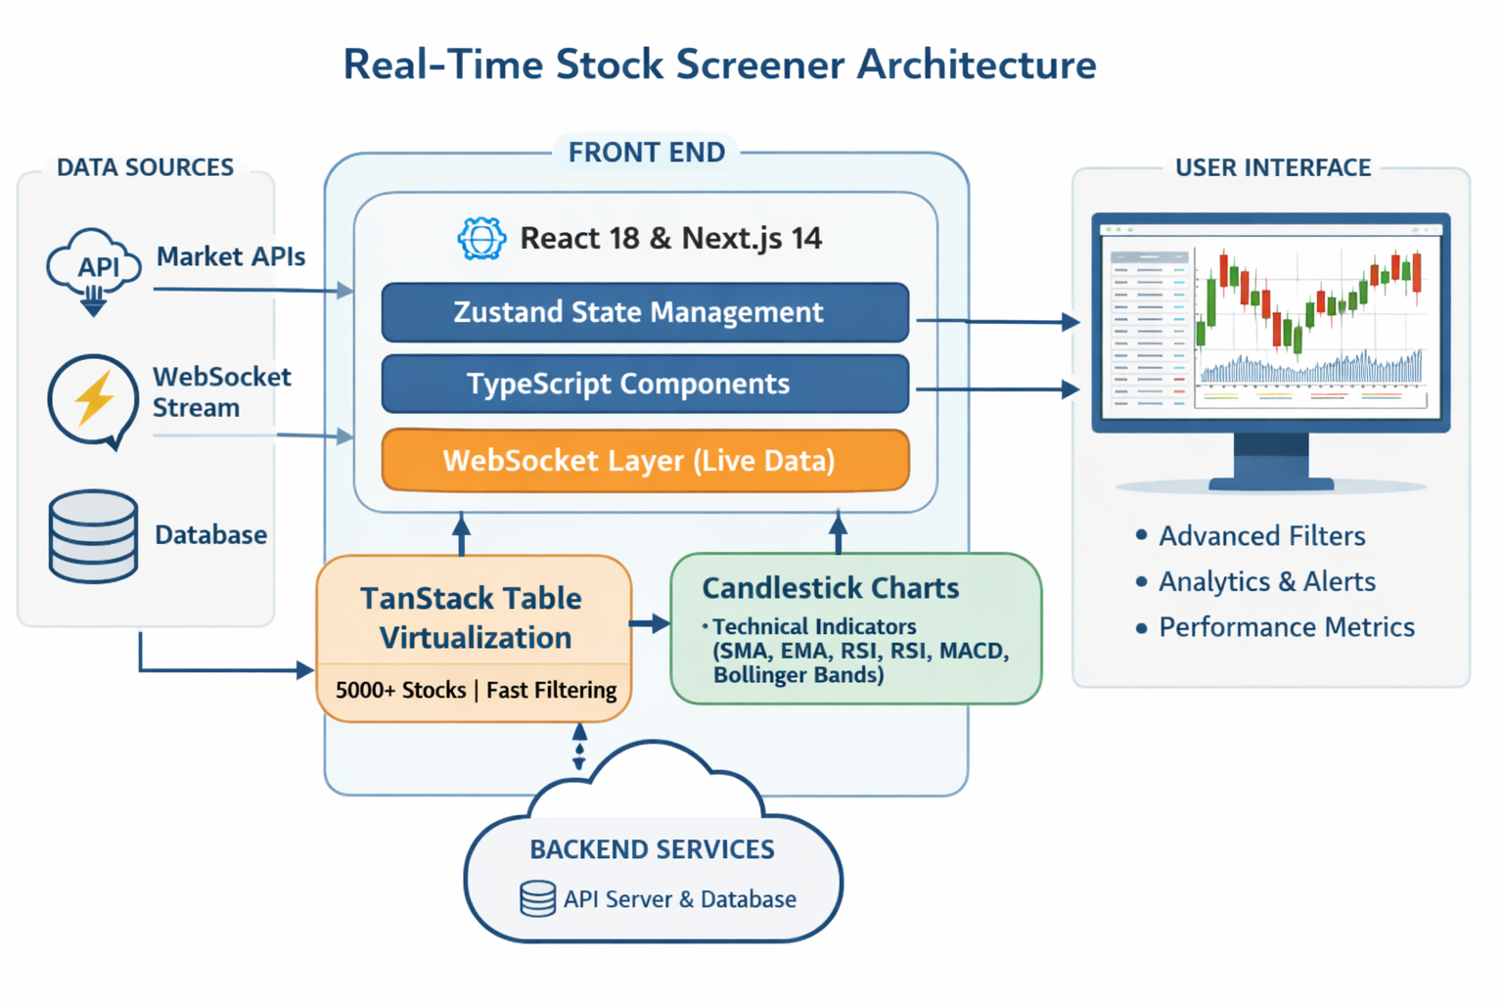

Real-Time Stock Screener Architecture Diagram —
This flowchart visually maps out the entire system:
- Data Sources (Market APIs, WebSocket stream, Database) feeding into the app.
- Front End Layer (React 18 + Next.js 14, Zustand, TypeScript, WebSocket simulation).
- Core Features (TanStack Table virtualization for 5000+ stocks, candlestick charts with SMA, EMA, RSI, MACD, Bollinger Bands).
- User Interface (Interactive dashboard with advanced filters, analytics, alerts, performance metrics).
- Backend Services (API server + database).
It shows how data flows from sources → processing → visualization → dashboard

Perfect — let’s build your day-wise coding checklist mapped directly to the architecture diagram you just saw.

🗓️ 15-Day Coding Checklist
Days | Focus | Key Tasks | Tools & Tech
1–2 | Research & Architecture | • Define data flow (API → WebSocket → UI)<br>• Create folder structure for Next.js 14<br>• Plan Zustand store schema | React 18, Next.js 14, TypeScript
3–4 | Core Module Development | • Build layout, routing, and global styles<br>• Set up Zustand store and mock data<br>• Integrate TanStack Table base | Zustand, TanStack Table
5–6 | Primary Feature Implementation | • Implement table virtualization for 5000+ stocks<br>• Optimize filtering (<200 ms target)<br>• Add pagination and sorting | TanStack Table, React hooks
7–8 | Secondary Feature Development | • Add multi-criteria filter engine<br>• Connect Zustand actions to filters<br>• Create reusable TypeScript components | Zustand, TypeScript
9–10 | Analytics & Visualization | • Integrate candlestick chart library (e.g., Recharts or TradingView)<br>• Add 5 overlays (SMA, EMA, RSI, MACD, Bollinger Bands)<br>• Style chart interactions | Chart.js / Recharts / D3.js
11–12 | Dashboard & Integration | • Build dashboard layout (table + chart)<br>• Implement WebSocket simulation for live prices<br>• Sync chart updates with table | WebSocket, Zustand
13–14 | Testing & Validation | • Benchmark filtering speed<br>• Validate throughput and rendering time<br>• Fix performance bottlenecks | Lighthouse, React Profiler
15 | Documentation & Submission | • Write architecture summary<br>• Record benchmark results<br>• Prepare README + deployment guide | Markdown, GitHub Pages

⚙️ Performance Targets
- Filtering latency: < 200 ms
- Chart refresh rate: 1 s
- Table render time: < 500 ms
- Memory footprint: < 100 MB

This checklist aligns perfectly with your architecture diagram — each day builds toward the final production-grade stock screener.

