Computer and Communication Networks



**Laboratory Manuals**

*for*

**Computer Networks**

(CC3611WL)

|  |  |
| --- | --- |
| **Lab Instructor** | Hina Alam  [hina.alam@umt.edu.pk](mailto:hina.alam@umt.edu.pk) |
| **Section** | Y1 |
| **Semester** | Fall 2019 |

**Department of Informatics and System**

**UMT, Lahore, Pakistan**

**Lab Manual 03**

# Objectives:

* To learn basic commands of Linux related to Directory and File Manipulation, Process management and Network Management

# In-lab VIVA Statement

1. **Find out the purpose of the following commands and execute them on your system. Practice these terms on your own: [10]**

|  |  |  |
| --- | --- | --- |
| **top** | The top program provides a dynamic real-time view of a running system. It can display system summary information as well as a list of tasks currently being managed by the Linux kernel. | top |
| **ps** | ps displays status of a selection of the active/currently running processes. | ps  ps -a |
| **kill pid** | Kill is used to send a signal to a process. Where pid stands for process id   * Default syntax for this is **kill pid** * Default syntax for this is **kill [-signal number or name)] pid**   On your terminal to see the list of available signals. **Kill -l**  **A PID of -1 is special; it indicates all processes except the kill process itself and in it. It will terminate all programs and log off. BEWARE!** | kill pid  kill –SIGKILL pid |
| **chmod** | This command is used to grant or revert reading, writing, and executing permissions from a user, group or others. Following are the symbolic representation of three different roles:  You can check the details by typing  **man chmod**  chmod 400 lab1.txt  Check what happened to your file.  Now write  chmod 700 lab1.txt  What happened to your file? |  |
| **ifconfig** | ifconfig is used to configure the kernel-resident network interfaces.  If no arguments are given, ifconfig displays the status of the currently active interfaces. If a single interface argument is given, it displays the status of the given interface only; if a single -a argument is given, it displays the status of all interfaces, even those that are down. Otherwise, it configures an interface. | ifconfig  ifconfig -a  ifconfig eth0 |
| **traceroute** | traceroute prints the route that packets take to a network host. traceroute gives an insight to the entire path that a packet travels through, names and identity of routers and devices in your path, network latency (the time taken to send and receive data to each devices on the path). It’s a tool that can be used to verify the path that your data will take to reach its destination, without actually sending your data.  Write on your terminal  traceroute google.com |  |

**Task Using Network commands with Windows**

**You just need to follow the under write instructions.**

1. Verify the connectivity of your workstation to the internet.
2. Open the Command Prompt of the operating system using either of the following methods:
   * Click on **Start > All Programs > Accessories > Command Prompt**

OR

* + **Click on Start > Run, enter cmd** (short for command) and click on ok.

*A Command Prompt screen should open.*

1. Type ipconfig (short for IP configuration) and press Enter, the screen will show the IP

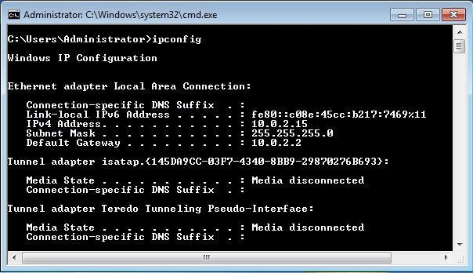address, subnet mask, and default gateway for your computer’s connection.

*Fig.1* A successful result of a ipconfig

*The IP address and the default gateway should be in the same network/subnet; otherwise this host would not be able to communicate outside the network. In Fig. 1, the subnet mask tells us that the first three octets of the IP address and the default gateway must be same in order to be in the same network.*

1. Ping the IP address of another computer. Note that for the **ping** and tracert commands to work the PC firewalls have to be disabled. Why do you think this is so?

*Ask the IP address of the workstation that is being used by another group of students. Then type ping, space, and the IP address that you received, then press Enter. Notice the outputs.*

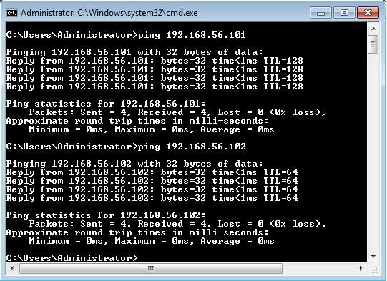

1. Ping the IP address of the gateway router from the details that have been observed in the output of step 4 above. If the ping is successful, it means that there is a physical connectivity to the router on the local network and probably the rest of the world.
2. Ping the Loopback IP address of your computer. Type the following command:

***ping*** 127.0.0.1.

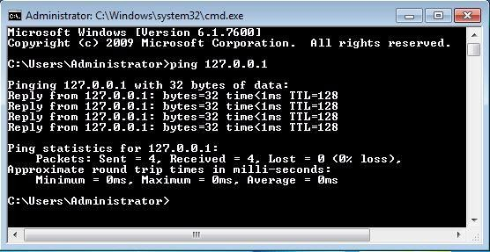

*The IP address 127.0.0.1 is reserved for loopback testing. If the ping is successful, then TCP/IP is properly installed and functioning on this computer.*

# Lab Statement 02

1. **Ping command: [10]**

Ping is a command that is used to check the connection and latency rate between two computers in a network. One network pings another in order to exchange data packets (Response) to calculate the latency and exchange rate.

Syntax for Pinging is:

**ping [other network’s ID (Domain/IP Address)]**

**ping google.com**

**ping 127.0.0.1**

**Question - You are required to ping at least 5 other networks and compare the latency (including your own address i.e. 127.0.0.1**