In this mini project, we are using one 8051 families based microcontroller, one 16×2 LCD display and one 4×4 keyboard for settling the time.

**Components required**

For making a simple digital clock using microcontroller you will require following components:

|  |  |  |
| --- | --- | --- |
| Sr. no. | Component | Quantity |
| 1 | Microcontroller (P89V51RD2) | 1 |
| 2 | LCD display (16×2) | 1 |
| 3 | 4×4 keyboard | 1 |
| 4 | Resistor 10K | 1 |
| 5 | Capacitor 33pF | 2 |
| 6 | Capacitor 10uF | 1 |
| 7 | 12MHz Crystal | 1 |

**Circuit diagram**

A circuit diagram for simple digital clock using 8051 microcontrollers is shown below:

**[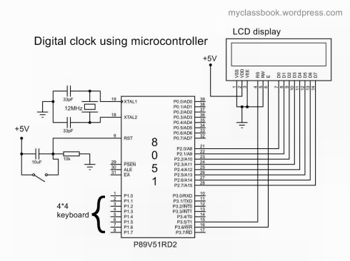](http://myclassbook.files.wordpress.com/2014/04/digital-clock-using-8051-microcontroller-and-lcd-display.jpg)Digital clock using 8051 microcontroller and LCD display**

**Circuit building**

Connect the 4×4 keypad with port 1 of the microcontroller. Connect 16×2 LCD display with port 2 of the microcontroller (make sure that all the data pins of LCD display are connected to the microcontroller correctly). The rs (register set) pin of  LCD is connected to pin 3.5 (pin number: 15) and en (enable) pin is connected to pin 3.6 (pin number 16) of the microcontroller. Connect crystal to pin 18 and 19 of the microcontroller. We are using 12MHz frequency Crystal. For reset, circuitry connects a pushbutton to pin 9 of the microcontroller. We can also use a potentiometer to adjust the contrast of LCD.

**Pin description of LCD display**

[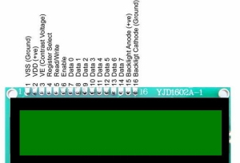](https://myclassbook.files.wordpress.com/2014/04/lcd-pin-diagram.jpg)

|  |  |  |
| --- | --- | --- |
| Pin number | Name | Description |
| 1 | Vss | Ground |
| 2 | Vdd | +5V |
| 3 | Vee | Contrast Adjustment -2V to -5V |
| 4 | RS | Register Select |
| 5 | RW | 1 -Read, 0-Write |
| 6 | E | Enable Strobe |
| 7 | D0 | Data Line |
| 8 | D1 | Data Line |
| 9 | D2 | Data Line |
| 10 | D3 | Data Line |
| 11 | D4 | Data Line |
| 12 | D5 | Data Line |
| 13 | D6 | Data Line |
| 14 | D7 | Data Line |
| 15 | LED+ | Backlit LED +V Vdd (Optional signal) |
| 16 | LED- | Backlit LED +V Vdd (Optional signal) |