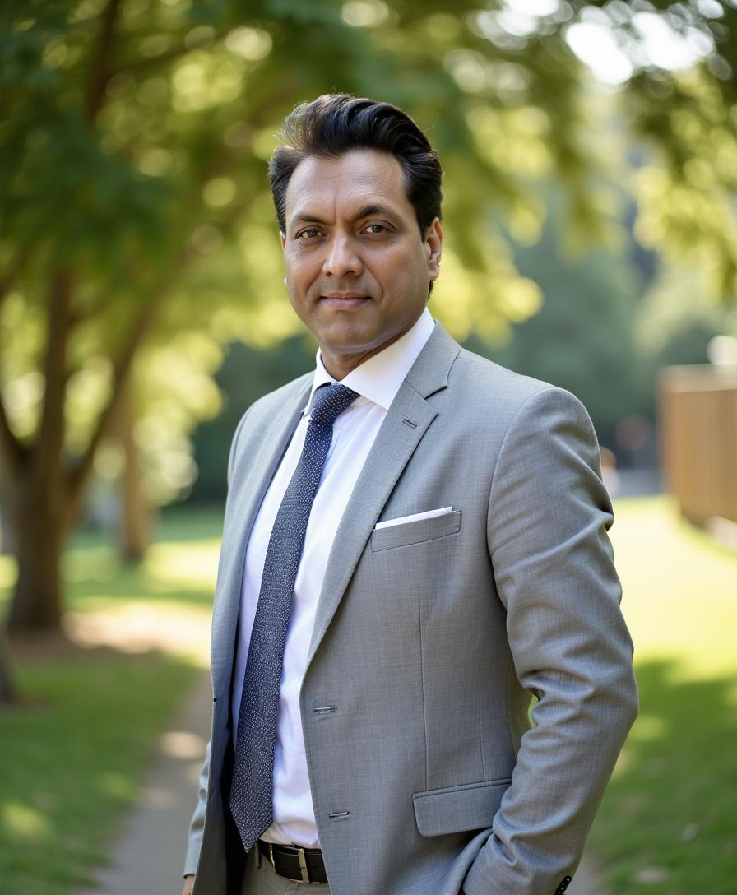 | Ateet Bahamani  AI Architect / Agentic AI Engineer  Essen, Germany+49 176 2346 3484ab@masxai.comPortfolio:  GitHub: LinkedIn:
  German Citizen · EU Work Rights · Available Immediately

PROFESSIONAL SUMMARY
AI Architect / Engineer with 15+ years building enterprise platforms & now specializing in deterministic, auditable Agentic AI systems. I lead cross-team architecture & technical strategy while staying deeply hands-on, modernizing complex legacy estates & building greenfield platforms for 20+ global clients, shipping production features daily. I design multi-agent orchestration, multi-model validation, & modern agent interoperability patterns (MCP, A2A) that bring reliability (controls, confidence, governance) to real-world AI workflows.
CORE COMPETENCIES

Engineering Leadership | System Design & AI | Platform & Infrastructure
Technical Strategy & Architecture | Microservices & Event-Driven | Python · TypeScript · Node.js · C# · React
Roadmaps | Architecture | FastAPI · Pydantic · Kubernetes · Docker
Cross-Team / Cross-Continent Delivery | Distributed Systems & Scalability | MongoDB · PostgreSQL · Redis · Kafka ·
Platform Migration & Modernisation at | Patterns | NATS
Scale | API Design (REST, OpenAPI, WebSockets) | Azure · AWS (Lambda/ECS/S3) · CI/CD
Mentoring Senior Engineers & Building | Deterministic & Agentic AI Architecture | Pipelines
Teams | MCP, A2A & Agent Interop Protocols | LLMOps, Evaluation Harnesses &
Stakeholder Management & Capacity | MCP, A2A & Agent Interop Protocols | Observability

Planning

PROFESSIONAL EXPERIENCE
Principal AI Architect / Product Engineer| MASX AI Platforms | Feb 2026 - Present
MASX Strategic Intelligence: | MASX Bittensor Intelligence:
• AI agentic solution — Built & launched two full-scale agentic forecasting platforms: MASX Strategic Intelligence (forecast.masxai.com) for geopolitical forecasting & MASX Bittensor Intelligence (bt.masxai.com) for decentralized AI network intelligence.
• Designed deterministic multi-agent AI workflows combining OSINT ingestion, anomaly detection, RAG-grounded reasoning, multi-agent analysis, probabilistic forecasting, validation guardrails, autonomous resolution, & calibration feedback loops.
• Architected MASX Strategic Intelligence as a doctrine-driven forecasting system using 35 strategic AI agents across 7 intelligence domains & 115+ sub-domains, with live dashboards, forecast tracking, research documentation, & autonomous intelligence outputs.
• Built MASX Bittensor Intelligence to monitor subnet health, miner & validator dynamics, emission shifts, liquidity stress, sentiment, GitHub activity, Discord intelligence, chain signals, & generate bounded forecasts + stakeholder advisories.• Implemented the platforms using Python, FastAPI, Pydantic, PostgreSQL/Supabase, RAG pipelines, LLM orchestration, scheduled jobs, deterministic validators, audit-friendly provenance, & public React/Tailwind dashboards.
• Created methodology, calibration, resolution, & research-facing documentation explaining the forecasting architecture, quality controls, scoring, autonomous resolution process, & production intelligence workflow.
AI Architect — Agentic AI Systems| 12IQ Inc., Essen, Germany Nov 2025 - Jan 2026
• Leading architecture & end-to-end development of a large-scale Deterministic AI platform focused on predictable, auditable, & intelligent workflows.
• Architected a modular, execution-driven AI system with a single deterministic execution spine, coordinating orchestration, context management, knowledge processing, reasoning, & multi-model validation.
• Designed agent orchestration patterns enforcing execution order, context propagation, budget control, fault isolation, & confidence scoring.
• Implemented MCP-based tool integration & A2A agent communication protocols for cross-system interoperability.• Integrated LangChain for LLM orchestration, RAG pipeline construction, & tool-calling agent chains, enabling structured retrieval-augmented reasoning across multi-source knowledge bases.

• Enforced security & compliance standards aligned with ISO 27001 & GDPR, including RBAC, secrets vaulting, audit
logging, & data isolation.
• Built workflow automation pipelines using n8n for scheduling, event-driven triggers, data routing, & agent orchestration.
• Built multi-database AI infrastructure (relational, document, graph, vector, cache) to support persistent reasoning state
& continuous learning.
• Hands-on Python lead, defining core abstractions, data contracts, & CI/CD standards.
• Leading technical delivery, interviewing, mentoring, & guiding engineers & interns.
Freelance Consulting & AI Engineering| Independent, Essen, Germany Dec 2024 - Oct 2025
• Transitioned into AI Engineering through Masterschool Institute of Technology, Berlin, followed with independent
freelance-style project execution.
• Engineered three AI platforms (mainly Python): Med AI (Healthcare Automation), MASX AI (Geopolitical Forecasting), &
Echo AI (Personal AI Clone).
• Delivered functional AI prototypes showcasing expertise in multi-agent systems, real-time data pipelines, RAG
architectures, & LLM integrations.
Senior Software Engineer| IHS Markit (now S&P Global), Essen, Germany Jul 2017 - Nov 2024
• Owned platform migration & project delivery across backend/frontend, leading team of 5+. Aligned with global
stakeholders across 3 continents.
• Engineered secure, async-ready APIs & dashboards using Python, C#, Node.js, & AWS (Lambda, ECS).
• Migrated 10+ legacy applications to AWS / Angular, reducing latency 40% & accelerating deployment cycles - 60%.
• Built CI/CD pipelines using GitLab, Docker, & Azure DevOps, cutting deployment errors by over 60%.
Software Engineer| IHS Markit, Essen/Leverkusen, Germany Mar 2012 - Jul 2017
• Delivered digital analytics systems for enterprise automotive clients across 7 continents.
• Developed scalable analytics platforms using C#, VB.NET, serving 20+ global clients.
Software Engineer| Pitney Bowes Software, Noida, India Nov 2009 - Feb 2012
• Developed reusable geospatial components for MapInfo MapXtreme GIS SDK used by enterprise clients worldwide.
• Built & maintained a high-volume automated testing framework, reducing regression test cycles by 50%.
KEY AI PROJECTS
Galileo Arena: LLM Benchmarking + Quality Controls — AI Agentic Solution
Multi-model evaluation platform with hybrid scoring engine (deterministic + ML), automated content generation, human-in-
the-loop approval via Telegram, & social media distribution. Dynamic model registry, 10+ analytics visualizations, Dockerized
deployment.
Repo: github.com/AteetVatan/AIGalileoArena
EchoAI: Real-Time Voice-Driven Agentic Intelligence
Voice-first AI clone with real-time STT to RAG memory retrieval to LLM reasoning to TTS. Built with LangChain orchestration
(chains, retrieval, agents) & LangGraph stateful multi-step workflows for conversational memory, RAG pipeline routing, &
agentic decision loops.
Repo: github.com/AteetVatan/echo-ai
TECHNICAL SKILLS

Languages | Python 3.10+, TypeScript, JavaScript, C#, SQL
AI & Agentic | LangChain, LangGraph, AutoGen, CrewAI, MCP, A2A, n8n, RAG, PyTorch, Prompt Engineering
Backend | FastAPI, Pydantic v2, Node.js, REST/OpenAPI, WebSockets
Databases | MongoDB, PostgreSQL, Redis, Vector DBs (Chroma, FAISS, Pinecone), SQL Server
Cloud & DevOps | Azure, AWS (Lambda/ECS/S3), Kubernetes, Docker, GitHub Actions, GitLab CI
Security | ISO 27001, GDPR, Data Isolation, RBAC, Secrets Management, Audit Logging
Event Streaming | Kafka, NATS, Airflow, Redis Pub/Sub
LLMOps | LangSmith, TruLens, RAGAS, Cost Tracking, Prompt Versioning
EDUCATION & CERTIFICATIONS
AI Engineering Specialization -- Masterschool Institute of Technology (2025)
M.Sc. Geographic Information Systems -- Symbiosis International University (2007-2009)
B.Tech. Information Technology -- GGSIPU, New Delhi (2001-2005)
Certifications: AI Engineering (Masterschool, 2025) · PCEP Python (2025) · Certified ScrumMaster (Scrum Alliance, 2019)
Languages: English (Native) · Hindi (Native) · German (B1)

