# Objectives

* To construct a peertopeer LAN and demonstrate its operations.
* Introduction to the various types of cables and the construction of a crossover twistedpair cable.
* Introduce a number of useful and common networking applications

# Equipment & Environment

Networks share the same components, functions, and features which are Servers, Clients, Media Shared, Shared printers and other peripherals and Resources. Servers are data Computers that provide shared resources to network users. Clients are computers that access shared network resources provided by a server. Media are the wires that make the physical connections. Shared data Files provided to clients by servers across the network. Shared printers and other peripherals any service or device, such as files, printers, or other items, made available for use by members of the network. Additional resources provided by servers.

# Introduction

## Peer-to-Peer Networks:

In its simplest form, a peer-to-peer (P2P) network is created when two or more PCs are connected and share resources without going through a separate server computer. A P2P network can be an ad hoc connection—a couple of computers connected via a Universal Serial Bus to transfer files. A P2P network also can be a permanent infrastructure that links a half-dozen computers in a small office over copper wires. Or a P2P network can be a network on a much grander scale in which special protocols and applications set up direct relationships among users over the Internet.

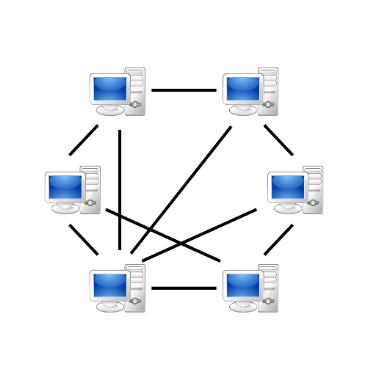

**Advantages:** Much easier to set up than a client-server network - does not need specialist knowledge

**Disadvantages:** Because each computer might be being accessed by others it can slow down the performance for the user, Files and folders cannot be centrally backed up, and There is little or no security besides the permissions.

## Client/Server Networks:

Client-server networks are computer networks that use a dedicated computer (server) to store data, manage/provide resources and control user access. The server acts as a central point on the network upon which the other computers connect to. A computer that connects to the server is called a client.

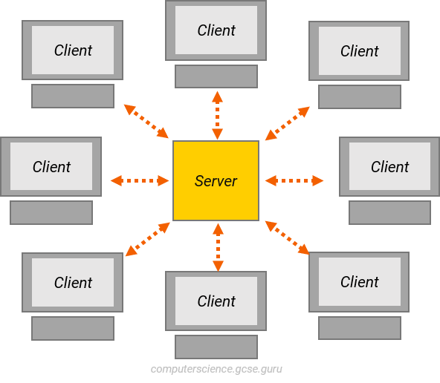

**Advantages:**

* Accessibility
* Flexibility
* Interoperability

**Disadvantages:**

* Expensive
* Dependence

## Types of connections:

### Physical Connection:

Cabling: This lab focuses on copper wire. Some of the most obvious advantages of copper cable are that it is cheaper than fiber optic cable and is much easier to terminate in the field.

There are two common types of common copper cables which are:

• Unshielded twisted pair (UTP)

This is the most widely used cable. Known as balanced twisted pair, UTP consists of twisted

pairs (usually four).

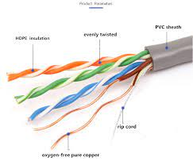

• Shielded twisted pair (STP)

Are often shielded in an attempt to prevent electromagnetic interference.

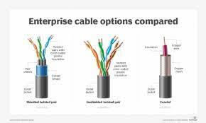

* Crossover connection, used to connect between machines of same type.

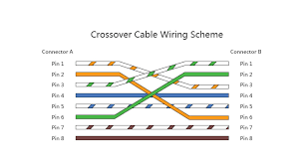

* Straight through connection used to connect two different machines with different types.

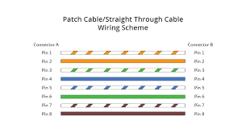

### 2. Logical connection:

Configure the IP address in order to be able to communicate two or more machines together.

Two types of address:

Physical address: MAC address whichcannot be change, it represents the machine itself

Contains 48 bits in hexadecimal format.

Logical address: IP address which specify the network am used

Contains 32 bits in decimal format.

To configure the IP address:

Double click on the first computer, then click on config and select fast Ethernet to set the IP address as shown in figure:

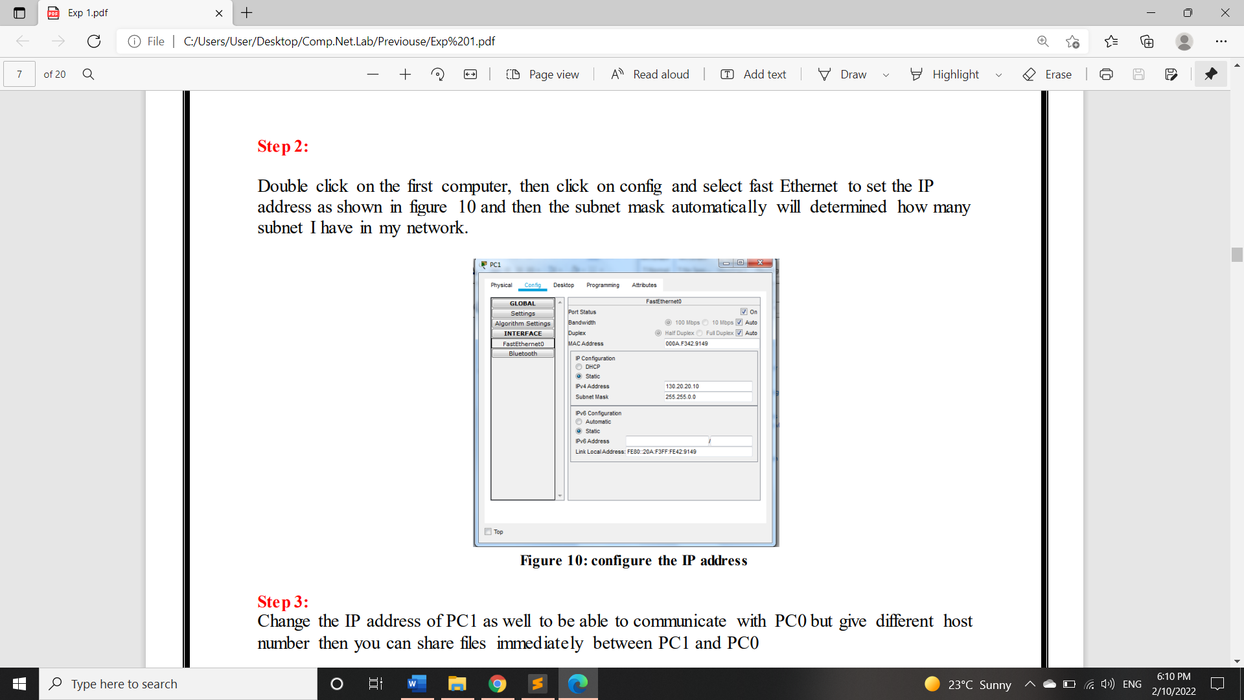

Change the IP address of PC1 as well to be able to communicate with PC0 but give different host

number then you can share files immediately between PC1 and PC0:

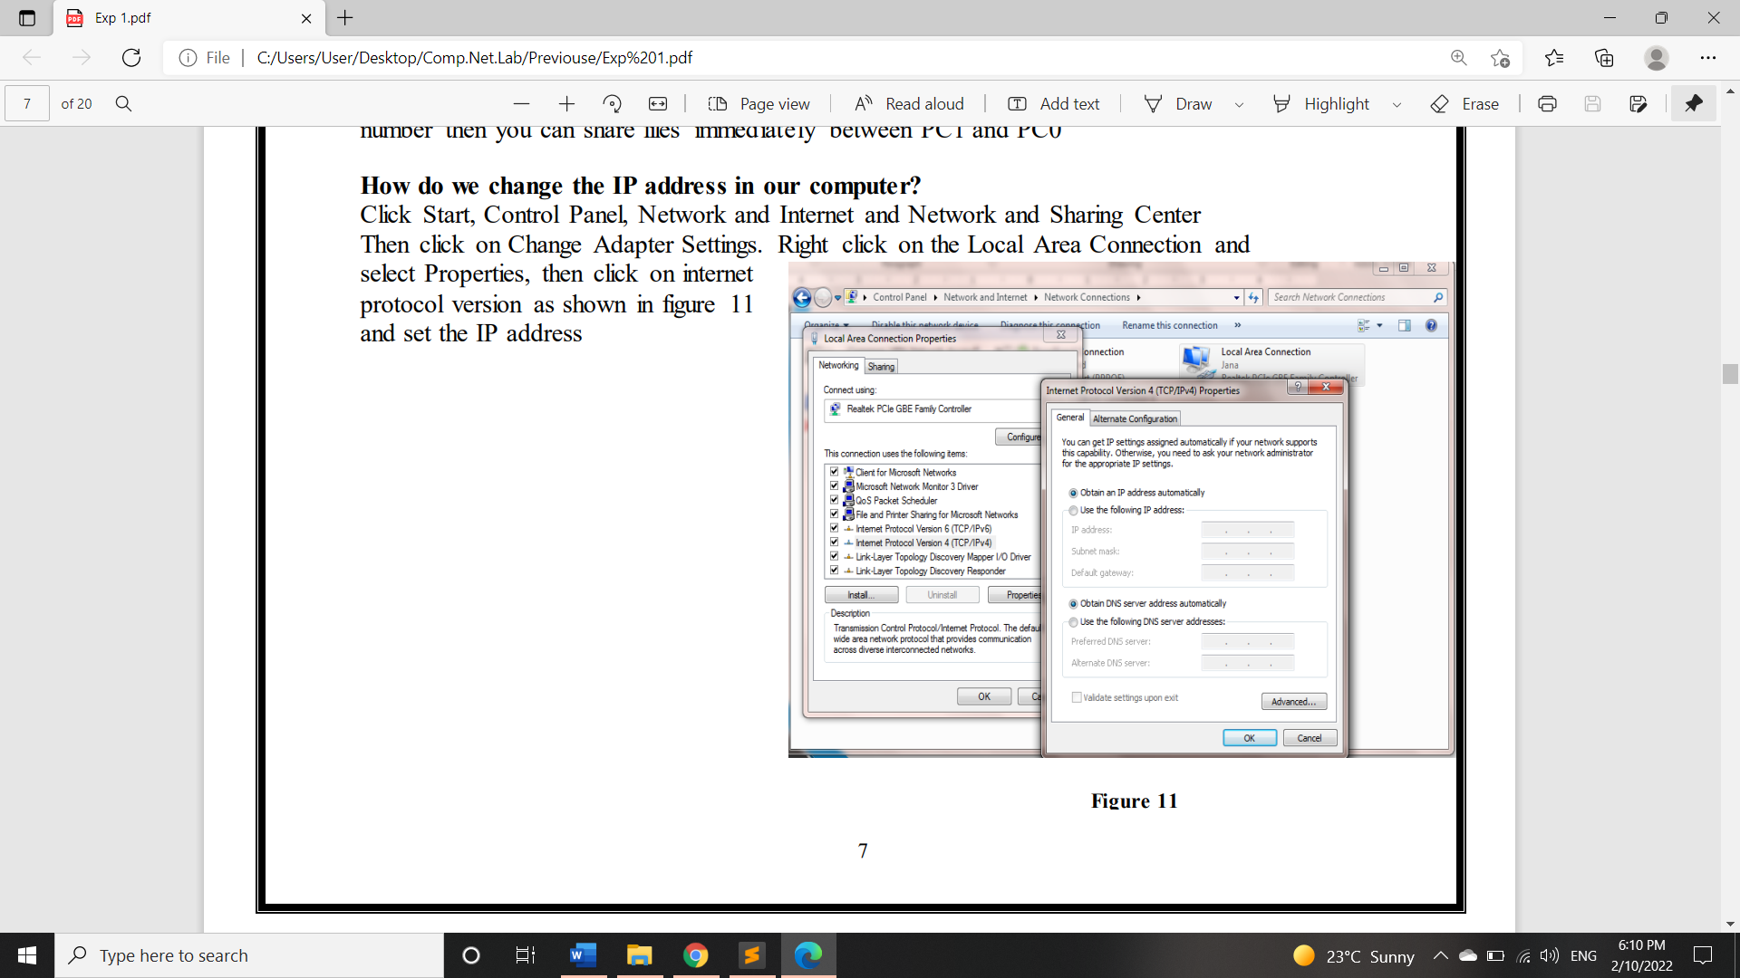

# Procedures:

## Understand Crossover cable implementation

To learn how to implement an ethernet crossover cable. Please review the provided links and videos in the power point file on Blackboard.

## Sharing in Peer-to-Peer Implementation

In any Windows network environment (peer-to-peer or server-based), you can set sharing permissions for drives and folders. By default, when you set up a PC on a network, no drives or folders on that PC are shared. The local user of that PC can then choose to share entire drives or individual folders on a drive. This type of security is not really that secure, however, because it affects only network access. In the following steps, you learn how to share folders and files on Window 7.

### Procedure steps

To Access my shared files write Ip in run like the following:

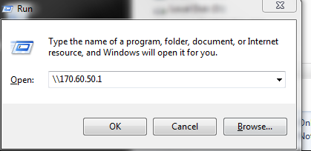

In order to map (sharing the files in faster way by assigns a local drive letter to a shared drive that stored on other computer), Using the option “Map Network Drive” that is accessible by right clicking on “My PC”, we choose a letter for the drive and insert the location of a shared folder:

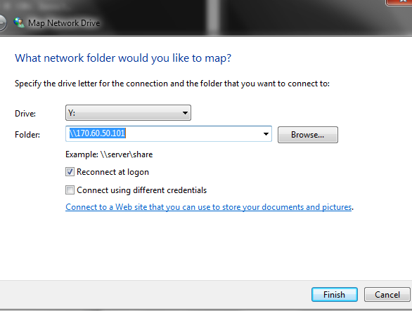

Now that the mapping is done, the shared folders can be easily accessed through “My PC” as shown in the figure:

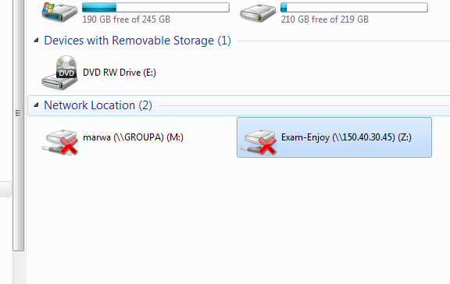

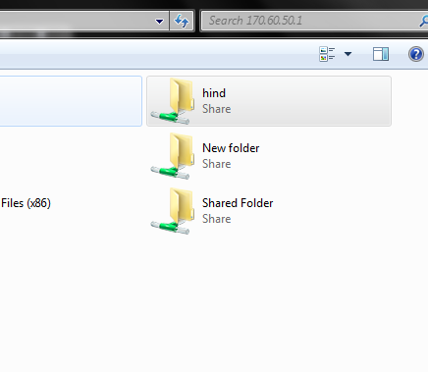

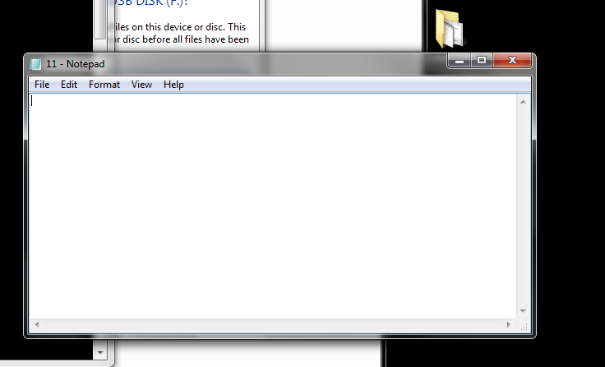

## Network Applications

## IPConfig

We use ‘IPConfig’ command to show the communication setup information on the local machine.

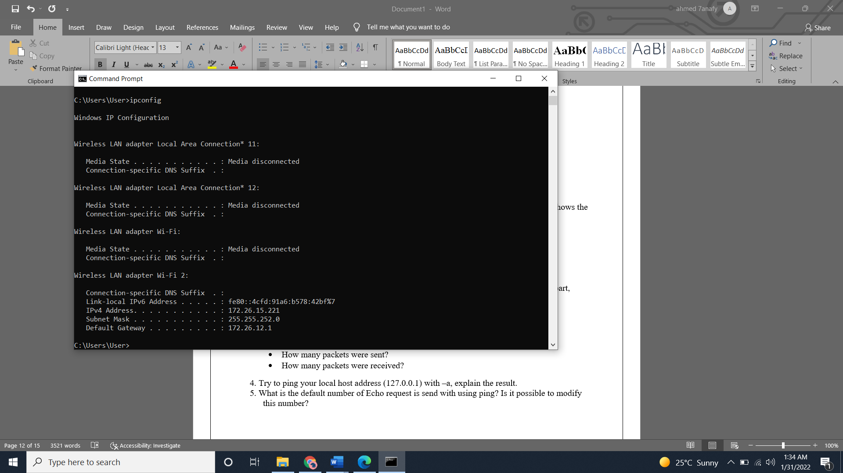

we also use the command followed by ‘/all’ to show the physical address of our machine: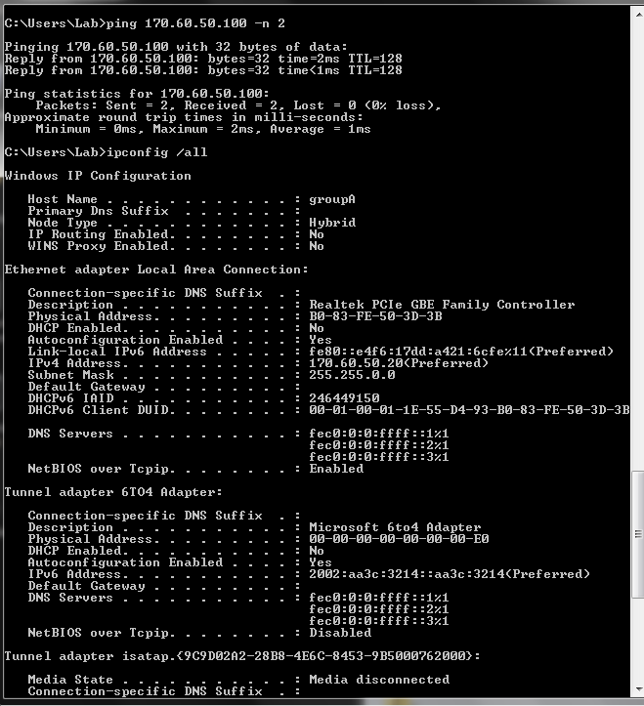

**Ping**

In order to check the connection with another machine on the server we use the ‘ping’ command followed by the ip address of the machine we want to check with, shown in the bellow figure:

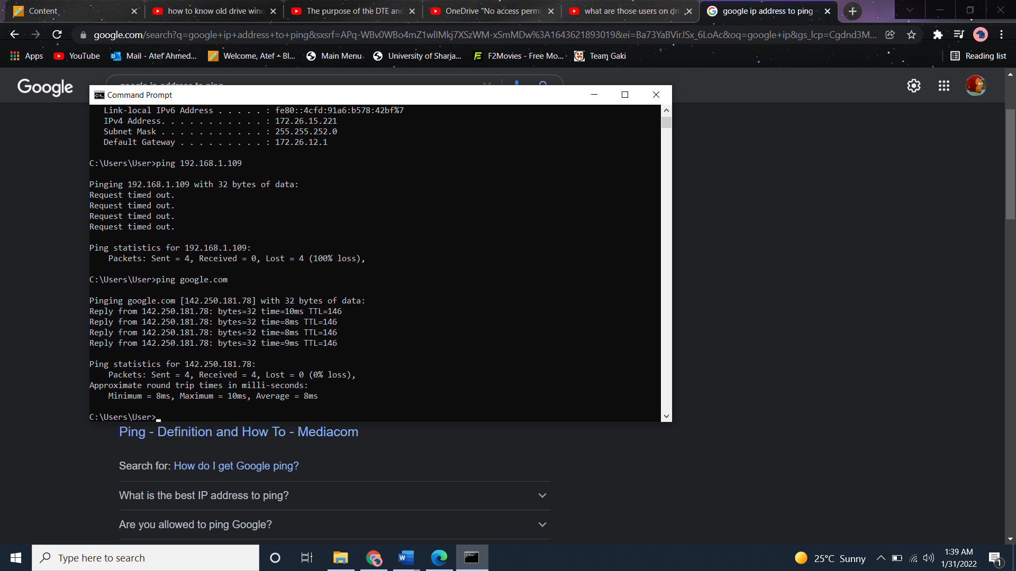

And to use only to reply’s we use the ‘-n’ followed by the number we want like follows:



**Tracert**

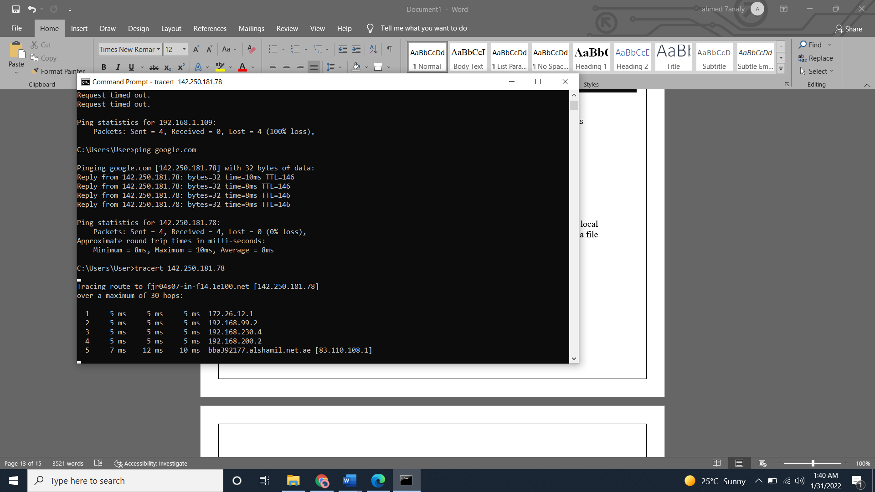Tracert is used in order to trace the route along which a packet crosses in a network and number of hopes, bellow figure shows using ‘tracert’ command followed by ip address we want to check with:

**FTP (practical part in the lab)**

Application that is used in order to send and receive files to and from a File server.

‘FTP followed by the IP address of the server’ in order to connect to the server in the following figure(we enter username and password to get connection):

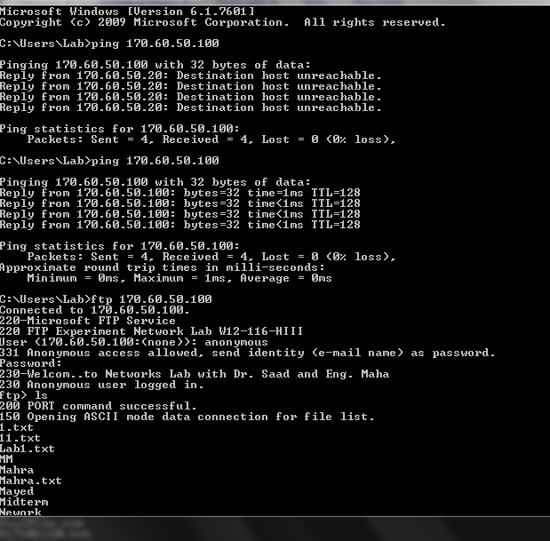

Using ‘Dir’ (directory) command to show the remote files in the server with more details than just listing, like time and date of the adding of each file as you can see:

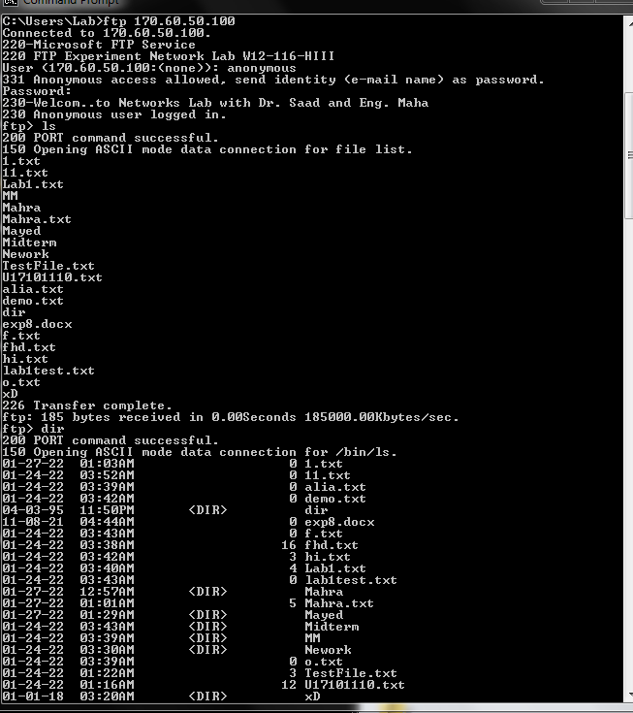

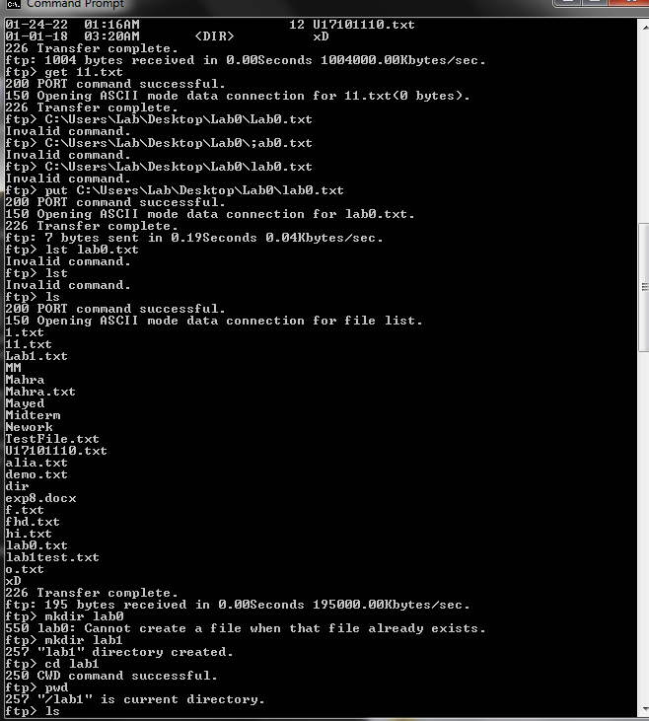

Using ‘ls’ (list) command in order to list all existing files in the server as you can see in the following screenshots: 

We use the command get and file name and type in order to open the file we need as following:



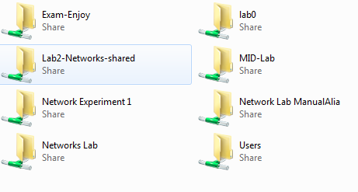

And in order to add a file we use ‘Put’ command followed by the file location and “\file.type” in order to add the file, and then check with the ‘Lst’ command as shown in the below figure:



In order to make file into directory we will utilize the ‘mkdir’ command followed by file name, then we will use ‘cd’ command to add the file and finally ‘pwd’ command to show directory change as followed in the figure (cd command used to change the directory, ‘pwd’ check the current

directory and mkdir to create a file in the current directory) :



Here ‘cd ..’ returns to normal directory and we check again using ‘pwd’ command as shown:

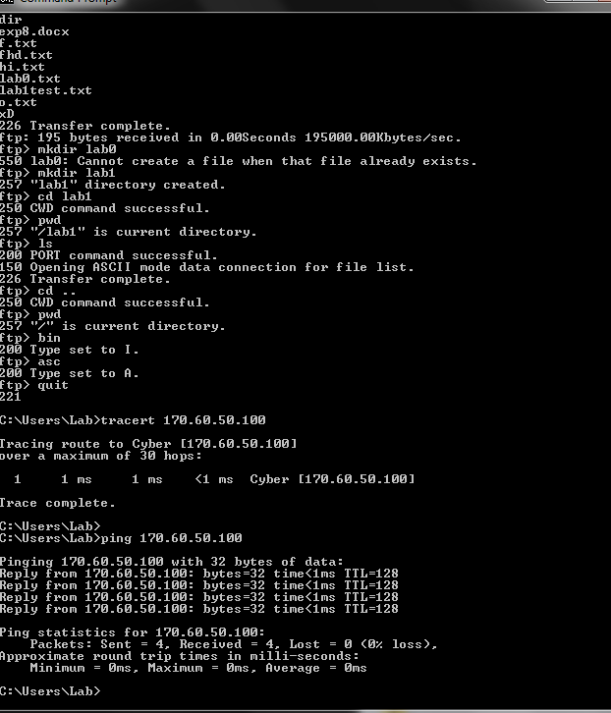

Finally, ‘bin’ and ‘asc’ commands change from the binary to ascii types as shown below, where ASCII is used for single text files while Binary is for sending other types like Tar and Compressed., after we can end the ‘Ftp’ connection using the ‘quit’ command:



**Questions (Part of the report):**

Answer the following question:

1. Why are different twisting patterns used among the twisted pairs within one cable?

* Because they differ in voltage.

1. What is meant by TCP/IP?

* Transmission protocol and Internet protocol, they are rules to govern communication between devices within network.

1. In order to connect a PC to an external modem, a serial cable is used. Do I use a straight serial or cross-over serial cable? Why?

* Straight since we are connecting two different devices.

1. The network adapter plug is called “RJ-45”, what is the name used for the phone plug?

* RJ-11 is used for phones.

1. Is it possible to establish communication between the two workstations, where each is using a different protocol? Why?

* No, because protocols are used to govern the communication and for the workstations to understand each other (send/receive) they must share same protocol.

1. If you would like to configure three workstations, using a peer-to-peer architecture, what are the equipment and software needed? Draw an architecture diagram of the overall design.

* Will need twisted copper cables with cross-over type and RJ-45 tips.





1. Describe the advantages of a peer-to-peer network.
2. For small networks
3. Easy setup
4. Less expense and maintenance compared to c/s.
5. Describe the advantages of a server-based network.
6. Centralized system
7. Secure, flexible with new technology and accessed remotely.
8. Scalable.
9. Log on to any workstation connected to the internet (from home this can be simply done by dialing your internet service provider). Report the IP address of the workstation you are working on.

* 172.26.12.1

1. When you perform a ping, every packet has a “TTL” associated with it, What is TTL (explain in detail)? A good reference is to find a help page on ping on the internet or use the man pages of UNIX.

* It stands for amount of hops that packets take inside the network before discarding them.

1. From any workstation connected to the internet, go to a prompt. Connect to the site ftp.gnu.org through ftp command. Once you are connected, you will be prompted for a user name and password. This is the “gnu” public ftp server. Anyone is allowed to enter and download needed files. For a user name enter “anonymous”. For a password, enter your email, e.g., 123@sharjah.ac.ae. At this point, you should be connected and within the remote ftp server. You should see a listing of the files and folders available on the server. How many files exist in that folder? Record the number in your report. One of the files is named *Readme.* You need to download the file to your local machine. Record the size of the file, open the file and the first three words from it. Record these three words and the size of the file in your report. Now after you finish you may close your connection.

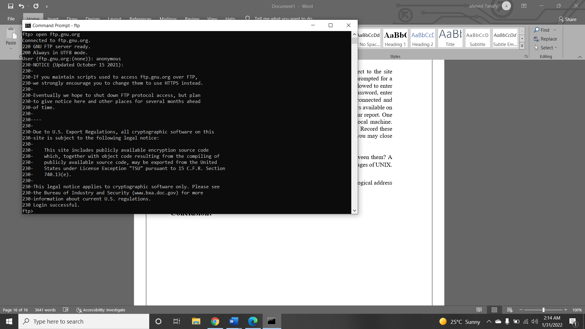

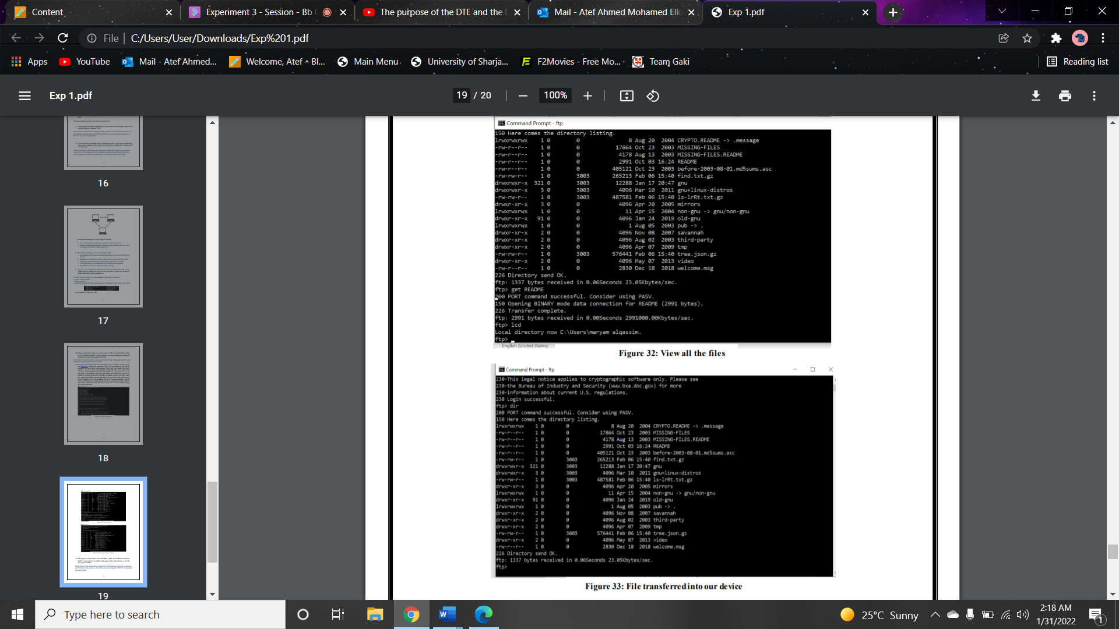

1. FTP operates in two modes: ascii and binary. What is the difference between them? A good reference is to find a help page on ftp on the internet or use the man pages of UNIX.

* ASCII is used for single text files while Binary is for sending other types like Tar and Compressed.

1. What is the difference between physical address (MAC address) and the logical address (IP address)?

* MAC Address is used for the physical address of computer. While IP address are used to uniquely identify the connection of network with that device take part in a network.

**Conclusion:**

We learned in this experiment about the different networks commonly used, main components in those networks and the type of cables used to connect the devices in such networks. Moreover, we learned about different command that used to check my network activity, for example ping command is used to detect whether a node (workstation) is alive, while tracert to check path of said package.