# Use of Different Machine Learning Algorithms for The Classification of Breast Cancer

Atef Ahmed, Talal Bonny

*Research Institute of Science and Engineering (RISE), University of Sharjah, Sharjah, UAE.*

*College of Computing and Informatics, University of Sharjah, Sharjah, UAE.*

*College of Engineering, University of Sharjah, Sharjah, UAE.*

[U18105136@sharjah.ac.ae](mailto:U18105136@sharjah.ac.ae), [tbonny@sharjah.ac.ae](mailto:tbonny@sharjah.ac.ae)

***Abstract—Every year, thousands of women lose their lives to illnesses like breast cancer. For the early, quick, and accurate identification of breast cancers, artificial intelligence (AI) has been used. The random forest classifier, the support vector machine classifier, the decision trees, and logistic regression are some of the machine learning methods we employed to an expanded dataset of breast cancer in this research study to compare their various performances. The organized form of the data is the primary justification for selecting these supervised algorithms over neural networks***. ***A trained and tested artificial neural network was able to distinguish between malignant and benign tumors with an accuracy of 95.83%. The findings indicate that artificial neural networks are a reliable and promising method for detecting breast cancer. SVM classifier was the highest accuracy and the most suited with 97.2% accuracy. Random Forest with 96%, 95.4% for logistic regression, decision trees algorithm with 94.9% accuracy, 93.7%, for MLP and finally 91.9% for Naive Bayes classifier.***

## *Keywords:* logistic regression, support vector machines, decision trees, random forests, machine learning, deep learning, data augmentation, classification, breast cancer.

## INTRODUCTION

Many academics have recently noted that breast cancer-related deaths among women have increased. Est-imitation of around 627,000 deaths of females in 2018 alone, and that is according to the World’s Health Organization (WHO). Additionally, according to this group, the number might reach 2.7 million globally in 2030 [1]. The major causes of the poor survival rate include the disease's late identification and difficult treatments. Therefore, earlier breast cancer identification is essential to provide adequate treatment and reduce the chance of cancer spreading to other tissue cells [2]. Cancer develops when normal cells undergo genetic alteration, spreads throughout the body, and becomes fatal if detected late enough to be treated.

There are two types for the breast cancer illness: invasive and non-invasive. The invasive is thought to be harmful, cancerous, and able to infect other organs while non-

invasive doesn't spread to other organs and doesn't harm the body. Breast cancer commonly metastasizes to other organs and may do so via the bloodstream [3]. The disease affects women's chests, particularly the glands and milk ducts.

In this study, we will use several machine learning algorithms to categorize breast cancer according to a number of criteria. Breast cancer illness is the second leading cause of death for women globally. Breast cancer illness is the most shared malignancy/cancers among women. Around 2.1 million individuals are affected globally, and it causes 25% of all cancer cases. Breast cancer illness is initially identified when its cells start to uncontrollably grow. The cells that grow, naturally produce and form into X-ray-visible tumors and/or lumps in the breast area of the subject tested on. The main difficulty in identifying it is how to tell benign tumors apart from malignant (cancerous) ones (non-cancerous). We aim to complete the investigation of detecting these tumors using machine learning (with SVMs) using the Breast Cancer Wisconsin (Diagnostic) Dataset.In our study, we attempted to diagnose breast cancer based on a generated dataset of many attributes. However, these algorithms were applied to photos rather than constructed datasets. Our study focuses on assessing these machine learning algorithms and methods in order to determine the most effective strategy for early detection and diagnosis of breast cancer illness. Such that the use of MLP classifier and other applied are unique to the numerical data set used in this study.This is why we opted for machine learning methods of SVM, Random Forests, Logistic Regression, Decision Tree, Naïve Bayes, and MLP. rather than convolution neural networks, which are more commonly utilized for unstructured data like photos and signals in general. The paper is organized as follows: Part II will discuss prior similar studies, part III will address the entire approach, section IV addresses results and discussion, and finally section V which will conclude the whole paper.

1. *The dataset*

The dataset we used for this research includes a variety of patient-related features, the numerical data included diagnosis, perimeter, compactness, radius, texture, symmetry, area, concave points, smoothness, concavity, concave points, and fractal dimension means, a total of 31 columns worth of features. Note that the dataset was augmented be-fore we apply the machine learning classification algorithms to it. This data augmentation is really helpful to avoid the over fit-ting of the model (This indicates that while the model performs well on the training dataset, it performs poorly on the testing dataset.)

1. *Definitions and Theorems*

***Support vector machines (SVM)****—* Used in regression analysis and is a model belonging with the supervised machine learning algorithms models; they are based on support vectors and will be discussed thoroughly later on. Support vector machines is classification technique for different data sets.

***Logistic regression—*** Logistic regression is a model grouped with supervised machine learning classifiers even if the term includes regression, it remains part of that classification.

***Decision trees—*** Decision trees are an approach for supervised machine learning that is used to classify data based on a number of threshold judgments made for its attributes.

***Naive Bayes—*** The Naive Bayes classifier uses supervised machine learning to make classification decisions based on the probabilities of each feature.

***MLP: multilayer perceptron*—** Multilayer Perceptrons (MLPs) are neural networks made up of several layers and neurons that may be utilized to solve classification and

regression issues. In an MLP, there are multiple parameters called the model hyper parameters that can be tuned to improve the model performance.

1. *The Algorithms of Machine Learning*

Algorithms for machine learning are separated in two different categories, unsupervised and supervised learning. In order to train for the first kind, a labeled dataset with inputs and outputs as a goal is needed. The training phase and the testing phase are the two phases in this kind. The SL model is first constructed using data that are manually labeled by a human during the training phase, and it is then put to the test using fresh data that the model hasn't seen before [4]. There is no need to train a model for the second category of machine learning algorithm, known as USL. The classification of data samples is based on their shared characteristics; this kind is appropriate in the absence of labeled data. Between the two previously described forms of machine learning comes another type. Semi-Supervised Learning (SSL) is a method of learning that requires a small sample size of labeled data to be utilized in labeling unlabeled samples. Classification and regression issues can be resolved with the help of SL algorithms. Discrete data are dealt with through the classification process, which divides them into several groups. Regression, in contrast, deals with actual data variables, such time or temperature, or continuous data [5]. The issue of sample identification based on shared traits is resolved in the USL via clustering. Researchers and developers employ a range of techniques to automatically and quickly classify and identify samples. The most well-known algorithms for identifying breast cancer tumors are Support Vector Machine (SVM), K-NN, Naive Bayes (NB), and C-means [6]. The focus was to detect cancer from a numerical data set, six algorithms were used all with high accuracy, SVM, Random Forest, Logistic Regression, Decision Tree, MLP, and Naïve Bayes. Many studies show work on various illnesses and data sets [7].

## Literature Review

Naive Bayes algorithm, Random Forest, Logistic Regression, Decision tree models, Support Vector Machine (SVM), and K-Nearest Neighbors (KNN Network), among other machine learning algorithms, are some examples of machine learning models used extensively for detection of different types of cancers illnesses. Several datasets, including the SEER dataset, mammogram images as a dataset, the Wisconsin Dataset, and dataset from different hospitals, have been used by many researchers to do research on breast cancer. The authors' study is completed by extracting and choosing different attributes from these datasets. These studies are important ones. The author Sudarshan Nayak [18] uses a variety of supervised machine learning algorithms to classify breast cancer using 3D pictures, and he concludes that SVM performs the best overall. In contrast, we discover that B.M. Gayathri's [19] comparative study of Relevance vector machine, which offers low computational cost when comparing with other machine learning techniques used for breast cancer detection, explains why RVM is superior to other machine learning algorithms for diagnosing breast cancer even when the variables are reduced and achieved 97% accuracy. Support vector machine (SVM) is effective in diagnosing and predicting breast cancer, according to Hiba Asri [20], who also showed that SVM delivers the highest results in terms of precision and low error rates, with an accuracy rate of 97.13%. In more recent works, Youness Khoudfi and Mohamed Bahaj [21] proposed a comparison of machine learning algorithms and found the SVM to be the best classifier with an accuracy of 97.9% in comparison to K-NN, RF, and NB. These algorithms are based on multilayer perception with 5 layers and 10 times cross validation using MLP. A classification value of 98.4% was discovered by the author Latchoumiet TP [22], who proposed an optimization weighting of the particle swarm (WPSO) based on the SSVM for the classification. Using fusing a clustering method with a powerful probabilistic vector support machine, Ahmed Hamza Osman [23] offered a solution for the detection of Wisconsin breast cancer (WBCD), with a prediction of 99.10% discovered by the SVM technique. Through a data set of breast cancer images, another study utilized the clustering technique in order to establish a more accurate result from the detection of the classifiers [24]. The study in focus is by using local clustering technique for the neural networks utilized within said study.

1. METHODOLOGY
2. *Support vector machine (SVM)*

Researchers have used this approach to solve a variety of regression and classification issues, the latter of which is often applied. Each coordinate is constructed for each feature in the n-spaces, which are formed according to the number of features. In order to identify the optimal line with the greatest margin among the n-spaces, this method attempts to create several new, so-called hyper planes. A margin that divides into several groups and is represented by data points is the greatest margin [8, 9]. This method has been employed in a number of studies with encouraging results, including [10, 11], which classified breast cancer tumors. Several algorithms were used in these experiments (i.e., SVM, K-NN, C4.5, NB, K-means, EM, PAM, and fuzzy c-means). They found that the SVM approach performed better in terms of accuracy than other methods.

1. *Random Forest (RF)*

A popular method for quickly and effectively processing huge datasets is random forest. This approach has been employed in several academic initiatives as well as numerous practical applications [12]. The method is based on the idea of ensemble learning, which builds several classifiers and combines their outputs [13]. A single weak classifier performs worse than a number of weak classifiers using the same dataset. Numerous ensemble techniques exist, including boosting, bagging, and most recently, Random Forest. The boosting approach [14] begins by giving all instances the identical starting weights before successively allocating greater weights to examples that are incorrectly categorized and lower weights to instances that are successfully classified. According to a majority vote, the dataset is split into several training subsets in the bagging technique [15] and supplied in parallel to the classifier. The Random Forest, on the other hand, is a form of ensemble technique that uses majority voting and several decision trees to classify fresh cases. In this approach, each subset of features represents a decision tree that is randomly chosen, and the total collection of features is split into numerous subsets. Faster than bagging and boosting and more resistant to noise from boosting, Random Forest [16] is a better option.

This section includes a review of the literature on the various types of data and methodologies that have been utilized to date to diagnose breast cancer. This examination will aid in finding machine and deep learning-based deep learning approaches. The topic of breast cancer detection and classification has been the focus of several machine learning studies, including Deep Learning for Breast Cancer Classification: Convolution neural networks are used by Enhanced Tangent Function to identify and classify breast cancer. This article attempts to increase the classification accuracy of breast cancer by raising picture contrast and lowering the vanishing gradient. K-means techniques are utilized in order to address the accuracy issues in the classification of breast cancer illness of histopathological mammograms (cancer pictures) and the sensitivity issues, that being shown in the study of classification using deep learning helped by clustering [17]. A deep neural network guided by cell nuclei position and orientation is proposed to improve performance large datasets are used to train the deep neural network model in order to use methods for data augmentation, transfer learning, and precise local tuning to produce clear evaluations of pictures.

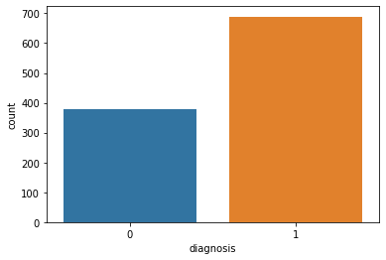

Fig. 1. Malignant Vs Benign Diagnosis for Our RF Classifier

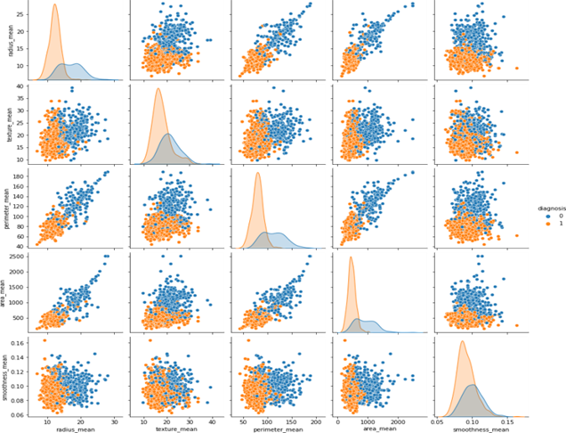

Fig. 2. RF Pair Plot for Performance Study

## THE MACHINE LEARNING CLASSIFICATION ALGORITHMS

1. *The random forest classifier*

First, we attempted to train a random forest algorithm on my dataset, splitting it in half for training and testing, as we can see in Fig 1 the malignant samples vs the benign samples count and the results for the random forest are as follows:

1. Random forest training accuracy: 99.8
2. Random forest testing accuracy: 96.5

The random forest classifier performs flawlessly on the training dataset, but its accuracy has decreased somewhat on the testing dataset (by around 4%), indicating that the model performs well on the test dataset and does not have a high variance. In the pair plot for our data visualization side in Fig 2, we can clearly see linear separation for our data set, the blue being the malignant samples and orange being benign. Clear separation reflects on the high accuracy of the RF classifier, such that the different sections show the different parameters within our data set, texture, radius, area, and smoothness. Table I shows the RF accuracy average from the results we get; such classification is weighted at 0.96 accuracy and is seen from the support testing sample. The F1-Score is important to predict the performance from the metrics of both precision and recall.

TABLE I

The RF Classifier Model Accuracy Score

|  |  |  |  |  |
| --- | --- | --- | --- | --- |
|  | Precision | Recall | F1-score | support |
| 0.0 | 0.95 | 0.94 | 0.94 | 114 |
| 1.0 | 0.97 | 0.97 | 0.97 | 207 |
| Accuracy |  |  | 0.96 | 321 |
| Macro avg | 0.96 | 0.96 | 0.96 | 321 |
| Weighted avg | 0.96 | 0.96 | 0.96 | 321 |

1. *The logistic regression algorithm*

After applying the logistic regression technique to our dataset, the following outcomes were obtained:

1. Logistic regression Training Accuracy: 95.5
2. Logistic regression Testing Accuracy: 95.4

we observe that the accuracy has decreased a little bit comparing to the random forest classifier. Fig 3 confusion matrix provides the accuracy of the model, we observe the performance in the number of true positives and negatives within the total test samples of around 30%. Shows the correctly identified data and the unsuccessful. Accuracy of the model is relatively high as seen.

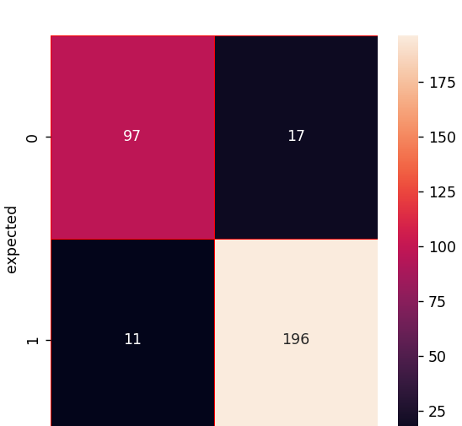

Fig. 3. Logistic Regression Algorithm Confusion Matrix

1. y $=\frac{e(b0+b1x)}{1 + e(b0+b1x)}$

Above is the equation for logistic regression classifying model: where x is the input value, y is the predicted outcome, b0 is the bias or intercept term, and b1 is the coefficient for the input (x).

TABLE II

The Decision Trees Classifier Accuracy Score

|  |  |  |  |  |
| --- | --- | --- | --- | --- |
|  | Precision | Recall | F1-score | support |
| 0.0 | 0.90 | 0.85 | 0.87 | 114 |
| 1.0 | 0.92 | 0.95 | 0.93 | 207 |
| Accuracy |  |  | 0.91 | 321 |
| Macro avg | 0.91 | 0.90 | 0.90 | 321 |
| Weighted avg | 0.91 | 0.91 | 0.91 | 321 |



Fig. 4. Decision Tree Algorithm Confusion Matrix

TABLE III

Data Parameters Snip

|  |  |  |  |  |  |
| --- | --- | --- | --- | --- | --- |
| Diagnosis | Radius  mean | Texture  mean | Perimeter  mean | Area  mean | Smoothness  mean |
| 01 | 17.99 | 10.38 | 122.80 | 1001.0 | 0.11840 |
| 11 | 20.57 | 17.77 | 13290 | 1326.0 | 0.08474 |
| 21 | 19.69 | 21.25 | 130.00 | 1203.0 | 0.10960 |
| 31 | 11.42 | 20.38 | 77.58 | 386.1 | 0.14250 |
| 41 | 20.29 | 14.34 | 135.10 | 1297.0 | 0.10030 |

## *Decision trees*

The decision trees algorithm gave us the following accuracy:

1. Decision trees training accuracy: 98.8
2. Decision trees testing accuracy: 95

We see that the model has a significant variance, which causes the training accuracy to be higher than the test accuracy.Table II shows the accuracy score for the classifier, were The F1-Score is important to predict the performance from the metrics of both precision and recall. The accuracy overall for this classifier is 93. Table III shows parameters variance for the data. There are 31 columns of parameters and tables shows a snip of them. Thirty of them will be used as input parameters and diagnosis will be used as the variable to be predicted.

1. *Info*(D)= − *pi*log2(*pi*)
2. *InfoA(D)*= − $∑\frac{⎹ Dj⎹}{⎹ D⎹}$ × *Info* (*Dj*)

Pi is calculated as |Ci, D|/|D| and represents the likelihood that each given tuple in dataset D belongs to class Ci. Info(D) is just the average amount of data that is required to classify a data point in D. In most situations, information is encoded in bits, hence a log function to base 2 is utilized.

*Info(D) is also known as the entropy of the dataset D.* Efficacy of the decision tree technique was assessed and investigated for the identification of breast cancer. We observe that the model gives a little lower accuracy on both the training and testing dataset, Fig 4 confusion matrix shows the performance of our model.

## *SVM: support vector machines*

SVM uses support vectors to create a hyperplane, [25, Fig. 5] shows them in dataset of two categories. SVM classifier's is a means to create a hyper-lane in an N-dimensional space, the different classes are fill with those split data points. The support vector machines algorithm gave us the following accuracy:

i. SVM Training accuracy: 98.4

ii. SVM Testing accuracy: 97.2

1. W* = argw max $\frac{1}{ǁ w ǁ2}$ [ minnyn⎹ wT (Ф(x) + *b*⎹]

The inner term (minn yn |wT (x) + b |) essentially denotes the smallest separation between a point and the decision boundary as well as the point that is H's closest neighbor. As the highest accuracy model, the SVM classifier showed great stability and high accuracy. Table IV F1-Score shows consistency in weight and macro average, which is computed via the arithmetic mean. To train the model we will use SVC which is imported from sklearn.svm. This will allow testing different parameters for C and Gama when we do the optimization. The number of patients diagnosed as 'M' and those diagnosed as 'B', Fig 6.

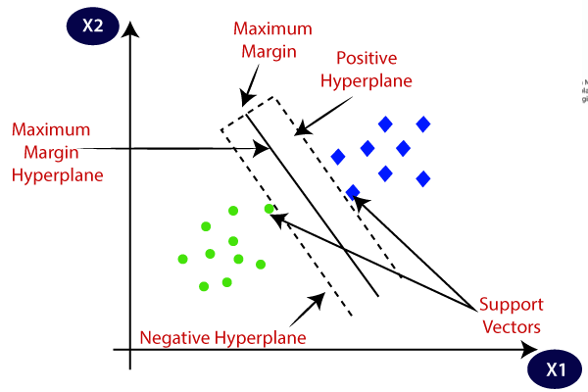

Fig. 5. SVM Algorithm Explanation Diagram [25]

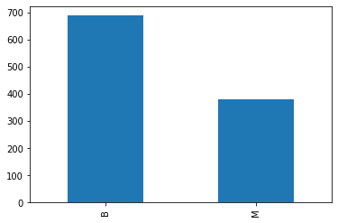

Fig. 6. SVM Malignant and Benign samples

|  |  |  |  |  |
| --- | --- | --- | --- | --- |
|  | Precision | Recall | F1-score | support |
| 0 | 0.94 | 0.99 | 0.96 | 137 |
| 1 | 0.97 | 0.90 | 0.93 | 77 |
| Accuracy |  |  | 0.95 | 214 |
| Macro avg | 0.96 | 0.94 | 0.95 | 214 |
| Weighted avg | 0.95 | 0.95 | 0.95 | 214 |

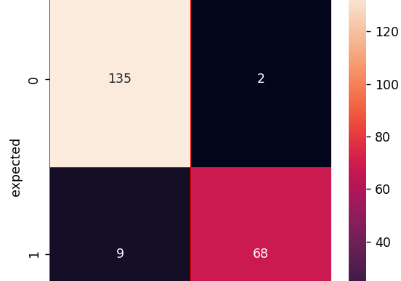

Fig. 7. SVM Confusion Matrix

## *MLP: multi-layer perceptron*

The MLP algorithm gave us the following accuracy:

1. MLP Training accuracy: 94.6
2. MLP Testing accuracy: 93.7

The multilayer perceptron (MLP) model's performance, which is superior to other models in terms of accuracy, precision, recall, and F-measure. Additionally, an MLP was also the best model that the tests could provide. The models may need some time to adjust during the training phase, but classifiers may be used in real-time for prediction processes. Following equations show the mathematical side of the classifier.

Inputs LTU layer, Outputs LTU layer

1. w = ( → ∑⎹ꓽꝈ → y1
2. x = ( → ∑⎹ꓽꝈ → y2
3. b = ( → ∑⎹ꓽꝈ → y3

Three LTUs in a perceptron. The example above uses x as the input vector and b = (1, 1, 1) T as the bias vector (consists of ones only). It generates three binary values, y.

It's important to remember that there is a weight vector for each LTU:

1. y1 =step(z1) = step (w1T · x + b1)
2. y2 =step(z2) = step (w2T · x + b2)
3. y3 =step(z3) = step (w3T · x + b3)

The three classifiers' prediction variability is stable, therefore in general, we may utilize a trained classifier as an annotation tool. [26, Fig. 8] provides further information and the connectivity about this model’s neural network logic. Table V shows the accuracy score for the classifier, were The F1-Score is important to predict the performance from the metrics of both precision and recall. The accuracy overall for this classifier is 93 We observe that the model gives a little lower accuracy than the random forest on both the training and testing dataset.

TABLE IV

SVM Accuracy Score

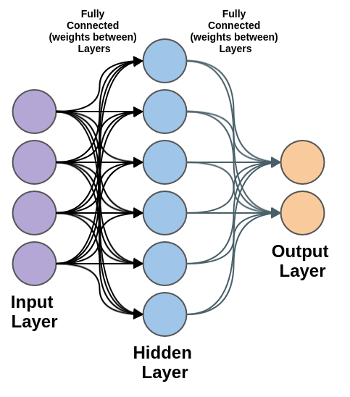

Fig. 8. The Multi-Layer Perceptron of the Neural Network [26]

TABLE V

The MLP Classifier Model Accuracy Score

|  |  |  |  |  |
| --- | --- | --- | --- | --- |
|  | Precision | Recall | F1-score | support |
| 0.0 | 0.90 | 0.85 | 0.87 | 114 |
| 1.0 | 0.91 | 0.95 | 0.92 | 207 |
| Accuracy |  |  | 0.90 | 321 |
| Macro avg | 0.89 | 0.90 | 0.89 | 321 |
| Weighted avg | 0.90 | 0.91 | 0.92 | 321 |

## *Naive Bayes classifier*

The naive bayes classifier accuracy is as follow:

i. Naive bayes training accuracy: 94.2

ii. Naive bayes testing accuracy: 91.9

We see that with the naive Bayes classifier, the training accuracy is lower than the testing accuracy, indicating that the model was unable to acquire sufficient characteristics to distinguish between the benign and malignant classifications.

1. *P (c⎹ x) =*
2. *P (c⎹ x) = P (x1⎹ c) ×P (x2⎹ c) ×···×P (xn⎹ c) x P(c)*

In this instance,

* P(c|x): posterior likelihood of class (c, target) given predictor (x, attributes). In the event that x is true, this reflects the likelihood that c is true.
* P(c): The previous likelihood of the class. This is the observed probability of the class based on all observations.
* P(x|c): The likelihood, or probability of the predictor-given class. Given that x is true, this is the likelihood that x will occur.
* P(x) signifies the predictor's prior probability. This is the observed prediction probability based on all the observations.

Concerning the categorization report, model Gaussian (NB) Based on our analysis of different machine learning models, we see that the random forest classifier is far better at classifying our data than decision trees and logistic regression, which both exhibit larger variance and are thus over fitting. Table VI shows the accuracy score for the classifier, were The F1-Score is important to predict the performance from the metrics of both precision and recall. The accuracy overall for this classifier is 91.9%.

TABLE VI

The NB Classifier Model Accuracy Score

|  |  |  |  |  |
| --- | --- | --- | --- | --- |
|  | Precision | Recall | F1-score | support |
| 0.0 | 0.83 | 0.83 | 0.83 | 105 |
| 1.0 | 0.91 | 0.91 | 0.91 | 218 |
| Accuracy |  |  | 0.91 | 321 |
| Macro avg | 0.89 | 0.89 | 0.87 | 321 |
| Weighted avg | 0.88 | 0.89 | 0.86 | 321 |

1. RESULT AND DISCUSSION

After using the specified ML algorithms on the Wisconsin Diagnostic dataset for breast cancer illness. As performance indicators, we employed RF Pair plot, Accuracy readings, Precision readings, Sensitivity, F1 Score, and AUC to assess and contrast the models and choose the optimal algorithm for the prediction of breast cancer. A classification issue where the result might be of two or more types of classes can be evaluated using a confusion matrix. A confusion matrix is a table containing two dimensions: "Actual" and "Predicted” as well as "True Positives" "True Negatives" "False Negatives" and "False Positives" in each of the two dimensions, we utilize them here to show the performance that is reflected in said confusion matrices. The most used performance indicator for classification algorithms is accuracy. As a percentage of all forecasts, it was defined as the quantity of accurate predictions. The quantity of accurate documents returned by our ML model may be thought of as precision, which is employed in document retrievals. The quantity of positive results your ML model generated may be used to determine sensitivity. The weighted average of the accuracy and sensitivity makes up the F1 score mathematically. The accuracy rate for all of the classifiers on the Wincson Breast Cancer Diagnostic datasets is displayed in Table VII. The results of the training set and testing set show that all the classifiers have varied degrees of accuracy, but SVM consistently outperforms the other classifiers in the testing set (97.2%). By concentrating on its main kind, the SVM classifier, the SVM method may be understood most well. The hyperplane offering the greatest margin between the two classes, however, is taken into consideration while selecting this hyper-pane. Utilizing data points referred to as Support Vectors, these margins are computed. Data points close to the hyper-plane that aid in orienting it are known as support vectors.

TABLE VII

Classifier’s Accuracies Summary

|  |  |  |
| --- | --- | --- |
| **Algorithms** | **Accuracy Training Set (%)** | **Accuracy Testing**  **Set (%)** |
| SVM | 98.4% | 97.2% |
| Radom Forest | 99.8% | 96.1% |
| Logistic Regression | 95.5% | 95.4% |
| Decision Tree | 98.8% | 94.9% |
| MLP | 94.6% | 93.7% |
| Naïve Bayes | 94.2% | 91.9% |

1. CONCLUSION

ML is used for many applications, and detection of different illnesses in the medical world is one important use. Other studies have applied ML to detect said illnesses, like epileptic seizures [27]. Furthermore, in order to compare the effectiveness of various machine learning algorithms in identifying breast cancer, research wasconducted. The SVM technique, which uses support vector machines, had the highest accuracy, scoring a 97.2% accuracy rate in the tests. Second, and having approximately 96% accuracy rate, was the random forest classifier. With a 95.4% accuracy rate, logistic regression came in third. Fourth place went to the decision trees algorithm, which had a 94.9% accuracy rate. With an accuracy of 93.7%, the MLP: multi-layer perceptron method placed fifth. With a final accuracy ranking of sixth and 91.9%, the Naive Bayes classifier came in. According to these findings, breast cancer may be accurately detected using machine learning. SVM:support vector machines appear to be the approach that is most effective in detecting this illness.

## REFERENCES

[1] World Health Organization. [Online]. Available: https://www.who.int/. [Accessed: 28-Jun-2021].

[2] D. Bardou, K. Zang, and S. M. Ahmed, “Classification of Breast Cancer Based on Histology Images using Convolut. Neural Networks” IEEE Access, vol. 6, pp. 24680–24693, 2018.

[3] Priyanka and K. Sanjeev, “A review paper on breast cancer detection using deep learning,” IOP Conf. Ser. Mater. Sci. Eng., vol. 1022, no. 1, 2021.

[4] M. Fatima and M. Pash, “Survey of ML Algorithms for Disease Diagnostic” J. Intell. Learn. Syst. Appl., vol. 09, no. 01, pp. 1–16, 2017.

[5] K. Kourou, T. P. Exarchos, K. P. Exarchos, M. V. Karamouzis, and D. I. Fotiadis, “Machine learning applications in cancer prognosis and prediction,” Comput. Struct. Biotechnol. J., vol. 13, no. May 2015, pp. 8–17, 2015.

[6] D. M. Abdulkader, A. M. Abdulaziz, and D. Q. Zeebaree, “Machine learning supervised algorithms of gene selection: A review,” Technol. Reports Kansai Univ., vol. 62, no. 3, pp. 233–244, 2020.

[7] Y. Amethiya, P.Piparya, S. Patel, & M. Shah, “Comparative analysis of breast cancer detection using machine learning and biosensors”, Journal of intelligent medicine, vol. 2, no. 3, pp. 69-81, Jan. 2022. Accessed: Nov 9, 2022. Available: https://www.sciencedirect.com/journal/intelligent-medicine

[8] M. W. Huang, C. W. Chen, W. C. Lin, S. W. Ke, and C. F. Tsai, “SVM and SVM ensembles in breast cancer prediction,” PLoS One, vol. 12, no. 1, pp. 1–14, 2017.

[9] Z. Li, R. Yuan, and X. Guan, “Accurate classification of the internet traffic based on the SVM method,” ICC, June 2007, pp. 1373–1378.

[10] H. Asri, H. Mousanif, H. Al Moatasime, and T. Noel, “Using ML Algorithms for Breast Cancer Risk Prediction and Diagnosis,” Procedia Computer. Sci., vol. 83, no. Fams, pp. 1064–1069, 2016.

[11] R. Rawal, “BREAST CANCER PREDICTION USING MACHINE LEARNING,” J. Emerge. Technol. Innov. Res., vol. 7, no. 5, 2020.

[12] C. Nguyen, Y. Wang, and H. N. Nguyen, “Random Forest classifier combined with feature selection for breast cancer diagnosis and prognostic,” J. Biomed. Sci. Eng., vol. 06, no. 05, pp. 551–560, 2013.

[13] N. Sirikulviriya and S. Sinthupinyo, “Integration of rules from a random forest,” Int. Conf. Inf. …, vol. 6, pp. 194–198, 2011.

[14] Y. Freund, R. E. Schapire, and M. Hill, “Experiments with a New Boosting Algorithm Rooms f 2B -428, 2A-424 g,” 1996.

[15] R. Richman and M. V. Wüthrich, “bagging predictors,” Risks, vol. 8, no. 3, pp. 1–26, 2020.

World Health Organization. [Online]. Available: https://www.who.int/. [Accessed: 28-Jun-2021].

[16] Boehmke, B., & Greenwell, B.M. Hands-On Machine Learning with R (1st ed.). Chapman and Hall/CR 2019, ch.9, pp. 37–62. lochttps://doi.org/10.1201/9780367816377

[17] Ashutosh Thapa, A. Alsadoon, P. Prasad, Simi Bajaj, Omar Hisham Alsadoon, T. Rashid, R. Ali, Oday D. “Computational Intelligence Deep Learning for Breast Cancer Classification Enhanced Tangent Function” Computational Intelligence. 2022; 38(2): 506– 529. https://doi.org/10.1111/coin.12476

[18] S. Nayak and D. Gope, "Comparison of supervised learning algorithms for RF-based breast cancer detection," 2017 Computing and Electromagnetics International Workshop (CEM), Barcelona, 2017, pp.

[19] B.M. Gayathri and C. P. Sumathi, "Comparative study of relevance vector machine with various machine learning techniques used for detecting breast cancer," 2016 IEEE Int.Conf. on Computational Intelligence and Comp. Research (ICCIC), Chennai, 2016, pp. 1-5.

[20] H. Asri, H. Mousannif, H. A. Moatassime, and T. Noel, ‘Using Machine Learning Algorithms for Breast Cancer Risk Prediction and Diagnosis’, Procedia Computer Science, vol. 83, pp. 1064–1069, 2016, doi: 10.1016/j.procs.2016.04.224.

[21] Y. khoudfi and M. Bahaj, Applying Best Machine Learning Algorithms for Breast Cancer Prediction and Classification, 978-1-5386- 4225-2/18/$31.00 ©2018 IEEE.

[22] L. Latchoumi, T. P., & Parthiban, “Abnormality detection using weighed particle swarm optimization and smooth support vector machine,” Biomed. Res., vol. 28, no. 11, pp. 4749–4751, 2017.

[23] A. H. Osman, “An Enhanced Breast Cancer Diagnosis Scheme based on Two-Step-SVM Technique,” Int. J. Adv. Computer. Sciience. Appl., vol. 8, no. 4, pp. 158–165, 2017.

[24] Nahid, A. A., Mehrabi, M. A., & Kong, Y. (2018). “Histopathological breast cancer image classification by deep neural network techniques guided by local clustering”. BioMed Research Int., 2018, 1-20. [2362108]. https://doi.org/10.1155/2018/2362108

[25] S. Bansal. “Introduction to SVM – Support Vector Machine Algorithm of Machine Learning”. Analytixlabs <https://www.analytixlabs.co.in/blog/introduction-support-vector-machine-algorithm/> (accessed Nov. 20, 2022).

[26] A. Walters. “Classify Sentences via a Multilayer Perceptron (MLP)”. Austingwalters. <https://austingwalters.com/classify-sentences-via-a-multilayer-perceptron-mlp/> (accessed Nov. 20, 2022).

[27] M. Qatmh, T. Bonny, N. Nasir, M. Al-Shabi, A. AlShamah. “Detection of epileptic seizure using discrete wavelet transform on gamma band and artificial neural network” presented at the 14th Int Conf on Developments in eSystems Engineering (DeSE), Sharjah, UAE, Dec. 2022.