Lissage Exponentiel

## Loading required package: forecast  
## Loading required package: zoo  
##   
## Attaching package: 'zoo'  
##   
## The following objects are masked from 'package:base':  
##   
## as.Date, as.Date.numeric  
##   
## Loading required package: timeDate  
## This is forecast 5.9

# Produit BHL_CAT:

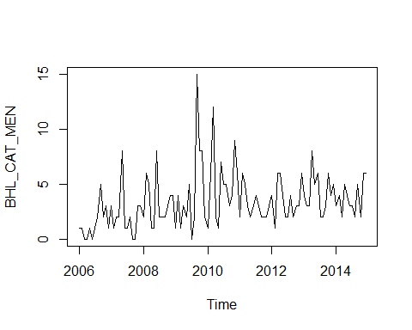 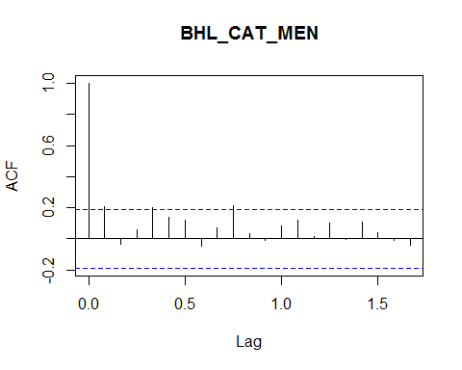

## [1] "results of the automatic exponentiel smoothing:"  
## ETS(A,N,N)   
##   
## Call:  
## ets(y = Cat[[paste(i[1], j, sep = "_")]][, i[2]])   
##   
## Smoothing parameters:  
## alpha = 0.0922   
##   
## Initial states:  
## l = 1.6467   
##   
## sigma: 2.4274  
##   
## AIC AICc BIC   
## 701.2241 701.3383 706.5883   
## [1] ""  
## [1] "results of forecasts of the automatic exponentiel smoothing:"  
## Point Forecast Lo 80 Hi 80 Lo 95 Hi 95  
## Jan 2015 3.98494 0.8740931 7.095787 -0.7726898 8.742570  
## Feb 2015 3.98494 0.8608913 7.108989 -0.7928803 8.762761  
## Mar 2015 3.98494 0.8477450 7.122135 -0.8129859 8.782866  
## Apr 2015 3.98494 0.8346535 7.135227 -0.8330075 8.802888  
## May 2015 3.98494 0.8216162 7.148264 -0.8529463 8.822827  
## Jun 2015 3.98494 0.8086325 7.161248 -0.8728033 8.842684  
## Jul 2015 3.98494 0.7957016 7.174179 -0.8925794 8.862460  
## Aug 2015 3.98494 0.7828229 7.187057 -0.9122756 8.882156  
## Sep 2015 3.98494 0.7699958 7.199885 -0.9318930 8.901773  
## Oct 2015 3.98494 0.7572197 7.212661 -0.9514324 8.921313  
## Nov 2015 3.98494 0.7444939 7.225386 -0.9708947 8.940775  
## Dec 2015 3.98494 0.7318180 7.238062 -0.9902809 8.960161  
## Jan 2016 3.98494 0.7191912 7.250689 -1.0095919 8.979472  
## Feb 2016 3.98494 0.7066131 7.263267 -1.0288285 8.998709  
## Mar 2016 3.98494 0.6940830 7.275797 -1.0479916 9.017872  
## Apr 2016 3.98494 0.6816005 7.288280 -1.0670819 9.036962  
## May 2016 3.98494 0.6691649 7.300715 -1.0861004 9.055981  
## Jun 2016 3.98494 0.6567759 7.313105 -1.1050479 9.074928  
## Jul 2016 3.98494 0.6444327 7.325448 -1.1239251 9.093805  
## Aug 2016 3.98494 0.6321351 7.337745 -1.1427328 9.112613  
## Sep 2016 3.98494 0.6198823 7.349998 -1.1614717 9.131352  
## Oct 2016 3.98494 0.6076740 7.362206 -1.1801427 9.150023  
## Nov 2016 3.98494 0.5955097 7.374371 -1.1987464 9.168627  
## Dec 2016 3.98494 0.5833889 7.386491 -1.2172836 9.187164

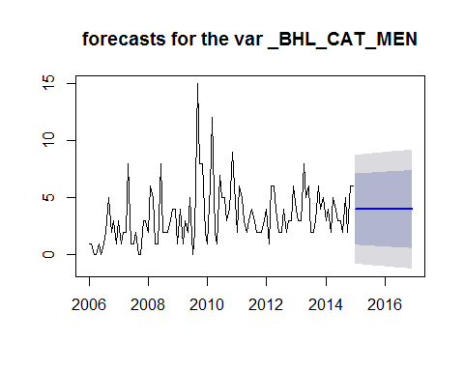 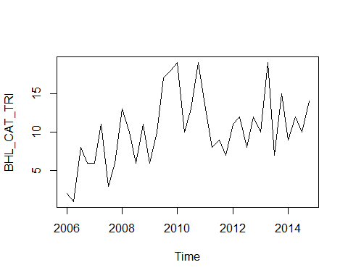 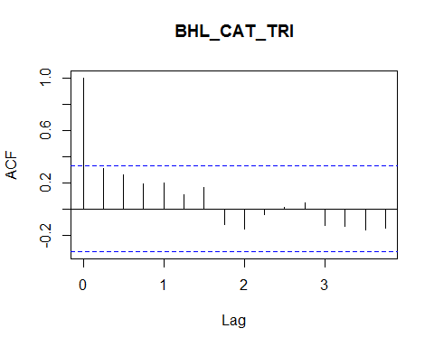

## [1] "results of the automatic exponentiel smoothing:"  
## ETS(A,Ad,N)   
##   
## Call:  
## ets(y = Cat[[paste(i[1], j, sep = "_")]][, i[2]])   
##   
## Smoothing parameters:  
## alpha = 0.001   
## beta = 1e-04   
## phi = 0.863   
##   
## Initial states:  
## l = 1.818   
## b = 1.6498   
##   
## sigma: 3.6928  
##   
## AIC AICc BIC   
## 233.0660 235.0660 240.9836   
## [1] ""  
## [1] "results of forecasts of the automatic exponentiel smoothing:"  
## Point Forecast Lo 80 Hi 80 Lo 95 Hi 95  
## 2015 Q1 12.15803 7.425543 16.89052 4.920316 19.39574  
## 2015 Q2 12.16395 7.431462 16.89644 4.926234 19.40167  
## 2015 Q3 12.16906 7.436569 16.90156 4.931339 19.40679  
## 2015 Q4 12.17347 7.440976 16.90597 4.935743 19.41120  
## 2016 Q1 12.17728 7.444777 16.90978 4.939542 19.41501  
## 2016 Q2 12.18056 7.448057 16.91307 4.942820 19.41831  
## 2016 Q3 12.18340 7.450886 16.91591 4.945646 19.42115  
## 2016 Q4 12.18584 7.453327 16.91836 4.948084 19.42360

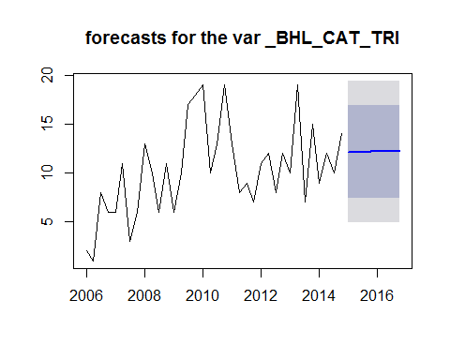 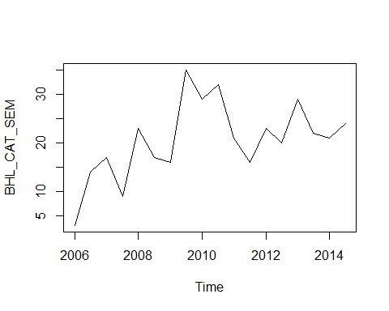 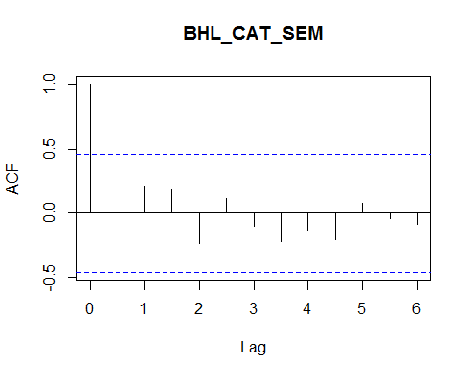

## [1] "results of the automatic exponentiel smoothing:"  
## ETS(A,N,N)   
##   
## Call:  
## ets(y = Cat[[paste(i[1], j, sep = "_")]][, i[2]])   
##   
## Smoothing parameters:  
## alpha = 0.4551   
##   
## Initial states:  
## l = 9.7237   
##   
## sigma: 7.2048  
##   
## AIC AICc BIC   
## 127.1178 127.9178 128.8986   
## [1] ""  
## [1] "results of forecasts of the automatic exponentiel smoothing:"  
## Point Forecast Lo 80 Hi 80 Lo 95 Hi 95  
## 2015.0 23.09679 13.86340 32.33017 8.975542 37.21803  
## 2015.5 23.09679 12.95223 33.24135 7.582023 38.61155  
## 2016.0 23.09679 12.11641 34.07717 6.303745 39.88983  
## 2016.5 23.09679 11.33986 34.85372 5.116114 41.07746

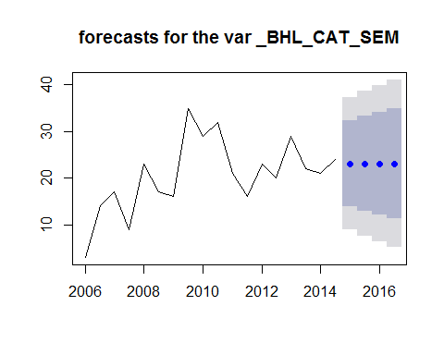 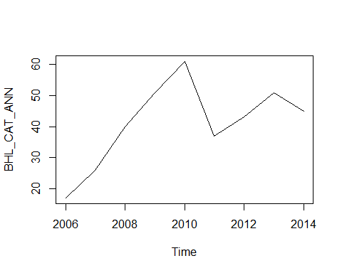 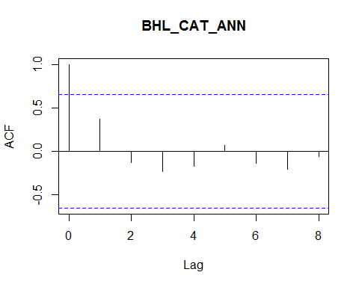

## [1] "results of the automatic exponentiel smoothing:"  
## ETS(M,N,N)   
##   
## Call:  
## ets(y = Cat[[paste(i[1], j, sep = "_")]][, i[2]])   
##   
## Smoothing parameters:  
## alpha = 0.9999   
##   
## Initial states:  
## l = 15.5488   
##   
## sigma: 0.3202  
##   
## AIC AICc BIC   
## 67.01667 69.01667 67.41112   
## [1] ""  
## [1] "results of forecasts of the automatic exponentiel smoothing:"  
## Point Forecast Lo 80 Hi 80 Lo 95 Hi 95  
## 2015 45.0006 26.5357593 63.46544 16.761063 73.24014  
## 2016 45.0006 18.2278983 71.77330 4.055286 85.94592  
## 2017 45.0006 11.3684049 78.63280 -6.435404 96.43661  
## 2018 45.0006 5.1516437 84.84956 -15.943120 105.94432  
## 2019 45.0006 -0.7331352 90.73434 -24.943112 114.94431  
## 2020 45.0006 -6.4467418 96.44794 -33.681320 123.68252  
## 2021 45.0006 -12.0869930 102.08819 -42.307340 132.30854  
## 2022 45.0006 -17.7202124 107.72141 -50.922605 140.92381  
## 2023 45.0006 -23.3951658 113.39637 -59.601697 149.60290  
## 2024 45.0006 -29.1500877 119.15129 -68.403091 158.40429

