AMA Student Age Analysis
May be shared to the general public- Created by Ateh Nji-Tanji
This study analysis trends over time from the data of ages at which students left AMA. This analysis involves averages of ages over time and the distribution of ages over specific periods of time. The dataset was anonymized, with scrambled last names to protect student identities and personal information.
The dataset on AMA students contains the anonymized last names, their date of birth, their exit year and their age at exit, calculated from exit year and date of birth. Due to inconsistent data entry, some years were input as two-digit numbers, and for the cleaning of the dataset, the assumption that all these dates were from the 20th century, therefore just needed a 19 added at the beginning. Additionally, students from AMA’s ages are supposed to range from 7 to 23, therefore all data about students younger than 7 or older than 23 was discarded.
Visualization of Results:
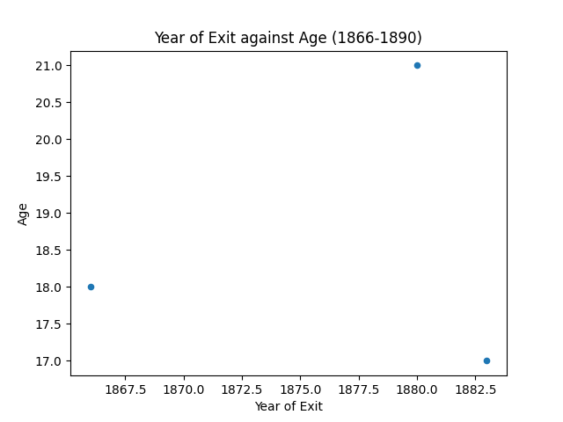
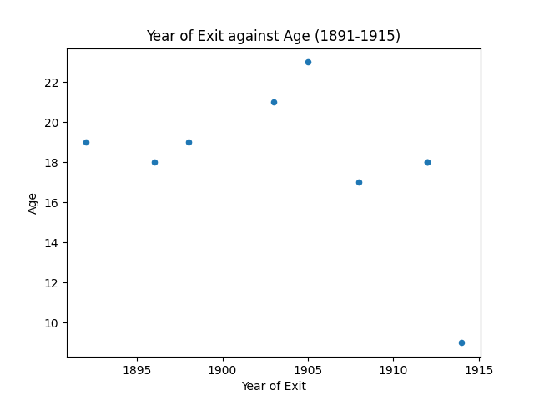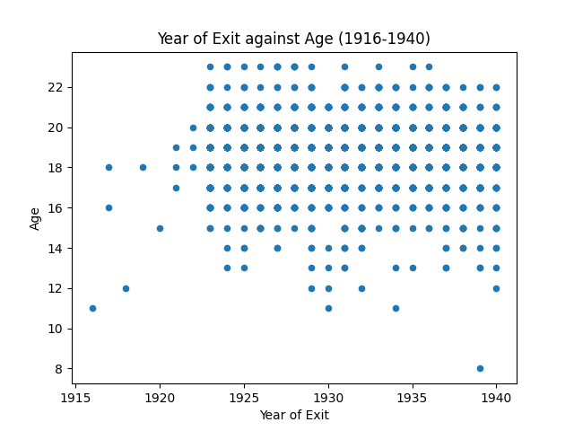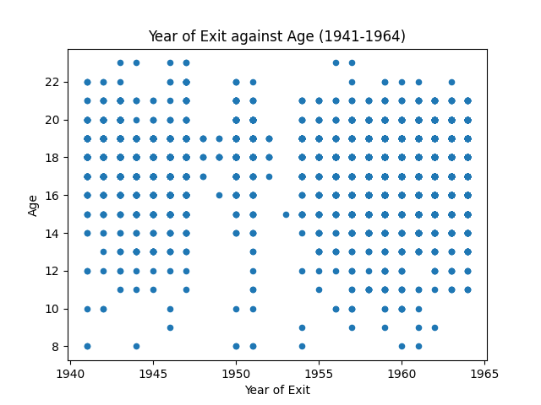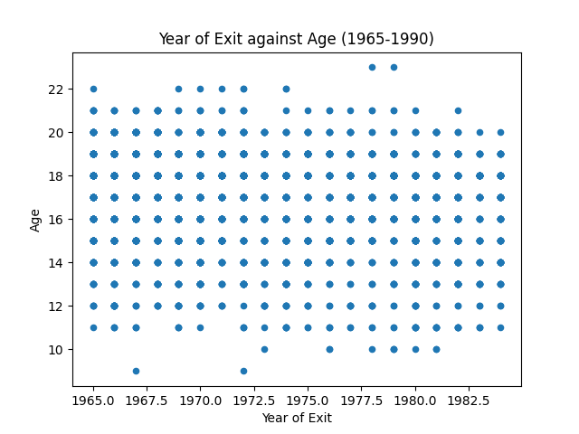
The above graphs show the distribution of age across years from 1866 to 1984, in 25-year periods. The x-axis holds the year of exit over a 25-year period, and the y-axis shows the ages of students during this period. From the graphs we can see that there is more data for the later years of the program than the beginning. With time we also see how the distribution of ages shifts over the years. From 1891 to 1915, we see that majority of the students exiting were above 16. Later, we see that the amount of data increases from 1915 to 1940, and more students below the age of 16 exit the program. Over the next 50 years we see the ages of students who exit the program balance out.
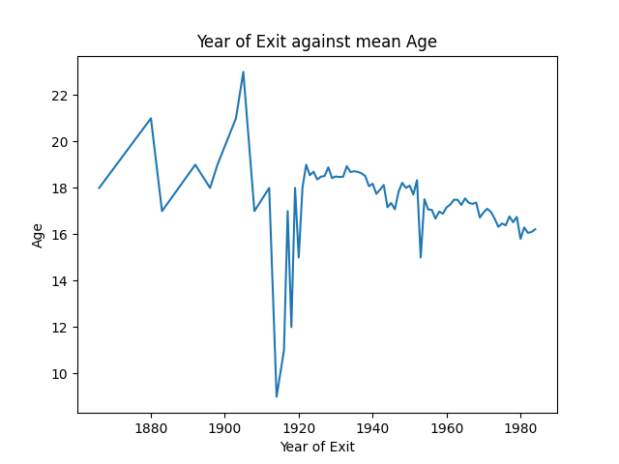
Description: This graph shows the average age of students at AMA at the time of exit, with average age on the y-axis and year of exit on the x-axis. From the graph we can see a lot of fluctuations in the age of exit from 1866 to about 1912. These fluctuations could be explained by the limited data on students during this range as stated above. Then we see a sharp drop in average age in 1913 to about 9 years old. This drop is followed by a just as drastic change, as the average age increases to 19 in 1922. The average age from 1922 to 1984 showed a slow net decrease in the average age of students from about 19 to 16.

Conclusions:
From the analysis, we can observe that there were limited exits from the program in the late 19th century and early 20th century. Additionally, the ages of these exits were all mostly above 16. Which could suggest the following, fewer students were leaving the program, fewer students got into the program or that the cleaning process of the data was bias towards this period. From about 1916 to 1984, we observe a larger number of students exiting the program, from a wide range of ages, suggesting that enrollment may have gone up. The general trend in the mean ages of students exiting the program progressively went them, suggesting they were completing the program faster.
5. Sharing Consent
I [choose ONE: consent / do not consent] for this report to be shared with the AMA historian and/or the public. (Replace this statement with your actual choice before submission.)

