College of Computer Sciences and Information Technology
King Faisal University
Fundamentals of Programming
Final Project

Project title:

sport area reservations system

Members:
Atekah hussain aljafar - 222427138
Alaa hussain harabh-222421527
Rawan abdulaziz alsafi-222414494

Submitted to:
Dr.Sharmila banu sheilk Imam

Date:
Feb 2023

I. PROJECT DESCRIPTION
This project is a sports area registration management system that was created to help clubs manage customers' registration, adding, deleting, and modifying materials in an easy way and helping to save time and effort. This system allows storing and accessing all customer's data in one place and collecting all these elements and creating this system is our goal in this project.

II. PROGRAM FEATURES
• Add customer: this feature allows the user to add a new customer by adding the customer's name, phone, and ID.
• Remove customers: this feature allows users to remove added customers by searching for customers added before and deleting them from the system.
• Search customer: this feature searches a customer in the system by comparing every customer ID with the ID entered.
• List customers: this feature will list every customer assigned in the system.
• Update customer: this feature allows the user to update customers' old information with new info that the user enters.
• Add area: this feature allows the user to add a new sports area by completing area info.
• remove area: this feature allows customers to remove reserved areas by their number(ID
• search area: this feature allows customers to search for already existed or added areas by their ID
• list area: this feature will list all areas in the system
• update area: this feature allows customers to change some information or change the reserved areas
• add reservation: this feature asks the user to enter name, phone, and ID and save this information
• remove reservation: this feature deletes information for customers who want to drop out.

II. USER MANUAL
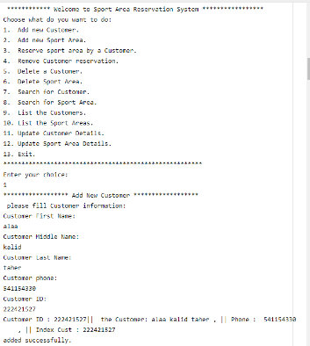
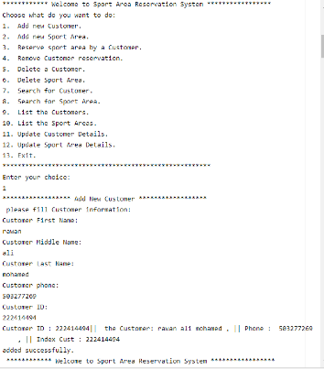
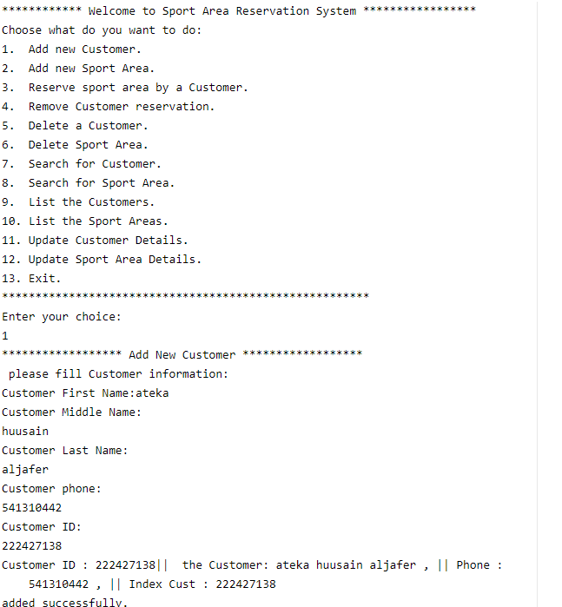
1-The first process that the program performs is adding a customer (customer name, phone, and id)and storing it in the records.

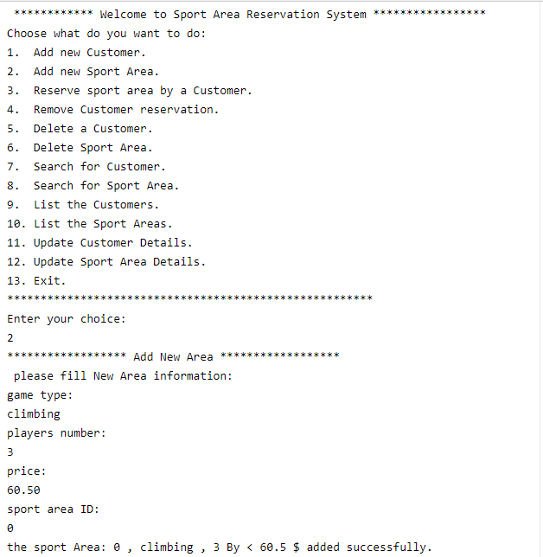
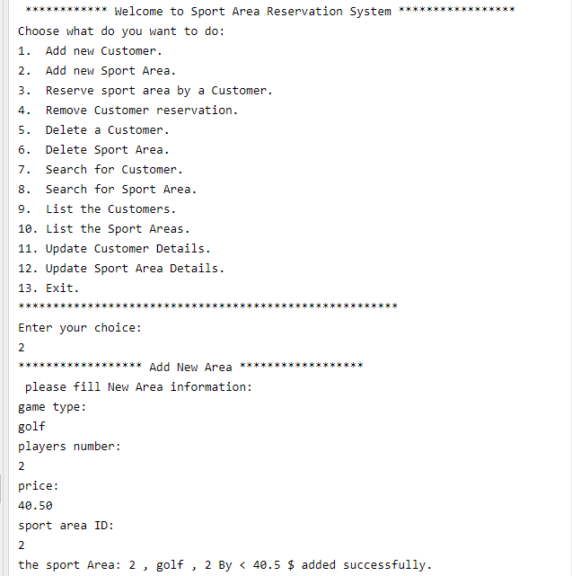
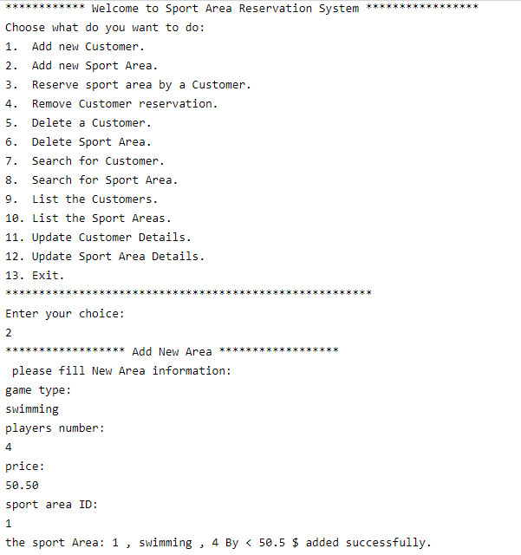
2- The second step is adding a new sports area(game type, players number, price , sports area id)

3-The third step here customer can join to sports area(customer id, sports area id ).
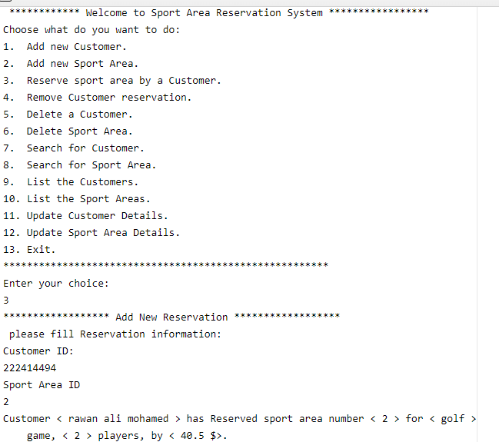
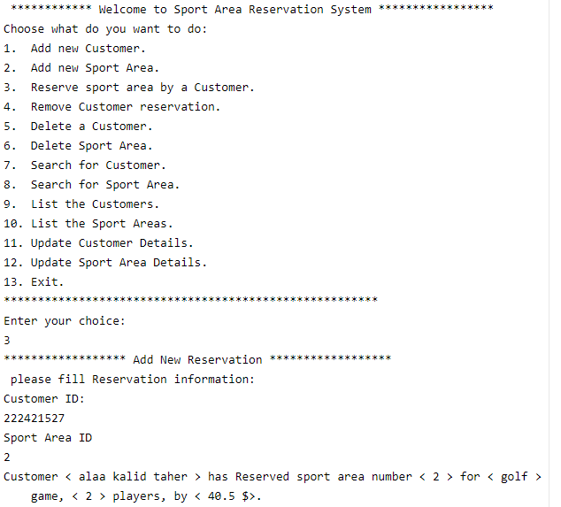
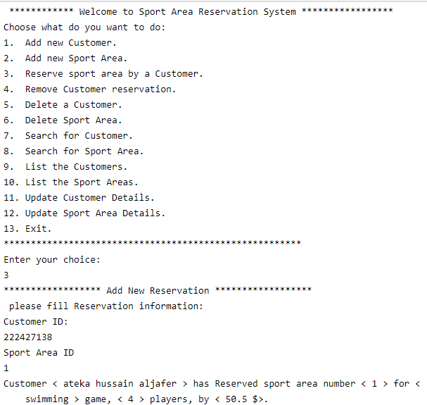
4-The fourth step is the process of deleting a customer reserve when entering(customer id).
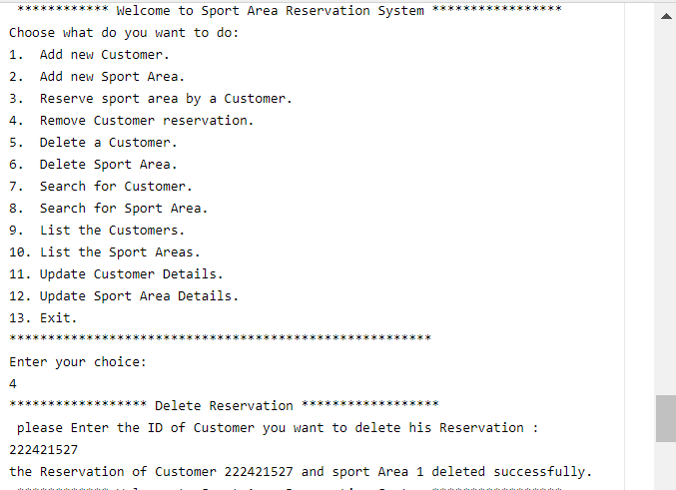

5-The fifth step is to delete a customer completely when entering (id of the customer).
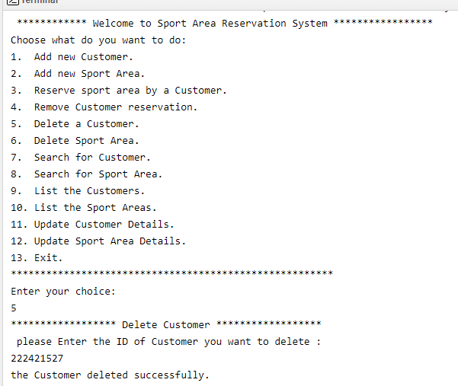

6-The sixth step is the process of deleting the sports area that has been added by entering the id of the sports area.
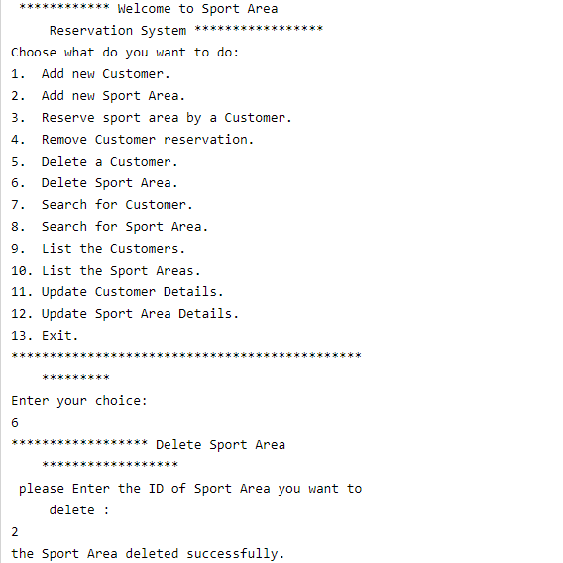
7-The seventh step is a search process, searching for the customer by the customer id, when the customer id enters the program will search if the customer exited or not.
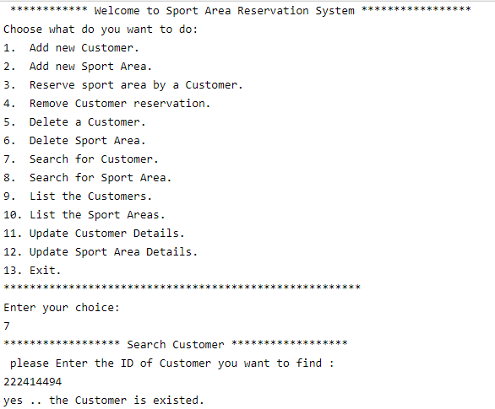
8-The eighth step is a search process, searching for the sports area by the sport id, when the sport id enters the program will search if the sports area exists or not.
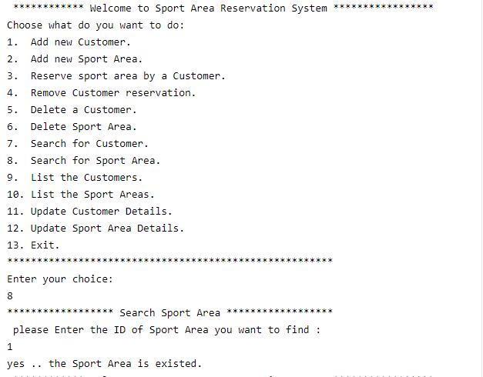
9-The ninth step is to display the list of customers who have been assigned.

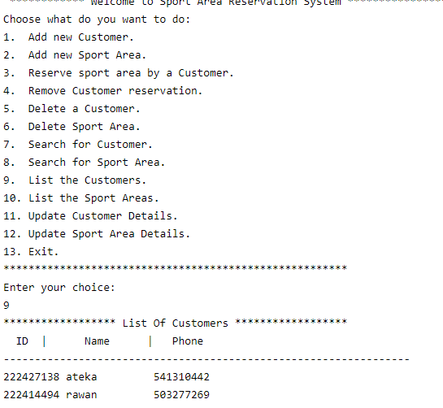

10-The tenth step of the program displays a list of sports areas that have been added.
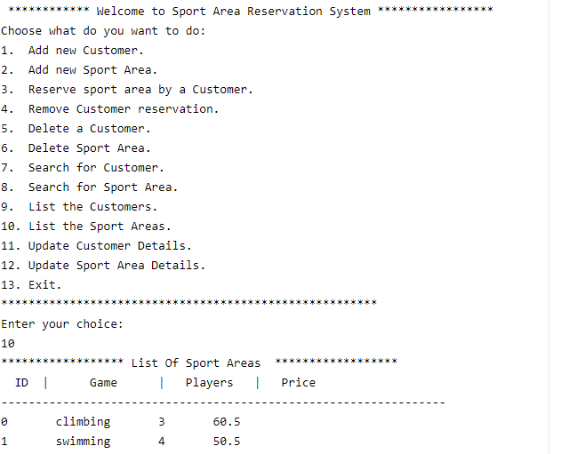
11-The eleventh step is the modification process, it is the entry of the customer id that will modify the customer name and phone.
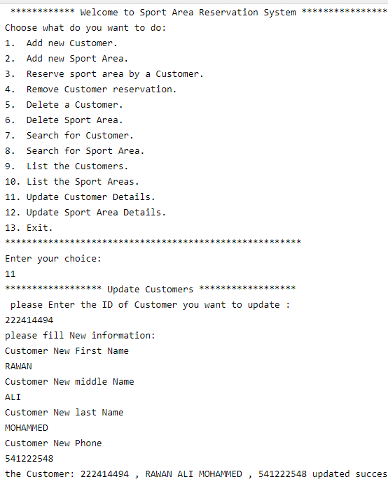
12-The twelfth step is the modification process of sport area details when entering the sports area id, can modify the sports area name, number of players, and price.
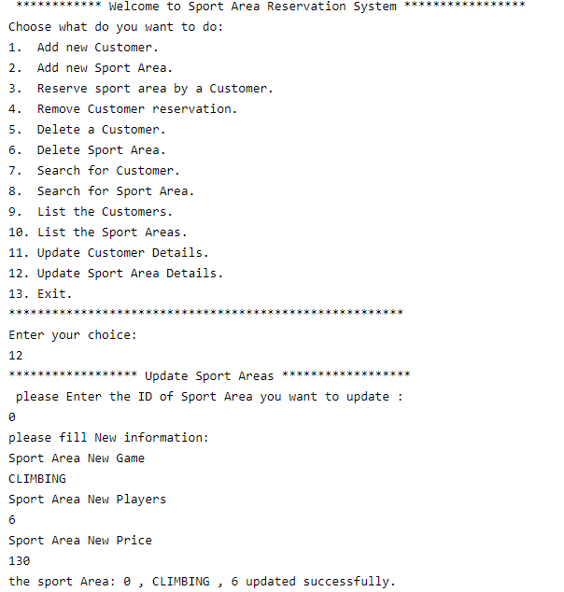

13-The thirteenth step is the step to exit the program permanently.
The program will repeat itself until the exit process is completed.
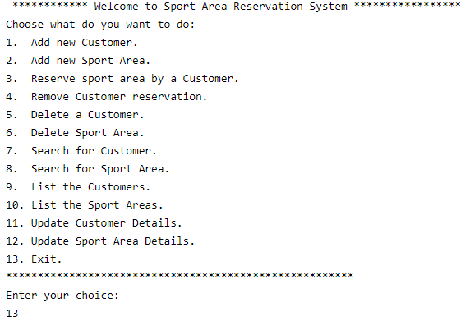

IV. Program Code

