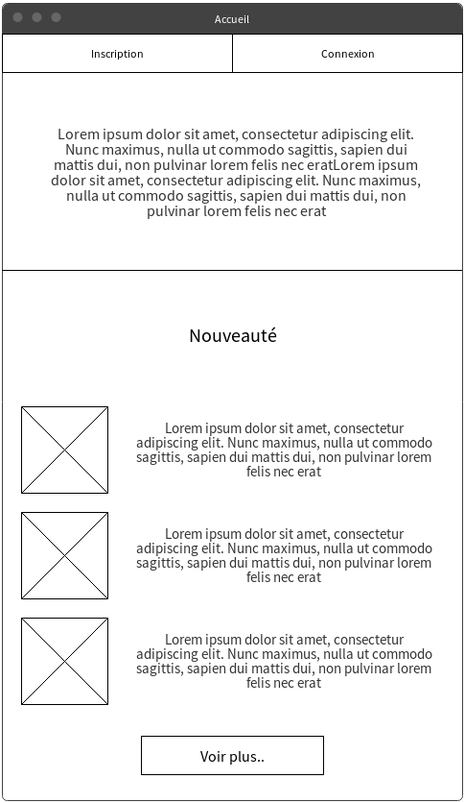
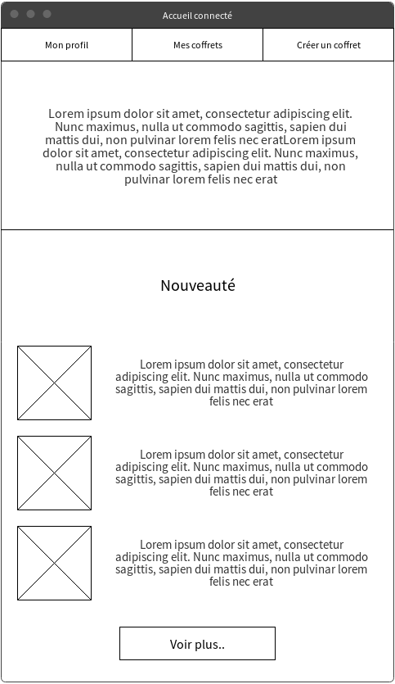
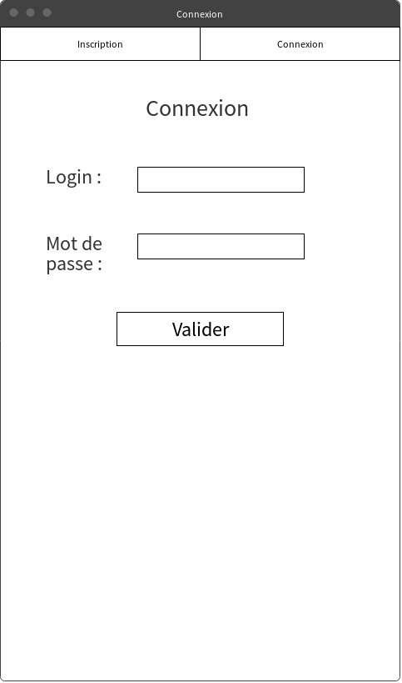
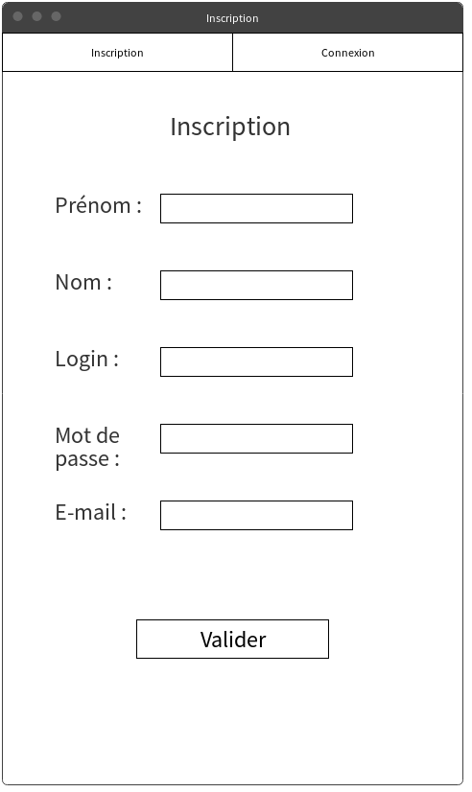
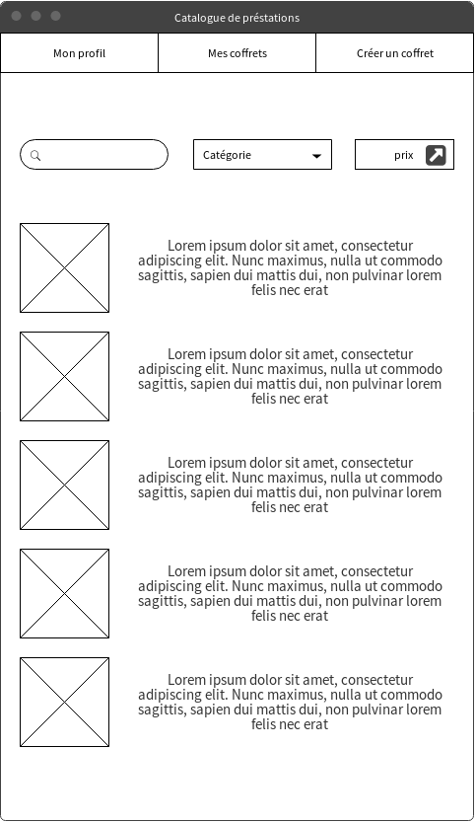
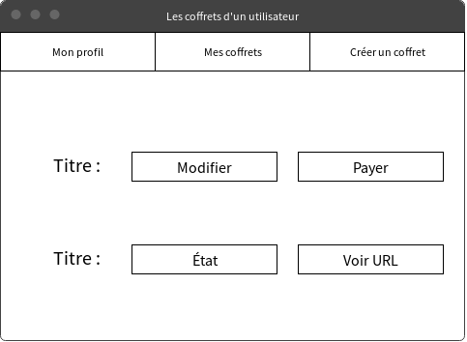

/admin/

/login/

/login/
/register/

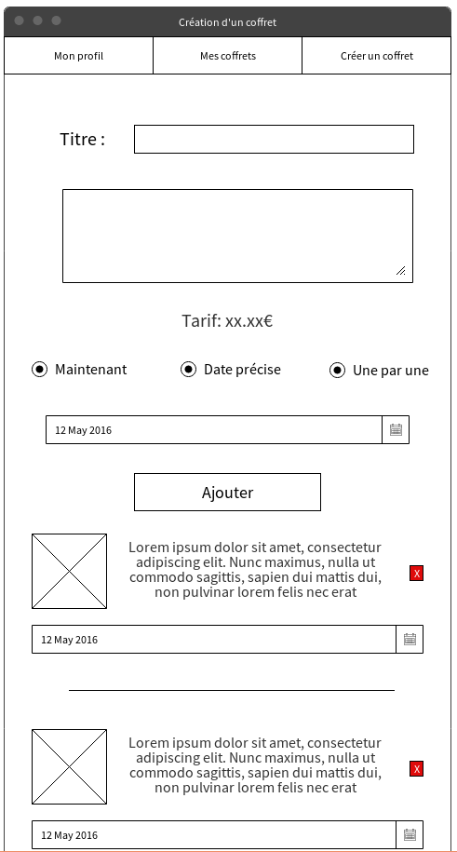
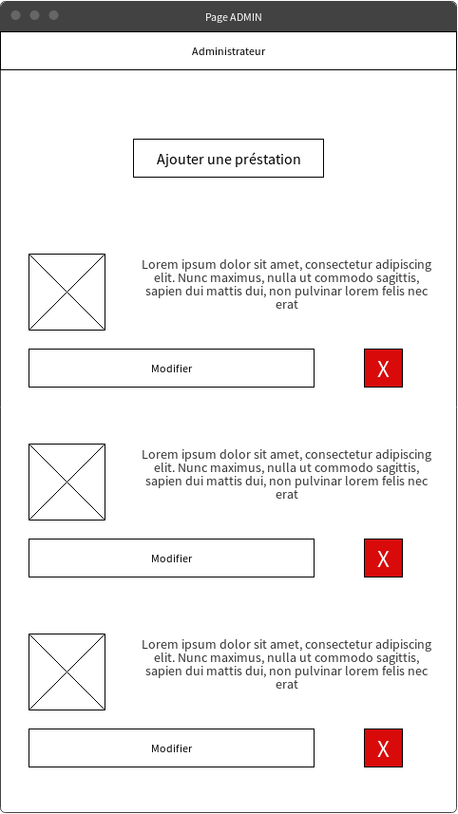
/box/new/
/admin/

/login/
/register/
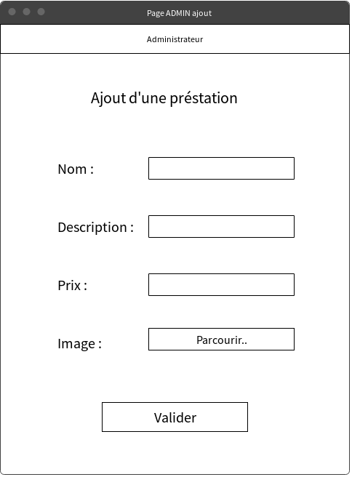

/admin/new/

/home/
/loginPost/
/admin/prestation/remove/

/login/
/boxes/

/box/remove/

/loginPost/

/admin/post/

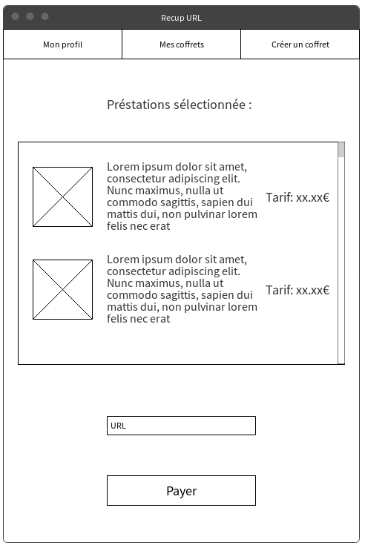
/home/
/registerPost/

/prestations/
/admin/prestation/

/box/
/prestations/
/admin/
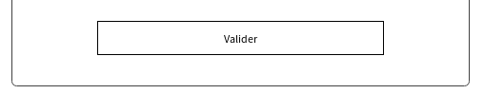
/prestations/

/boxes/

/box/update/
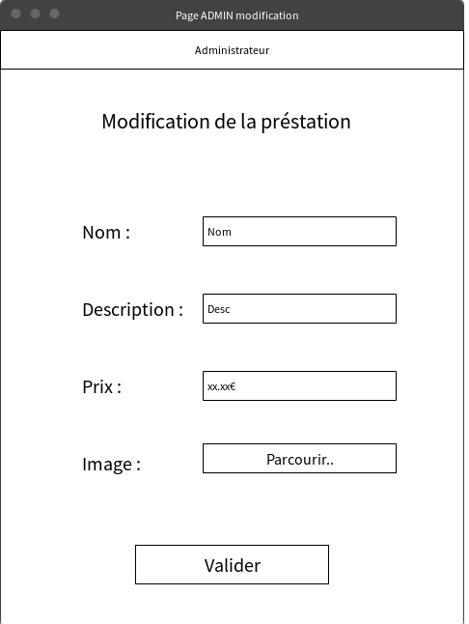

/box/post/

/boxes/
/admin/prestation/update/
OU
/box/summary/
/login/

/box/add/
/box/url/

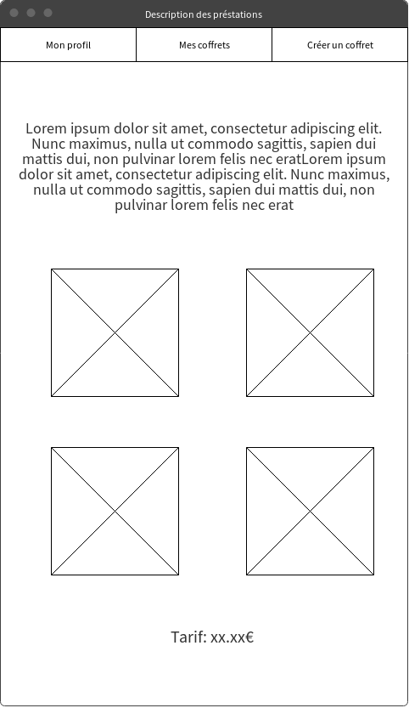
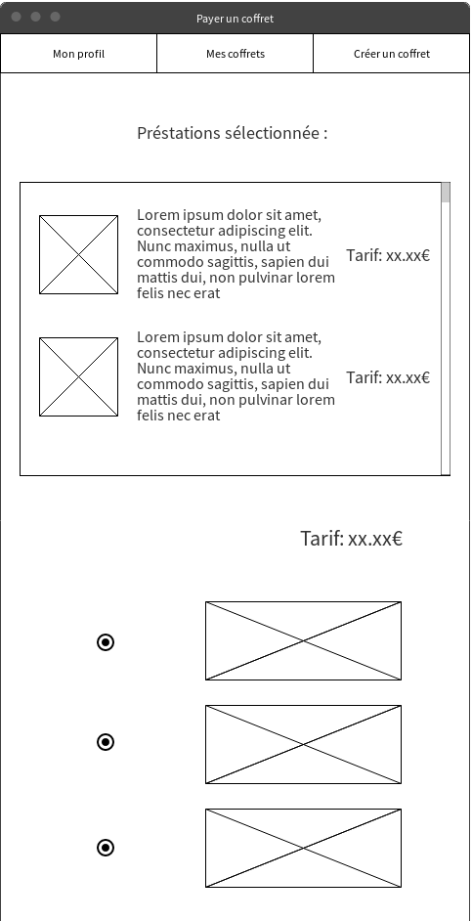

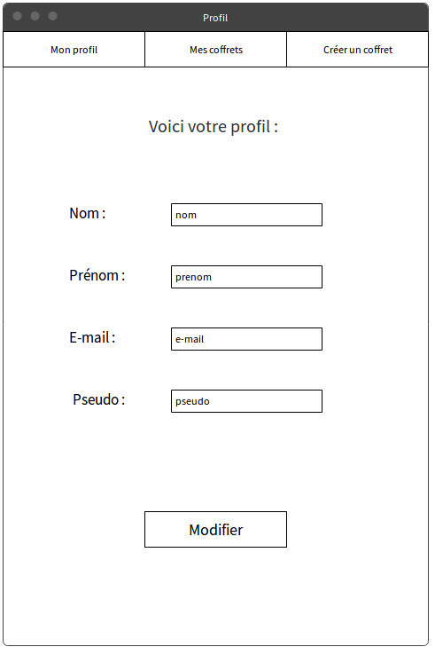
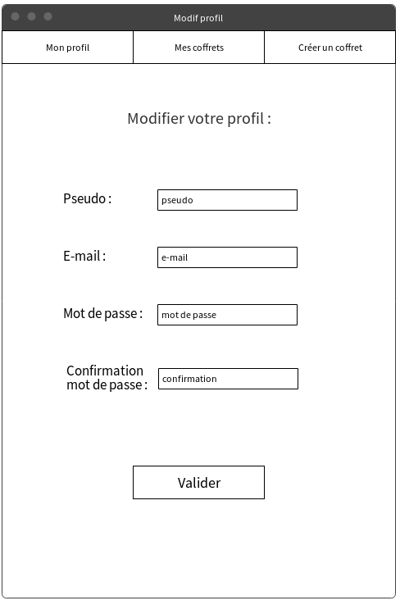
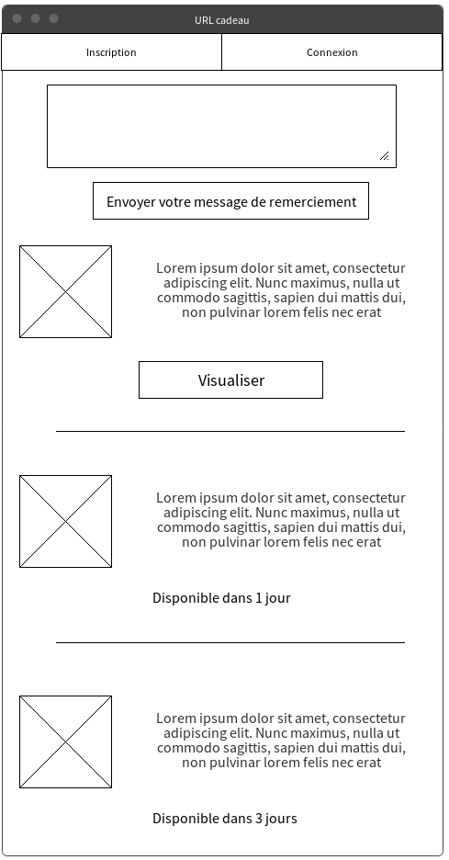
/register/
/prestation/{id}
/prestation/{id}
/box/pay/
/box/pay/
/profile/
/profile/
/profile/update
/boxes/
/box/add/
/box/confirm/
/box/confirm/
/box/receiver/message/
/profile/view/

