Cover Page
Student Name: Martin Wanzetse
Registration Number: BBIT/2024/58201
Course: Bachelor of Business and Information Technology
Unit Code: BIT3208
Unit Name: Advanced Web Design and Development
Lecturer Name: Michael Nyoro
Year: Year 3 sem 2
Project Details
Project Title: Nexora
Selected Technologies: PHP, MySQL, HTML, CSS, JavaScript
Server: XAMPP / WAMP (Apache + MySQL)

GitHub Repository Link:
https://github.com/Atenza1917/nexora

Table of Contents
Cover Page 1
Table of Contents 2
1. Project Overview 4
2. Project Folder Structure 4
Week 1: Local Environment Setup 4
1.1 Installation and Testing of Local Development Environment 4
Fig 1.1: Installation of XAMPP 4
Fig 1.2: Apache and MySQL Running 5
Fig 1.3: Localhost Test Page 6
Week 1.2 Reflection 6
Week 2: Wireframes and GUI Design 7
2.1User Interface Planning and System Design 7
Fig 2.1.1: Hand-drawn Wireframe homepage 7
Fig 2.1.2: Mobile View Mockup 7
2.2 Week 2 Reflection 8
Week 3: JavaScript and PHP Basics 9
3.1 Frontend Interaction and Backend Foundations 9
Fig 3.1.1: JavaScript Form Validation 9
Fig 3.1.2: Password Strength Checker 9
Fig 3.1.3: PHP Syntax Practice 9
Fig 3.1.4: Database Connection Script 9
Fig 3.1.5: Dynamic User Input Handling 10
3.2 Week 3 Reflection 10
Week 4 Database creation 12
Fig 4.1: Database Created in phpMyAdmin 12
Fig 4.2: Users Table Structure 12
Fig 4.3: Products Table Structure 12
Fig 4.4: Database Relationships 13
4.2 Week 4 Reflection 13
Week 5: User Registration and Login Module 14
Fig5.1: Registration Form 14
Fig 5.3: User Data Stored in Database 14
Fig 5.5: Password Hashing. 14
5.2 Week5 Reflection 15

1. Project Overview
Nexora is a full-stack web application developed as a semester project. It is a modern platform built using React on the frontend and xampp and my sql as the database layer. The system demonstrates practical application of advanced web design and development concepts taught across the course.

The project covers all major topics introduced throughout the course: Restful API design, component-based UI development, authentication and authorization, database modelling, and deployment workflows.

2. Project Folder Structure
Fig 2.1: Nexora Project Folder Structure

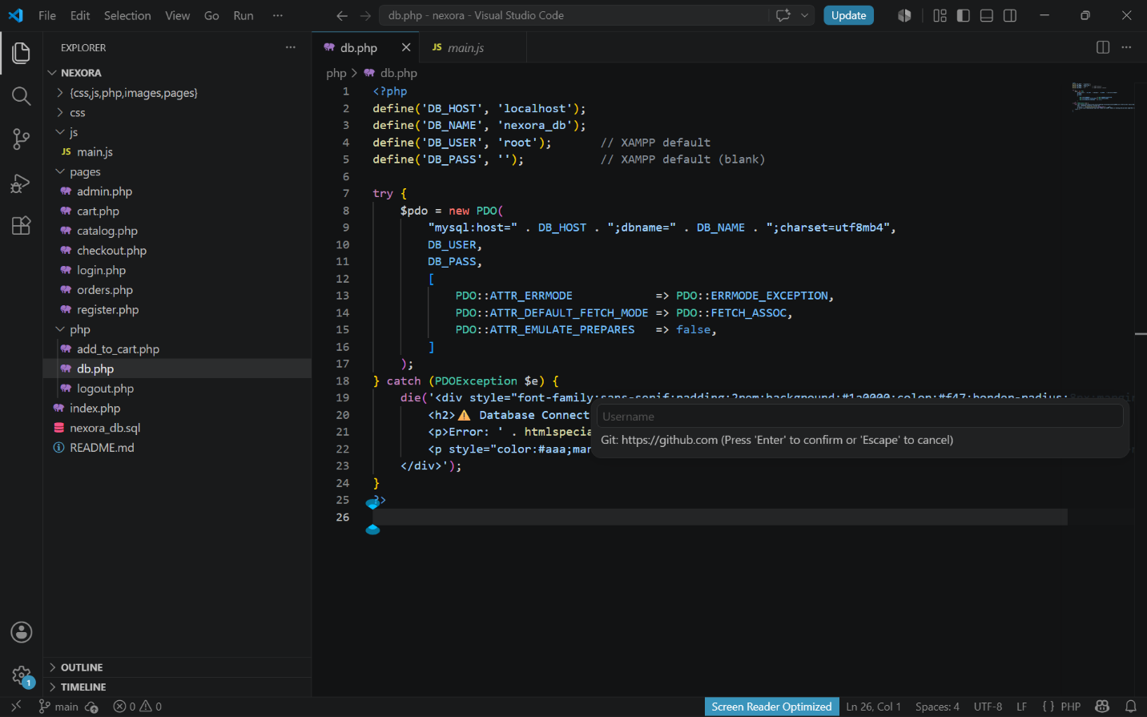

Week 1: Local Environment Setup

1.1 Installation and Testing of Local Development Environment

Fig 1.1: Installation of XAMPP
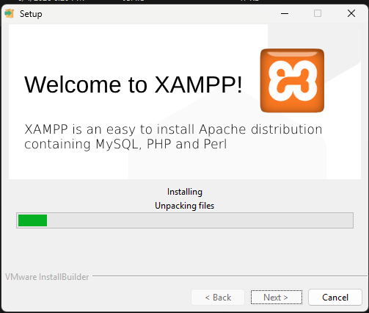

Fig 1.2: Apache and MySQL Running
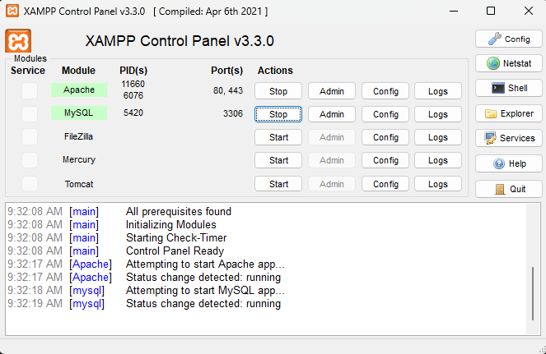

Fig 1.3: Localhost Test Page
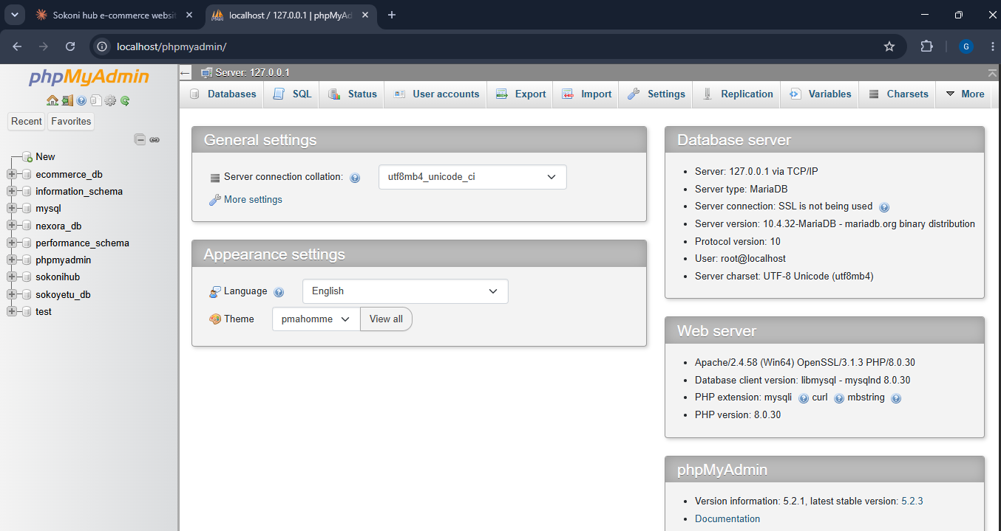

Week 1.2 Reflection
This week was dedicated to preparing the development environment needed for the nexora project. I installed and configured XAMPP, ensuring that both Apache and MySQL services were functioning properly. Visual Studio Code was set up as the main platform for writing and testing PHP code.
During the setup process, I experienced some difficulties connecting PHP to the MySQL database. After checking the database settings and confirming that all services were active, the connection was established successfully. The screenshots included show the installation process, localhost testing, execution of PHP files, and successful communication between PHP and the database.
Completing this stage ensured that all the necessary tools were ready for the development of the system.

Week 2: Wireframes and GUI Design
Planning the application visually before writing any HTML or CSS wireframes, GUI layouts, and technology decisions.

2.1User Interface Planning and System Design

Fig 2.1.1: Hand-drawn Wireframe homepage
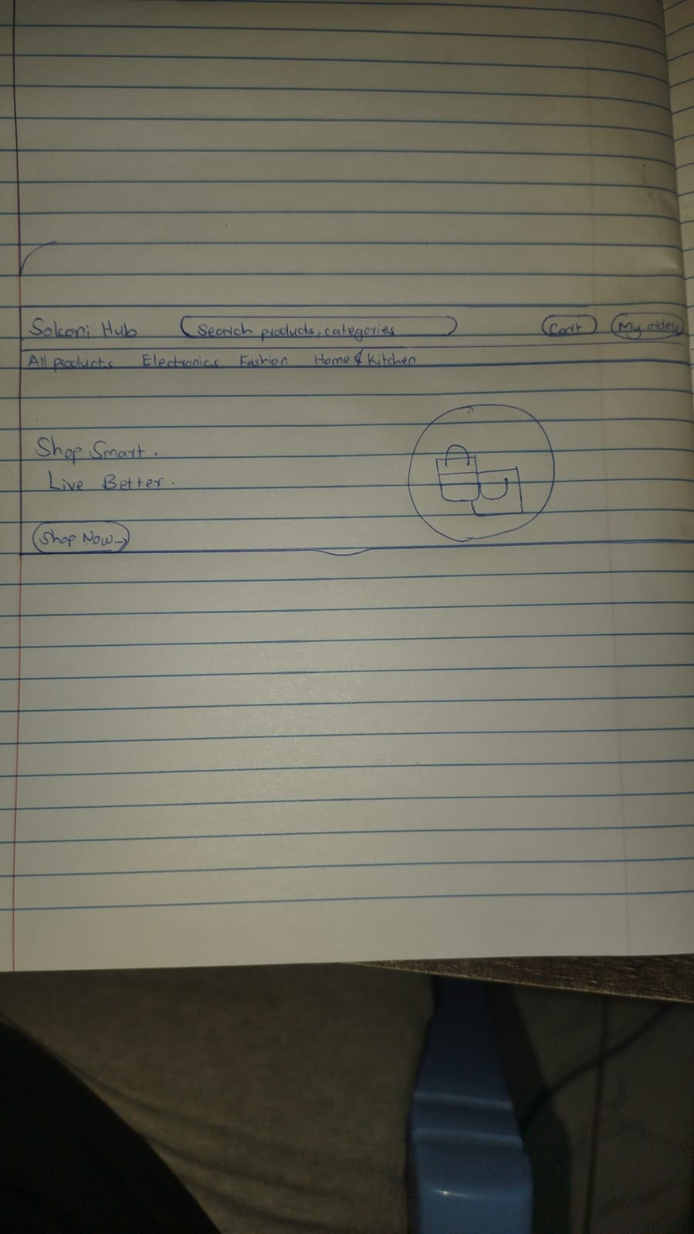

Fig 2.1.2: Mobile View Mockup

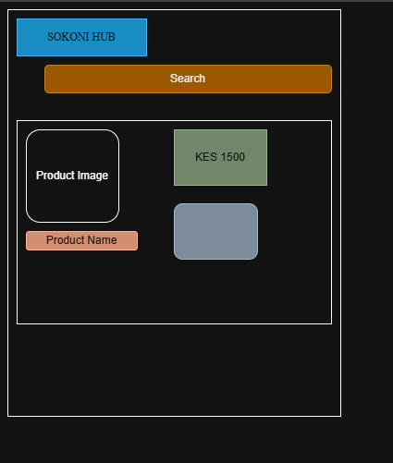

2.2 Week 2 Reflection
This week focused on designing the visual structure of the Nexora system before actual coding began. I developed wireframes and interface layouts to map out how users would move through the application. Key sections such as user login, product listings, shopping cart, and dashboard pages were planned during this phase.
Special attention was given to creating a simple and user-friendly interface that would be easy to navigate. Mobile responsiveness was also considered to ensure the platform could be accessed conveniently from different devices. The screenshots illustrate the wireframe sketches, layout concepts, navigation planning, color choices, and prototype designs.
This design phase provided a clear guide that would help streamline the development process in the following weeks.

Week 3: JavaScript and PHP Basics

3.1 Frontend Interaction and Backend Foundations

Fig 3.1.1: JavaScript Form Validation
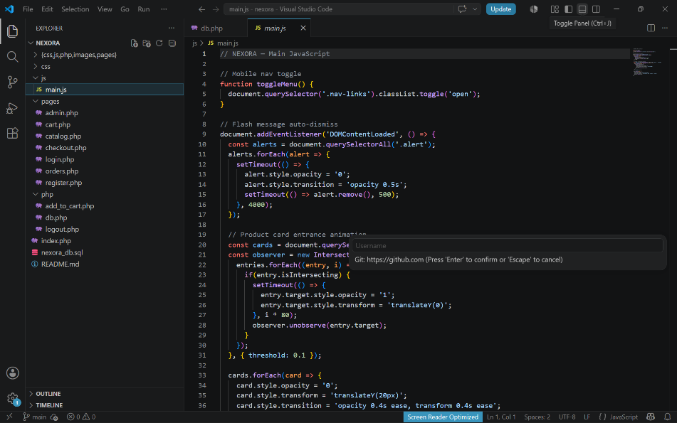

Fig 3.1.2: Password Strength Checker
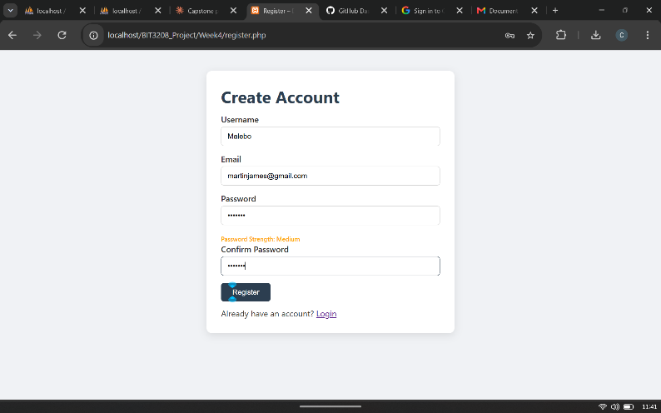

Fig 3.1.3: PHP Syntax Practice

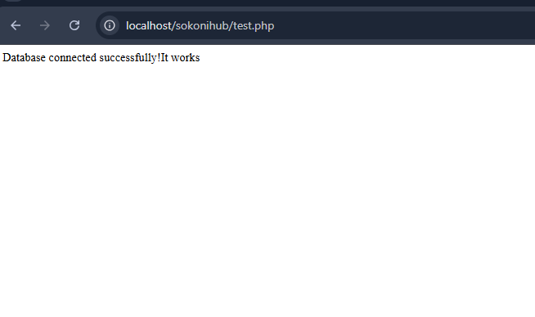

Fig 3.1.4: Database Connection Script
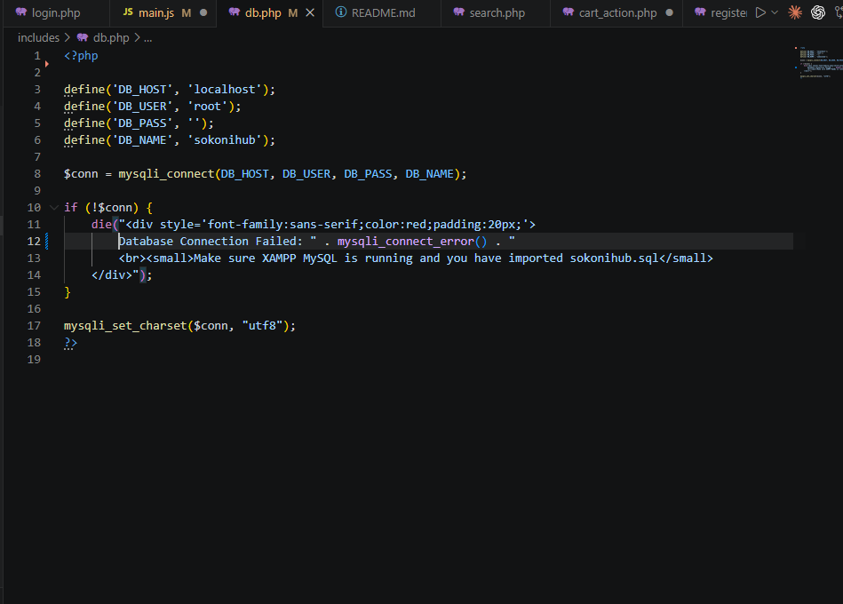

Fig 3.1.5: Dynamic User Input Handling

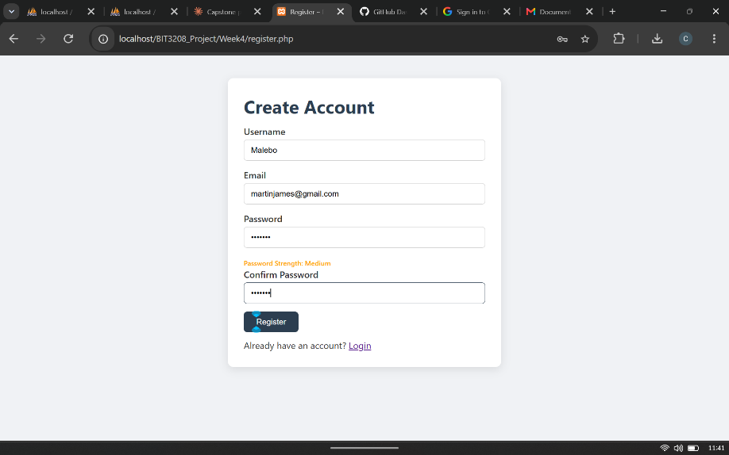

3.2 Week 3 Reflection
This week introduced practical concepts in JavaScript and PHP, which are essential for creating dynamic and interactive web applications. I worked on implementing JavaScript validation to ensure users enter correct information before submitting forms. On the server side, PHP was used to process form data and interact with the database.
I also practiced creating database connection scripts and handling user input dynamically. At first, it was challenging to understand how client-side validation and server-side processing work together, but hands-on exercises helped strengthen my understanding. The screenshots show examples of form validation, password strength checks, PHP coding activities, database connections, and dynamic data processing.
The skills acquired this week laid the groundwork for developing more advanced application features.

Week 4 Database creation

Fig 4.1: Database Created in phpMyAdmin
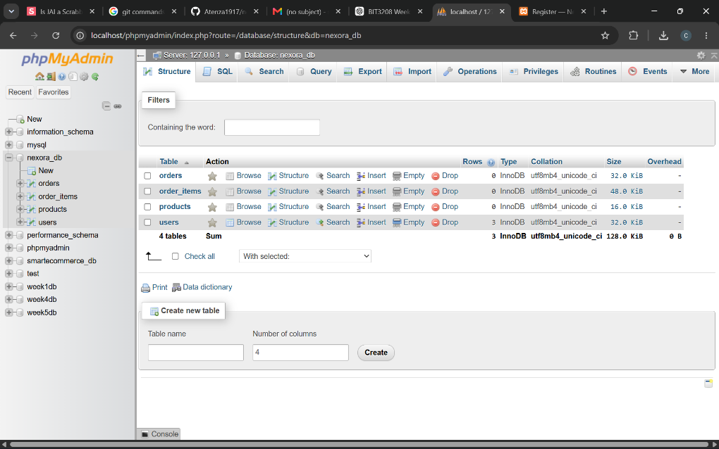

Fig 4.2: Users Table Structure
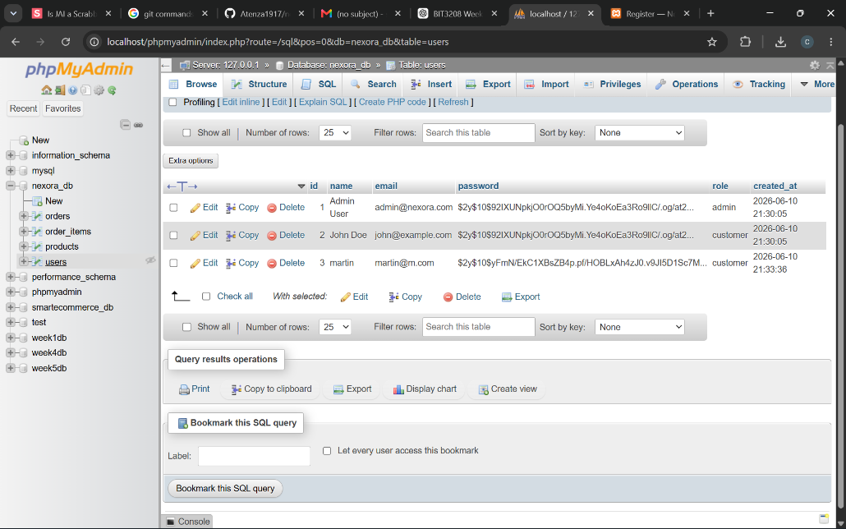

Fig 4.3: Products Table Structure
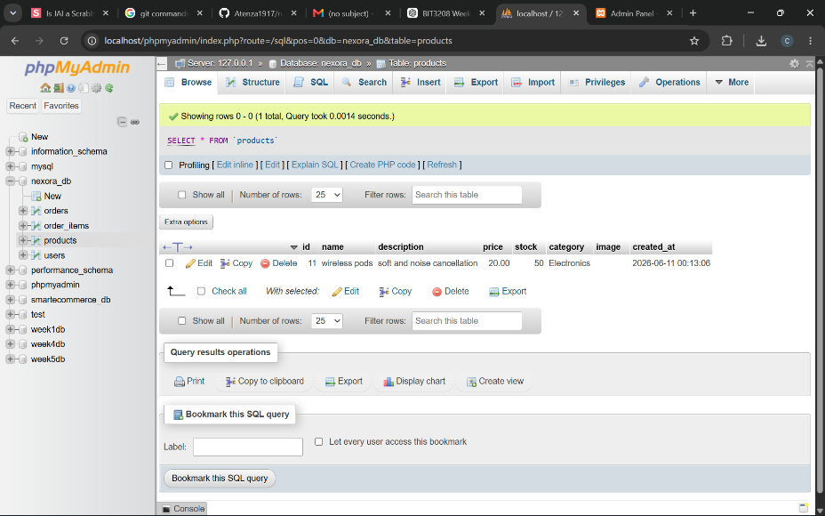

Fig 4.4: Database Relationships
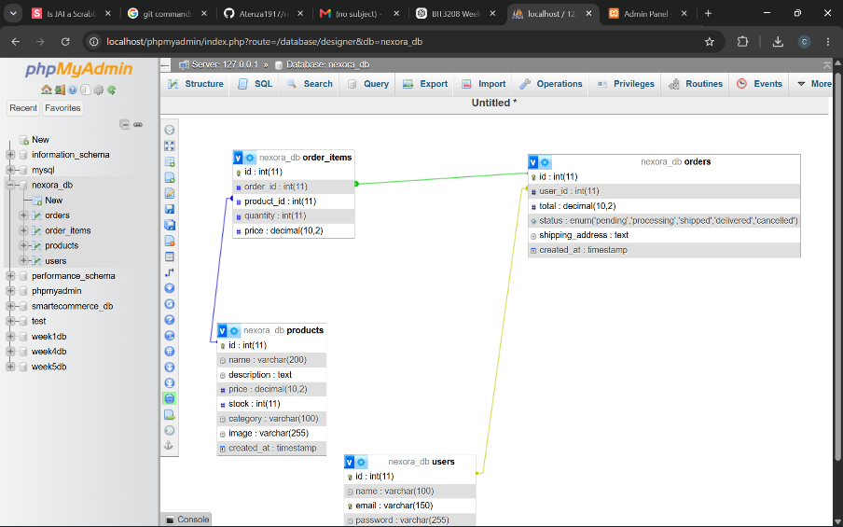

4.2 Week 4 Reflection
This week concentrated on building the database structure for the Nexora system using MySQL and phpMyAdmin. Various tables were created to store important information, including users, products, orders, and shopping cart details. Relationships between tables were carefully designed to ensure efficient data management and consistency.
One of the main challenges was setting up foreign key relationships correctly. Through testing and reviewing the database design, the issue was resolved successfully. The screenshots demonstrate database creation, table design, relationship mapping, and sample records entered into the system.
The completed database serves as the backbone of the application by providing an organized and reliable method of storing information.

Week 5: User Registration and Login Module

Fig5.1: Registration Form
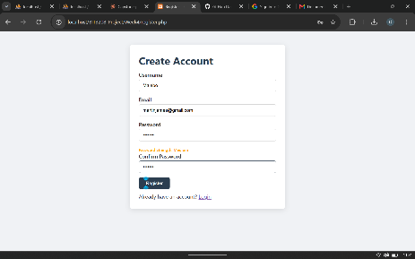

Fig 5.3: User Data Stored in Database
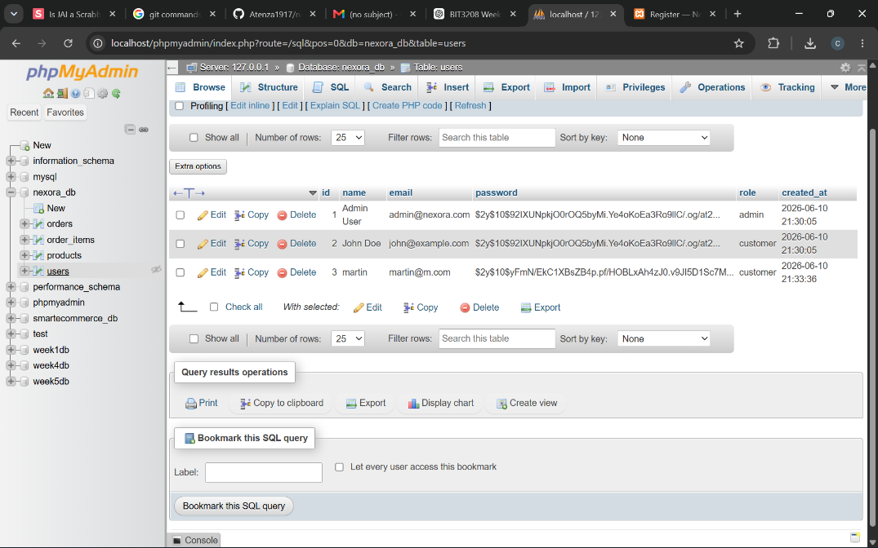Fig 5.4: Successful Login
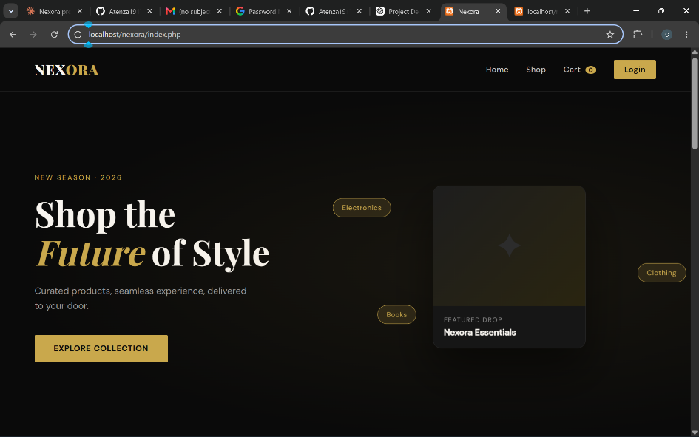

Fig 5.5: Password Hashing.

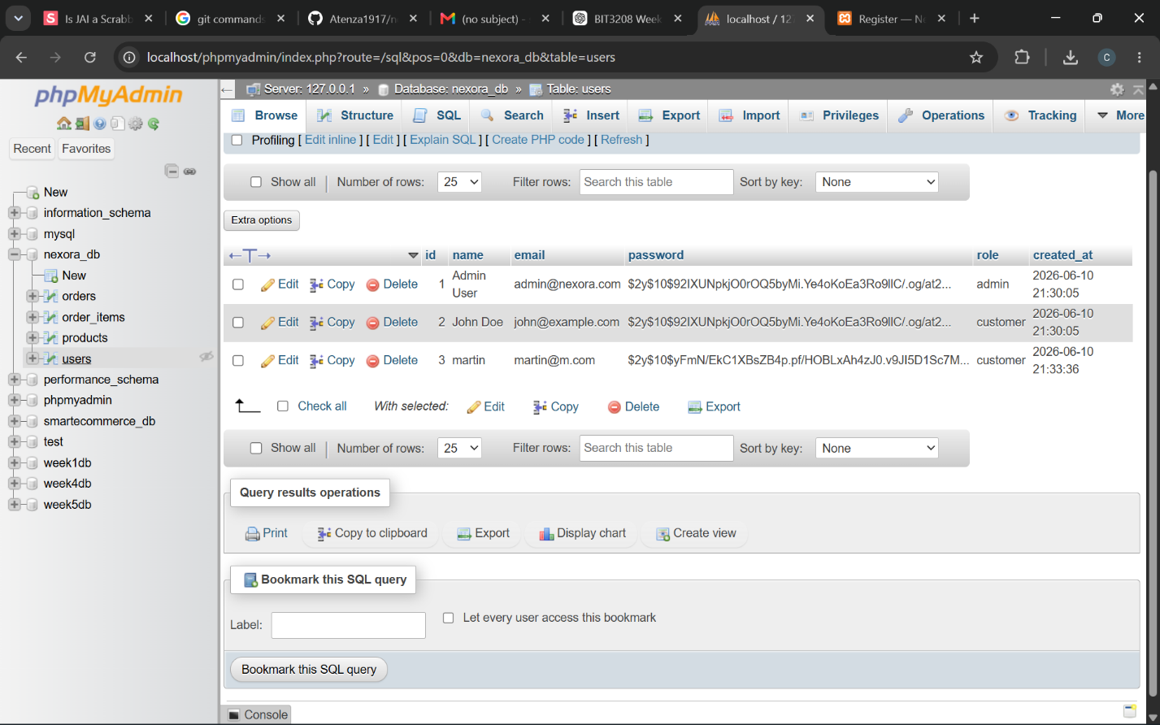

5.2 Week5 Reflection
This week focused on developing the authentication features of the Nexora platform. User registration and login functionalities were implemented using HTML, CSS, PHP, and MySQL. To enhance security, passwords were encrypted using hashing techniques before being saved in the database.
Additional validation measures were introduced to prevent invalid entries and duplicate user accounts. Managing user sessions after login initially presented some challenges, but these were overcome through the use of PHP session management. The screenshots included demonstrate the registration process, login interface, storage of user details in the database, session handling, and successful authentication.
The completion of this module marked an important milestone by allowing secure access to the system for registered users.

