19CSE331 - Cryptography

S5 CSE-B

Group No: 5

Title: Smart IOT System

I. Introduction

Team Members:
- Gadha Saji Menon (AM.EN.U4CSE22123)
- Pranav Krishna S (AM.EN.U4CSE22142)

Brief Overview

- This project integrates IoT, Federated Learning (FL), and Cryptographic Techniques to build a secure and privacy-preserving system.

- Federated Learning (FL) for collaborative and decentralized machine learning while ensuring authentication, integrity, and security using cryptographic tools. It allows distributed IoT devices to train machine learning models locally and share only model updates, preserving data privacy.

- IoT devices collect data, train machine learning models locally, and send encrypted and signed model updates securely using TLS/SSL, digital signatures, and hashing.

Objectives

- Implement Federated Learning for energy consumption prediction.
- Secure communication and data integrity using cryptographic tools:
- Digital Signatures for authenticity.
- Symmetric Encryption for confidentiality.
- Key Exchange Algorithms for secure key sharing (Diffie-Hellman).
- Hash Functions for integrity checks.

II. Implementation

Tools and Softwares Used
Libraries:
- TensorFlow Federated (TFF) – Federated Learning
- Paho-MQTT – Secure Communication
- PyCryptodome – Cryptographic algorithms (AES, RSA, SHA-256)
- OpenSSL – Key generation and hashing
- IoT Hardware: Simulated IoT data

- Programming Language: Python 3.12.3

Steps Taken:

1. Key Generation and Digital Signatures
Generating RSA Keys:

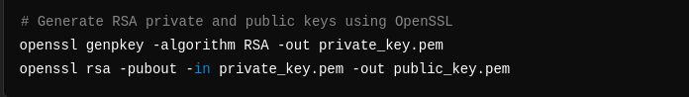
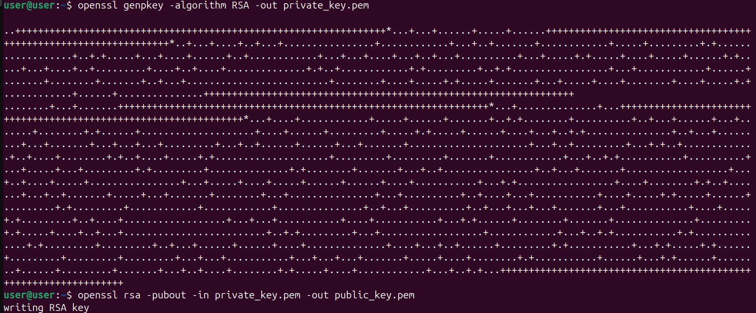

Signing a Model Update:
Using the RSA private key to sign model weights.

sign_model_update.py
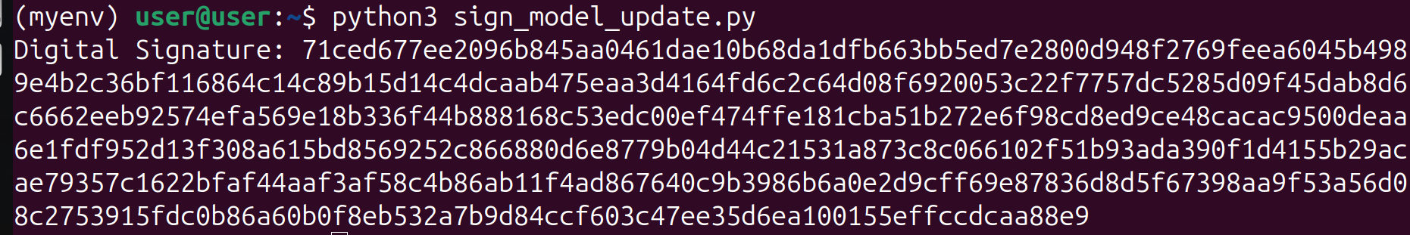
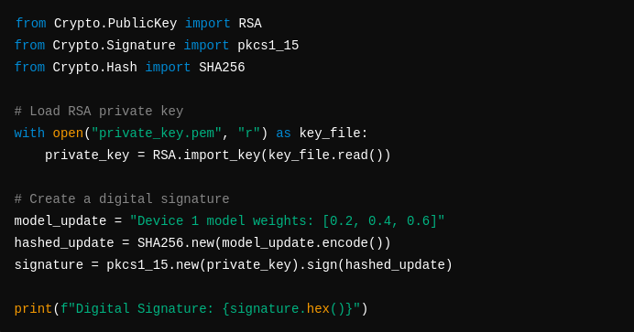

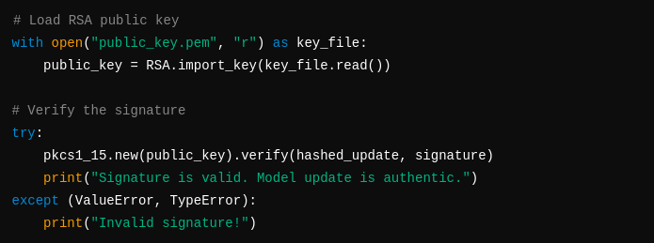
Verification on server side:

2. Encryption and Decryption

Symmetric Encryption (AES) to secure model updates:

aes_encryption.py
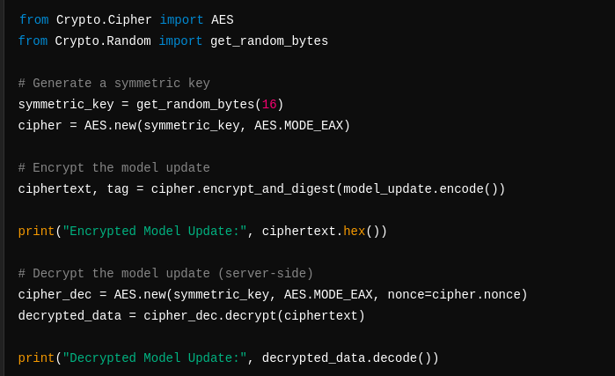

3. Secure Key Exchange Using Diffie-Hellman Algorithm

To securely share the AES key, we use Diffie-Hellman key exchange:

key_exchange_diffie_hellman.py
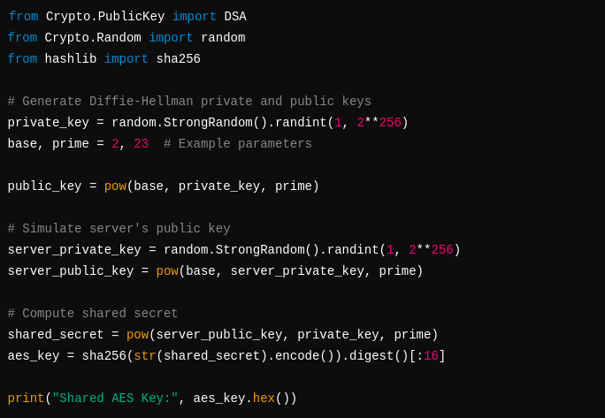

4. Federated Learning with Model Updates
Federated Averaging trains models locally and securely sends updates to the central server.

federated_learning.py
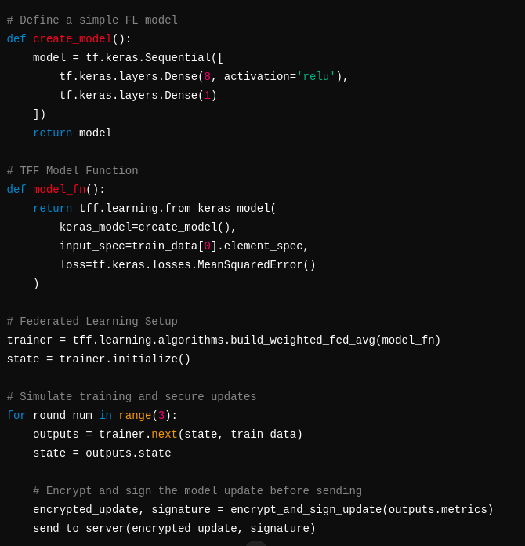

5. Secure Communication Using MQTT with TLS
MQTT Configuration for secure communication with encryption:

secure_communication.py
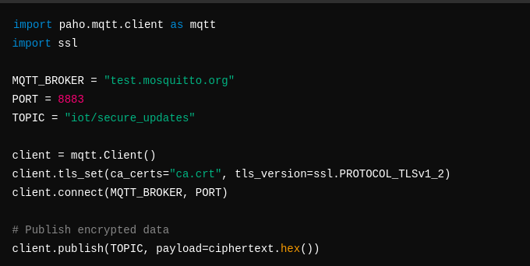
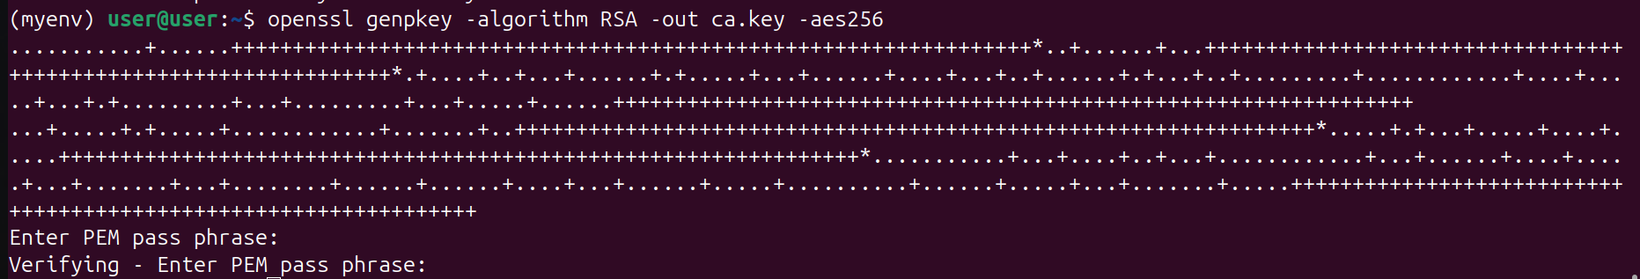

pranav

III. Results

a) Federated Learning Results:
- Local models trained on IoT devices.
- Model updates encrypted and signed before being sent.

b) Key Exchange:
- Shared AES key securely exchanged using Diffie-Hellman.

c) Digital Signature Validation:
- Server verifies model updates' authenticity.

d) Secure Communication:
- TLS-secured MQTT ensures encrypted model transfer.

Features

- Privacy: Federated Learning avoids sharing raw data.

- Confidentiality: AES encryption protects model updates.

- Authenticity: Digital signatures validate updates.

- Integrity: Hashing ensures tamper detection.

IV. Conclusion

- We successfully implemented a Secure IoT system with Federated Learning and other cryptographic techniques.
- This system demonstrates a robust approach to privacy-preserving IoT networks and can be extended for real-world smart home, anomaly detection, or energy management applications.

- Federated Learning for decentralized model training.
- Diffie-Hellman Key Exchange for secure key sharing.
- AES Encryption for confidentiality.
- Digital Signatures for authenticity.
- TLS-Secured MQTT for safe communication.

