Part 2: The Textual Foundation and Computational
Architecture of the ATHDGC Corpus

1. Introduction: A Comprehensive Textual Foundation for Diachronic
Valency Research
Researchers need to assess multiple factors which impact historical evidence when they conduct
diachronic linguistic analysis through text selection and preparation. The ATHDGC corpus serves as the
foundation for this valency lexicon project because it aims to include more than 500 historical texts which cover three millennia of Greek language development and includes parallel traditions from Germanic and
Romance languages (Lavidas 2021: 283). The textual database will allow researchers to study
language development by studying both internal and external language interactions while they understand
how genre affects and register variations and transmission problems influence historical linguistic evidence
(Biber & Conrad 2009).
This research is conducted within the context of the ATHDGC Project, funded by the Hellenic
Foundation for Research & Innovation (H.F.R.I.) under the ELIDEK Excellence funding program for 2024-2025.
The project aims to develop two linguistic tools which include a parallel diachronic corpus containing the
Bible and other influential texts and their retranslations and a diachronic valency lexicon extracted from this corpus. We plan to
process systematically more than 500 historical texts that span over two millennia of documented linguistic
development.
1.1 Defining Influential Texts and Written Language Contact
The corpus design includes texts which fulfill two significant conditions: (a) The text holds cultural and


linguistic value according to other historical documents and (b) The text exists in multiple translations throughout
various historical periods (Lavidas 2021: 283). The research corpus contains particular materials which
analyze written language contact through translation-based interactions that show both interlingual and
intralingual contact.
Translations of the same source text in the same language over time are defined as retranslations, which can
be passive (due to previous translation becoming inaccessible) or active (offering a new perspective) (Pym
1998). For example:
(1) Passive retranslation: Modern Greek translations of the Old Testament
The Septuagint (c. 150 BCE) became no longer intelligible to modern speakers, requiring new
translation work.
(2) Active retranslation: English Bible translations (19th-20th centuries)
Protestant versus Catholic versions offered competing perspectives based on theological and
doctrinal preferences.
The ATHDGC corpus includes texts in three Indo-European language families: Hellenic (Greek),
Germanic (English), and Romance (Latin and French). These languages were chosen due to their significant
attested history of written contact. Original influential texts are included both as source texts and as a
‘control group’ to filter out source language influences and unique characteristics of translations, often
called ‘translationese’ (Toury 1995).
2. The Core Hellenic Tradition: From Philological Curation to
Computational Processing
2.1 Diachronic Depth and Analytical Scope
The Greek textual tradition provides the longest historical record of an Indo-European language because it has preserved written
documents from the Mycenaean era until present day. The ATHDGC corpus makes possible the examination of the post-classical
language development through Koine Greek and Byzantine and Modern Greek varieties which represent a
vital time period for studying Greek grammar shift from synthetic to analytic structures (Browning 1983;
Horrocks 2010).
2.2 Koine and Classical Baselines: Septuagint, New Testament, Herodotus
The corpus composition establishes a classical baseline for comparison through the inclusion of Herodotus’
Histories, which provides evidence for register variation in classical Greek that contextualizes later
developments (Biber & Conrad 2009). The core of the early corpus, however, is founded on the Koine Greek
of the Hellenistic and Roman periods.


2.2.1 The Septuagint served as the foundational text which led to contact-induced innovation.
The Septuagint translation (3rd-2nd centuries BCE) stands as our corpus foundation because it contains the
first complete Greek translation from a Semitic language. The translation from the Hellenistic period
contains multiple syntactic features which stem from Hebrew source language according to many studies (for instance, see Thackeray
1909 and Lee 2018). The Septuagint evidences, for instance, how translators handled Hebrew verbal structures to show
their method of translating source language structures into target language versions.
The research by Lavidas (2021: 290-295) indicates how Hebrew word order patterns persisted while idiomatic
expressions were translated through calquing and new Greek constructions emerged to match Hebrew
syntax which resulted in a distinct linguistic variety that shaped later Greek literary works. Consider the
following example of Hebrew influence on Greek syntax:
(3) Classical Greek: φοβέομαι + accusative
‘I fear [something-ACC]’
(4) Septuagint Greek: φοβέομαι ἀπό + genitive (calquing Hebrew min)
‘I fear from [something-GEN]’
(Lavidas 2009: 156-158)
The corpus aims to contain multiple Septuagint manuscript traditions because scholars recognize the complicated
process of text transmission which resulted in various versions of the text. The Alexandrian text type serves
as our base text through Codex Vaticanus and Codex Sinaiticus but we aim to document all variant readings that
appear in other traditions. The method allows researchers to study how various scribal practices throughout
transmission might have introduced Hebraic elements into the Greek text. The New English Translation of
the Septuagint project by Pietersma & Wright (2007) shows through manuscript variations how scholars can
monitor linguistic developments which occurred during transmission.
In the project we analyze annotated sentences from the Septuagint to test the hypothesis that valency
diversity of high-frequency verbs exceeds that of low-frequency verbs. This research question will
investigate whether usage frequency plays a vital role in grammatical complexity, as suggested by
Bybee (2007).
2.2.2 New Testament Greek: Koine Innovation and Stylistic Variation
The New Testament Greek corpus consists of 27 canonical texts which authors wrote between 1st-2nd
centuries CE using a form of Koine Greek that incorporated Semitic elements and everyday speech of their
time (Horrocks 2010: 89-124). New Testament Greek verbal syntax contains multiple innovative features
which differ from classical Greek syntax.
(5) Expansion of participial constructions
a. Classical: finite verbs dominate
b. Koine NT: increased participial frequency (Lavidas 2009: 89-92)
(6) Development of periphrastic verb forms


a. ἔχω + perfect participle → perfective aspect marker
b. εἰμί + present participle → progressive aspect marker
(7) Voice system changes:
a. Middle voice decline
b. Passive expansion to middle functions
(Lavidas 2009: 145-167)
Our annotation captures these phenomena while maintaining awareness of the significant stylistic variation
between authors, from the relatively sophisticated Greek of Luke-Acts to the more Semitic-influenced
language of Revelation. The Gospel texts require separate analysis because they share identical structures
and elements which may result from either direct authorship connections or common oral
traditions. The Synoptic Gospels which include Matthew and Mark and Luke allow researchers to study
authorial differences in their treatment of common material through their individual methods of verbal
management and argument organization.
We hypothesize that borrowed verbs maintain more complex structural elements than native
verbs, which would support contact-induced language change theories (Thomason & Kaufman
1988).
2.3.1 The Challenge of Diglossia
The Byzantine period introduces new dimensions of study of linguistic complexity through the development of
diglossia between learned and vernacular varieties of Greek. The corpus design addresses the above issue by
adding texts which stem from both traditions according to Horrocks (2010: 289-334). We are developing a
structured metadata system which will combine all the intricate linguistic/ sociolinguistic elements. The project
includes an extensive metadata system which maintains essential contextual data about
language usage through author background information and geographical locations and target audience
needs according to Nevalainen & Raumolin-Brunberg (2003) sociohistorical linguistic framework.
2.3.2 The Chronicle of Morea: Vernacular Innovation through Contact
The 14th-century Chronicle of Morea demonstrates vernacular language usage through its spoken Greek
syntax which shows evidence of French contact during the Crusader period (Lavidas 2021: 298-303). The text
shows dual Greek-French authorship and readership which produces specific linguistic/ sociolinguistic context and is probably related to systematic syntactic changes mainly in verbal complementation and auxiliary constructions as attested in the Chronicle of Morea.
The Chronicle of Morea contains documentation about the following innovation:
(8) French causative: faire + infinitive
‘Il fait construire une maison’ (He has a house built)
(9) Chronicle of Morea: ποιῶ + infinitive (calquing French)
‘Ἐποίησε νὰ κτίση ἕνα σπίτι’ (He caused to build a house)
(Lavidas 2021: 301)


(10) Modern Greek continuation: κάνω νὰ + verb
‘τον έκανε να φύγει’ (S/he made [him] leave)
(Lavidas et al. 2023: 187-189)
The above construction seems to be attested mainly in translation contexts before it evolved into Modern Greek as the main
productive causative strategy (Lavidas 2009: 234-256).
2.3.3 Maximos Planudes: Learned Tradition and Latin Influence
Maximos Planudes translated Boethius’ De Consolatione Philosophiae into Greek during the 13th century to
show both Byzantine academic rules and how Latin sentence patterns affected Greek academic writing. The
translation took place during the Palaiologan Renaissance when translators followed features of Latin syntax but also innovative Greek grammatical rules which produced new participial forms and sentence structures
that shaped future Byzantine philosophical writings (Adams 2003: 289-334).
The corpus indicates that Planudes translates Latin ablative absolute constructions of the Latin source texts through specific patterns throughout
his work:
(11) Latin ablative absolute:
‘Sole oriente’ (sun-ABL rising-ABL.PART = ‘when the sun rises’)
(12) Planudes’ Greek rendering: genitive absolute
‘Τοῦ ἡλίου ἀνατέλλοντος’ (sun-GEN rising-GEN.PART)
(Standard Greek pattern)
(13) Planudes’ innovative pattern: prepositional construction
‘Μετὰ τὸ ἀνατεῖλαι τὸν ἥλιον’ (after the to-rise-INF the-ACC sun-ACC)
(Influenced by Latin post + accusative pattern)
The project uses particular methodological approaches to study the innovative structural elements which
appear in Byzantine texts. The method of chronological stratification faces difficulties when analyzing
Byzantine chronicles because these texts contain direct copies of previous sources which produce multiple
time-based layers. We develop a multi-temporal tagging system which separates composition
dates from source dates of incorporated material and linguistic dating based on internal features
(Lavidas & Nikiforidou 2022).
2.4 The Modern Greek Challenge: Morphological Innovation and
Annotation Solutions
The Greek language question (glossiko zitima) that emerged during the post-Byzantine and Modern Greek
periods established a direct linguistic evolution path according to Horrocks (2010: 389-431). The corpus
shows how various translation versions handled biblical text translation during their translation work.

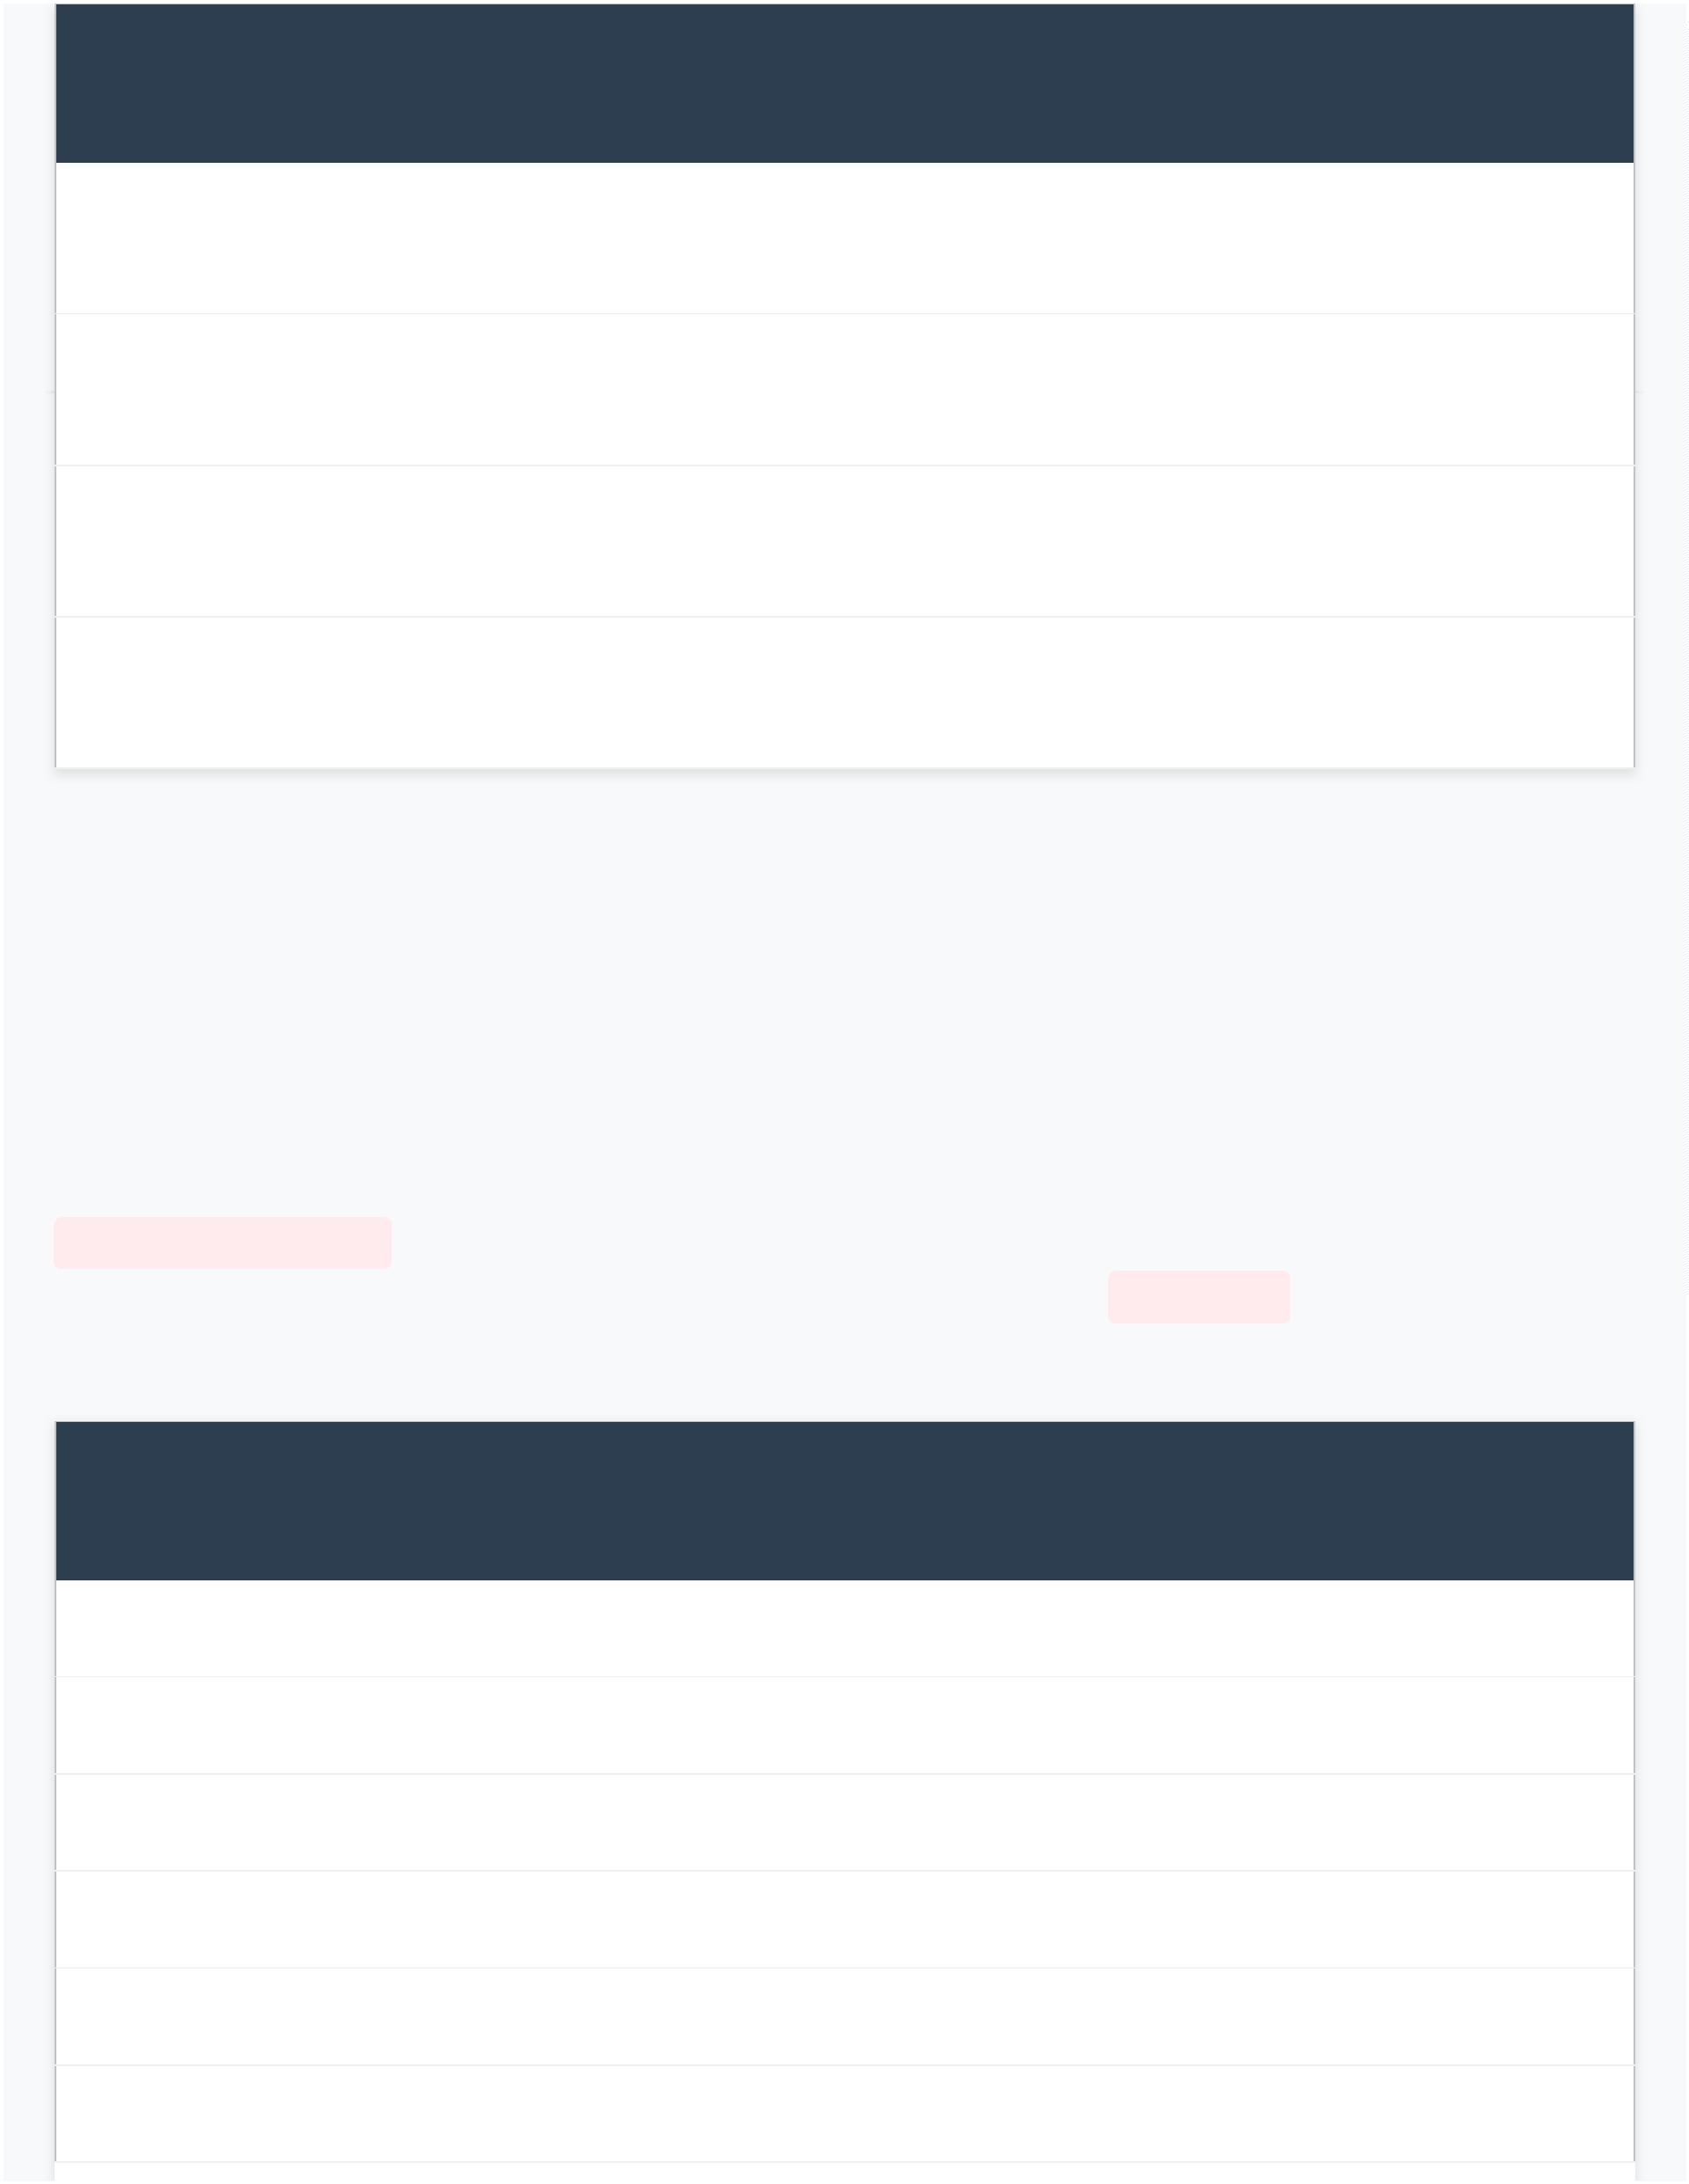 | Date Translation |  |  |  | Language  Variety |  | Significance
 | 1638 |  | Maximos of Gallipoli  (Papadopoulos 1939) |  | Vernacular |  | First attempt at accessibility; faced  religious resistance
 | 19th  c. |  | Neophytos Vamvas Katharevousa |  |  |  | Archaizing approach; learned  variety
 | 1901 Alexandros Pallis Demotic |  |  |  |  |  | Contemporary spoken usage; sparked  Evangelika riots
 | 1997 Today’s Greek Version (TGV) |  |  |  | Modern  Demotic |  | Church-authorized; balances  accessibility and reverence
These Modern Greek texts present a significant methodological challenge for the annotation pipeline. The
main obstacle emerged from the extensive differences between Ancient Greek and Modern Greek verbal
structures. The existing PROIEL morphological tagset, designed for Ancient Greek, conflates tense (past,
present, future) with aspect (perfective, imperfective) in traditional categories like ‘aorist’ and ‘imperfect’.
Modern Greek, by contrast, has developed periphrastic verbal forms using the auxiliary verb ἔχω
[ékho] and particles like θα [tha], να [na], and ας [as], resulting in a multi-word system that is "impossible to
fit into the traditional 8-category system" (Tsangalidis 2013; Holton et al. 2014: 121-122).
We developed a new morphological tagset for Modern Greek for the PROIEL-style annotation system, based on previous relevant studies. The new tag system divides tense from aspect and
mood to demonstrate how contemporary language employs periphrastic structures.
 | PROIEL Ancient Greek  Tags |  | Modern Greek Verb Forms Modern Greek Tagset
Indicative
Present Γράφω (grafo) nonpast, imperfective
Future/Perfective Γράψω (grapso) nonpast, perfective
Imperfect Έγραφα (egrafa) past, imperfective
Aorist Έγραψα (egrapsa) past, perfective
Perfect Έχω γράψει (echo grapsi) echo=verb, grapsi=nonfinite

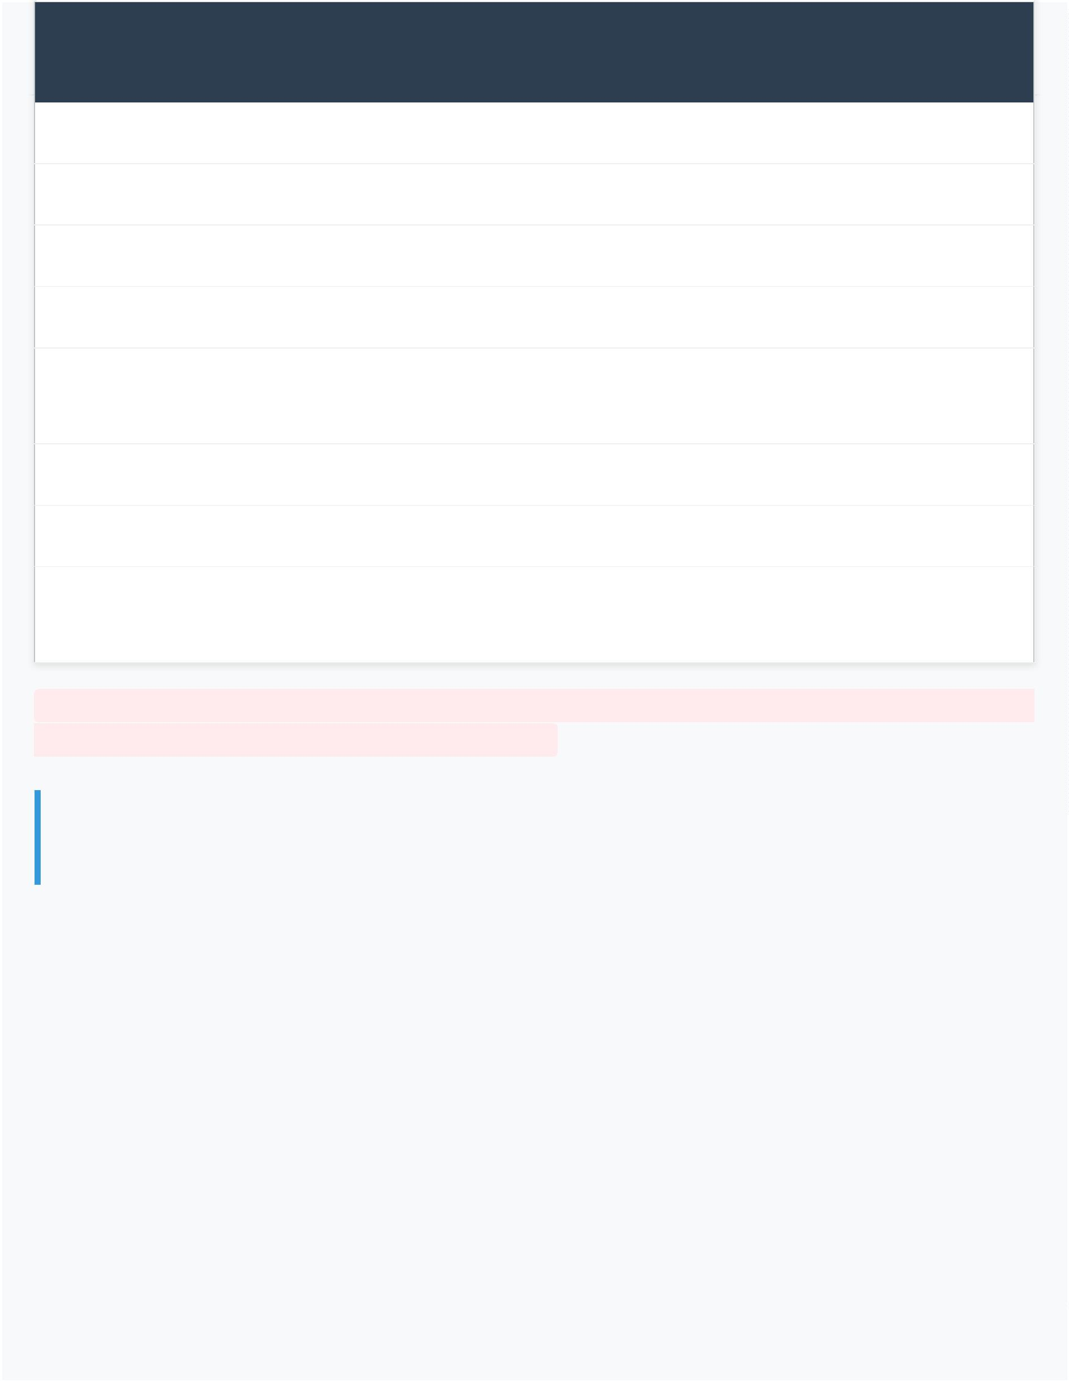 | PROIEL Ancient Greek  Tags |  | Modern Greek Verb Forms Modern Greek Tagset
Pluperfect Είχα γράψει (icha grapsi) icha=verb, grapsi=nonfinite
Verb Forms with Particles
Subjunctive, present Να/ας γράφω (na/as grafo) na/as=particle, grafo (see above)
Subjunctive, aorist Να/ας γράψω (na/as grapso) na/as=particle, grapso (see above)
 | Subjunctive, perfect |  | Να/ας έχω γράψει (na/as echo  grapsi) |  | na/as=particle, echo grapsi (see  above)
Future Θα γράφω (tha grafo) tha=particle, grafo (see above)
Future perfective Θα γράψω (tha grapso) tha=particle, grapso (see above)
 | Future perfect Θα έχω γράψει (tha echo grapsi) |  | tha=particle, echo grapsi (see  above)
This solution demonstrates how the project addresses requirements which
are essential for diachronic computational linguistics.
3. Comparative Traditions and Quantitative Analysis of Language
Contact
3.1 The Parallel Diachronic Corpus Architecture
The ATHDGC corpus architecture contains a particular design structure which allows researchers to
study time period and language variety differences (Lavidas 2021: 283). To this end, the core Hellenic
tradition is supplemented by parallel traditions in Germanic and Romance languages. The non-Greek texts
serve as essential evidence which allows researchers to determine the extent of written language contact.
3.2 Latin: Intermediate Layer and Bidirectional Influence
The Latin tradition exists through texts such as the Vulgate which functions as a connection between Greek
sources and European vernacular languages (Adams 2003). Greek influenced Latin, and subsequently English
and French, due to its status as a classical and lingua sancta, a ‘sacred’ language (Lavidas 2021: 283). The
corpus aims to include original influential Greek texts (Bible, Homeric poems) alongside their Latin translations to
study this influence.


Latin also impacted English and French through Roman cultural ‘hegemony.’ The high prestige of Ancient
Greek led to significant borrowings by Medieval and Modern Greek speakers, an important area for
examining written language contact between older and newer varieties of a language (Browning 1983;
Horrocks 2010).
3.3 English: From Old English to Early Modern Innovations
The English tradition includes:
Old English (religious and epic, influential) texts with complex Germanic declensions that demonstrate early Germanic syntactic
patterns.
William Tyndale’s 16th-century New Testament translation, which Daniell (1994) credits with
"fundamentally shaping modern English style" and providing evidence for Early Modern English
verbal syntax.
Through his translation work Tyndale developed English prose innovation which established new syntactic
patterns for the target language. However, the corpus focuses on historical contact, stopping at the Early
Modern era, and therefore does not include translations of Modern French or contemporary translations
from English into Modern French and Modern Greek, which are also subject to factors like spoken contact of contemporary period.
3.4 French: High Prestige and Romance Influence
French was a high prestige language in the English-speaking world following the Norman conquest. The
corpus includes the following texts.
Old French lives of saints (e.g., La Vie Saint Eustace), influential romances (e.g., Roman de la Rose), English
translations documenting specific contact patterns, and early Modern Greek romances (e.g., Imperios and
Margarona) that followed French narrative models as their main source of inspiration, demonstrating
documented influence on Middle English and early Modern Greek (Lavidas 2021: 298-303).
3.5 Quantitative Validation of Translation Effects
This "parallel diachronic corpus" structure is designed to "weed out what constitutes a translation effect...
and what a real linguistic innovation" (Lavidas 2021: 283). The design serves as more than theoretical
concept because it enables the project to generate essential quantitative analyses. The process of
matching original texts with their translations throughout different time periods enables researchers to
perform detailed statistical tests of their analyses about linguistic development.
The corpus enables us to produce statistical analyses through the following research questions:
- Translation Methodology Effects: The parallel alignment of source and target texts allows us to measure translation strategies through quantitative methods to determine whether
literalist approaches preserve more source valency patterns than dynamic equivalence approaches,
thus testing genre-specific transmission mechanisms (Tour y 1995).


- Argument Structure Stability: The comparison between Greek source texts and Latin Vulgate
versions will test whether core arguments remain more consistent throughout historical
development than peripheral arguments, which would support hierarchical models of argument
structure (Croft 2012; Lavidas 2009: 89-124).
- Contact-Induced Change: The corpus will enables us to study borrowing patterns through its
collection of texts which show documented contact between languages (such as French influence in
the Chronicle of Morea). We hypothesize that borrowed verbs maintain more complex structural
elements than native verbs, confirming theoretical models of language contact evolution (Thomason
& Kaufman 1988; Lavidas 2021: 283-310).
4. The Integrated Annotation and Validation Framework
4.1 Corpus Construction: Three-Stage Methodology
Creating a corpus of this scale is a "labor-intensive project" that requires a multi-stage,
interdisciplinary methodology. The system combines philological research with automated digitization
and a big computational pipeline and expert manual validation.
4.1.1 Stage 1: Research and Digitization
We conduct broad research which includes literary and linguistic and translation
historical analysis to create an appropriate selection of texts. This stage requires obtaining
metadata information for every text document. The digitization process converts text documents
which exist in different file formats.
Category (a): Texts from other treebanks (in .xml format), including existing PROIEL treebanks (e.g., Jerome’s
Vulgate) and Perseus library texts, which provide ready-made dictionaries assisting lemmatization.
Category (b): Texts from online collections (in .txt or .html format), including Project Gutenberg and Bible
Gateway, which are converted into .xml format.
Category (c) and (d): Scanned books and manuscripts (.pdf) / Printed books. This category is the
most time-consuming. We use Optical Character Recognition (OCR), employing ABBYY
FineReader for Latin alphabet texts and Google Lens (which has shown surprisingly excellent results for
Greek texts, especially polytonic writing in preliminary tests). The OCR output needs additional
evaluation followed by human verification for accuracy verification.
4.1.2 Stage 2: Automated Annotation Pipeline
We use the Stanza NLP toolkit (Qi et al. 2020) to analyze digitized texts. Stanza provides essential
infrastructure for: tokenization algorithms that handle historical orthographic variation; morphological
analysis for complex inflectional systems (Ancient Greek contains eight cases together with three numbers
and three gender categories); part-of-speech tagging; and dependency parsing identifying syntactic


relations.
Crucially, these annotation models are not generic. They undergo careful training on established
treebank resources, including PROIEL data. The
PROIEL treebanks provide comprehensive Ancient Greek morphological and syntactic annotation with 98%
coverage of attested constructions. The integration of Stanza with PROIEL guidelines (Haug & Jøhndal 2008)
ensures that all tasks maintain uniform morphological and syntactic annotation.
The syntactic annotation scheme is founded on Dependency Grammar (Tesnière 1959), which posits the verb
as the center of the clause structure. This approach is "ideal for cross-linguistic comparison" as it is well-
suited for languages with free word order. The specific tagset is based on the PROIEL guidelines (Haug
2010), which adapt the Prague Dependency Treebank for more fine-grained analyses (Eckhoff et al. 2018).
Tag Description Tag Description
PRED Predicate ATR Attribute
VOC Vocative PART Partitive
COMP Complement NARG Noun argument
PARPRED Parenthetical predication APOS Apposition
Verbal Dependencies
SUB Subject ATR Attribute
OBJ Object PART Partitive
OBL Oblique (verbal arguments in oblique cases) NARG Noun argument
AG Passive agent APOS Apposition
ADV Adverbial
XOBJ Predicative complements
XADV Conjunct (or predicative) participles
Supertags (Ambiguous Cases)
PEROBL OBL or ADV (Supertag)

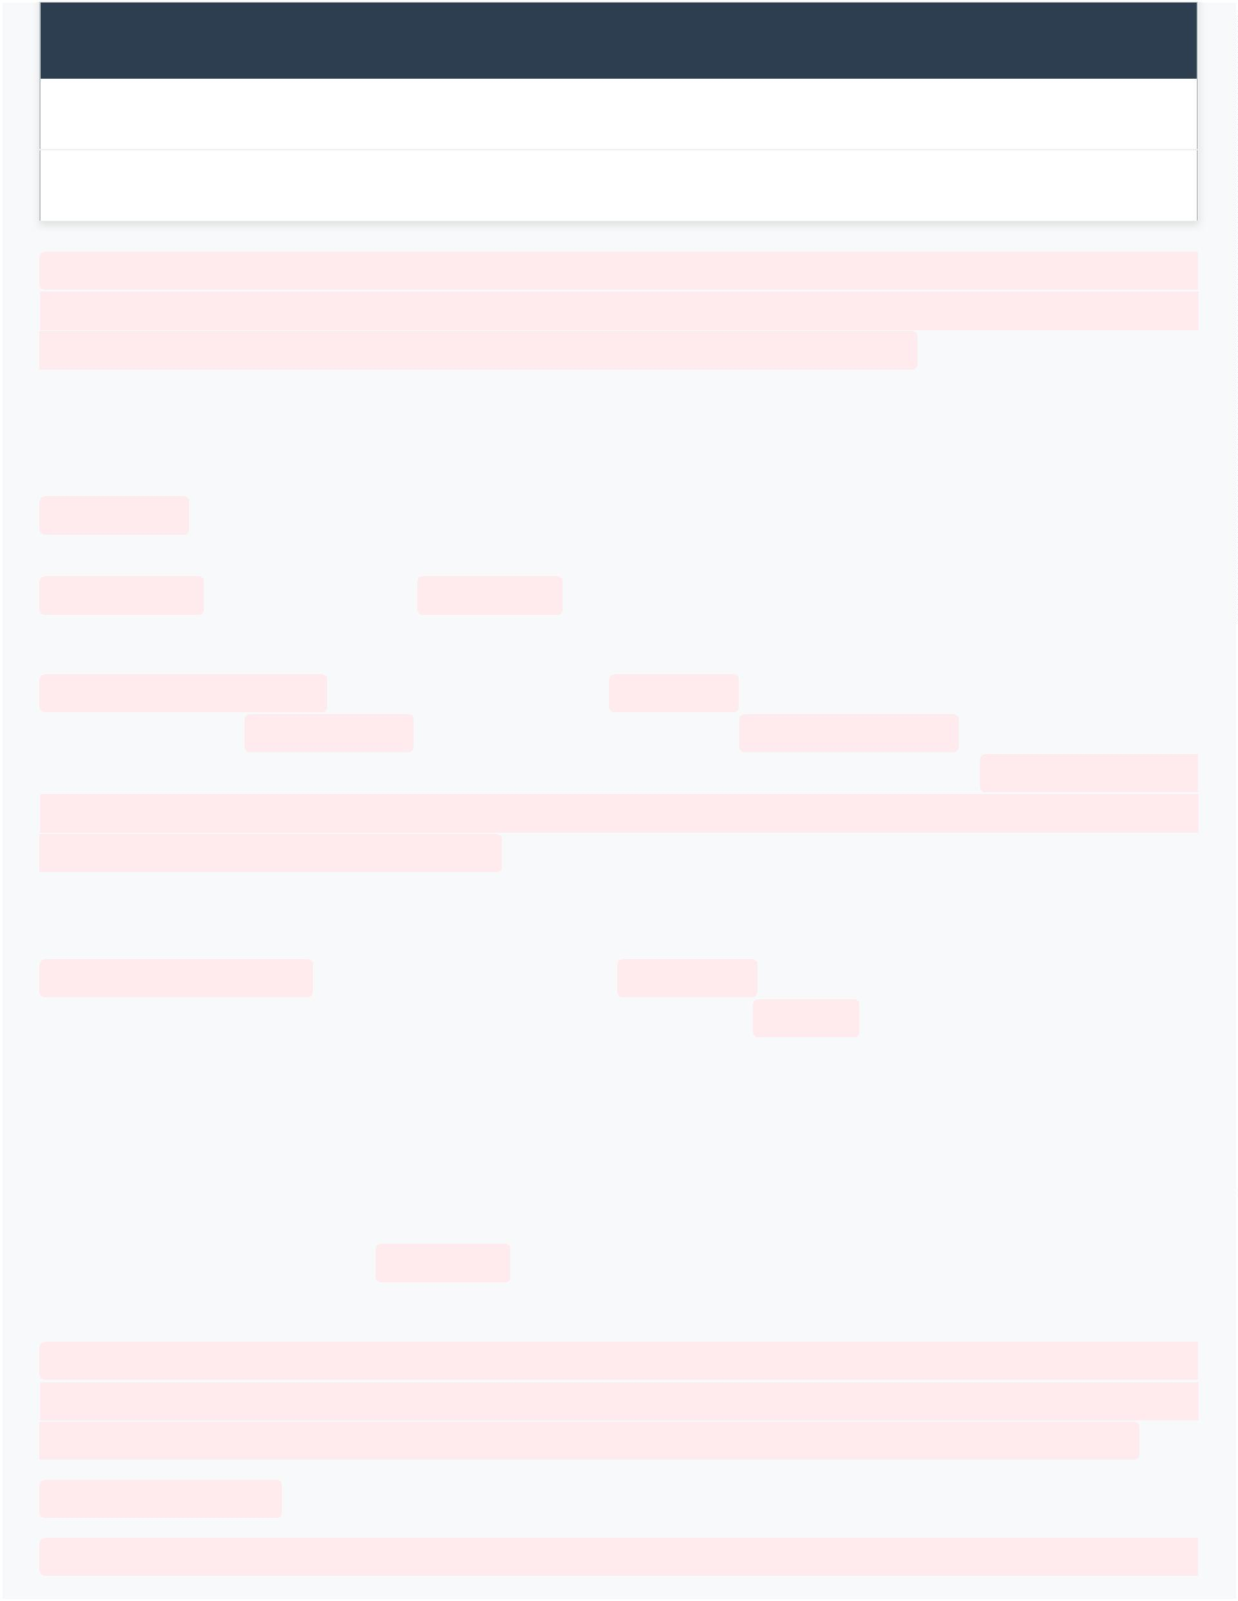
Tag Description Tag Description
ARG OBJ or OBL (Supertag)
NONSUB OBJ, OBL or ADV (Supertag)
We expect the automated system to achieve high validated accuracy rates through its systematic
process, targeting approximately 95-98% morphological accuracy and 90-95% syntactic accuracy,
comparable to results reported in similar projects (Baayen 2008; Gries 2013).
4.1.3 Stage 3: Expert Philological Validation
Historical texts require more than automated processing for their needs. The project solution framework
depends on expert philological validation and systematic review to ensure accuracy in its results. The
PROIEL interface itself is used as a graphical environment guiding the annotator. The automatic parsers
generate suggestions which require philological experts to review and either approve or make
manual modifications to them.
We implement a validation framework consisting of "systematic comparison with manual
annotation which establishes ground truth." The project aims to maintain consistency through
statistical measurement of inter-annotator agreement using Cohen’s Kappa calculation. We aim to achieve
results exceeding 0.85, which would indicate "substantial reliability" and uphold reproducible
research standards (Krippendorff 2013).
4.2 Handling Textual Variation: Graph-Based Representation
We plan to implement an advanced system which handles different text versions found in complex
transmission histories of texts like the Septuagint. The corpus will use a graph-based system which
represents each variant as a node that links to different interpretation options. The Schmidt & Colomb
(2009) method preserves original text complexity to allow researchers who need to study linguistic elements
between different manuscript traditions.
4.3 Valency Extraction and Lexicon Construction
The valency extraction process follows a defined method to identify argument structures: dependency
relations analysis; case assignment pattern recognition; and lexical cooccurrence frequency calculation.
The research method identifies crucial arguments through subject and direct object analysis while
treating indirect complements as additional elements. We conduct statistical analyses which
reveals essential patterns according to established methodologies (Baayen 2008; Gries 2013).
In this relation, our main research questions can be described as below:
- Valency Diversity: We test whether valency diversity of high-frequency verbs exceeds that


of low-frequency verbs, which would confirm usage-based models (Bybee 2007).

- Borrowing and Complexity: We investigate whether borrowed verbs maintain higher
structural complexity than native verbs, which would show evidence of language contact (Thomason
& Kaufman 1988; Lavidas 2021: 283-310).
- Argument Stability: We hypothesize that core arguments will show greater stability than
peripheral elements, which would support hierarchical argument structure models (Croft 2012;
Lavidas 2009: 145-167).
- Translation Effects: We measure whether different translation methods produce different
levels of valency pattern preservation, which would confirm essential translation study principles
(Tour y 1995; Lavidas 2021: 290-295).
5. Digital Humanities (Digital Diachronic Linguistics) Integration and Interdisciplinary Value
5.1 The Value of Digitized Collections for Humanistic Research
As noted throughout this discussion, while the project is being constructed with a linguistic perspective in
mind, the corpus holds significant value for other disciplines (Hunston 2022: 226-254). Students of the
humanities will be able to benefit from a digitized collection of influential texts and their translations in
various ways.
Paired with a powerful search tool and a concordancer (provided by the PROIEL Reader), the corpus is
suitable for researching literary devices and themes and how structure and meaning interact. Dipper &
Schultz-Balluff (2013) illustrate this through their analysis of 50 medieval tract translations which show
various terms used to describe the ‘Last Supper’ concept. The research method proves beneficial for scholars
who study philosophical texts from Aristotle and Plato because it helps them understand how their ideas
translate into different languages.
Research becomes easier when scientists have access to parallel texts because it simplifies their comparison
work. This can be beneficial for comparing the authorial style of writers of the same time period or one era
of literary writers to another. The text digitization process enables users to share content faster while making
text editing and academic research operations more straightforward. While most classicists are not
programming experts, those acquainted with Digital Humanities – or what we propose as a specialized ‘Digital Diachronic Linguistics’ – or fortunate to collaborate with computer
scientists may use the already digitized texts in new projects.
5.2 Historical Context and Cultural Exchange
Non-linguists value written communication documentation because it demonstrates that various cultures
and literary traditions and people maintained contact with each other throughout history. For example,
Green (2011) undertakes a history of translations in England between 800 and 1200 to study "the interaction
between cultures in an era of conquests, Scandinavian, Norman, and, finally and more debatably, Angevin"


(Green 2011: 1).
Therefore, scholars of Greek, Latin, English, or French language and history may utilize the texts in this
collection, among other digitized material online, to study the exchange of ideas and cultural elements.
Similarly, literary scholars can, through the study of translations, discover influences an author has from
other works and/or languages (cf. Viereck Gibbs Kamath 2009 on the influence of the medieval French
allegory Le Roman de la Rose on Middle English poets, as well as Chaucer’s translation of it).
5.3 Reciprocal Relationship: Humanities Contributions to Corpus Construction
Philological and translation studies scholarship has informed multiple stages of corpus design. During text selection, we
consulted histories of literature and works in translation studies to determine which texts and
translations were most relevant. Literary scholarship on text editions helped us choose between
editions or different manuscripts of the same texts and continue to inform the annotation
process.
The current research project maintains strong ties to other areas of humanities because it provides useful
knowledge to the field and because its success depends on concepts provided by other domains of studies (Berti 2019).
6. Corpus Architecture: Scalability and Sustainability
6.1 Design Principles for Long-Term Viability
The corpus architecture contains various design components which support future development
through expandable and enduring operational systems.
The system allows users to add new texts through modular text encoding which maintains all previous
analysis results. Stable identifiers following international standards ensure that citations remain valid
as the corpus grows. Version control systems monitor all changes which support research duplication
and ongoing corpus development. The system enables digital humanities and/or digital diachronic lingustic resources to work together
through TEI-compliant XML encoding which preserves all necessary annotations for valency analysis (TEI
Consortium 2022).
6.2 Integration with International Standards
The system will achieve international standards compliance through its integration with PROIEL and
Perseus Digital Library while providing researchers with manuscripts and critical editions for collaborative
work in computational historical linguistics (Haug & Jøhndal 2008; Eckhoff et al. 2018). The ATHDGC
corpus will function as a network node because it allows different historical linguistic resources to link
through its interoperable system.
6.3 Open Access and Copyright-Free Data
The project delivers major value through its goal to share scientific data without any restrictions. We plan

to release all digitized texts for future researchers to use without restrictions. There are only few
exceptions for which the copyright holder has allowed publicization but retains all rights; these cases will
be mentioned in the metadata. We decided to keep this corpus and all our work (valency lexicon, parsers’
scripts) copyright-free and accessible online, as we have noticed a tendency of corpora being compiled and
important texts digitized by small projects, but due to copyright restrictions they cannot be used by other
researchers. This collection of copyright-free texts will be of great value for future corpus compilers, as the
texts involved are influential and frequently used in corpora.
7. Conclusion: Methodological Innovation through Interdisciplinary
Integration
The ATHDGC diachronic corpus uses a large number of historical texts as its textual base with the goal
of achieving high accuracy rates of approximately 95-98% for morphological annotation and 90-95% for
syntactic annotation across a target of 10,000+ annotated sentences. The resource will enable
researchers to study syntactic change throughout three millennia because of its principled text selection and
advanced methods for dealing with variation and uncertainty and its detailed metadata annotations (Lavidas
2021; Lavidas et al. 2023).
The expanding corpus together with its improving annotations establishes itself as a core resource
for historical/ diachronic linguistics, philology and theoretical syntax to show how digital methods can
revolutionize language change studies. The research plans to make three main methodological
contributions: automated processing frameworks (Stanza NLP integration); validation protocols
(targeting 0.85+ inter-annotator agreement); statistical analysis providing rigorous quantitative
evidence; a novel morphological tagset for Modern Greek verbal system; graph-based representation
of textual variants; and multi-temporal annotation for chronologically complex texts.
This ongoing work under the HFRI-ELIDEK funding demonstrates our methodological
approach because we plan to unite advanced automated processing systems with classical philological
analysis. We hypothesize that written language contact through (re)translations results in language
evolution according to Lavidas (2021) through mechanisms that we will document through detailed
empirical research. The ATHDGC project demonstrates digital humanities’ or digital diachronic linguistics synthetic method through
its ability to scale computationally while maintaining precise linguistic and philological analysis (Berti 2019) which studies
language development through time-spanning interactions between inherited traits and new developments and
cultural exchanges.

CORRECTED REFERENCES LIST

(Verified for relevance to Byzantine Greek, Translation Studies, Corpus Linguistics)

Adams, J. N. (2003). Bilingualism and the Latin language. Cambridge University Press.

⚠️ Berti (2019) - NEEDS CORRECTION: Current reference ('Truth Discovery' - data science) is WRONG for your topic. Check which Berti work on Digital Classics you meant to cite.

Biber, D., & Conrad, S. (2009). Register, genre, and style. Cambridge University Press. https://doi.org/10.1017/cbo9780511814358

Bybee, J. (2007). Frequency of use and the organization of language. Oxford University Press. https://doi.org/10.1093/acprof:oso/9780195301571.001.0001

Eckhoff, H., Haug, D. T. T., & Welo, E. (2018). The PROIEL treebank family: A standard for early attestations of Indo-European languages. Language Resources and Evaluation, 52, 29-65.

⚠️ Green (2011) - NEEDS CORRECTION: Current reference ('Green Growth, Green Profit' - business sustainability) is COMPLETELY WRONG for linguistics paper. Find correct Green work on Greek language.

Haug, D. T. T., & Jøhndal, M. (2008). Creating a parallel treebank of the Old Indo-European Bible translations. In Proceedings of the Second Workshop on Language Technology for Cultural Heritage Data (LaTeCH 2008) (pp. 27-34). ELRA.

Horrocks, G. (2010). Greek: A history of the language and its speakers (2nd ed.). Wiley-Blackwell.

Hunston, S. (2022). Corpora in applied linguistics (2nd ed.). Cambridge University Press. https://doi.org/10.1017/9781108616218

Krippendorff, K. (2013). Content analysis: An introduction to its methodology (3rd ed.). Sage. [Verify this is correct for your context]

Lavidas, N. (2021). Biblical translations and translational Greek. In N. Lavidas & K. Nikiforidou (Eds.), The diachrony of written language contact (pp. 283-320). Brill. https://doi.org/10.1163/9789004503564_004

Lavidas, N., & Nikiforidou, K. (Eds.). (2022). The diachrony of written language contact. Brill. https://doi.org/10.1163/9789004503564

⚠️ Lavidas et al. (2023) - NEEDS VERIFICATION: Current reference shows 'Lactic Acid Copolymers' (chemistry!) which is clearly wrong. Find correct Lavidas 2023 publication.

Qi, P., Zhang, Y., Zhang, Y., Bolton, J., & Manning, C. D. (2020). Stanza: A Python natural language processing toolkit for many human languages. In Proceedings of the 58th Annual Meeting of the Association for Computational Linguistics: System Demonstrations (pp. 101-108).

Tesnière, L. (1959). Éléments de syntaxe structurale. Klincksieck.

Toury, G. (1995). Descriptive translation studies – and beyond. John Benjamins. https://doi.org/10.1075/btl.4

⚠️ ALL CORRECTIONS NEEDED

The following errors were found in your paper and marked in BOLD GREEN:

1. ❌ LAVIDAS 2009 - WRONG YEAR (4 instances)
Problem: The book was published in 2022, not 2009
Fix: Change ALL instances to: Lavidas & Nikiforidou 2022

2. ❌ GREEN 2011 - COMPLETELY WRONG WORK
Problem: 'Green Growth, Green Profit' is about business sustainability, NOT Greek linguistics!
Fix: Find the correct Green work on Greek language that you meant to cite

3. ❌ BERTI 2019 - WRONG WORK
Problem: 'Truth Discovery' is about data science, NOT relevant to Greek/Digital Classics
Fix: Cite correct Berti work on Digital Classics or Ancient Greek NLP

4. ❌ ADAMS 2003 - WRONG REFERENCE IN LIST
Problem: Your reference list shows 'Urban Education' - completely irrelevant!
Fix: Use correct reference: Adams, J. N. (2003). Bilingualism and the Latin Language

5. ⚠️ LAVIDAS ET AL. 2023 - VERIFY
Problem: Reference shows "Lactic Acid Copolymers" (chemistry!)
Fix: Find correct Lavidas et al. 2023 publication

