Game Proposal: Convoy to Athalin

CPSC 427 - Video Game Programming
Team Members:
Niklas Krieg 3838417
Joris Wachsmuth 3967425

Story:
Describe the overall game structure with a possible background story or motivation.
Various convoys and caravans over the land start their journey towards the capital Athalin to aid in the defense against the monster armies ravaging the country. Every time the convoy rests after a day of travel it has be protected from the nightly monster raids by placing your available units on a tower defense map that shows different attack paths the monster will take. Every new resting place comes with a new map for which the player will have to figure out the best defense strategy. On the way to the capital they convoy will pass through different villages/cities/fortresses with the opportunity to recruit new units, improve units already in possession and stock up on resources.

Technical Elements:
Identify how the game satisfies the core technical requirements: rendering; geometric/sprite/other assets; 2D geometry manipulation (transformation, collisions, etc.); gameplay logic/AI, physics.
- Use drag and drop to place player units
- Move enemy units on map
- Use sprites for all units
- 2D geometry manipulation transformation for player units movement/attacks and enemy unit movement
- Attack enemy units with projectiles and other attacks from player units
- collisions for player unit projectiles with enemy units and for controlling placement of player units
- Generate rougelike map progression procedural
- Randomly provide upgrades and temporary boons during progression

Advanced Technical Elements:
List the more advanced and additional technical elements you intend to include in the game prioritized on likelihood of inclusion. Describe the impact on the gameplay in the event of skipping each of the features and propose an alternative.
- Shaders to apply visual effects to units or maps
  - No impact on gameplay
  - alternative is rendering simple sprites without visual fidelity
- Saving gamestate for continuing at a later point.
  - Slight impact on gameplay, the game can only be finished in one session
  - alternative is a simplified system that does not save the game during battles
- Procedural generated TD-Maps
  - Medium impact on gameplay, the game can have less variety when playing
  - alternative is a pre-made map selection
Devices:
Explain which input devices you plan on supporting and how they map to in-game controls.
- Mouse for menu interaction and unit placement
- Keyboard for shortcuts

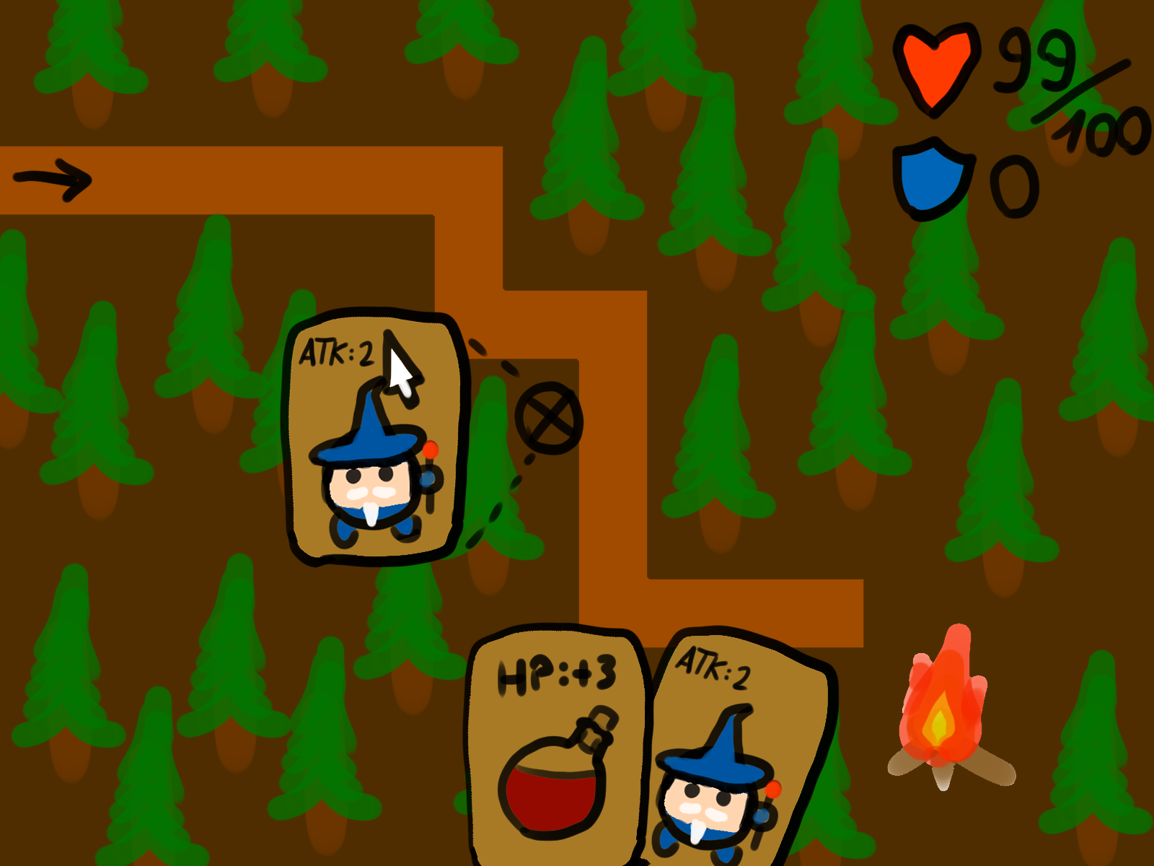
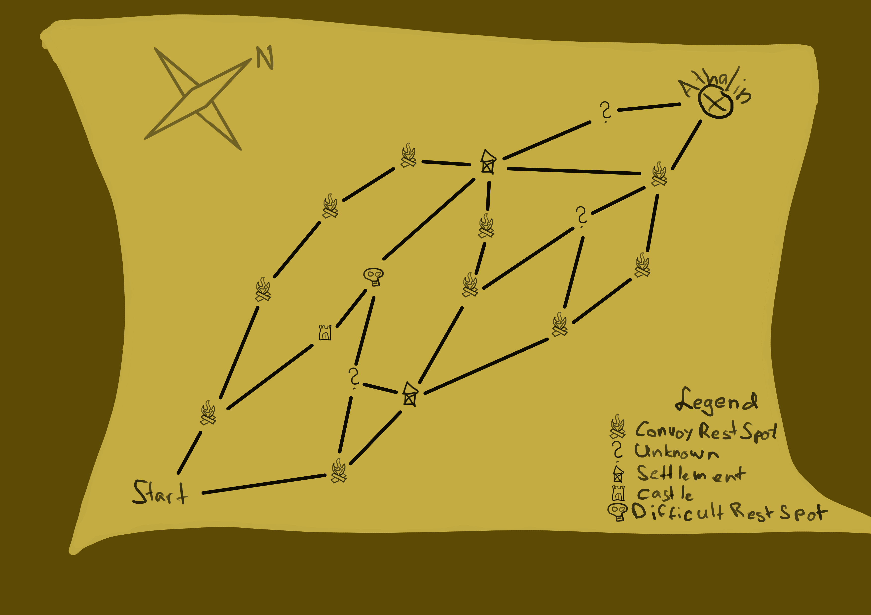
Concepts:
Produce basic, yet descriptive, sketches of the major game states (screens). These should be consistent with the game design elements, and help you assess the amount of work to be done.
Example of the procedural overview map:

Example of Towerdefence map unit placement and combat:

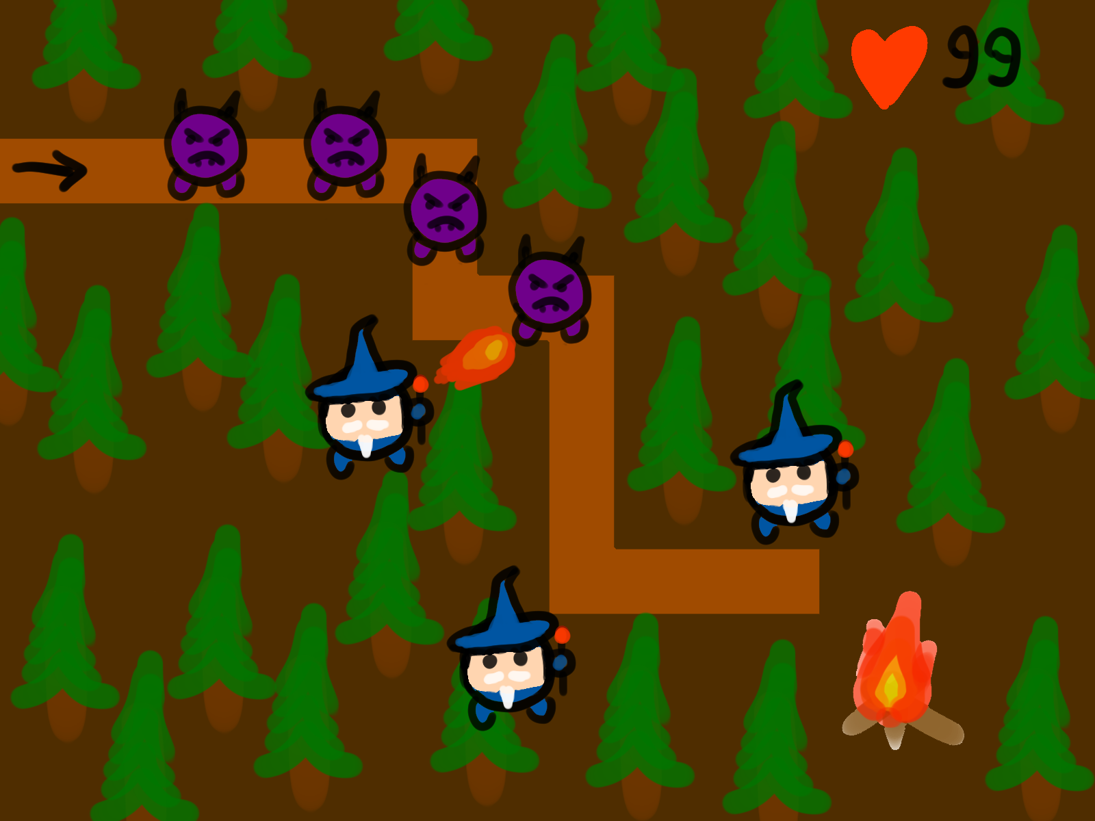

Tools:
Specify and motivate the libraries and tools that you plan on using except for C/C++ and OpenGL.
- Audacity for Sounds
- Clip Studio Paint, Krita, ASEprite, GIMP
- Dear ImGUI for debug-userinterfaces

Team management:
Identify how you will assign and track tasks, and describe the internal deadlines and policies you will use to meet the goals of each milestone.
- Task Tracking with Gitlab Issues
- Main branch + feature branches

Development Plan:
Provide a list of tasks that your team will work on for each of the weekly deadlines. Account for some testing time and potential delays, as well as describing alternative options (plan B). Include all the major features you plan on implementing (no code).

Skeletal Game
1 Towertype, 1 Map, 1 Enemytype, Overview-Map Mokup
Week 1 (04.11.24)
- Fixed Tower placement on map
- Basic Tower attack/targeting (without projectile)
  - Towertype: Archer
  - Basic attack: arrow shot
- Enemy path and damage
  - Enemytype: Slime
Week 2 (11.11.24)
- Tower drag and drop placement
  - block placement on enemy path
  - block placement on other towers
- build phase & combat phase
  - build phase: first phase to place towers in possession
  - combat phase: no longer placement allowed (only items) and enemies get spawned
- Hardcoded Overview-Map (choice between multiple maps)
  - A comabt map consists of:
    - 1 player base
    - min 1 enemy path towards base
    - min 1 enemy spawn point
  - buttons for combat map selection
  - render overview map only
Week 3 (18.11.24)
- Cleanup
- Finishing open tasks

Milestone Deadline: 20.11.24

Minimal Playability
Functioning gameplay loop, hardcoded Overview-Map, multiple paths with multiple levels, player/enemy assets and animation

Week 1 (25.11.24)
- combat win and lose
  - win condition: defeat all enemies in wave
  - lose condition: lose all health
- player unit projectiles (mesh-based collision detection) Rework hitboxes/collision instead
  - arrow for archer(pass through multiple enemies)
- player unit assets
  - aim direction
  - projectile sprites
- enemy assets
  - sprites/animation for movement
  - sprites/animation for death
  - sprites/animation for reaching player base
- map tiling system
  - define map in data structure
  - place path assets according to enemy path
- td map assets
  - ground tiles
  - path tiles
  - tree tiles
  - stone tiles
Week 2 (02.12.24)
- unit attack animation
- enemy movement animation
- item system
  - health potions(regenerate health)
  - barricade/spikes(placeable on enemy path)
- user tutorial/help
Week 3 (09.12.24)
- Cleanup
- Finishing open tasks

Milestone 2 Deadline: 11.12.24

Playability
Overview-Map generation, different map encounters, loot, shopping

Week 1 (16.12.24)
- shop encounter
  - Buy Items, Troops, (Upgrades?)
  - location on map instead of combat (Fortified City/Traveling merchant)
- currency (gold)
  - gain through combat or special encounters
  - spend at shop
  - more money at the end ~ Higher score
- post combat loot
  - items
  - currency
  - (tower leveling?)
- new player unit
  - warrior: short range, attack in area with sword
  - (mage: chain strike enemies?)
  - (assassin: throw multiple daggers?)

Winterbeak: 21.12.-5.1

Week 2 (06.01.25)
- Cleanup
- Finishing open tasks

Milestone 3 Deadline: 08.01.25

Final Game
Music, Sound Effects, more encounters, more units, more maps, leveling units

Week 1 (14.01.25)
- leveling
  - increase tower damage/speed
  - (change attack patterns)
  - (gain additional effects)
- new encounters
  - miscellaneous mystery encounters
  - cities with additional pre-placed allied units
- sound effects
  - attack
  - player health damage
  - player unit placement

Week 2/3 (21.01.25/28.01.25)
- new player units
- new enemy units
  - spawn more enemies on enemy units death
  - different movement speed
  - different damage to player
- background music

Milestone 4 Deadline: 29.01.25

TODO: make points as precise as possible(options if task too complex), make expectations of each other clear, make clear who worked on what, push this updated document as pdf
Weekly meeting: ~10:45 Wednesday

