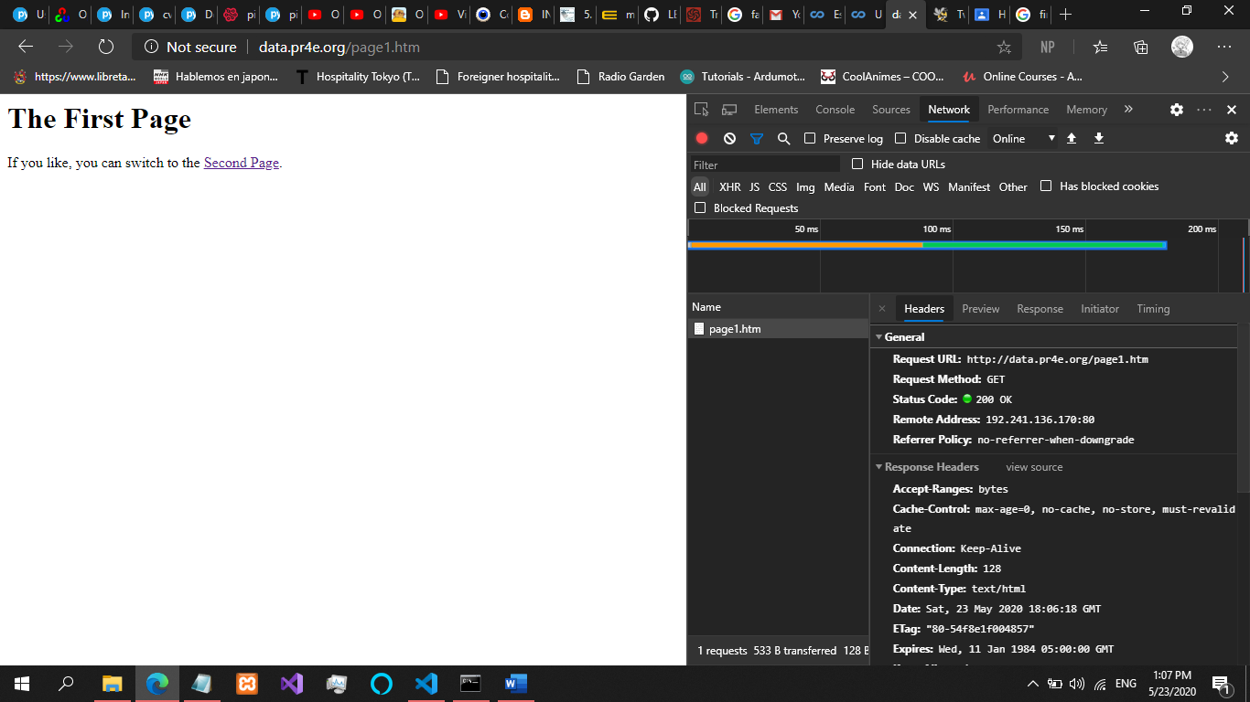

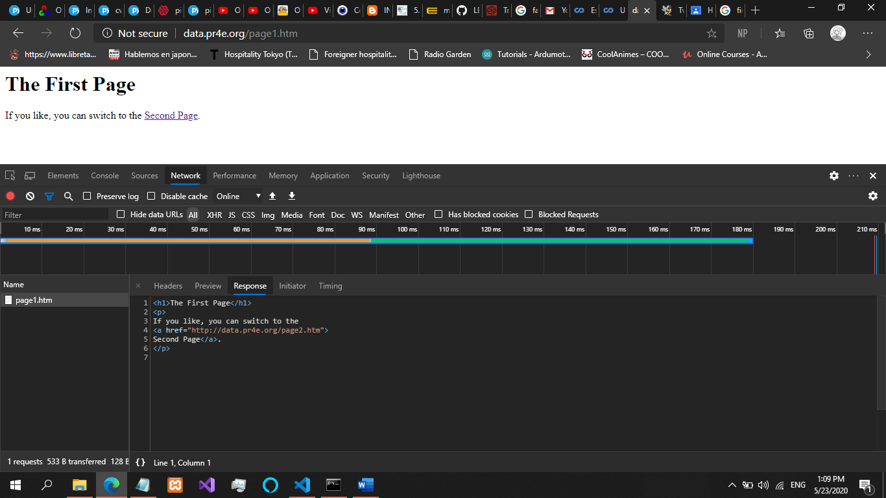

STATUS CODE CAN BE SOMETHING ELSE THAN 200 THAT MEANS A DOCUMENT

**STATUS 404 THERES NO URL:.....**

**STATUS 302 REDIRECTING HAVING HEADERS IN A PHP(THROUG A POST REQUEST)**

**CONTENT TIPY CAN ALSO CHANGE: image/jpg, text/html….css…js**

