Detailed Game Specification:  
TRON-Lightcycle

Course: COMP 2659, Winter 2017  
Instructor: Paul Pospisil  
  
Author(s): Jaden McConkey, Phillip Renwick  
Last Modified: Jan 15th 2017

# 1. General Game Overview

Tron – light cycle is a 2D territory claiming skill based racing game for two players. The aim is to survive longest within the confines of the playing field while also interfering with the survival/play of the competing player.

Each player directly controls a “lightcycle” with the arrow keys, that can move in the four cardinal direcitons within the rectangular playing field. Both players leave a permanent “light wall” on any location they traverse. If a player contacts either the field wall, a light wall, or the opposing player, the opposing player wins.

Scoring is based upon time with modifiers to speed, maneuvering, and opponent kills, with losses for own deaths. Three lives are afforded the player and opponents are presented one by one until the player has exhausted his supply of lives.

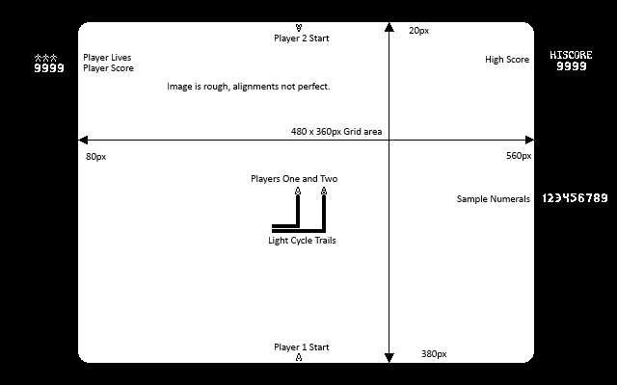Example of Gameplay Screen with additional placements and descriptive text overlaid. Larger verson at the end of this document.

# 2. Game Play Details for Core 1-Player Version

## Objectives and Rules

Players seek to eliminate the opponent via trapping them, which is accomplished by enclosing them with a light trail, forcing them to collide with either the boundary wall, a light trail or the players light cycle.

Movement is 2-directional: left, right, with turns being instantaneous, and oriented to the current direction of travel. Players may alter their speed by holding up or down arrow respectively, but may not stop.

Coming into contact with a wall or enemy trail will result in their destruction.

## Objects

|  |  |  |  |
| --- | --- | --- | --- |
| Object or Object Type Name | Properties | Behaviours | Graphical Image |
| Light Cycle (2 players) | * position (UINT16 pair) * speed (UINT8) * direction(UINT8 pair) * alive(bool) | * Move Forward * Accelerate * Turn * Collision(death) | 4 orientations in template file |
| Grid Cell | * occupied(bool) * Boundary wall   (occupied=true) | * occupied? (trail/cycle) * "trail"(width 4 cells) | N/A |
| Grid | * P1 start position   (UINT16 pair)   * P2 start position   (UINT16 pair) | * init(new match) * reset(next match) | N/A |
| Score | * 4 digit(UINT16) | * increases | In template file |
| Lives | * 1 digit(UINT8) | * decreases | In template file |
| Background | * "occupied" cells around   perimeter | * None, it sits there | In template file |

## Physics

Speed of the lightcycles is 2, 4, or 6 pixels per tick, depending on player action.

Speed changes are instantaneous, not over time.

Passing into a cell occupied by either an opponent or trail is considered to be a fatal collision.

## Asynchronous (Input) Events

|  |  |  |
| --- | --- | --- |
| Event Name | Triggering Input Event | Description |
| Accelerate | Up arrow(hold) | Speed increased by 50%(+2px/sec)  Increase pitch of "engine" tone |
| Decelerate | Down Arrow(hold) | Speed decreased by 50%(-2px/sec)  Decrease pitch of "engine tone |
| Turn Left | Left Arrow | Turns left |
| Turn Right | Right Arrow | Turns right |

## Synchronous (Timed) Events

|  |  |  |
| --- | --- | --- |
| Event Name | Trigger Timing | Description |
| Position update | 1/5 ticks  0.0714 sec. | * Lightcycle positions updated * Collisions checked-Call Collision if found * Score Increased |

## Condition-Based (Cascaded) Events

|  |  |  |
| --- | --- | --- |
| Event Name | Triggering Condition | Description |
| Init | Game Started | Initial screen drawn  Score set to zero  Lives set to three.  Call Match Start |
| Match Start | Init  Reset | Cycles placed at starting positions  Placed in motion  Call release |
| Release | Init | Start accepting Keyboard Input  Start Position updates |
| Collision | Cycle has moved into cell occupied by wall or trail. | Fatal.  Last player to collide wins.  Simultaneously collision is draw.  Call Crash |
| Crash | Collision | Remove appropriate cycle.  Replace with collision effect.  Call Reset |
| Reset | Collision | If draw or loss, lives decreased by one.  If loss, score decreased.  If win, score increased |

## Hypothetical Gaming Session

Movement on the grid is described with the four cardinal directions, given that left and right for the cycles depends on their orientation. When headed North, a left turn is a turn to Eest, but when headed South a left is to East.

Players begin at opposite ends with the local human player at the bottom of the grid, the computer or remote player at the top. As control is released, both players are put n motion on a headon collision. Player one accelerates and beats Player two to the middle of the grid. Just before colliding, both turn east. Upon reaching the boundary Player one slows and Player two slams into the boundary wall first, a victory for player one.

In the next match, things proceed much as before, except player two accelerates before reaching the boundary, and gets to the edge before Player one. Player two turns south along the edge of the grid, Player one follows suit at the last moment and accelerates as well. Play continues for a bit like this until the grid has become full of their trails. Both players are trapped within their trails, both playes reduce speed and try to outlast the other. Inevitably, they will run out of room. In this occurrence, they do so on the same update, and the match is considered a draw.

# 3. Game Play Details for Core 2-Player Version

Nearly identical to the one player version except:

1) The computer player exchanged for a human player at another terminal.

2) Play is not until Player one has run out of lives, rather, it is until either Player One or Two has run out.

# 4. Sound Effects

|  |  |  |
| --- | --- | --- |
| Sound Effect Name | Brief Description | Event which Triggers Playback |
| Theme | Tron Themed tonal | Menu |
| Chime | Match start count down beeper | Init |
| Engine low | Lower pitch engine tone | Player decelerates |
| Engine mid | Standard engine tone | Player not (de/ac)celerate |
| Engine high | Higher pitch engine tone | Player accelerates |
| Collision | White noise "explosion" | Collision |

# 5. Additional Features (Time Permitting)

-Toggling gates to enable different "circuits". Essentially a single maze with gates to enable or close off paths.

-More than two computer cycles in play-new starting positions, more entities on grid.

-Fixed ai patterns to battle against with a total of 12 stages with increasing difficulty

-Mode for playing on the same keyboard, mapping wasd for one player, arrows for the other.

-Screen Flourishes using empty border space.

-Color

