**MODULE :COS**

**Name :Athang Milind Patil**

**Assignment - 1**

**Problem 1: Read the instructions carefully and answer accordingly. If there is any need to insert some data then do that as well.**

**a) Navigate and List:**

a. Start by navigating to your home directory and list its contents. Then, move into a

directory named "LinuxAssignment" if it exists; otherwise, create it.

**Ans:**

**Command :**

**Mkdir :** creates a new directory

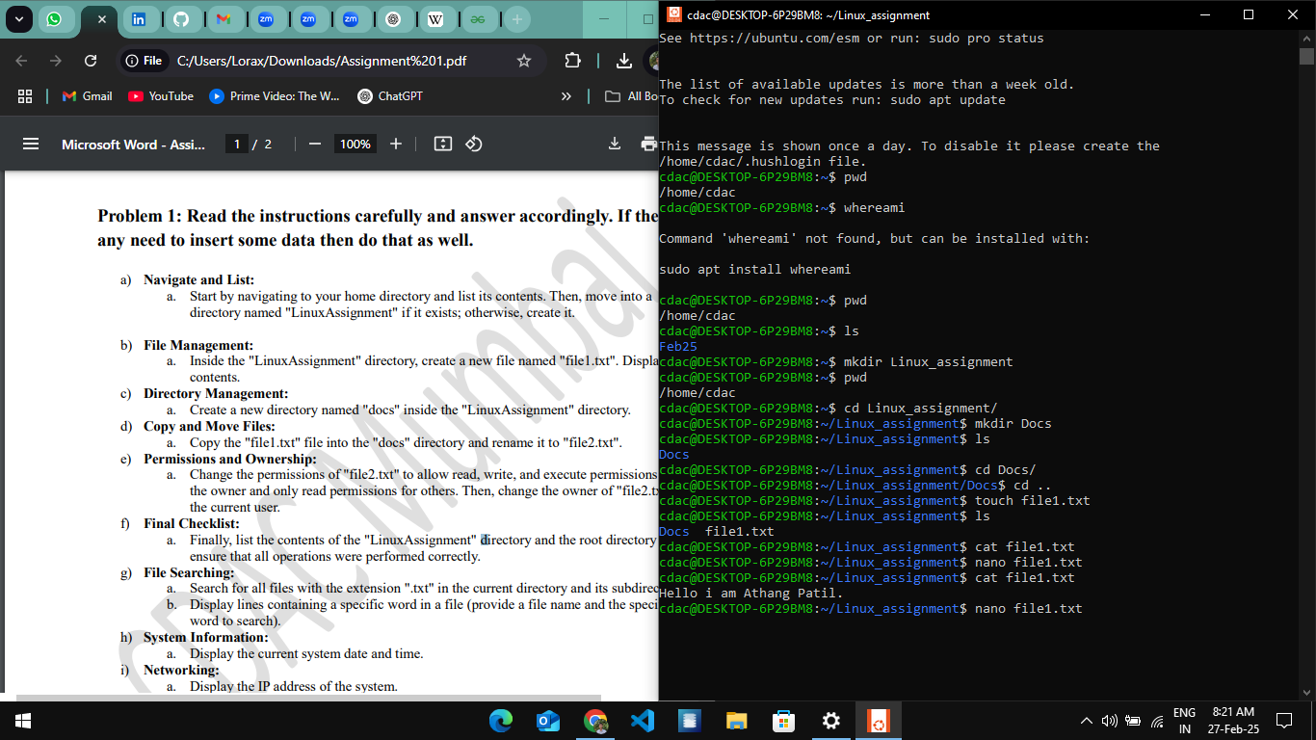

**b) File Management:**

a. Inside the "LinuxAssignment" directory, create a new file named "file1.txt". Display its

contents.

**Ans :**

**Commands :**

**Touch :** cretes an empty file

**Nano** : it is an editor which helps to edit and create a file



**c) Directory Management:**

a. Create a new directory named "docs" inside the "LinuxAssignment" directory.

**Commands**

**Mkdir :** Creates a new directory



**d) Copy and Move Files:**

**Commands :**

**CP –** helps to copy files to another directory or file

**MV** : helps to rename a file

a. Copy the "file1.txt" file into the "docs" directory and rename it to "file2.txt".

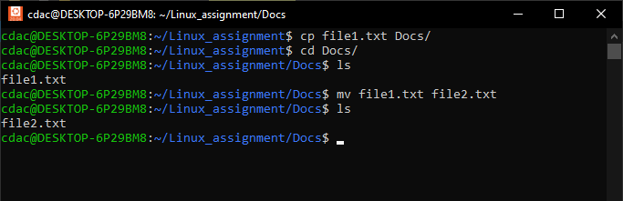

**e) Permissions and Ownership:**

a. Change the permissions of "file2.txt" to allow read, write, and execute permissions for

the owner and only read permissions for others. Then, change the owner of "file2.txt" to

the current user.

**Commands :**

**chmod** : helps to change the permissions of the files which are read write and execute.

**Chown :** helps to change the ownership of the file

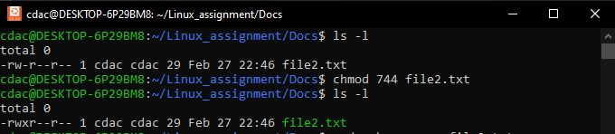

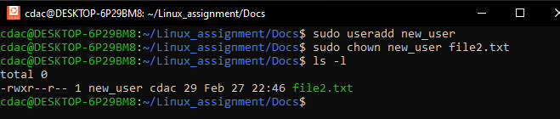

**f) Final Checklist:**

a. Finally, list the contents of the "LinuxAssignment" directory and the root directory to

ensure that all operations were performed correctly.

**Command :**

**ls :** helps to list out all the files and directories

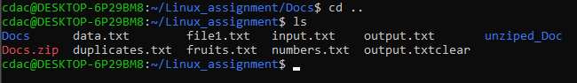

**g) File Searching:**

a. Search for all files with the extension ".txt" in the current directory and its subdirectories.

b. Display lines containing a specific word in a file (provide a file name and the specific

word to search).

**Command :**

**find :** helps to find out particular filetype

**grep :** helps to find out particular word ,letter

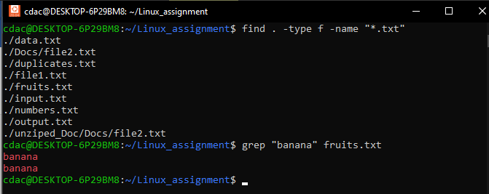

**h) System Information:**

a. Display the current system date and time.

**Command :**

**Date :**  helps to find out current system date and time



**i) Networking:**

a. Display the IP address of the system.

b. Ping a remote server to check connectivity (provide a remote server address to ping).

**Commands :**

**hostname :** helps to display the IP address of the system

**ping :** pings a remote server to check connectivity

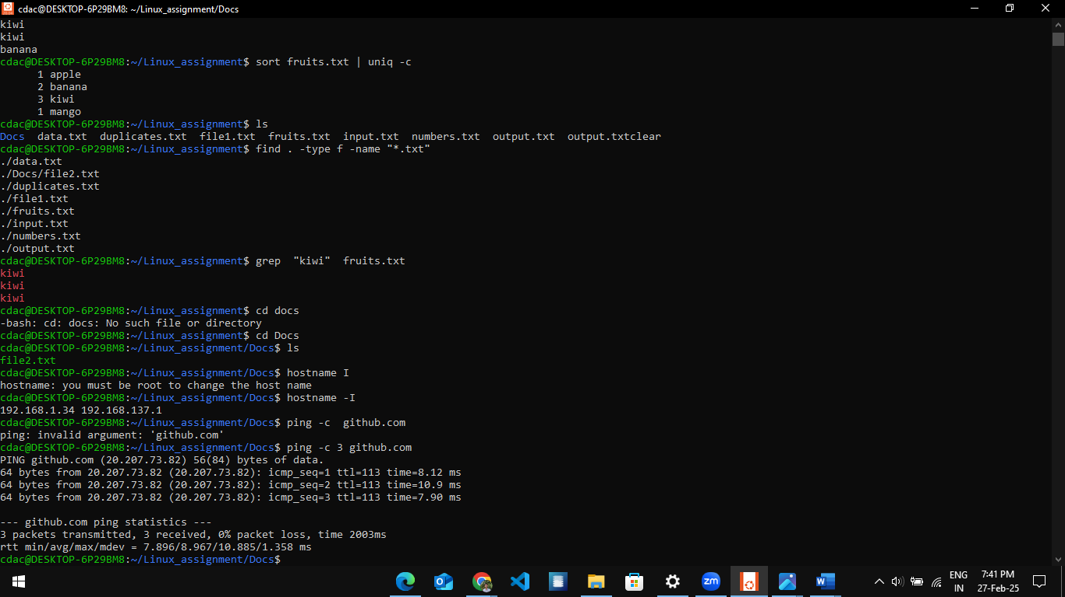

**j) File Compression:**

a. Compress the "docs" directory into a zip file.

b. Extract the contents of the zip file into a new directory.

**Commands :**

**zip** : compresses the file in .zip

**unzip :** decompresses the file from .zip to original file

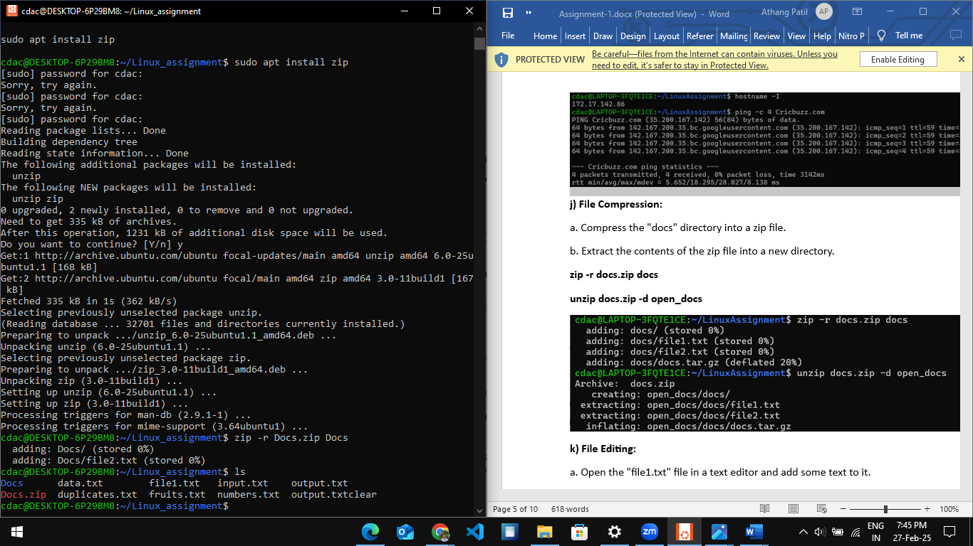

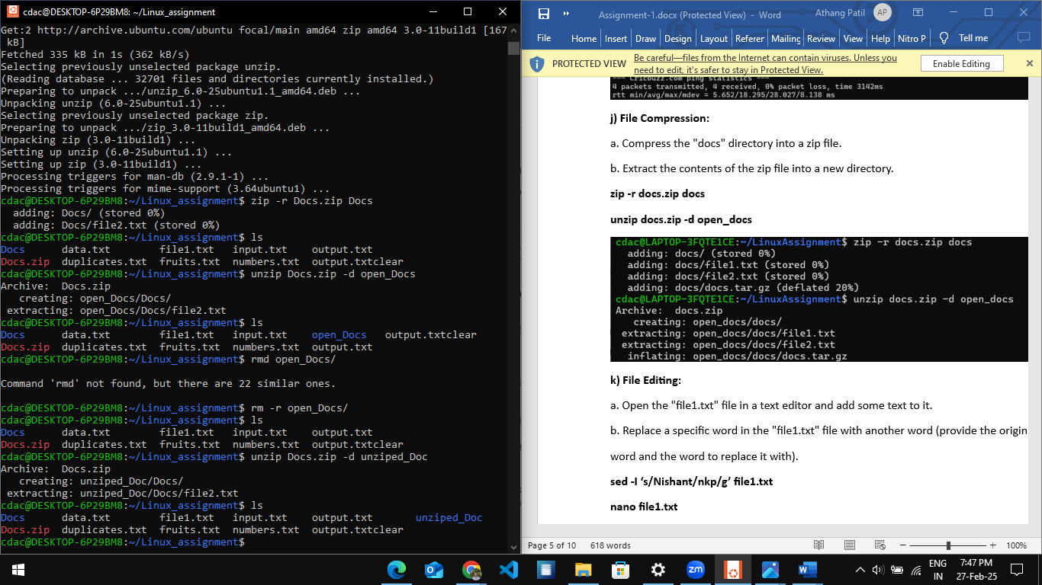

**k) File Editing:**

a. Open the "file1.txt" file in a text editor and add some text to it.

b. Replace a specific word in the "file1.txt" file with another word (provide the original

word and the word to replace it with).

**Command:**

**sed :**  helps to replace a specific word , letter with the original.

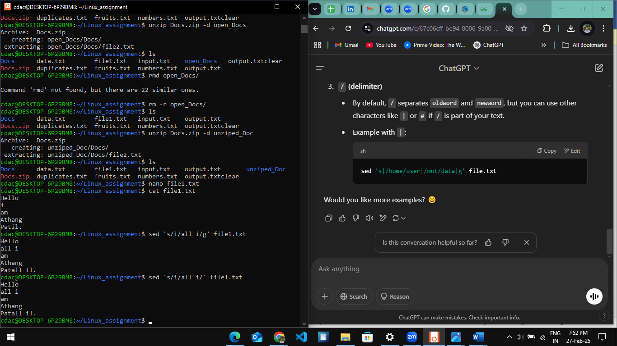

**Problem 2: Read the instructions carefully and answer accordingly. If there is**

**any need to insert some data then do that as well.**

a. Suppose you have a file named "data.txt" containing important information. Display the

first 10 lines of this file to quickly glance at its contents using a command.

**Command :**

**head -n 10 :**  helps to print the first 10 line from file

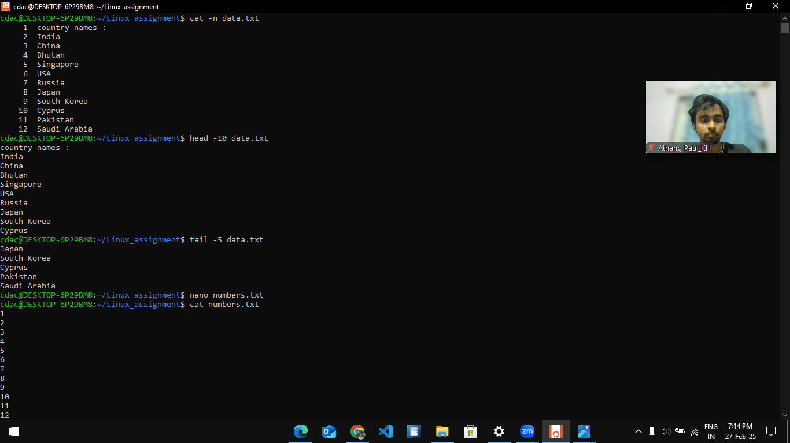

b. Now, to check the end of the file for any recent additions, display the last 5 lines of

"data.txt" using another command.

**tail -n 5 :**  helps to print the last 5 line from file



c. In a file named "numbers.txt," there are a series of numbers. Display the first 15 lines of

this file to analyze the initial data set.

**Command :**

**head -n 15**

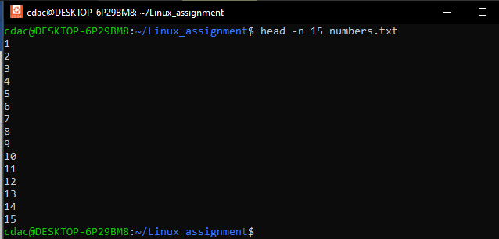

d. To focus on the last few numbers of the dataset, display the last 3 lines of "numbers.txt".

**Command :**

**tail -n 3**

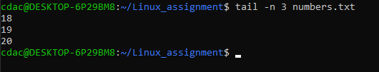

e. Imagine you have a file named "input.txt" with text content. Use a command to translate

all lowercase letters to uppercase in "input.txt" and save the modified text in a new file

named "output.txt."

**Command :**

**tr 'a-z' 'A-Z' < input file > output file :** helps to convert file content from lowercase to uppercase and save the modified file into another file

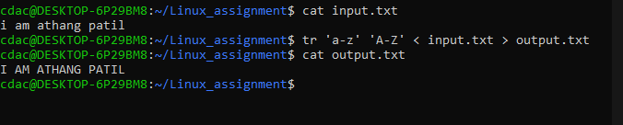

f. In a file named "duplicate.txt," there are several lines of text, some of which are

duplicates. Use a command to display only the unique lines from "duplicate.txt."

**Command :**

**sort duplicates.txt | uniq :** helps to sort and find out the unique values.

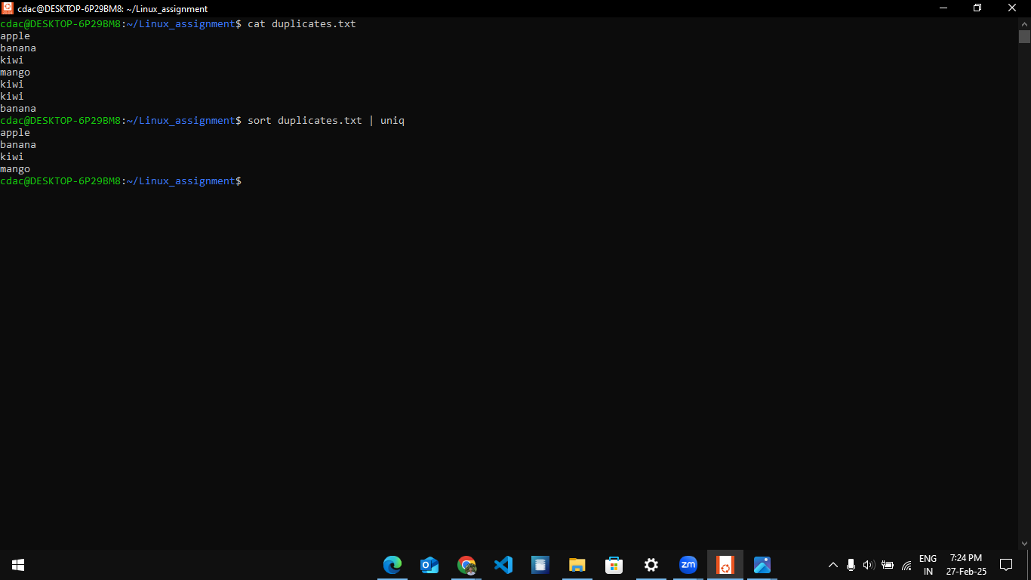

g. In a file named "fruit.txt," there is a list of fruits, but some fruits are repeated. Use a

command to display each unique fruit along with the count of its occurrences in

"fruit.txt."

**sort fruit.txt | uniq -c :** -c helps to get the count of the all duplicate values

