Software Design Document
Modeling Longitudinal Learning Dynamics Using Markov Models



Submitted by
Athar Hussain (F22BINFT1M01231)
Submitted to
Dr. Mustafa Hameed

Department of Information Technology
Faculty of Computing
The Islamia University of Bahawalpur

Summary
This Software Design Document describes the design of “Modeling Longitudinal Learning Dynamics Using Markov Models”, a self-contained learning-analytics application that follows the VaSSTra method (Variables → States → Trajectories) and is implemented entirely in Python. The system reads a single longitudinal engagement dataset, standardizes each behavioural indicator within its course, discovers latent engagement states with a Gaussian-mixture model, composes the per-student state sequences across eight time points, and clusters those sequences into learner trajectories.
Operationally, the design has three parts: an offline Python pipeline that performs the VaSSTra and Markov computations and writes its results as CSV and JSON files; a small FastAPI service that exposes those generated results and matches a manually entered state sequence to its closest trajectory; and a static HTML/CSS/JavaScript dashboard that renders the results with Plotly. A companion Jupyter notebook reproduces the same analysis step by step, including the first-order Markov transition matrices.
The design favours reproducibility and transparency over scale: a fixed random seed makes each run repeatable, the configuration (three states, three trajectories) is held in the pipeline module, and all data and code stay on the user’s machine. The application is intended for a single local user — an instructor, analyst, or researcher — and uses no database, no accounts, and no external services.
Finally, this document maps the design to the requirements recorded in the SRS, documents the data model and file artifacts, and explains the model execution, prediction, and analysis workflows so that the outputs remain interpretable to non-technical readers.

Table of Contents
1 Introduction 6
1.1 Purpose 6
1.2 Scope 7
Out of scope: relational databases, model registries, and multi-user deployment. 7
1.4 Assumptions and Dependencies 8
2 System Overview 9
2.1 Context Overview (Context Diagram) 9
2.2 System Objectives 10
2.3 Stakeholders 10
3 System Architecture 11
3.1 High Level Architecture 11
3.2 Component Architecture 12
3.3 Technology Stack 13
3.4 Module Breakdown 13
4 Data Model and Schema 14
4.1 Entity Definitions 14
4.2 Data Relationships (ER Diagram) 15
4.3 Dataset Schema and Data Dictionary 16
4.4 Storage and File Layout 17
5 User Interface Design 18
5.1 UI Mockups and Wireframes 18
5.2 Navigation Flow 20
5.3 Visualization Components 20
5.4 User Interaction Guidelines 21
6 Component and API Design 21
6.1 Module Specifications 21
Analytical Pipeline (run_vasstra_pipeline.py) 21
State Discovery (assign_states / GaussianMixture) 21
Sequence and Trajectory Construction 22
Result-Serving API (api.py + fyp_shared.api) 22
Trajectory Prediction (predict) 22
Frontend Dashboard (frontend/js/app.js) 22
6.2 API Specifications 23
6.3 Class and Sequence Diagrams 23
7 Algorithm and Methodology 24
7.1 Feature Engineering Pipeline 24
7.2 Model Selection and Training 26
7.3 Processing Workflow 26
8 Integration and Communication 30
9 Security and Privacy 30
9.1 Authentication 30
9.2 Authorization 30
9.3 Data Protection 31
10 Non-Functional Requirements 31
11 Deployment Strategy 32
11.1 Environment Requirements 32
11.2 Deployment Pipeline 33
12 Testing and Validation 33
12.1 Functional Testing 33
12.2 Validation and Model Evaluation 34
12.3 QA and Verification Methods 34
13 Constraints and Limitations 34
14 Design Decisions and Rationale 35
15 Future Enhancements 35
16 Appendices 36
Appendix A: Dataset Summary 36
Appendix B: Use Case Library 37
Appendix C: Requirements Traceability 37
Appendix D: Data Quality Rules 38
Appendix E: Operational Monitoring 39
Appendix D: Concluding Summary 39
References 40

1 Introduction

1.1 Purpose
The purpose of this document is to describe the software design of the system that realizes the requirements in the SRS. It defines the system architecture and its three components (the Python analytical pipeline, the FastAPI result-serving API, and the static browser dashboard), the file-based data model, the module and API design, and the modelling algorithms (within-course standardization, Gaussian-mixture state discovery, Ward trajectory clustering, and first-order Markov transition estimation).
It also documents the design decisions, the local deployment approach, the testing and validation strategy, and the assumptions and constraints, so that the implementation can be understood, reproduced, and extended for academic use.

1.2 Scope
- Reading a single local engagement dataset (data/raw/LongitudinalEngagement.csv) — no live LMS/SIS feeds.
- Within-course standardization of the eight engagement indicators and Gaussian-mixture engagement-state discovery.
- Building per-student eight-step state sequences and clustering them into learner trajectories (Ward linkage).
- Estimating first-order Markov transition matrices over the engagement states (in the companion notebook).
- Serving the generated results through a small FastAPI service and rendering them in a Plotly dashboard.
- Manual trajectory prediction: matching a user-entered eight-step state sequence to the closest trajectory prototype.
- Out of scope: real-time streaming, automated interventions, user accounts, and any external/cloud service.

Out of scope: relational databases, model registries, and multi-user deployment.
Term | Definition
SDD | Software Design Document
SRS | Software Requirements Specification
VaSSTra | Variables → States → Trajectories modelling method
GMM | Gaussian Mixture Model (used for engagement-state discovery)
State | Latent engagement level: Disengaged, Average, or Active
Trajectory | A cluster of similar eight-step state sequences
Markov matrix | First-order state-to-state transition probability matrix
API | Application Programming Interface (FastAPI: /health, /schema, /predict)
BIC / AIC | Bayesian / Akaike Information Criterion (state-model selection)

1.4 Assumptions and Dependencies
- The input file LongitudinalEngagement.csv keeps its expected columns (UserID, CourseID, Sequence, the eight indicators, Final_Grade).
- Each student has up to eight ordered weekly time points (Sequence 1–8); missing positions default to the Average state.
- Python 3.11+ with pandas, NumPy, and scikit-learn is available on the local machine.
- The dataset uses anonymized identifiers and contains no personally identifiable information.
- The application is run on demand by a single local user; no concurrent multi-user access is assumed.
- A fixed random seed (2026) is used so that model runs are reproducible.

2 System Overview

2.1 Context Overview (Context Diagram)
The system is a single local application accessed by one User through a web browser. Its only data source is the local file LongitudinalEngagement.csv; there are no upstream LMS or SIS connections.
The application transforms that dataset into engagement states, learner trajectories, and Markov transition results, which it writes to disk as CSV and JSON files. The User views these results in the browser and can submit a manual state sequence for trajectory prediction.
All processing and storage stay on the User’s machine; nothing is transmitted to an external server.
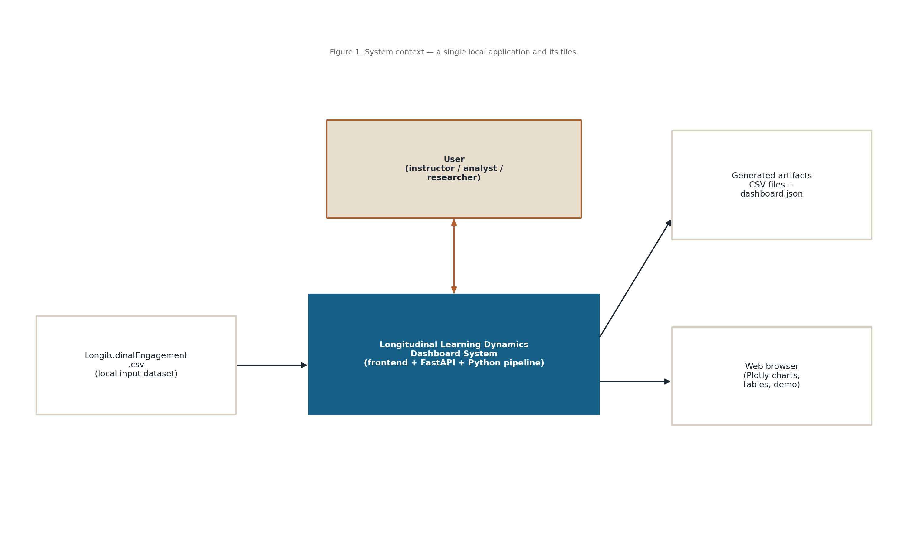
Figure 1. System context: a single local application, its input file, and its generated artifacts.

2.2 System Objectives
- Discover a small set of interpretable engagement states from behavioural indicators.
- Compose per-student state sequences and group them into learner trajectories.
- Estimate first-order Markov transitions between engagement states.
- Present model-selection metrics, state profiles, and trajectory prototypes in an interactive dashboard.
- Let the User test a manual state sequence against the discovered trajectories.
- Keep every run reproducible and fully offline on a single machine.

2.3 Stakeholders

Stakeholder | Role / Interest
Student (developer) | Designs and implements the system as the Final Year Project
Supervisor | Reviews the methodology, design, and results
Instructor / Analyst (User) | Runs the dashboard to interpret cohort engagement
Researcher | Reproduces and extends the VaSSTra/Markov analysis
Evaluation committee | Assesses the project against academic criteria

3 System Architecture

3.1 High Level Architecture
The system uses a simple three-tier offline architecture. An analytical pipeline (run_vasstra_pipeline.py) reads the dataset, performs the VaSSTra computations with scikit-learn, and writes a set of CSV files and a consolidated dashboard.json.
A FastAPI service (api.py) loads dashboard.json at start-up and exposes three endpoints (/health, /schema, /predict); the prediction endpoint scores a submitted state sequence against the stored trajectory prototypes. A static frontend (HTML, CSS, JavaScript, Plotly) fetches dashboard.json and calls the API to render charts, tables, and the manual prediction demo.
The three parts communicate only through the local file system and local HTTP on 127.0.0.1; there is no database, scheduler, or external dependency.
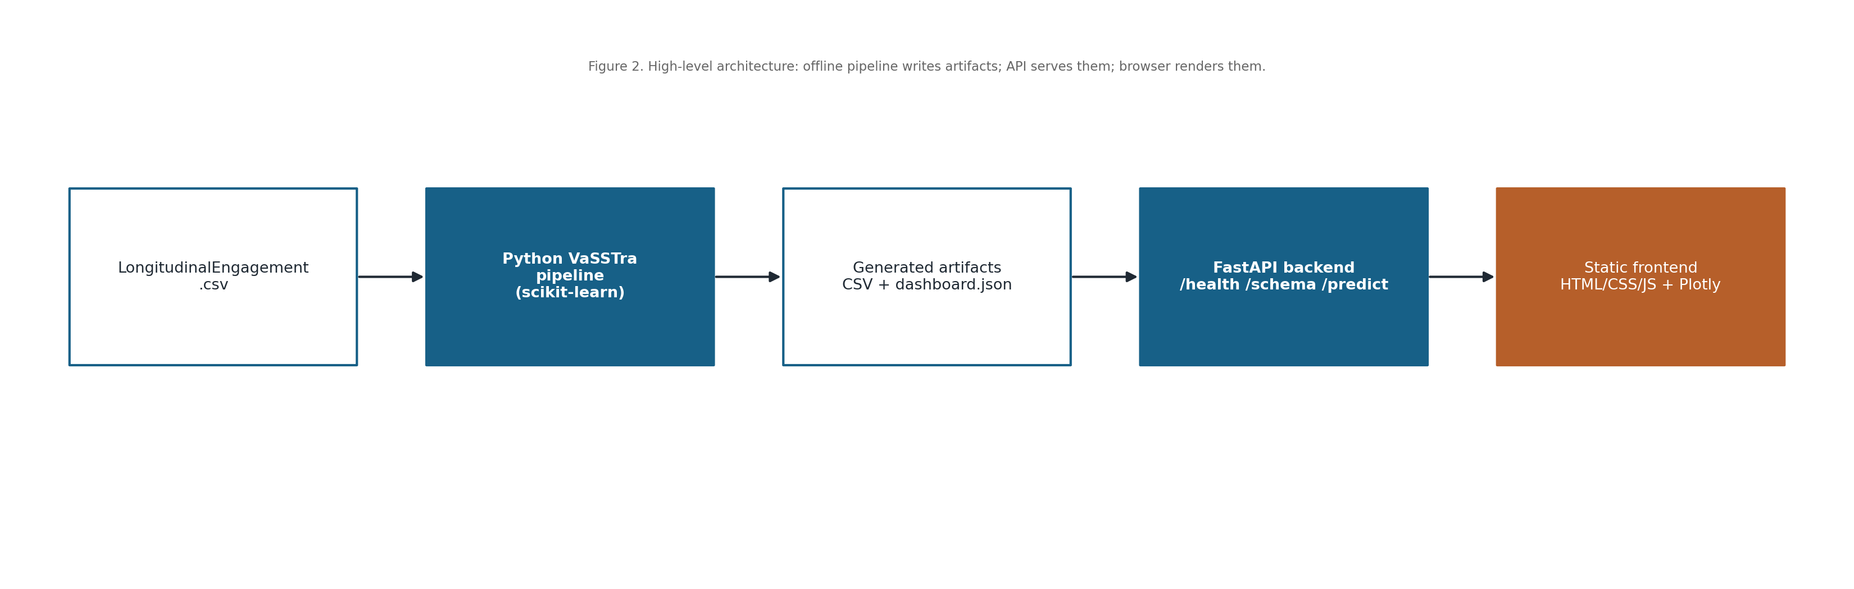
Figure 2. High-level architecture: offline pipeline → artifacts → FastAPI → browser dashboard.

3.2 Component Architecture
The presentation layer is the static dashboard (index.html, css/styles.css, js/app.js) that renders all analytics with Plotly. The service layer is the FastAPI application built by fyp_shared.api.create_app, which serves the generated results and handles prediction requests with permissive CORS for localhost.
The analytics layer is the Python pipeline that performs within-course standardization, Gaussian-mixture state assignment, sequence construction, and Ward trajectory clustering. The data layer is the local file system: the raw input CSV, the processed CSVs under data/processed, and the generated artifacts under outputs/backend.
No shared metadata service, message queue, or object store is used; the layers are coupled only through files and local HTTP.
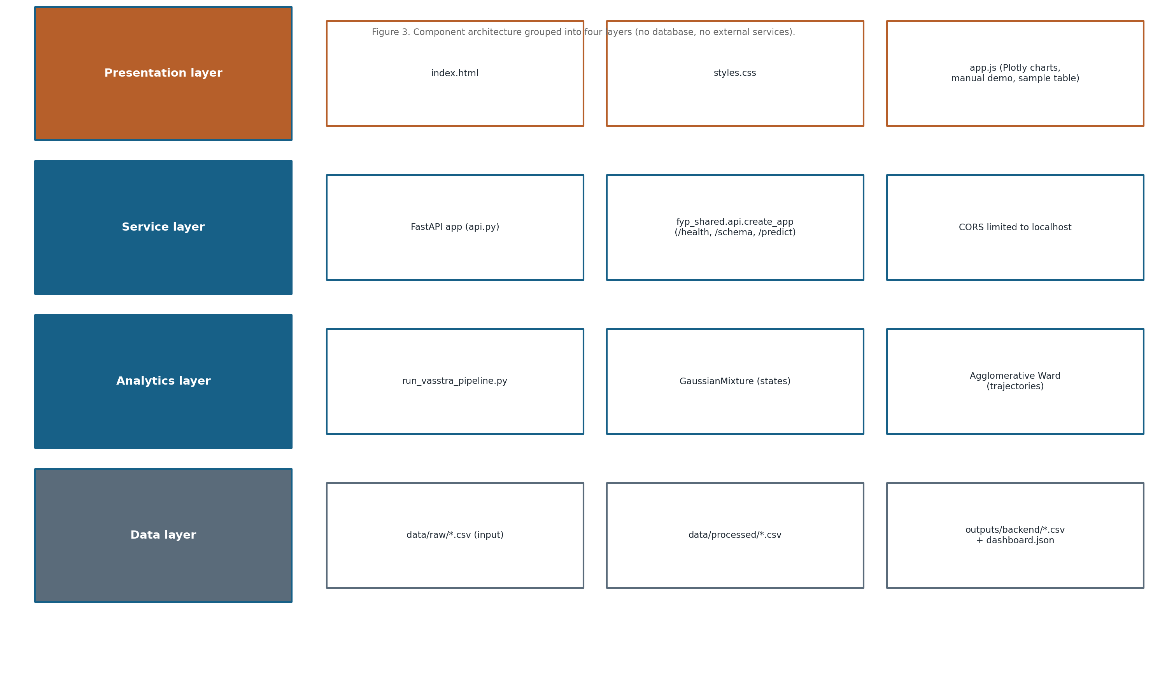
Figure 3. Component architecture grouped into presentation, service, analytics, and data layers.

3.3 Technology Stack
Layer | Technology
Frontend | HTML5, CSS3, vanilla JavaScript (ES2020+), Plotly.js (vendored)
Backend / API | Python 3.11+, FastAPI, served by uvicorn on 127.0.0.1:9511
Analytics | pandas, NumPy, scikit-learn (GaussianMixture, AgglomerativeClustering)
Notebook | Jupyter, Matplotlib, SciPy (VaSSTra + Markov reproduction)
Storage | Local file system — CSV input and CSV/JSON outputs (no database)

3.4 Module Breakdown
Module | Purpose
run_vasstra_pipeline.py | Offline VaSSTra pipeline; writes CSV artifacts and dashboard.json
api.py | FastAPI app; /predict matches a state sequence to the closest trajectory
fyp_shared.api | Shared factory wiring /health, /schema, /predict and CORS
frontend/js/app.js | Loads dashboard.json, renders Plotly charts, drives the manual demo
notebook/vasstra_python.ipynb | Step-by-step VaSSTra and Markov-transition reproduction
run/*.ps1, run/*.bat | Launchers for the pipeline, backend, frontend, notebook, and full project

4 Data Model and Schema

4.1 Entity Definitions
Entity / Artifact | Description
Raw record | One CSV row: a student (UserID) in one course (CourseID) at one time point (Sequence)
State assignment | A raw record labelled with its engagement State (Disengaged/Average/Active) and probabilities
State sequence | One row per student: the ordered states step_1..step_8
Trajectory | A Ward cluster of similar state sequences, with a prototype path and label
Trajectory profile | Per-trajectory size, prototype, state shares, and mean final grade
Markov matrix | First-order state-to-state transition probabilities derived from the sequences

4.2 Data Relationships (ER Diagram)
Each student has one engagement record per weekly time point. After state assignment, the records for a student form a single eight-step state sequence; sequences are then clustered into trajectories.
Each trajectory aggregates the students assigned to it, summarising their dominant (prototype) state path, the share of time spent in each state, and the mean final grade. The generated artifacts are plain files, related by the UserID and trajectory keys rather than by a relational database.
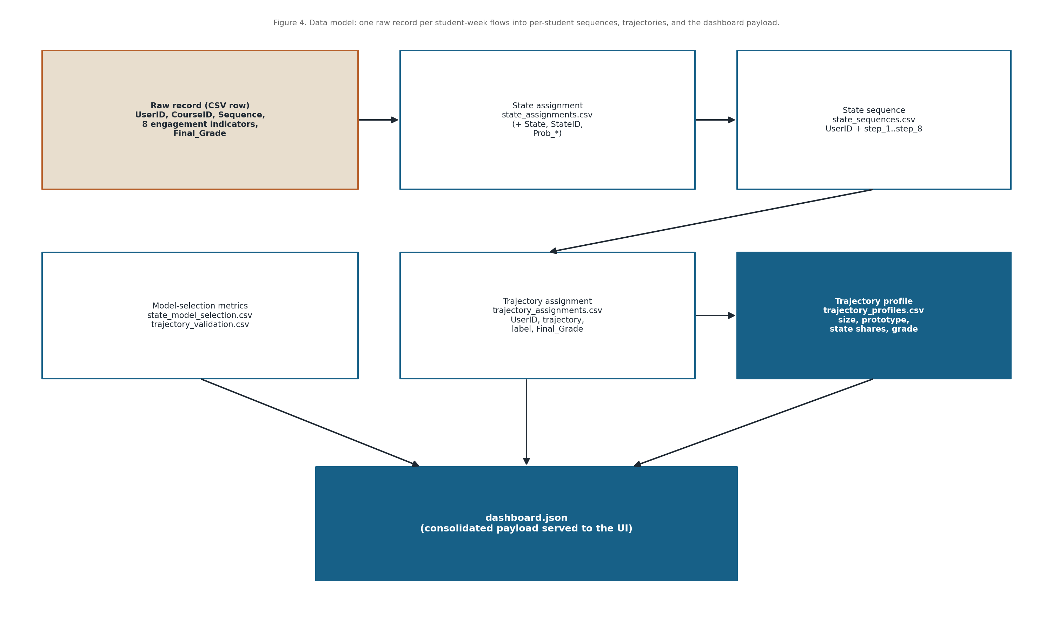
Figure 4. Data model: how a raw record flows into state sequences, trajectories, and dashboard.json.

4.3 Dataset Schema and Data Dictionary
Field | Type | Description
UserID | String | Anonymized learner identifier
CourseID | String | Anonymized course identifier
Sequence | Integer | Weekly time-point index (1–8)
Freq_Course_View | Integer | Count of course-page views
Freq_Forum_Consume | Integer | Count of forum reads
Freq_Forum_Contribute | Integer | Count of forum posts
Freq_Lecture_View | Integer | Count of lecture views
Regularity_Course_View | Float | Regularity of course views
Regularity_Lecture_View | Float | Regularity of lecture views (not used for clustering)
Regularity_Forum_Consume | Float | Regularity of forum reading (not used for clustering)
Regularity_Forum_Contribute | Float | Regularity of forum posting (not used for clustering)
Session_Count | Integer | Number of learning sessions
Total_Duration | Integer | Total active duration (seconds)
Active_Days | Integer | Number of active days
Final_Grade | Float | Final course grade (analysis target)

4.4 Storage and File Layout
The system stores all data as files. The raw input is read once from data/raw; processed per-student tables are written to data/processed; and model-selection metrics, state and trajectory profiles, and the consolidated dashboard.json are written to outputs/backend.
Raw records are never overwritten. Each pipeline run regenerates the processed and output files, so the artifacts always reflect the current dataset and configuration; if a run fails, the previous artifacts remain on disk so the dashboard still loads.
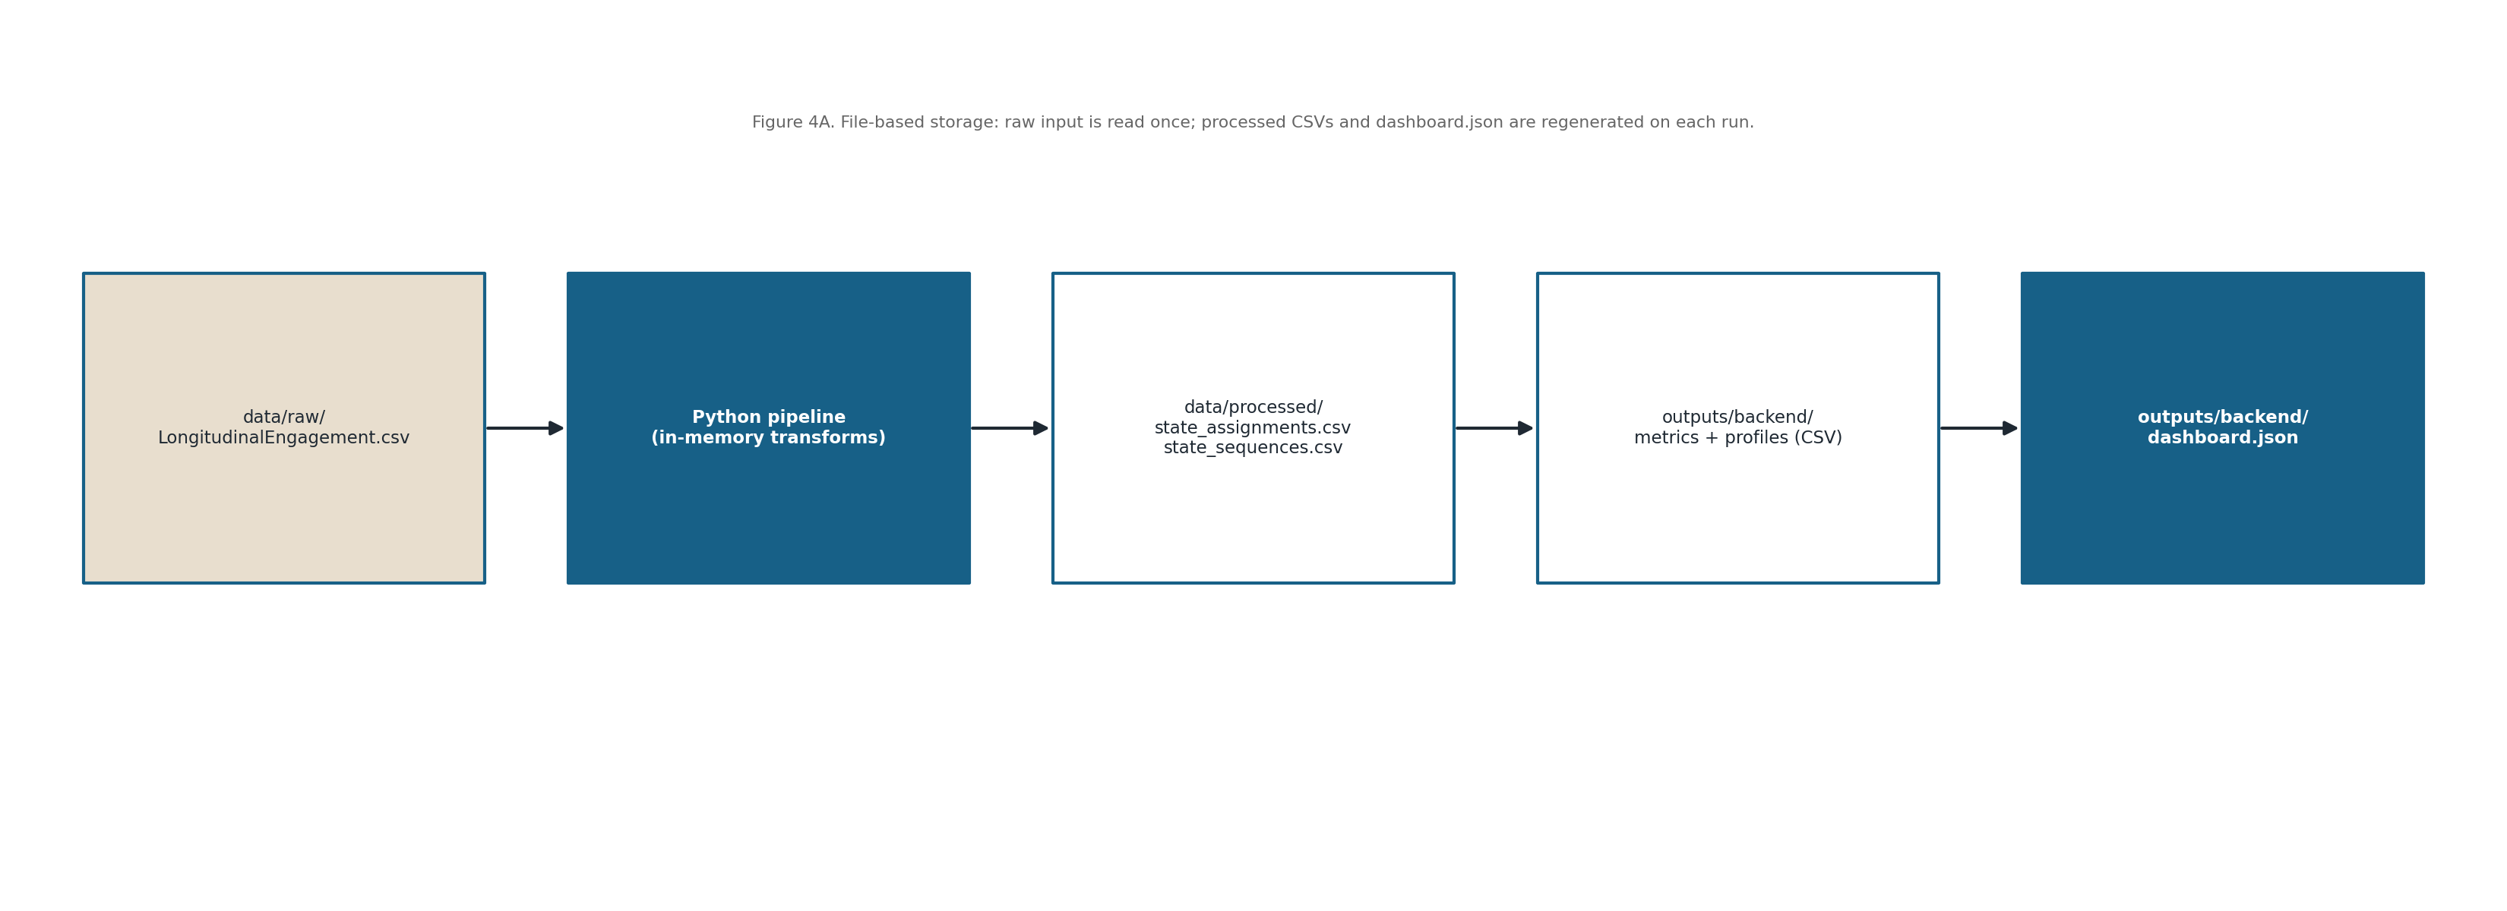
Figure 4A. File-based storage and processing layout (raw input, processed CSVs, and outputs).

5 User Interface Design

5.1 UI Mockups and Wireframes
The interface is a single scrolling dashboard page. A hero banner states the project title and a short VaSSTra description, followed by four summary cards (total records, unique students, number of states, number of trajectories).
Below the cards are paired panels for state-model selection (BIC/AIC), trajectory validation (silhouette), per-state engagement profiles, and trajectory prototype cards, then the manual state-sequence demo and a searchable trajectory-samples table.
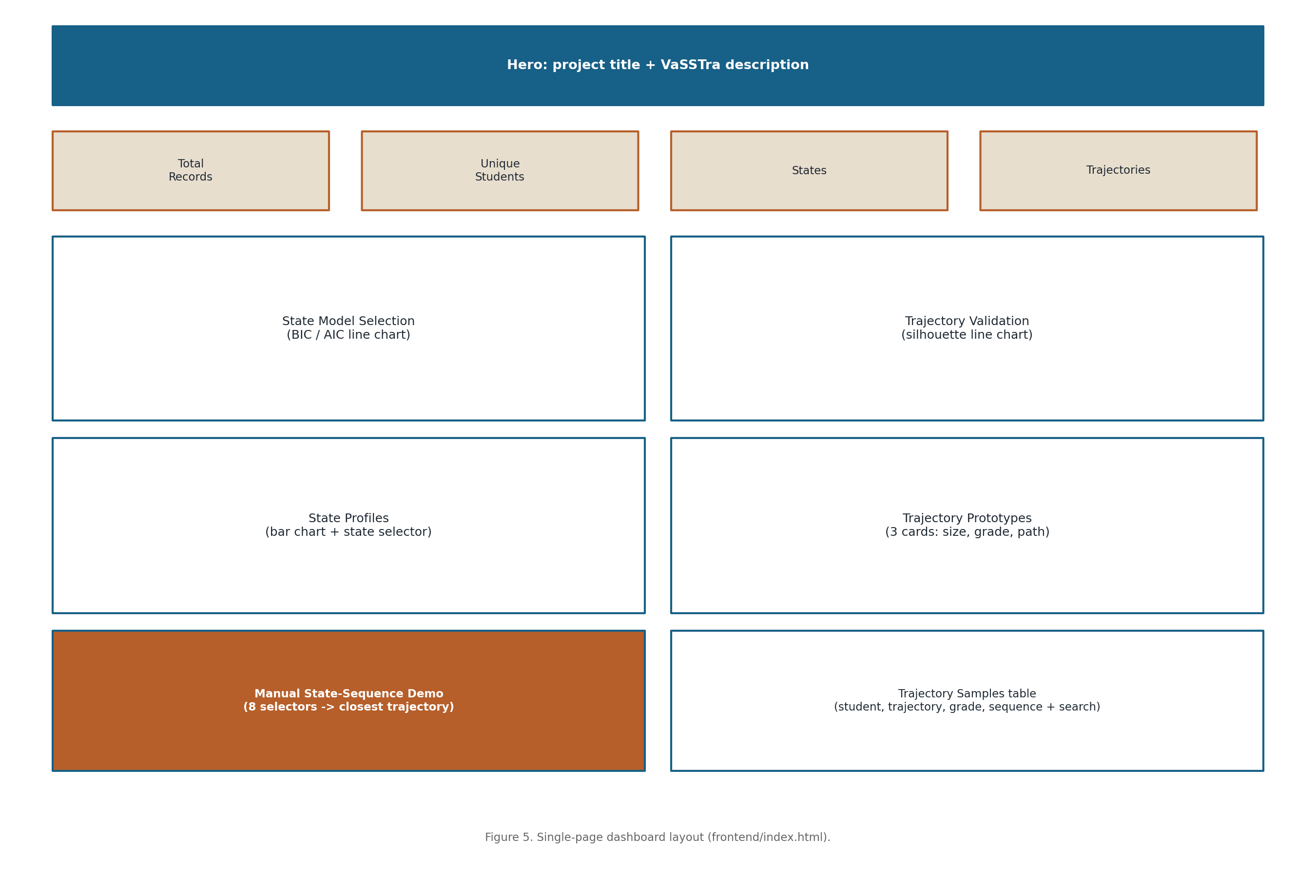
Figure 5. Single-page dashboard layout (frontend/index.html).
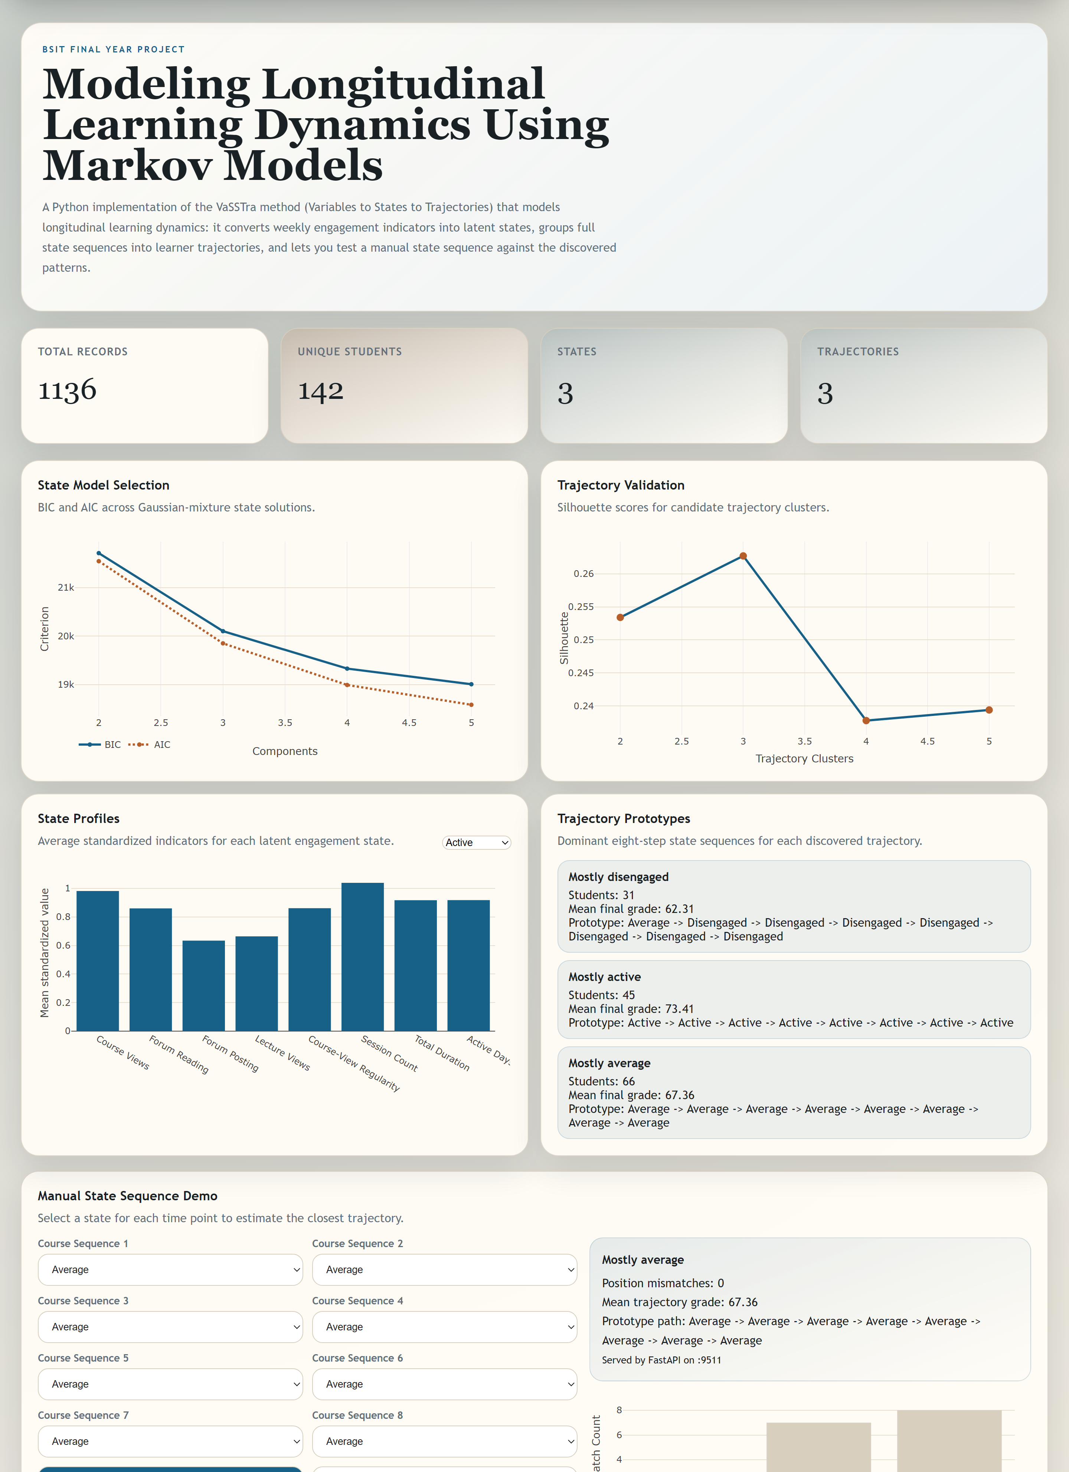
Figure 5A. The implemented dashboard user interface (live rendering of the VaSSTra results).

5.2 Navigation Flow
There is no multi-page navigation or login. Running the launcher regenerates dashboard.json, starts the API, and opens the single page in the browser.
All interaction happens on that page: the User reads the panels, selects a state to inspect its profile, submits an eight-step sequence to the prediction endpoint, and searches the sample table.
The page reports backend status messages so the User knows whether the API and generated artifacts are available.
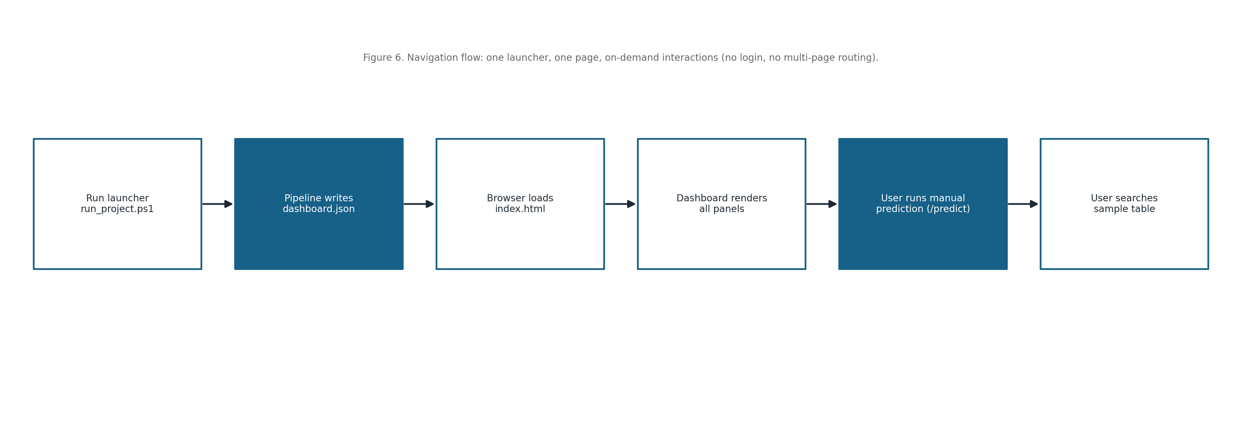
Figure 6. Navigation flow: one launcher, one page, on-demand interactions.

5.3 Visualization Components
- BIC/AIC line chart for Gaussian-mixture state-model selection.
- Silhouette line chart for trajectory-cluster validation.
- Per-state bar chart of mean standardized engagement indicators (with a state selector).
- Trajectory prototype cards showing size, mean final grade, and the eight-step state path.
- Manual-prediction bar chart of position mismatches against each trajectory prototype.

5.4 User Interaction Guidelines
Charts update live in response to the state selector, the manual-demo form, and the sample search box, all without a page reload.
A clear distinction is kept between viewing the precomputed results and submitting a manual prediction; the prediction is the only action that contacts the backend API.
A consistent colour mapping is used for the three engagement states across the charts and the prototype cards.

6 Component and API Design

6.1 Module Specifications

Analytical Pipeline (run_vasstra_pipeline.py)
Input: data/raw/LongitudinalEngagement.csv. Processing: orchestrates the full VaSSTra run — within-course standardization, state-model evaluation, state assignment, sequence construction, trajectory validation and clustering, and profile building.
Output: processed CSVs (state_assignments.csv, state_sequences.csv), output CSVs (state_model_selection, trajectory_validation, state_profiles, trajectory_profiles, trajectory_assignments), and dashboard.json. Errors (e.g. a missing dataset) are raised with a clear message.

State Discovery (assign_states / GaussianMixture)
Input: the standardized indicator matrix. Processing: fits a three-component diagonal-covariance Gaussian mixture (random seed 2026, 15 restarts), orders components by mean level, and labels them Disengaged → Average → Active.
Output: a State label, StateID, and per-state membership probabilities for every record; a candidate scan (2–5 components) reports BIC and AIC for model selection.

Sequence and Trajectory Construction
Input: the state-labelled records. Processing: pivots each student’s states into an eight-step sequence (missing steps default to Average), one-hot encodes the steps, and applies Ward agglomerative clustering, selecting the number of trajectories by silhouette score.
Output: per-student state sequences and trajectory assignments, plus per-trajectory prototypes, state shares, and mean final grades.

Result-Serving API (api.py + fyp_shared.api)
Input: HTTP requests. Processing: loads dashboard.json once at start-up and exposes /health, /schema, and /predict through the shared create_app factory, with CORS limited to localhost origins.
Output: service status and title (/health), the input schema and trajectory profiles (/schema), and prediction results (/predict). Invalid input returns a 422; unexpected errors return a 500 with detail.

Trajectory Prediction (predict)
Input: an object mapping step_1..step_8 to a chosen state. Processing: builds the ordered sequence and, for each trajectory prototype, counts the number of position mismatches; the closest trajectory is the one with the fewest mismatches.
Output: the best-matching trajectory label, its mismatch count, mean final grade, and prototype path, plus the mismatch score for every trajectory.

Frontend Dashboard (frontend/js/app.js)
Input: dashboard.json and the /predict response. Processing: renders the overview cards, the four analytics charts, the prototype cards, the manual-demo form, and the sample table using Plotly and the DOM.
Output: the rendered, interactive dashboard; it also surfaces human-readable status messages when the artifacts or backend are unavailable.

6.2 API Specifications
Method | Endpoint | Description
GET | /health | Returns {ok, title}; confirms the service is running
GET | /schema | Returns the input schema, state list, and trajectory profiles
POST | /predict | Matches a submitted eight-step state sequence to the closest trajectory

6.3 Class and Sequence Diagrams
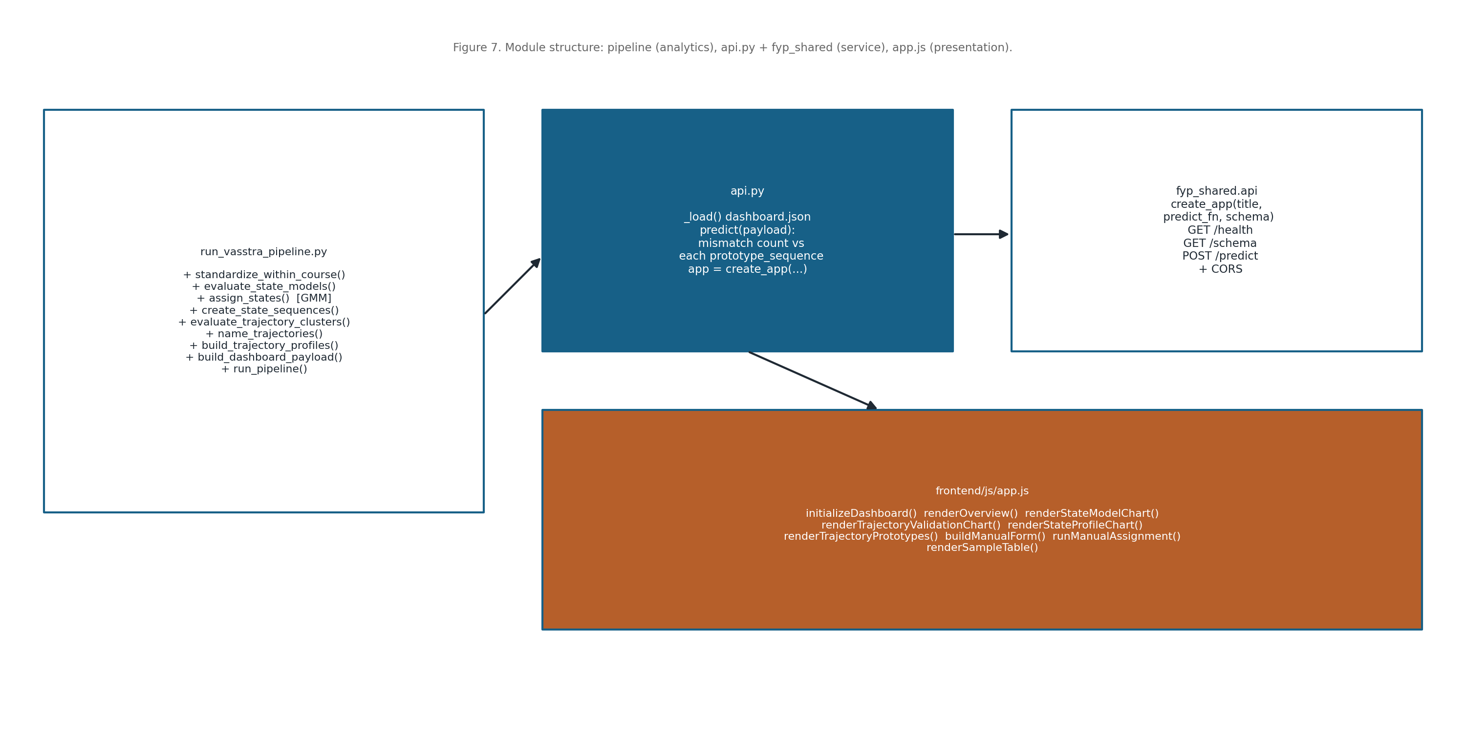
Figure 7. Module and function structure across the pipeline, API, and frontend.
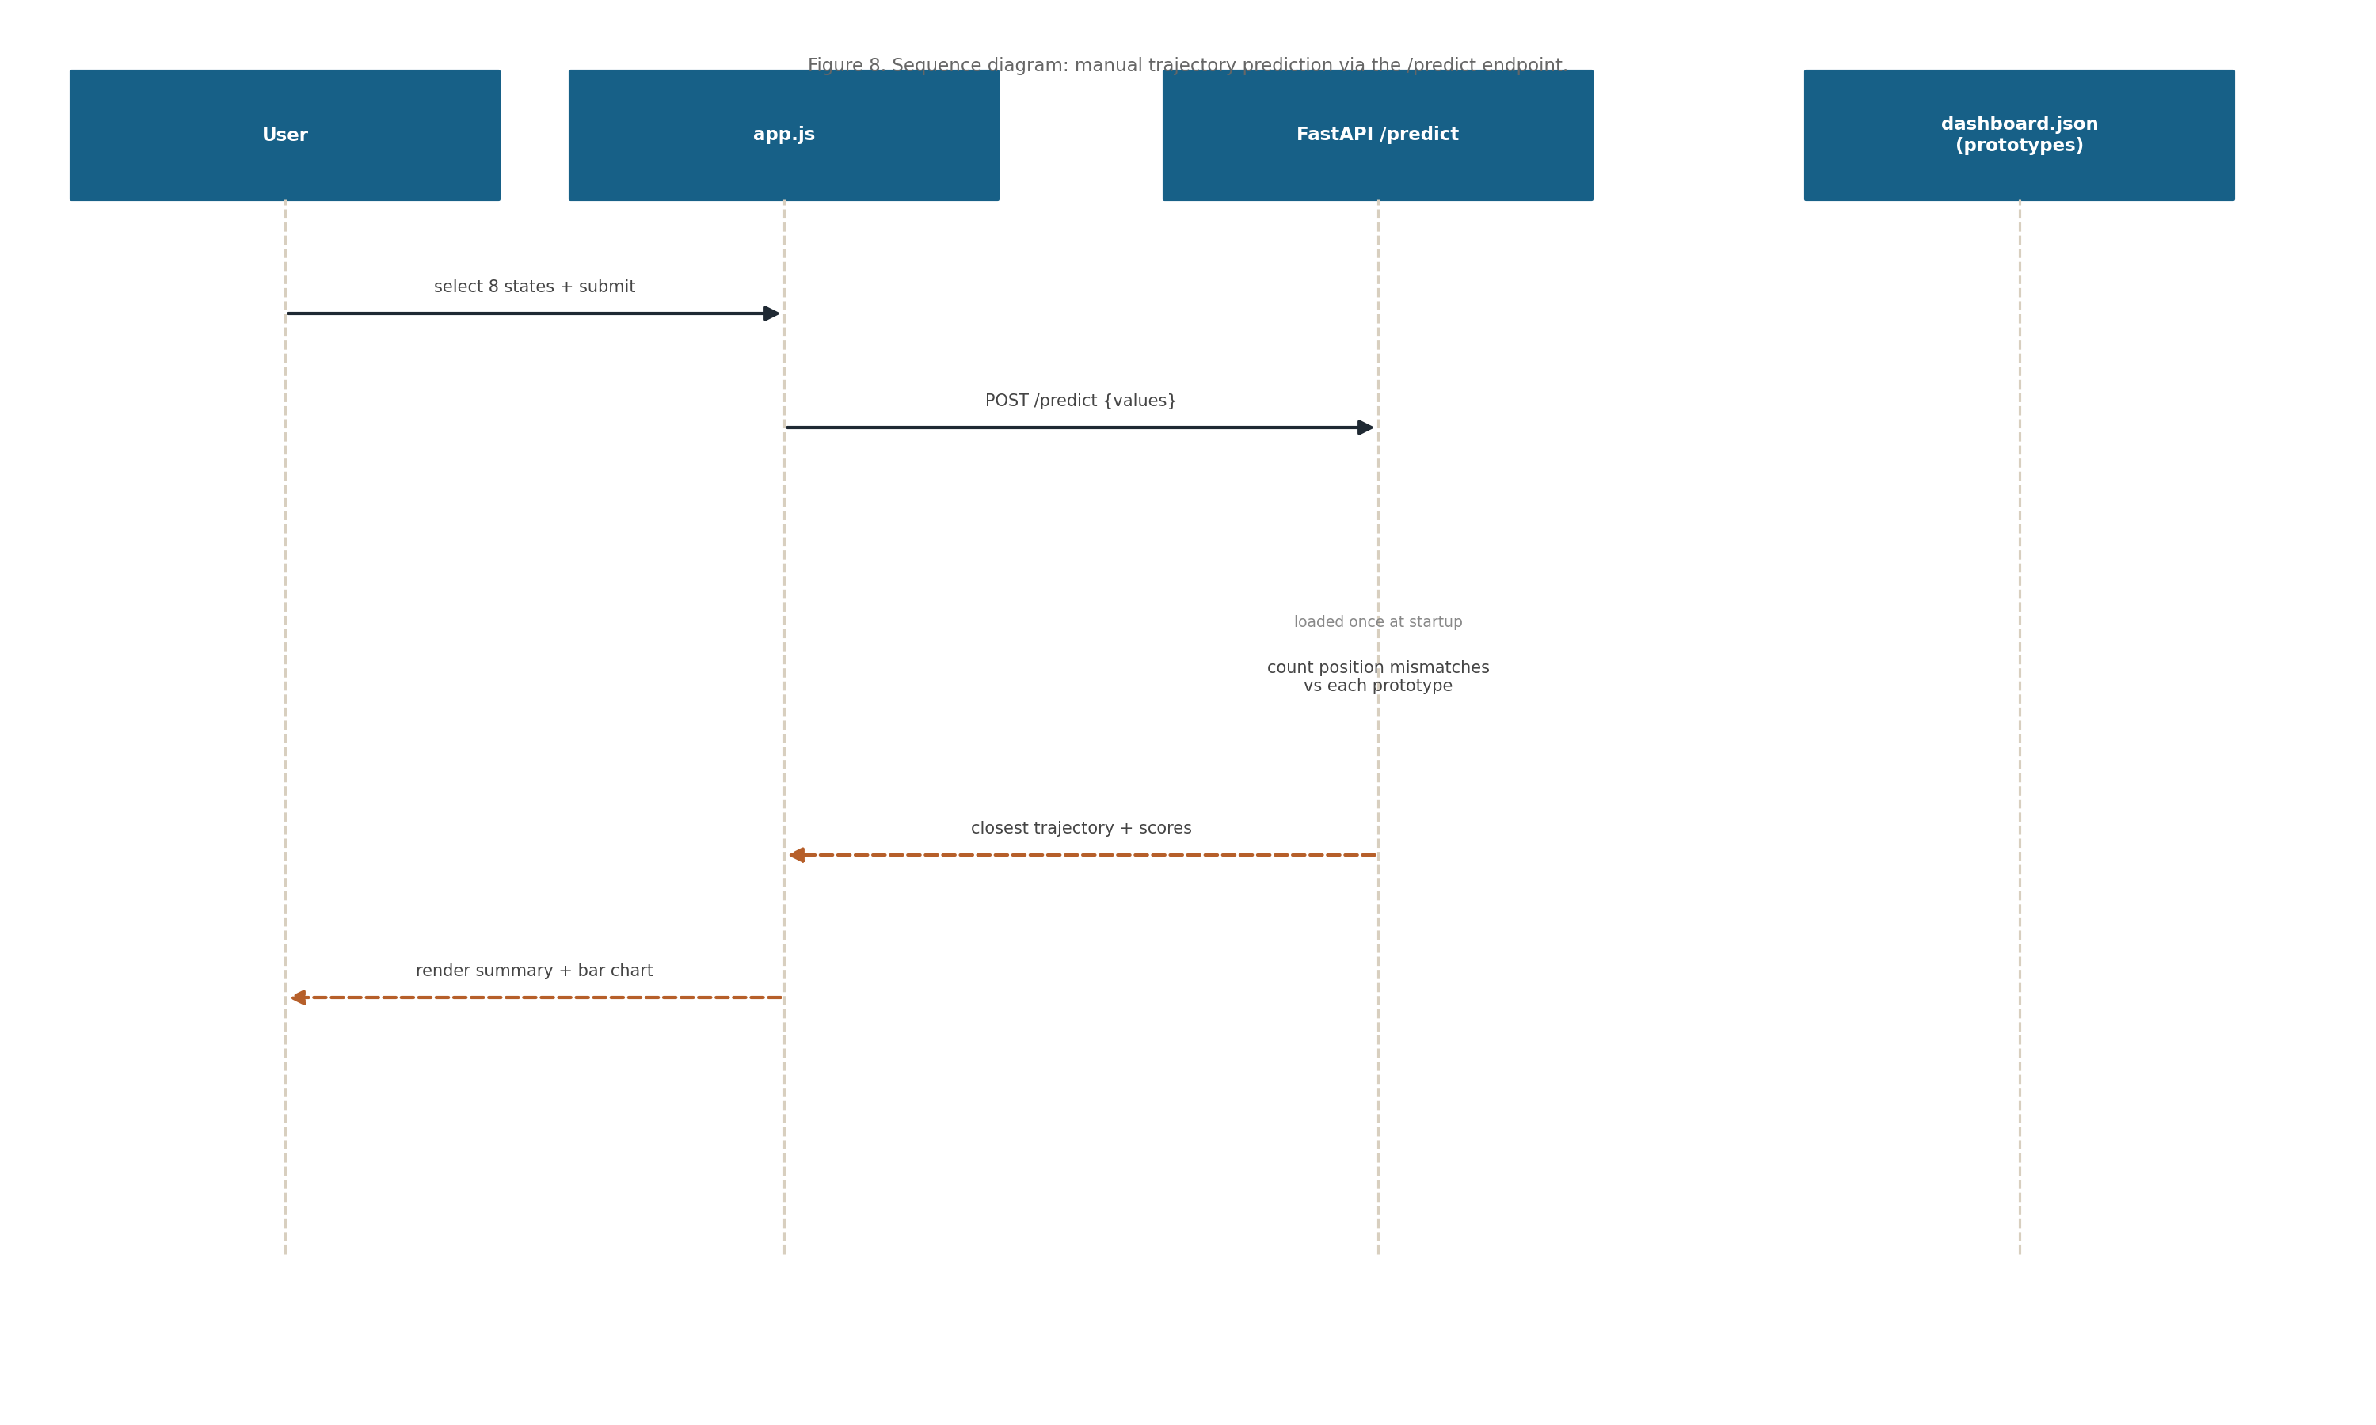
Figure 8. Sequence diagram: manual trajectory prediction via the /predict endpoint.

7 Algorithm and Methodology

7.1 Feature Engineering Pipeline
The pipeline begins by reading the engagement dataset and selecting the eight clustering indicators (course views, forum reading, forum posting, lecture views, course-view regularity, session count, total duration, and active days).
Each indicator is standardized within its course (z-scored per CourseID, with undefined values set to zero) so that engagement is compared relative to course-mates rather than on raw scales.
The standardized indicators are the features used for Gaussian-mixture state discovery; no sessionization or event-log processing is required because the dataset is already aggregated per student-week.
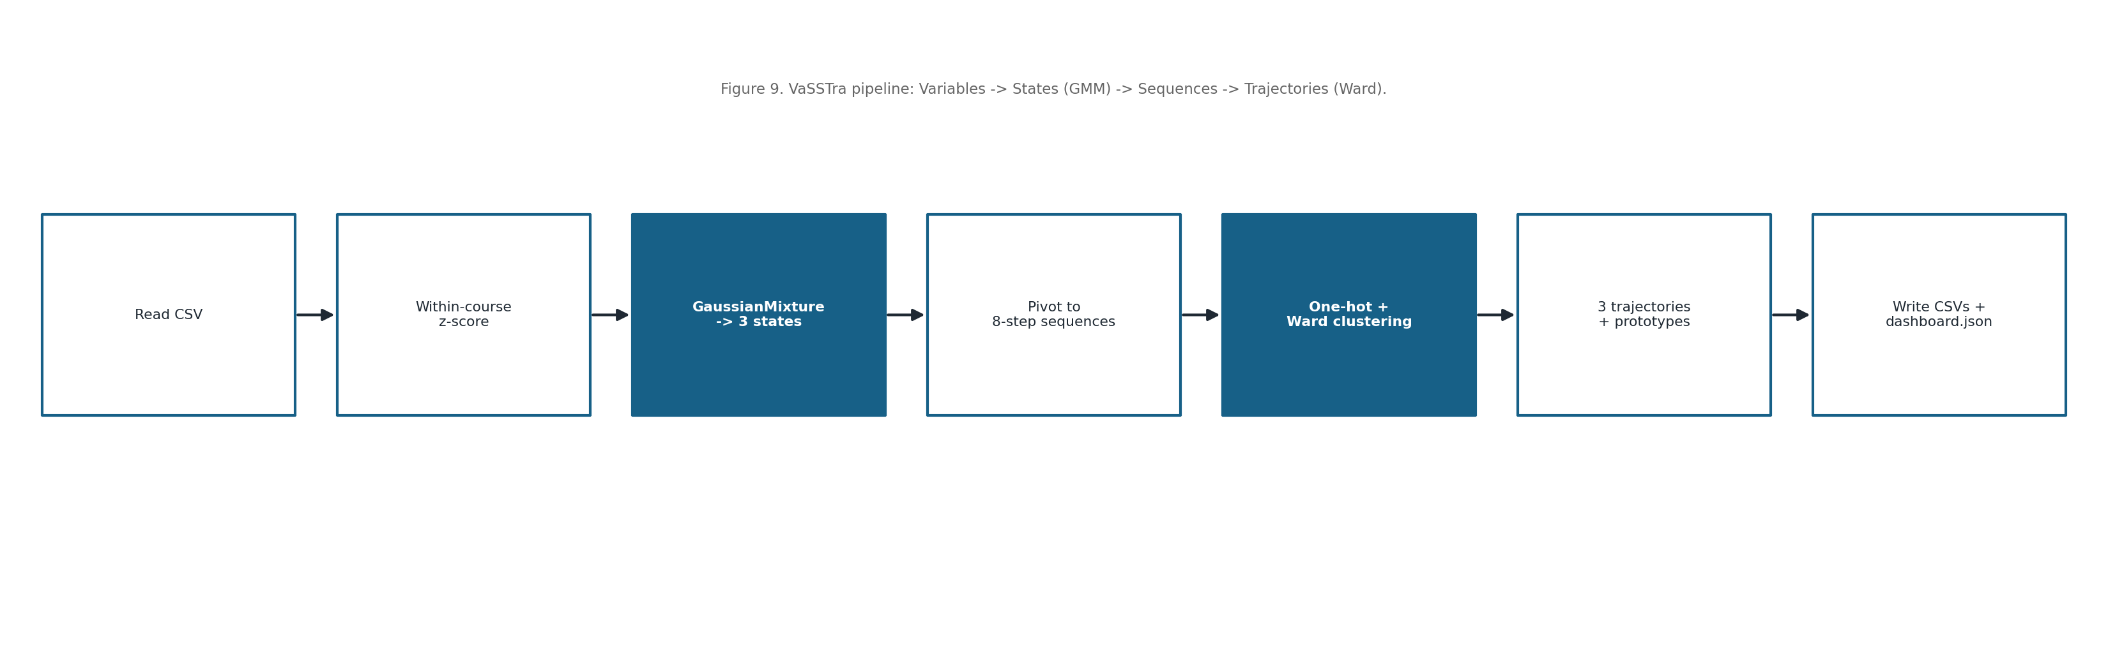
Figure 9. The VaSSTra analytical pipeline (Variables → States → Sequences → Trajectories).
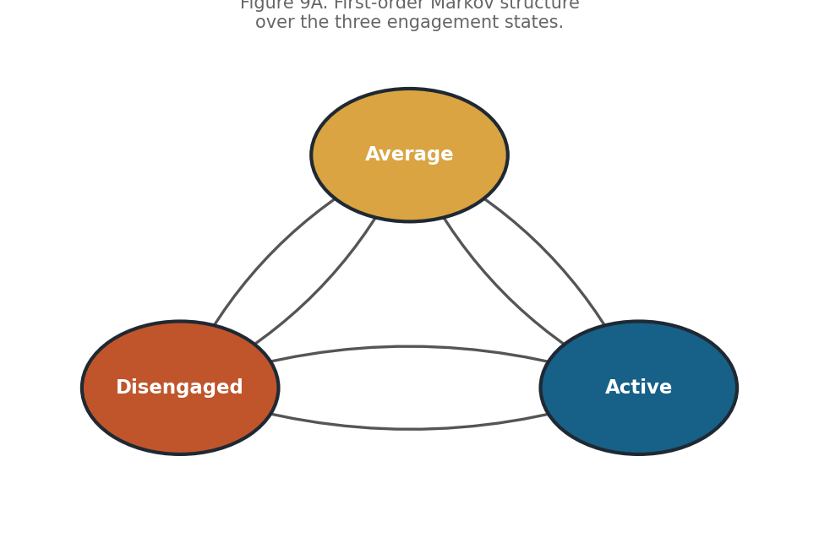
Figure 9A. First-order Markov structure over the three engagement states.

7.2 Model Selection and Training
Engagement states are discovered with a Gaussian-mixture model (the Python equivalent of latent-profile analysis). Candidate solutions with 2–5 components are compared by BIC and AIC, and a three-state model is chosen for interpretability (Disengaged, Average, Active).
Trajectories are formed by one-hot encoding the eight-step sequences and applying Ward agglomerative clustering; the number of trajectories (three) is selected using the silhouette score. The companion notebook additionally estimates first-order Markov transition matrices, overall and per trajectory.
All fitting uses a fixed random seed (2026) so results are reproducible across runs.
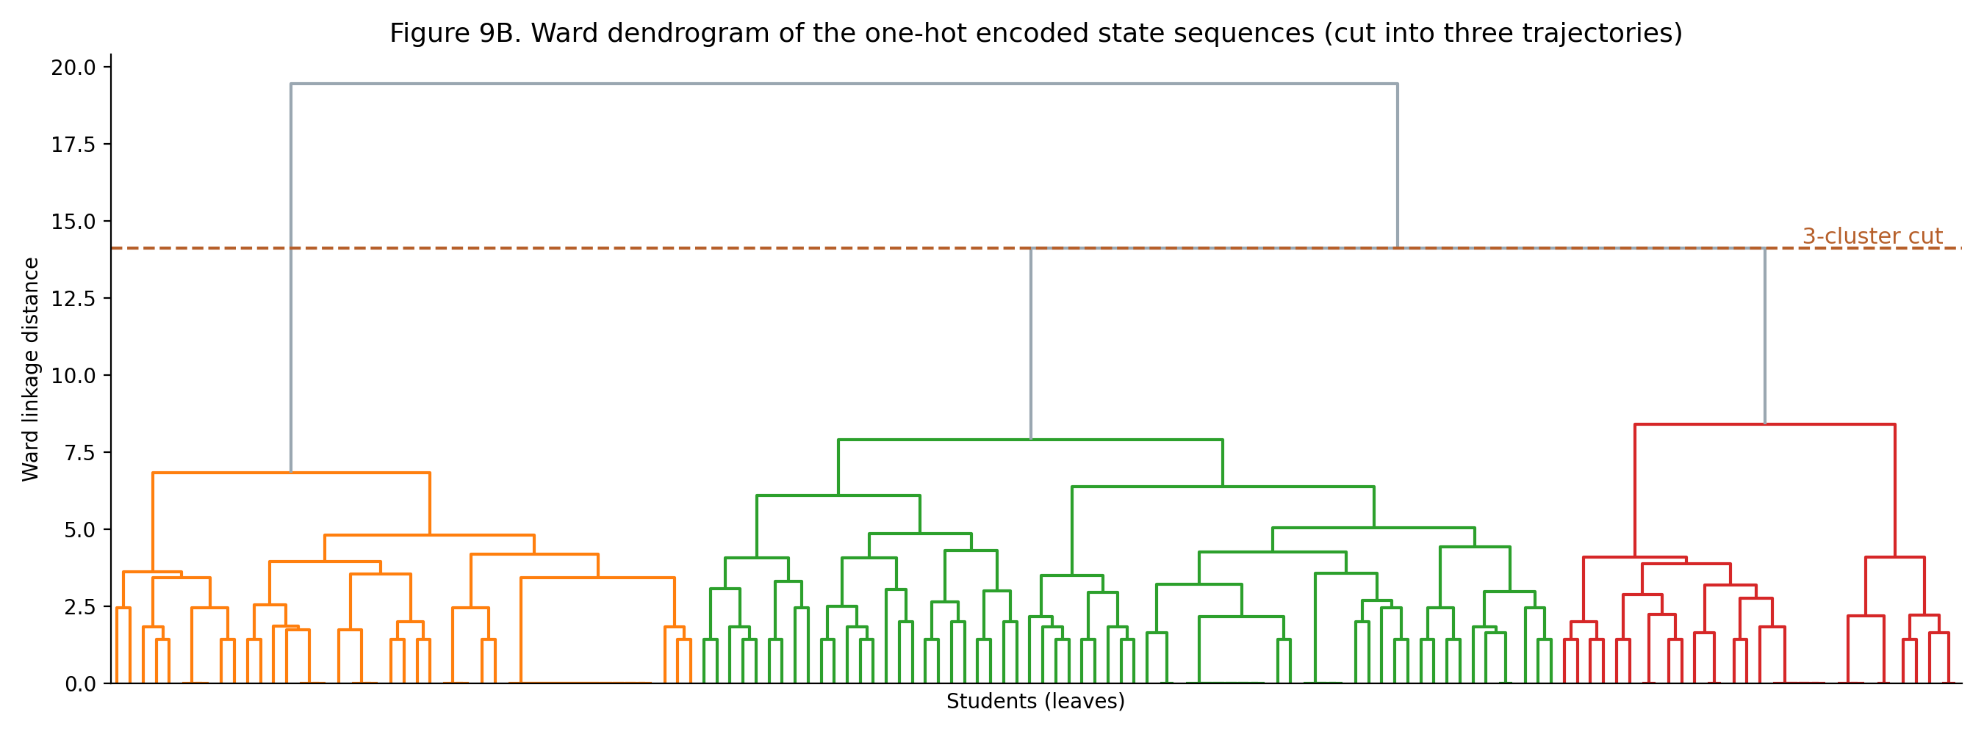
Figure 9B. Ward dendrogram of the one-hot encoded state sequences, cut into three trajectories.

7.3 Processing Workflow
The state alphabet is the three engagement levels. After fitting, each student’s states are encoded as an eight-step sequence, and the first-order transition matrix counts how often each state follows another, normalized per row to probabilities.
The transition matrix, its steady-state (stationary) distribution, and the comparison with the initial (first-step) distribution are visualized to interpret how engagement persists and shifts over the course; trajectory prototypes summarise the dominant path of each cluster.
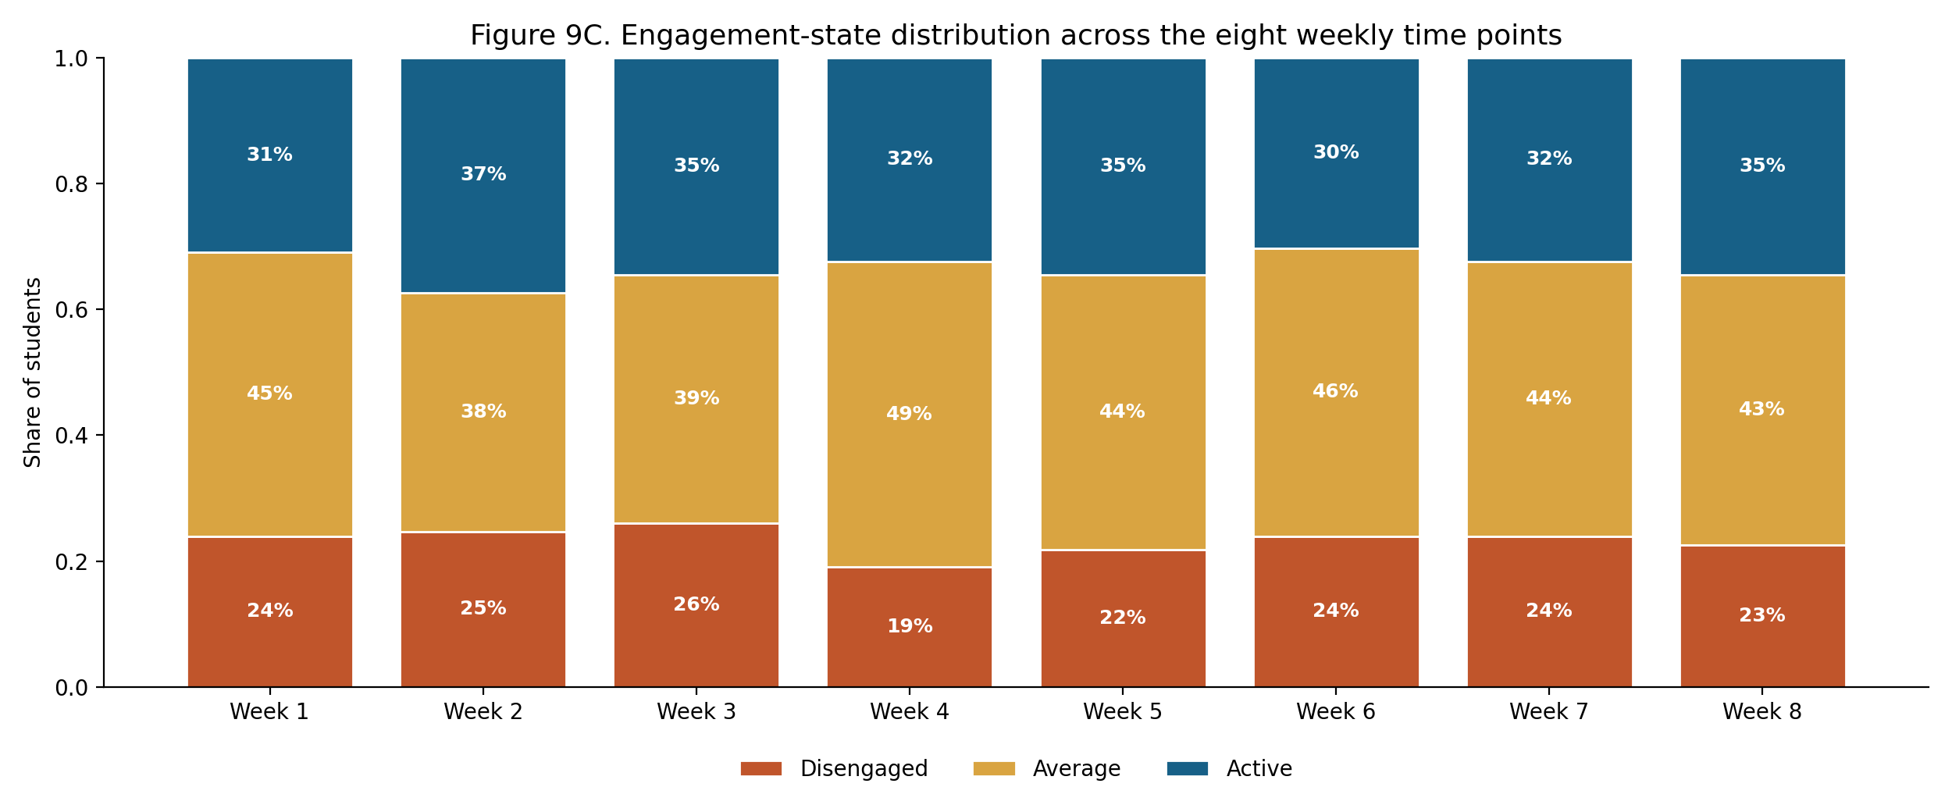
Figure 9C. Engagement-state distribution across the eight weekly time points (from the state sequences).
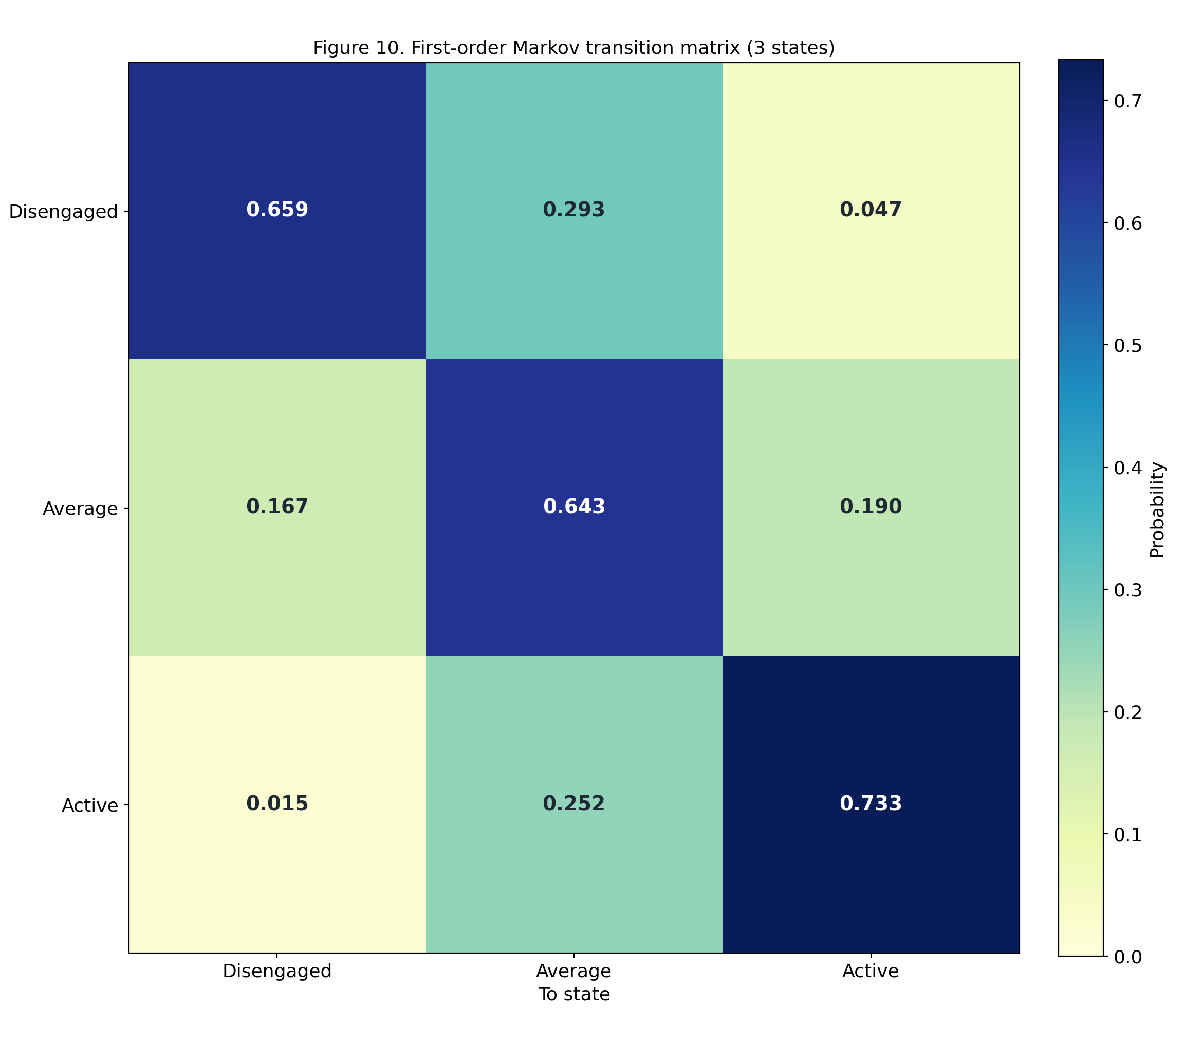
Figure 10. First-order Markov transition matrix over the three engagement states.
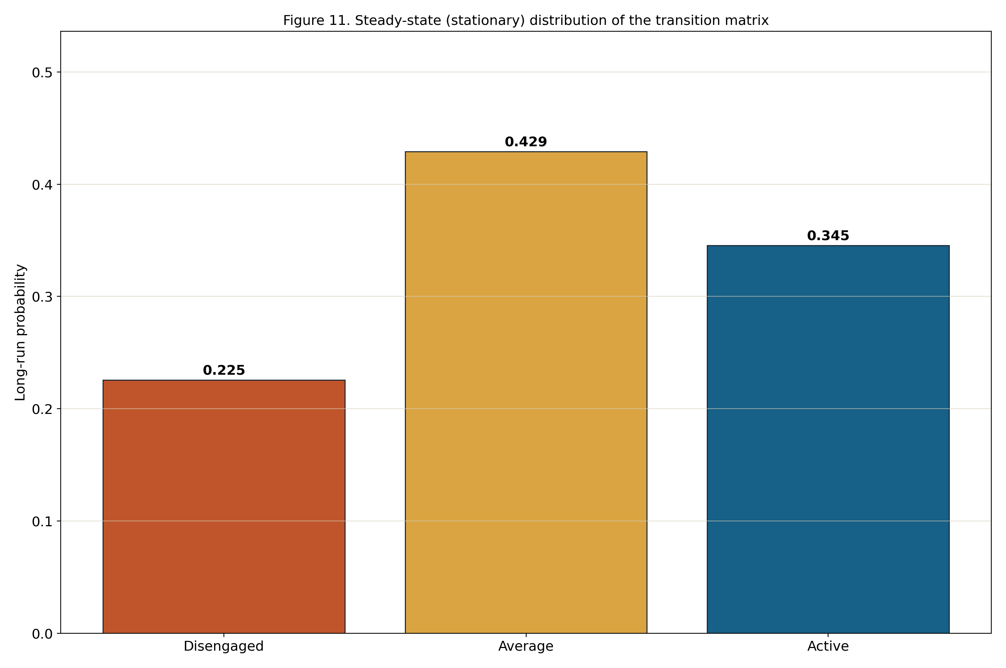
Figure 11. Steady-state (stationary) distribution of the transition matrix.
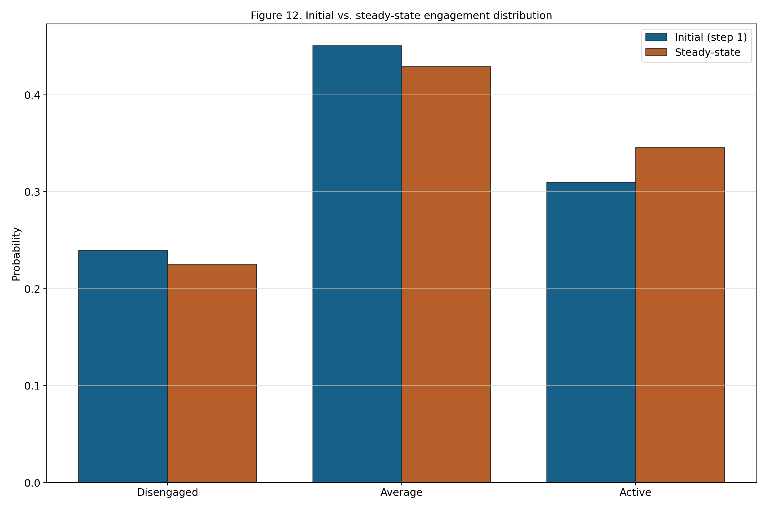
Figure 12. Initial (first-step) vs. steady-state engagement distribution.

8 Integration and Communication
The three components integrate through the local file system and local HTTP. The pipeline writes dashboard.json and the CSV artifacts; the FastAPI service reads dashboard.json at start-up; and the frontend fetches dashboard.json over HTTP and calls /predict.
There is no external integration: no LMS/SIS connectors, no message bus, and no scheduled jobs. The generated CSV and JSON files are the integration contract and can also be reused for reporting or placed under version control.

9 Security and Privacy

9.1 Authentication
The application requires no authentication. It runs locally for a single User, so there are no accounts, passwords, or sessions to manage.
Because nothing is exposed beyond the local machine, there are no login or token-issuance flows to secure.

9.2 Authorization
There are no user roles; the single User has access to all features, which is appropriate for a local analysis tool.
The FastAPI backend restricts cross-origin requests to localhost (127.0.0.1) origins, so the API is not reachable from other origins.

9.3 Data Protection
All communication is local, between the browser and a backend bound to 127.0.0.1; the application can be run entirely offline, so no engagement data is transmitted over a network.
The bundled dataset uses anonymized identifiers and contains no personally identifiable information; the views display only de-identified, aggregated results.

10 Non-Functional Requirements
Category | Target
Performance | Dashboard renders within ~3 s; the full pipeline completes within a few seconds on a laptop
Responsiveness | Prediction returns within ~1 s (sequence compared to stored prototypes only)
Reliability | Failed runs leave prior artifacts intact; predictable errors are handled gracefully
Reproducibility | Fixed random seed (2026) yields identical results for the same data and configuration
Maintainability | Modular pipeline functions, a shared API factory, and clearly separated frontend code
Usability | Single page, labelled charts, readable status messages, no setup beyond running a script

11 Deployment Strategy

11.1 Environment Requirements
Resource | Requirement
Operating system | Windows (PowerShell/.bat launchers); portable Python elsewhere
Python runtime | Python 3.11+ with pip
Python packages | fastapi, uvicorn, scikit-learn, pandas, numpy (plus jupyter/matplotlib for the notebook)
Browser | Any modern web browser (Chrome, Edge, Firefox)
Hardware | A standard laptop/desktop; no GPU or server required

11.2 Deployment Pipeline
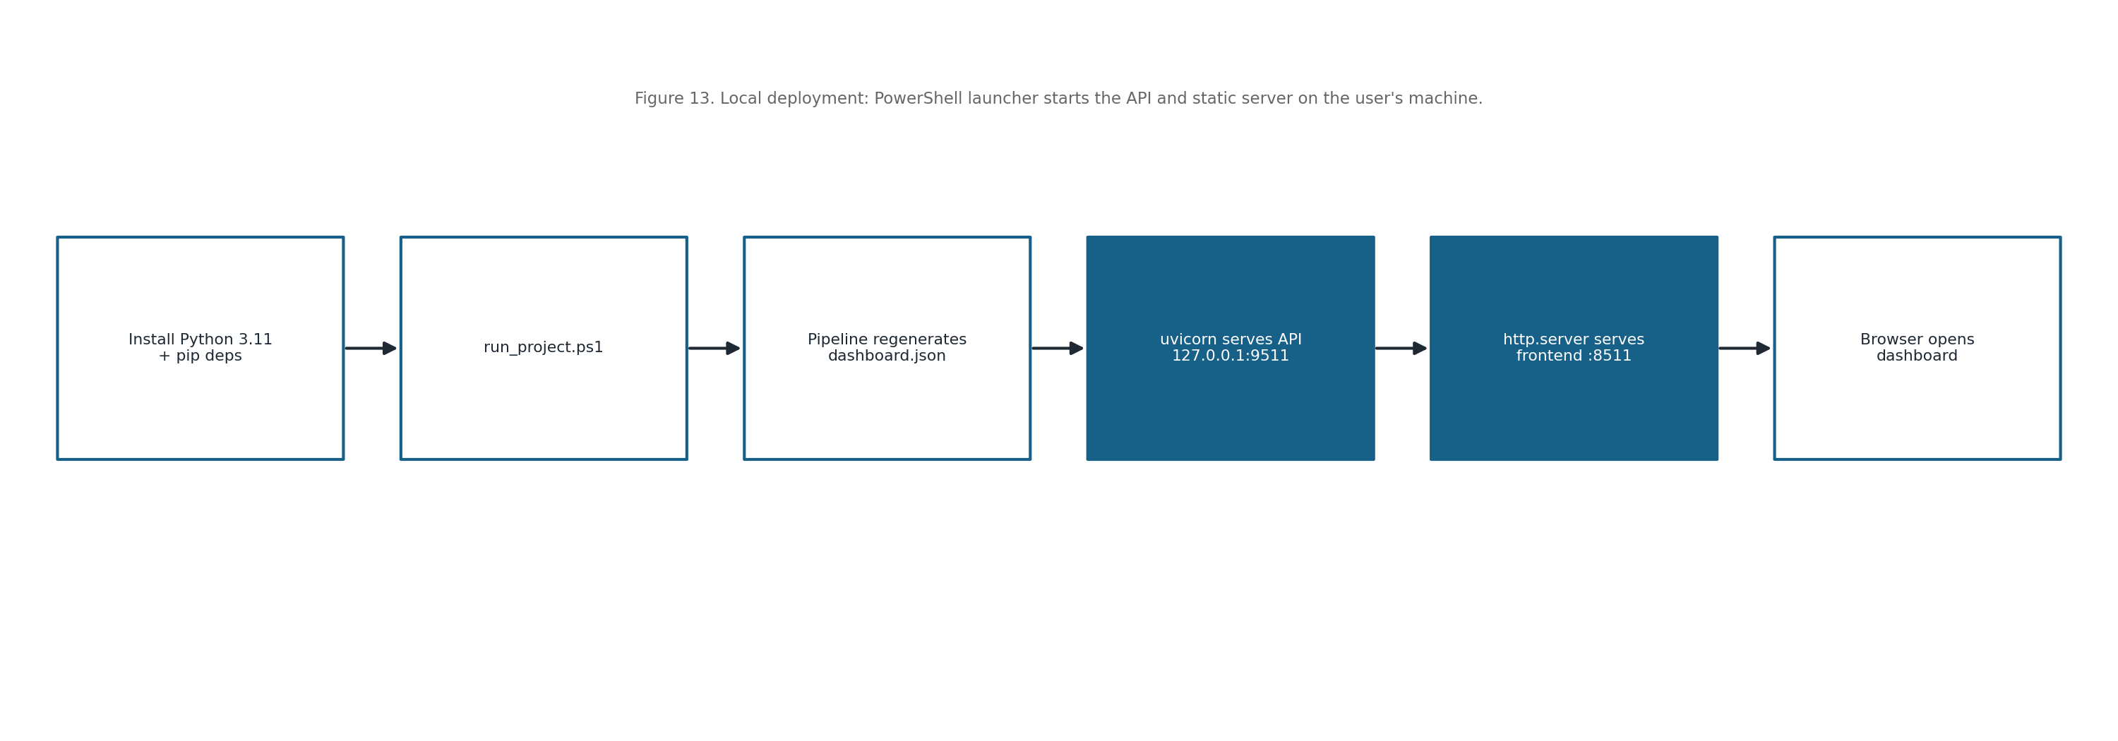
Figure 13. Local deployment and run flow on the user's machine.

12 Testing and Validation

12.1 Functional Testing
Test Case | Expected Result
Run pipeline on bundled dataset | All CSV artifacts and dashboard.json are regenerated without error
State assignment | Each record receives one of Disengaged/Average/Active with probabilities
Sequence construction | Each student yields an ordered step_1..step_8 sequence
GET /health | Returns {ok: true, title: <project title>}
POST /predict (valid sequence) | Returns the closest trajectory, mismatches, grade, and prototype
POST /predict (missing field) | Returns HTTP 422 with an invalid-input message
Dashboard load | All panels render from dashboard.json; status message confirms load

12.2 Validation and Model Evaluation
Model selection is validated quantitatively: BIC and AIC are compared across candidate Gaussian-mixture solutions to justify three states, and the silhouette score is compared across candidate cluster counts to justify three trajectories.
Results are inspected visually — the state profiles, the state-distribution over time, the trajectory prototypes, and the Markov transition matrix — to confirm the engagement levels and trajectories are interpretable and stable across the fixed-seed runs.

12.3 QA and Verification Methods
Quality is maintained by keeping the pipeline organized into small, testable functions, by validating the presence of the dataset before running, and by handling and logging prediction errors in the API.
Because the random seed is fixed and the artifacts are plain files, runs are reproducible and can be checkpointed or version-controlled, which makes regressions easy to detect.

13 Constraints and Limitations
- The first-order Markov assumption captures only step-to-step transitions, not long-range dependencies.
- Small cohorts or short sequences can make state and trajectory estimates less stable.
- The analysis is offline and batch; the dashboard reflects the last pipeline run rather than live data.
- Engagement-state labels depend on the chosen indicators and the within-course standardization.
- The system targets a single local user and is not designed for concurrent multi-user deployment.

14 Design Decisions and Rationale
Markov and VaSSTra modelling were chosen for interpretability: discrete engagement states and transition probabilities are easy for non-specialists to read, which is the project’s goal.
The analytics were implemented in Python (pandas, scikit-learn) — converting the original R tutorial — so the whole system shares one language, and a fixed seed makes runs reproducible. The analytics engine is kept separate from the UI for clarity and testability.
File-based storage (CSV/JSON) was chosen over a database to keep the project self-contained, portable, and easy to inspect; a small FastAPI surface provides a clean boundary for the prediction feature.

15 Future Enhancements
- Higher-order or hidden Markov models to capture longer dependencies and latent dynamics.
- Probabilistic trajectory prediction that uses the transition matrix, not only prototype mismatches.
- Configurable number of states and trajectories exposed in the dashboard.
- Support for additional datasets and an in-app upload of a new engagement CSV.
- Automatically generated narrative summaries of each trajectory.
- Optional packaging as a single executable for one-click local use.

16 Appendices

Appendix A: Dataset Summary
Metric |  |  | Value
Total rows |  |  | 1136
Unique users |  |  | 142
Unique courses |  |  | 38
Distinct sequence indices |  |  | 8
Metric | Min | P50 |  | P90 | Max
Freq_Course_View | 32.00 | 221.00 |  | 305.00 | 440.00
Freq_Forum_Consume | 84.00 | 590.00 |  | 807.00 | 1091.00
Freq_Forum_Contribute | 17.00 | 179.00 |  | 243.00 | 358.00
Freq_Lecture_View | 19.00 | 202.00 |  | 279.00 | 402.00
Session_Count | 27.00 | 187.00 |  | 258.00 | 326.00
Total_Duration | 11803.00 | 81988.00 |  | 113580.00 | 164243.00
Active_Days | 2.00 | 16.00 |  | 21.00 | 31.00
Final_Grade | 37.00 | 68.36 |  | 80.13 | 98.14

Appendix B: Use Case Library
Use Case | Trigger | Outcome
View analytics dashboard | User opens the dashboard after a pipeline run | Reads overview, metrics, state profiles, and trajectory prototypes
Run manual prediction | User selects a state for each of the eight time points | Receives the closest trajectory, mismatch count, and mean grade
Browse / search samples | User types a student id in the search box | Sees that student’s trajectory, final grade, and state sequence
Run / refresh pipeline | User runs run_project.ps1 (or run_pipeline) | Regenerates all CSV artifacts and dashboard.json

Appendix C: Requirements Traceability
Requirement ID | Description | Section
FR001 | Run / refresh the VaSSTra analytics pipeline | 3.1, 6.1, 7.1–7.3
FR002 | Serve dashboard data and service status | 6.1, 6.2
FR003 | View dashboard overview | 5.1, 5.3
FR004 | View state-model selection (BIC/AIC) | 5.3, 7.2
FR005 | View trajectory validation (silhouette) | 5.3, 7.2
FR006 | View per-state engagement profiles | 5.3, 7.1
FR007 | View trajectory prototypes | 5.3, 6.1
FR008 | Run manual state-sequence prediction | 6.1, 6.2
FR009 | Browse and search trajectory samples | 5.1, 5.3

Appendix D: Data Quality Rules
- Verify the input file data/raw/LongitudinalEngagement.csv exists before running (Q01).
- Confirm the required columns are present: UserID, CourseID, Sequence, the eight indicators, and Final_Grade (Q02).
- Ensure Sequence is an integer in the range 1–8 (Q03).
- Standardize each indicator within its CourseID; set undefined z-scores (zero variance) to 0 (Q04).
- Fill any missing step in a student sequence with the Average state (Q05).
- Fit the Gaussian mixture with a fixed seed (2026) so state assignments are reproducible (Q06).
- Order the mixture components by mean level and label them Disengaged → Average → Active (Q07).
- Check that each Markov transition-matrix row sums to 1 (Q08).
- Confirm the steady-state distribution sums to 1 (Q09).
- Verify the silhouette score is computed for each candidate trajectory count (Q10).

Appendix E: Operational Monitoring
- Pipeline console output reports record and student counts and any failure.
- The /health endpoint confirms the API is running and returns the project title.
- The dashboard shows a status message when dashboard.json or the backend is unavailable.
- Generated artifacts can be diffed between runs to detect unexpected changes.
- Fixed-seed reproducibility is checked by re-running the pipeline on the same data.

Appendix D: Concluding Summary
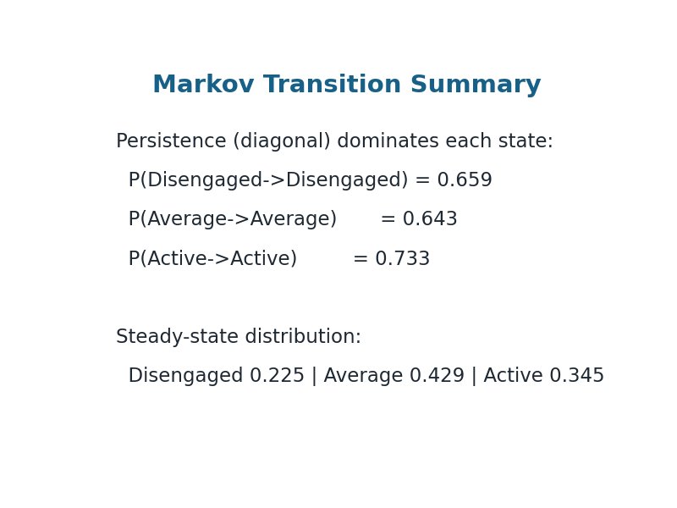

References
[1] S. Naeem, M. Hussain, and N. Iqbal, “A survey of knowledge tracing: Models, evaluation metrics and challenges,” IEEE Access, vol. 10, pp. 122345–122365, 2022.
[2] J. Shen, Q. Chen, and Y. Yang, “Progressive knowledge tracing: Modeling learning process from abstract to concrete,” Expert Systems with Applications, vol. 236, 2024.
[3] A. T. Corbett and J. R. Anderson, “Knowledge tracing in the ACT programming tutor,” in Proc. Annual Meeting of the Cognitive Science Society, 1992.
[4] G. Siemens, “Learning analytics: Envisioning a research discipline and a domain of practice,” in Proc. 2nd Int. Conf. Learning Analytics and Knowledge (LAK), 2012, pp. 4–8.
[5] J. A. Larusson and B. White, Eds., Learning Analytics: From Research to Practice. New York, NY, USA: Springer, 2014.
[6] M. A. Chatti, A. L. Dyckhoff, U. Schroeder, and H. Thüs, “A reference model for learning analytics,” Int. J. Technology Enhanced Learning, vol. 4, no. 5–6, pp. 318–331, 2012.
[7] A. F. Wise, “Designing pedagogical interventions to support student use of learning analytics,” in Handbook of Learning Analytics. Edmonton, Canada: Society for Learning Analytics Research, 2017, pp. 89–96.
[8] C. D. Dede, “Learning analytics and educational research,” in Handbook of Learning Analytics. Edmonton, Canada: SoLAR, 2017, pp. 34–45.
[9] G. Siemens, D. Gasevic, C. Haythornthwaite, S. Dawson, S. Shum, R. Ferguson, and E. Duval, “Open learning analytics: An integrated and modularized platform,” in Proc. 1st Int. Conf. Learning Analytics and Knowledge (LAK), 2011.
[10] A. F. Wise and Y. Cui, “Learning communities in the crowd: Characteristics of content and social interactions in MOOCs,” Computers & Education, vol. 92–93, pp. 38–49, 2016.
[11] L. R. Rabiner, “A tutorial on hidden Markov models and selected applications in speech recognition,” Proceedings of the IEEE, vol. 77, no. 2, pp. 257–286, 1989.
[12] A. P. Dempster, N. M. Laird, and D. B. Rubin, “Maximum likelihood from incomplete data via the EM algorithm,” Journal of the Royal Statistical Society: Series B (Methodological), vol. 39, no. 1, pp. 1–38, 1977.
[13] H. D. Vinther and E. J. Anderson, “Hidden Markov models for educational trajectories: A review,” Journal of Educational and Behavioral Statistics, vol. 46, no. 5, pp. 543–570, 2021.
[14] J. E. Beck and J. Chang, “Identifiability in Bayesian knowledge tracing,” in Proc. 8th Int. Conf. Educational Data Mining (EDM), 2007.
[15] S. Doroudi and E. Brunskill, “The misidentified identifiability problem of Bayesian knowledge tracing,” in Proc. 10th Int. Conf. Educational Data Mining (EDM), 2017, pp. 143–149.
[16] Z. A. Pardos and N. T. Heffernan, “KT-IDEM: Introducing item difficulty to the knowledge tracing model,” in Proc. User Modeling, Adaptation, and Personalization. Berlin, Germany: Springer, 2011, pp. 243–254.
[17] F. Pedregosa et al., “Scikit-learn: Machine learning in Python,” Journal of Machine Learning Research, vol. 12, pp. 2825–2830, 2011.
[18] C. R. Harris et al., “Array programming with NumPy,” Nature, vol. 585, no. 7825, pp. 357–362, 2020.
[19] W. McKinney, “Data structures for statistical computing in Python,” in Proc. 9th Python in Science Conf. (SciPy), 2010, pp. 51–56.
[20] F. Chollet et al., Deep Learning with Python, 2nd ed. Shelter Island, NY, USA: Manning, 2021.

