Software Requirement Specifications
Modeling Longitudinal Learning Dynamics Using Markov Models



Submitted by
Athar Hussain (F22BINFT1M01231)
Submitted to
Dr. Mustafa Hameed

Department of Information Technology
Faculty of Computing
The Islamia University of Bahawalpur

Meeting Details
Sr No | Details | Date | Supervisor Signature

Summary
This project develops a learning-analytics system that uses Markov models to study how students’ engagement evolves across a course. The central problem is that a single static score does not reveal how a learner progresses over time. The system addresses this by modeling longitudinal learning as a sequence of latent engagement states that change from one weekly time point to the next.
The system follows the VaSSTra method (Variables → States → Trajectories) and is implemented entirely in Python. An offline analytical pipeline reads a longitudinal engagement dataset, standardizes the indicators within each course, discovers three latent engagement states (Disengaged, Average, Active) with a Gaussian-mixture model, assembles each student’s states into an eight-step sequence, and groups those sequences into three learner trajectories using Ward agglomerative clustering. First-order Markov transition matrices summarize how students move between states. The results are served by a FastAPI backend and presented in a browser-based dashboard built with static HTML, CSS, JavaScript, and Plotly; data is exchanged as CSV and JSON files, and no database is used.
The requirements section describes what the system does through use cases for a single local user. The user can view dataset and model summaries, inspect state-model selection and trajectory-validation metrics, examine per-state engagement profiles and trajectory prototypes, browse and search student trajectory samples, and submit a manual state sequence to estimate its closest trajectory. The document also defines non-functional requirements covering performance, reliability, usability, and maintainability.
The document includes diagrams — a use-case diagram, a system context diagram, data-flow diagrams, and a Markov state-transition diagram — that visualize how the system is used, how data flows through the analytical pipeline, and how learners transition between engagement states. Overall, this document specifies the requirements that the completed system fulfils.

Table of Contents
1. Introduction 4
1.1. Purpose 6
1.2. Scope 6
1.3. Product Perspective 7
1.4. User Characteristics. 8
1.5. Similar apps and systems/Literature Review 8
1.6. Proposed Technologies 9
1.7. Definitions, Acronyms, and Abbreviations 12
2. Requirements 13
2.1. Function Requirements 14
2.1.1. Overview of System Features 14
2.2. Non-Functional Requirements 17
2.2.1. Performance Requirements 17
2.2.2. Reliability and Availability Requirements 17
2.2.3. Security Requirements 18
2.2.4. Usability and Accessibility Requirements 18
2.2.5. Maintainability and Extensibility Requirements 19
3. Use Cases and Flow of Processes 20
3.1. Overview of System Models 24
3.2. System Context Diagram 24
3.3. State-Transition Model (Markov) 25
3.4. Data Flow Diagrams (DFD) 26
3.4.1. DFD Level-0 – VaSSTra Pipeline Overview 26
3.4.2. DFD Level-1 – State and Trajectory Processing 27
4. References 28

- Introduction
The project “Modeling Longitudinal Learning Dynamics Using Markov Models” aims to understand how students’ engagement evolves over the weeks of a course, rather than reducing learning to a single final score. Conventional assessment summarizes performance with marks or grades, but such snapshots do not reveal whether a learner is becoming more engaged, stagnating, or disengaging over time. This project addresses that limitation by treating longitudinal engagement as a probabilistic process and using Markov models to represent how learners transition between a small set of latent engagement states across successive time points.
The system is based on the premise that a learner’s level of engagement is not captured by any single measurement but can be inferred from observable behavioural indicators such as course views, lecture views, forum reading and posting, session counts, total duration, and active days. By collecting these indicators at eight successive weekly time points, the system assigns each observation to a latent engagement state and estimates how likely a learner is to move from one state to another. A first-order Markov transition matrix captures these dynamics, producing learning trajectories that reflect improvement, stability, or decline rather than a single average.
The application is implemented entirely in Python and exposed through a lightweight browser-based dashboard. The analytical pipeline uses NumPy, pandas, and scikit-learn to standardize indicators within each course, fit a Gaussian-mixture model that discovers the engagement states, build per-student state sequences, and cluster those sequences into learner trajectories with Ward agglomerative clustering. A FastAPI service exposes the generated results and a trajectory-matching endpoint, while the frontend — built with static HTML, CSS, JavaScript, and Plotly — renders interactive charts of model selection, state profiles, trajectory prototypes, and student samples. The pipeline reads a single CSV dataset and writes its results as CSV and JSON files; no database, authentication, or multi-user infrastructure is required.
From an educational standpoint, the dashboard is intended to help an instructor, analyst, or researcher interpret how a cohort of learners engages over time. By visualizing the discovered engagement states, the trajectory each student follows, and the transition probabilities between states, the user can identify groups that remain highly engaged, those that drift toward disengagement, and the time points at which transitions are most likely. By combining behavioural data, probabilistic modeling, and visualization, the system turns raw engagement logs into an interpretable picture of how learning unfolds across a course.
  - Purpose
The primary purpose of this project is to build a software system that reveals how students’ engagement changes over the course of a term using probabilistic modeling, rather than relying on a single summary score. The system transforms a longitudinal engagement dataset into interpretable insights about how learners move between engagement states over time and which overall trajectory each learner follows.
The project infers a small set of latent engagement states from observable behavioural indicators and models the transitions between them with a first-order Markov chain. By determining, for each time point, which state a learner occupies and how likely they are to move to another state, the system offers a longitudinal perspective on learning that uncovers patterns of improvement, stability, or decline. These insights are delivered through an interactive dashboard, allowing the user to observe engagement progress throughout a course.
In practice, the system supports data-informed reflection on teaching and learning. It lets an instructor or analyst see which learners stay engaged, which drift toward disengagement, and where in the term the most important transitions occur. For researchers, it illustrates how the VaSSTra method and Markov models can be implemented end-to-end in Python and exposed through a simple, self-contained web application.
In summary, the project designs and implements a maintainable and extensible application that employs Markov models to represent longitudinal learning dynamics. The application delivers these insights through an interactive dashboard, thereby enhancing the understanding and monitoring of student engagement throughout a course.
  - Scope
The system is a browser-based learning-analytics application that processes a longitudinal engagement dataset and builds probabilistic models that capture how learner engagement changes over time. It reads time-indexed engagement indicators, standardizes them within each course, and applies the VaSSTra method together with a first-order Markov model to assign engagement states, group learners into trajectories, and summarize state transitions. Its primary function is to deliver a complete pipeline that converts raw engagement records into state assignment, trajectory clustering, and visualization, all accessible through a single-page dashboard in the browser.
The system consists of a static HTML, CSS, and JavaScript frontend that uses Plotly for visualization, a FastAPI backend that serves the generated results and a trajectory-prediction endpoint, and a Python analytical layer that uses NumPy, pandas, and scikit-learn. The frontend handles presentation and interactive charts. The backend exposes read-only endpoints for the dashboard data and a single prediction endpoint that matches a state sequence to the closest trajectory. Results are stored as CSV and JSON files in the project folder; the system does not use a relational database, user accounts, or authentication.
Functionally, the system will support three primary categories of capabilities.
- Data preparation: reading the engagement dataset, standardizing each indicator within its course, and organizing the records into per-student state sequences across the eight weekly time points.
- Modeling and inference: fitting a Gaussian-mixture model to assign engagement states, clustering the state sequences into learner trajectories with Ward agglomerative clustering, and estimating first-order Markov transition matrices between states.
- Analytics and visualization: presenting model-selection metrics, per-state engagement profiles, trajectory prototypes, and student samples in an interactive dashboard, and matching a manually entered state sequence to its closest trajectory.
  - Product Perspective
The system is a self-contained analytics application that runs on a single machine and does not depend on any external service, database server, or learning-management system. It can be used in two complementary ways:
- As an interactive dashboard, in which the generated results are explored in a web browser through charts, tables, and a manual trajectory-prediction form, or
- As a reproducible Python notebook, in which the same VaSSTra and Markov analysis can be run and inspected step by step for study or extension.
At a high level, the system comprises the following components:
- A frontend dashboard that runs in a web browser (static HTML, CSS, JavaScript, and Plotly) and presents all analytics to the user.
- A FastAPI backend that loads the generated results and exposes health, schema, and trajectory-prediction endpoints.
- An offline analytical pipeline, implemented in Python with scikit-learn, that performs the VaSSTra and Markov computations.
- File-based storage consisting of a single input CSV dataset and the generated CSV and JSON artifacts; no database is used.
The system reads its input from a local engagement dataset and writes its results as CSV and JSON files that can be reused for reporting or research. The user interacts only with the dashboard and the backend endpoints; the internal computations are not exposed.
  - User Characteristics.
The system is intended for a single category of user, referred to throughout this document as the User. There are no separate accounts, roles, or permission levels; whoever runs the application has full access to every feature.
- Primary_user:
an instructor, teaching assistant, analyst, or researcher who wants to understand how a cohort of learners engages over time. The User is expected to have basic familiarity with a web browser; specialized knowledge of machine learning or Markov models is not required to read the dashboard.
- Assumed_background:
the User is assumed to be comfortable reading charts and tables. No programming or statistics expertise is required to interpret the dashboard, although the accompanying Python notebook is available for users who wish to inspect the underlying method in detail.
- Operating_environment:
the User runs the application locally and views it in a desktop or laptop web browser. The application is served from the local machine, so no login, user account, or internet connection is required.
The User is assumed to have access to a modern web browser on the machine where the application is running.
  - Similar apps and systems/Literature Review
The proposed system addresses these limitations by implementing a Markov-based modeling approach in a self-contained Python application (a FastAPI backend with a static, Plotly-based dashboard). It focuses on making the temporal evolution of learner engagement states visible, interpretable, and usable, while remaining independent of any specific LMS or tutoring system. In doing so, it bridges the gap between the rich theoretical work on Markov models for longitudinal data and the practical need for accessible, transparent learning-analytics tools.
Educational technology research has produced intelligent tutoring systems (ITS) and learning analytics dashboards that monitor student progress through detailed interaction data. These platforms deliver immediate feedback and support mastery-based progression within controlled environments.
A central focus is knowledge tracing, which estimates learner knowledge states based on performance data. Bayesian Knowledge Tracing (BKT) models knowledge as a hidden Markov process and is widely implemented in adaptive learning systems. Hidden Markov Models (HMMs) are similarly utilized in medicine and psychology to model latent traits over time.
Most current learning analytics platforms provide visual reporting; however, they typically depend on descriptive statistics instead of explicit probabilistic models of learner knowledge states.
Despite these advances, several significant gaps persist:
- Knowledge tracing functionality is typically embedded within large platforms and is not available as a standalone component.
- There is limited support for the longitudinal visualization of trajectories of probabilistic knowledge states.
- Learning models often lack transparency, making their outputs difficult for instructors to interpret.
- Research prototypes seldom provide production-ready web applications.
The proposed system addresses these gaps by implementing Markov-based modeling in a self-contained Python application (scikit-learn analytics, a FastAPI service, and a static Plotly dashboard). It makes the evolution of learners’ engagement states visible, interpretable, and actionable, while remaining independent of any specific learning-management system.
  - Proposed Technologies
The system uses modern, widely adopted technologies chosen for clarity, reproducibility, and ease of maintenance across the user interface, backend service, data storage, and machine-learning components. The technologies are organized as follows.
1.6.1 Frontend Technologies
The user interface will be implemented as a single-page application (SPA) using the following tools and libraries.
- HTML5 provides the structure of the single dashboard page.
- CSS3 provides the styling and responsive layout, using the project stylesheet together with a shared shell stylesheet.
- Vanilla JavaScript (ES2020+) implements all client-side logic; no frontend framework or build step is used.
- The browser Fetch API loads the generated dashboard.json and calls the backend prediction endpoint.
- Plotly.js (vendored locally) renders the interactive charts, including the BIC/AIC state-model-selection chart and the silhouette trajectory-validation chart.
- Plotly.js also renders the per-state engagement-profile bar chart and the trajectory-mismatch bar chart for the manual prediction demo.
- During local use, the page and its assets are served as static files by Python’s built-in HTTP server.
Collectively, these technologies will support a responsive, interactive, and maintainable frontend capable of presenting complex analytics and visualizations effectively within the browser.
1.6.2 Backend and Machine Learning Stack
The backend services and machine learning engine will be implemented using the following technologies:
- Python 3.11 or newer will serve as the primary programming language.
- FastAPI provides the backend web framework, exposing a small REST API (health, schema, and prediction endpoints); the development server is run with Uvicorn.
For modeling and analytics, the system will utilize the following libraries:
- NumPy will be used for numerical computation, including operations on Markov transition matrices and probability-related calculations.
- pandas manages the longitudinal engagement data, supporting the within-course standardization, grouping, pivoting, and aggregation used throughout the pipeline.
- scikit-learn provides the core modeling components: GaussianMixture for engagement-state discovery, AgglomerativeClustering with Ward linkage for trajectory clustering, OneHotEncoder for sequence encoding, and the silhouette score for cluster validation.
- SciPy and Matplotlib are used in the accompanying Python notebook to produce the hierarchical-clustering dendrogram and the static plots that mirror the pipeline.
The backend exposes endpoints that return the precomputed dashboard data and match a manually entered state sequence to its closest trajectory; results are read from the generated artifacts rather than recomputed on each request.
1.6.3 Data Storage
The system stores all data as files and does not use a database server:
- A single CSV file, LongitudinalEngagement.csv, provides the input dataset.
The generated results are written as CSV files (state assignments, state sequences, model-selection metrics, and state and trajectory profiles) together with a consolidated dashboard.json that the frontend loads directly. No relational database, user accounts, or server-side persistence are involved, which keeps the project self-contained and easy to reproduce.
1.6.4 Security Considerations
Because the application runs locally on a single machine and stores no personal accounts, it does not implement authentication. The following measures define its security posture:
- No login or user accounts are required; the dashboard and API are intended for local use by a single user.
- The FastAPI backend restricts cross-origin requests to localhost (127.0.0.1) addresses, so the API is not exposed to other origins.
- The bundled dataset uses anonymized identifiers, so no personally identifiable information is stored or transmitted.
Other relevant properties:
- All data and code remain on the local machine; nothing is uploaded to an external server.
- The application can be run entirely offline, which avoids exposing engagement data over a network.
Together, these properties keep the application self-contained and remove the need to manage credentials or protect data in transit beyond the local machine.

  - Definitions, Acronyms, and Abbreviations
Term / Acronym | Definition
SRS (Software Requirements Specification) | Document that describes what the system must do (functional and non-functional requirements).
SDD (Software Design Description) | Document that explains how the system will be built (architecture, components, design).
Learning Analytics | Analysis of learner data to understand and improve learning and teaching.
Longitudinal Data | Data collected from the same learner over multiple time points (here, eight weekly time points across a course).
Engagement State | A latent level of engagement (Disengaged, Average, or Active) inferred from a learner’s behavioural indicators at a given time point.
Markov Model (MM) | Probabilistic model where the next state depends only on the current state; used here for first-order engagement-state transitions.
Dataset | The collection of longitudinal engagement records used as input for modeling and analytics.
Dashboard | A single web page that shows charts, summaries, and key indicators for the User.
Student | A learner whose engagement indicators are recorded in the dataset and grouped into states and a trajectory.
VaSSTra | The method followed by the system: deriving engagement States from Variables and composing them into Trajectories, with Markov transitions summarizing movement between states.
Gaussian Mixture Model (GMM) | An unsupervised model that groups standardized indicators into latent engagement states; the number of states is chosen using BIC and AIC.
Frontend | Browser-based part of the system (static HTML, CSS, JavaScript, and Plotly) that the User sees and interacts with.
Backend | Server-side part of the system (FastAPI) that serves the generated results and the trajectory-prediction endpoint.
REST API | HTTP-based interface used by the frontend to communicate with the backend (here, the health, schema, and predict endpoints).
Trajectory | A group of learners whose eight-step state sequences are similar; the system discovers three (Mostly active, Mostly average, Mostly disengaged).
Transition Matrix | A table of first-order Markov probabilities P[i, j] = Pr(next state = j | current state = i), estimated from consecutive time points.
FastAPI | A Python web framework used to implement the backend REST API.
Plotly | A JavaScript charting library used to render the interactive visualizations in the dashboard.

- Requirements
The system is a self-contained analytics application operated by a single User. It reads a longitudinal engagement dataset, standardizes the indicators within each course, and organizes them by learner and time point to form state sequences. The analytical pipeline applies a Gaussian-mixture model and Ward clustering to estimate engagement states and learner trajectories, and computes first-order Markov transition probabilities between those states.
The dashboard presents the User with the dataset overview, the model-selection and trajectory-validation metrics, the per-state engagement profiles, and the trajectory prototypes, and lets the User browse and search the per-student samples. A manual prediction feature matches an entered state sequence to the closest trajectory. All processing is local: results are stored as CSV and JSON files, and the backend restricts requests to localhost, so no authentication or network exposure is required.
  - Function Requirements
Functional requirements define the services and responses that the system provides to the User. They cover the offline analytical pipeline, the API that serves the generated results, the visual analytics presented in the dashboard, the manual trajectory-prediction feature, and the browsing of student samples. The requirements are independent of specific implementation details and are organized according to the system’s primary features.
    - Overview of System Features
- Analytical pipeline: standardizes the engagement indicators within each course, discovers engagement states, builds per-student state sequences, clusters them into trajectories, and estimates Markov transition matrices.
- Result serving: a small REST API exposes the generated results to the dashboard and reports service status.
- Visual analytics: the dashboard presents the dataset overview, model-selection and trajectory-validation metrics, per-state engagement profiles, and trajectory prototypes.
- Manual prediction: the User can enter an eight-step state sequence and have it matched to the closest learner trajectory.
- Sample exploration: the User can browse and search the per-student trajectory samples.
FR001 – Run / Refresh the VaSSTra Analytics Pipeline
- Purpose: Generate the engagement-state, trajectory, and Markov-transition results from the engagement dataset and write them to the output artifacts.
- Actor(s): User
- Input: The bundled LongitudinalEngagement.csv dataset and the fixed method configuration (three states, three trajectories, random seed 2026).
- Output: Processed CSVs (state assignments and state sequences), output CSVs (model-selection metrics, state profiles, trajectory validation, trajectory profiles, and trajectory assignments), and a consolidated dashboard.json.
FR002 – Serve Dashboard Data and Service Status
- Purpose: Expose the generated results to the frontend and report whether the backend service is available.
- Actor(s): User (through the frontend) and the frontend itself
- Input: HTTP GET requests to the health and schema endpoints.
- Output: The health endpoint returns the service status and project title; the schema endpoint returns the input schema, the list of states, and the trajectory prototypes used by the manual-prediction form.
FR003 – View Dashboard Overview
- Purpose: Show a high-level summary of the dataset and the chosen model.
- Actor(s): User
- Input: The loaded dashboard.json.
- Output: Summary cards showing the total number of records, the number of unique students, the chosen number of engagement states, and the chosen number of trajectories.
FR004 – View State-Model Selection
- Purpose: Let the User see how the number of engagement states was chosen.
- Actor(s): User
- Input: The model-selection metrics in dashboard.json.
- Output: A line chart of the BIC and AIC values across the candidate Gaussian-mixture solutions.
FR005 – View Trajectory Validation
- Purpose: Let the User see how the number of trajectories was chosen.
- Actor(s): User
- Input: The trajectory-validation metrics in dashboard.json.
- Output: A line chart of the silhouette score across the candidate numbers of trajectory clusters.
FR006 – View Per-State Engagement Profiles
- Purpose: Show the mean standardized indicator profile that characterizes each engagement state.
- Actor(s): User
- Input: Selection of a state (Disengaged, Average, or Active) from a drop-down list.
- Output: A bar chart of the selected state’s mean standardized engagement indicators.
FR007 – View Trajectory Prototypes
- Purpose: Summarize each discovered learner trajectory.
- Actor(s): User
- Input: The trajectory profiles in dashboard.json.
- Output: For each trajectory (Mostly active, Mostly average, Mostly disengaged): the number of students, the mean final grade, and the dominant eight-step state sequence (the prototype).
FR008 – Run Manual State-Sequence Trajectory Prediction
- Purpose: Estimate which trajectory a manually entered eight-step state sequence most closely matches.
- Actor(s): User
- Input: A state (Disengaged, Average, or Active) chosen for each of the eight time points and submitted to the prediction endpoint.
- Output: The closest trajectory, the number of position mismatches, that trajectory’s mean final grade, the prototype path, and a bar chart comparing the mismatch counts of all trajectories.
FR009 – Browse and Search Trajectory Samples
- Purpose: Let the User inspect individual students’ trajectories.
- Actor(s): User
- Input: An optional search term matching a student identifier.
- Output: A table of students showing each student’s assigned trajectory, final grade, and full eight-step state sequence, filtered live by the search term.
  - Non-Functional Requirements
Non-functional requirements define the quality attributes, constraints, and operational conditions that the system “Modeling Longitudinal Learning Dynamics Using Markov Models” must satisfy. These requirements address how the system operates rather than its specific functionalities. They apply to all system components, including the static HTML/JavaScript frontend, the FastAPI backend, the file-based artifacts, and the Python analytical and Markov-modelling code.
    - Performance Requirements
- The dashboard loads and renders all of its charts within about 3 seconds on a typical laptop for the bundled dataset (about 1,100 records and 142 students).
- The offline VaSSTra pipeline completes a full run on the bundled dataset within a few seconds on a typical laptop, regenerating all output artifacts.
- The prediction endpoint returns a result within about one second, because it only compares the submitted sequence against the stored trajectory prototypes rather than retraining any model.
- The pipeline reads the input dataset directly from disk and requires no manual data-import step; loading the generated dashboard.json into the browser is effectively instantaneous for the bundled dataset.
- The frontend renders and updates the Plotly charts without noticeable lag for the dataset sizes shown on screen (a few hundred data points per chart), maintaining a smooth user experience.
    - Reliability and Availability Requirements
The system must operate reliably, handle failures gracefully, and ensure reasonable availability for users.
- The system shall detect and manage predictable error conditions, such as an invalid input file, a missing dataset, or a missing dashboard.json, without terminating unexpectedly. It shall present a clear message to the User and log technical details to the console.
- The pipeline writes a complete set of output artifacts on each run; if a run fails, the previous artifacts remain on disk so the dashboard continues to display the last successful results.
- Because the application runs locally on demand, its availability depends only on the User’s machine; the backend starts within a few seconds and can be restarted at any time.
- The generated artifacts are plain CSV and JSON files that can be copied or placed under version control for backup; regenerating them from the dataset is deterministic.
- When the same dataset and configuration are used, the pipeline produces reproducible results because the random seed is fixed (2026), so repeated runs yield the same states, trajectories, and transition matrices.
    - Security Requirements
Security requirements describe how the system protects data, given that it runs locally for a single user, without accounts or network exposure.
- The application requires no authentication: it runs locally for a single User, so there are no accounts, passwords, or sessions to manage.
- No passwords or personal credentials are stored, processed, or logged by the system.
- There are no user roles; the single User has access to all features, which is appropriate for a local analysis tool.
- All communication is local, between the browser and a backend bound to 127.0.0.1; the backend additionally restricts cross-origin requests to localhost addresses.
- Because the application can be run entirely offline, no tokens, credentials, or engagement data are transmitted over a network.
- The bundled dataset uses anonymized identifiers and contains no personally identifiable information; the analytics views display only de-identified, aggregated results.
    - Usability and Accessibility Requirements
The system must provide an interface that is understandable, consistent, and accessible to its intended users.
- The user interface shall be responsive and functional on common screen resolutions, including laptops and standard desktop monitors. While basic tablet usability is desirable, mobile optimization is not required for this project.
- All charts, such as Plotly visualizations of trajectories and state distributions, shall include clear axis labels, legends, and titles to enable users to interpret learning dynamics without requiring expert knowledge of Markov models.
- A new user with basic web-application experience shall be able to complete core tasks, such as viewing the dashboard, running the manual prediction, and refreshing the pipeline, within 15 to 30 minutes of first use, without formal training.
- The system shall present meaningful, human-readable status messages, such as a notice that dashboard.json is missing and that the backend pipeline should be run, rather than generic technical errors.
- The user interface shall avoid using color as the sole means of encoding critical information and shall ensure sufficient contrast for text and charts in accordance with basic accessibility practice.
    - Maintainability and Extensibility Requirements
The system should be designed in a way that supports future modifications, debugging, and extensions, both for academic experimentation and further development.
- The system shall employ a modular architecture that separates concerns among the frontend (static HTML, CSS, and JavaScript), the backend/API (FastAPI), the file-based artifacts, and the Python analytical and Markov-modelling code.
- Source code shall be organized into clearly named modules and packages, and shall include comments or concise developer-level documentation that explains key components, such as the model pipeline and API routes.
- Configurable values, such as the backend and frontend port numbers, are kept in the run scripts rather than hard-coded into the analytical code, and the project contains no secret keys or database connection strings.
- The backend logs prediction errors, and the pipeline reports its progress and any failures to the console, to facilitate debugging and analysis.
- The analytical pipeline is organized into well-defined functions (within-course standardization, state assignment, sequence construction, trajectory clustering, and transition estimation) so that alternative models can be substituted with minimal changes to the rest of the system.
- The pipeline functions and the API are structured to support unit and integration testing of key parts (data preparation, state and trajectory assignment, and the prediction endpoint), to simplify regression testing after changes.
- Use Cases and Flow of Processes
This section presents the system’s use cases and the models that describe its behaviour and data flow. Because the application is operated by a single User with full access, the use cases describe the analytical and visualization tasks the User performs. The diagrams that follow — a use-case diagram, a system context diagram, two data-flow diagrams, and a Markov state-transition diagram — are all consistent with the implemented system.
Use-Case Diagram
The use-case diagram below summarizes the interactions between the User and the system.
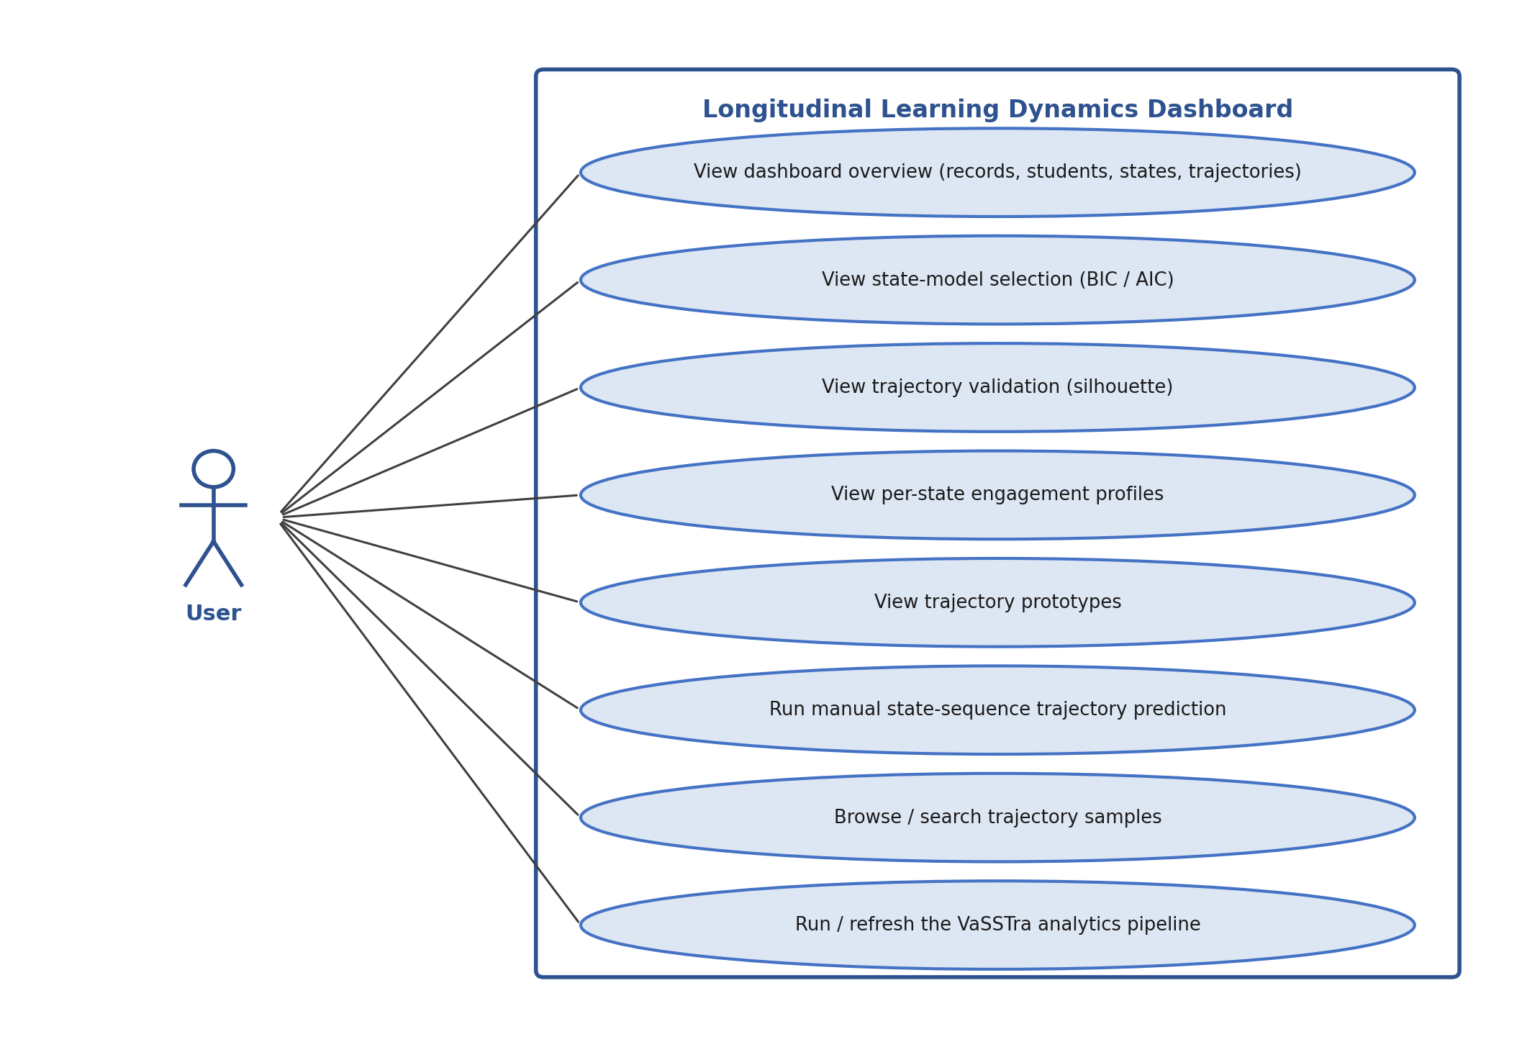
Figure 1 Use-case diagram of the system
Use Case 1: View the Analytics Dashboard
ID | UC001
Name | View the Analytics Dashboard
Description | The User opens the dashboard and reviews the dataset overview, the model-selection and trajectory-validation metrics, the per-state engagement profiles, and the trajectory prototypes.
Requirement(s) | FR003, FR004, FR005, FR006, FR007
Actor(s) | User
Precondition | The pipeline has been run and dashboard.json exists; the frontend is open in a web browser.
Postcondition | The dashboard displays the generated analytics.
Basic Flow | 1. The User opens the dashboard page. 2. The page loads dashboard.json. 3. The overview cards, the BIC/AIC and silhouette charts, the state-profile chart, and the trajectory-prototype cards are rendered. 4. The User selects a state from the drop-down to update the profile chart.
Alternative Flow | If dashboard.json is missing, the page shows a message asking the User to run the backend pipeline first.
Exceptions | The artifact file cannot be loaded because it has not been generated.
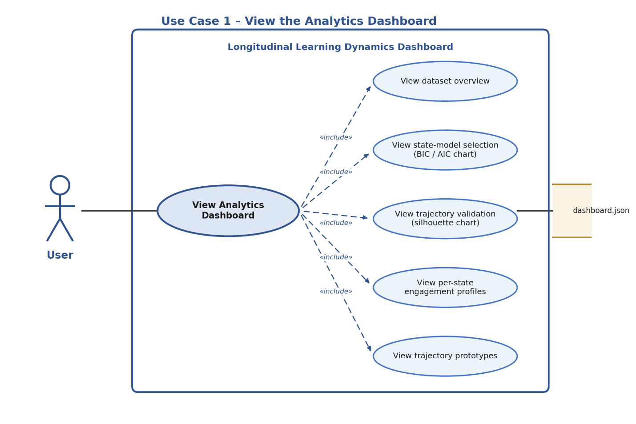
Use Case 2: Run Manual Trajectory Prediction
ID | UC002
Name | Run Manual Trajectory Prediction
Description | The User selects an engagement state for each of the eight time points and submits the sequence to estimate the closest trajectory.
Requirement(s) | FR002, FR008
Actor(s) | User
Precondition | The backend API is running and the dashboard is loaded.
Postcondition | The closest trajectory and the per-trajectory mismatch scores are displayed.
Basic Flow | 1. The User sets a state for each of the eight steps. 2. The User clicks “Estimate Trajectory”. 3. The frontend posts the sequence to the prediction endpoint. 4. The backend counts position mismatches against each trajectory prototype and returns the closest one. 5. The result card and the mismatch bar chart are updated.
Alternative Flow | The User clicks “Reset Defaults” to restore the default sequence and re-runs the estimate.
Exceptions | The backend is unreachable or returns an error; the dashboard shows a message indicating that the API must be started.
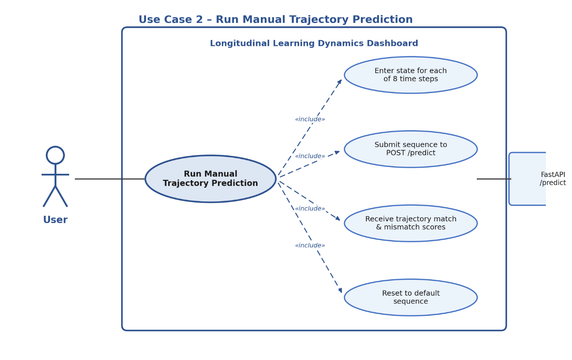
Use Case 3: Browse and Search Trajectory Samples
ID | UC003
Name | Browse and Search Trajectory Samples
Description | The User browses the per-student samples and filters them by student identifier.
Requirement(s) | FR009
Actor(s) | User
Precondition | dashboard.json is loaded in the browser.
Postcondition | The samples table reflects the current search filter.
Basic Flow | 1. The samples table lists students with their trajectory, final grade, and eight-step state sequence. 2. The User types a student identifier in the search box. 3. The table updates to show only the matching rows.
Alternative Flow | An empty search box shows all available samples.
Exceptions | A search term that matches no student yields an empty table.
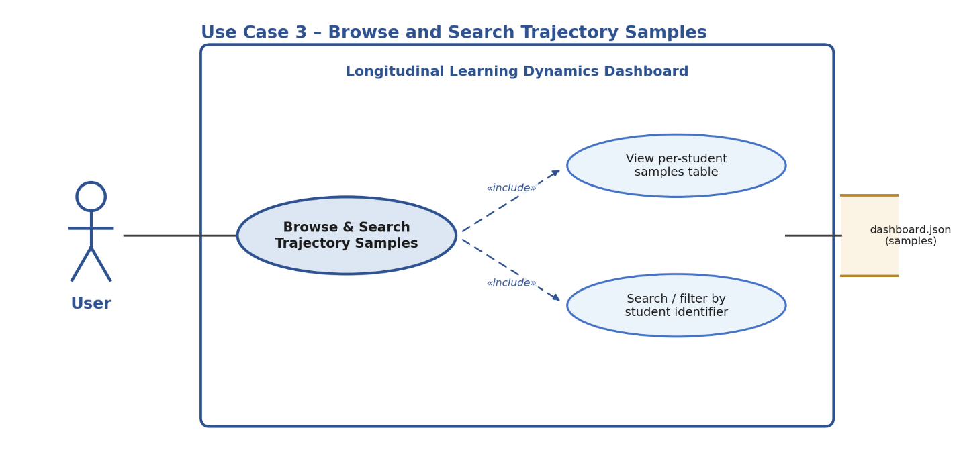
Use Case 4: Run / Refresh the VaSSTra Pipeline
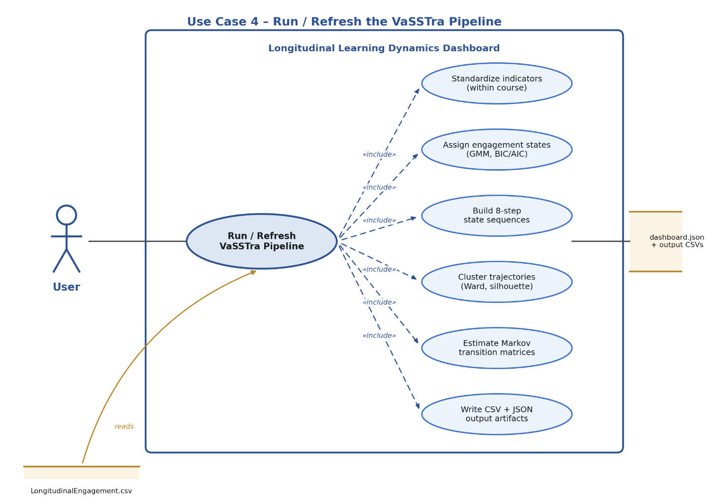
ID | UC004
Name | Run / Refresh the VaSSTra Pipeline
Description | The User runs the offline pipeline to regenerate the analytical artifacts from the dataset.
Requirement(s) | FR001
Actor(s) | User
Precondition | The dataset LongitudinalEngagement.csv is present in the data/raw folder.
Postcondition | The processed CSVs, the output CSVs, and dashboard.json are (re)generated.
Basic Flow | 1. The User runs the pipeline launcher. 2. The pipeline standardizes the indicators, fits the Gaussian-mixture model, builds the state sequences, clusters the trajectories, and estimates the Markov transitions. 3. The results are written to the output files. 4. The User opens or refreshes the dashboard.
Alternative Flow | The combined launcher also starts the API and serves the frontend automatically after the artifacts are generated.
Exceptions | The dataset is missing; the pipeline reports a file-not-found error and stops.
  - Overview of System Models
The system is described by four complementary models: a use-case diagram (behavioural), a system context diagram and two data-flow diagrams (structural and data), and a Markov state-transition diagram (analytical). Together they show how the User interacts with the system, how data flows through the VaSSTra pipeline, and how learners move between engagement states.
  - System Context Diagram
The system is modeled as a single application that the User accesses through a web browser. It reads the engagement dataset (LongitudinalEngagement.csv), writes its results as JSON and CSV artifacts, and exchanges requests and results with the browser over local HTTP. There are no external services, databases, or learning-management systems in scope.
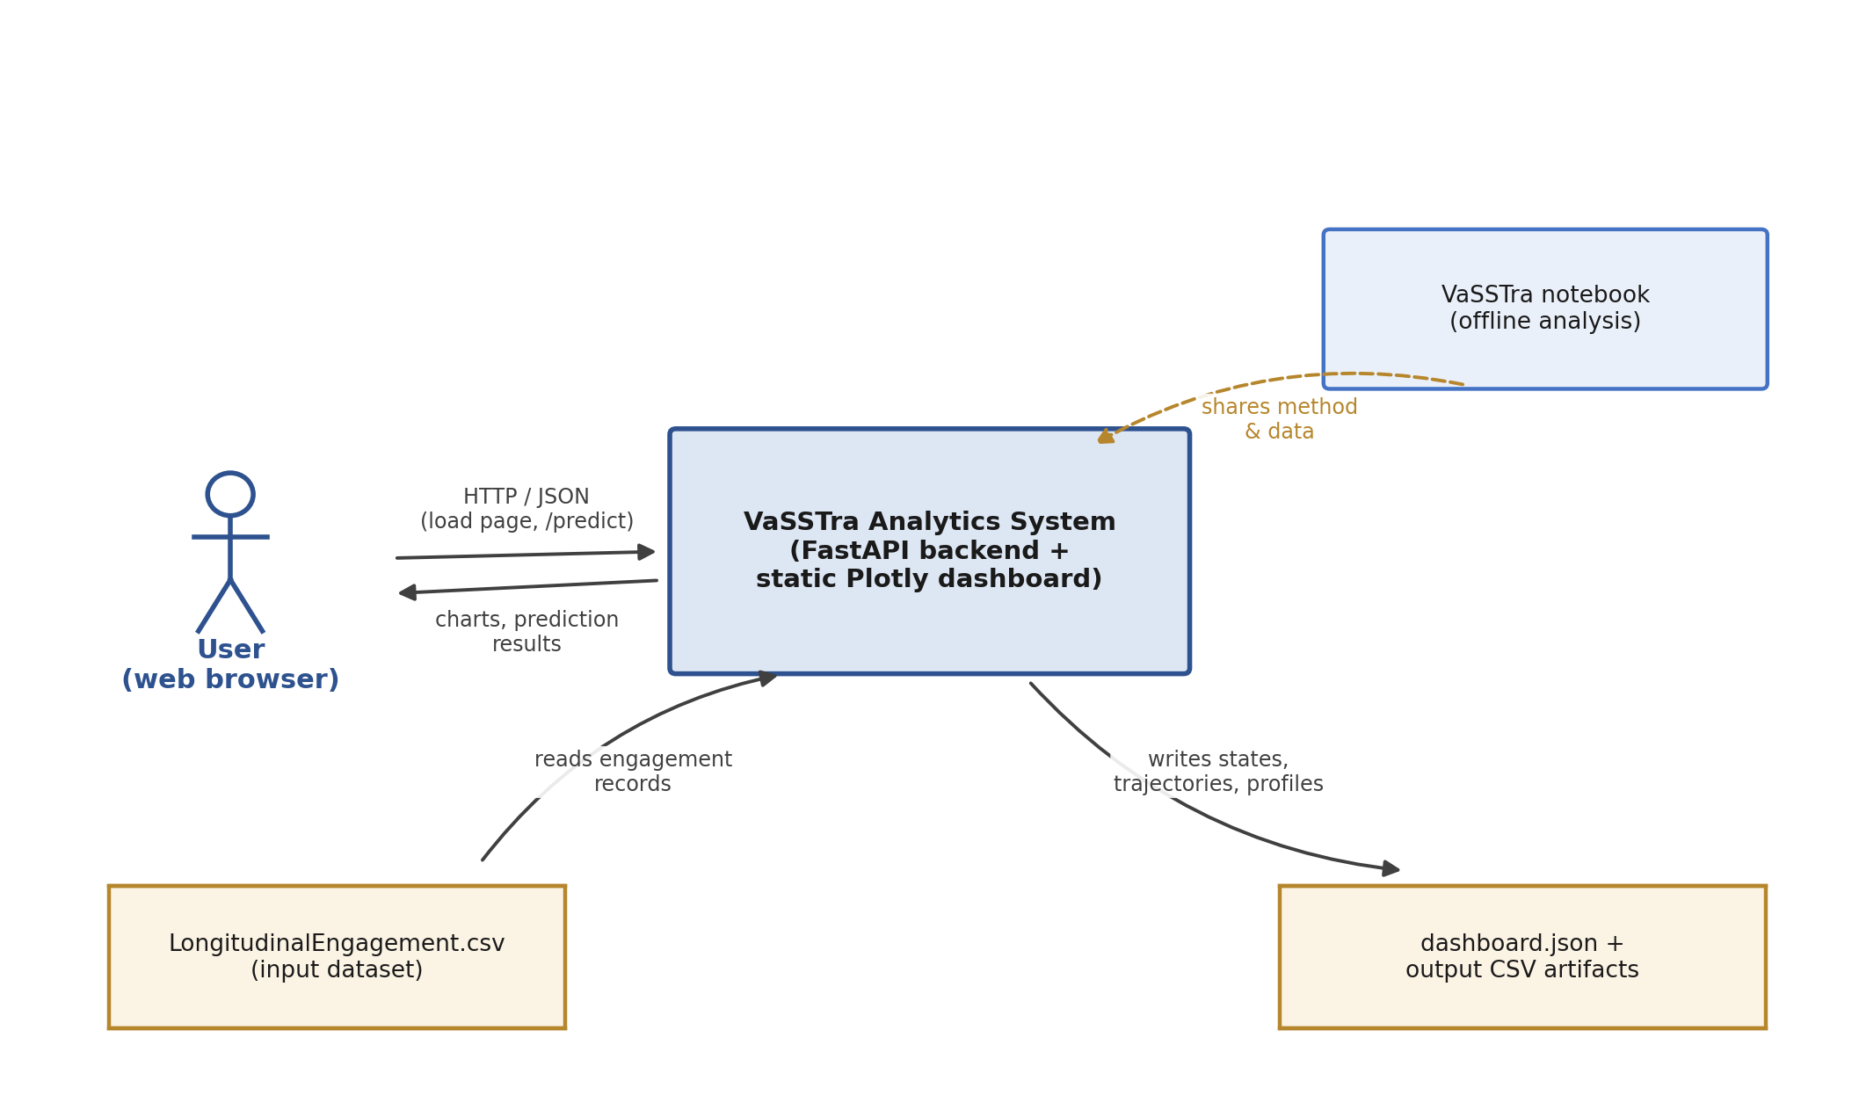
Figure 2 System context diagram
  - State-Transition Model (Markov)
The system estimates a first-order Markov transition matrix over the three engagement states. Each entry P[i, j] is the probability of moving from state i at one time point to state j at the next, estimated from every consecutive step pair across all students. The diagram below shows the estimated transitions: the states are most likely to persist (Disengaged 0.66, Average 0.64, Active 0.73), with the remaining probability describing movement between adjacent engagement levels.
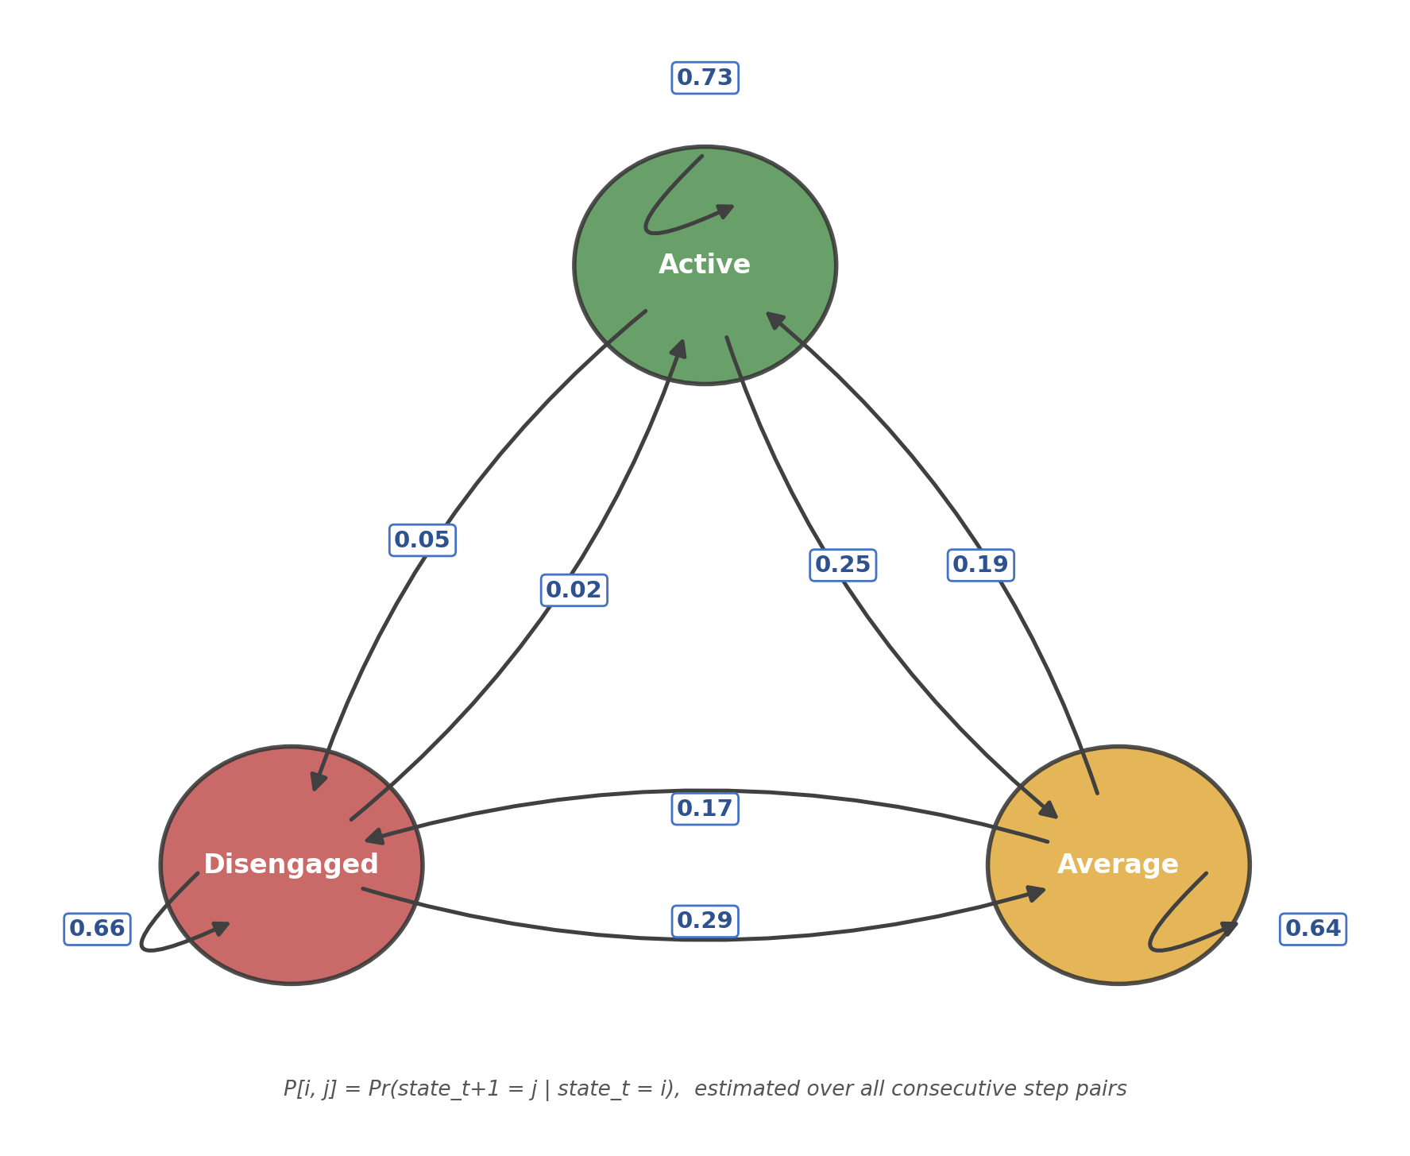
Figure 3 Markov state-transition diagram over the three engagement states
  - Data Flow Diagrams (DFD)
The data-flow diagrams describe how engagement records are transformed into analytical results. The Level-0 diagram gives the context-level view, and the Level-1 diagram decomposes the VaSSTra analytical pipeline into its processing steps.
    - DFD Level-0 – VaSSTra Pipeline Overview
At the context level, the User interacts with a single process — the VaSSTra analytics dashboard system — which reads the engagement dataset, generates the dashboard artifacts, and returns analytics and prediction results to the User.
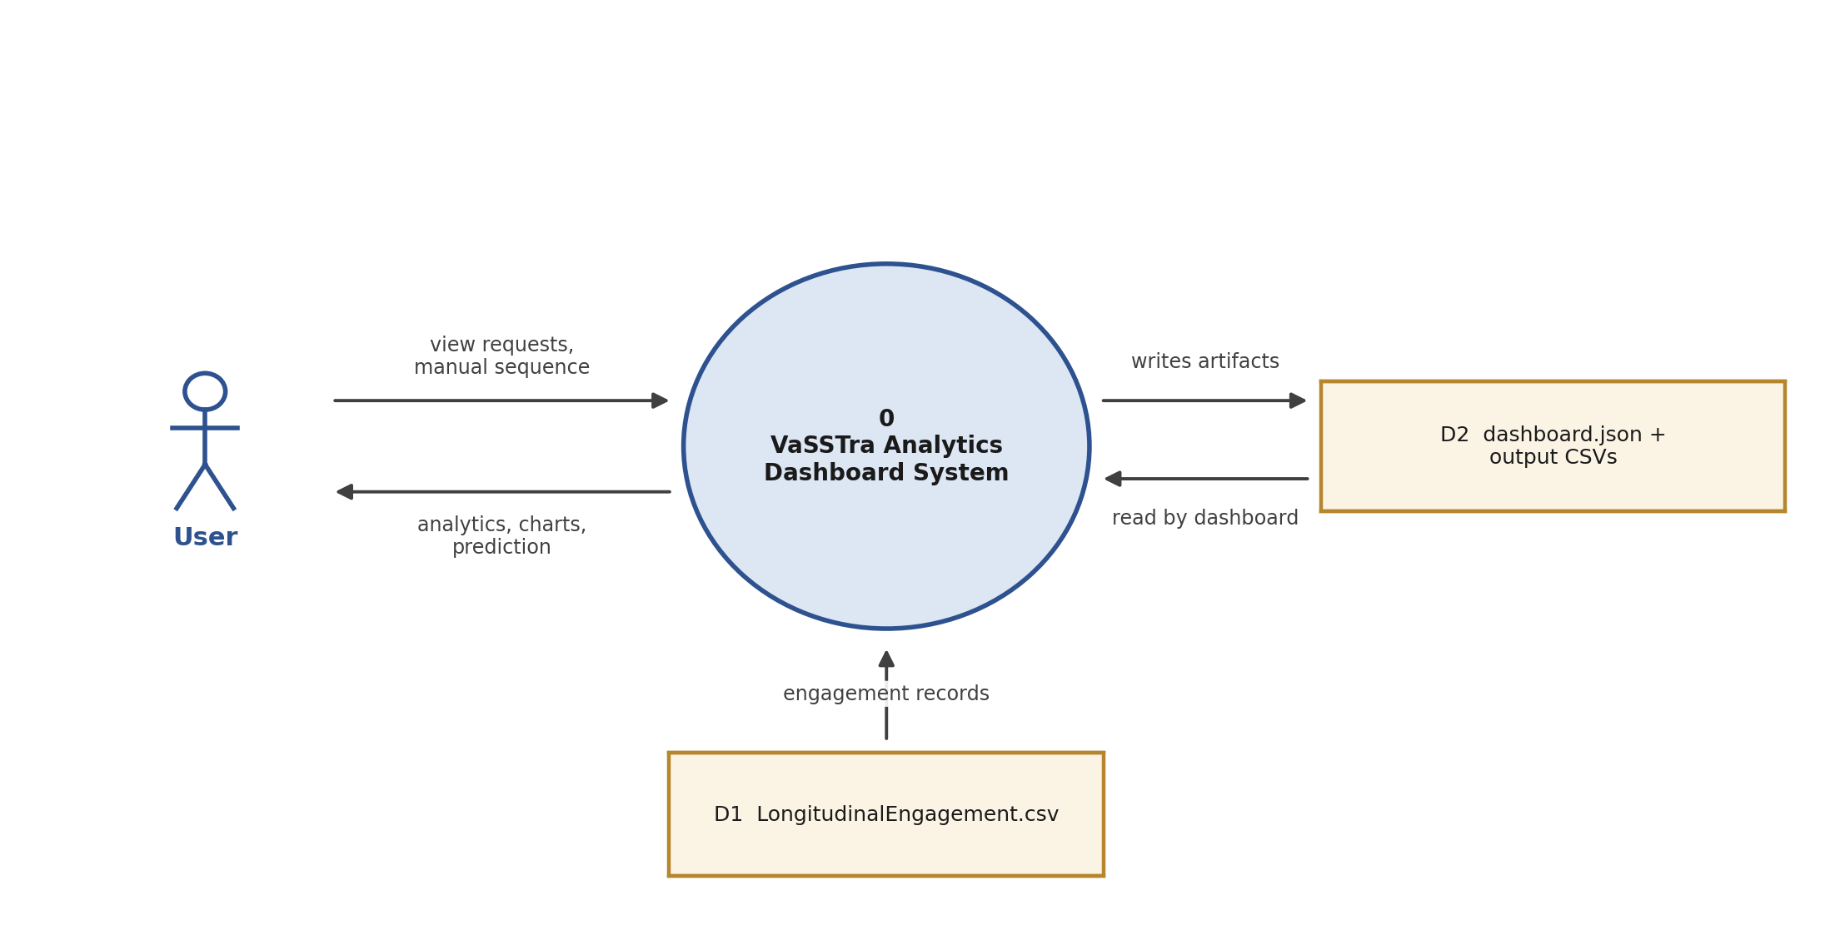
Figure 4 DFD Level-0 – context-level data flow
    - DFD Level-1 – State and Trajectory Processing
The Level-1 diagram decomposes the pipeline into its steps: within-course standardization, Gaussian-mixture state assignment, eight-step sequence construction, Ward trajectory clustering, Markov transition estimation, and building the dashboard artifacts that the frontend and prediction endpoint consume.
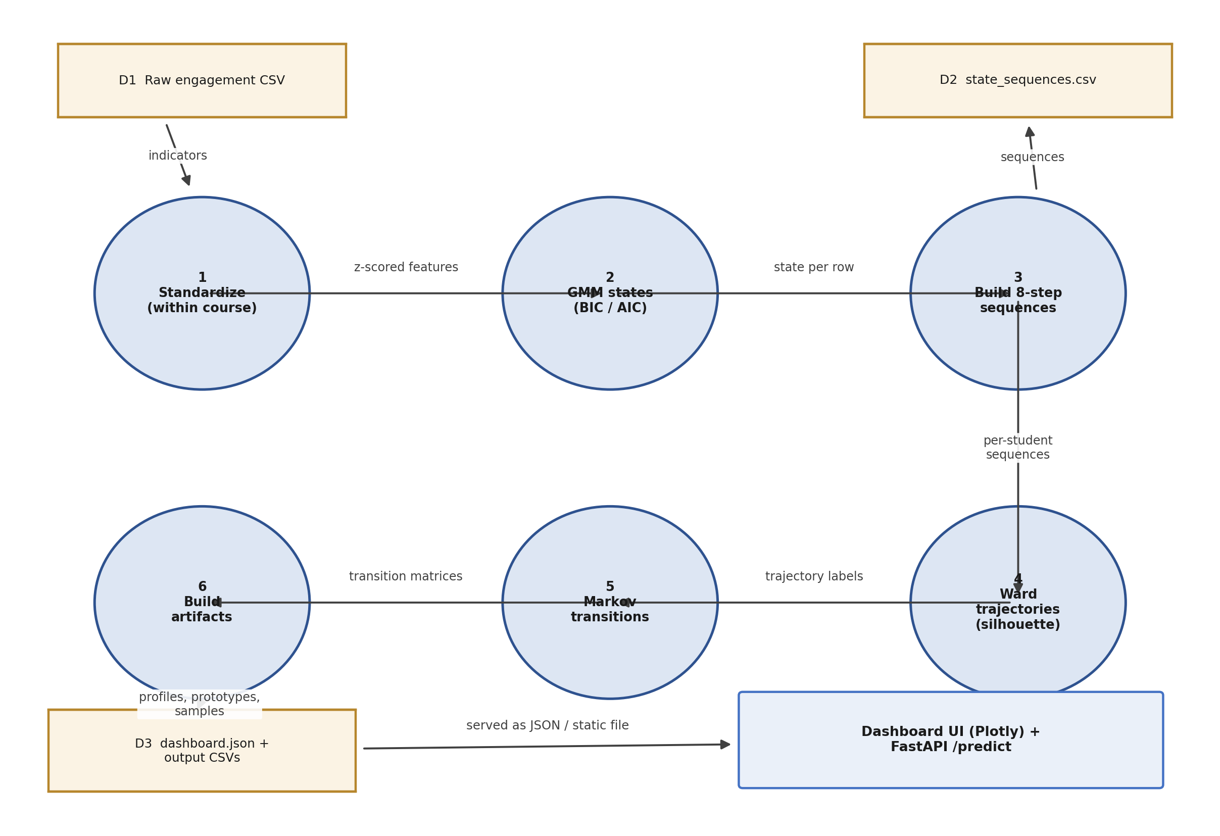
Figure 5 DFD Level-1 – the VaSSTra analytical pipeline
- References
[1] A. T. Corbett and J. R. Anderson, “Knowledge tracing: Modeling the acquisition of procedural knowledge,” User Modeling and User-Adapted Interaction, vol. 4, no. 4, pp. 253–278, 1995.

[2] G. Siemens and P. Long, “Penetrating the fog: Analytics in learning and education,” EDUCAUSE Review, vol. 46, no. 5, pp. 30–40, 2011.

[3] Z. Papamitsiou and A. A. Economides, “Learning analytics and educational data mining in practice: A systematic literature review of empirical evidence,” Educational Technology & Society, vol. 17, no. 4, pp. 49–64, 2014.

[4] C. Romero and S. Ventura, “Data mining in education,” Wiley Interdisciplinary Reviews: Data Mining and Knowledge Discovery, vol. 3, no. 1, pp. 12–27, 2013.

[5] G. Siemens, “Learning analytics: The emergence of a discipline,” American Behavioral Scientist, vol. 57, no. 10, pp. 1380–1400, 2013.

[6] C. Piech, J. Bassen, J. Huang, S. Ganguli, M. Sahami, L. Guibas, and J. Sohl-Dickstein, “Deep knowledge tracing,” in Proc. Advances in Neural Information Processing Systems 28 (NeurIPS), 2015.

[7] Z. A. Pardos and N. T. Heffernan, “Modeling individualization in a Bayesian networks implementation of knowledge tracing,” in User Modeling, Adaptation, and Personalization, Berlin, Germany: Springer, 2010, pp. 255–266.

[8] R. S. J. d. Baker, A. T. Corbett, and V. Aleven, “More accurate student modeling through contextual estimation of slip and guess probabilities in Bayesian knowledge tracing,” in Intelligent Tutoring Systems, vol. 5091, Berlin, Germany: Springer, 2008, pp. 406–415.

[9] Y. X. Wang and Y. Lin, “An introduction to Bayesian knowledge tracing with pyBKT,” Psych, vol. 5, no. 3, pp. 770–786, 2023.

[10] T. A. Badrinath, N. K. Jha, and S. S. Iyengar, “Bayesian knowledge tracing: A review of models and applications in intelligent tutoring systems,” Technology, Knowledge and Learning, vol. 27, no. 4, pp. 1001–1022, 2022.

[11] S. Naeem, M. Hussain, and N. Iqbal, “A survey of knowledge tracing: Models, evaluation metrics and challenges,” IEEE Access, vol. 10, pp. 122345–122365, 2022.

[12] J. Shen, Q. Chen, and Y. Yang, “Progressive knowledge tracing: Modeling learning process from abstract to concrete,” Expert Systems with Applications, vol. 236, 2024.

[13] A. T. Corbett and J. R. Anderson, “Knowledge tracing in the ACT programming tutor,” in Proc. Annual Meeting of the Cognitive Science Society, 1992.

[14] G. Siemens, “Learning analytics: Envisioning a research discipline and a domain of practice,” in Proc. 2nd Int. Conf. Learning Analytics and Knowledge (LAK), 2012, pp. 4–8.

[15] J. A. Larusson and B. White, Eds., Learning Analytics: From Research to Practice. New York, NY, USA: Springer, 2014.

[16] M. A. Chatti, A. L. Dyckhoff, U. Schroeder, and H. Thüs, “A reference model for learning analytics,” Int. J. Technology Enhanced Learning, vol. 4, no. 5–6, pp. 318–331, 2012.

[17] A. F. Wise, “Designing pedagogical interventions to support student use of learning analytics,” in Handbook of Learning Analytics. Edmonton, Canada: Society for Learning Analytics Research, 2017, pp. 89–96.

[18] C. D. Dede, “Learning analytics and educational research,” in Handbook of Learning Analytics. Edmonton, Canada: SoLAR, 2017, pp. 34–45.

[19] G. Siemens, D. Gasevic, C. Haythornthwaite, S. Dawson, S. Shum, R. Ferguson, and E. Duval, “Open learning analytics: An integrated and modularized platform,” in Proc. 1st Int. Conf. Learning Analytics and Knowledge (LAK), 2011.

[20] A. F. Wise and Y. Cui, “Learning communities in the crowd: Characteristics of content and social interactions in MOOCs,” Computers & Education, vol. 92–93, pp. 38–49, 2016.

[21] L. R. Rabiner, “A tutorial on hidden Markov models and selected applications in speech recognition,” Proceedings of the IEEE, vol. 77, no. 2, pp. 257–286, 1989.

[22] A. P. Dempster, N. M. Laird, and D. B. Rubin, “Maximum likelihood from incomplete data via the EM algorithm,” Journal of the Royal Statistical Society: Series B (Methodological), vol. 39, no. 1, pp. 1–38, 1977.

