
The Islamia University of Bahawalpur

Modeling Longitudinal Learning Dynamics Using Markov Models

A project presented to
Department of Information Technology, IUB Bahawalpur

In partial fulfillment
of the requirement for the degree of

Bachelor of Science in Information Technology (2022-2026)

By

Athar Hussain
F22BINFT1M01231
4M
DECLARATION
We hereby declare that this software, neither whole nor as a part has been copied out from any source. It is further declared that we have developed this software and accompanied report entirely on the basis of our personal efforts. If any part of this project is proved to be copied out from any source or found to be reproduction of some other. We will stand by the consequences. No Portion of the work presented has been submitted of any application for any other degree or qualification of this or any other university or institute of learning.

Athar Hussain
(F22BINFT1M01231)
CERTIFICATE OF APPROVAL

It is hereby certified that the final year project titled “Modeling Longitudinal Learning Dynamics Using Markov Models”, submitted in partial fulfillment of the requirements for the degree of BS (IT), was developed by Athar Hussain (Registration No. F22BINFT1M01231, 4M) under the supervision of Dr. Mustafa Hameed. In his opinion, the project is fully adequate in scope and quality for the award of the degree of Bachelor of Science in Information Technology.

Supervisor

-----------------------------------

External Examiner

-------------------------------------

Chairman Department of Information Technology

------------------------------------------------

Acknowledgement
In the name of Allah, the Most Gracious, the Most Merciful. First and foremost, I offer my humble and sincere gratitude to Almighty Allah, who blessed me with the strength, knowledge, patience, and determination to undertake and complete this project successfully. Without His countless blessings, this accomplishment would never have been possible.
I would like to express my deepest and most heartfelt gratitude to my respected supervisor, Dr. Mustafa Hameed, Department of Information Technology, for his invaluable guidance, continuous support, and constructive feedback throughout the course of this project. His expertise, patience, and constant encouragement guided me at every stage from shaping the initial idea to bringing this work to its final completion. It has truly been an honour to carry out this project under his supervision.
I am also sincerely thankful to all the respected faculty members and staff of the Department of Information Technology, Faculty of Computing, The Islamia University of Bahawalpur, for providing a supportive learning environment and the resources required to complete this work. The knowledge and skills I gained throughout my degree program laid the foundation upon which this project was built.
I would also like to thank my friends and fellow classmates for their cooperation, helpful discussions, and moral support during the development of this project. Their companionship made this journey both memorable and rewarding.
Finally, I extend my sincere gratitude to everyone who, directly or indirectly, contributed to the successful completion of this project. May Allah reward them all for their kindness, guidance, and support.

Athar Hussain
(F22BINFT1M01231)

Abstract
This report presents the design and implementation of “Modeling Longitudinal Learning Dynamics Using Markov Models”, a self contained learning analytics system that studies how students’ engagement evolves across the weeks of a course. The central problem it addresses is that a single static score does not reveal how a learner progresses over time; the system therefore models longitudinal engagement as a sequence of latent states that change from one weekly time point to the next.
The system follows the VaSSTra method (Variables → States → Trajectories) and is implemented entirely in Python. An offline analytical pipeline reads a longitudinal engagement dataset, standardizes each behavioural indicator within its course, discovers three latent engagement states (Disengaged, Average, Active) with a Gaussian mixture model, assembles each student’s states into an eight step sequence, and groups those sequences into three learner trajectories using Ward agglomerative clustering. First order Markov transition matrices summarize how students move between states. The generated results are served by a small Fast API backend and presented in a browser based dashboard built with static HTML, CSS, JavaScript, and Plotly; data is exchanged as CSV and JSON files, and no database is used.
The design favours reproducibility and transparency over scale: a fixed random seed makes each run repeatable, the configuration is held in the pipeline module, and all data and code remain on the user’s machine. This document consolidates the project’s requirements and design covering the functional and nonfunctional requirements, use cases and system models, the software architecture, the data model, the user interface, the component and API design, the modelling algorithms, deployment, and testing so that the completed system can be understood, reproduced, and extended for academic use.

Table of Contents
1. Introduction 10
1.1 Purpose 11
1.2 Scope 11
1.3 Product Perspective 13
1.4 System Objectives 13
1.5 User Characteristics 13
1.6Assumptions and Dependencies 14
1.7 Definitions, Acronyms, and Abbreviations 14
2. Literature Review and Related Work 17
3. Requirements Specification 18
3.1 Functional Requirements 18
3.2 Non Functional Requirements 20
3.2.1 Performance Requirements 20
3.2.2 Reliability and Availability Requirements 21
3.2.3 Security Requirements 21
3.2.4 Usability and Accessibility Requirements 22
3.2.5 Maintainability and Extensibility Requirements 22
3.3 Non Functional Requirements Summary 23
4. System Models and Use Cases 24
4.1 UseCase Diagram 24
Use Case 1: View the Analytics Dashboard 24
Use Case 2: Run Manual Trajectory Prediction 26
Use Case 3: Browse and Search Trajectory Samples 27
Use Case 4: Run / Refresh the VaSSTra Pipeline 28
4.2 Overview of System Models 30
4.3 System Context Diagram 30
4.4 State Transition Model (Markov) 31
4.5 Data Flow Diagrams (DFD) 32
5. System Architecture 34
5.1 High Level Architecture 34
5.2 Component Architecture 34
5.3 Technology Stack 35
5.4 Module Breakdown 35
6. Data Model and Schema 37
6.1 Entity Definitions 37
6.2 Data Relationships (ER Diagram) 37
6.3 Dataset Schema and Data Dictionary 38
6.4 Storage and File Layout 39
7. User Interface Design 40
7.1 UI Mockups and Wireframes 40
7.2 Navigation Flow 42
7.3 Visualization Components 42
7.4 User Interaction Guidelines 42
8. Component and API Design 43
8.1 Module Specifications 43
Analytical Pipeline (run_vasstra_pipeline.py) 43
State Discovery (assign_states / GaussianMixture) 43
Sequence and Trajectory Construction 43
Result Serving API (api.py + fyp_shared.api) 43
Trajectory Prediction (predict) 43
Frontend Dashboard (frontend/js/app.js) 44
8.2 API Specifications 44
8.3 Class and Sequence Diagrams 44
9. Algorithm and Methodology 46
9.1 Feature Engineering Pipeline 46
9.2 Model Selection and Training 47
9.3 Processing Workflow 48
10. Integration and Communication 51
11. Security and Privacy 51
11.1 Authentication 51
11.2 Authorization 51
11.3 Data Protection 51
12. Deployment Strategy 52
12.1 Environment Requirements 52
12.2 Deployment Pipeline 52
13. Testing and Validation 53
13.1 Functional Testing 53
13.2 Validation and Model Evaluation 53
13.3 QA and Verification Methods 53
14. Constraints, Limitations, and Design Decisions 54
14.1 Constraints and Limitations 54
14.2 Design Decisions and Rationale 54
15. Future Enhancements 54
16. Conclusion 55
Appendices 56
Appendix A: Dataset Summary 56
Appendix B: Use Case Library 56
Appendix C: Requirements Traceability 57
Appendix D: Data Quality Rules 57
Appendix E: Operational Monitoring 58
References 59

List of Figures
Figure 1. Usecase diagram of the system 24
Figure 2. Usecase detail for UC001 – View the Analytics Dashboard 26
Figure 3. Usecase detail for UC002 – Run Manual Trajectory Prediction 27
Figure 4. Usecase detail for UC003 – Browse and Search Trajectory Samples 28
Figure 5. Usecase detail for UC004 – Run / Refresh the VaSSTra Pipeline 30
Figure 6. System context diagram 31
Figure 7. Markov statetransition diagram over the three engagement states 32
Figure 8. DFD Level0 – contextlevel data flow 33
Figure 9. DFD Level1 – the VaSSTra analytical pipeline 33
Figure 10. Highlevel architecture: offline pipeline → artifacts → FastAPI → browser dashboard 34
Figure 11. Component architecture grouped into presentation, service, analytics, and data layers 35
Figure 12. Data model: how a raw record flows into state sequences, trajectories, and dashboard.json 38
Figure 13. Filebased storage and processing layout (raw input, processed CSVs, and outputs) 39
Figure 14. Singlepage dashboard layout (frontend/index.html) 40
Figure 15. The implemented dashboard user interface (live rendering of the VaSSTra results) 41
Figure 16. Navigation flow: one launcher, one page, ondemand interactions 42
Figure 17. Module and function structure across the pipeline, API, and frontend 44
Figure 18. Sequence diagram: manual trajectory prediction via the /predict endpoint 45
Figure 19. The VaSSTra analytical pipeline (Variables → States → Sequences → Trajectories) 46
Figure 20. Firstorder Markov structure over the three engagement states 47
Figure 21. Ward dendrogram of the onehot encoded state sequences, cut into three trajectories 48
Figure 22. Engagementstate distribution across the eight weekly time points 48
Figure 23. Firstorder Markov transition matrix over the three engagement states 49
Figure 24. Steadystate (stationary) distribution of the transition matrix 50
Figure 25. Initial (firststep) vs. steadystate engagement distribution 50
Figure 26. Local deployment and run flow on the user's machine 52
Figure 27. Markov transition summary: state persistence and the steadystate engagement distribution 55

1. Introduction
The project “Modeling Longitudinal Learning Dynamics Using Markov Models” aims to understand how students’ engagement evolves over the weeks of a course, rather than reducing learning to a single final score. Conventional assessment summarizes performance with marks or grades, but such snapshots do not reveal whether a learner is becoming more engaged, stagnating, or disengaging over time. This project addresses that limitation by treating longitudinal engagement as a probabilistic process and using Markov models to represent how learners transition between a small set of latent engagement states across successive time points.
The system is based on the premise that a learner’s level of engagement is not captured by any single measurement but can be inferred from observable behavioural indicators such as course views, lecture views, forum reading and posting, session counts, total duration, and active days. By collecting these indicators at eight successive weekly time points, the system assigns each observation to a latent engagement state and estimates how likely a learner is to move from one state to another. A firs torder Markov transition matrix captures these dynamics, producing learning trajectories that reflect improvement, stability, or decline rather than a single average.
The application is implemented entirely in Python and exposed through a lightweight browser based dashboard. The analytical pipeline uses NumPy, pandas, and scikitlearn to standardize indicators within each course, fit a Gaussian mixture model that discovers the engagement states, build per student state sequences, and cluster those sequences into learner trajectories with Ward agglomerative clustering. A FastAPI service exposes the generated results and a trajectory ymatching endpoint, while the frontend built with static HTML, CSS, JavaScript, and Plotly renders interactive charts of model selection, state profiles, trajectory prototypes, and student samples. The pipeline reads a single CSV dataset and writes its results as CSV and JSON files; no database, authentication, or multiuser infrastructure is required.
From an educational standpoint, the dashboard is intended to help an instructor, analyst, or researcher interpret how a cohort of learners engages over time. By visualizing the discovered engagement states, the trajectory each student follows, and the transition probabilities between states, the user can identify groups that remain highly engaged, those that drift toward disengagement, and the time points at which transitions are most likely. By combining behavioural data, probabilistic modeling, and visualization, the system turns raw engagement logs into an interpretable picture of how learning unfolds across a course.

1.1 Purpose
The primary purpose of this project is to build a software system that reveals how students’ engagement changes over the course of a term using probabilistic modeling, rather than relying on a single summary score. The system transforms a longitudinal engagement dataset into interpretable insights about how learners move between engagement states over time and which overall trajectory each learner follows.
The project infers a small set of latent engagement states from observable behavioural indicators and models the transitions between them with a first order Markov chain. By determining, for each time point, which state a learner occupies and how likely they are to move to another state, the system offers a longitudinal perspective on learning that uncovers patterns of improvement, stability, or decline. These insights are delivered through an interactive dashboard, allowing the user to observe engagement progress throughout a course.
In practice, the system supports datainformed reflection on teaching and learning. It lets an instructor or analyst see which learners stay engaged, which drift toward disengagement, and where in the term the most important transitions occur. For researchers, it illustrates how the VaSSTra method and Markov models can be implemented end-to-end in Python and exposed through a simple, selfcontained web application.
In summary, the project designs and implements a maintainable and extensible application that employs Markov models to represent longitudinal learning dynamics. The application delivers these insights through an interactive dashboard, thereby enhancing the understanding and monitoring of student engagement throughout a course.
From a design standpoint, the purpose of the accompanying design is to describe the software that realizes these requirements: the system architecture and its three components (the Python analytical pipeline, the FastAPI result serving API, and the static browser dashboard), the file based data model, the module and API design, and the modelling algorithms within course standardization, Gaussian mixture state discovery, Ward trajectory clustering, and first order Markov transition estimation.

1.2 Scope
The system is a browser based learning analytics application that processes a longitudinal engagement dataset and builds probabilistic models that capture how learner engagement changes over time. It reads time indexed engagement indicators, standardizes them within each course, and applies the VaSSTra method together with a first order Markov model to assign engagement states, group learners into trajectories, and summarize state transitions. Its primary function is to deliver a complete pipeline that converts raw engagement records into state assignment, trajectory clustering, and visualization, all accessible through a single page dashboard in the browser.
The system consists of a static HTML, CSS, and JavaScript frontend that uses Plotly for visualization, a FastAPI backend that serves the generated results and a trajectory prediction endpoint, and a Python analytical layer that uses NumPy, pandas, and scikitlearn. The frontend handles presentation and interactive charts. The backend exposes read only endpoints for the dashboard data and a single prediction endpoint that matches a state sequence to the closest trajectory. Results are stored as CSV and JSON files in the project folder; the system does not use a relational database, user accounts, or authentication.
Functionally, the system will support three primary categories of capabilities.
- Data preparation: reading the engagement dataset, standardizing each indicator within its course, and organizing the records into per student state sequences across the eight weekly time points.
- Modeling and inference: fitting a Gaussian mixture model to assign engagement states, clustering the state sequences into learner trajectories with Ward agglomerative clustering, and estimating firstorder Markov transition matrices between states.
- Analytics and visualization: presenting model selection metrics, per state engagement profiles, trajectory prototypes, and student samples in an interactive dashboard, and matching a manually entered state sequence to its closest trajectory.
In terms of the design scope, the system covers the following capabilities:
- Reading a single local engagement dataset (data/raw/Longitudinal Engagement.csv) no live LMS/SIS feeds.
- Within course standardization of the eight engagement indicators and Gaussian mixture engagement state discovery.
- Building per student eight step state sequences and clustering them into learner trajectories (Ward linkage).
- Estimating first order Markov transition matrices over the engagement states (in the companion notebook).
- Serving the generated results through a small FastAPI service and rendering them in a Plotly dashboard.
- Manual trajectory prediction: matching a user entered eight step state sequence to the closest trajectory prototype.
- Out of scope: realtime streaming, automated interventions, user accounts, and any external/cloud service.
- Out of scope: relational databases, model registries, and multiuser deployment.

1.3 Product Perspective
The system is a self contained analytics application that runs on a single machine and does not depend on any external service, database server, or learning management system. It can be used in two complementary ways:
- As an interactive dashboard, in which the generated results are explored in a web browser through charts, tables, and a manual trajectory prediction form, or
- As a reproducible Python notebook, in which the same VaSSTra and Markov analysis can be run and inspected step by step for study or extension.
At a high level, the system comprises the following components:
- A frontend dashboard that runs in a web browser (static HTML, CSS, JavaScript, and Plotly) and presents all analytics to the user.
- A FastAPI backend that loads the generated results and exposes health, schema, and trajectory prediction endpoints.
- An offline analytical pipeline, implemented in Python with scikit learn, that performs the VaSSTra and Markov computations.
- File based storage consisting of a single input CSV dataset and the generated CSV and JSON artifacts; no database is used.
The system reads its input from a local engagement dataset and writes its results as CSV and JSON files that can be reused for reporting or research. The user interacts only with the dashboard and the backend endpoints; the internal computations are not exposed.

1.4 System Objectives
The system is designed to meet the following objectives:
- Discover a small set of interpretable engagement states from behavioural indicators.
- Compose per student state sequences and group them into learner trajectories.
- Estimate first order Markov transitions between engagement states.
- Present model selection metrics, state profiles, and trajectory prototypes in an interactive dashboard.
- Let the User test a manual state sequence against the discovered trajectories.
- Keep every run reproducible and fully offline on a single machine.

1.5 User Characteristics
The system is intended for a single category of user, referred to throughout this document as the User. There are no separate accounts, roles, or permission levels; whoever runs the application has full access to every feature.
Primary_user:
an instructor, teaching assistant, analyst, or researcher who wants to understand how a cohort of learners engages over time. The User is expected to have basic familiarity with a web browser; specialized knowledge of machine learning or Markov models is not required to read the dashboard.
Assumed_background:
the User is assumed to be comfortable reading charts and tables. No programming or statistics expertise is required to interpret the dashboard, although the accompanying Python notebook is available for users who wish to inspect the underlying method in detail.
Operating_environment:
the User runs the application locally and views it in a desktop or laptop web browser. The application is served from the local machine, so no login, user account, or internet connection is required.
The User is assumed to have access to a modern web browser on the machine where the application is running.

1.6Assumptions and Dependencies
The system is developed and operated under the following assumptions and dependencies:
- The input file LongitudinalEngagement.csv keeps its expected columns (User ID, CourseID, Sequence, the eight indicators, Final_Grade).
- Each student has up to eight ordered weekly time points (Sequence 1–8); missing positions default to the Average state.
- Python 3.11+ with pandas, NumPy, and scikit learn is available on the local machine.
- The dataset uses anonymized identifiers and contains no personally identifiable information.
- The application is run on demand by a single local user; no concurrent multiuser access is assumed.
- A fixed random seed (2026) is used so that model runs are reproducible.

1.7 Definitions, Acronyms, and Abbreviations
The terms and acronyms used throughout this report are defined below.
Term / Acronym | Definition
SRS (Software Requirements Specification) | Document that describes what the system must do (functional and nonfunctional requirements).
SDD (Software Design Description) | Document that explains how the system will be built (architecture, components, design).
Learning Analytics | Analysis of learner data to understand and improve learning and teaching.
Longitudinal Data | Data collected from the same learner over multiple time points (here, eight weekly time points across a course).
Engagement State | A latent level of engagement (Disengaged, Average, or Active) inferred from a learner’s behavioural indicators at a given time point.
Markov Model (MM) | Probabilistic model where the next state depends only on the current state; used here for first order engagement state transitions.
Dataset | The collection of longitudinal engagement records used as input for modeling and analytics.
Dashboard | A single web page that shows charts, summaries, and key indicators for the User.
Student | A learner whose engagement indicators are recorded in the dataset and grouped into states and a trajectory.
VaSSTra | The method followed by the system: deriving engagement States from Variables and composing them into Trajectories, with Markov transitions summarizing movement between states.
Gaussian Mixture Model (GMM) | An unsupervised model that groups standardized indicators into latent engagement states; the number of states is chosen using BIC and AIC.
Frontend | Browser based part of the system (static HTML, CSS, JavaScript, and Plotly) that the User sees and interacts with.
Backend | Server side part of the system (FastAPI) that serves the generated results and the trajectoryprediction endpoint.
REST API | HTTP based interface used by the frontend to communicate with the backend (here, the health, schema, and predict endpoints).
Trajectory | A group of learners whose eight step state sequences are similar; the system discovers three (Mostly active, Mostly average, Mostly disengaged).
Transition Matrix | A table of first order Markov probabilities P[i, j] = Pr(next state = j | current state = i), estimated from consecutive time points.
FastAPI | A Python web framework used to implement the backend REST API.
Plotly | A JavaScript charting library used to render the interactive visualizations in the dashboard.

2. Literature Review and Related Work
Educational technology research has produced intelligent tutoring systems (ITS) and learning analytics dashboards that monitor student progress through detailed interaction data. These platforms deliver immediate feedback and support mastery based progression within controlled environments.
A central focus is knowledge tracing, which estimates learner knowledge states based on performance data. Bayesian Knowledge Tracing (BKT) models knowledge as a hidden Markov process and is widely implemented in adaptive learning systems. Hidden Markov Models (HMMs) are similarly utilized in medicine and psychology to model latent traits over time.
Most current learning analytics platforms provide visual reporting; however, they typically depend on descriptive statistics instead of explicit probabilistic models of learner knowledge states.
Despite these advances, several significant gaps persist:
- Knowledge tracing functionality is typically embedded within large platforms and is not available as a standalone component.
- There is limited support for the longitudinal visualization of trajectories of probabilistic knowledge states.
- Learning models often lack transparency, making their outputs difficult for instructors to interpret.
- Research prototypes seldom provide production ready web applications.
The proposed system addresses these gaps by implementing Markov based modeling in a self contained Python application (scikit learn analytics, a FastAPI service, and a static Plotly dashboard). It makes the evolution of learners’ engagement states visible, interpretable, and actionable, while remaining independent of any specific learning management system.
The proposed system addresses these limitations by implementing a Markov based modeling approach in a self contained Python application (a FastAPI backend with a static, Plotly based dashboard). It focuses on making the temporal evolution of learner engagement states visible, interpretable, and usable, while remaining independent of any specific LMS or tutoring system. In doing so, it bridges the gap between the rich theoretical work on Markov models for longitudinal data and the practical need for accessible, transparent learning analytics tools.

3. Requirements Specification
The system is a self contained analytics application operated by a single User. It reads a longitudinal engagement dataset, standardizes the indicators within each course, and organizes them by learner and time point to form state sequences. The analytical pipeline applies a Gaussian mixture model and Ward clustering to estimate engagement states and learner trajectories, and computes first order Markov transition probabilities between those states.
The dashboard presents the User with the dataset overview, the models election and trajectory validation metrics, the per state engagement profiles, and the trajectory prototypes, and lets the User browse and search the per student samples. A manual prediction feature matches an entered state sequence to the closest trajectory. All processing is local: results are stored as CSV and JSON files, and the backend restricts requests to localhost, so no authentication or network exposure is required.

3.1 Functional Requirements
Functional requirements define the services and responses that the system provides to the User. They cover the offline analytical pipeline, the API that serves the generated results, the visual analytics presented in the dashboard, the manual trajectory prediction feature, and the browsing of student samples. The requirements are independent of specific implementation details and are organized according to the system’s primary features.
Overview of System Features
- Analytical pipeline: standardizes the engagement indicators within each course, discovers engagement states, builds per student state sequences, clusters them into trajectories, and estimates Markov transition matrices.
- Result serving: a small REST API exposes the generated results to the dashboard and reports service status.
- Visual analytics: the dashboard presents the dataset overview, model selection and trajectory validation metrics, per state engagement profiles, and trajectory prototypes.
- Manual prediction: the User can enter an eight step state sequence and have it matched to the closest learner trajectory.
- Sample exploration: the User can browse and search the per student trajectory samples.
FR001 – Run / Refresh the VaSSTra Analytics Pipeline
- Purpose: Generate the engagement state, trajectory, and Markov transition results from the engagement dataset and write them to the output artifacts.
- Actor(s): User
- Input: The bundled LongitudinalEngagement.csv dataset and the fixed method configuration (three states, three trajectories, random seed 2026).
- Output: Processed CSVs (state assignments and state sequences), output CSVs (model selection metrics, state profiles, trajectory validation, trajectory profiles, and trajectory assignments), and a consolidated dashboard.json.
FR002 – Serve Dashboard Data and Service Status
- Purpose: Expose the generated results to the frontend and report whether the backend service is available.
- Actor(s): User (through the frontend) and the frontend itself
- Input: HTTP GET requests to the health and schema endpoints.
- Output: The health endpoint returns the service status and project title; the schema endpoint returns the input schema, the list of states, and the trajectory prototypes used by the manual prediction form.
FR003 – View Dashboard Overview
- Purpose: Show a high level summary of the dataset and the chosen model.
- Actor(s): User
- Input: The loaded dashboard.json.
- Output: Summary cards showing the total number of records, the number of unique students, the chosen number of engagement states, and the chosen number of trajectories.
FR004 – View State Model Selection
- Purpose: Let the User see how the number of engagement states was chosen.
- Actor(s): User
- Input: The model selection metrics in dashboard.json.
- Output: A line chart of the BIC and AIC values across the candidate Gaussian mixture solutions.
FR005 – View Trajectory Validation
- Purpose: Let the User see how the number of trajectories was chosen.
- Actor(s): User
- Input: The trajectory validation metrics in dashboard.json.
- Output: A line chart of the silhouette score across the candidate numbers of trajectory clusters.
FR006 – View Per State Engagement Profiles
- Purpose: Show the mean standardized indicator profile that characterizes each engagement state.
- Actor(s): User
- Input: Selection of a state (Disengaged, Average, or Active) from a dropdown list.
- Output: A bar chart of the selected state’s mean standardized engagement indicators.
FR007 – View Trajectory Prototypes
- Purpose: Summarize each discovered learner trajectory.
- Actor(s): User
- Input: The trajectory profiles in dashboard.json.
- Output: For each trajectory (Mostly active, Mostly average, Mostly disengaged): the number of students, the mean final grade, and the dominant eightstep state sequence (the prototype).
FR008 – Run Manual State Sequence Trajectory Prediction
- Purpose: Estimate which trajectory a manually entered eight step state sequence most closely matches.
- Actor(s): User
- Input: A state (Disengaged, Average, or Active) chosen for each of the eight time points and submitted to the prediction endpoint.
- Output: The closest trajectory, the number of position mismatches, that trajectory’s mean final grade, the prototype path, and a bar chart comparing the mismatch counts of all trajectories.
FR009 – Browse and Search Trajectory Samples
- Purpose: Let the User inspect individual students’ trajectories.
- Actor(s): User
- Input: An optional search term matching a student identifier.
- Output: A table of students showing each student’s assigned trajectory, final grade, and full eightstep state sequence, filtered live by the search term.

3.2 Non Functional Requirements
Nonfunctional requirements define the quality attributes, constraints, and operational conditions that the system “Modeling Longitudinal Learning Dynamics Using Markov Models” must satisfy. These requirements address how the system operates rather than its specific functionalities. They apply to all system components, including the static HTML/JavaScript frontend, the FastAPI backend, the file based artifacts, and the Python analytical and Markov modelling code.

3.2.1 Performance Requirements
- The dashboard loads and renders all of its charts within about 3 seconds on a typical laptop for the bundled dataset (about 1,100 records and 142 students).
- The offline VaSSTra pipeline completes a full run on the bundled dataset within a few seconds on a typical laptop, regenerating all output artifacts.
- The prediction endpoint returns a result within about one second, because it only compares the submitted sequence against the stored trajectory prototypes rather than retraining any model.
- The pipeline reads the input dataset directly from disk and requires no manual detain port step; loading the generated dashboard.json into the browser is effectively instantaneous for the bundled dataset.
- The frontend renders and updates the Plotly charts without noticeable lag for the dataset sizes shown on screen (a few hundred data points per chart), maintaining a smooth user experience.

3.2.2 Reliability and Availability Requirements
The system must operate reliably, handle failures gracefully, and ensure reasonable availability for users.
- The system shall detect and manage predictable error conditions, such as an invalid input file, a missing dataset, or a missing dashboard.json, without terminating unexpectedly. It shall present a clear message to the User and log technical details to the console.
- The pipeline writes a complete set of output artifacts on each run; if a run fails, the previous artifacts remain on disk so the dashboard continues to display the last successful results.
- Because the application runs locally on demand, its availability depends only on the User’s machine; the backend starts within a few seconds and can be restarted at any time.
- The generated artifacts are plain CSV and JSON files that can be copied or placed under version control for backup; regenerating them from the dataset is deterministic.
- When the same dataset and configuration are used, the pipeline produces reproducible results because the random seed is fixed (2026), so repeated runs yield the same states, trajectories, and transition matrices.

3.2.3 Security Requirements
Security requirements describe how the system protects data, given that it runs locally for a single user, without accounts or network exposure.
- The application requires no authentication: it runs locally for a single User, so there are no accounts, passwords, or sessions to manage.
- No passwords or personal credentials are stored, processed, or logged by the system.
- There are no user roles; the single User has access to all features, which is appropriate for a local analysis tool.
- All communication is local, between the browser and a backend bound to 127.0.0.1; the backend additionally restricts cross origin requests to localhost addresses.
- Because the application can be run entirely offline, no tokens, credentials, or engagement data are transmitted over a network.
- The bundled dataset uses anonymized identifiers and contains no personally identifiable information; the analytics views display only deidentified, aggregated results.

3.2.4 Usability and Accessibility Requirements
The system must provide an interface that is understandable, consistent, and accessible to its intended users.
- The user interface shall be responsive and functional on common screen resolutions, including laptops and standard desktop monitors. While basic tablet usability is desirable, mobile optimization is not required for this project.
- All charts, such as Plotly visualizations of trajectories and state distributions, shall include clear axis labels, legends, and titles to enable users to interpret learning dynamics without requiring expert knowledge of Markov models.
- A new user with basic web application experience shall be able to complete core tasks, such as viewing the dashboard, running the manual prediction, and refreshing the pipeline, within 15 to 30 minutes of first use, without formal training.
- The system shall present meaningful, human readable status messages, such as a notice that dashboard.json is missing and that the backend pipeline should be run, rather than generic technical errors.
- The user interface shall avoid using color as the sole means of encoding critical information and shall ensure sufficient contrast for text and charts in accordance with basic accessibility practice.

3.2.5 Maintainability and Extensibility Requirements
The system should be designed in a way that supports future modifications, debugging, and extensions, both for academic experimentation and further development.
- The system shall employ a modular architecture that separates concerns among the frontend (static HTML, CSS, and JavaScript), the backend/API (FastAPI), the file based artifacts, and the Python analytical and Markov modelling code.
- Source code shall be organized into clearly named modules and packages, and shall include comments or concise developer level documentation that explains key components, such as the model pipeline and API routes.
- Configurable values, such as the backend and frontend port numbers, are kept in the run scripts rather than hardcoded into the analytical code, and the project contains no secret keys or database connection strings.
- The backend logs prediction errors, and the pipeline reports its progress and any failures to the console, to facilitate debugging and analysis.
- The analytical pipeline is organized into well defined functions (within course standardization, state assignment, sequence construction, trajectory clustering, and transition estimation) so that alternative models can be substituted with minimal changes to the rest of the system.
- The pipeline functions and the API are structured to support unit and integration testing of key parts (data preparation, state and trajectory assignment, and the prediction endpoint), to simplify regression testing after changes.

3.3 Non Functional Requirements Summary
The table below summarizes the nonfunctional targets that the implemented design satisfies.
Category | Target
Performance | Dashboard renders within ~3 s; the full pipeline completes within a few seconds on a laptop
Responsiveness | Prediction returns within ~1 s (sequence compared to stored prototypes only)
Reliability | Failed runs leave prior artifacts intact; predictable errors are handled gracefully
Reproducibility | Fixed random seed (2026) yields identical results for the same data and configuration
Maintainability | Modular pipeline functions, a shared API factory, and clearly separated frontend code
Usability | Single page, labelled charts, readable status messages, no setup beyond running a script

4. System Models and Use Cases
This section presents the system’s use cases and the models that describe its behaviour and data flow. Because the application is operated by a single User with full access, the use cases describe the analytical and visualization tasks the User performs. The diagrams that follow a use case diagram, a system context diagram, two dataflow diagrams, and a Markov state transition diagram are all consistent with the implemented system.

4.1 UseCase Diagram
The use case diagram below summarizes the interactions between the User and the system.
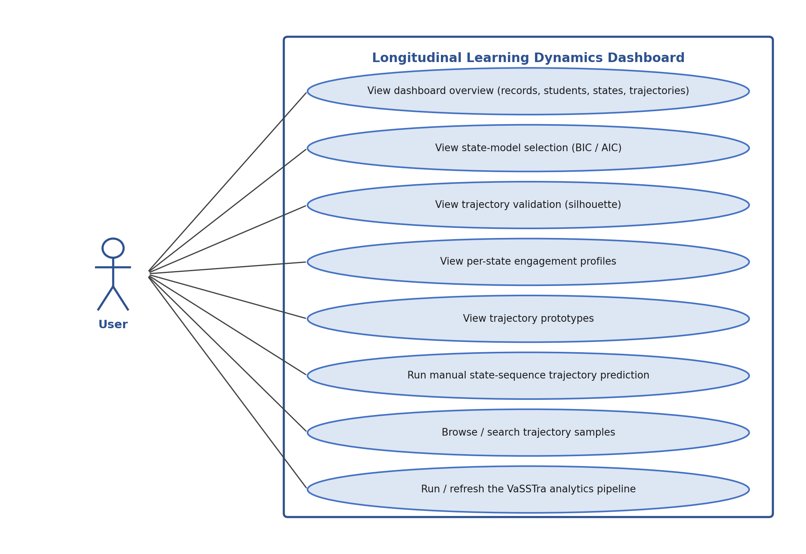
Figure 1. Use case diagram of the system

Use Case 1: View the Analytics Dashboard
ID | UC001
Name | View the Analytics Dashboard
Description | The User opens the dashboard and reviews the dataset overview, the model selection and trajectory validation metrics, the per state engagement profiles, and the trajectory prototypes.
Requirement(s) | FR003, FR004, FR005, FR006, FR007
Actor(s) | User
Precondition | The pipeline has been run and dashboard.json exists; the frontend is open in a web browser.
Postcondition | The dashboard displays the generated analytics.
Basic Flow | 1. The User opens the dashboard page. 2. The page loads dashboard.json. 3. The overview cards, the BIC/AIC and silhouette charts, the state profile chart, and the trajectory prototype cards are rendered. 4. The User selects a state from the dropdown to update the profile chart.
Alternative Flow | If dashboard.json is missing, the page shows a message asking the User to run the backend pipeline first.
Exceptions | The artifact file cannot be loaded because it has not been generated.
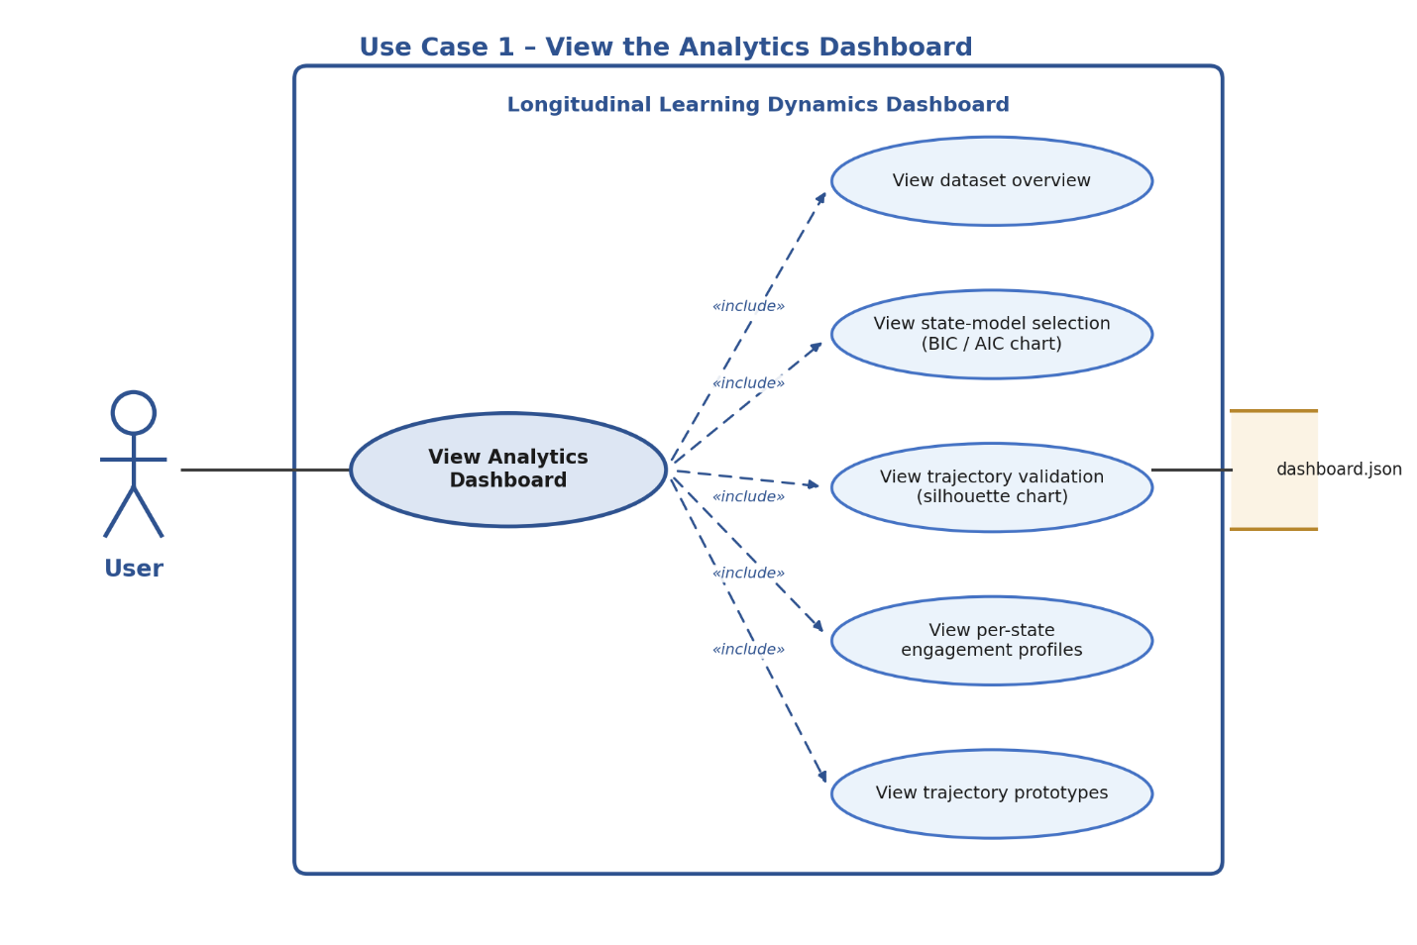
Figure 2. Use case detail for UC001 – View the Analytics Dashboard

Use Case 2: Run Manual Trajectory Prediction
ID | UC002
Name | Run Manual Trajectory Prediction
Description | The User selects an engagement state for each of the eight time points and submits the sequence to estimate the closest trajectory.
Requirement(s) | FR002, FR008
Actor(s) | User
Precondition | The backend API is running and the dashboard is loaded.
Postcondition | The closest trajectory and the per trajectory mismatch scores are displayed.
Basic Flow | 1. The User sets a state for each of the eight steps. 2. The User clicks “Estimate Trajectory”. 3. The frontend posts the sequence to the prediction endpoint. 4. The backend counts position mismatches against each trajectory prototype and returns the closest one. 5. The result card and the mismatch bar chart are updated.
Alternative Flow | The User clicks “Reset Defaults” to restore the default sequence and reruns the estimate.
Exceptions | The backend is unreachable or returns an error; the dashboard shows a message indicating that the API must be started.
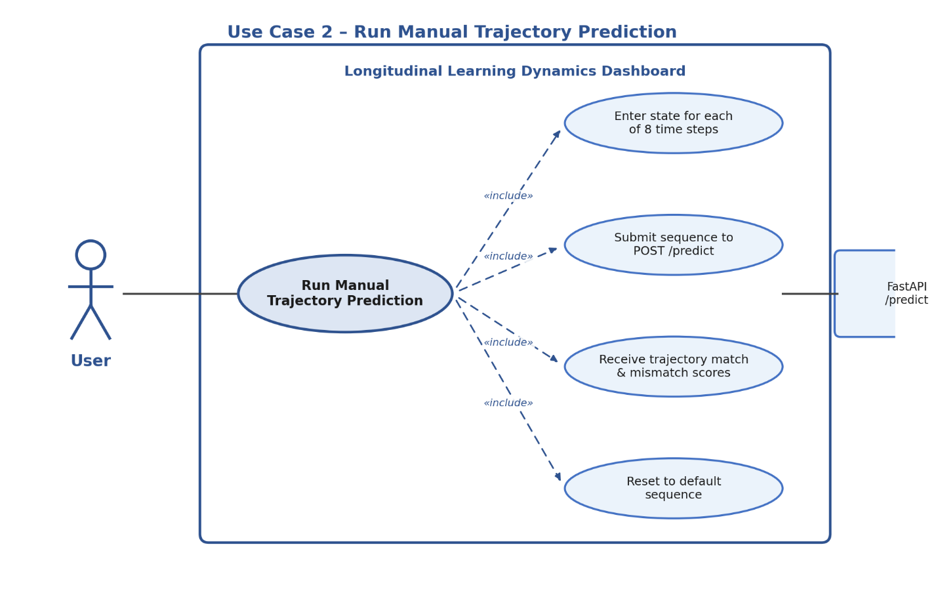
Figure 3. Use case detail for UC002 – Run Manual Trajectory Prediction

Use Case 3: Browse and Search Trajectory Samples
ID | UC003
Name | Browse and Search Trajectory Samples
Description | The User browses the per student samples and filters them by student identifier.
Requirement(s) | FR009
Actor(s) | User
Precondition | dashboard.json is loaded in the browser.
Postcondition | The samples table reflects the current search filter.
Basic Flow | 1. The samples table lists students with their trajectory, final grade, and eightstep state sequence. 2. The User types a student identifier in the search box. 3. The table updates to show only the matching rows.
Alternative Flow | An empty search box shows all available samples.
Exceptions | A search term that matches no student yields an empty table.
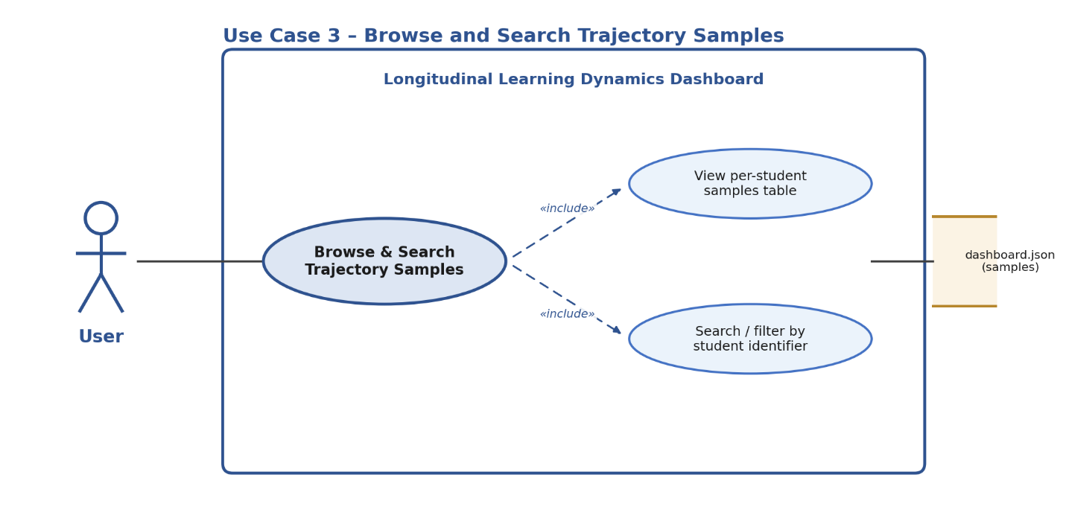
Figure 4. Use case detail for UC003 – Browse and Search Trajectory Samples

Use Case 4: Run / Refresh the VaSSTra Pipeline
ID | UC004
Name | Run / Refresh the VaSSTra Pipeline
Description | The User runs the offline pipeline to regenerate the analytical artifacts from the dataset.
Requirement(s) | FR001
Actor(s) | User
Precondition | The dataset LongitudinalEngagement.csv is present in the data/raw folder.
Postcondition | The processed CSVs, the output CSVs, and dashboard.json are (re)generated.
Basic Flow | 1. The User runs the pipeline launcher. 2. The pipeline standardizes the indicators, fits the Gaussian mixture model, builds the state sequences, clusters the trajectories, and estimates the Markov transitions. 3. The results are written to the output files. 4. The User opens or refreshes the dashboard.
Alternative Flow | The combined launcher also starts the API and serves the frontend automatically after the artifacts are generated.
Exceptions | The dataset is missing; the pipeline reports a file not found error and stops.
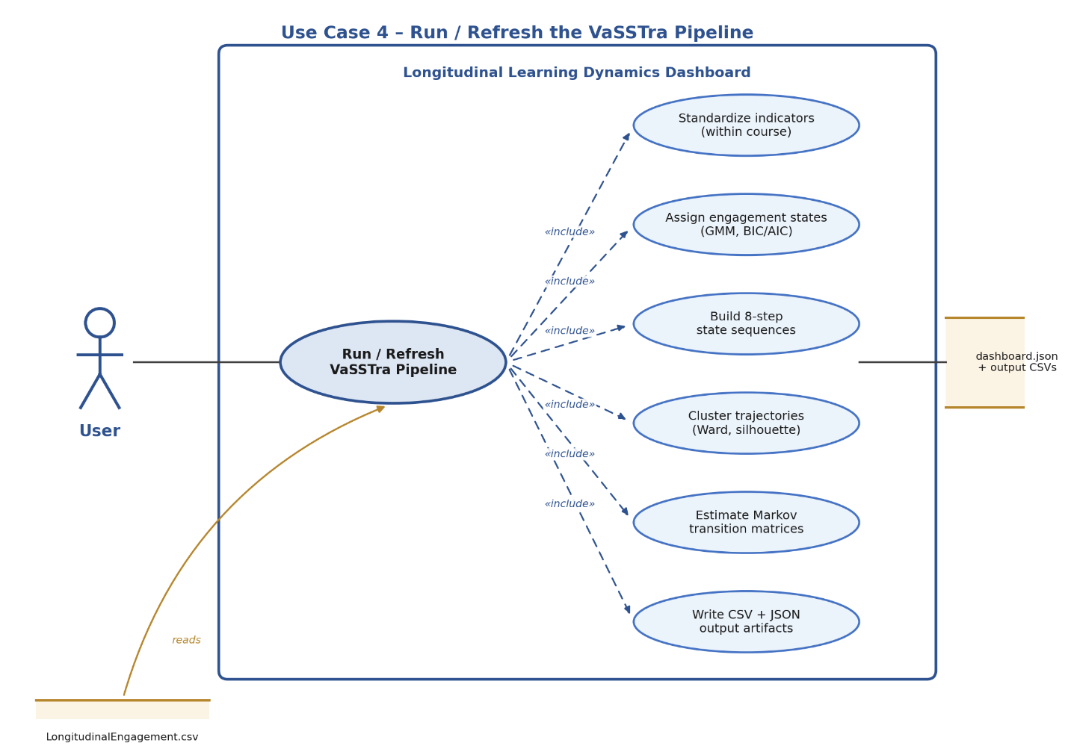
Figure 5. Use case detail for UC004 – Run / Refresh the VaSSTra Pipeline

4.2 Overview of System Models
The system is described by four complementary models: a use case diagram (behavioural), a system context diagram and two dataflow diagrams (structural and data), and a Markov state transition diagram (analytical). Together they show how the User interacts with the system, how data flows through the VaSSTra pipeline, and how learners move between engagement states.

4.3 System Context Diagram
The system is modeled as a single application that the User accesses through a web browser. It reads the engagement dataset (LongitudinalEngagement.csv), writes its results as JSON and CSV artifacts, and exchanges requests and results with the browser over local HTTP. There are no external services, databases, or learning management systems in scope.
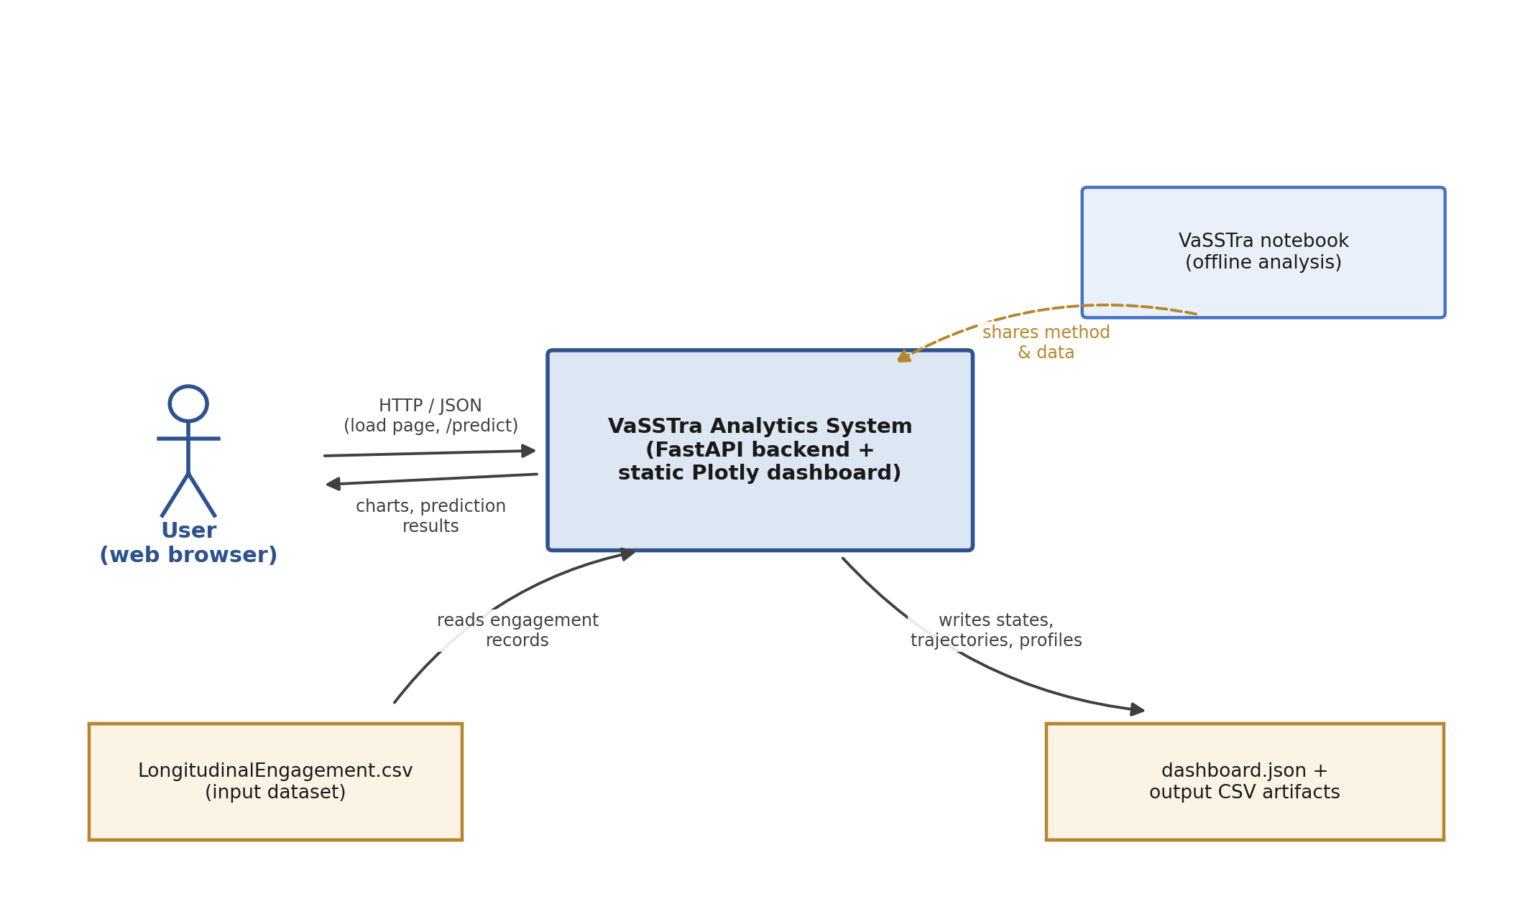
Figure 6. System context diagram

4.4 State Transition Model (Markov)
The system estimates a first order Markov transition matrix over the three engagement states. Each entry P[i, j] is the probability of moving from state i at one time point to state j at the next, estimated from every consecutive step pair across all students. The diagram below shows the estimated transitions: the states are most likely to persist (Disengaged 0.66, Average 0.64, Active 0.73), with the remaining probability describing movement between adjacent engagement levels.
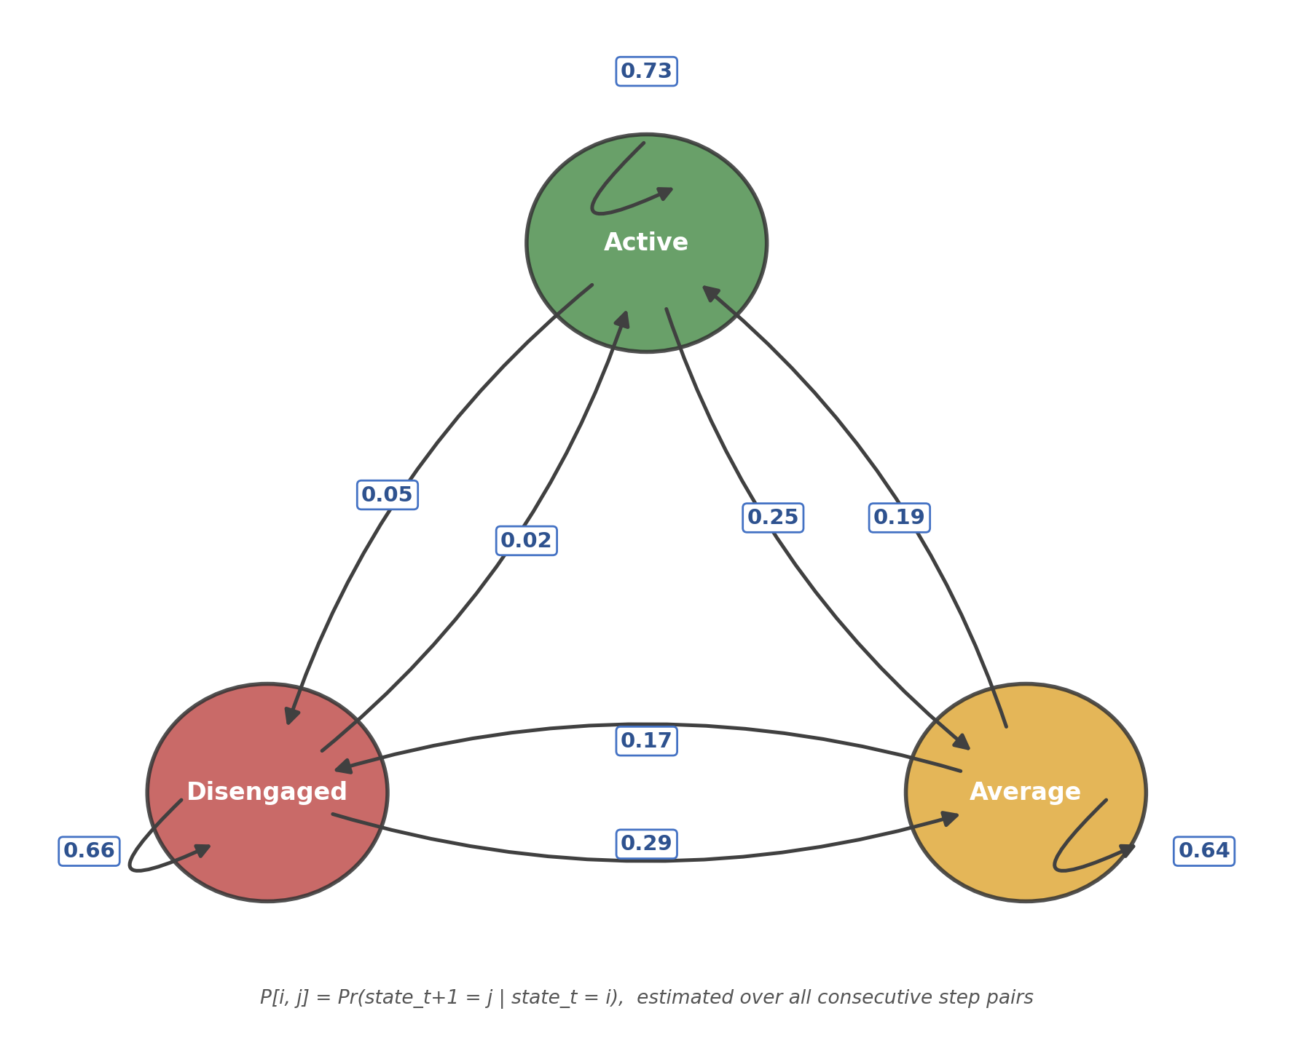
Figure 7. Markov state transition diagram over the three engagement states

4.5 Data Flow Diagrams (DFD)
The dataflow diagrams describe how engagement records are transformed into analytical results. The Level0 diagram gives the context level view, and the Level1 diagram decomposes the VaSSTra analytical pipeline into its processing steps.
DFD Level0 – VaSSTra Pipeline Overview
At the context level, the User interacts with a single process the VaSSTra analytics dashboard system which reads the engagement dataset, generates the dashboard artifacts, and returns analytics and prediction results to the User.
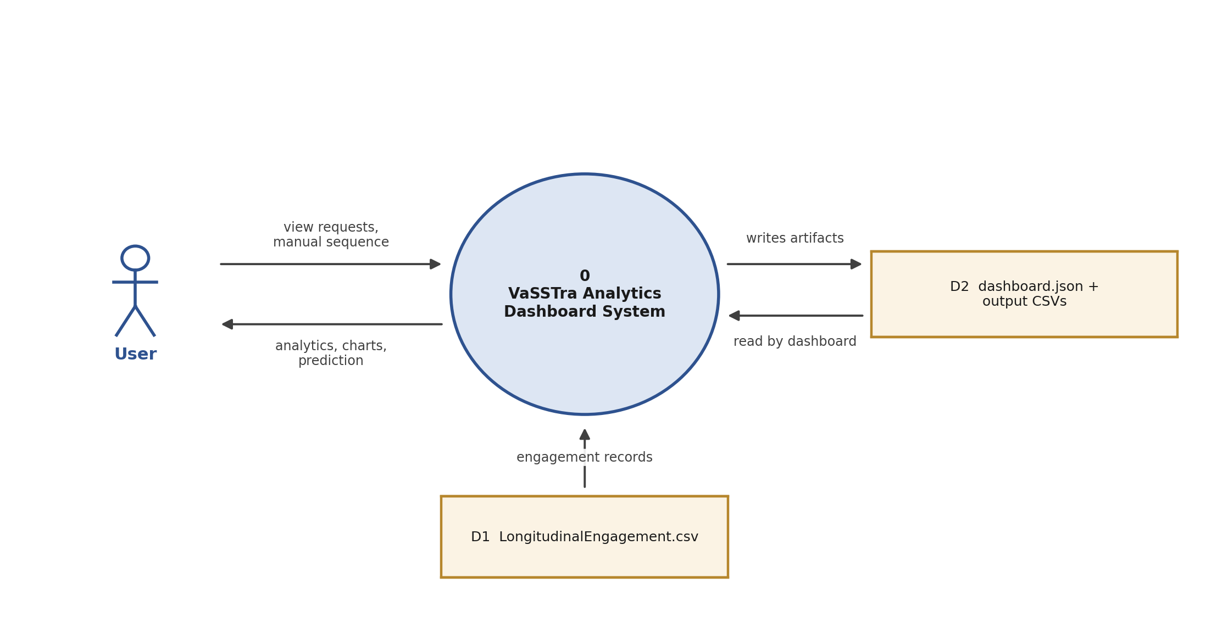
Figure 8. DFD Level0 – contextlevel data flow
DFD Level1 – State and Trajectory Processing
The Level1 diagram decomposes the pipeline into its steps: within course standardization, Gaussian mixture state assignment, eight step sequence construction, Ward trajectory clustering, Markov transition estimation, and building the dashboard artifacts that the frontend and prediction endpoint consume.
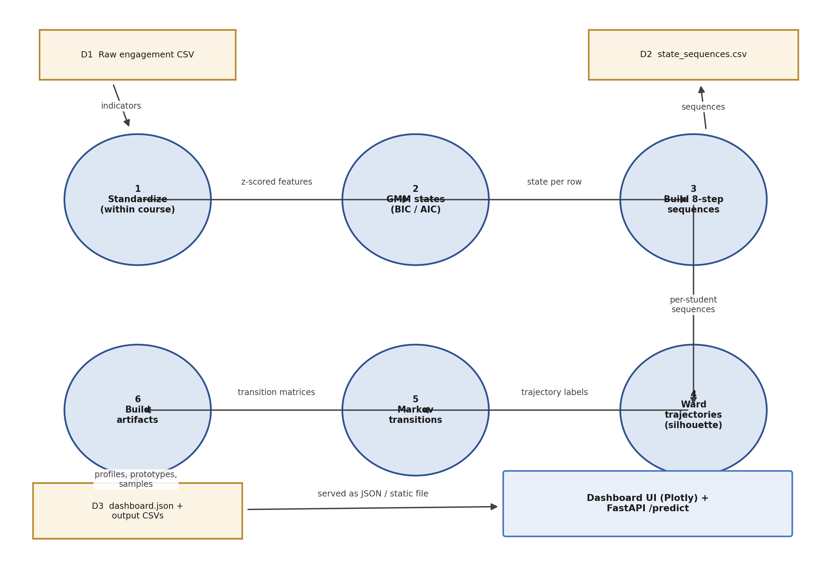
Figure 9. DFD Level1 – the VaSSTra analytical pipeline

5. System Architecture

5.1 High Level Architecture
The system uses a simple three tier offline architecture. An analytical pipeline (run_vasstra_pipeline.py) reads the dataset, performs the VaSSTra computations with scikit learn, and writes a set of CSV files and a consolidated dashboard.json.
A FastAPI service (api.py) loads dashboard.json at startup and exposes three endpoints (/health, /schema, /predict); the prediction endpoint scores a submitted state sequence against the stored trajectory prototypes. A static frontend (HTML, CSS, JavaScript, Plotly) fetches dashboard.json and calls the API to render charts, tables, and the manual prediction demo.
The three parts communicate only through the local file system and local HTTP on 127.0.0.1; there is no database, scheduler, or external dependency.
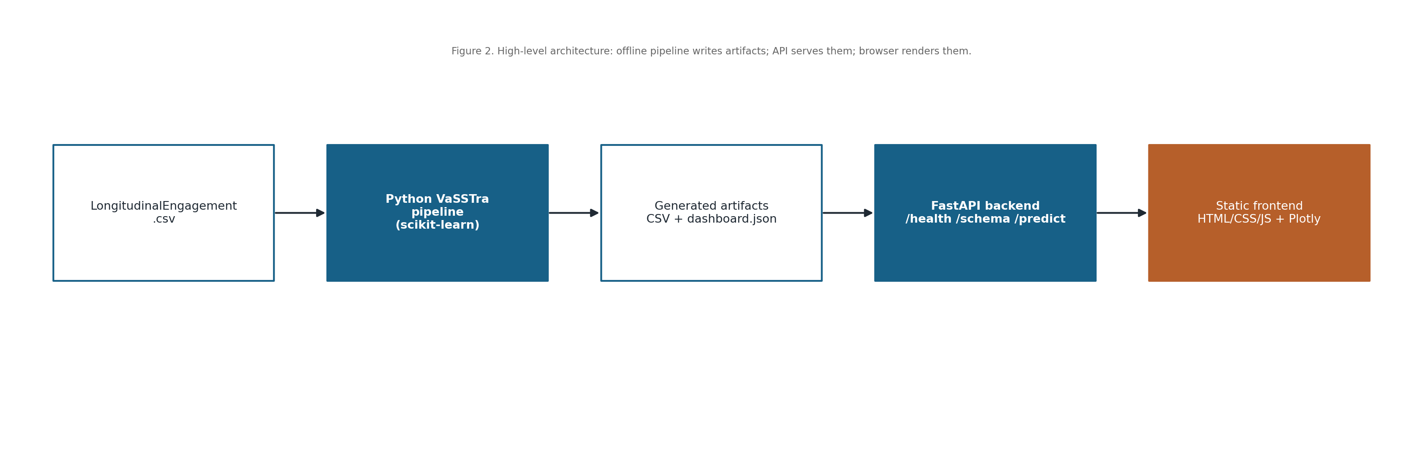
Figure 10. High level architecture: offline pipeline → artifacts → Fast API → browser dashboard

5.2 Component Architecture
The presentation layer is the static dashboard (index.html, css/styles.css, js/app.js) that renders all analytics with Plotly. The service layer is the Fast API application built by fyp_shared.api.create_app, which serves the generated results and handles prediction requests with permissive CORS for localhost.
The analytics layer is the Python pipeline that performs within course standardization, Gaussian mixture state assignment, sequence construction, and Ward trajectory clustering. The data layer is the local file system: the raw input CSV, the processed CSVs under data/processed, and the generated artifacts under outputs/backend.
No shared metadata service, message queue, or object store is used; the layers are coupled only through files and local HTTP.
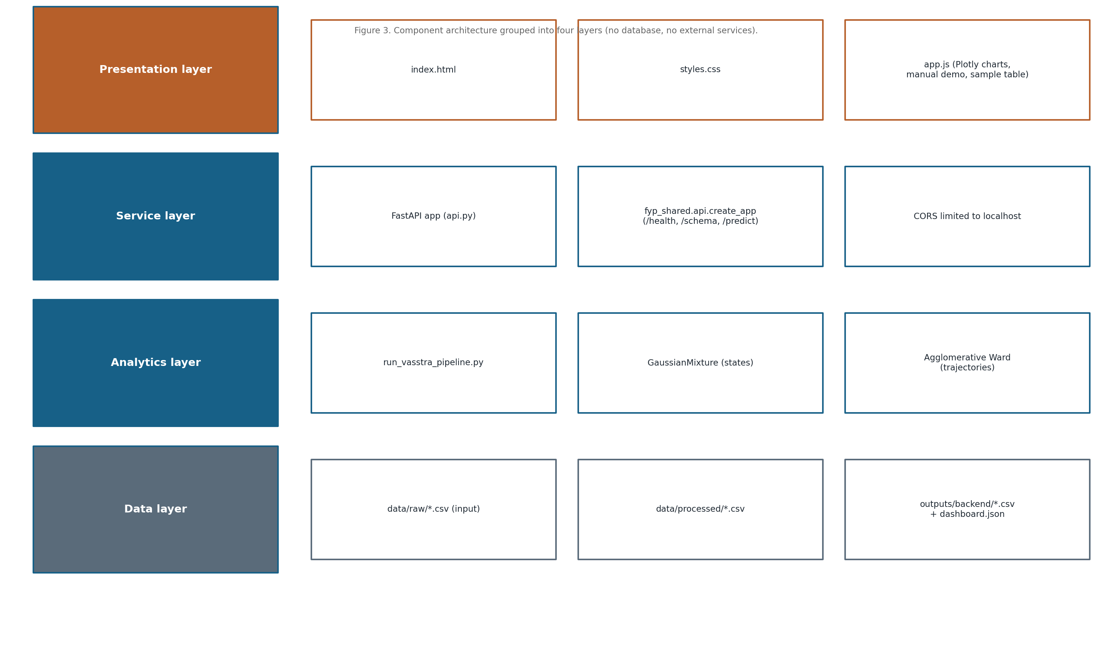
Figure 11. Component architecture grouped into presentation, service, analytics, and data layers

5.3 Technology Stack
Layer | Technology
Frontend | HTML5, CSS3, vanilla JavaScript (ES2020+), Plotly.js (vendored)
Backend / API | Python 3.11+, Fast API, served by uvicorn on 127.0.0.1:9511
Analytics | pandas, NumPy, scikit learn (Gaussian Mixture, Agglomerative Clustering)
Notebook | Jupyter, Matplotlib, SciPy (VaSSTra + Markov reproduction)
Storage | Local file system CSV input and CSV/JSON outputs (no database)

5.4 Module Breakdown
Module | Purpose
run_vasstra_pipeline.py | Offline VaSSTra pipeline; writes CSV artifacts and dashboard.json
api.py | Fast API app; /predict matches a state sequence to the closest trajectory
fyp_shared.api | Shared factory wiring /health, /schema, /predict and CORS
frontend/js/app.js | Loads dashboard.json, renders Plotly charts, drives the manual demo
notebook/vasstra_python.ipynb | Stepbystep VaSSTra and Markov transition reproduction
run/*.ps1, run/*.bat | Launchers for the pipeline, backend, frontend, notebook, and full project

6. Data Model and Schema

6.1 Entity Definitions
The core entities and generated artifacts of the system are described below.
Entity / Artifact | Description
Raw record | One CSV row: a student (UserID) in one course (CourseID) at one time point (Sequence)
State assignment | A raw record labelled with its engagement State (Disengaged/Average/Active) and probabilities
State sequence | One row per student: the ordered states step_1..step_8
Trajectory | A Ward cluster of similar state sequences, with a prototype path and label
Trajectory profile | Per trajectory size, prototype, state shares, and mean final grade
Markov matrix | First order state tostate transition probabilities derived from the sequences

6.2 Data Relationships (ER Diagram)
Each student has one engagement record per weekly time point. After state assignment, the records for a student form a single eight step state sequence; sequences are then clustered into trajectories.
Each trajectory aggregates the students assigned to it, summarising their dominant (prototype) state path, the share of time spent in each state, and the mean final grade. The generated artifacts are plain files, related by the User ID and trajectory keys rather than by a relational database.
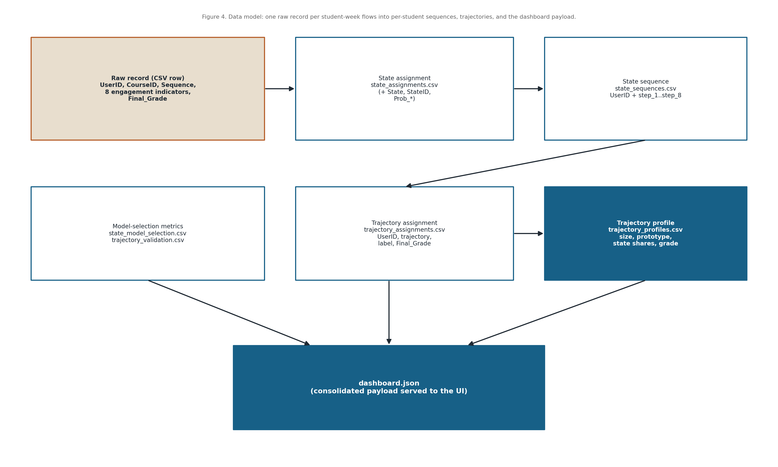
Figure 12. Data model: how a raw record flows into state sequences, trajectories, and dashboard.json

6.3 Dataset Schema and Data Dictionary
Field | Type | Description
UserID | String | Anonymized learner identifier
CourseID | String | Anonymized course identifier
Sequence | Integer | Weekly timepoint index (1–8)
Freq_Course_View | Integer | Count of course page views
Freq_Forum_Consume | Integer | Count of forum reads
Freq_Forum_Contribute | Integer | Count of forum posts
Freq_Lecture_View | Integer | Count of lecture views
Regularity_Course_View | Float | Regularity of course views
Regularity_Lecture_View | Float | Regularity of lecture views (not used for clustering)
Regularity_Forum_Consume | Float | Regularity of forum reading (not used for clustering)
Regularity_Forum_Contribute | Float | Regularity of forum posting (not used for clustering)
Session_Count | Integer | Number of learning sessions
Total_Duration | Integer | Total active duration (seconds)
Active_Days | Integer | Number of active days
Final_Grade | Float | Final course grade (analysis target)

6.4 Storage and File Layout
The system stores all data as files. The raw input is read once from data/raw; processed per student tables are written to data/processed; and model selection metrics, state and trajectory profiles, and the consolidated dashboard.json are written to outputs/backend.
Raw records are never overwritten. Each pipeline run regenerates the processed and output files, so the artifacts always reflect the current dataset and configuration; if a run fails, the previous artifacts remain on disk so the dashboard still loads.
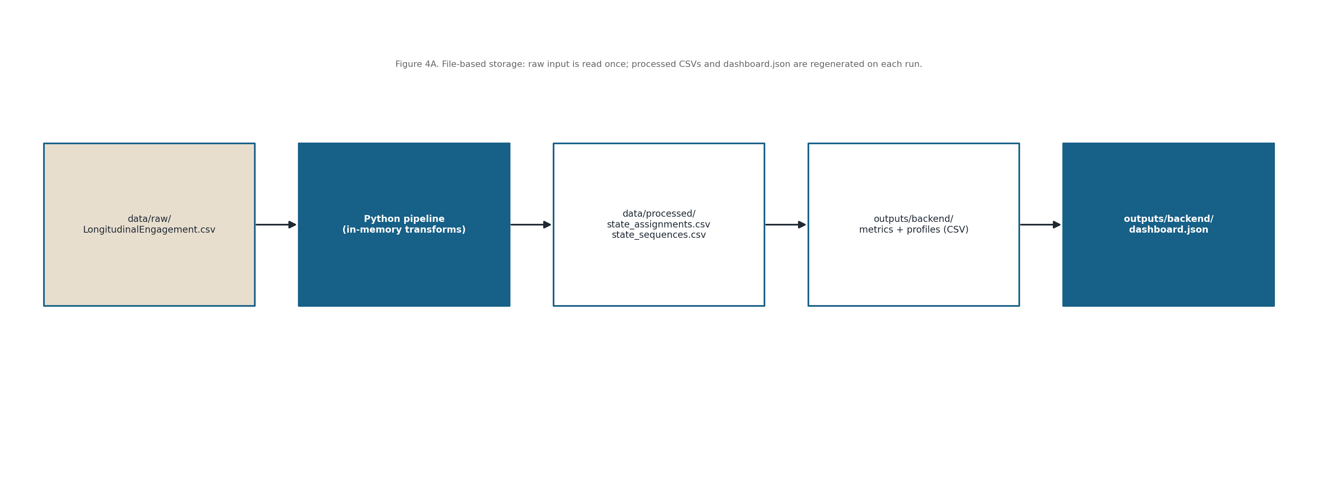
Figure 13. File based storage and processing layout (raw input, processed CSVs, and outputs)

7. User Interface Design

7.1 UI Mockups and Wireframes
The interface is a single scrolling dashboard page. A hero banner states the project title and a short VaSSTra description, followed by four summary cards (total records, unique students, number of states, number of trajectories).
Below the cards are paired panels for state model selection (BIC/AIC), trajectory validation (silhouette), per state engagement profiles, and trajectory prototype cards, then the manual states equence demo and a searchable trajectory samples table.
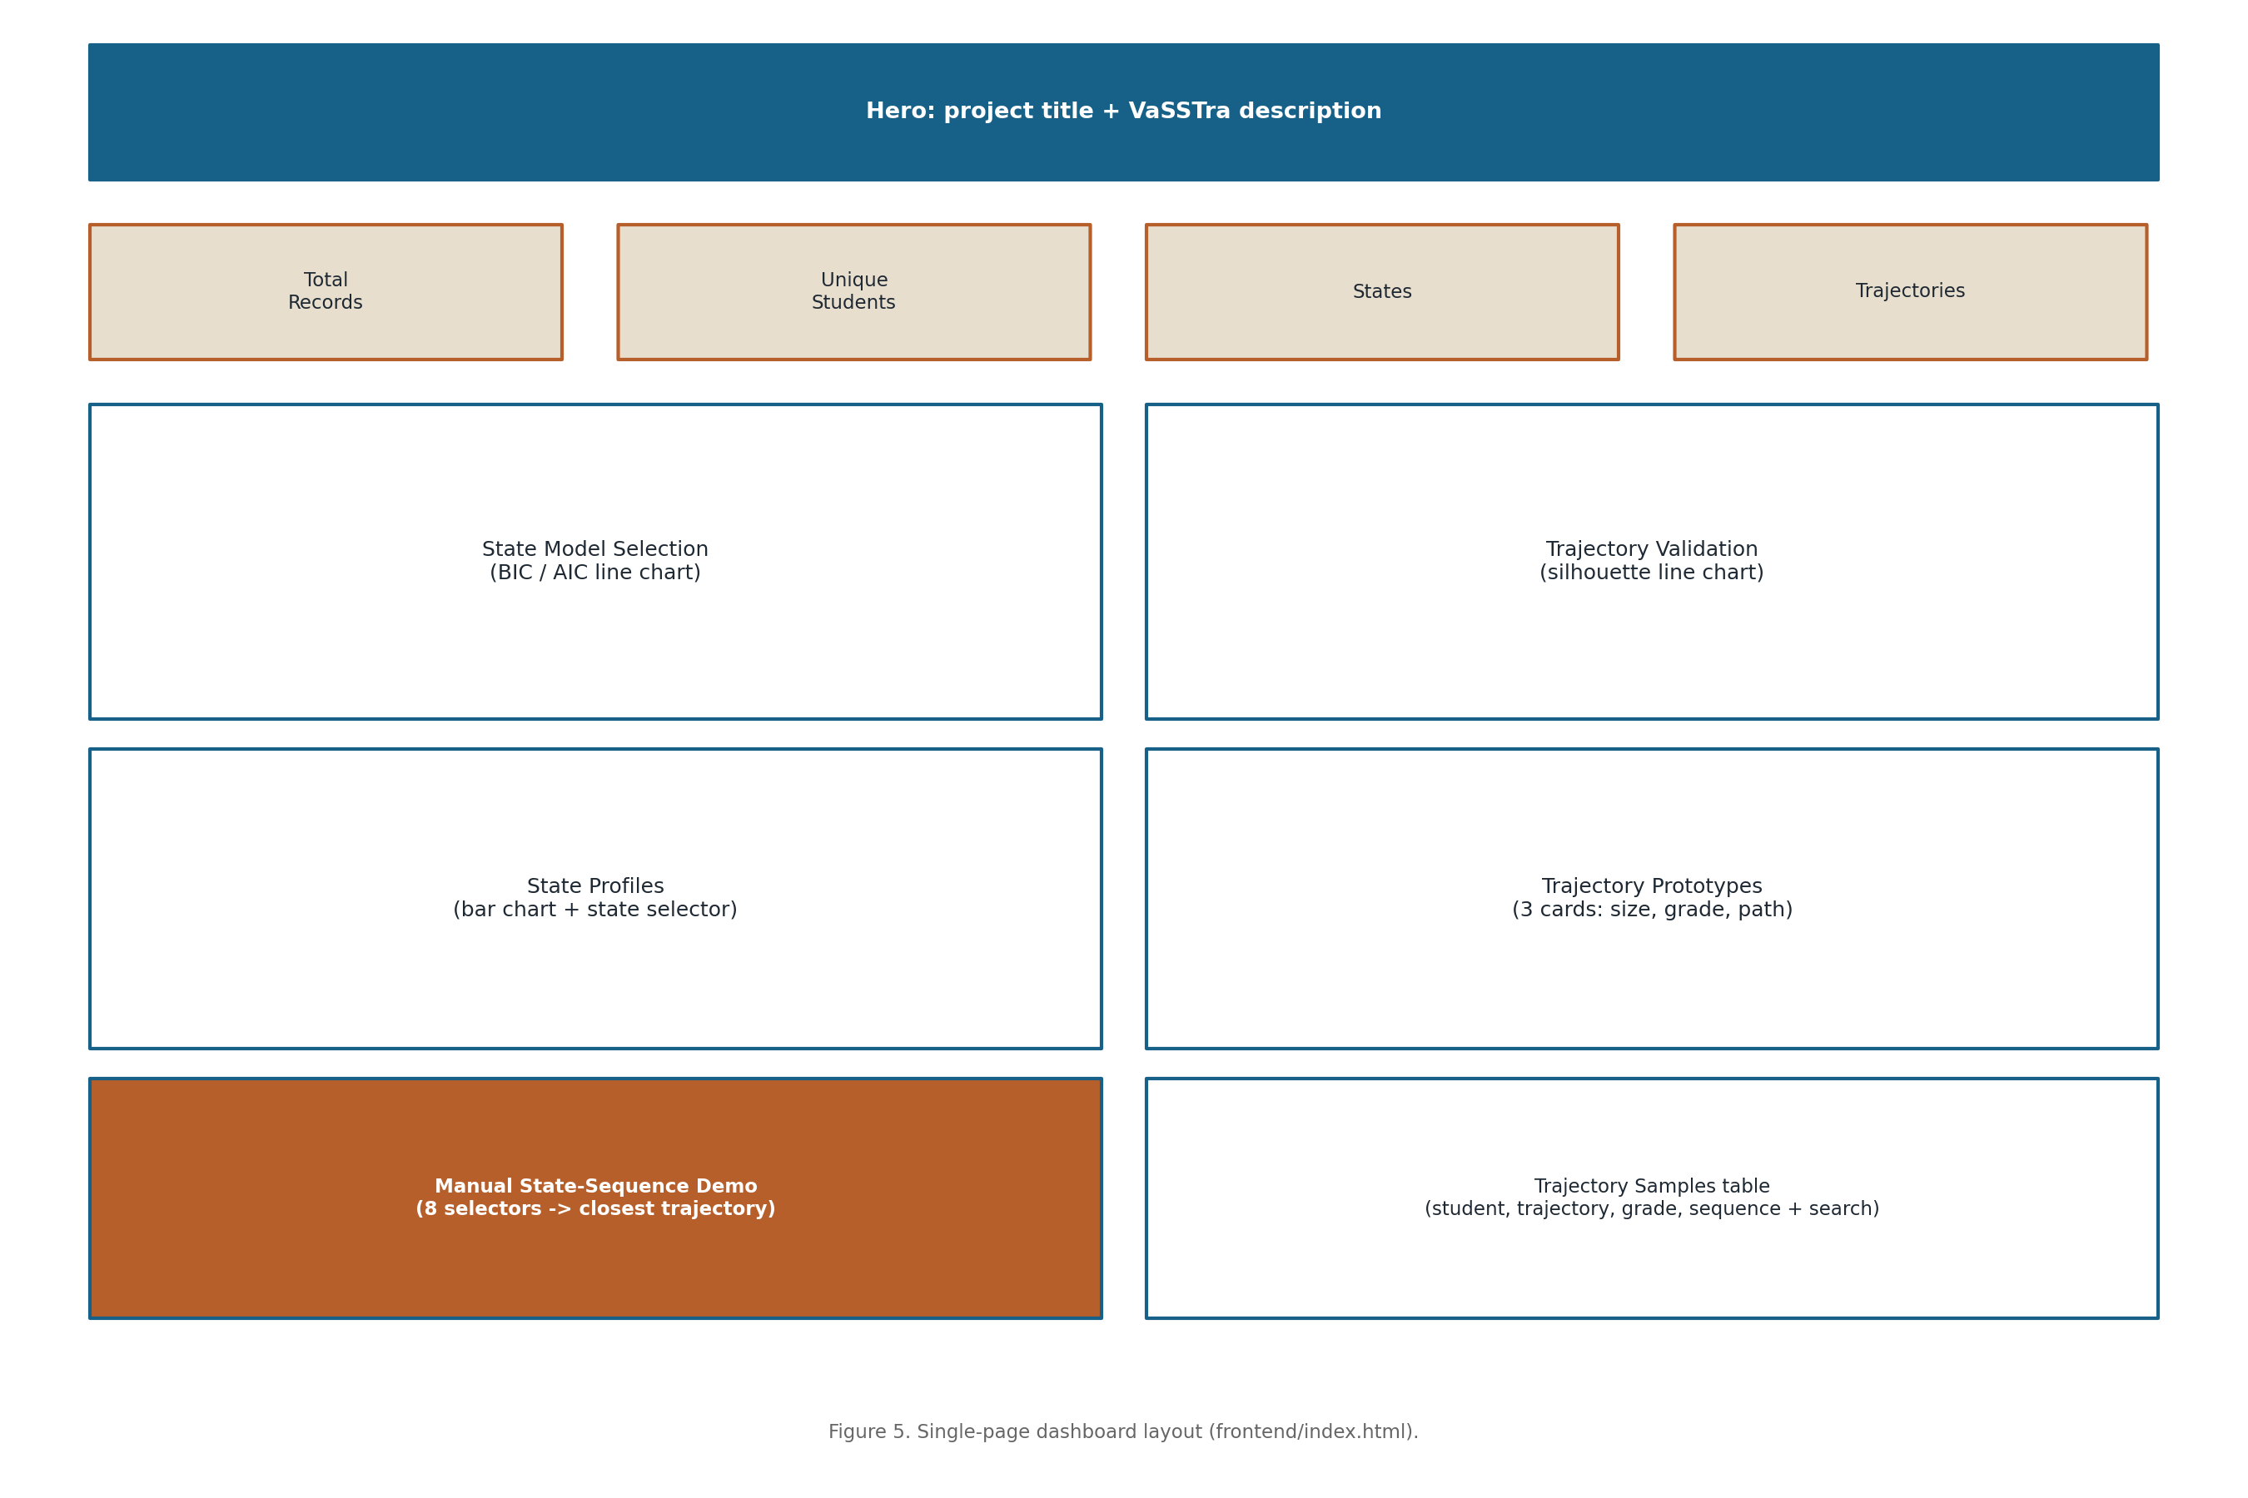
Figure 14. Single page dashboard layout (frontend/index.html)
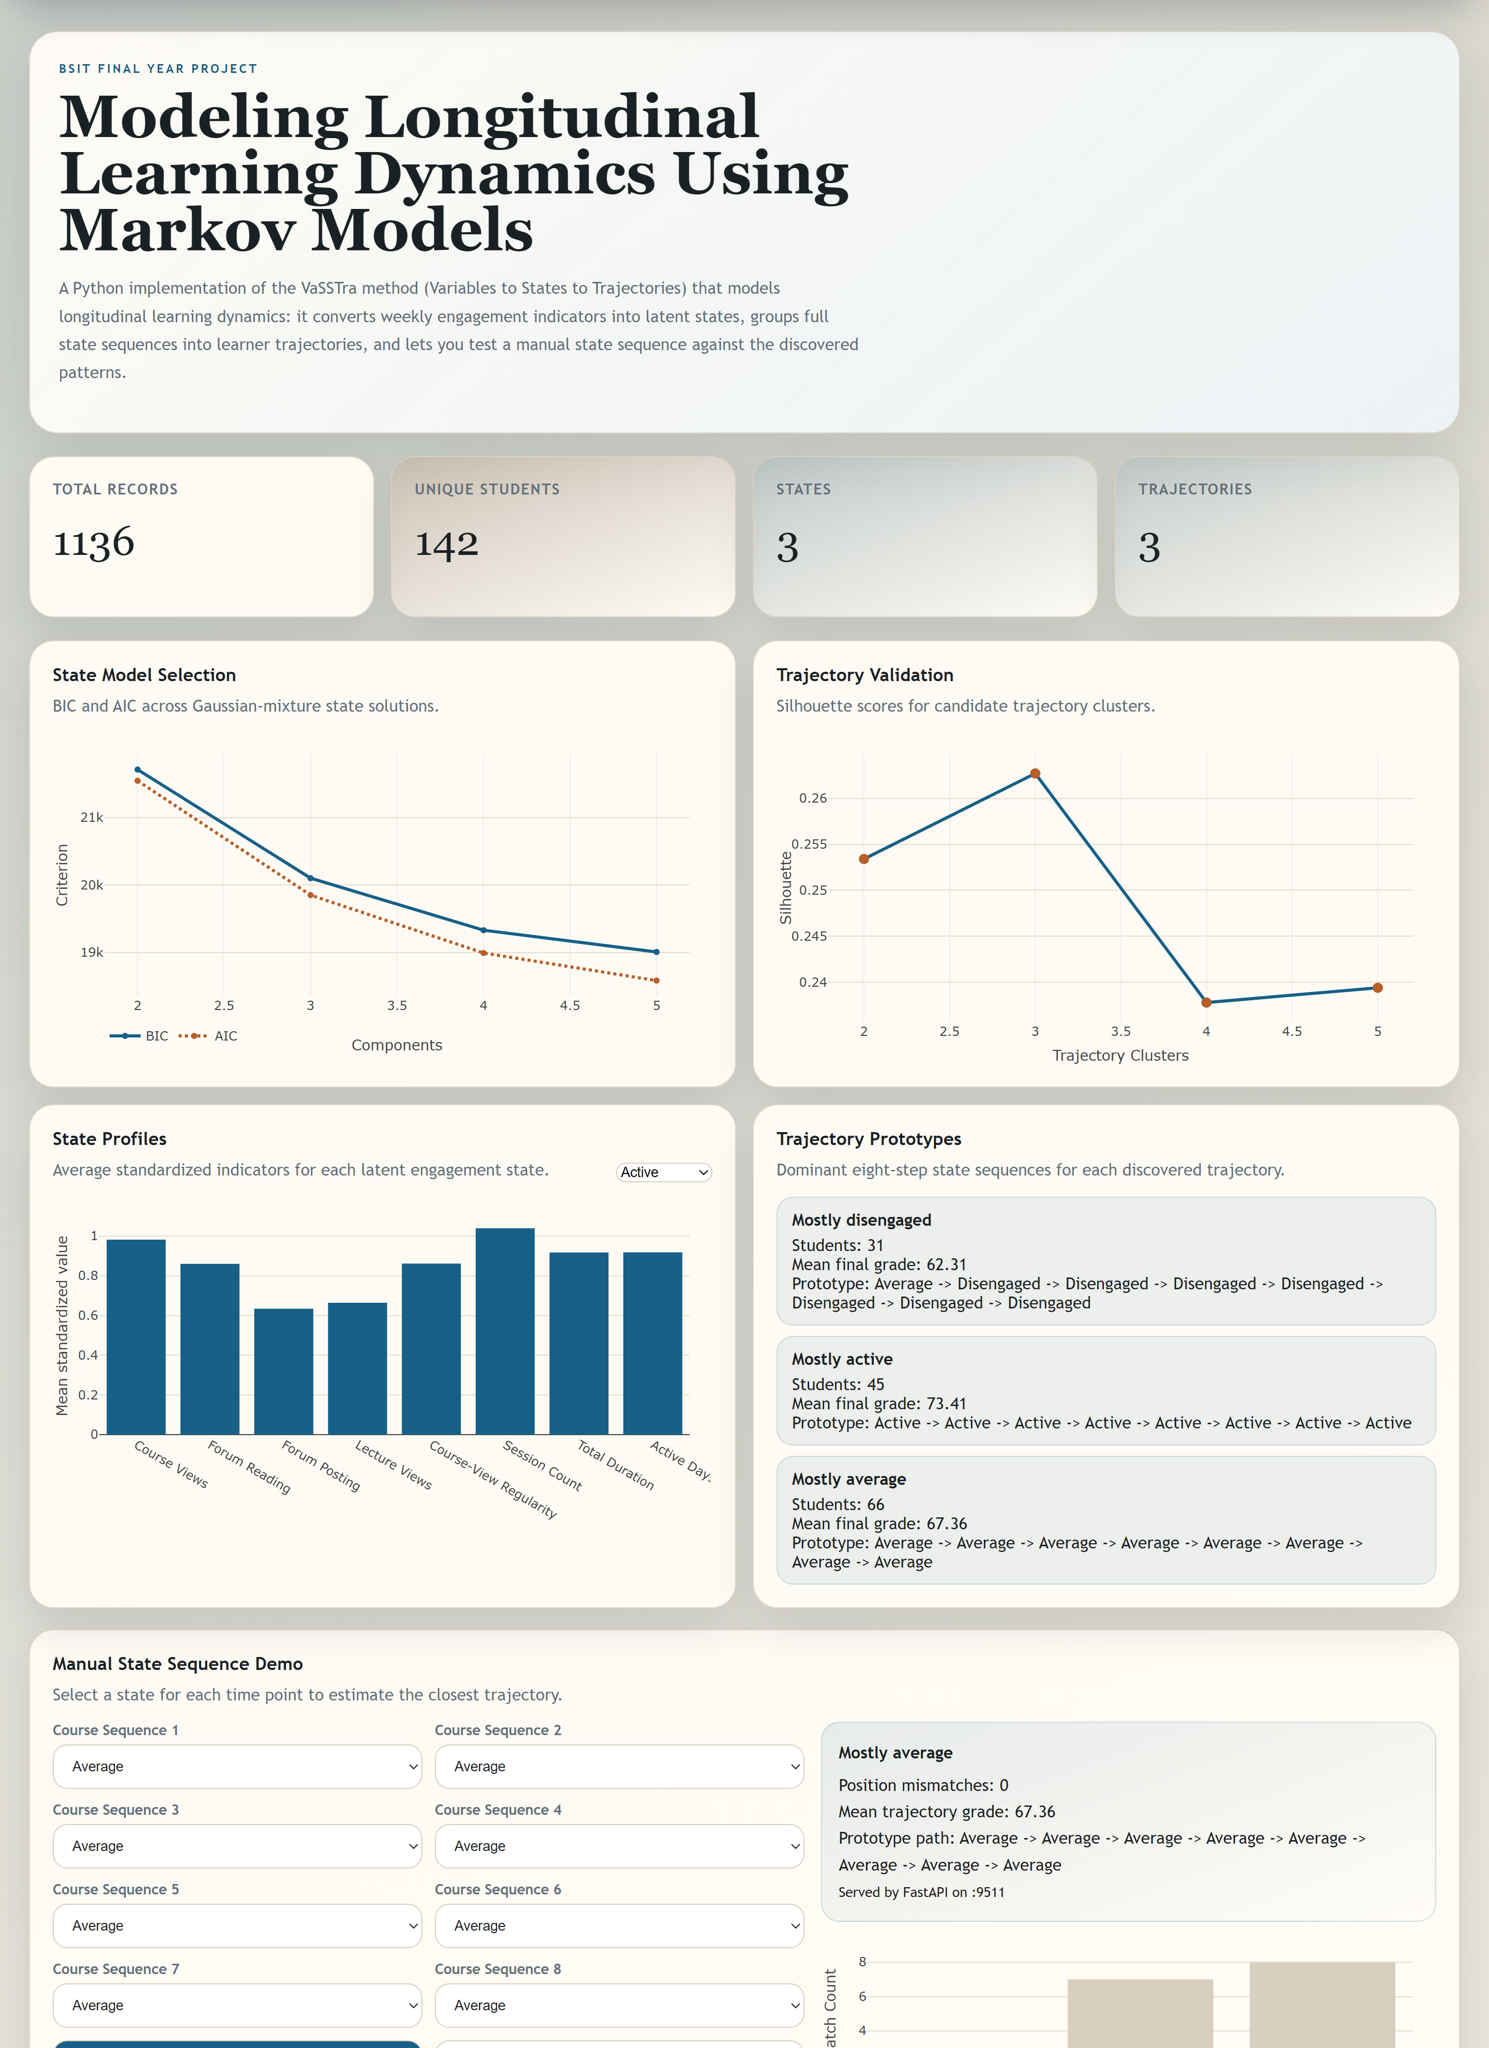
Figure 15. The implemented dashboard user interface (live rendering of the VaSSTra results)

7.2 Navigation Flow
There is no multipage navigation or login. Running the launcher regenerates dashboard.json, starts the API, and opens the single page in the browser.
All interaction happens on that page: the User reads the panels, selects a state to inspect its profile, submits an eight step sequence to the prediction endpoint, and searches the sample table.
The page reports backend status messages so the User knows whether the API and generated artifacts are available.
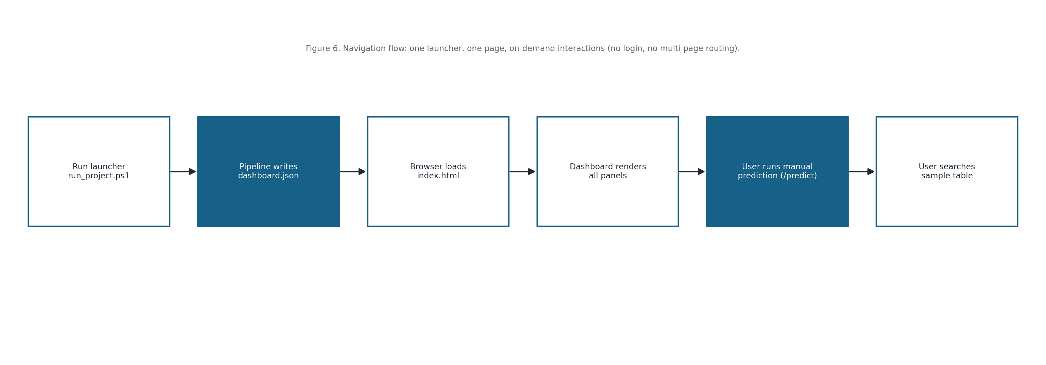
Figure 16. Navigation flow: one launcher, one page, on demand interactions

7.3 Visualization Components
- BIC/AIC line chart for Gaussian mixture state model selection.
- Silhouette line chart for trajectory cluster validation.
- Per state bar chart of mean standardized engagement indicators (with a state selector).
- Trajectory prototype cards showing size, mean final grade, and the eight step state path.
- Manual prediction bar chart of position mismatches against each trajectory prototype.

7.4 User Interaction Guidelines
Charts update live in response to the state selector, the manual demo form, and the sample search box, all without a page reload.
A clear distinction is kept between viewing the precomputed results and submitting a manual prediction; the prediction is the only action that contacts the backend API.
A consistent colour mapping is used for the three engagement states across the charts and the prototype cards.

8. Component and API Design

8.1 Module Specifications

Analytical Pipeline (run_vasstra_pipeline.py)
Input: data/raw/LongitudinalEngagement.csv. Processing: orchestrates the full VaSSTra run within course standardization, state model evaluation, state assignment, sequence construction, trajectory validation and clustering, and profile building.
Output: processed CSVs (state_assignments.csv, state_sequences.csv), output CSVs (state_model_selection, trajectory_validation, state_profiles, trajectory_profiles, trajectory_assignments), and dashboard.json. Errors (e.g. a missing dataset) are raised with a clear message.

State Discovery (assign_states / GaussianMixture)
Input: the standardized indicator matrix. Processing: fits a three component diagonal covariance Gaussian mixture (random seed 2026, 15 restarts), orders components by mean level, and labels them Disengaged → Average → Active.
Output: a State label, State ID, and per state membership probabilities for every record; a candidate scan (2–5 components) reports BIC and AIC for model selection.

Sequence and Trajectory Construction
Input: the state labelled records. Processing: pivots each student’s states into an eight step sequence (missing steps default to Average), one hot encodes the steps, and applies Ward agglomerative clustering, selecting the number of trajectories by silhouette score.
Output: per student state sequences and trajectory assignments, plus per trajectory prototypes, state shares, and mean final grades.

Result Serving API (api.py + fyp_shared.api)
Input: HTTP requests. Processing: loads dashboard.json once at startup and exposes /health, /schema, and /predict through the shared create_app factory, with CORS limited to localhost origins.
Output: service status and title (/health), the input schema and trajectory profiles (/schema), and prediction results (/predict). Invalid input returns a 422; unexpected errors return a 500 with detail.

Trajectory Prediction (predict)
Input: an object mapping step_1… step_8 to a chosen state. Processing: builds the ordered sequence and, for each trajectory prototype, counts the number of position mismatches; the closest trajectory is the one with the fewest mismatches.
Output: the best matching trajectory label, its mismatch count, mean final grade, and prototype path, plus the mismatch score for every trajectory.

Frontend Dashboard (frontend/js/app.js)
Input: dashboard.json and the /predict response. Processing: renders the overview cards, the four analytics charts, the prototype cards, the manual demo form, and the sample table using Plotly and the DOM.
Output: the rendered, interactive dashboard; it also surfaces human readable status messages when the artifacts or backend are unavailable.

8.2 API Specifications
Method | Endpoint | Description
GET | /health | Returns {ok, title}; confirms the service is running
GET | /schema | Returns the input schema, state list, and trajectory profiles
POST | /predict | Matches a submitted eightstep state sequence to the closest trajectory

8.3 Class and Sequence Diagrams
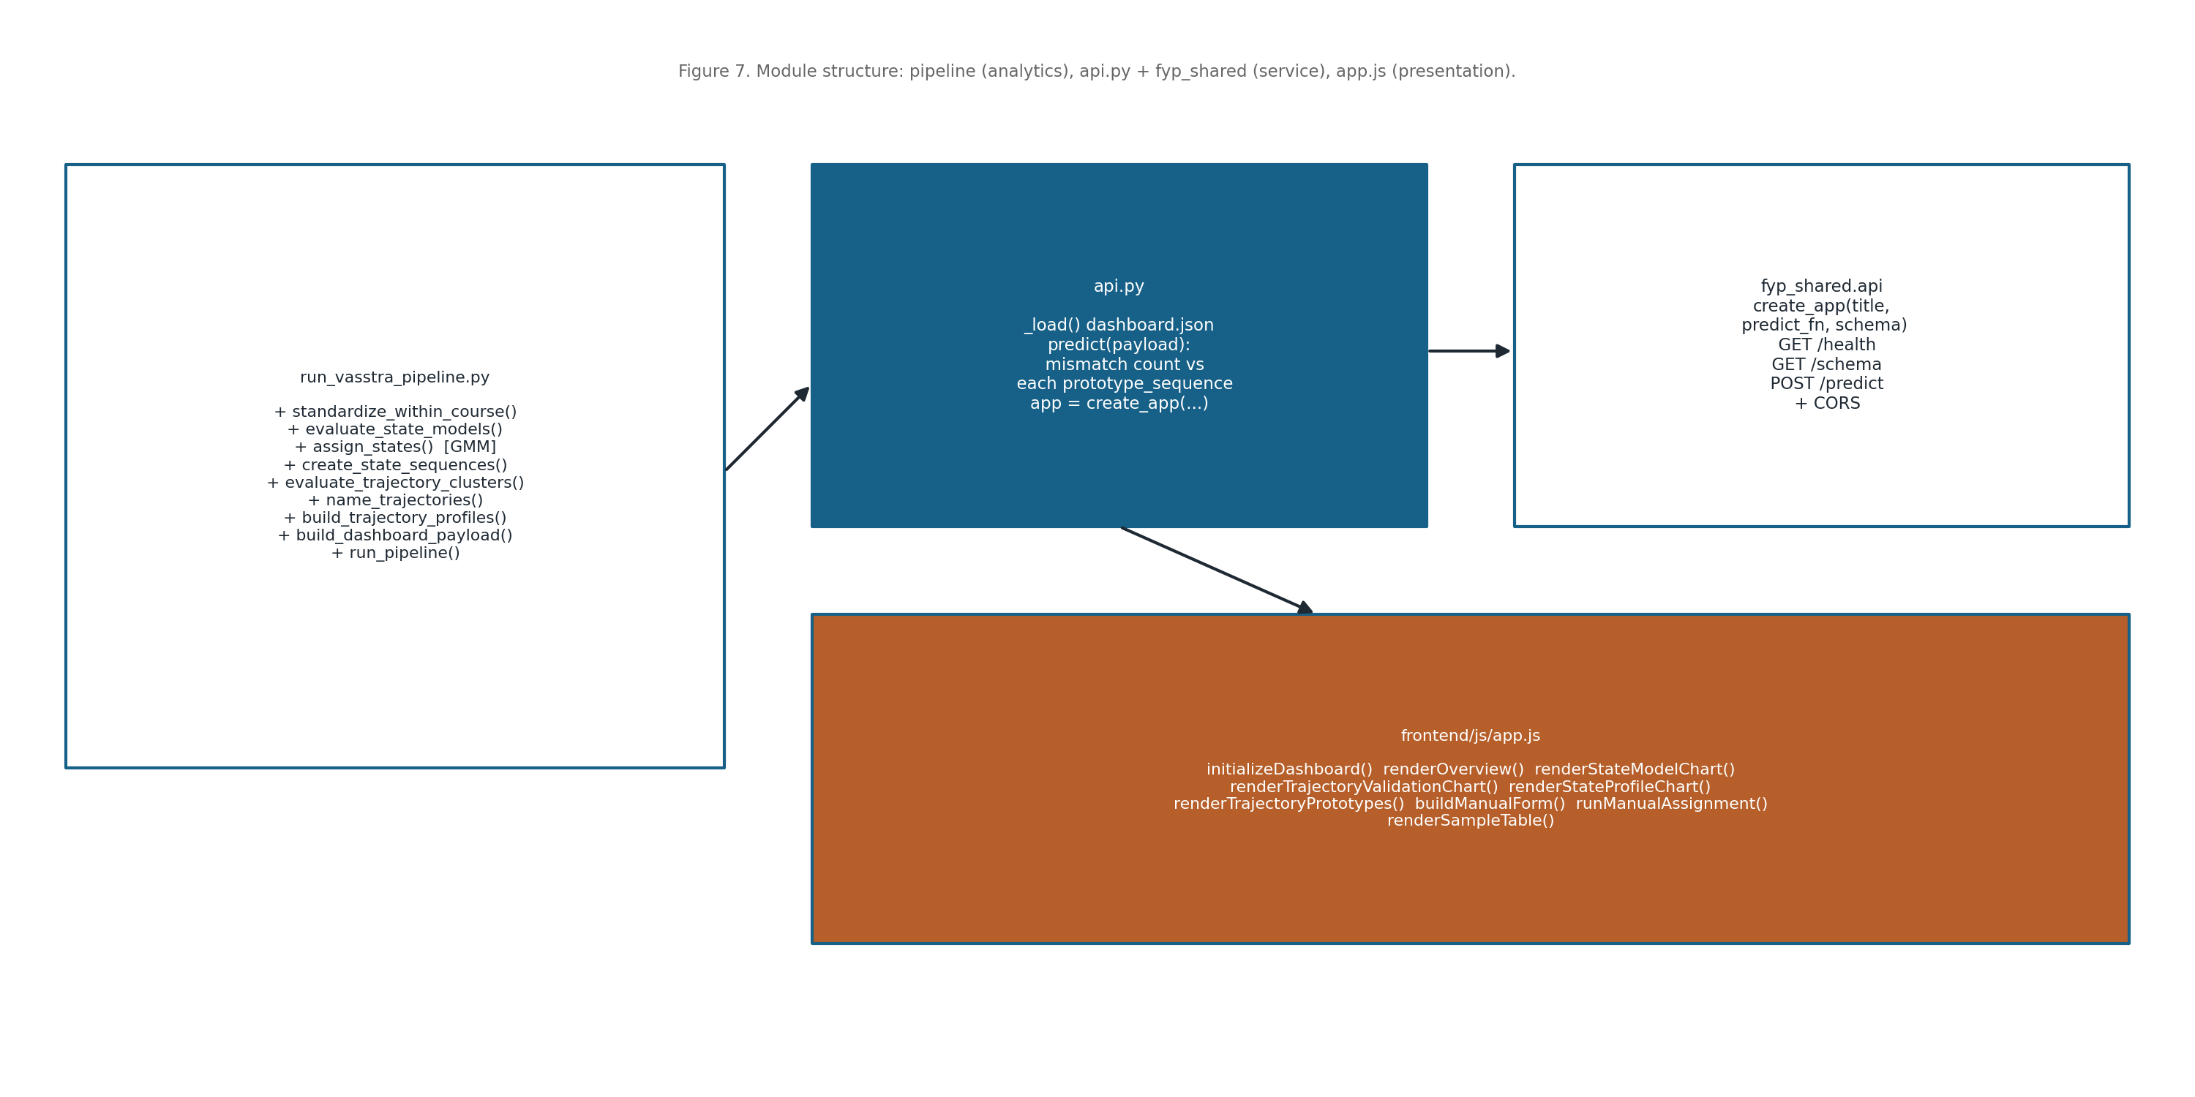
Figure 17. Module and function structure across the pipeline, API, and frontend
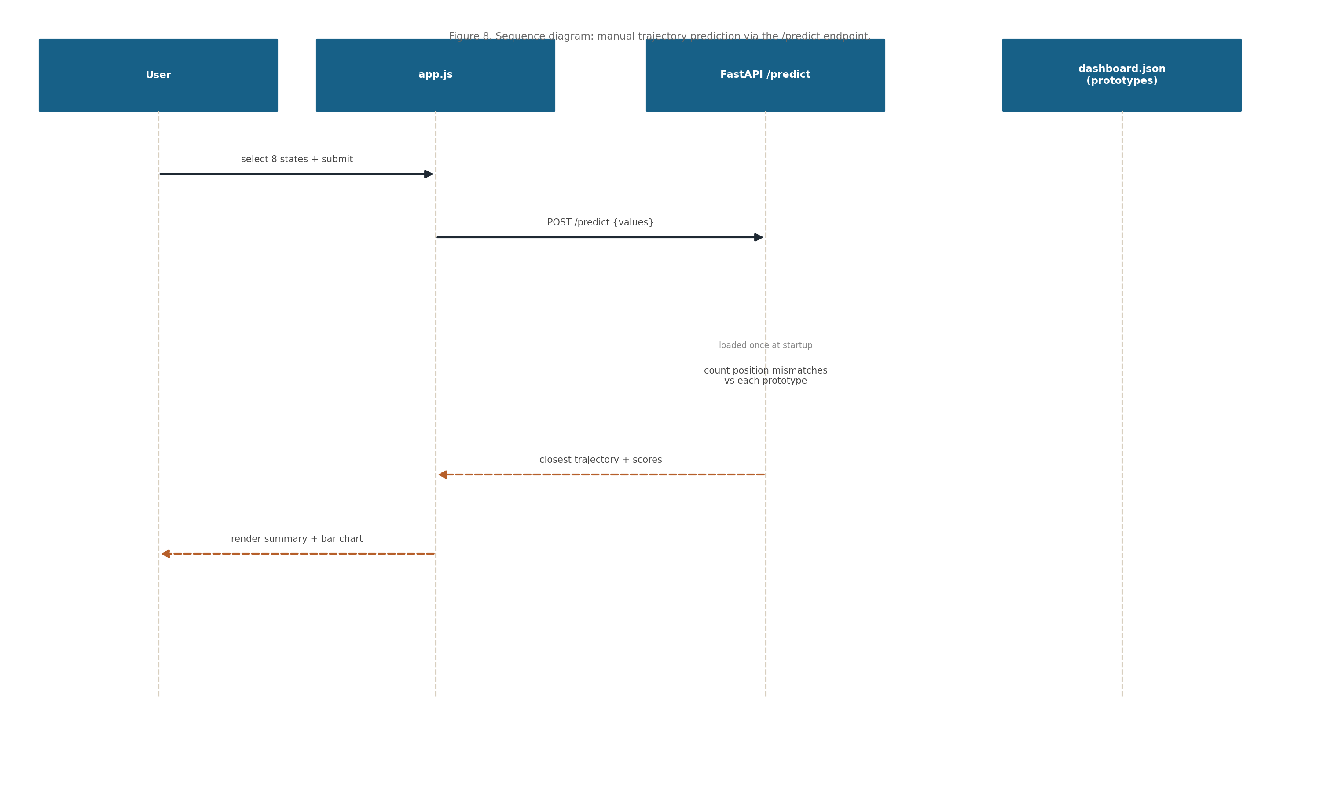
Figure 18. Sequence diagram: manual trajectory prediction via the /predict endpoint

9. Algorithm and Methodology

9.1 Feature Engineering Pipeline
The pipeline begins by reading the engagement dataset and selecting the eight clustering indicators (course views, forum reading, forum posting, lecture views, course view regularity, session count, total duration, and active days).
Each indicator is standardized within its course (z scored per Course ID, with undefined values set to zero) so that engagement is compared relative to course mates rather than on raw scales.
The standardized indicators are the features used for Gaussian mixture state discovery; no sessionization or event log processing is required because the dataset is already aggregated per student week.
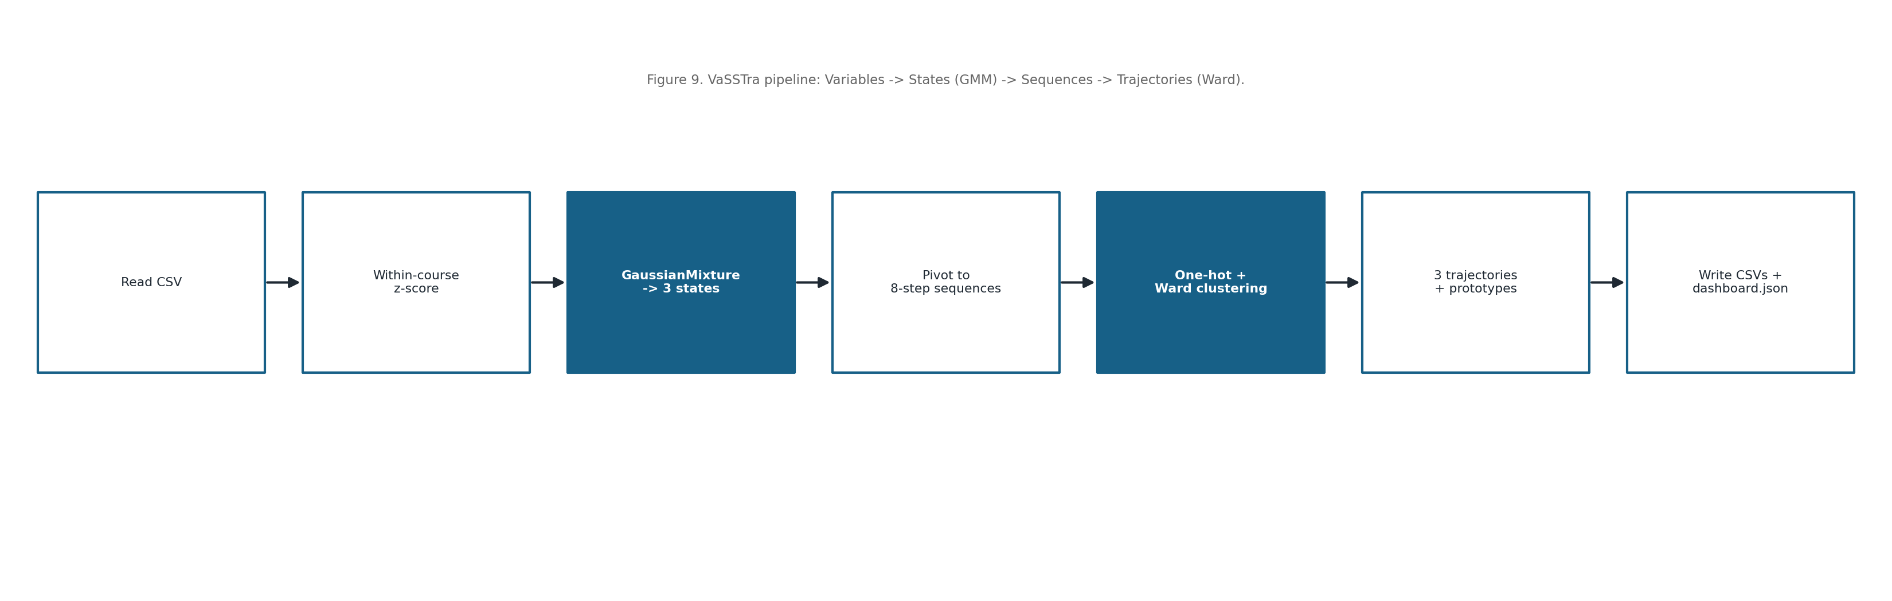
Figure 19. The VaSSTra analytical pipeline (Variables → States → Sequences → Trajectories)
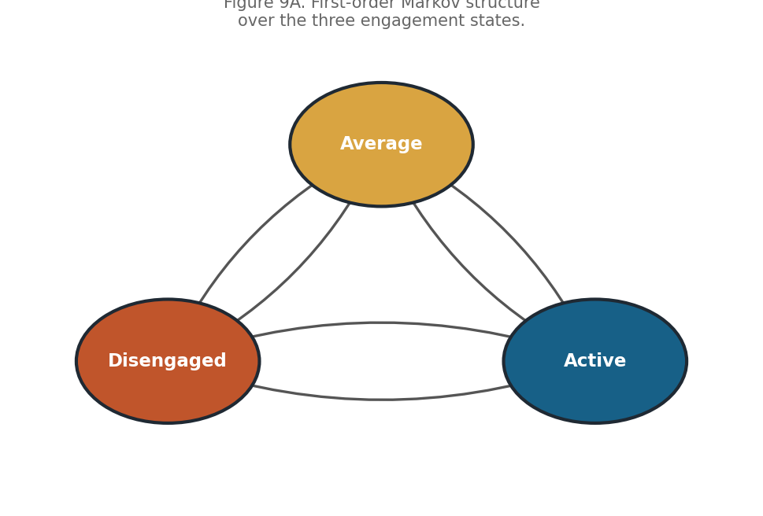
Figure 20. First order Markov structure over the three engagement states

9.2 Model Selection and Training
Engagement states are discovered with a Gaussian mixture model (the Python equivalent of latent profile analysis). Candidate solutions with 2–5 components are compared by BIC and AIC, and a three state model is chosen for interpretability (Disengaged, Average, Active).
Trajectories are formed by one hot encoding the eight step sequences and applying Ward agglomerative clustering; the number of trajectories (three) is selected using the silhouette score. The companion notebook additionally estimates first order Markov transition matrices, overall and per trajectory.

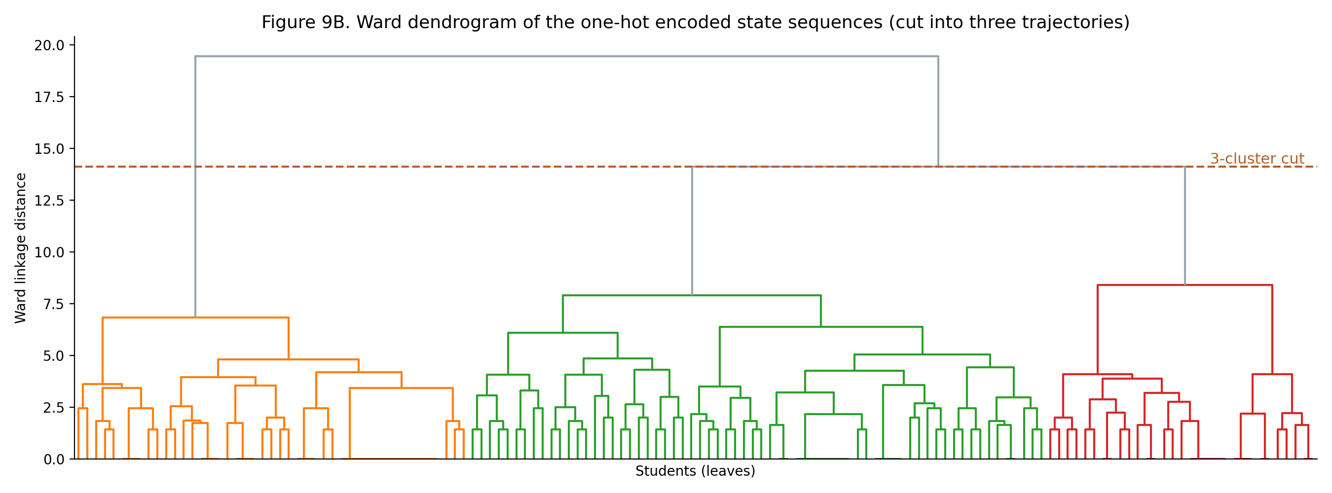
Figure 21. Ward dendrogram of the one hot encoded state sequences, cut into three trajectories

9.3 Processing Workflow
The state alphabet is the three engagement levels. After fitting, each student’s states are encoded as an eight step sequence, and the first order transition matrix counts how often each state follows another, normalized per row to probabilities.
The transition matrix, its steady state (stationary) distribution, and the comparison with the initial (first step) distribution are visualized to interpret how engagement persists and shifts over the course; trajectory prototypes summaries the dominant path of each cluster.
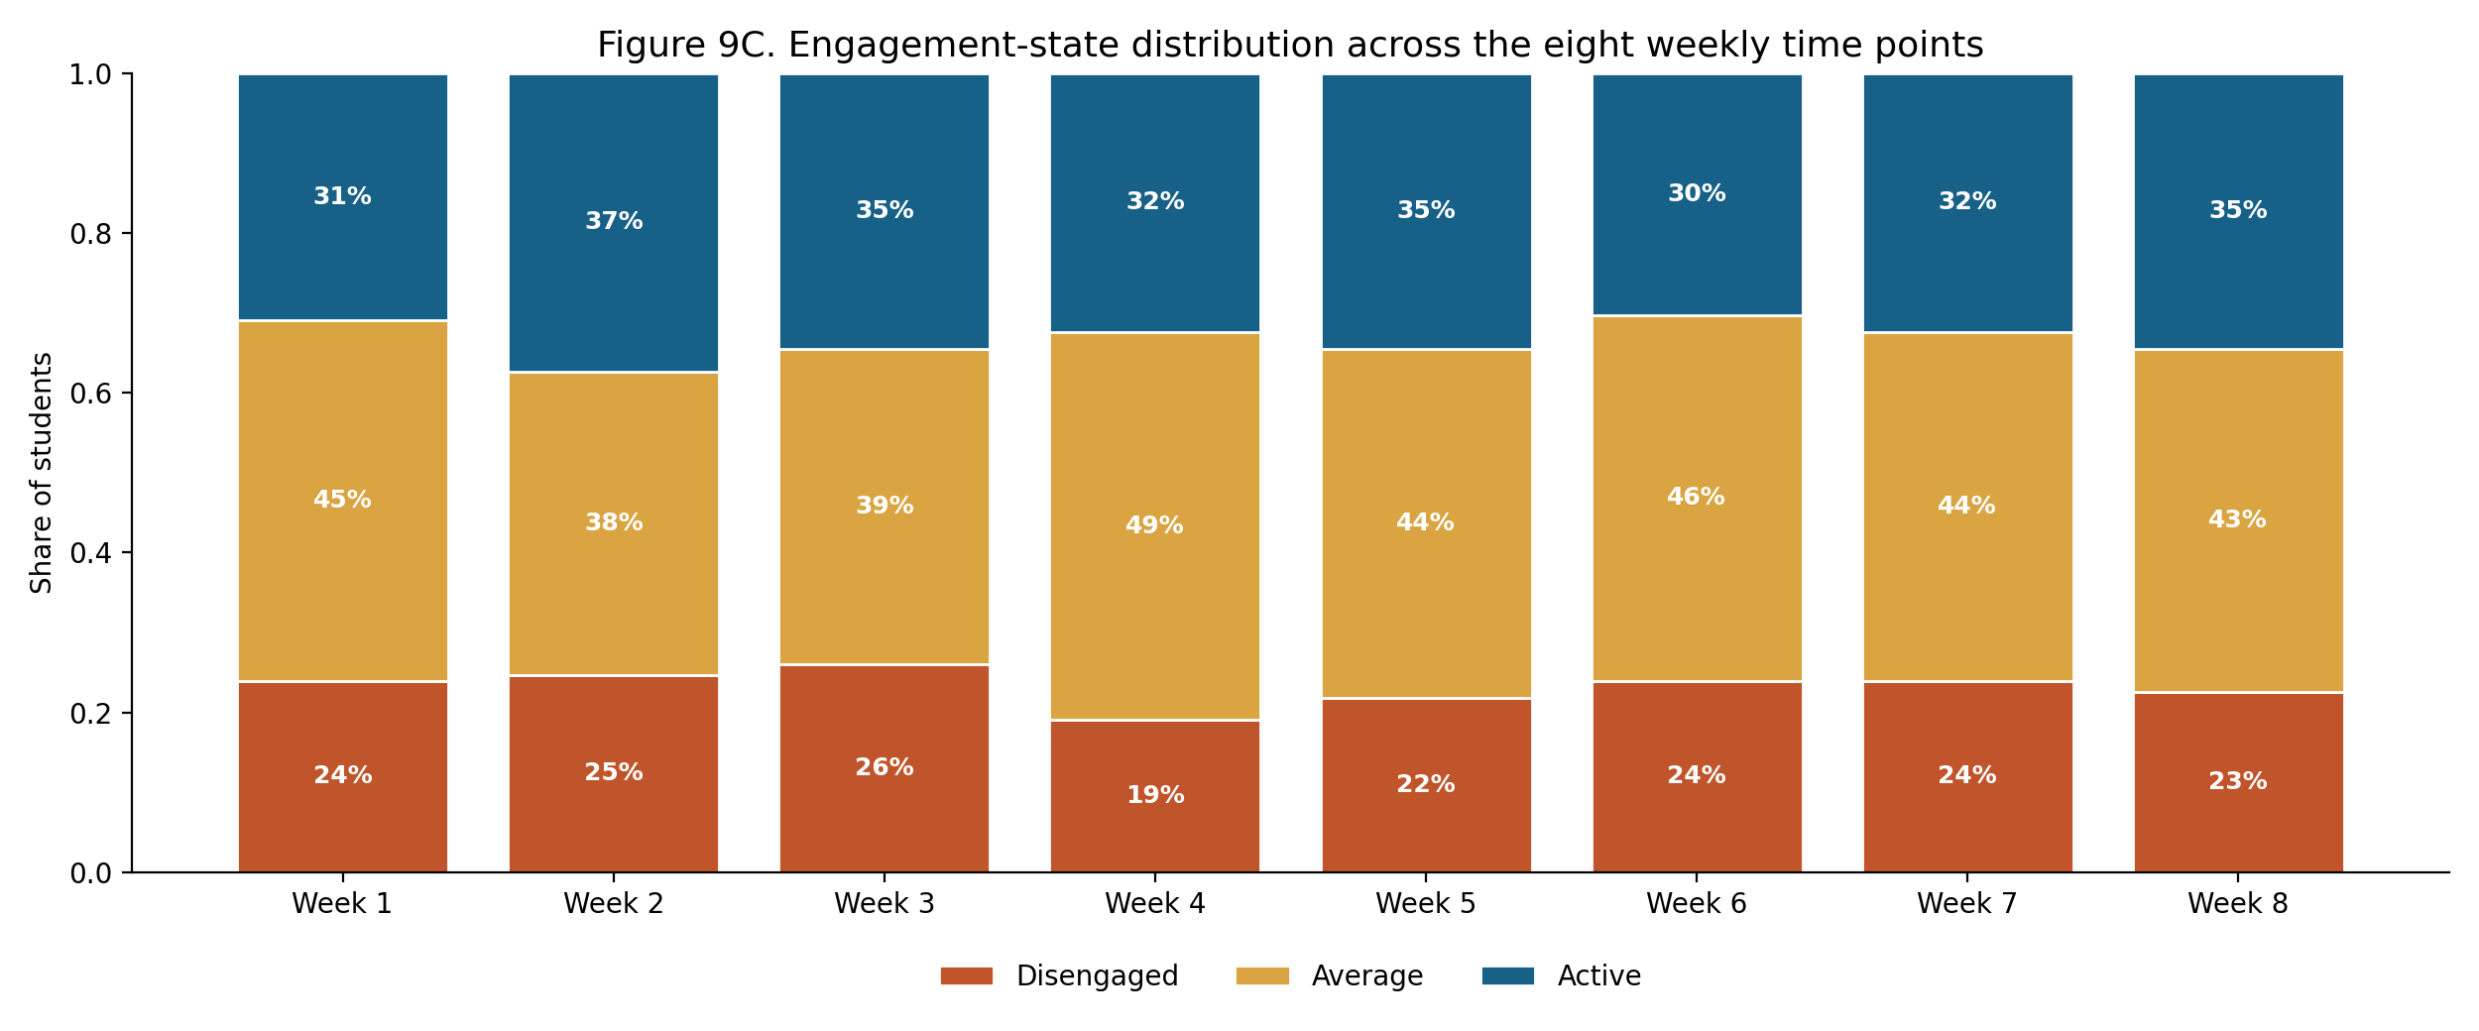
Figure 22. Engagement state distribution across the eight weekly time points
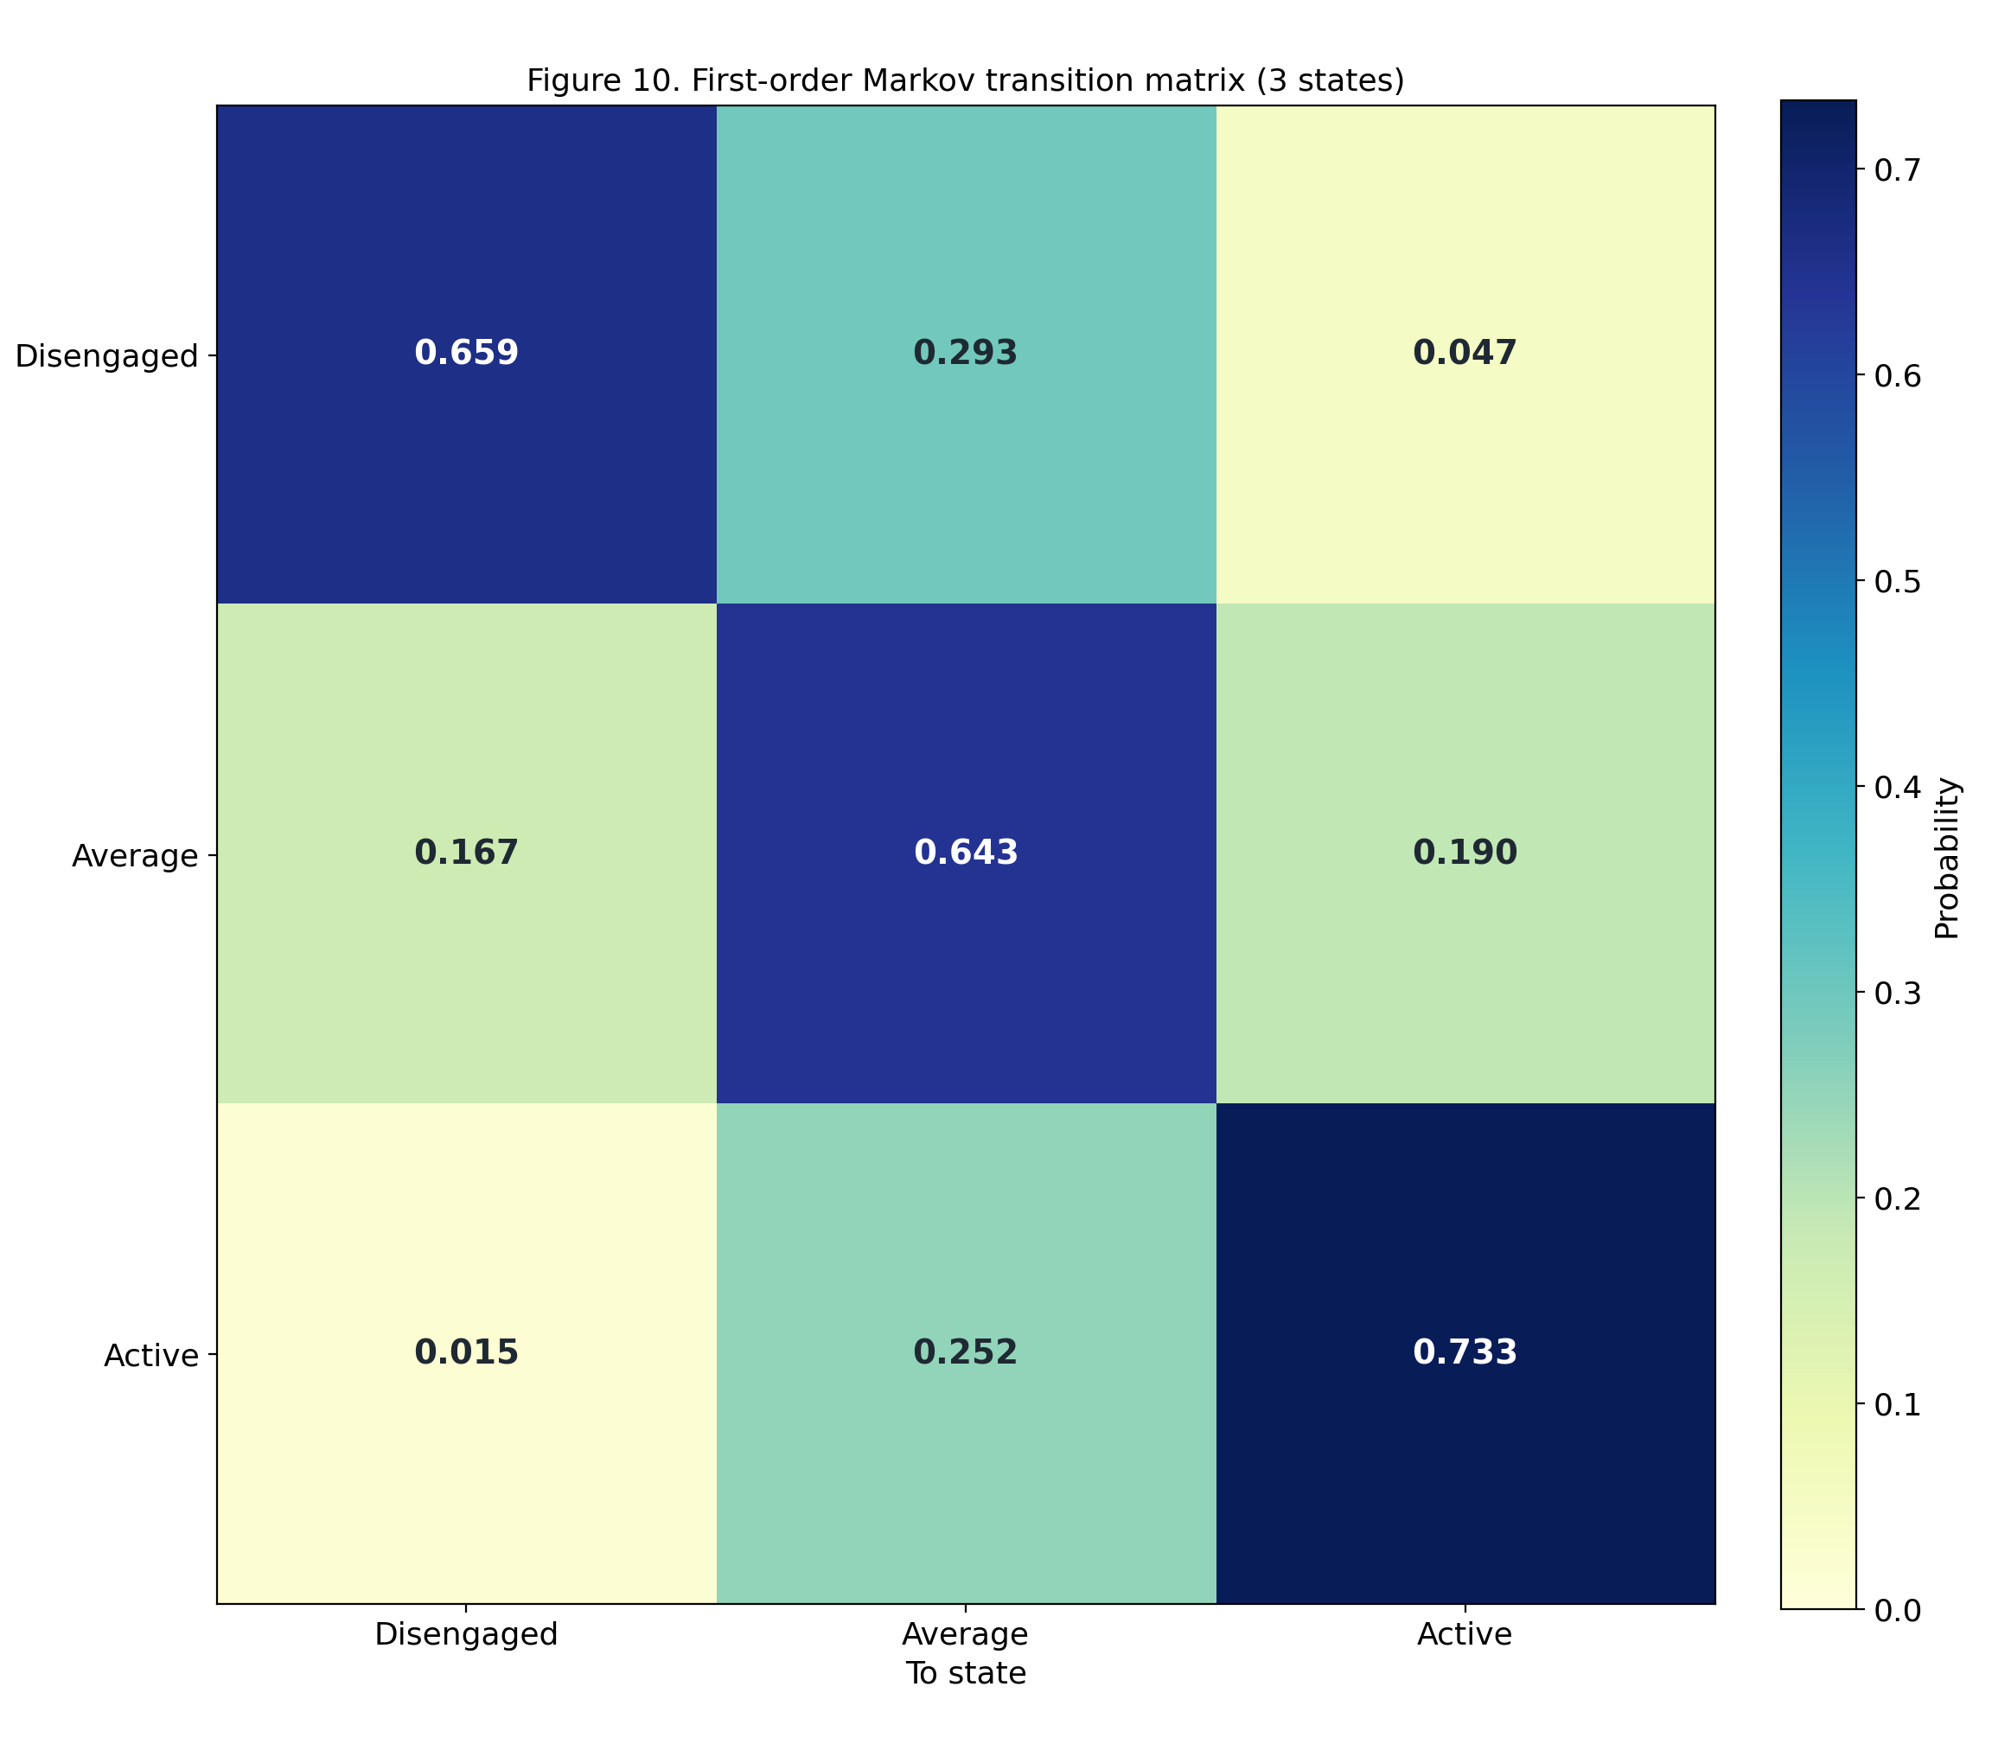
Figure 23. First order Markov transition matrix over the three engagement states
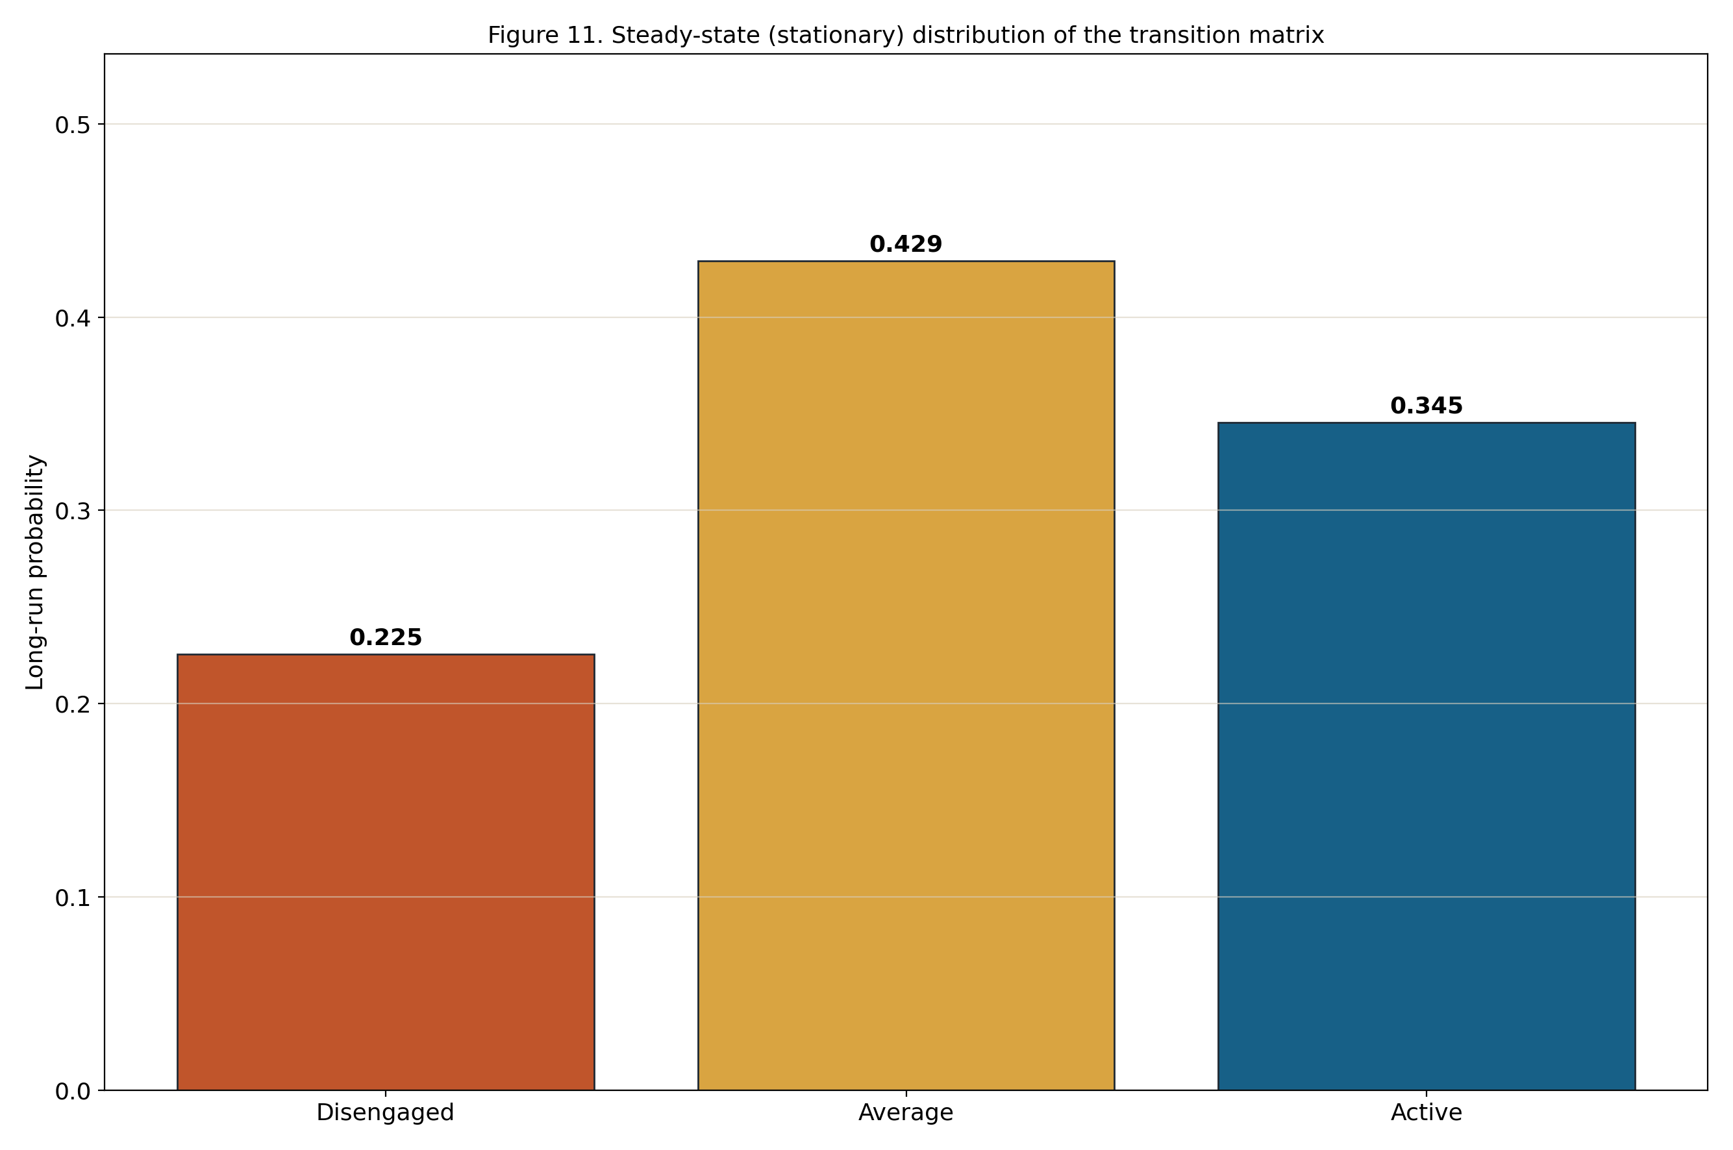
Figure 24. Steady state (stationary) distribution of the transition matrix
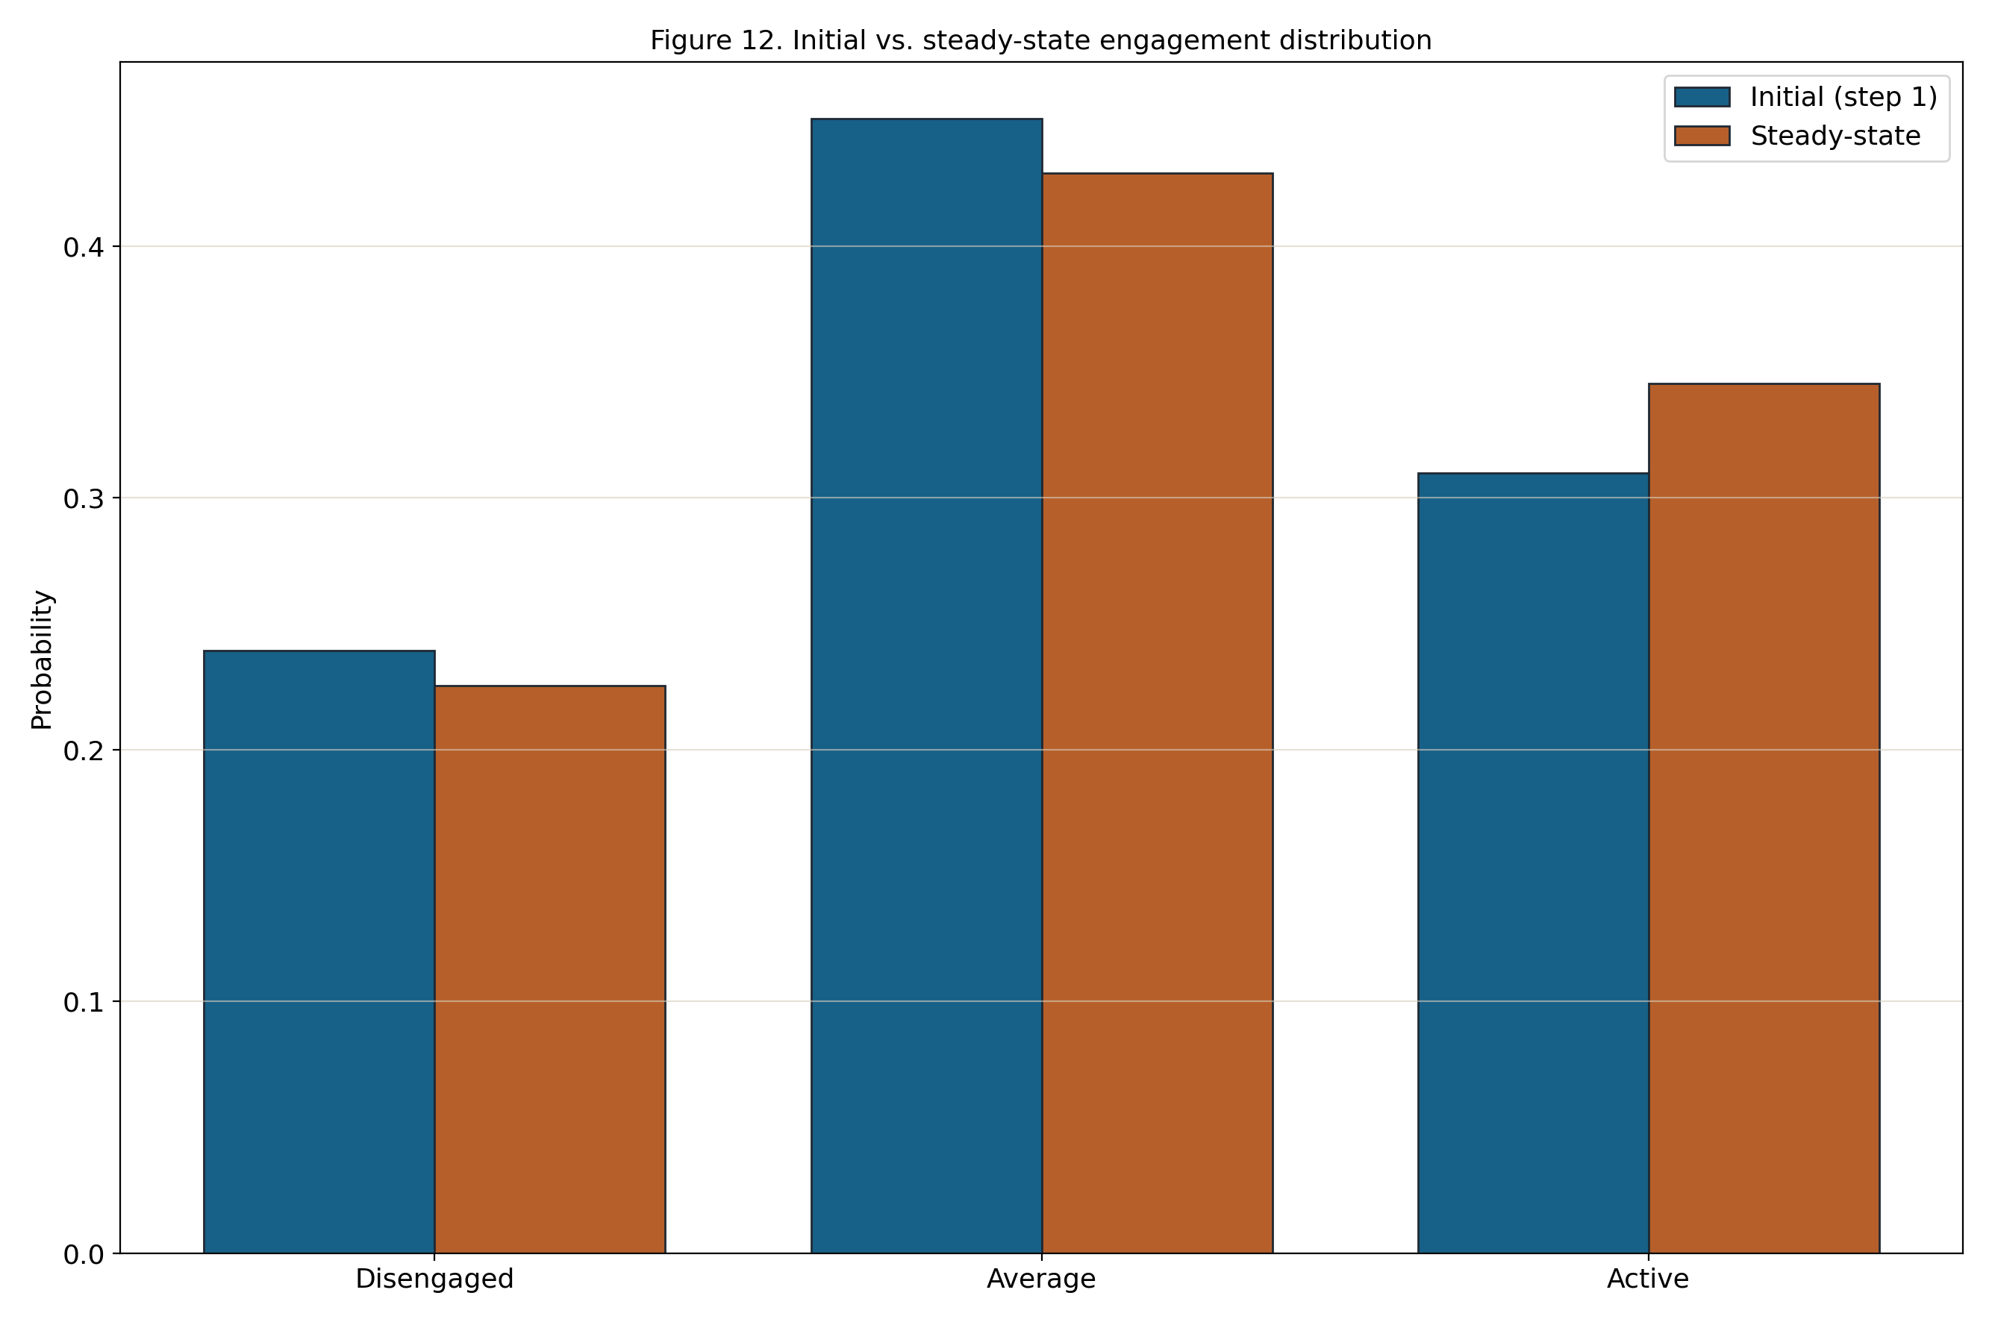
Figure 25. Initial (first step) vs. steady state engagement distribution

10. Integration and Communication
The three components integrate through the local file system and local HTTP. The pipeline writes dashboard.json and the CSV artifacts; the Fast API service reads dashboard.json at startup; and the frontend fetches dashboard.json over HTTP and calls /predict.
There is no external integration: no LMS/SIS connectors, no message bus, and no scheduled jobs. The generated CSV and JSON files are the integration contract and can also be reused for reporting or placed under version control.

11. Security and Privacy

11.1 Authentication
The application requires no authentication. It runs locally for a single User, so there are no accounts, passwords, or sessions to manage.
Because nothing is exposed beyond the local machine, there are no login or token issuance flows to secure.

11.2 Authorization
There are no user roles; the single User has access to all features, which is appropriate for a local analysis tool.
The Fast API backend restricts cross origin requests to localhost (127.0.0.1) origins, so the API is not reachable from other origins.

11.3 Data Protection
All communication is local, between the browser and a backend bound to 127.0.0.1; the application can be run entirely offline, so no engagement data is transmitted over a network.
The bundled dataset uses anonymized identifiers and contains no personally identifiable information; the views display only deidentified, aggregated results.

12. Deployment Strategy

12.1 Environment Requirements
Resource | Requirement
Operating system | Windows (PowerShell/.bat launchers); portable Python elsewhere
Python runtime | Python 3.11+ with pip
Python packages | Fast api, uvicorn, scikit learn, pandas, num py (plus jupyter/matplotlib for the notebook)
Browser | Any modern web browser (Chrome, Edge, Firefox)
Hardware | A standard laptop/desktop; no GPU or server required

12.2 Deployment Pipeline
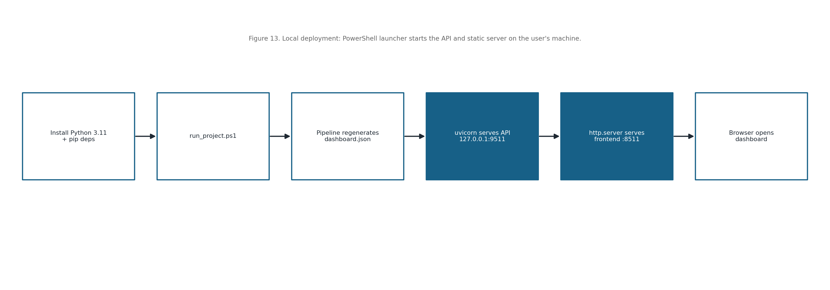
Figure 26. Local deployment and run flow on the user's machine

13. Testing and Validation

13.1 Functional Testing
Test Case | Expected Result
Run pipeline on bundled dataset | All CSV artifacts and dashboard.json are regenerated without error
State assignment | Each record receives one of Disengaged/Average/Active with probabilities
Sequence construction | Each student yields an ordered step_1..step_8 sequence
GET /health | Returns {ok: true, title: <project title>}
POST /predict (valid sequence) | Returns the closest trajectory, mismatches, grade, and prototype
POST /predict (missing field) | Returns HTTP 422 with an invalid input message
Dashboard load | All panels render from dashboard.json; status message confirms load

13.2 Validation and Model Evaluation
Model selection is validated quantitatively: BIC and AIC are compared across candidate Gaussian mixture solutions to justify three states, and the silhouette score is compared across candidate cluster counts to justify three trajectories.
Results are inspected visually the state profiles, the state distribution over time, the trajectory prototypes, and the Markov transition matrix to confirm the engagement levels and trajectories are interpretable and stable across the fixed seed runs.

13.3 QA and Verification Methods
Quality is maintained by keeping the pipeline organized into small, testable functions, by validating the presence of the dataset before running, and by handling and logging prediction errors in the API.
Because the random seed is fixed and the artifacts are plain files, runs are reproducible and can be checkpointed or version controlled, which makes regressions easy to detect.

14. Constraints, Limitations, and Design Decisions

14.1 Constraints and Limitations
- The first order Markov assumption captures only step to step transitions, not long-range dependencies.
- Small cohorts or short sequences can make state and trajectory estimates less stable.
- The analysis is offline and batch; the dashboard reflects the last pipeline run rather than live data.
- Engagement state labels depend on the chosen indicators and the within course standardization.
- The system targets a single local user and is not designed for concurrent multiuser deployment.

14.2 Design Decisions and Rationale
Markov and VaSSTra modelling were chosen for interpretability: discrete engagement states and transition probabilities are easy for non specialists to read, which is the project’s goal.
The analytics were implemented in Python (pandas, scikit learn). The analytics engine is kept separate from the UI for clarity and testability.
File based storage (CSV/JSON) was chosen over a database to keep the project self contained, portable, and easy to inspect; a small Fast API surface provides a clean boundary for the prediction feature.

15. Future Enhancements
- Higher order or hidden Markov models to capture longer dependencies and latent dynamics.
- Probabilistic trajectory prediction that uses the transition matrix, not only prototype mismatches.
- Configurable number of states and trajectories exposed in the dashboard.
- Support for additional datasets and an in app upload of a new engagement CSV.
- Automatically generated narrative summaries of each trajectory.
- Optional packaging as a single executable for one click local use.

16. Conclusion
This project demonstrates that longitudinal learning dynamics can be modelled in a transparent, reproducible, and fully self contained way. By following the VaSSTra method and pairing a Gaussian mixture engagement state model with Ward trajectory clustering and first order Markov transition estimation, the system turns raw engagement logs into an interpretable picture of how a cohort of learners moves between disengaged, average, and active states over the weeks of a course. The accompanying dashboard makes these results accessible to instructors, analysts, and researchers without requiring expertise in machine learning.
The Markov analysis confirms that engagement is largely persistent each state is most likely to be retained from one week to the next while the steady state distribution and trajectory prototypes reveal the longer term tendencies of the cohort, as summarized below.
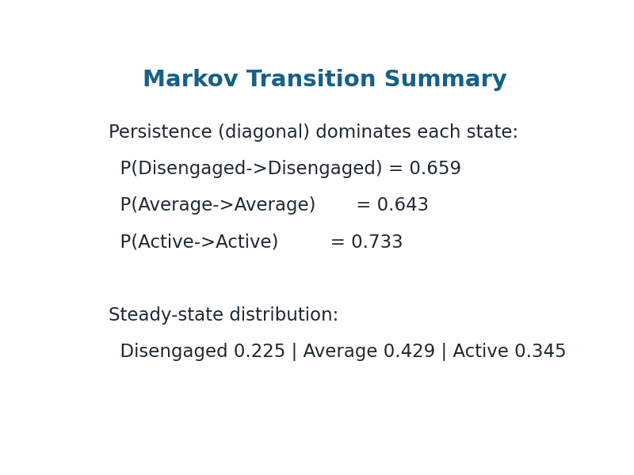
Figure 27. Markov transition summary: state persistence and the steady state engagement distribution

Appendices

Appendix A: Dataset Summary
The bundled dataset has the following overall characteristics:
Metric | Value
Total rows | 1136
Unique users | 142
Unique courses | 38
Distinct sequence indices | 8
Perindicator distribution statistics:
Metric | Min | P50 | P90 | Max
Freq_Course_View | 32.00 | 221.00 | 305.00 | 440.00
Freq_Forum_Consume | 84.00 | 590.00 | 807.00 | 1091.00
Freq_Forum_Contribute | 17.00 | 179.00 | 243.00 | 358.00
Freq_Lecture_View | 19.00 | 202.00 | 279.00 | 402.00
Session_Count | 27.00 | 187.00 | 258.00 | 326.00
Total_Duration | 11803.00 | 81988.00 | 113580.00 | 164243.00
Active_Days | 2.00 | 16.00 | 21.00 | 31.00
Final_Grade | 37.00 | 68.36 | 80.13 | 98.14

Appendix B: Use Case Library
Use Case | Trigger | Outcome
View analytics dashboard | User opens the dashboard after a pipeline run | Reads overview, metrics, state profiles, and trajectory prototypes
Run manual prediction | User selects a state for each of the eight time points | Receives the closest trajectory, mismatch count, and mean grade
Browse / search samples | User types a student id in the search box | Sees that student’s trajectory, final grade, and state sequence
Run / refresh pipeline | User runs run_project.ps1 (or run_pipeline) | Regenerates all CSV artifacts and dashboard.json

Appendix C: Requirements Traceability
Requirement ID | Description | Section
FR001 | Run / refresh the VaSSTra analytics pipeline | 3.1, 6.1, 7.1–7.3
FR002 | Serve dashboard data and service status | 6.1, 6.2
FR003 | View dashboard overview | 5.1, 5.3
FR004 | View state model selection (BIC/AIC) | 5.3, 7.2
FR005 | View trajectory validation (silhouette) | 5.3, 7.2
FR006 | View per state engagement profiles | 5.3, 7.1
FR007 | View trajectory prototypes | 5.3, 6.1
FR008 | Run manual state sequence prediction | 6.1, 6.2
FR009 | Browse and search trajectory samples | 5.1, 5.3

Appendix D: Data Quality Rules
- Verify the input file data/raw/LongitudinalEngagement.csv exists before running (Q01).
- Confirm the required columns are present: User ID, Course ID, Sequence, the eight indicators, and Final_Grade (Q02).
- Ensure Sequence is an integer in the range 1–8 (Q03).
- Standardize each indicator within its Course ID; set undefined z scores (zero variance) to 0 (Q04).
- Fill any missing step in a student sequence with the Average state (Q05).
- Fit the Gaussian mixture with a fixed seed (2026) so state assignments are reproducible (Q06).
- Order the mixture components by mean level and label them Disengaged → Average → Active (Q07).
- Check that each Markov transition matrix row sums to 1 (Q08).
- Confirm the steady state distribution sums to 1 (Q09).
- Verify the silhouette score is computed for each candidate trajectory count (Q10).

Appendix E: Operational Monitoring
- Pipeline console output reports record and student counts and any failure.
- The /health endpoint confirms the API is running and returns the project title.
- The dashboard shows a status message when dashboard.json or the backend is unavailable.
- Generated artifacts can be diffed between runs to detect unexpected changes.
- Fixed seed reproducibility is checked by rerunning the pipeline on the same data.

References
[1] A. T. Corbett and J. R. Anderson, “Knowledge tracing: Modeling the acquisition of procedural knowledge,” User Modeling and User Adapted Interaction, vol. 4, no. 4, pp. 253–278, 1995.
[2] G. Siemens and P. Long, “Penetrating the fog: Analytics in learning and education,” EDUCAUSE Review, vol. 46, no. 5, pp. 30–40, 2011.
[3] Z. Papa mitsiou and A. A. Economides, “Learning analytics and educational data mining in practice: A systematic literature review of empirical evidence,” Educational Technology & Society, vol. 17, no. 4, pp. 49–64, 2014.
[4] C. Romero and S. Ventura, “Data mining in education,” Wiley Interdisciplinary Reviews: Data Mining and Knowledge Discovery, vol. 3, no. 1, pp. 12–27, 2013.
[5] G. Siemens, “Learning analytics: The emergence of a discipline,” American Behavioral Scientist, vol. 57, no. 10, pp. 1380–1400, 2013.
[6] C. Piech, J. Bassen, J. Huang, S. Ganguli, M. Sahami, L. Guibas, and J. SohlDickstein, “Deep knowledge tracing,” in Proc. Advances in Neural Information Processing Systems 28 (NeurIPS), 2015.
[7] Z. A. Pardos and N. T. Heffernan, “Modeling individualization in a Bayesian networks implementation of knowledge tracing,” in User Modeling, Adaptation, and Personalization, Berlin, Germany: Springer, 2010, pp. 255–266.
[8] R. S. J. d. Baker, A. T. Corbett, and V. Aleven, “More accurate student modeling through contextual estimation of slip and guess probabilities in Bayesian knowledge tracing,” in Intelligent Tutoring Systems, vol. 5091, Berlin, Germany: Springer, 2008, pp. 406–415.
[9] Y. X. Wang and Y. Lin, “An introduction to Bayesian knowledge tracing with pyBKT,” Psych, vol. 5, no. 3, pp. 770–786, 2023.
[10] T. A. Badrinath, N. K. Jha, and S. S. Iyengar, “Bayesian knowledge tracing: A review of models and applications in intelligent tutoring systems,” Technology, Knowledge and Learning, vol. 27, no. 4, pp. 1001–1022, 2022.
[11] S. Naeem, M. Hussain, and N. Iqbal, “A survey of knowledge tracing: Models, evaluation metrics and challenges,” IEEE Access, vol. 10, pp. 122345–122365, 2022.
[12] J. Shen, Q. Chen, and Y. Yang, “Progressive knowledge tracing: Modeling learning process from abstract to concrete,” Expert Systems with Applications, vol. 236, 2024.
[13] A. T. Corbett and J. R. Anderson, “Knowledge tracing in the ACT programming tutor,” in Proc. Annual Meeting of the Cognitive Science Society, 1992.
[14] G. Siemens, “Learning analytics: Envisioning a research discipline and a domain of practice,” in Proc. 2nd Int. Conf. Learning Analytics and Knowledge (LAK), 2012, pp. 4–8.
[15] J. A. Larusson and B. White, Eds., Learning Analytics: From Research to Practice. New York, NY, USA: Springer, 2014.
[16] M. A. Chatti, A. L. Dyckhoff, U. Schroeder, and H. Thüs, “A reference model for learning analytics,” Int. J. Technology Enhanced Learning, vol. 4, no. 5–6, pp. 318–331, 2012.
[17] A. F. Wise, “Designing pedagogical interventions to support student use of learning analytics,” in Handbook of Learning Analytics. Edmonton, Canada: Society for Learning Analytics Research, 2017, pp. 89–96.
[18] C. D. Dede, “Learning analytics and educational research,” in Handbook of Learning Analytics. Edmonton, Canada: SoLAR, 2017, pp. 34–45.
[19] G. Siemens, D. Gasevic, C. Haythornthwaite, S. Dawson, S. Shum, R. Ferguson, and E. Duval, “Open learning analytics: An integrated and modularized platform,” in Proc. 1st Int. Conf. Learning Analytics and Knowledge (LAK), 2011.
[20] A. F. Wise and Y. Cui, “Learning communities in the crowd: Characteristics of content and social interactions in MOOCs,” Computers & Education, vol. 92–93, pp. 38–49, 2016.
[21] L. R. Rabiner, “A tutorial on hidden Markov models and selected applications in speech recognition,” Proceedings of the IEEE, vol. 77, no. 2, pp. 257–286, 1989.
[22] A. P. Dempster, N. M. Laird, and D. B. Rubin, “Maximum likelihood from incomplete data via the EM algorithm,” Journal of the Royal Statistical Society: Series B (Methodological), vol. 39, no. 1, pp. 1–38, 1977.
[23] H. D. Vinther and E. J. Anderson, “Hidden Markov models for educational trajectories: A review,” Journal of Educational and Behavioral Statistics, vol. 46, no. 5, pp. 543–570, 2021.
[24] J. E. Beck and J. Chang, “Identifiability in Bayesian knowledge tracing,” in Proc. 8th Int. Conf. Educational Data Mining (EDM), 2007.
[25] S. Doroudi and E. Brunskill, “The misidentified identifiability problem of Bayesian knowledge tracing,” in Proc. 10th Int. Conf. Educational Data Mining (EDM), 2017, pp. 143–149.
[26] Z. A. Pardos and N. T. Heffernan, “KTIDEM: Introducing item difficulty to the knowledge tracing model,” in Proc. User Modeling, Adaptation, and Personalization. Berlin, Germany: Springer, 2011, pp. 243–254.
[27] F. Pedregosa et al., “Scikitlearn: Machine learning in Python,” Journal of Machine Learning Research, vol. 12, pp. 2825–2830, 2011.
[28] C. R. Harris et al., “Array programming with NumPy,” Nature, vol. 585, no. 7825, pp. 357–362, 2020.
[29] W. McKinney, “Data structures for statistical computing in Python,” in Proc. 9th Python in Science Conf. (SciPy), 2010, pp. 51–56.
[30] F. Chollet et al., Deep Learning with Python, 2nd ed. Shelter Island, NY, USA: Manning, 2021.
[31] J. H. Ward Jr., “Hierarchical grouping to optimize an objective function,” Journal of the American Statistical Association, vol. 58, no. 301, pp. 236–244, 1963.
[32] P. J. Rousseeuw, “Silhouettes: A graphical aid to the interpretation and validation of cluster analysis,” Journal of Computational and Applied Mathematics, vol. 20, pp. 53–65, 1987.
[33] G. Schwarz, “Estimating the dimension of a model,” The Annals of Statistics, vol. 6, no. 2, pp. 461–464, 1978.
[34] H. Akaike, “A new look at the statistical model identification,” IEEE Transactions on Automatic Control, vol. 19, no. 6, pp. 716–723, 1974.
[35] G. J. McLachlan and D. Peel, Finite Mixture Models. New York, NY, USA: Wiley, 2000.
[36] L. M. Collins and S. T. Lanza, Latent Class and Latent Transition Analysis: With Applications in the Social, Behavioral, and Health Sciences. Hoboken, NJ, USA: Wiley, 2010.
[37] M. Saqr and S. LópezPernas, “The longitudinal trajectories of online engagement over a full program of studies,” Computers & Education, vol. 175, 2021, Art. no. 104325.
[38] R. F. Kizilcec, C. Piech, and E. Schneider, “Deconstructing disengagement: Analyzing learner subpopulations in massive open online courses,” in Proc. 3rd Int. Conf. Learning Analytics and Knowledge (LAK), 2013, pp. 170–179.
[39] D. Coffrin, L. Corrin, P. de Barba, and G. Kennedy, “Visualizing patterns of student engagement and performance in MOOCs,” in Proc. 4th Int. Conf. Learning Analytics and Knowledge (LAK), 2014, pp. 83–92.
[40] J. Jovanović, D. Gašević, S. Dawson, A. Pardo, and N. Mirriahi, “Learning analytics to unveil learning strategies in a flipped classroom,” The Internet and Higher Education, vol. 33, pp. 74–85, 2017.
[41] J. S. Kinnebrew, K. M. Loretz, and G. Biswas, “A contextualized, differential sequence mining method to derive students’ learning behavior patterns,” Journal of Educational Data Mining, vol. 5, no. 1, pp. 190–219, 2013.
[42] M. C. Desmarais and R. S. J. d. Baker, “A review of recent advances in learner and skill modeling in intelligent learning environments,” User Modeling and User Adapted Interaction, vol. 22, no. 1–2, pp. 9–38, 2012.
[43] C. Romero and S. Ventura, “Educational data mining and learning analytics: An updated survey,” Wiley Interdisciplinary Reviews: Data Mining and Knowledge Discovery, vol. 10, no. 3, 2020, Art. no. e1355.
[44] J. D. Hunter, “Matplotlib: A 2D graphics environment,” Computing in Science & Engineering, vol. 9, no. 3, pp. 90–95, 2007.
[45] P. Virtanen et al., “SciPy 1.0: Fundamental algorithms for scientific computing in Python,” Nature Methods, vol. 17, no. 3, pp. 261–272, 2020.

