**Installing PHP 7 on Ubuntu**

Like many developer tools, PHP has several different release versions.

By default, PHP 7.2 is included in Ubuntu 18.04. At the time of writing, PHP 7.3.1 was released. It was tagged as a release of a “stable” version of the software. A stable release is well-tested and is designed to be used and supported for a longer period

**How to Install PHP 7.2 with Apache on Ubuntu**

**Update Ubuntu**

Ensure you are using the latest Ubuntu updates by entering the following command into a terminal window:

apt-get update && apt-get upgrade

**Install PHP 7.2**

1. To install PHP 7.2, enter the following command:

sudo apt-get install php libapache2-mod-php

Confirm the installation by hitting **Enter**. The system will download and install PHP from the software repositories. This command also installs dependencies and modules for use with Apache.

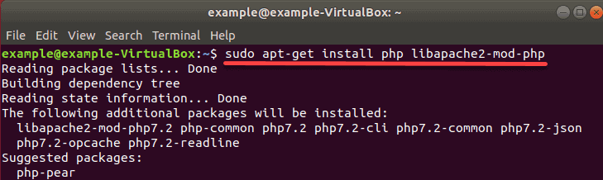

2. Verify PHP was installed, with the command:

php -v

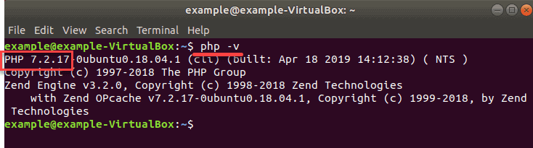

3. Restart the Apache service to apply the changes:

sudo systemctl restart apache2

**How to Install PHP 7.2 with Nginx on Ubuntu 18.04**

**Update Ubuntu to Latest Version**

Entering the following command into a terminal window to ensure you are using the latest software:

apt-get update && apt-get upgrade

**Install PHP 7.2 with Nginx**

1. To install PHP for Nginx, enter the following command:

sudo apt-get install php-fpm

The system will reach out to download and install the package and its dependencies.

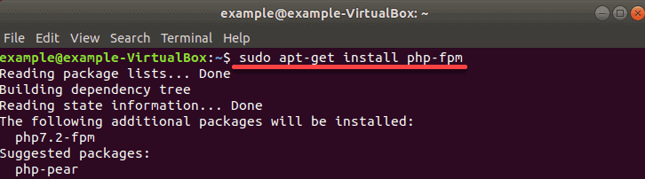

2. Once installation finishes, restart the service by entering:

sudo systemctl restart nginx

This will apply any changes.

3. If you are using Nginx, you must be familiar with configuring server blocks.

First, add the following code to your server block file for Nginx to make use of PHP:  
server {

# . . . existing configuration

location ~ \.php$ {

include snippets/fastcgi-php.conf;

fastcgi_pass unix:/run/php/php7.2-fpm.sock;

}

}

4. Save the file and exit. Then, [restart Nginx on Ubuntu](https://phoenixnap.com/kb/nginx-start-stop-restart) with:

sudo systemctl restart nginx

**How to Install PHP 7.3 on Ubuntu 18.04**

**Update Ubuntu Server**

The Ubuntu repositories still point at PHP 7.2.

However, a stable release of PHP 7.3 is available from the developers.

Update the Ubuntu server with the command:

apt-get update && apt-get upgrade

**Add the PHP repository**

1. To add this repository, you’ll need to add software-properties-common:

sudo apt-get install software-properties-common

2. Next, add the new ondrej repository:

sudo add-apt-repository ppa:ondrej/php

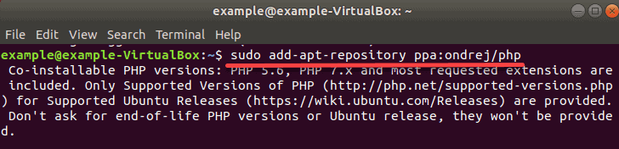

The system will ask for confirmation – hit enter, and allow the process to complete.  
3. Update your package list:

sudo apt-get update

**Install PHP 7.3**

Now, you can install PHP 7.3 software (and dependencies) by entering the command:

sudo apt install php7.3 php7.3-common php7.3-opcache

php7.3-cli php7.3-gd php7.3-curl php7.3-mysql

To verify installation and check the version of your local PHP use:

php –v

