Eclipse

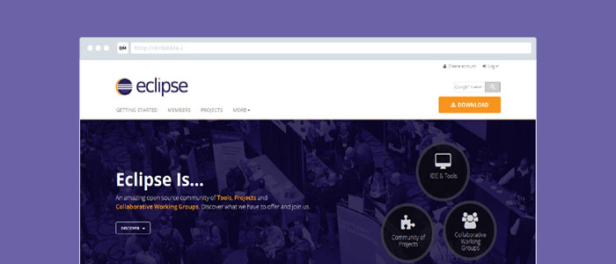

* **Platform(s):** Microsoft Windows, Mac OS X, Linux, Solaris
* **Supported Languages:** Ada, ABAP, C, C++, COBOL, D, Fortran, Haskell, Java, JavaScript, Julia, Lasso, Lua, NATURAL, Perl, PHP, Prolog, Python, R, Ruby, Ruby on Rails, Rust, Scala, Clojure, Groovy, Scheme, and Erlang, LaTeX, Mathematica.
* **Price:** FREE (Eclipse Public License)
* **More Information:** Rich Client Platform, supports Tomcat, GlassFish and other servers, Web Tools Platform.
* **Visit:**[Eclipse](https://www.eclipse.org/)

Sublime Text

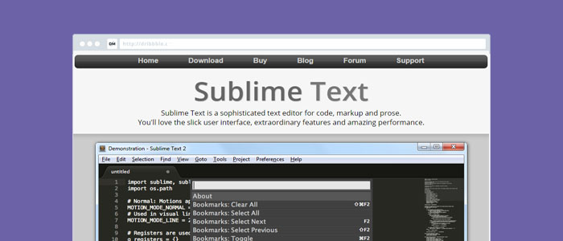

* **Platform(s):** Microsoft Windows, Mac OS X, Linux
* **Supported Languages:** All popular languages
* **Price:** USD 70/license
* **More Information:** Package Manager
* **Visit:**[Sublime Text](http://www.sublimetext.com/)

Visual Studio Code

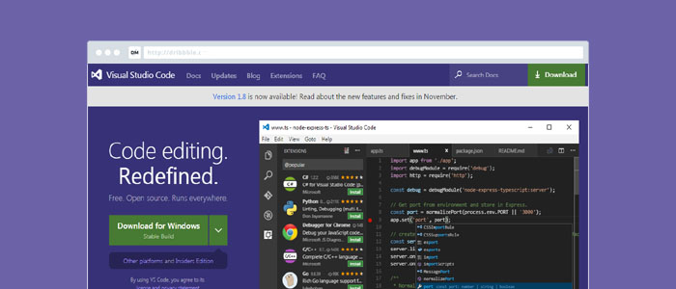

* **Platform(s):** Microsoft Windows, Mac OS X, Linux
* **Supported Languages:** Batch, C++, Clojure, CoffeeScript, DockerFile, Elixir, F#, Go, Pug template language, Java, HandleBars, Ini, Lua, Makefile, Objective-C, Perl, PowerShell, Python, R, Razor, Ruby, Rust, SQL, Visual Basic, XML
* **Price:** FREE (MIT License)
* **More Information:** GitHub support, code refactoring, debugger
* **Visit:**[Visual Studio Code](https://code.visualstudio.com/)

Atom

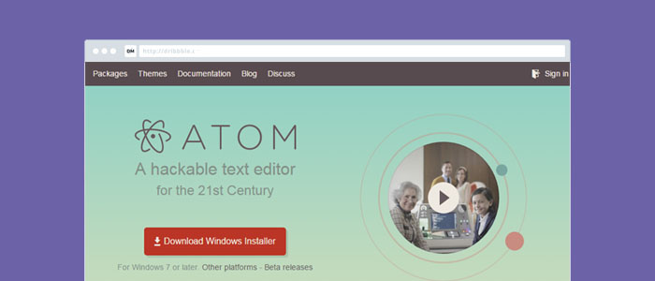

* **Platform(s):** Microsoft Windows, Mac OS X, Linux
* **Supported Languages:** HTML, CSS, Less, Sass, GitHub Flavored Markdown, C/C++, C#, Go, Java, Objective-C, JavaScript, JSON, CoffeeScript, Python, PHP, Ruby, Ruby on Rails, shell script, Clojure, Perl, Git, Make, Property List (Apple), TOML, XML, YAML, Mustache, Julia & SQL
* **Price:** FREE (MIT License)
* **More Information:** Open source, built-in Package Manager, Themes.
* **Visit:**[Atom](https://atom.io/)

Notepad++

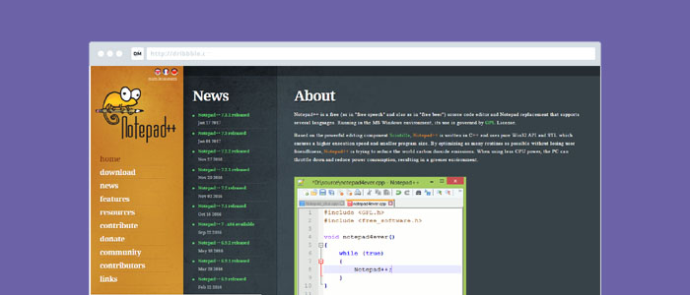

* **Platform(s):** Microsoft Windows,
* **Supported Languages:** Ada, asp, Assembly, AutoIt, Batch, C, C++, C#, Caml, Cmake, COBOL, CoffeeScript, CSS, D, Diff, Flash ActionScript, Fortran, Gui4CLI, Haskell, HTML, INNO, Java, JavaScript, JSP, KiXtart, LISP, Lua, Makefile, Matlab, MS-DOS, INI file, NSIS, Normal Text File, Objective-C, Pascal, Perl, PHP, PostScript, PowerShell, Properties, Python, R, Resource file, Ruby, Shell, Scheme, Smalltalk, SQL, TCL, TeX, Visual Basic, VHDL, Verilog, XML, YAML
* **Price:** FREE (GPL)
* **More Information:** Open source, Macro recording and playback, User Defined Syntax Highlighting and Folding
* **Visit:**[Notepad++](https://notepad-plus-plus.org/)