Name: Atharav Tukaram Pawar

Roll no= 405

import pandas as pd

import numpy as np

import matplotlib.pyplot as plt

data=pd.read_csv('/content/grainsales.csv')

top_10_grains = data['GrainName'].value_counts().head(10).index.tolist()

subset_data = data[data['GrainName'].isin(top_10_grains)]

plt.figure(figsize=(10, 6))

plt.bar(subset_data['GrainName'], subset_data['Sales'])

plt.title('Sales by Grain')

plt.xlabel('Grain')

plt.ylabel('Sales')

plt.xticks(rotation=45)

plt.show()

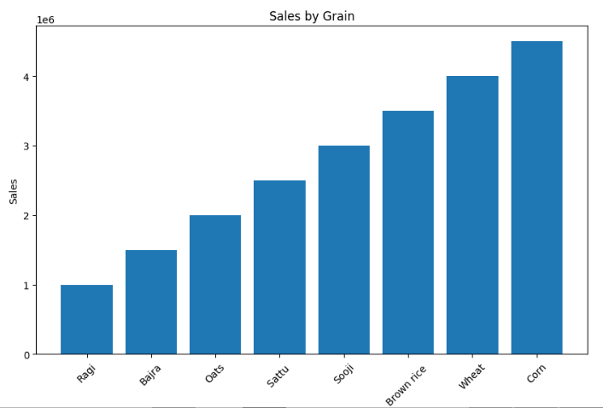

plt.figure(figsize=(8, 8))

subset_data['GrainName'].value_counts().plot.pie(autopct='%1.1f%%')

plt.title('Grain Distribution')

plt.ylabel('')

plt.show()

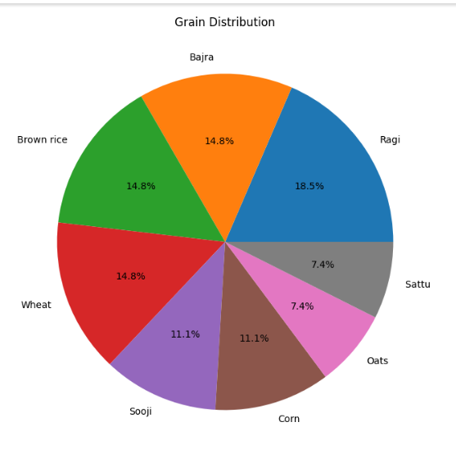

plt.figure(figsize=(10, 6))

plt.boxplot([subset_data[subset_data['GrainName'] == grain]['Sales']

for grain in top_10_grains], labels=top_10_grains)

plt.title('Sales Distribution by Grain')

plt.xlabel('Grain')

plt.ylabel('Sales')

plt.xticks(rotation=45)

plt.show()

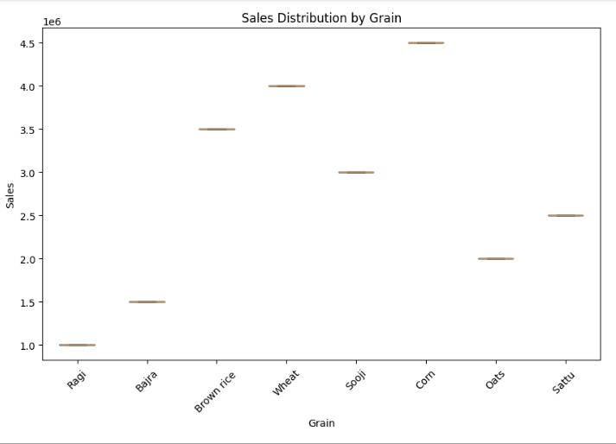

plt.figure(figsize=(10, 6))

plt.scatter(data['Months'], data['Sales'])

plt.title('Sales vs. Months')

plt.xlabel('Months')

plt.ylabel('Sales')

plt.show()

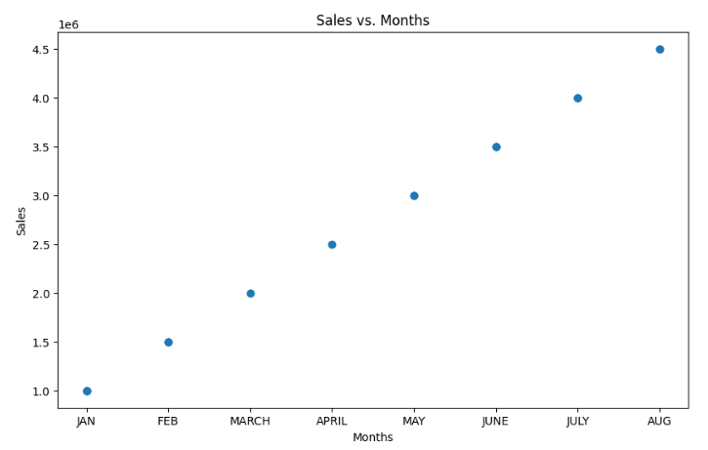

plt.figure(figsize=(10, 6))

plt.hist(data['Sales'], bins=10, edgecolor='black')

plt.title('Distribution of Sales')

plt.xlabel('Sales')

plt.ylabel('Frequency')

plt.show()

