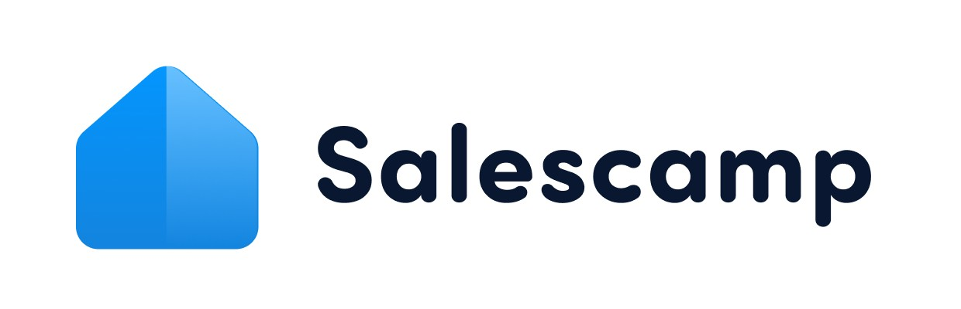

Business Proposal Template for [Client.Company]
This template outlines the services, pricing, and deliverables as requested by
[Client.First.Name][Client.Last.Name].

This proposal was prepared by:
[Sender.FirstName]
[Sender.Company]
[Sender.Phone]
[Sender.Email]

Company Overview


[Sender. Company] offers business planning and product or service to startups and small businesses. We’ve successfully partnered with companies in the industry name industry. This means we have the knowledge, expertise, and skills required to help you meet your business objectives.

Executive Summary




Name Name
Occupation Occupation

CEO name has been a leader in the industry name industry for years of experience. He is dedicated to
improving the customer experience and furthering the mission statement of the company.
Account exec name will be your primary point of contact going forward. If you have any questions or concerns, you can contact her by phone or email.

Client Testimonials

CEO name has been a leader in the industry name industry for years of experience. He is dedicated to improving the customer experience and furthering the mission statement of the company.





Name | Name | Name
Job Title | Job Title | Job Title

Testimonial text Testimonial text Testimonial text

Scope of Work

Here is an overview of the challenges and goals of this new business project. It includes a detailed description of the pricing strategy, timeline, and deliverables you can expect
from [Sender.Company].

In summary, there is a description of the legal requirements outlined in our business proposal contact.

Challenges and Goals

Challenges Goals and Objectives

Company challenge 1 Identifying target customers

Company challenge 2 Completing market analysis

Deliverables and Timeline

Deliverables Timeline

Market research and analysis Set up business plan Set up marketing plan

Project Overview
We believe that our product/service will help you address your current challenges and meet your goals and objectives within the agreed-upon timeline.
Product/service was designed to help companies in [target market] achieve their business objectives and improve critical areas.

Our seamless onboarding process will allow you to get started with no delays. And our team is available to answer questions and offer support during the transition and planning process.

Terms and Pricing

Below you will ﬁnd a detailed outline of the ﬁnancial terms needed to employ Product/service. The signatures of both [Sender.Company] and [Client.Company] are required before we can move forward and execute the business proposal contract.

Name Price Qty Subtotal

Subtotal | $0.00
Discount | $0.00
Tax | $0.00
Total | $0.00

Payment Schedule

Payment Amount Payment Due Date



Product/service Sales Contract

This Product/service Business Proposal Contract (the “Contract”) outlines the terms and conditions that govern the contractual agreement between [Sender.Company] and
[Client.Company]. Both [Sender.Company] and [Client.Company] agree to be bound by the terms laid out in this Business Proposal Contract.

WHEREAS, the Seller agrees to produce Product/service, a product description and

WHEREAS, the Purchaser agrees to purchase Product/service according to the terms and conditions laid out in this contract.

THEREFORE, in consideration of the mutual agreement made by the parties hereto, the Seller and the Purchaser (individually, each a “Party” and collectively, the “Parties”) agree to the following:

Product Purchased

The Purchaser hereby agrees to purchase the amount and type of the Product outlined in the Business Proposal Contact.

Payment

The Purchaser hereby agrees to purchase the amount and type of the Product outlined in the Business Proposal Contract.

Default

Any failure to meet payment due dates outlined on the payment schedule attached shall be considered a full and material breach of this Business Proposal Contract.

Warranty

Insert warranty here.

Modification

There will be no modiﬁcation of this Business Proposal Contract unless it is agreed to in writing by both Parties.

Applicable Law

The Business Proposal Contract and its terms are governed by the laws of the state of the sender state. This contract is subject to the exclusive jurisdiction of both the federal and state courts located in the sender state.

Agreement
By signing the document below, [Sender.FirstName][Sender.LastName] and
[Client.FirstName][Client.LastName] agree to the terms of this business proposal and form a contractual agreement that begins upon the date of signing.

[Sender.Company] [Client.Company]





[Sender.FirstName][Sender.LastName] [Client.FirstName][Client.LastName]

AI Generated Content
Error generating text: 429 You exceeded your current quota, please check your plan and billing details. For more information on this error, head to: https://ai.google.dev/gemini-api/docs/rate-limits. To monitor your current usage, head to: https://ai.dev/rate-limit.
* Quota exceeded for metric: generativelanguage.googleapis.com/generate_content_free_tier_requests, limit: 20, model: gemini-3.6-flash
Please retry in 46.894458698s. [links {
description: "Learn more about Gemini API quotas"
url: "https://ai.google.dev/gemini-api/docs/rate-limits"
}
, violations {
quota_metric: "generativelanguage.googleapis.com/generate_content_free_tier_requests"
quota_id: "GenerateRequestsPerDayPerProjectPerModel-FreeTier"
quota_dimensions {
key: "model"
value: "gemini-3.6-flash"
}
quota_dimensions {
key: "location"
value: "global"
}
quota_value: 20
}
, retry_delay {
seconds: 46
}
]

