CBSE

Computer Science Project



Blockbuster: Database Management system for movies

Objective:

To store information about movies locally on a computer system using MySQL along with Python connectivity and Tkinter Module for GUI.

Made By: Atharava Srivastava

Class: 12th Aryabhatta

Roll No.: 4

Contents

1. Story behind the name ‘Blockbuster’
2. Purpose of the project
3. Requirements   
   Hardware used in project

Software used in project

1. Implementation  
    Attributes used  
    Features available

Source code

Outputs

1. Recommendations
2. Conclusion
3. Bibliography

# Story behind the name

Blockbuster was a business founded by David Cook in 1985 as a single home video rental shop. As the company saw growth it became a public store chain featuring video game rentals, DVD-by-mail, streaming, video on demand and cinema theater.

Poor leadership and the residual effects of the Great Recession were major factors leading to Blockbuster’s decline. The competition from Netflix’s mail order service and Redbox automated kiosks ultimately led to the company filing for bankruptcy in 2010.

In 2011, its remaining 1700 stores were bought by Dish Network, a satellite television provider. By 2014, the last 300 company-owned stores were closed.

Dish retained a small number of franchise agreements, enabling some privately owned franchises to remain open irrespective of the termination of the corporate support for the brand.

Following a series of further closures in 2019, only one franchise store remains open in Bend, Oregon, United States.

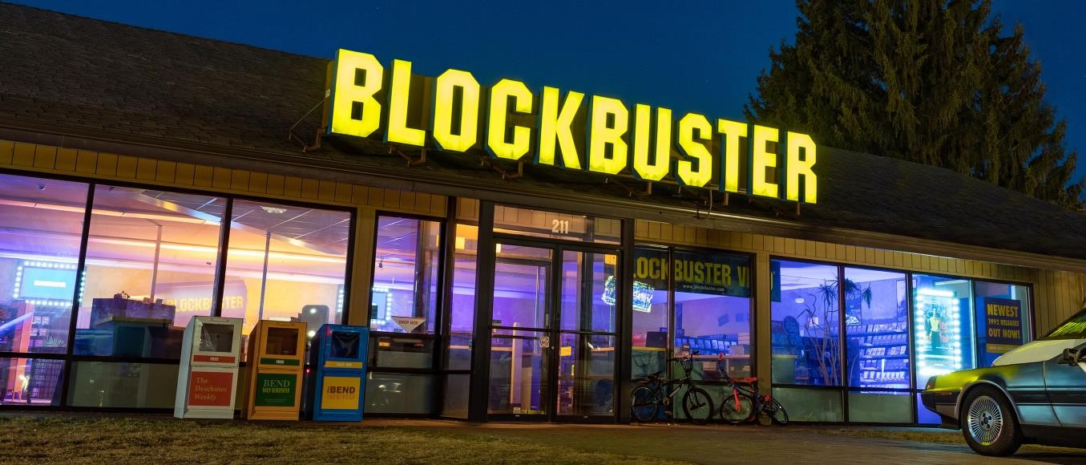

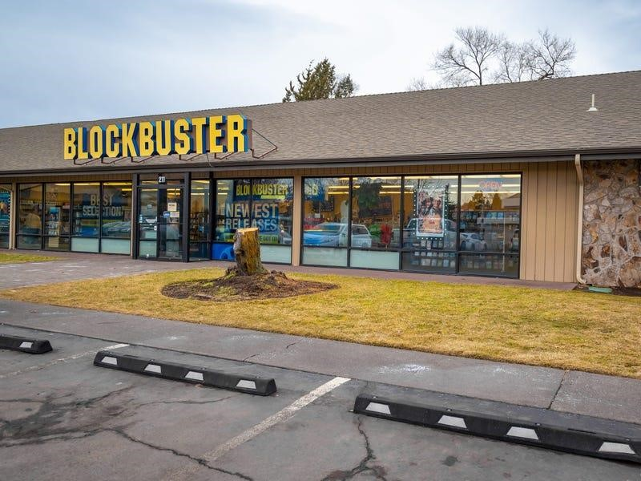

**The Last Blockbuster, Bend, Oregon, USA**

Purpose of the project

I decided to create this project so that I would be able to maintain a database for movies which allowed me to store information pertaining to the movie and let me access it easily.

Although such services are already available, creating this project also helped learn about working with user interfaces while using Tkinter to create the UI for my project.

Creating this project also helped me become more familiar with Python and its connectivity with MySQL.

Requirements

1. 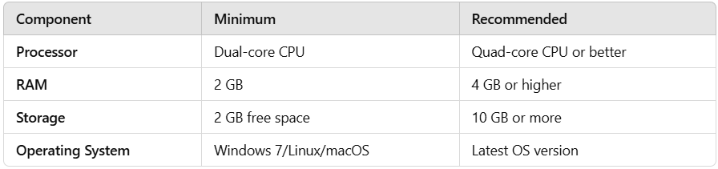Hardware requirements:
2. Software requirements:  
   Python Version 3.13  
   Tkinter Version 8.6  
   MySQL Command line client Version 8.0

Implementation

1. Attributes used

Movie Name  
Genre  
Date of Release  
IMDB ID

Director   
Rating

1. Features available   
   Insert records  
   Update a record using name of the movie  
   Delete a record using name of the movie  
   Check availability of a movie using its name  
   Display all the records available  
   Exit the applet
2. Source code
3. Outputs

Recommendations

1. More features can be added to this project like:
   * 1. Ability to add whether the movie has been watched yet or not
     2. Ability to add personal reviews for the movie
2. The UI can be improved by using advanced funcitons of Tkinter.
3. The code can be optimized further to reduce its time complexity.

Conclusion

This applet can be used for personal use to store information about movies locally on computer systems.

Creating this project helped me explore the world of UI and Python connectivity with MySQL.

Bibliography

1. Information about Blockbuster and logo: <https://en.wikipedia.org/wiki/Blockbuster_(retailer)>
2. The Last Blockbuster image 1:  
   <https://news.airbnb.com/store-manager-lists-worlds-last-blockbuster-on-airbnb-for-local-residents/>
3. The Last Blockbuster image 2:  
   <https://www.businessinsider.com/inside-last-blockbuster-in-the-world-photo-tour-bend-oregon#the-last-open-blockbuster-store-is-located-in-a-plaza-in-bend-oregon-1>