ACROPOLIS INSTITUTE OF TECHNOLOGY AND RESEARCH
Department of Information Technology
Synopsis
On

HISTORICA: AR/VR Powered Historical Immersive Experience
- Introduction

Overview
History has long served as a gateway to understanding human civilization, yet conventional methods, books, images, and museums often fall short in offering immersive educational experiences. Many significant historical sites lie in ruins today, making it difficult for learners and tourists to visualize their original architecture and cultural context.
Historica is a web-based platform that provides interactive 3D models of historical sites, showcasing how they appeared in ancient times. It allows users to explore ancient landmarks in detail with zoom, rotation, and AR integration for an immersive experience. The platform combines historical accuracy with digital technology, making history more engaging and accessible. Designed for students, researchers, educators, and history enthusiasts, it serves as an educational and cultural preservation tool.

Purpose
- Enhance Historical Learning: Provides an interactive way to study history with visual reconstructions, making education more engaging.
- Virtual Exploration & Tourism: Enables users to experience historical sites remotely, bridging the gap between travel and digital learning.
- Preservation of Cultural Heritage: Digitally preserves historical monuments and artifacts in 3D, allowing future generations to access and learn from them even if the physical structures degrade or become inaccessible.
- Accessible Education: Expands access to historical and cultural education globally by leveraging AR/VR, ensuring learners from remote or underprivileged areas can explore important sites without needing expensive travel.

Literature Survey

Existing Problem
Traditional historical learning methods do not provide an immersive, engaging, and easily accessible way to visualize ancient architecture and environments. Many modern solutions rely on VR headsets or specialized software, making them inaccessible to a broader audience.
There is a need for a web-based platform that offers interactive 3D models of historical sites, allowing users to explore these locations as they originally appeared—without requiring additional hardware or applications. The AR History Explorer website aims to bridge this gap by providing realistic, interactive 3D AR models of ancient landmarks, combined with historical descriptions and insights, making history more engaging, accessible, and educational for students, researchers, and history enthusiasts worldwide.

Proposed Solution
The AR History Explorer is a web-based platform that provides interactive 3D models of historical sites, allowing users to visualize how these landmarks appeared in ancient times. Unlike existing solutions that require VR headsets or mobile apps, this website is accessible directly from a browser, making history engaging, immersive, and widely available.
Key Features:
- High-Quality 3D Reconstructions – Users can explore detailed, historically accurate models with zoom, rotation, and annotations.
- Web-Based AR Integration – Supports browser-based AR without extra applications.
- Informative Historical Context – Clickable annotations provide historical facts and architectural details.
- Accessibility & Preservation – No special hardware required, ensuring global reach and cultural heritage preservation.

Theoretical Analysis

Diagrams

    - Flowchart
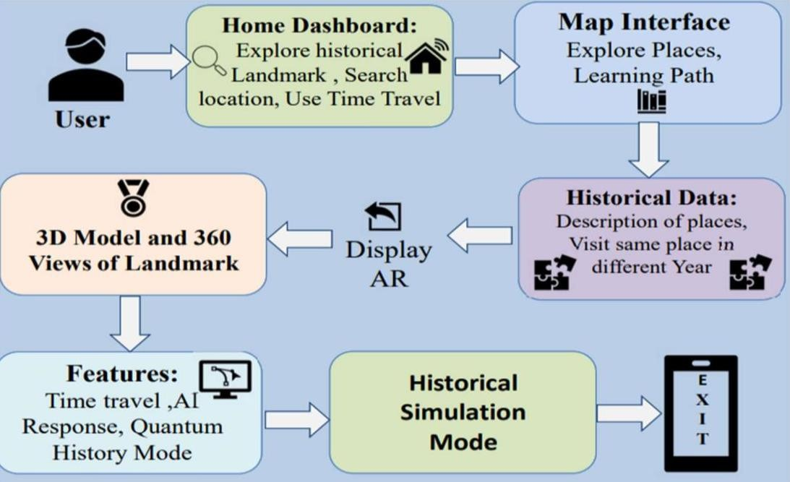
Fig.3.1.1. Flowchart

3.2.2 Use Case Diagram
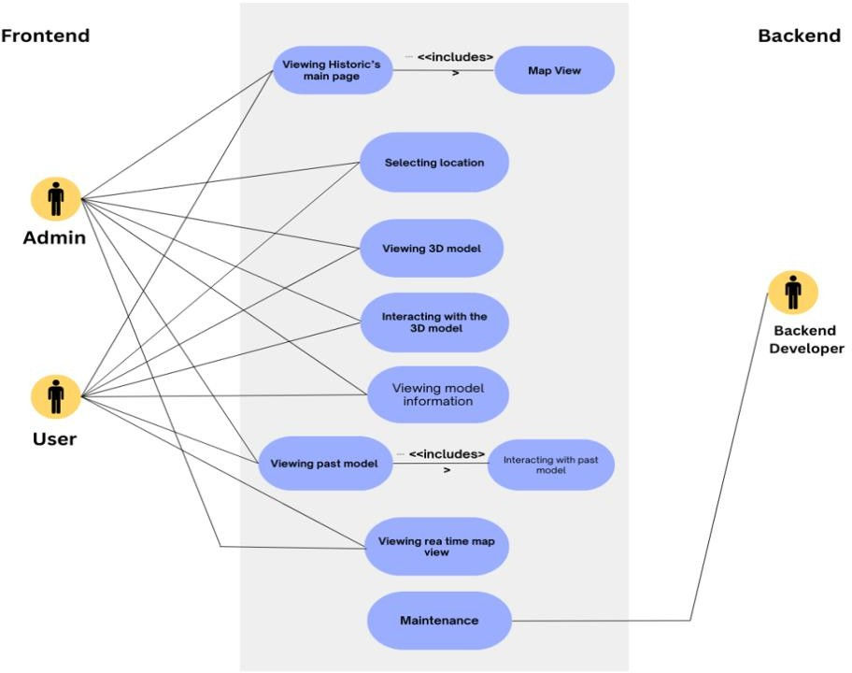
Fig3.1.2 Use Case Diagram

Sequence Diagram

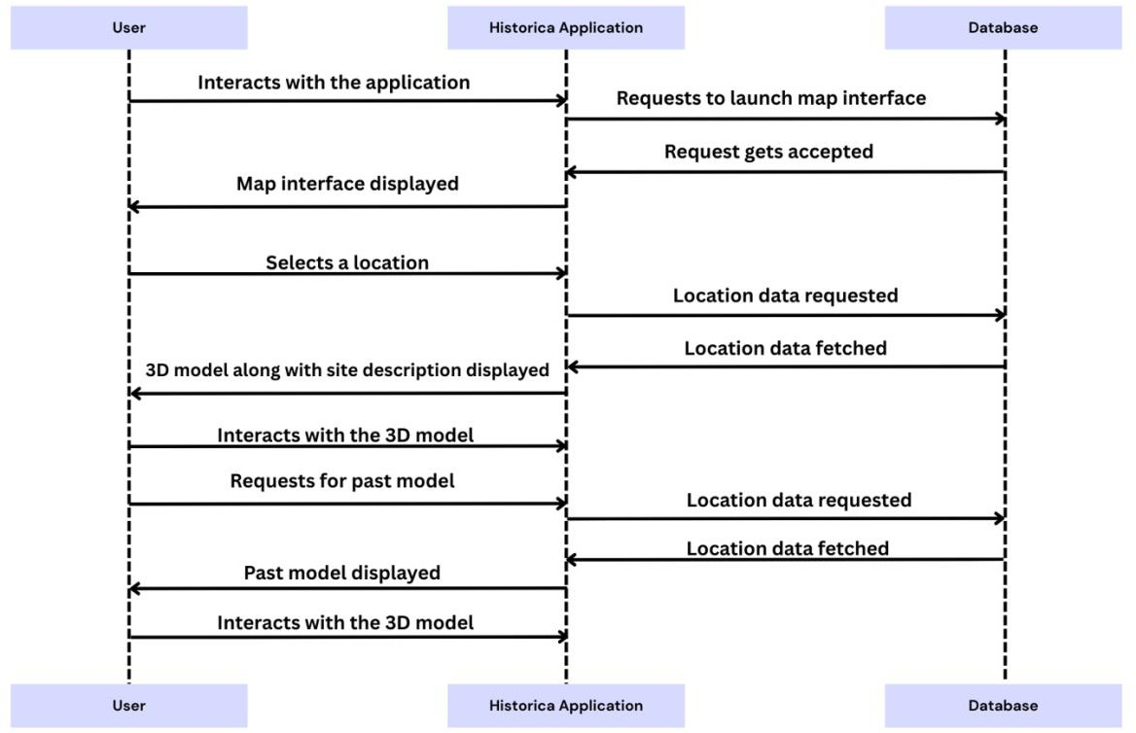
Fig.3.1.3 Sequence Diagram

Hardware/Software Designing
    - Hardware Requirements
      - Processor: Quad core or higher processor
      - RAM: Minimum 4GB
      - Storage: Minimum 200MB
      - HD display for better experience

Software Requirements

Frontend Stack
Frameworks & Libraries: React, React Three Fiber, Drei, XR, TailwindCSS, Framer Motion, Lucide-react, react-icons, Recharts, React Router DOM, Radix UI, Mapbox GL, Leaflet, React Leaflet, GSAP, Pixi.js, matter-js, Sonner, Zustand, Zod, Wouter
Core Tech: TypeScript, JavaScript, HTML, CSS
Build Tools: Vite, Tailwind plugins (merge, typography, scrollbar, animate)

Backend Stack
Server & Auth: Express.js, CORS, Express-session, Passport (local strategy)

Database: NeonDB (PostgreSQL), Drizzle ORM, connect-pg-simple, memorystore
APIs: REST (via Express.js), PostgreSQL session storage

Dev Dependencies
Replit Vite Runtime, TypeScript, tsx, @vitejs/plugin-react, Drizzle-kit, ESBuild, PostCSS, Autoprefixer

Applications
- Educational Tool: Enhances classroom learning with interactive 3D models and detailed historical narratives.
- Virtual Tourism: Enables remote exploration of ancient sites, providing immersive visualizations for travelers.
- Research & Preservation: Serves as a digital archive for historians and archaeologists, preserving cultural heritage.
- Public Engagement: Offers an accessible platform for history enthusiasts to explore and learn about ancient civilizations.
- Gamified Learning Experiences: Incorporates elements of gamification such as quizzes, challenges, and rewards to make learning about history fun and motivating, especially for younger audiences.
- Cultural Exchange & Storytelling: Facilitates global sharing of heritage stories and experiences, encouraging cross-cultural understanding through immersive digital reconstructions of historical narratives.

REFERENCES

- R. Baruah, “Creating an Augmented Reality Website with Three.js and the WebXR API,” AR and
VR Using the WebXR API, vol. 1, no. 1, pp. 45–60, Jan. 2021.
- C. Hadsell, "CyArk: Preserving cultural heritage through digital documentation," J. Cult. Herit. Digit. Arch., vol. 8, no. 2, pp. 101–112, Oct. 2019.
- CyArk. (2024, Jan. 12). CyArk: Digital Preservation of Cultural Heritage [Online].
Available: https://www.cyark.org/
- UNESCO. (2023, Mar. 15). World Heritage List [Online].
Available: https://whc.unesco.org/en/list/
- WebAR Collective. (2022, Aug. 10). WebAR and 3D Visualization Technologies: Three.js, A- Frame & Model Viewer [Online].
Available: https://threejs.org, https://aframe.io, https://modelviewer.dev

Guided By: Group Members:
Prof. Monika Choudhary Atharv Sharma (0827IT233D02)
Khushi Agrawal (0827IT221076)
Abhishek Rathore (0827IT233D01)
Jatin Rao (0827IT233D03)

