Historica

AR/VR-Powered Immersive Learning Experience

A
Project Report
Submitted in partial fulfilment of the requirement for the award of degree of
Bachelor of Technology
In
Information Technology

Submitted to
RAJIV GANDHI PROUDYOGIKI VISHWAVIDYALAYA,
BHOPAL (M.P.)

Guided By: Submitted By:
Prof. Monika Choudhary Khushi Agrawal (0827IT221076)

Department of Information Technology
Acropolis Institute of Technology and Research,
Indore (M.P.) 452002
2025-2026

DECLARATION

We hereby declared that the work, which is being presented in the project entitled Historica : AR/VR Powered Immersive Learning Experience partial fulfilment of the requirement for the award of the degree of Bachelor of Technology, submitted in the Department of Information Technology at Acropolis Institute of Technology & Research, Indore is an authentic record of our own work carried under the supervision of “Prof. Monika Choudhary”. We have not submitted the matter embodied in this report for the award of any other degree.

Khushi Agrawal (0827IT221076)

Prof. Monilka Choudhary
Supervisor

PROJECT APPROVAL FORM

I hereby recommend that the project HISTORICA under my supervision by Khushi Agrawal (0827IT221076) be accepted in partial fulfilment of the requirement for the degree of Bachelor of Technology in Information Technology.

Prof. Monika Choudhary
Supervisor

Recommendation concurred in 2025-2026

Prof. Mahendra Verma
Project In charge

Prof. Deepak Singh Chouhan
Project Coordinator

Acropolis Institute of Technology & Research


Department of Information Technology

CERTIFICATE
The project work entitled HISTORICA is approved as partial fulfilment for the award of the degree of Bachelor of Technology in Information Technology by Rajiv Gandhi Proudyogiki Vishwavidyalaya, Bhopal (M.P.).

Submitted by:
Khushi Agrawal (0827IT221076)

Internal Examiner External Examiner
Name: …………… Name: ……………..
Date: …./…/……… Date: …./…/………..

ACKNOWLEDGEMENT

With boundless love and appreciation, I would like to extend my heartfelt gratitude and appreciation to the people who helped us to bring this work to reality. I would like to have some space of acknowledgement for them.
Foremost, I would like to express my sincere gratitude to my supervisor Prof. Monika Choudhary whose expertise, consistent guidance, ample time spent and consistent advice that helped me to bring this study into success.
To the project in-charge Prof. Mahendra Verma and project coordinator Prof. Deepak Singh Chouhan for their constructive comments, suggestions, and critiquing even in hardship.
To the honourable Prof. (Dr.) Prashant Lakkadwala, Head, Department of Information Technology for his favourable responses regarding the study and providing necessary facilities.
To the honourable Dr. S.C. Sharma, Director, AITR, Indore for his unending support, advice and effort to make it possible.
Finally, I would like to pay thanks to faculty members and staff of the Department of Information Technology for their timely help and support.
I also like to pay thanks to my parents for their eternal love, support and prayers without them it is not possible.

Khushi Agrawal (0827IT221076)

ABSTRACT

The project titled HISTORICA: AR/VR Powered Historical Immersive Experience aims to revolutionize the way history is taught, learned, and experienced by leveraging emerging web-based augmented reality (AR) and virtual reality (VR) technologies. The motivation behind this project stems from the limitations of traditional historical education, which often fails to provide a vivid or engaging understanding of ancient civilizations. Many significant historical landmarks lie in ruins or are geographically inaccessible, making it challenging for learners and tourists to appreciate their original architectural grandeur and cultural significance.
To address this issue, a web-based platform was developed that offers interactive, historically accurate 3D reconstructions of ancient sites. Users can explore these digital models directly through their browsers, utilizing features such as zoom, rotation, and AR integration. Unlike conventional VR solutions that require expensive headsets or specialized software, this platform is accessible without additional hardware, thus making immersive learning widely available. The platform also includes contextual historical information through clickable annotations, enriching the user’s understanding of each site.
Through the design and implementation of this system, it was found that immersive 3D experiences significantly enhance user engagement, retention, and curiosity about historical topics. By combining educational content with visual storytelling and interactivity, the platform transforms passive learning into an active, exploratory process. Additionally, it contributes to the digital preservation of cultural heritage, ensuring that even deteriorating or inaccessible landmarks can be studied by future generations.
The significance of this project lies in its potential to redefine historical education, research, and cultural tourism. It not only bridges the gap between education and technology but also democratizes access to world heritage by removing financial and geographical barriers. HISTORICA stands as a forward-thinking initiative that merges innovation with cultural preservation, offering a meaningful, modern approach to understanding our past.

TABLE OF CONTENT

Page No.
DECLARATION ………………………………………………………………......... I
PROJECT APPROVAL FORM ………………………………………………........ II
CERTIFICATE ………………...………………………………………………........ III
ACKNOWLEDGEMENT …………………………………………………………. IV
ABSTRACT ……………………………………………………………………........ V
LIST OF FIGURES………………………………………………………………… IX
LIST OF TABLES………………………………………………………………....... X
ABBREVIATIONS………..………………………………………………………... XI
CHAPTER 1: INTRODUCTION
1.1 Rationale ………………………………………………………………… 1
1.2 Existing System …………………………………………………………. 1
1.3 Problem Formulation……….……………………………………………. 1
1.4 Proposed System…………………………………………………………. 2
1.5 Objectives……………………………………………………………….... 2
1.6 Contribution of the Project
1.6.1 Market Potential……………..…………………………………. 3
1.6.2 Innovativeness…….……………………………………………. 3
1.6.3 Usefulness…….…………………………………..……………. 4
1.7 Report Organization…….……………………………………..…………. 4
CHAPTER 2: REQUIREMENT ENGINEERING
2.1 Feasibility Study (Technical, Economical, Operational) …….…..………. 5
2.2 Requirement Collection
2.2.1 Discussion…….…………………………………………………. 5
2.2.2 Requirement Analysis…….…………………………………....... 6

2.3 Requirements
2.3.1 Functional Requirements…….…………………………………. 6
2.3.1.1 Statement of Functionality
2.3.2 Non-functional Requirements…….…………………………….... 6
2.3.2.1 Statement of Functionality
2.4 Hardware & Software Requirements
2.4.1 Hardware Requirement (Developer & End User) …….…….……. 7
2.4.2 Software Requirement (Developer & End User) …….……...….... 7
2.5 Use-case Diagrams…….………………………………………………..... 8
2.5.1 Use-case Descriptions…….………………….…………………. 8
CHAPTER 3: ANALYSIS & CONCEPTUAL DESIGN & TECHNICAL ARCHITECTURE
3.1 Technical Architecture…….…………………………………………..……. 10
3.2 Sequence Diagrams…….………………..…………………………………. 10
3.3 Class Diagrams…….……………………….………………………………. 11
3.4 Data Flow Diagram…….…………………………………..………………. 12
3.5 User Interface Design……...….……………………………………………. 13
3.6 Data Design
3.6.1 Schema Definitions…….………………………………………….. 15
3.6.2 E-R Diagram…….……………………………..………………….. 16
CHAPTER 4: IMPLEMENTATION & TESTING
4.1 Methodology…….……………………………………………………….. 17
4.1.1 Proposed Algorithm
4.2 Implementation Approach…….…………………………………………...18
4.2.1 Introduction to Languages, IDEs Tools and Technologies

4.3 Testing Approaches
4.3.1 Unit Testing
- Test Cases…….……………………………………...…….. 19
4.3.2 Integration Testing
- Test Cases…….……………………………………………. 20
CHAPTER 5: RESULTS & DISCUSSION
5.1 User Interface Representation…….………………………………………...... 22
    - Brief Description of Various Modules…….………………….. 22
  - Snapshot of System with Brief Description…….…………………….…….... 23
5.3 Database Description…….……………………………………………..…….. 25
5.3.1 Snapshot of Database Tables with Brief Description…….………….. 25
  - Final Findings…….…………………………………………….……………. 26
CHAPTER 6: CONCLUSION & FUTURE SCOPE
  - Conclusion………………………………………………………………...…... 27
  - Future Scope ………………………………………………………………...... 27
REFERENCES
Appendix A: Project Synopsis
Appendix B: Guide Interaction Report
Appendix C: User Manual
Appendix D: Git/GitHub Commits/Version History

LIST OF FIGURES

- Fig. 1 Use-case Diagram………………………………………………………….20
- Fig. 2 Technical Architecture……………………………………………………...22
- Fig. 3 Sequence Diagram……………………………………………………….....22
- Fig. 4 Class Diagram……………………………………………………………...23
- Fig. 5 Data Flow Diagram………………………………………………………...24
- Fig. 6 Home page………………………………………………………………….25
- Fig. 7 Map interface……………………………………………………………….25
- Fig. 8 Model page (part-1)………………………………………………………...26
- Fig. 9 Model page (part-2)…………………………………………………….......26
- Fig. 10 Time travel page…………………………………………………………..27
- Fig. 11 ER-Diagram……………………………………………………………….28
- Fig. 12 Home page………………………………………………………………...35
- Fig. 13 Map interface……………………………………………………………...35
- Fig. 14 Model page………………………………………………………………..36
- Fig. 15 Time travel page…………………………………………………………..36
- Fig.16 Database tables with fields………………………………………………...37

LIST OF TABLES

- Table 4.2: Unit Testing Test Cases and Results………………………………………31
- Table 4.3: Integration Testing Test Cases and Results……………………………….33
- Table 5.1: Module Descriptions in the System………………………………………37
- Table 5.2: Database Tables with Fields and Descriptions……………………………38

ABBREVIATIONS

- AI: Artificial Intelligence
- CSS: Cascading Style Sheets
- E-R: Entity-Relationship
- HTML: Hyper Text Markup Language
- IDE: Integrated Development Environment
- RESTful API: Representational State Transfer Application Programming Interface

CHAPTER 1: INTRODUCTION

1.1 Rationale
The need for engaging and immersive historical learning experiences has grown significantly in recent years. Traditional teaching methods often lack the visual and interactive elements needed to fully capture learner’s interest, especially when exploring cultural heritage and ancient landmarks. Additionally, many individuals are unable to physically visit historical sites due to geographic or financial limitations. The Historica web application addresses this gap by offering a centralized, interactive platform that uses AR/VR and 3D visualization to bring history to life. By allowing users to explore monuments as they appear today and in the past, Historica enhances educational outcomes, supports digital heritage preservation, and makes historical exploration accessible to all.

1.2 Existing System
Existing platforms like SketchFab (Cultural Heritage), HistoryView VR, and National Geographic AR Experiences offer limited access to historical content through 3D models or immersive tours. However, these systems often fall short of delivering a comprehensive, interactive, and educational experience. SketchFab allows 3D model viewing but lacks integrated historical storytelling or AR capabilities. HistoryView VR provides virtual tours but requires VR headsets and has limited 3D reconstructions. National Geographic’s AR experiences are engaging but not designed as full-scale platforms for historical exploration and learning.
In contrast, Historica bridges these gaps by combining interactive 3D visualization, historical context, time-travel features, and AR integration in a single web-based platform. It allows users to explore monuments as they exist today and as they appeared 100 years ago, making history more accessible, immersive, and meaningful—especially for learners without access to physical sites or VR devices.

1.3 Problem Formulation
  - Traditional methods of teaching history (e.g., textbooks, lectures) lack interactivity and engagement, especially for modern digital learners.
  - Access to historical sites is often limited due to geographical, financial, or preservation-related constraints.
  - Existing platforms either:
  - Do not provide immersive AR/VR experiences
  - Require expensive hardware (e.g., VR headsets)

  - Lack historical context and storytelling integration.
  - There is a lack of a unified platform that combines 3D visualization, time-based exploration (past vs present), and educational content.
  - A solution is needed that is accessible via web browsers, offers immersive learning experiences, and supports digital preservation of cultural heritage.

1.4 Proposed System
To address the limitations of traditional historical learning and existing digital platforms, Historica proposes the development of a web-based application powered by AR/VR technologies. The platform aims to provide users with an immersive, interactive, and educational experience of historical sites. The solution includes the following key components:
Interactive 3D Models: High-quality 3D visualizations of historical monuments that users can rotate, zoom, and explore in real time.
Time Travel Feature: A toggle that allows users to view how a monument looked in the past (e.g., 100 years ago) compared to its current state.
Map-Based Navigation: Integration with Mapbox or Leaflet to let users select historical locations from a global map interface.
Augmented Reality Support: AR features that allow users to visualize monuments in their real-world environment using compatible devices.
Educational Content Overlay: Informative panels and overlays providing historical context, facts, timelines, and cultural relevance of each site.
Cross-Platform Accessibility: Developed as a responsive web application using React, Three.js, and WebXR to ensure compatibility across devices.

1.5 Objectives

- Enhance Historical Learning: Provides an interactive way to study history with visual reconstructions, making education more engaging.
- Virtual Exploration & Tourism: Enables users to experience historical sites remotely, bridging the gap between travel and digital learning.
- Preservation of Cultural Heritage: Digitally preserves historical monuments and artifacts in 3D, allowing future generations to access and learn from them even if the physical structures degrade or become inaccessible.
- Accessible Education: Expands access to historical and cultural education globally by leveraging AR/VR, ensuring learners from remote or underprivileged areas can explore important sites without needing expensive travel.

1.6 Contribution of the Project
1.6.1 Market Potential
The demand for immersive educational technologies is rapidly increasing, driven by the growing adoption of AR/VR in learning environments and the need for innovative digital tools in tourism and heritage preservation. Historica has strong market potential in several domains:
- Educational Sector: Schools, colleges, and online learning platforms are seeking engaging tools to make history more interactive. Historica can be integrated into digital classrooms, museums, and e-learning platforms to enhance curriculum delivery.
- Virtual Tourism: With the rise of virtual experiences post-pandemic, users are actively seeking ways to explore world heritage sites from the comfort of their homes. Historica caters to this demand by offering interactive and educational virtual tours.
- Cultural Heritage Institutions: Museums, archaeological departments, and government heritage bodies can use Historica to digitally preserve monuments and offer public access without risking physical deterioration of sites.
- Global Accessibility: Learners in remote or underprivileged areas who lack the resources to visit historical sites in person can benefit from a web-based solution that requires no expense.

1.6.2 Innovativeness
    - Time-Travel Feature: Allows users to view historical sites as they appeared 100 years ago and compare with the present.
    - Web-Based AR/VR: Delivers immersive experiences directly in the browser without requiring VR headsets.
    - Map-Based Navigation: Users can explore global historical sites interactively through a map interface.
    - Educational Overlays: Combines 3D models with historical facts, timelines, and context for enriched learning.
    - Digital Heritage Preservation: Helps digitally preserve and showcase cultural monuments for future generations.

1.6.3 Usefulness
- Enhances learning with immersive 3D and AR/VR experiences
- Enables remote access to historical sites
- Aids in digital preservation of cultural heritage
- Serves as an educational tool for students and educators
- Accessible on standard devices without extra hardware

1.7 Report Organization
This report is structured to provide a comprehensive understanding of the Historica platform, its objectives, and its potential to revolutionize historical learning through immersive AR/VR experiences. The organization of the report is as follows:
- Chapter 2: Requirement Engineering, including feasibility studies and requirements analysis.
- Chapter 3: Analysis & Conceptual Design & Technical Architecture
- Chapter 4: Implementation & Testing, detailing development tools, methodologies, and testing strategies.
- Chapter 5: Results & Discussion, presenting the user interface, system snapshots, and database structure.
- Chapter 6: Conclusion & Future Scope, summarizing the project’s impact and potential enhancements.

CHAPTER 2: REQUIREMENT ENGINEERING

2.1 Feasibility Study
- Technical Feasibility:
    - Historica is developed using modern, proven technologies such as React, Three.js, React Three Fiber, and WebXR, which are widely supported and well-documented.
    - The platform runs directly in web browsers, eliminating the need for specialized VR hardware, making it more feasible to deploy and maintain.
    - Backend technologies like Node.js, Express.js, and PostgreSQL are scalable and compatible with cloud infrastructure, ensuring smooth data management and performance.
    - Open-source tools like Mapbox, Leaflet, and Blender (for model creation) reduce dependency on proprietary software and support cost-effective development.
- Economic Feasibility:
- The use of open-source libraries and frameworks significantly reduces development costs.
- Since Historica is web-based, users don't need to purchase additional hardware, lowering the overall cost of adoption.
- Hosting and database services (e.g., using platforms like NeonDB or Render) can be scaled as per demand, allowing for controlled spending.
- Long-term returns may include partnerships with educational institutions, museums, or tourism boards, making it potentially sustainable and self-funding.
- Operational Feasibility:
- The system is designed to be user-friendly, with intuitive navigation, map-based selection, and minimal learning curve, ensuring ease of use for students, educators, and general users.
- Admin functionalities allow easy content updates and site management without technical intervention.
- The application can be easily integrated into educational curricula or tourism initiatives with minimal operational changes.
- Web-based delivery ensures accessibility from a wide range of devices, supporting remote learning and exploration without infrastructure changes.

2.2 Requirement Collection
2.2.1 Discussion
Requirements were gathered through brainstorming sessions with key stakeholders, including students, educators, and history enthusiasts. User surveys and informal interviews were conducted to understand learning challenges, user expectations, and the demand for immersive historical experiences. Feedback from these sessions helped identify key features such as 3D interaction, time-travel visualization, map-based navigation, and accessibility through web browsers.

2.2.2 Requirement Analysis
The analysis focused on categorizing requirements into functional and non-functional groups, prioritizing features based on their educational impact and technical feasibility. Core features such as interactive 3D models, time-travel visualization, map-based site selection, and AR integration were identified as essential. Additional features like multilingual support and user bookmarking were considered secondary and planned for future enhancement.

2.3 Requirements
2.3.1 Functional Requirements
2.3.1.1 Statement of Functionality
- Site Selection on Map:
Users can view and select historical sites through an intuitive, interactive map interface.
- 3D Model Interaction:
Users can rotate, zoom, and explore detailed 3D reconstructions of historical sites for an immersive experience.
- Time Travel Feature:
A toggle button allows users to switch between the current view of a site and how it appeared 100 years ago, helping visualize historical transformations.
- Information Display:
Each historical site includes contextual data such as historical facts, reference images, architectural details, and timelines to enhance educational value.
    - Non-Functional Requirements
2.3.2.1 Statement of Functionality
- Fast and smooth performance: Built with Vite and optimized 3D rendering for fast load and smooth animations.
- Cross-device compatibility: Works well on desktops, tablets, and phones, future-ready for VR headsets.
- Easy to maintain & update: Uses TypeScript and Drizzle ORM to make backend logic and updates easy to manage.
- Attractive and responsive UI: Uses Tailwind CSS, Framer Motion, and Lucide icons to create a user-friendly and visually appealing interface.

2.4 Hardware & Software Requirements
2.4.1 Hardware Requirements
- Developer:
  - High-performance PC with at least 16GB RAM .
  - Stable internet connection.
- End User:
  - High-performance PC with at least 4 GB RAM .
  - Stable internet connection.
2.4.2 Software Requirements
- Developer:
  - Operating System: Windows/Linux/macOS.
  - IDE: Visual Studio Code.
  - Programming languages:
Frontend : React with TypeScript, TailwindCSS, Three.js, Leaflet.js.
Backend : Express.js, Node.js, NeonDB.
- End User:
  - Operating System: Web Browser.
  - Website: Historica web application
  - Use-case Diagram:

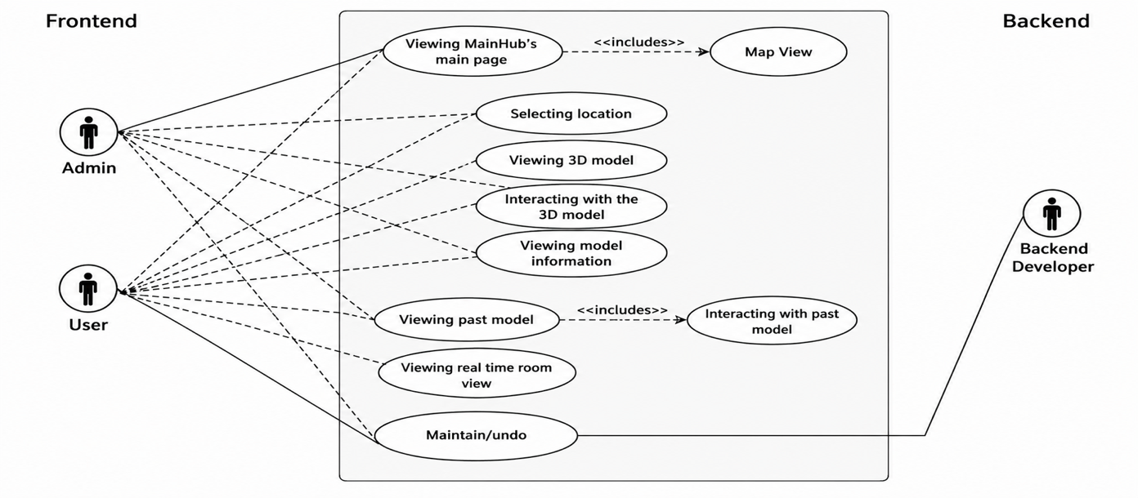
Fig.1 Use Case Diagram

2.5.1 Use-case Descriptions

1. Viewing Historica’s main page
- Actors: Admin, User
- Description: After logging in, users are directed to the main page, which provides an overview of available features, historical models, and navigation options. It serves as the entry point for exploring the platform.
- Includes: Map View

2. Map view
- Actors: Admin, User
- Description: Users can browse historical sites through an interactive map interface. Clicking on a location provides access to its 3D model and historical data, enhancing spatial awareness and discovery.

3. Selecting location
- Actors: Admin, User
- Description: Users can select a historical site from the map or list view. This selection filters the content to show specific models and related information.

4. Viewing 3d model
- Actors: Admin, User
- Description: Users can view high-resolution, interactive 3D models of historical sites. These models are designed to replicate the site's original architecture based on historical data.

5. Interacting with the 3D Model
- Actors: Admin, User
- Description: Enables users to zoom, rotate, and explore 3D reconstructions in detail. Interactions may also trigger animations or reveal additional contextual information about specific features of the model.

6. Viewing model information
- Actors: Admin, User
- Description: Provides detailed historical context, facts, and annotations related to the selected model. This helps users understand the cultural and architectural significance of the site.

7. Viewing past model
- Actors: Admin, User
- Description: Users can explore how a site evolved over time by selecting past versions of the model. This feature visualizes architectural changes or destruction due to natural or human events.
- Includes: Interacting with past model

8. Interacting with past model
- Actors: Admin, User
- Description: Similar to interacting with the current 3D model, users can examine older states of the structure, aiding in understanding historical transformations or restorations.

9. Viewing real-time map view
- Actors: Admin, User
- Description: Displays live or updated visual overlays (e.g., weather, user positions, current site conditions) to enrich user experience and correlate modern-day data with historical insights.

10. Maintenance
- Actors: Backend Developer
- Description: The backend developer ensures the platform remains operational by handling updates, bug fixes, database management, and implementing new features or security patches.

CHAPTER 3: ANALYSIS & CONCEPTUAL DESIGN & TECHNICAL ARCHITECTURE

3.1 Technical Architecture
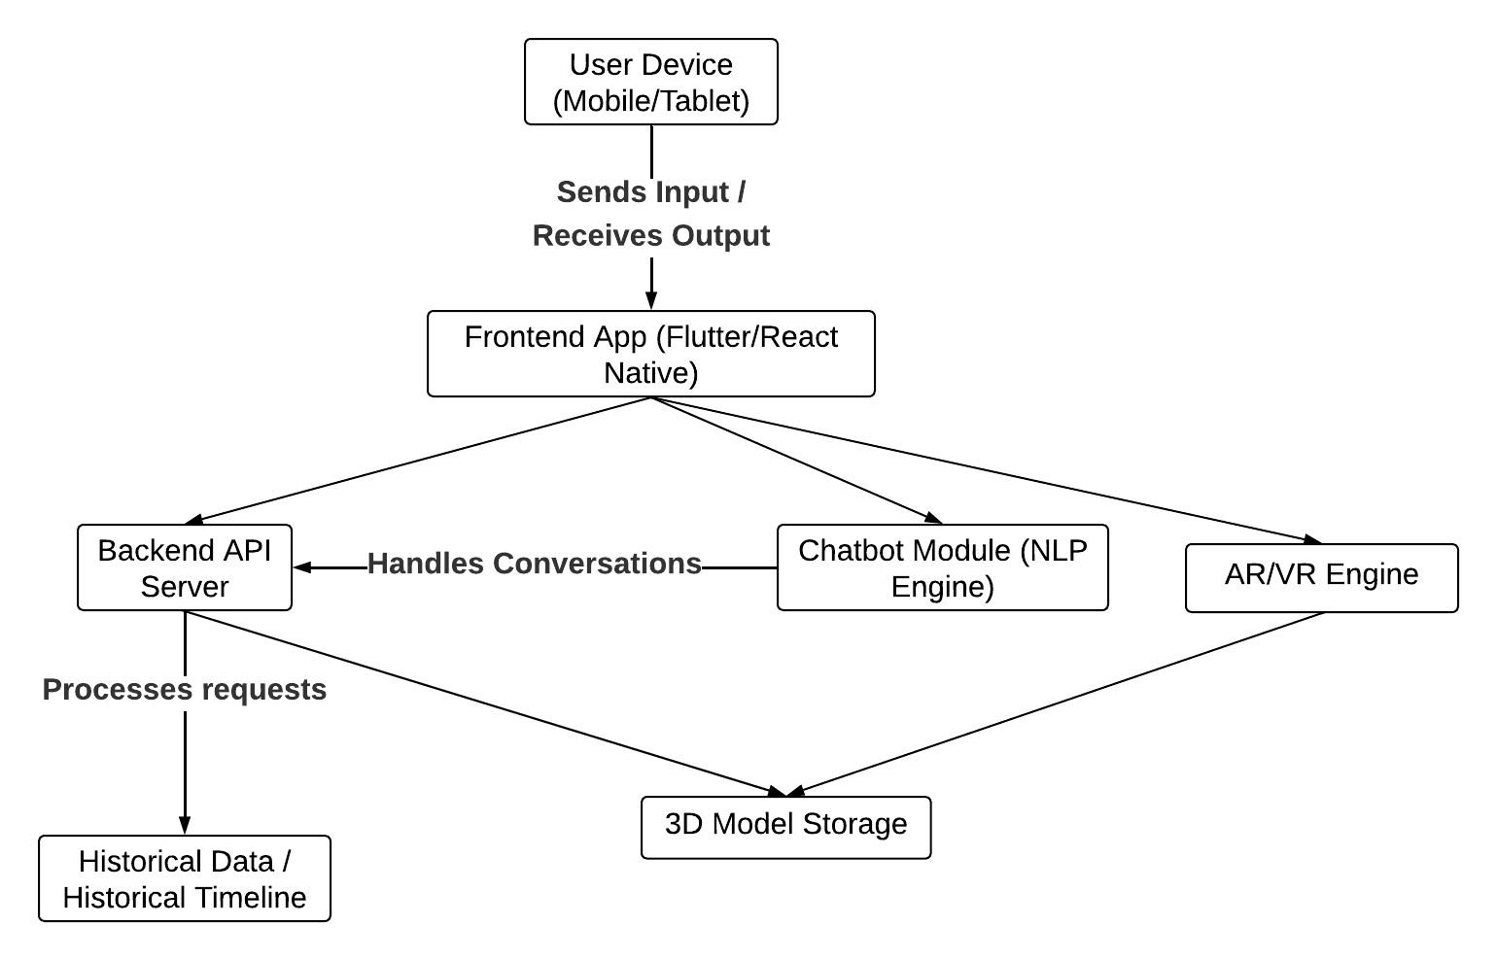
Fig. 2 Technical Architecture

3.2 Sequence Diagram
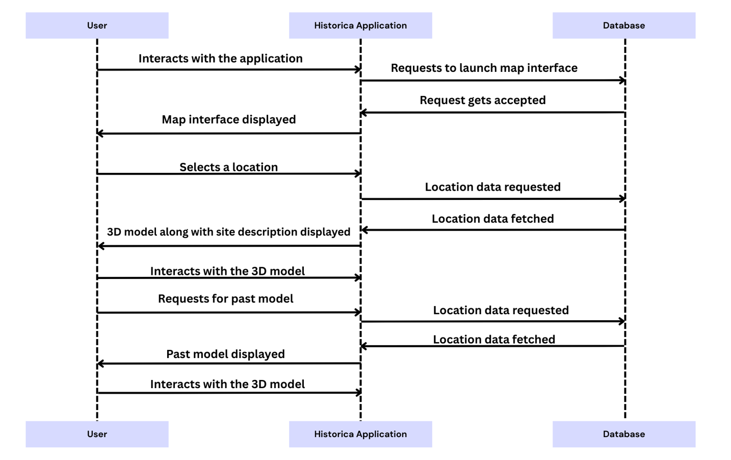
Fig. 3 Sequence Diagram

3.3 Class Diagram
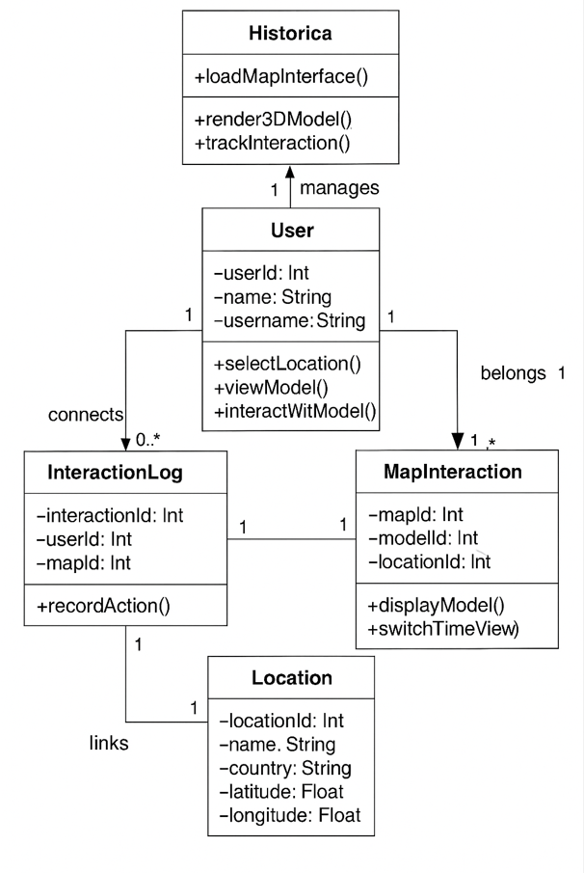
Fig. 4 Class Diagram

3.4 Data Flow Diagram
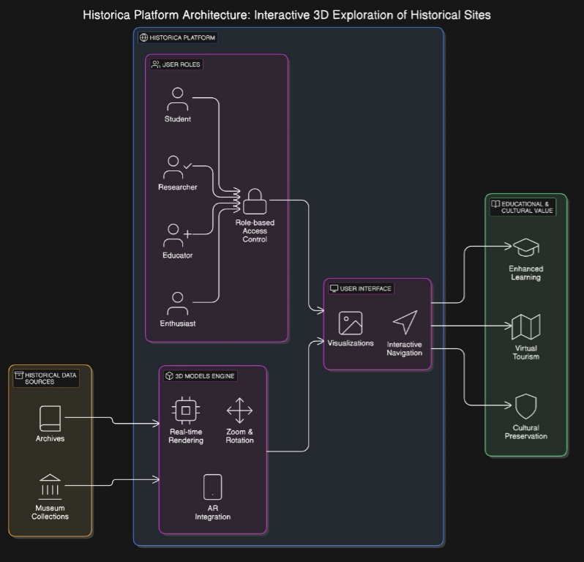
Fig. 5 Data Flow Diagram

3.5 User Interface Design
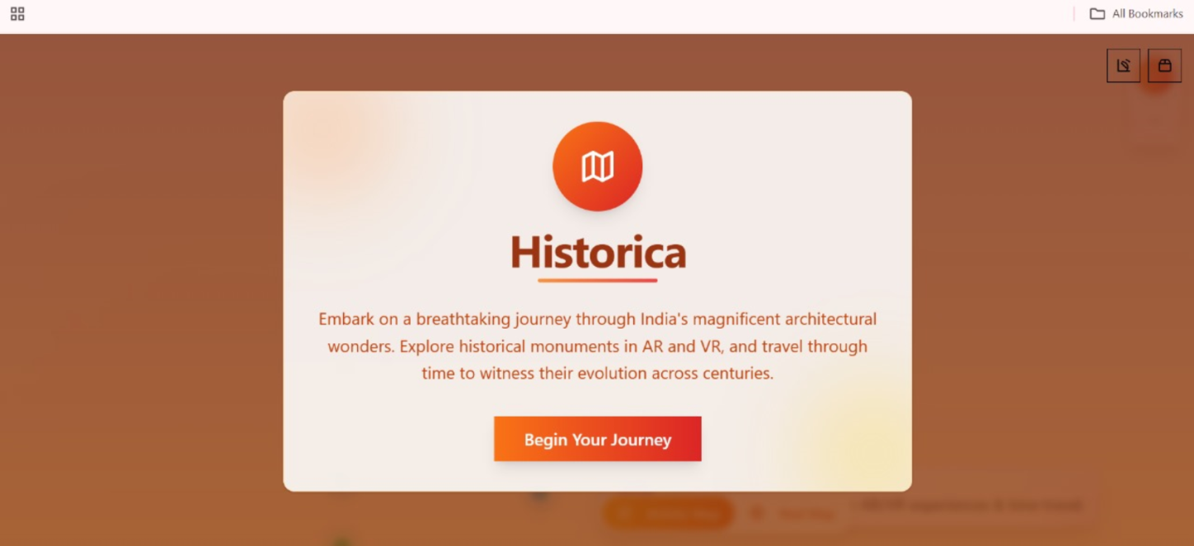
Fig. 6 Home page

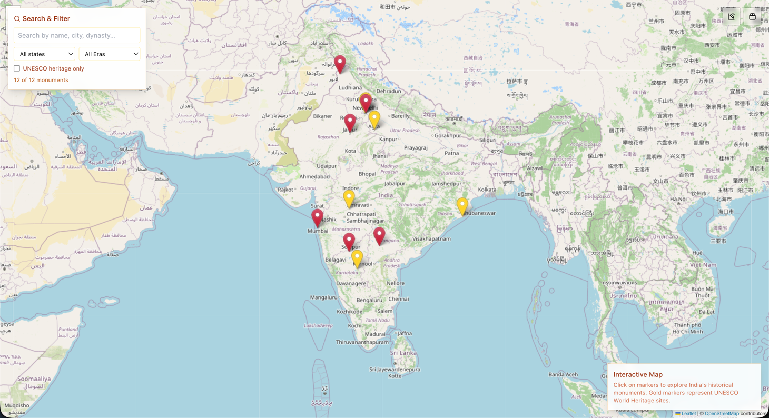
Fig. 7 Map interface

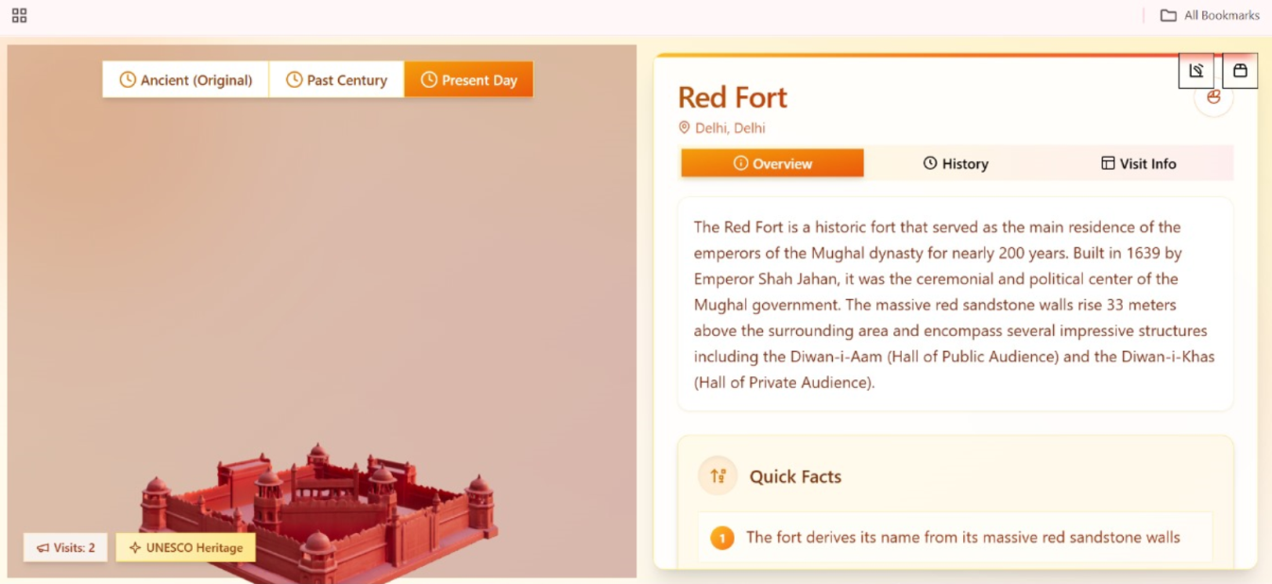

Fig. 8 Model page (part-1)

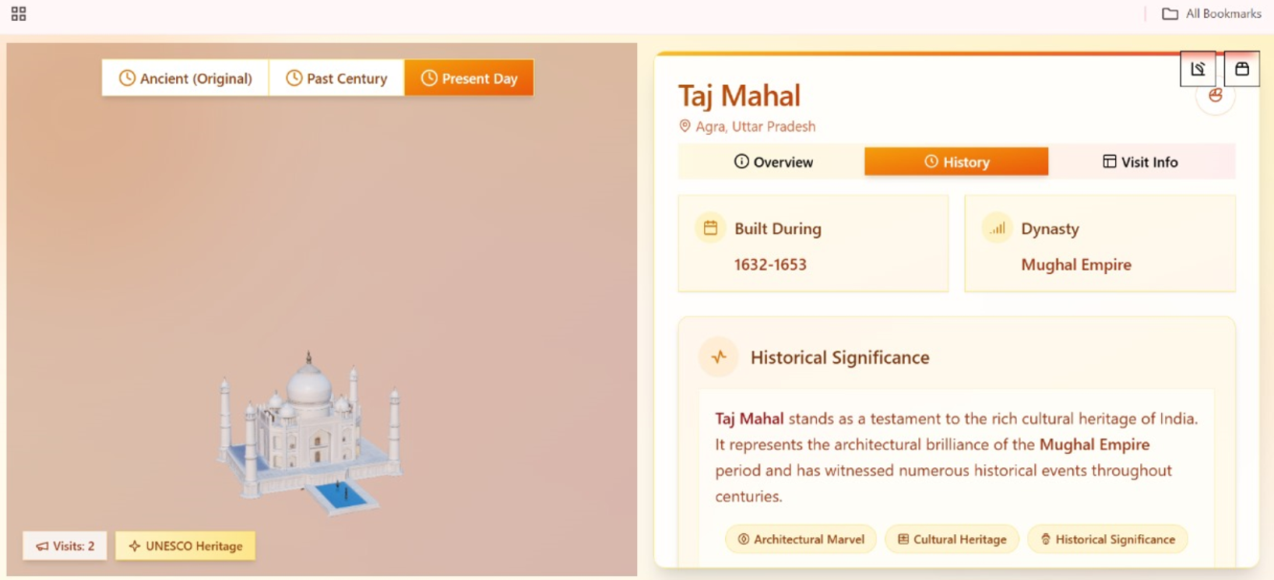
Fig. 9 Model page (part-2)

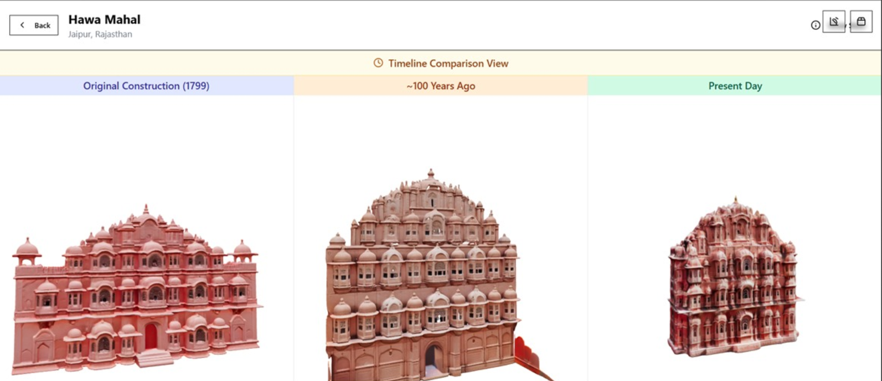
Fig. 10 Time travel page

3.6 Data Design
3.6.1 Schema Definitions
This schema represents a system where users can explore historical locations, interact with 3D models, and maintain records of their activity on the platform.
The USER table is central, storing general information like user ID, name, and username. All platform users—admins, history enthusiasts, students, or guests—are represented through this table.
The LOCATION table stores geospatial and identification data for historical sites, including attributes like name, country, latitude, and longitude. Each location corresponds to a real-world heritage site.
The HISTORICAL_MODEL table represents detailed 3D reconstructions of historical sites. Each model is tied to a LOCATION and includes a textual description. This forms the educational core of the system.
The MAP_INTERFACE table links users to specific models and locations through interactions with the map-based UI. It represents user access to historical data via map navigation and serves as a bridge between models, locations, and user actions.
Users can engage with models through INTERACTION_LOG, which records interactions (such as viewing, rotating, or time-travel toggles). This supports tracking user behavior and enables future personalization or analytics.
Relationships among tables are maintained using foreign keys:
- A Historical Model belongs to one Location.
- A Map Interface connects a User, Location, and Model.
- An Interaction Log connects a User to a Map Interface instance, tracking how users engage with site content.
The schema efficiently supports:
- Educational exploration of historical reconstructions.
- User-specific interaction history for personalization and analysis.
- Admin control over model uploads and content management.

3.6.2 E-R Diagram

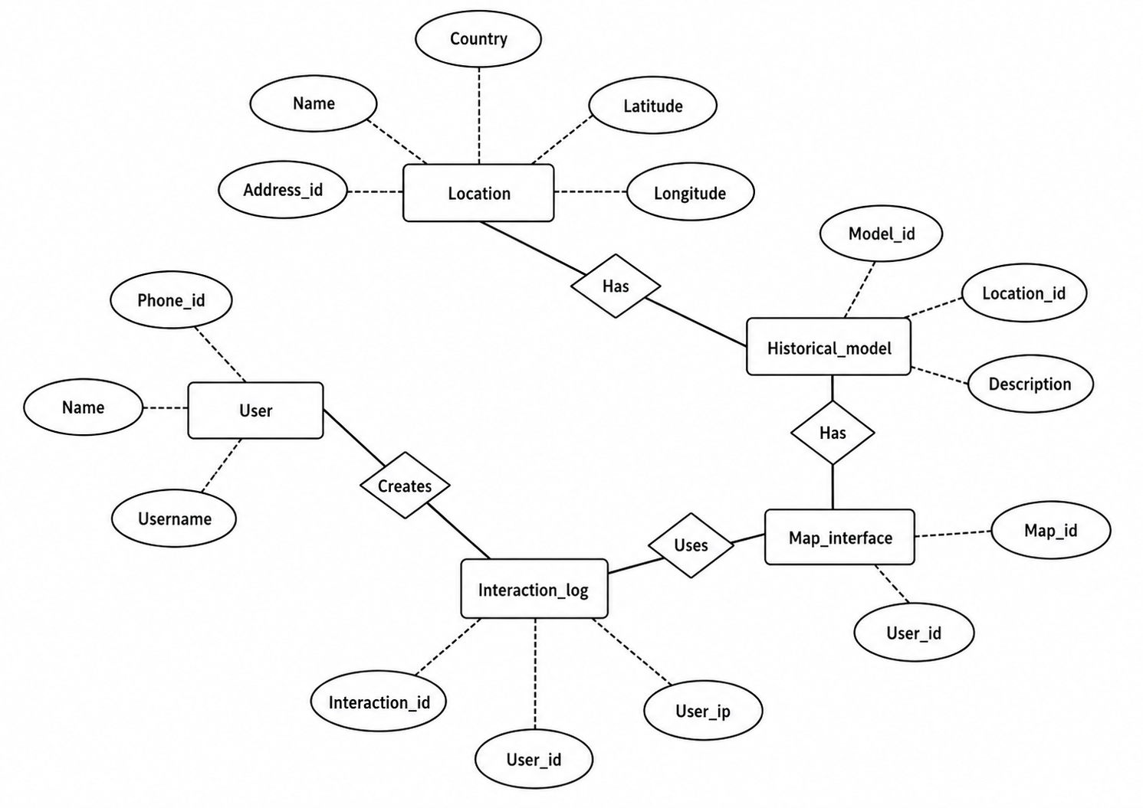

Fig. 11 ER-Diagram

CHAPTER 4: IMPLEMENTATION & TESTING

4.1 Methodology
The development of Historica follows a user-focused approach to ensure it provides an engaging and educational experience for its target audience, including students, educators, and history enthusiasts. The platform is built using modern web technologies to ensure high performance, scalability, and immersive interaction.

4.1.1 Proposed Algorithm
- Requirement Analysis
- Conducted research to identify gaps in traditional history education and current AR/VR solutions.
- Defined key user needs: accessibility, interactivity, historical accuracy, and immersive visualization.
- Finalized project scope to include interactive 3D AR models, historical simulations, and AI-based reconstructions.
- System Design
- Architecture Design:
  - Client-server model with a decoupled frontend (React + Three.js) and backend (Node.js/Express).
- Component Design:
  - Modular components for map interface, time travel scenes, 3D avatars, and AI interactions.
  - Integration of AR views through browser-based 3D rendering engines using WebGL.
  - Front-End Implementation
- Developed a dynamic interface using React 18 with TypeScript for robustness and scalability.
- Integrated Leaflet.js for map-based historical exploration.
- Utilized React Three Fiber and Three.js to render interactive 3D historical environments.
- Added Framer Motion and Radix UI for animations and UI elements to enhance user experience.
  - Back-End Development
- Built RESTful APIs using Express.js with TypeScript for secure and scalable data operations.
- Implemented session management for user authentication and personalization.
  - AI Integration
- Leveraged Generative AI to recreate historical scenes, events, and characters using pre-trained models.
- Enabled AI-driven interactions with historical avatars using NLP models to simulate conversations and storytelling.
- Designed a “Quantum History Mode” to simulate alternative timelines and "What If" scenarios.
- 3D Asset & Scene Development
- Generated 3D models of landmarks and ancient environments based on historical data.
- Incorporated AI-based reconstruction techniques to restore lost or destroyed structures visually.
- Ensured models are lightweight and optimized for web performance.
4.2 Implementation Approach
4.2.1 Introduction to Languages, IDEs, Tools, and Technologies
- Languages Used:
TypeScript: Used extensively on both the front-end (React) and backend (Node.js/Express) for type-safe development, reducing runtime errors and improving maintainability.
JavaScript: Utilized within libraries like Three.js and Leaflet for dynamic interactions and 3D rendering.
HTML/CSS: For structure and base styling, with modern enhancements using TailwindCSS and PostCSS.
- IDEs and Development Environments:
Visual Studio Code (VS Code): The primary development environment used for writing, debugging, and managing TypeScript, JavaScript, and styling files. VS Code’s extensions support efficient web development workflows.
Chrome DevTools: For in-browser testing, responsive design checking, and performance optimization.
- Development Tools and Utilities:
TypeScript: Brings static typing to JavaScript, allowing safer code and better IDE support.
TSX: Allows direct execution of TypeScript files during development for quick prototyping.
PostCSS: Processes CSS with plugins for better performance and enhanced compatibility.

4.3 Testing Approaches
4.3.1 Unit Testing
Unit testing focused on validating individual components of the app to ensure their correctness.
Table 4.2 Unit Testing Test Cases and Results
Test Case | Objective | Expected Outcome
Render Time Travel Scene | Test if 3D scene renders based on selected event | Correct 3D scene is displayed
Click Map Marker | Verify marker interaction and data fetch | Popup shows accurate historical info
AI Avatar Interaction | Test AI chat response to user input | Avatar replies with relevant historical details
Page Navigation | Ensure correct routing between pages | Target page loads and URL updates
Fetch Historical Data (API) | Test API call and data rendering | Data is displayed without error
Update Global State | Check state changes via user interaction | UI updates with new time/location
User Login | Validate session creation after login | Session is established and retained
Load 3D Asset | Confirm model loads properly | 3D asset appears within acceptable time
Trigger Entry Animation | Test animation on new scene load | Animation plays as expected
Display Learning Path | Test personalized content rendering | AI-based suggestions appear based on user history

4.3.2 Integration Testing
Integration testing ensured seamless communication between the front-end, back-end, and database.
Table 4.3 Integration Testing Test Cases and Results
Test Case | Objective | Expected Outcome
Map to Scene Integration | Verify that selecting a map marker loads the correct 3D scene | Corresponding historical scene is rendered on selection
User Login to Personalized Dashboard | Test login flow and personalized content rendering | User is logged in and sees tailored learning paths
AI Avatar with Scene Context | Test AI avatar response based on current 3D environment | Avatar gives scene-specific historical insights
API + 3D Model Load | Verify data fetch and model rendering together | Scene loads with accurate data and 3D visuals
Session Persistence + Routing | Test session retention during navigation | User remains logged in across different pages
Time Travel Selection + Animation Trigger | Check interaction of time period selection and animation | Scene changes and animation plays seamlessly
Scene Interaction + State Update | Test object interaction and UI state update | Info panel or avatar updates as user interacts
Avatar Chat + Data Store Update | Validate AI interaction modifies or logs user progress | User’s historical journey is updated based on conversation
Map Load + Performance Metrics | Test map component with live data and rendering performance | Map loads accurately without lag
Backend Sync with Frontend Preferences | Verify backend settings affect frontend UI (e.g., dark mode) | User preferences apply across frontend after backend fetch

CHAPTER 5: RESULTS & DISCUSSION

5.1 User Interface Representation
5.1.1 Brief Description of Various Modules
Table 5.1 Model description table
Module Name | Brief Description
User Authentication Module | Manages user login, registration, and session handling.
Interactive Map Module | Displays global landmarks and links them to historical scenes.
Time Travel & Scene Renderer Module | Renders 3D historical environments based on selected era and location.
AI Avatar Interaction Module | Allows users to chat with AI-powered historical characters.
Historical Content & Data Module | Provides facts, timelines, and descriptions from the database.
3D Asset Management Module | Loads and optimizes 3D models for immersive viewing.
Personalized Learning Path Module | Suggests tailored historical content based on user activity.
Quantum History Mode Module | Simulates alternate historical scenarios using AI.
UI/UX and Animation Module | Enhances user experience with transitions and visual effects.

5.2 Snapshot of System with Brief Description
- The landing page of Historica invites users to explore India's rich architectural heritage through immersive AR and VR experiences. It encourages users to "Begin Your Journey" through time to witness the transformation of historical monuments over centuries.

Fig.12 Home page
- This page displays an interactive map interface from the Historica platform, showcasing key historical monument locations across India. Users can explore these sites using either the "Artistic Map" or "Real Map" view options at the bottom centre. Coloured pins mark significant cultural or architectural landmarks, enabling users to select and engage with them for more immersive AR/VR-based historical exploration.
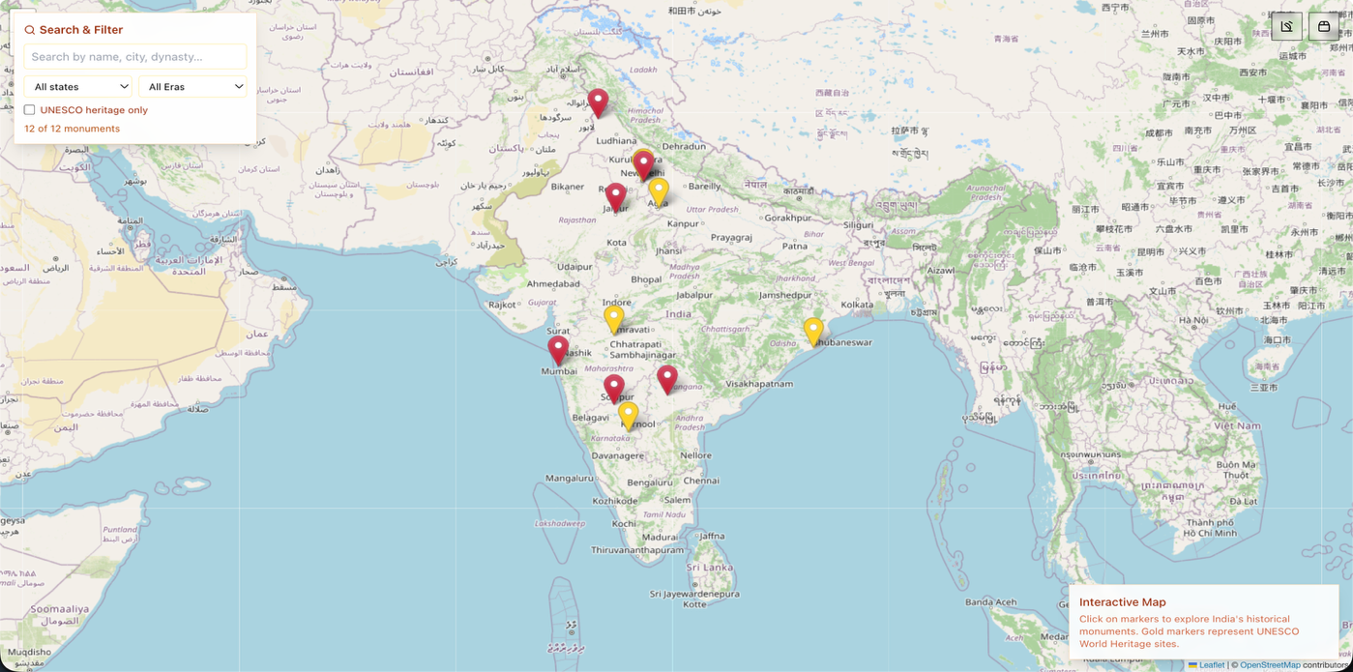
Fig.13 Map interface

- This page offers an interactive 3D view of the Red Fort with time-travel options, a brief historical overview, visit stats, UNESCO tag, and quick facts — making history visually engaging and informative.
Fig.14 Model page
- Timeline view of Hawa Mahal showing its 3D appearance in 1799, ~100 years ago, and present day.

Fig.15 Time travel page

5.3 Database Description
5.3.1 Snapshot of Database Tables
- users: Stores user info like username, email, role, and login details.
- historical_sites: Info about historical locations including name, location, period, and coordinates.
- models_3d: 3D models linked to historical sites with details like file URL, author, and AR support.
- educational_resources: Articles or content related to historical sites.
- user_comments: Comments made by users on historical sites.
- user_bookmarks: Bookmarked sites saved by users.
- media_assets: Media (images/videos) linked to 3D models.
- ar_sessions: AR usage sessions by users including time and device details.

Table 5.2: Database Tables with Fields
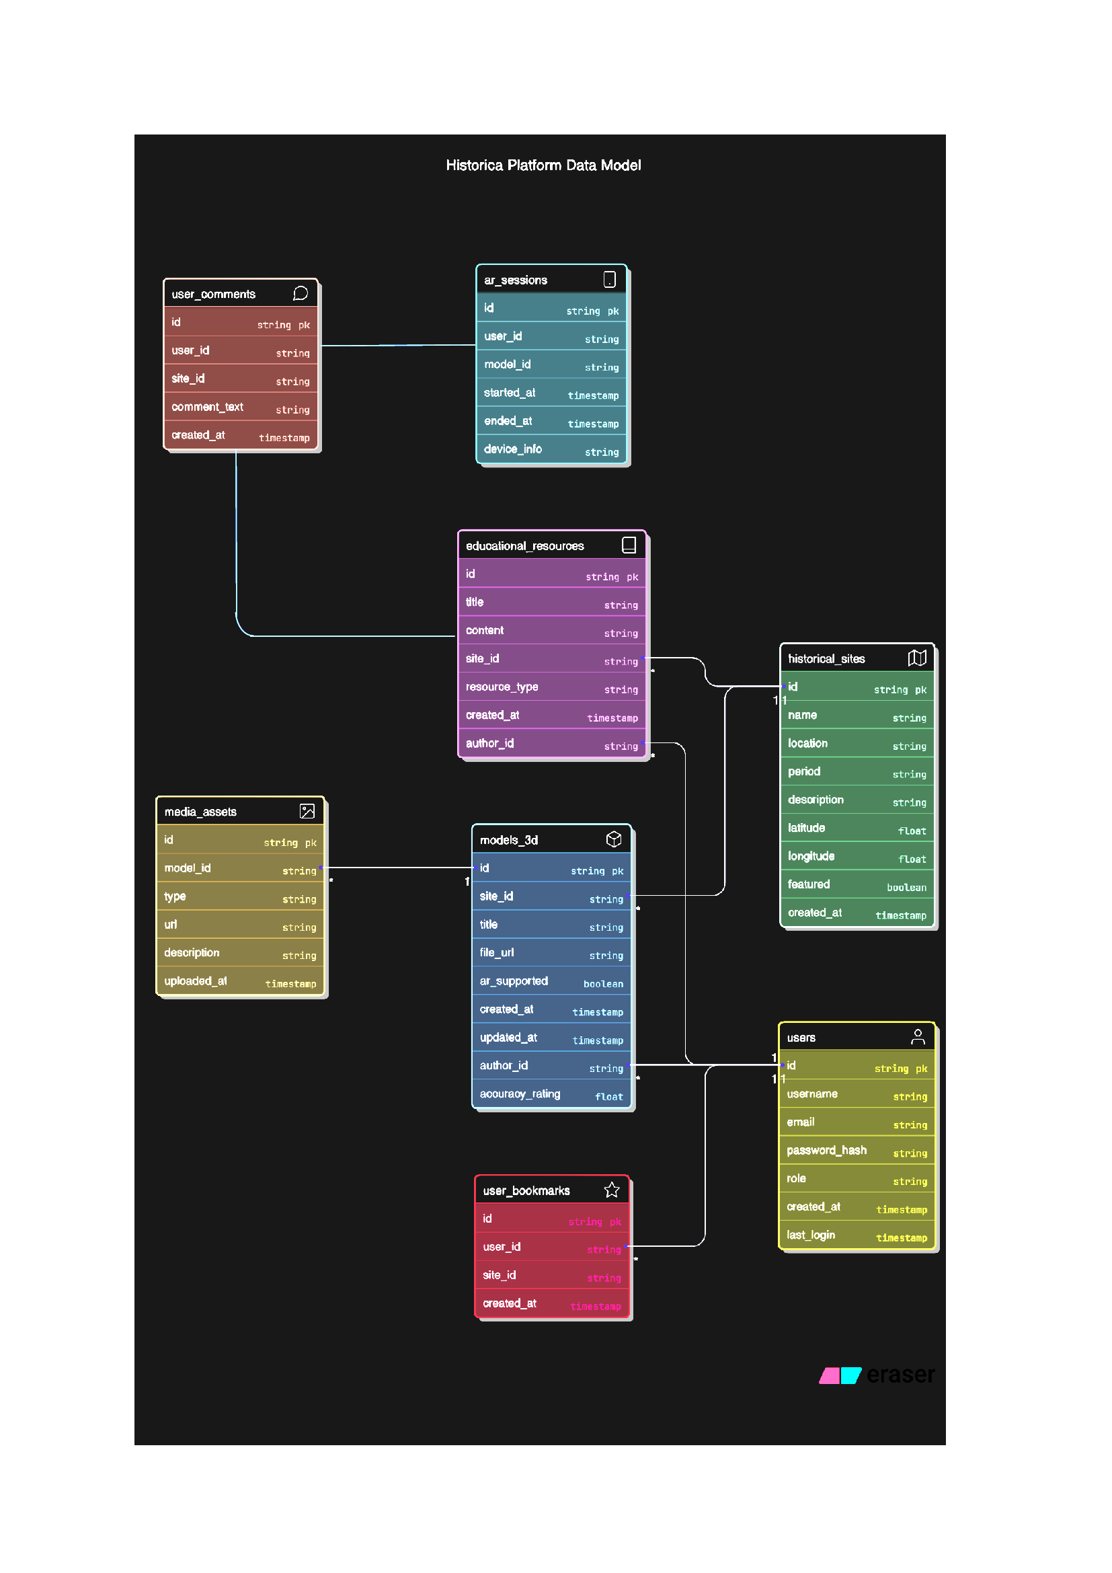

5.4 Final Findings
Table 5.3 Final Findings
Finding | Description
Enhanced Historical Engagement | Provided immersive AR-based learning with interactive 3D scenes and AI avatars.
Seamless Web-Based Access | Enabled users to explore historical content via browser without needing extra hardware.
Effective Use of Modern Tech Stack | Utilized React, Three.js, Leaflet, and Express for a smooth, high-performance experience.
AI Personalization & Simulation | Offered personalized learning paths and “What-if” scenarios using AI capabilities.
Interactive Map Navigation | Allowed intuitive exploration of historical landmarks through a dynamic map interface.
Educational and Cultural Impact | Promoted historical awareness and preserved cultural heritage digitally.
Scalable and Extensible Architecture | Designed for easy addition of new content, regions, and advanced features in the future.

CHAPTER 6: CONCLUSION & FUTURE SCOPE

6.1 Conclusion
The Historica application offers an immersive and educational platform that redefines how users experience and engage with history. By leveraging advanced technologies such as React, Three.js, and WebXR, Historica ensures a responsive, interactive, and cross-device compatible experience. The platform’s core functionalities—including interactive 3D models, a time-travel feature, AR integration, and map-based navigation—allow users to explore historical sites as they exist today and as they appeared in the past. Designed to serve students, educators, and history enthusiasts, Historica makes historical learning more accessible, engaging, and visually rich. The application not only supports cultural education but also plays a key role in the digital preservation of heritage sites. In a world where experiential learning and virtual accessibility are increasingly valuable, Historica stands as a powerful tool that connects users with the past through innovative technology and thoughtful design.

6.2 Future Scope
The potential of Historica extends far beyond its current implementation. In the future, the platform can integrate support for Virtual Reality (VR) headsets, voice-based AI avatars, multilingual content, real-time collaborative exploration, and integration with educational curricula. It also holds promise for global expansion, enabling the inclusion of world heritage sites and localized cultural stories.

REFERENCES
- Ardiny, H., & Khanmirza, E. (2018). The Role of AR and VR Technologies in Education Developments: Opportunities and Challenges. 2018 6th RSI International Conference on Robotics and Mechatronics (IcRoM), Tehran, Iran, pp. 482–487. https://doi.org/10.1109/ICRoM.2018.8657615
- Archaeological & Historical Research Sources: Based on UNESCO’s cultural heritage data (whc.unesco.org), academic research papers, and museum archives to ensure accurate reconstructions of historical sites.
- CyArk. https://www.cyark.org
- Fitria, Tira Nur. (2023). Augmented Reality (AR) and Virtual Reality (VR) Technology in Education: Media of Teaching and Learning: A Review. International Journal of Computer and Information System (IJCIS), 4(1), 14–25. https://doi.org/10.29040/ijcis.v4i1.102
- Godewithana, N., Jayasena, K., Nagarawaththa, C., Croos, P., Harshanath, B., & Alosius, J. (2020). Historical Places & Monuments Identification System. 2020 IEEE REGION 10 CONFERENCE (TENCON), Osaka, Japan, pp. 690–695. https://doi.org/10.1109/TENCON50793.2020.9293882
- Kaluku, M. R., Pakaya, N., & Punu, G. (2022). Implementation of augmented reality on historical monuments in Gorontalo Province. Indonesian Journal of Electrical Engineering and Computer Science, 28(1), 559–566. https://doi.org/10.11591/ijeecs.v28.i1.pp559-566
- Karaman, M. K., & Deniz, Ö. (2025). The Role of VR, AR, and Artificial Intelligence in the Sustainable Preservation of Cultural Heritage: Social Media Marketing of Historical Sites, New Media Education in Turkey, and Their Contributions to SDGs. Journal of Lifestyle and SDGs Review, 5(3), e05260. https://doi.org/10.47172/2965730X.SDGsReview.v5.n03.pe0526
- SketchFab Official Documentation. https://sketchfab.com/
- Qiu, X. Y., Chiu, C. K., Zhao, L. L., Sun, C. F., & Chen, S. J. (2021). Trends in VR/AR technology-supporting language learning from 2008 to 2019: a research perspective. Interactive Learning Environments, 31(4), 2090–2113. https://doi.org/10.1080/10494820.2021.1874999
- Shen, X., & Shirmohammadi, S. (2008). Virtual and Augmented Reality. In Furht, B. (Ed.), Encyclopedia of Multimedia. Springer, Boston, MA. https://doi.org/10.1007/978-0-387-78414-4_253
- Vîlcea, C., Popescu, L., & Niță, A. (2023). Historical Buildings and Monuments as Cultural Heritage In Situ—Perspectives from a Medium-Sized City. Heritage, 6(6), 4514–4526. https://doi.org/10.3390/heritage6060239
- WebAR and 3D Visualization Technologies: Utilizes Three.js (threejs.org), A-Frame (aframe.io), and Model Viewer (modelviewer.dev) for rendering interactive 3D models and AR experiences in web browsers.
- Appendix A: Project Synopsis: https://github.com/Atharv-082004/Historica/tree/main/Synposis
- Appendix B: Guide Interaction Report: https://github.com/Atharv-082004/Historica/tree/main/Log%20Book
- Appendix C: User Manual: https://github.com/Atharv-082004/Historica/tree/main/Report
- Appendix D: Git/GitHub Commits/ Version History
- GitHub Repository: https://github.com/Atharv-082004/Historica/tree/main
- Commits History: https://github.com/Atharv-082004/Historica/commits/main/

