FORMDETECT
Automatic Form Field Detection and Classification using Deep Learning
A Project Report
Submitted in partial fulfillment of the requirements for the award of the
Diploma in Artificial Intelligence and Machine Learning.
Submitted by:
Atharv Shetty — 8080110
Under the guidance of:
K.S SHIRUR

Government Tool Room and Training Centre (GTTC), Belagavi
[Academic Year : 2026]

Certificate
This is to certify that the project entitled “FORMDETECT — Automatic Form Field Detection and Classification using Deep Learning” has been carried out by Atharv Shetty (Roll No. 8080110) in partial fulfillment of the requirements for the Diploma in Artificial Intelligence and Machine Learning during the academic year 2026, under my supervision.
Guide’s Signature: ___________________________
Name: K.S Shirur
Head of Department: ___________________________
Name: [HOD’s Name]

Declaration
I hereby declare that the project entitled “FORMDETECT — Automatic Form Field Detection and Classification using Deep Learning” is an original piece of work carried out by me, under the guidance of K.S Shirur, and has not been submitted elsewhere for any other degree or diploma. All datasets, libraries, and external resources used have been duly acknowledged.
Signature: ___________________________
Name: Atharv Shetty
Date: ___________________________

Acknowledgement
I would like to express my sincere gratitude to my project guide, K.S Shirur, for the valuable guidance, constant encouragement, and support throughout the development of this project. I am also thankful to the Head of Department and all faculty members of the Department of Artificial Intelligence and Machine Learning, GTTC Belagavi, for providing the resources and environment necessary to complete this work.
I would also like to acknowledge Guillaume Jaume, Hazim Kemal Ekenel and Jean-Philippe Thiran, the creators of the FUNSD (Form Understanding in Noisy Scanned Documents) dataset, whose publicly shared annotated data made the practical implementation of this project possible.
Finally, I thank my family and friends for their continuous support and motivation.

Abstract
Forms such as application forms, invoices and registration sheets are very often available only as scanned images. Finding the different parts of such a form by hand is slow and tiring. This project, FormDetect, is a simple deep learning system that looks at a scanned form image, finds the text and field regions on it, and decides whether each region is a QUESTION, an ANSWER, a HEADER or OTHER text. The classifier is built from scratch using NumPy — no TensorFlow, no PyTorch and no pre-trained models.
The project covers the full pipeline: reading the real annotations of the FUNSD dataset, preprocessing images with OpenCV, candidate region detection, a hand-built multi-layer neural network with forward propagation, backpropagation, a weighted cross-entropy loss and the Adam optimizer, and evaluation metrics calculated manually (Accuracy, Precision, Recall, F1 score and Confusion Matrix). A Flask API serves the predictions to a web interface that lets the user upload a form, see coloured bounding boxes with labels, and read the confidence value produced by the model.
The model is trained on the annotated regions of the FUNSD training forms and tested on the separate FUNSD testing forms. All performance figures are measured values produced by the training and evaluation scripts. On the 2,332 test regions the model reached an accuracy of 57.42%, with the weakest results on the header and other classes, and Chapter 10 discusses the overfitting seen during training. The project is kept simple enough to be fully explained in a viva.

Table of Contents
Certificate 2
Declaration 3
Acknowledgement 4
Abstract 5
Table of Contents 6
Chapter 1: Introduction 7
1.1 Background 7
1.2 Problem Statement 7
1.3 Objectives 7
1.4 Scope of the Project 7
1.5 Organization of the Report 7
Chapter 2: Literature Review / Existing Approaches 8
Chapter 3: System Requirements 9
3.1 Functional Requirements 9
3.2 Non-Functional Requirements 9
3.3 Hardware Requirements 9
3.4 Software Requirements 9
Chapter 4: System Design 10
4.1 System Architecture 10
4.2 Data Flow Diagram 10
4.3 Module Description 11
Chapter 5: Dataset 12
5.1 Dataset Source 12
5.2 Class Definitions 12
5.3 Dataset Split 12
5.4 Class Imbalance 12
Chapter 6: Methodology and Implementation 13
6.1 Image Preprocessing 13
6.2 Candidate Region Detection 13
6.3 Feature Extraction 13
6.4 Neural Network Architecture 14
6.5 Loss Function and Optimizer 14
6.6 Training Procedure 14
Chapter 7: Backend API and Frontend Application 15
7.1 Flask REST API 15
7.2 Web Frontend 15
Chapter 8: Screenshots 16
8.1 Upload Page 16
8.2 Detection Result and Detected Fields 16
8.3 Model Information 16
Chapter 9: Testing 17
Chapter 10: Results and Discussion 18
10.1 Training Behavior 18
10.2 Final Model Evaluation 18
10.3 Class-wise Performance 18
10.4 Discussion 18
Chapter 11: Conclusion and Future Scope 19
11.1 Conclusion 19
11.2 Limitations 19
11.3 Future Scope 19
References 20
Appendix A: Project Structure 20

Chapter 1: Introduction

1.1 Background
Forms are used everywhere — admissions, banks, government offices and hospitals. Many of them are filled on paper and then scanned, so the computer only sees a picture. To use the information, a person must first understand the layout: which text is a heading, which text is a question such as “Name:”, and where the answer is written.
Deep learning can learn this kind of pattern from examples. FormDetect explores the idea at a learning level: instead of using a ready-made deep-learning library, every step — from basic matrix maths to backpropagation — is coded by hand in NumPy, so nothing about how the model works is hidden.

1.2 Problem Statement
Given a scanned form image, automatically find the field regions, classify each one as question, answer, header or other, draw a bounding box with a label around it, and show the result on a web page. The model must be trained on real annotations, the prediction must come from the trained model, and every number shown must be measured — nothing hard-coded or fabricated.

1.3 Objectives
- Build a region classifier using a hand-written NumPy neural network (no external ML framework, no pre-trained weights).
- Prepare a proper dataset from the real FUNSD annotation files: image, bounding box, label and text.
- Detect candidate field regions with OpenCV and classify each region into four classes.
- Serve predictions through a REST API (Flask) and a browser interface that shows coloured boxes, labels and confidence.
- Measure performance honestly with Accuracy, Precision, Recall, F1 score and a Confusion Matrix calculated by hand.

1.4 Scope of the Project
This is a diploma-level learning project, not a production document-processing tool. It handles one image at a time, does not read the text (no OCR), and uses a two-stage design: OpenCV finds candidate regions and a neural network classifies them. It runs on an ordinary student laptop without a GPU.

1.5 Organization of the Report
Chapter 2 looks at existing approaches. Chapter 3 covers requirements. Chapter 4 shows the system design. Chapter 5 explains the dataset. Chapter 6 covers how each part was built. Chapter 7 covers the Flask API and the web interface. Chapter 8 shows screenshots. Chapter 9 covers testing. Chapter 10 presents results. Chapter 11 concludes and lists future improvements.

Chapter 2: Literature Review / Existing Approaches
People have tried many ways to understand scanned forms automatically. Older methods are rule-based: they use template matching, line detection and morphological operations to find boxes and text lines, and they depend on knowing the form layout in advance. These methods are easy to understand but break when the layout changes.
A common modern approach first reads the text with OCR and then analyses the layout. Object detectors such as Faster R-CNN and YOLO can locate regions directly, and layout-aware transformer models such as LayoutLM combine the text, its position and the page image to label every word. The FUNSD dataset was introduced as a benchmark for exactly this kind of form understanding task.
These deep-learning methods are powerful, but they need large labeled datasets, a GPU, pre-trained weights and ready-made libraries that hide how the mathematics works. Since the goal of this diploma project is to show the basic building blocks — matrix maths, backpropagation, loss functions and optimizers — those tools are avoided on purpose.
FormDetect therefore sits between the two extremes. It uses a real public dataset and a genuine (if small) neural network, keeps every calculation visible and explainable, and chooses clarity over top-tier accuracy. Its weakness is also clear: it looks only at the shape and position of a region, not at the meaning of the words, so it cannot be expected to match transformer-based systems.

Chapter 3: System Requirements

3.1 Functional Requirements
- The system shall accept a form image (PNG, JPG, JPEG or BMP) uploaded through the web interface.
- The system shall preprocess the image with a fixed OpenCV pipeline (grayscale, noise reduction, thresholding, cropping, resizing, normalization).
- The system shall detect candidate field regions and classify each as question, answer, header or other, with the model’s probability.
- The system shall draw coloured bounding boxes with labels and show the result image, the field list and the field count.
- The system shall allow another image to be uploaded after a result is shown.

3.2 Non-Functional Requirements
- The system shall run on a standard laptop without a GPU.
- Prediction for a single page shall be fast enough for interactive use.
- No component shall fabricate results; if the model is missing, the system shall say so with a clear message instead of showing placeholder values.

3.3 Hardware Requirements
Component | Minimum Requirement
Processor | Intel Core i3 / equivalent or higher
RAM | 4 GB (8 GB recommended)
Storage | 2 GB free space (for dataset and dependencies)
GPU | Not required

3.4 Software Requirements
Component | Technology / Version
Backend language | Python 3.9+
ML / vision libraries | NumPy, OpenCV (opencv-python), Matplotlib
Web framework (backend) | Flask
Frontend | HTML, CSS, JavaScript (built with Vite)
Package managers | pip, npm (Node.js)
Dataset source | FUNSD — Form Understanding in Noisy Scanned Documents

Chapter 4: System Design

4.1 System Architecture
FormDetect has simple layers: a web page the user sees, a Flask API in the middle, OpenCV code that prepares the image and finds regions, and a NumPy model that classifies them.
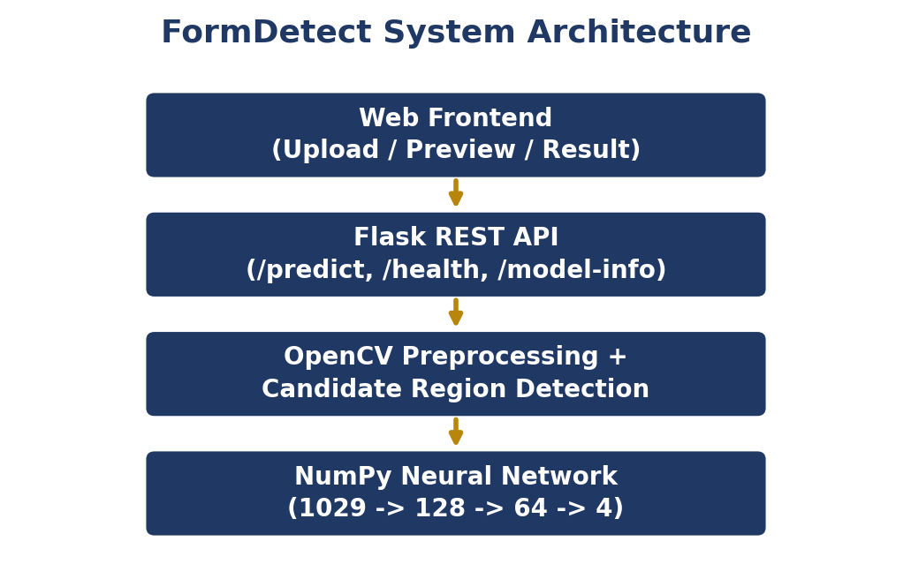
Figure 4.1 — System architecture: each layer calls the one below it.

4.2 Data Flow Diagram
The diagram shows the journey from the raw dataset to a prediction on the screen. The top row is the training side and the bottom row, read from right to left, is how a trained model is used.
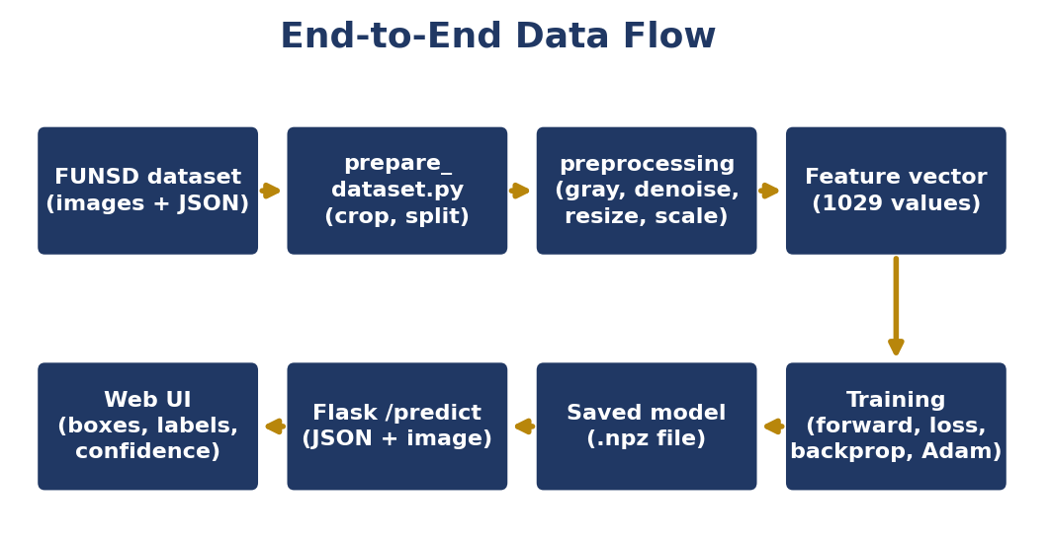
Figure 4.2 — End-to-end data flow, from dataset to prediction.

4.3 Module Description
Module (File) | Responsibility
config.py | Shared settings: class names, 32×32 region size, file paths, random seed, split fraction.
preprocessing.py | The single OpenCV pipeline used identically for training and prediction: loading, resizing, grayscale, noise reduction, thresholding, cropping, features.
prepare_dataset.py | Reads FUNSD images and annotation JSON, extracts box, label and text, builds feature vectors, splits the data and prints class counts.
model.py | The neural network: forward propagation, ReLU/Softmax, weighted cross-entropy loss, backpropagation, Adam optimizer, prediction, save/load.
train.py | Trains the network, records training and validation loss, saves the best model and the loss curve.
evaluation.py | Computes Accuracy, Precision, Recall, F1 and the Confusion Matrix manually on the test split; writes the report and chart.
predict.py | Detects candidate regions with OpenCV, classifies them with the trained model and draws the boxes and labels.
app.py | Flask REST API exposing /health, /model-info and /predict with input validation and error messages.
test_api.py | Automatic checks for the API error handling (invalid file, wrong format, missing model, large image).
frontend/ (index.html, src/main.js, src/style.css) | Web interface: upload, preview, Detect Fields button, result image, field list, model information and How It Works.

Chapter 5: Dataset

5.1 Dataset Source
The dataset used is FUNSD (Form Understanding in Noisy Scanned Documents) by Jaume, Ekenel and Thiran (ICDAR-OST 2019), available at https://guillaumejaume.github.io/FUNSD/. It contains 199 scanned form images — 149 for training and 50 for testing — with an annotation JSON file for every image. Each annotated entity has a bounding box, a label, its text, its words and links to other entities. This project uses the box, the label and the text.

5.2 Class Definitions
ID | Class | Meaning
0 | question | A field label or prompt, for example “Name:”
1 | answer | The text written in a field, or the value belonging to a question
2 | header | A title or section heading of the form
3 | other | Any other text on the form
Labels are read directly from the annotation files. They are never guessed or assigned randomly; any entity with an unknown label or an empty box is skipped.

5.3 Dataset Split
The 149 FUNSD training forms are split by document into training and validation sets (85% / 15%) with a fixed random seed (42), so regions of one form never appear in two sets. The 50 FUNSD testing forms form the test set. The counts below were printed by prepare_dataset.py.
Split | Documents | Regions
Training | 127 | 6,199
Validation | 22 | 1,212
Test | 50 | 2,332
Class counts per split (printed by prepare_dataset.py):
Class | Training | Validation | Test
question | 2,740 | 526 | 1,077
answer | 2,362 | 440 | 821
header | 365 | 76 | 122
other | 732 | 170 | 312

5.4 Class Imbalance
The four classes are clearly unequal: question has the most training regions (2,740) and header the fewest (365). To stop the network from ignoring the smaller classes, training uses class weights calculated from the training counts, and the report examines class-wise recall in Chapter 10 instead of relying only on overall accuracy.

Chapter 6: Methodology and Implementation

6.1 Image Preprocessing
A single set of functions in preprocessing.py is used for both training and prediction, so the model always sees data in the same form it was trained on:
- Read the image with OpenCV (very large images are shrunk so the longest side is at most 2000 pixels).
- Convert colour to grayscale.
- Reduce noise with a 3×3 Gaussian blur.
- Adaptive thresholding makes ink white and paper black; it is used only to find candidate regions.
- Crop each region, resize it to 32×32 pixels, invert it and scale pixel values to the range [0, 1].

6.2 Candidate Region Detection
Stage 1 of the two-stage approach uses classic image processing; no learning is involved:
- Threshold the page so that ink becomes white.
- Dilate with a wide, flat kernel so the letters and words of one text line join into one blob.
- Find the contours; the bounding rectangle of each blob is a candidate region.
- Remove regions that are too small (noise) or too large (page border or table frame), then sort the rest from top to bottom.

6.3 Feature Extraction
Each region becomes a vector of 1029 numbers: 1024 normalised pixel values (32×32) plus five numbers that describe where the region is and what shape it has — left edge, top edge, width and height (each as a fraction of the page) and the width-to-height ratio. These extra numbers matter because a question usually sits at the left, an answer to its right and a header near the top.
Important note: during training the network receives the annotated FUNSD boxes, whereas during prediction it receives boxes found by OpenCV. The two can differ slightly (for example, OpenCV may split or merge entities), so results on uploaded forms can be lower than the test-set score.

6.4 Neural Network Architecture
Stage 2 is a small, fully connected neural network (Multi-Layer Perceptron) with two hidden layers, written entirely with NumPy:
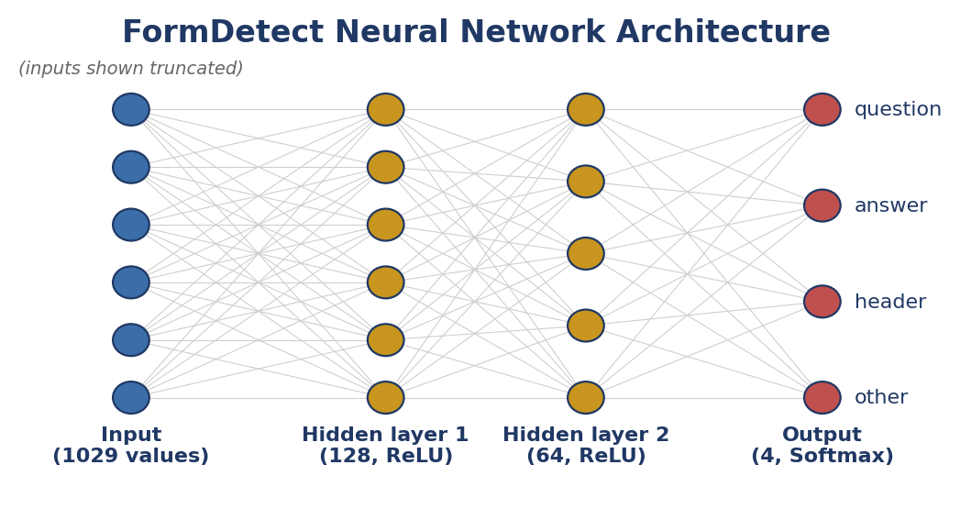
Figure 6.1 — The network: 1029 inputs, 128 and 64 hidden neurons, 4 outputs.
Forward propagation: Z1 = X·W1 + b1, A1 = ReLU(Z1); Z2 = A1·W2 + b2, A2 = ReLU(Z2); Z3 = A2·W3 + b3, and the Softmax of Z3 gives four probabilities that add up to 1. The largest one is the predicted class and also the confidence shown to the user. Weights start with He initialisation, which suits ReLU.
Backpropagation was worked out and coded by hand with the chain rule. For Softmax with cross-entropy the output error is simply (probabilities − true one-hot label); it is passed backwards through each layer to give the gradients of every weight and bias.

6.5 Loss Function and Optimizer
- Loss: weighted categorical cross-entropy, −log(probability given to the correct class), multiplied by the class weight so that rarer classes count more.
- Optimizer: Adam, implemented manually. It keeps running averages of the gradient and of its square (β1 = 0.9, β2 = 0.999) and gives every weight its own adaptive step size. The default learning rate is 0.001.

6.6 Training Procedure
Training uses mini-batch gradient descent with batches of 64 regions. The data is shuffled every epoch. After each epoch the training loss and validation loss are calculated and printed. The model with the lowest validation loss is saved to model/form_field_model.npz, together with model_info.json, and a loss graph is saved to results/loss_curve.png. The number of epochs is configurable (default 60).

Chapter 7: Backend API and Frontend Application

7.1 Flask REST API
The trained model is served through a lightweight Flask application with three endpoints:
Endpoint | Method | Description
/health | GET | Returns {"status": "ok"} to confirm that the API is running.
/predict | POST | Accepts a multipart form image, runs preprocessing, region detection and classification, and returns JSON with the fields (label, confidence, bounding box) and the processed image.
/model-info | GET | Returns real training and evaluation information if available, or states that the model is not trained yet.
Understandable error messages are returned as JSON:
Situation | HTTP code | Message (summary)
No file, or file is not a valid image | 400 | Choose an image / the file is not a valid or is corrupted
Unsupported file type (e.g. .txt, .gif) | 415 | Please upload a PNG, JPG, JPEG or BMP image
File larger than 10 MB | 413 | File is too large. Maximum upload size is 10 MB
Model not trained yet | 503 | No trained model found; run train.py first
Cross-origin access is allowed with a response header so the frontend, served from a different local port, can call the API.

7.2 Web Frontend
The frontend is a single page built with HTML, CSS and JavaScript using Vite. It talks to the backend at http://127.0.0.1:5000 (changeable through VITE_API_URL) and contains these sections:
- Upload Form — choose an image, see a preview and press Detect Fields.
- Result Image — the processed image with coloured boxes and a colour legend (question blue, answer green, header red, other grey).
- Detected Fields — a list with the label, model confidence and bounding box of every region, and the field count.
- Model Information — shows whether a trained model exists and its real training and test figures when available.
- How It Works — a short four-step explanation to support the viva.

Chapter 8: Screenshots

8.1 Upload Page
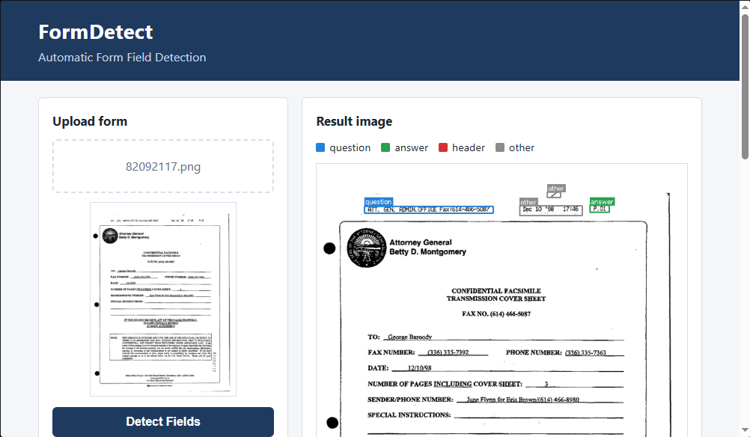
Figure 8.1 — Upload page with image preview and detection result.

8.2 Detection Result and Detected Fields
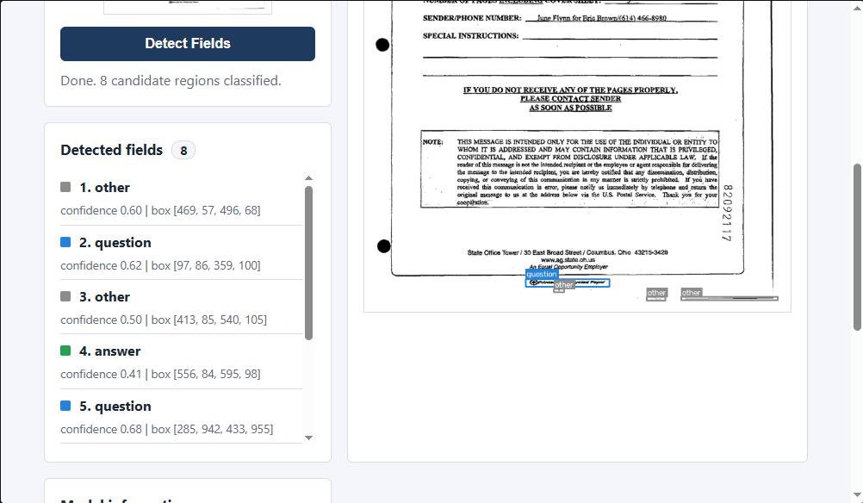
Figure 8.2 — Result image with coloured boxes and the detected fields list.

8.3 Model Information
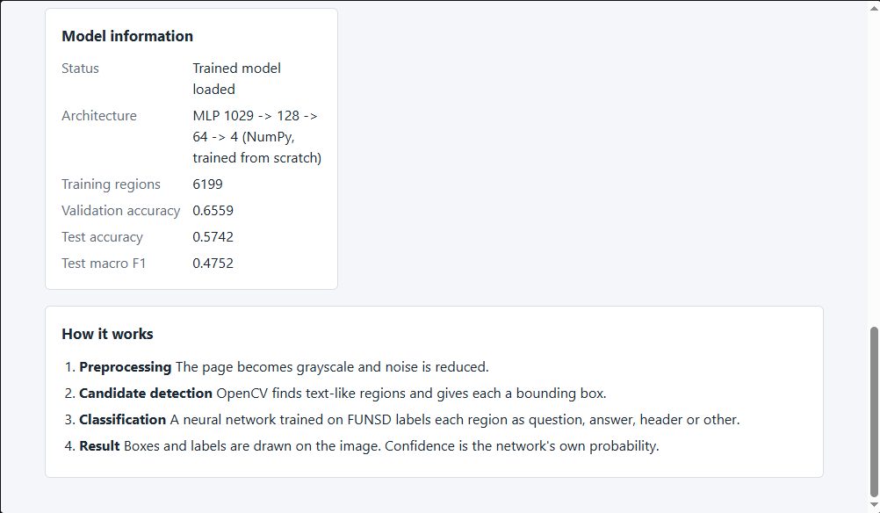
Figure 8.3 — Model information panel and How It Works section.

Chapter 9: Testing
The system was tested at component level and as an integrated system. “Pass” means the check was carried out during development using a small stand-in dataset created only to test the code; “Pass (FUNSD)” means it was run on the real FUNSD data and the trained model on the student’s machine.
# | Test | Expected Outcome | Result
1 | Python syntax check on all backend files (py_compile) | All files compile without error | Pass
2 | prepare_dataset.py on FUNSD | Class counts printed; train/validation/test files created | Pass (FUNSD)
3 | train.py full run | Loss decreases; best model saved; loss curve created | Pass (FUNSD)
4 | evaluation.py on test split | Real metrics, confusion matrix and report created | Pass (FUNSD)
5 | Flask /health endpoint | Returns {"status": "ok"} | Pass
6 | Upload a valid form image to /predict | JSON with fields and result image returned | Pass
7 | Upload an invalid file (.txt) | Clear “unsupported file type” message | Pass
8 | Upload a corrupted .png | “Not a valid image” message | Pass
9 | Upload an unsupported format (.gif) | Clear “unsupported file type” message | Pass
10 | Prediction before a model exists | Message asking to run train.py (HTTP 503) | Pass
11 | Upload a very large image (4500 × 3500) | Image shrunk and processed without crashing | Pass
12 | Upload a file larger than 10 MB | “File is too large” message (HTTP 413) | Pass
13 | Web page: select, preview and Detect Fields | Result image, field list and count shown | Pass (FUNSD)
14 | Frontend starts with npm run dev | Page opens at localhost:5173 and connects to the API | Pass (FUNSD)
Tests 5–12 can be repeated at any time with: python test_api.py

Chapter 10: Results and Discussion

10.1 Training Behavior
The model was trained for 60 epochs with Adam and weighted cross-entropy loss. Training loss fell from 1.1469 (epoch 1) to 0.0044 (epoch 60). Validation loss reached its lowest value of 1.0630 at epoch 5 and then rose steadily to 4.5211 at epoch 60. This widening gap is overfitting: after about epoch 5 the network memorised the training regions instead of learning patterns that generalise. As designed, train.py kept the model from the best epoch (5), and that model is used for all evaluation and prediction.
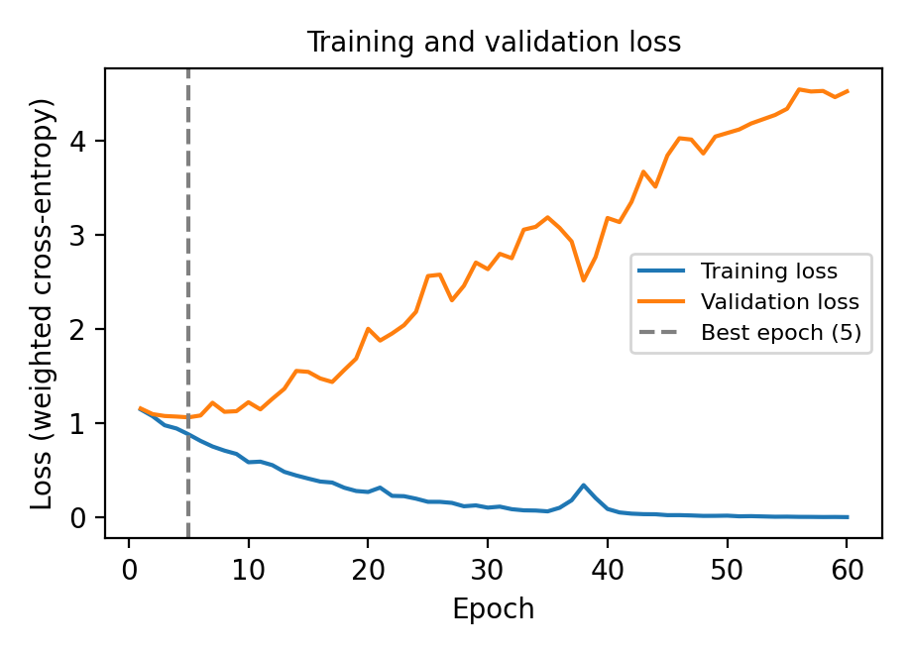  Figure 10.1 — Training and validation loss | 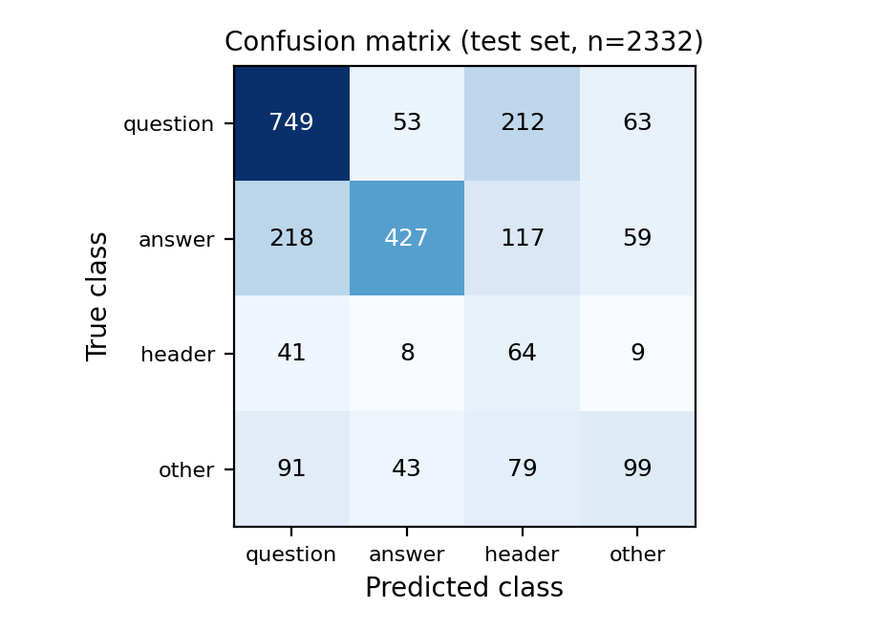  Figure 10.2 — Confusion matrix (test set)

10.2 Final Model Evaluation
The model was tested on 2,332 test regions it had never seen. Every value was calculated by hand with NumPy.
Accuracy | Macro Precision | Macro Recall | Macro F1 Score
57.42% | 0.5129 | 0.5144 | 0.4752
Confusion matrix (rows = true class, columns = predicted class):
True \ Predicted | question | answer | header | other
question | 749 | 53 | 212 | 63
answer | 218 | 427 | 117 | 59
header | 41 | 8 | 64 | 9
other | 91 | 43 | 79 | 99

10.3 Class-wise Performance
Class | Precision | Recall | F1-score | Support
question | 0.6815 | 0.6955 | 0.6884 | 1077
answer | 0.8041 | 0.5201 | 0.6317 | 821
header | 0.1356 | 0.5246 | 0.2155 | 122
other | 0.4304 | 0.3173 | 0.3653 | 312

10.4 Discussion
An accuracy of 57.42% is above the 46.2% that would be obtained by always predicting the biggest class (question), but it is a modest result. Question is the most balanced class (precision 0.68, recall 0.70). Answer has high precision (0.80) but low recall (0.52). Header has the lowest precision (0.14): 212 questions, 117 answers and 79 other regions were wrongly called header, probably because this small class gets a large class weight. Other has the lowest recall (0.32).
The main causes are overfitting (Section 10.1) and the limited input (a 32×32 picture plus position, no words). These scores use the annotated FUNSD boxes; OpenCV-detected boxes may give lower results.

Chapter 11: Conclusion and Future Scope

11.1 Conclusion
FormDetect demonstrates a complete deep learning workflow for form understanding using a neural network implemented entirely from scratch with NumPy, without any deep-learning framework. It combines dataset preparation from real FUNSD annotations, a consistent OpenCV preprocessing pipeline, candidate region detection, a trained classifier, manually calculated evaluation metrics, a REST API and a web interface that shows coloured bounding boxes with labels and confidence.
Throughout the project care was taken to avoid fabricated data, labels or results: labels come only from the annotation files, confidence values come only from the model, and the web application states clearly when the model has not been trained instead of showing placeholder values. On the FUNSD test set the model reached 57.42% accuracy and a macro F1 score of 0.4752. This is a modest result, and Chapter 10 explains it: the network overfits after about epoch 5, and the header and other classes are weak.

11.2 Limitations
- FUNSD is small (199 forms) and its classes are unequal in size; the network overfits quickly (best validation loss at epoch 5) and header precision is low (0.14).
- The OpenCV detector is simple; it can merge or split regions and has no understanding of the content.
- The model sees only the shape, position and 32×32 appearance of a region, not the meaning of the words (no OCR).
- The network is fully connected, not convolutional, so it does not exploit spatial structure in the image.
- Evaluation uses the annotated FUNSD boxes, not the automatically detected boxes, and the system works best on forms similar to FUNSD.

11.3 Future Scope
- Add OCR and use the words as extra features for classification.
- Replace the fully connected network with a convolutional network or a full object detector.
- Link every question to its answer using the FUNSD linking annotations.
- Reduce overfitting with dropout, weight decay and data augmentation, and train on more types of forms.
- Evaluate on the automatically detected boxes and deploy the Flask API and frontend on a cloud platform.

References
[1] G. Jaume, H. K. Ekenel, J.-P. Thiran — “FUNSD: A Dataset for Form Understanding in Noisy Scanned Documents,” ICDAR-OST, 2019. https://guillaumejaume.github.io/FUNSD/
[2] NumPy Documentation — https://numpy.org/doc/
[3] OpenCV Documentation — https://docs.opencv.org/
[4] Flask Documentation — https://flask.palletsprojects.com/
[5] Matplotlib Documentation — https://matplotlib.org/
[6] Vite Documentation — https://vitejs.dev/
[7] D. P. Kingma, J. Ba — “Adam: A Method for Stochastic Optimization,” 2014 (foundational reference for the Adam optimizer implemented manually in this project).
[8] Y. Xu et al. — “LayoutLM: Pre-training of Text and Layout for Document Image Understanding,” KDD, 2020.

Appendix A: Project Structure
Automatic-Form-Field-Detection/
|-- backend/
| |-- app.py (Flask API)
| |-- config.py (shared settings)
| |-- prepare_dataset.py |-- preprocessing.py
| |-- model.py |-- train.py
| |-- evaluation.py |-- predict.py
| |-- test_api.py |-- requirements.txt
| |-- dataset/{raw,train,validation,test}/
| |-- model/form_field_model.npz, model_info.json
| `-- results/loss_curve.png, confusion_matrix.png,
| evaluation_report.txt, metrics.json
|-- frontend/ (package.json, index.html, src/, public/)
|-- README.md
|-- REPORT.md
`-- .gitignore
— Atharv Shetty
Department of Artificial Intelligence and Machine Learning.

