**DBMS PROJECT: CRICPEDIA**

**GROUP DETAILS**

Group: D

Group Members:

1. **Siddharth Kulkarni (26)**
2. Atharv Chaudhari (7)
3. Gaurav Lodha (28)
4. Divit Shah (53)
5. Mandar Supate (56)

**INTRODUCTION**

**CRICPEDIA**:

* Cricket is a sport which is loved all over the world. The ICC Men's Cricket World Cup 2019 was the most watched ICC event ever, with a global cumulative average audience of 1.6 billion for live coverage.
* The aim of this project is to record the details of all the ICC ODI WORLD CUP matches and make it available to all who enjoy this sport in an easy and user-friendly manner by designing a database which would support an UI as its backbone and store all the information.

**REQUIREMENT SPECIFICATION**

Fundamental Requirements:

* Database Management.
* Information related to ICC ODI WORLD CUP matches.
* News Update.
* Data related to particular match.
* Data related to overall performance of each player.
* Contact Information.
* User Signup / Login.
* Features for registered users: Live Stream (To watch live matches).

Software Requirements:

* Windows Professional Operating Systems.
* PhpMyAdmin XAMPP Server (MySQL)
* Text editor (Visual Studio Code - Preferred) for Front-End & Back-End work.

**ENTITY RELATIONSHIP DIAGRAM OF CRICPEDIA**

**RELATIONAL VIEW OF CRICPEDIA**

**QUERIES PERFORMED ON DATABASE**

Q1) Write a query to display teams details according to ranking in descending order.

A1)

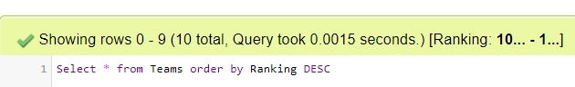

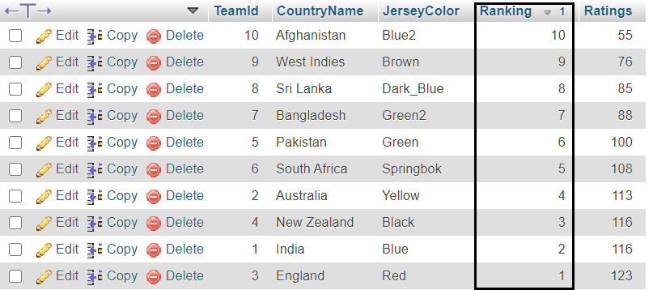

Q2) Write a query to find the max and min runs scored by Player-Id 102 in whole tournament.

A2)

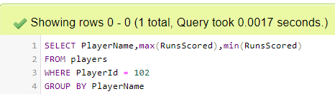

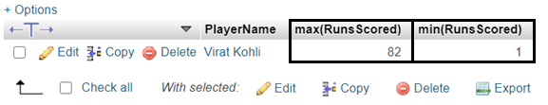

Q3) Write a query to display the record of Man of match in second match.

A3)

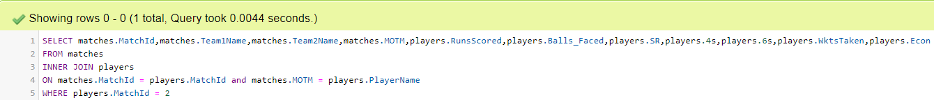



Q4) Write a query to display details of player with max. Runs & Wkts taken in tournament (USE ALISING).

A4)

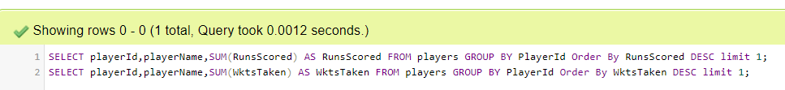





Q5) Write a query to display players record whose Batting average is in between 50 and 60.

A5)

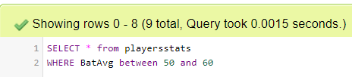

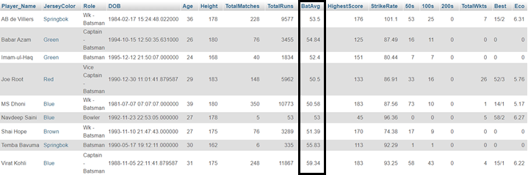

Q6) Write a query to display teams’ details with ICC cups >1 and T20Cups < 3.

A6)

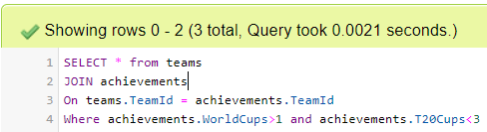

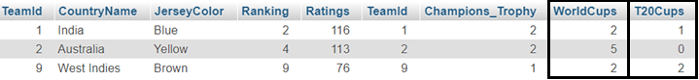

Q7) Write a query to display all details of Coach whose duration is >= 3 using “ANY” and “ALL” operator.

A7)

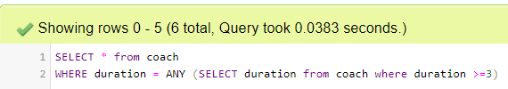

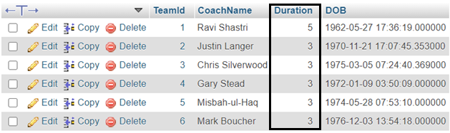

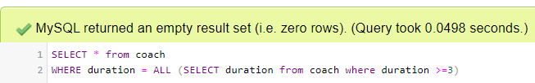



**IMPLEMENTATION**

Relational Schema Implementation Part:

* Created an Entity Relationship Model and learnt about Relational Algebra and Relational Schemas.
* Used Draw.io tool for ER Diagram.

Database Implementation Part:

* Used XAMPP Server to Create Database by using MYSQL.
* Created Suitable Database containing the required ENTITIES with their ATRIBUTES and RELATIONS.
* Eliminated the Redundancies in Database.
* Applied Normalization on few tables.
* Proper Linking of Foreign Key Constraints.
* Entered the data for 6 matches of ICC Cricket World Cup 2019.

Front End Implementation Part:

* Used HTML, CSS & Bootstrap.

Back End Implementation Part:

* Used PHP.
* Constraints on Sign up / Login Checks.
* Team Ratings Analysis using jQuery and JavaScript.

GitHub Repository link: <https://github.com/mykeysid10/Cricpedia>

**WEBSITE OVERVIEW**

***Home Page:***

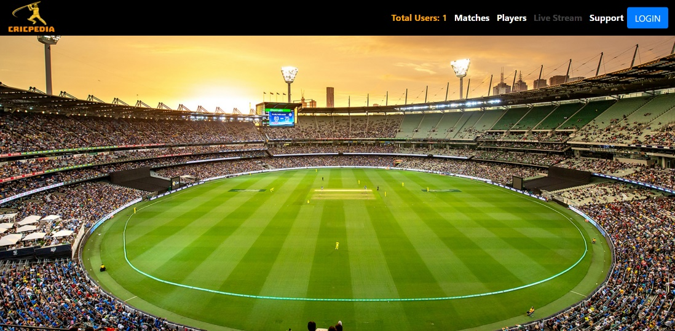

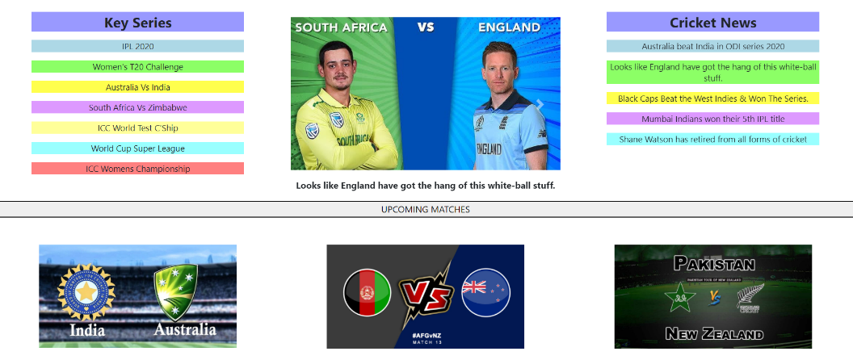

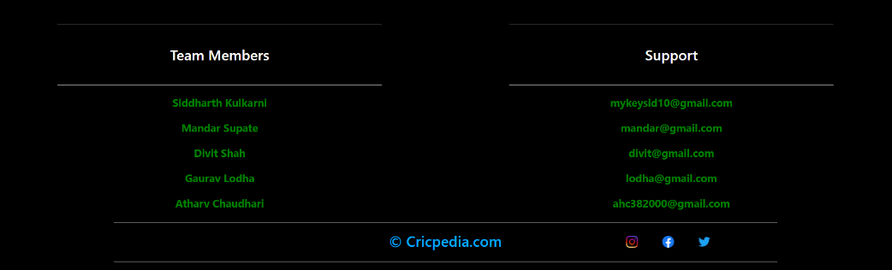

***Matches:***

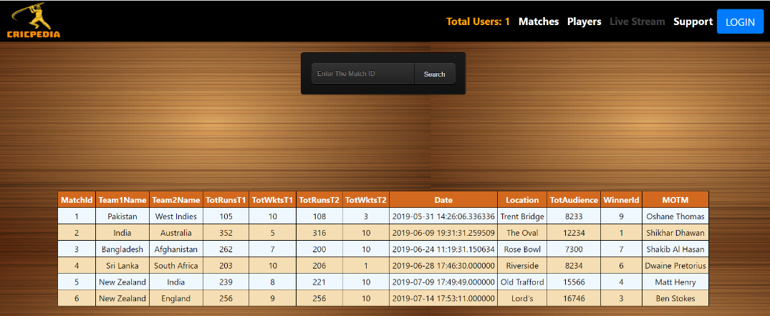

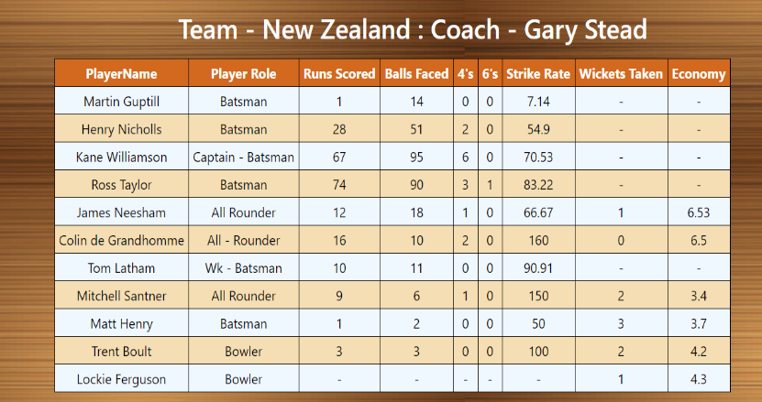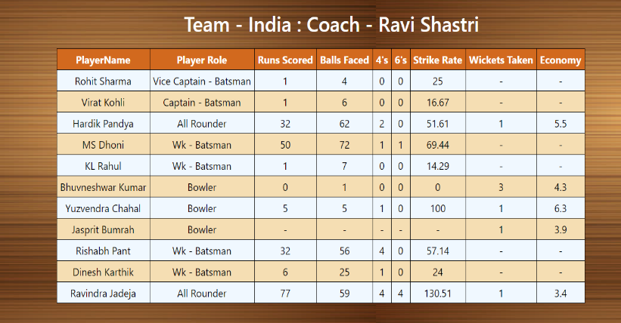

***Players:***

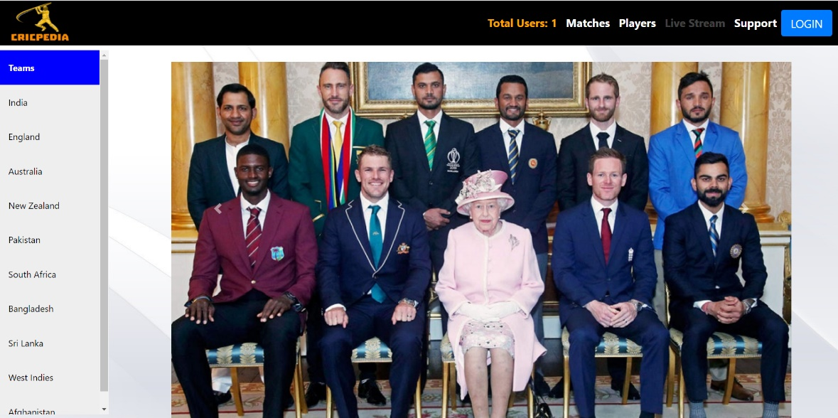

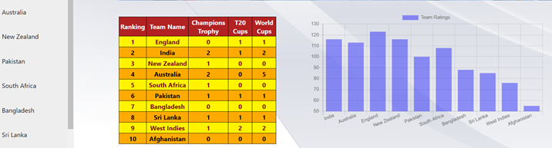

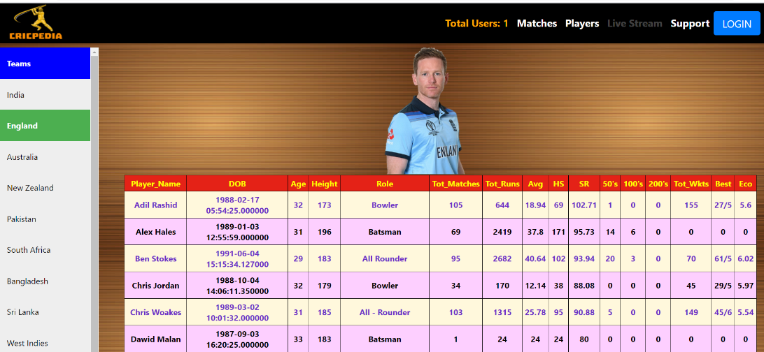

***Support:***

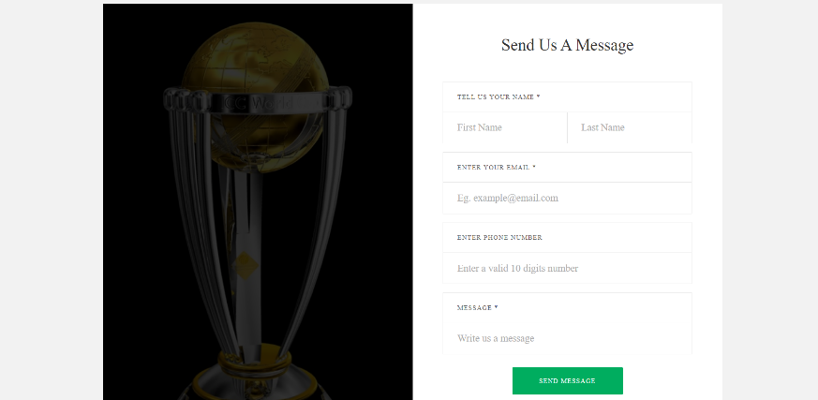

*After Login:*



***Signup: Login:***

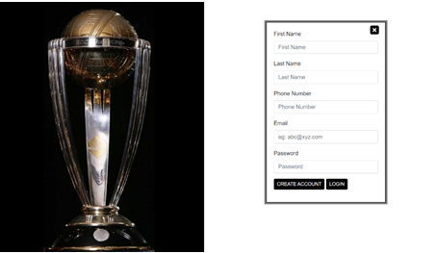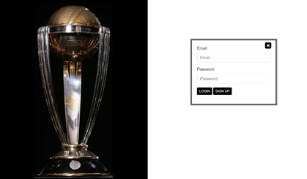

***User Profile:***

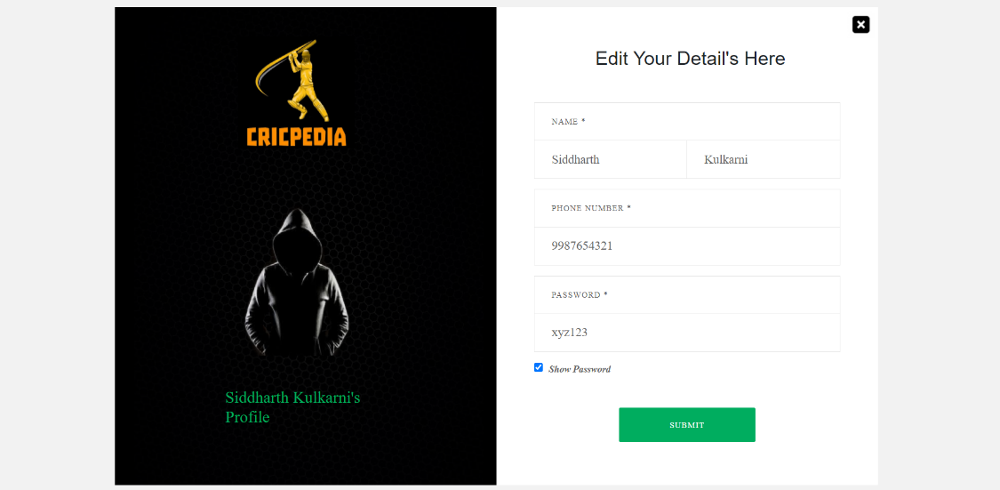

**CONCLUSION**

* Done with ER Model and Relational Schemas in Phase 1.
* Completed Database Design and Relational View in Phase 2.
* Normalization on database tables with Entry of data in Phase 3.
* Front-End and Back-End with Database Management in Phase 4.

Hence, we have successfully done the project CRICPEDIA (An online website for CRICKET updates).

**THINGS WE HAVE LEARNT**

* Entity Relationship Diagrams and their Uses.
* Relational Algebra & Relational Schema.
* MAMP & XAMP Servers for Database.
* MySQL queries.
* Normalization.
* Front-End:
* HTML
* CSS
* BOOTSTRAP
* Back-End:
* PHP
* JavaScript
* MySQL (Database)

**REFERENCE**

1. ER Diagram Drawing Tool: [https://app.diagrams.net/](https://app.diagrams.net/%20)

2. SQL Queries: [https://www.w3schools.com/sql/](https://meet.google.com/linkredirect?authuser=0&dest=https%3A%2F%2Fwww.w3schools.com%2Fsql%2F)

3. Database Server (XAMMP): [https://www.apachefriends.org/index.html](https://meet.google.com/linkredirect?authuser=0&dest=https%3A%2F%2Fwww.apachefriends.org%2Findex.html)

4. For Front-End (HTML, CSS & JS): [https://getbootstrap.com/](https://meet.google.com/linkredirect?authuser=0&dest=https%3A%2F%2Fgetbootstrap.com%2F)

5. For Backend (PHP & JavaScript): [https://www.w3schools.com/php/](https://meet.google.com/linkredirect?authuser=0&dest=https%3A%2F%2Fwww.w3schools.com%2Fphp%2F)

6. For Handling with Errors: <https://stackoverflow.com/>