CYBERCRIME- WANNACRY RANSOMWARE ATTACK

WannaCry ransomware cryptoworm, which targeted computers running the Microsoft Windows operating system by encrypting data and demanding ransom payments in the form of bitcoin cryptocurrency. It was propagated using EternalBlue, an exploit developed by the United States National Security Agency (NSA) for Microsoft Windows systems. EternalBlue was stolen and leaked by a group called The Shadow Brokers (TSB) a month prior to the attack. While Microsoft had released patches previously to close the exploit, much of WannaCry's spread was from organizations that had not applied these patches, or were using older Windows systems that were past their end of life. These patches were imperative to cyber security, but many organizations did not apply them, citing a need for 24/7 operation, the risk of formerly working applications breaking because of the changes, lack of personnel or time to install them, or other reasons.
The attack began at 07:44 UTC on 12 May 2017 and was halted a few hours later at 15:03 UTC by the registration of a kill switch discovered by Marcus Hutchins. The kill switch prevented already infected computers from being encrypted or further spreading WannaCry. The attack was estimated to have affected more than 300,000 computers across 150 countries, with total damages ranging from hundreds of millions to billions of dollars. At the time, security experts believed from preliminary evaluation of the worm that the attack originated from North Korea or agencies working for the country. In December 2017, the United States and United Kingdom formally asserted that North Korea was behind the attack, although North Korea has denied any involvement with the attack.
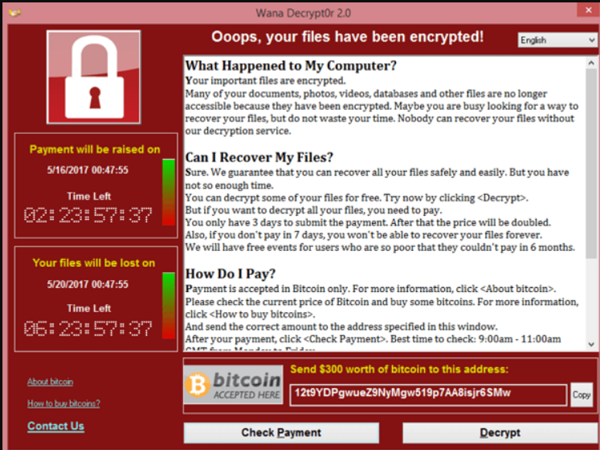
Screenshot of the ransom note left on an infected system

Description
WannaCry is a ransomware crypto worm, which targets computers running the Microsoft Windows operating system by encrypting (locking) data and demanding ransom payments in the Bitcoin cryptocurrency. The worm is also known as WannaCrypt, Wana Decrypt0r 2.0, WanaCrypt0r 2.0, and Wanna Decryptor. It is considered a network worm because it also includes a transport mechanism to automatically spread itself. This transport code scans for vulnerable systems, then uses the EternalBlue exploit to gain access, and the DoublePulsar tool to install and execute a copy of itself. WannaCry versions 0, 1 and 2 were created using Microsoft Visual C++ 6.0.
EternalBlue is an exploit of Microsoft's implementation of their Server Message Block (SMB) protocol released by The Shadow Brokers. Much of the attention and comment around the event was occasioned by the fact that the U.S. National Security Agency (NSA) (from whom the exploit was likely stolen) had already discovered the vulnerability, but used it to create an exploit for its own offensive work, rather than report it to Microsoft. Microsoft eventually discovered the vulnerability, and on Tuesday, 14 March 2017, they issued security bulletin MS17-010, which detailed the flaw and announced that patches had been released for all Windows versions that were currently supported at that time, these being Windows Vista, Windows 7, Windows 8.1, Windows 10, Windows Server 2008, Windows Server 2008 R2, Windows Server 2012, Windows Server 2012 R2, and Windows Server 2016.
Attack
The attack began on Friday, 12 May 2017, with evidence pointing to an initial infection in Asia at 07:44 UTC. The initial infection was likely through an exposed vulnerable SMB port, rather than email phishing as initially assumed. Within a day the code was reported to have infected more than 230,000 computers in over 150 countries.
Organizations that had not installed Microsoft's security update from March were affected by the attack. Those still running unsupported versions of Microsoft Windows, such as Windows XP and Windows Server 2003 were at particularly high risk because no security patches had been released since April 2014 for Windows XP and July 2015 for Windows Server 2003. A Kaspersky Lab study reported, however, that less than 0.1 percent of the affected computers were running Windows XP, and that 98 percent of the affected computers were running Windows 7. In a controlled testing environment, the cybersecurity firm Kryptos Logic found that it was unable to infect a Windows XP system with WannaCry using just the exploits, as the payload failed to load, or caused the operating system to crash rather than actually execute and encrypt files. However, when executed manually, WannaCry could still operate on Windows XP

Defensive response
Experts quickly advised affected users against paying the ransom due to no reports of people getting their data back after payment and as high revenues would encourage more of such campaigns. As of 14 June 2017, after the attack had subsided, a total of 327 payments totaling US$130,634.77 (51.62396539 BTC) had been transferred (worth approximately US$3,390,765.29 as of 27 February 2026).
The day after the initial attack in May, Microsoft released out-of-band security updates for end-of-life products Windows XP, Windows Server 2003 and Windows 8; these patches had been created in February, but were previously only available to those who paid for a custom support plan. Organizations were advised to patch Windows and plug the vulnerability in order to protect themselves from the cyber attack. The head of Microsoft's Cyber Defense Operations Center, Adrienne Hall, said that "Due to the elevated risk for destructive cyber-attacks at this time, we made the decision to take this action because applying these updates provides further protection against potential attacks with characteristics similar to WannaCrypt [alternative name to WannaCry]".
Researcher Marcus Hutchins discovered the kill switch domain hardcoded in the malware. Registering a domain name for a DNS sinkhole stopped the attack spreading as a worm, because the ransomware only encrypted the computer's files if it was unable to connect to that domain, which all computers infected with WannaCry before the website's registration had been unable to do. While this did not help already infected systems, it severely slowed the spread of the initial infection and gave time for defensive measures to be deployed worldwide, particularly in North America and Asia, which had not been attacked to the same extent as elsewhere. On 14 May, a first variant of WannaCry appeared with a new and second kill-switch registered by Matt Suiche on the same day. This was followed by a second variant with the third and last kill-switch on 15 May, which was registered by Check Point threat intelligence analysts. A few days later, a new version of WannaCry was detected that lacked the kill switch altogether
Impact
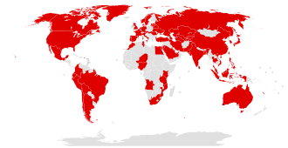Map of the countries initially affected
The ransomware campaign was unprecedented in scale according to Europol, which estimates that around 200,000 computers were infected across 150 countries. According to Kaspersky Lab, the four most affected countries were Russia, Ukraine, India and Taiwan.
One of the largest agencies struck by the attack was the National Health Service hospitals in England and Scotland, and up to 70,000 devices—including computers, MRI scanners, blood-storage refrigerators and theatre equipment—may have been affected. On 12 May, some NHS services had to turn away non-critical emergencies, and some ambulances were diverted. In 2016, thousands of computers in 42 separate NHS trusts in England were reported to be still running Windows XP. In 2018 a report by Members of Parliament concluded that all 200 NHS hospitals or other organisations checked in the wake of the WannaCry attack still failed cybersecurity checks. NHS hospitals in Wales and Northern Ireland were unaffected by the attack.
Nissan Motor Manufacturing UK in Tyne and Wear, England, halted production after the ransomware infected some of their systems. Renault also stopped production at several sites in an attempt to stop the spread of the ransomware. Spain's Telefónica, FedEx and Germany's Deutsche Bahn were hit, along with many other countries and companies worldwide.
The attack's impact is said to be relatively low compared to other potential attacks of the same type and could have been much worse had Hutchins not discovered that a kill switch had been built in by its creators or if it had been specifically targeted on highly critical infrastructure, like nuclear power plants, dams or railway systems.
According to cyber-risk-modelling firm Keyence, economic losses from the cyber attack could reach up to US$4 billion, with other groups estimating the losses to be in the hundreds of millions

Affected organisations
The following is an alphabetical list of organisations confirmed to have been affected:
- Andhra Pradesh Police, India
- Aristotle University of Thessaloniki, Greece
- Automobile Dacia, Romania
- Boeing Commercial Airplanes
- Cambrian College, Canada
- Chinese public security bureau
- CJ CGV (a cinema chain)
- Dalian Maritime University
- Deutsche Bahn
- Dharmais Hospital, Indonesia
- Faculty Hospital, Nitra, Slovakia
- FedEx
- Garena Blade and Soul
- Guilin University of Aerospace Technology
- Guilin University of Electronic Technology
- Harapan Kita Hospital, Indonesia
- Hezhou University
- Hitachi
- Honda
- Instituto Nacional de Salud, Colombia
- Lakeridge Health, Canada
- LAKS, Netherlands
- LATAM Airlines Group
- MegaFon
- Ministry of Internal Affairs of the Russian Federation
- National Health Service (England)
- NHS Scotland
- Nissan Motor Manufacturing UK
- O2, Germany
- Petrobrás
- PetroChina
- Portugal Telecom
- Pulse FM
- Q-Park
- Renault
- Russian Railways
- Sandvik
- Justice Court of São Paulo
- Sberbank
- Shandong University
- State Governments of India
  - Government of Gujarat
  - Government of Kerala
  - Government of Maharashtra
  - Government of West Bengal
- Suzhou Vehicle Administration
- Sun Yat-sen University, China
- Telefónica, Spain
- Yettel Hungary, Hungary
- Telkom (South Africa)
- Timrå Municipality, Sweden
- TSMC, Taiwan
- Universitas Jember, Indonesia
- University of Milano-Bicocca, Italy
- University of Montreal, Canada
- Vivo, Brazil

References
- "Ransomware attack still looms in Australia as Government warns WannaCry threat not over". Australian Broadcasting Corporation. 14 May 2017
- Cameron, Dell (13 May 2017). "Today's Massive Ransomware Attack Was Mostly Preventable; Here's How To Avoid It". Gizmodo.
- "Shadow Brokers threaten to release Windows 10 hacking tools". The Express Tribune. 31 May 2017.
- "Two years after WannaCry, a million computers remain at risk". TechCrunch. 12 May 2019.
- "What is the domain name that stopped WannaCry?". 15 May 2017
- Chappell, Bill; Neuman, Scott (19 December 2017). "U.S. Says North Korea 'Directly Responsible' For WannaCry Ransomware Attack".
- "Cyber-attack: US and UK blame North Korea for WannaCry". BBC News. 19 December 2017

