Walchand College of Engineering, Sangli
7CS353 Machine Learning Lab — Assignment 4
Univariate and Multivariate Outlier Detection
Name - Atharv Vinayak Kulkarni
PRN - 245109074
Class - TY CSE(B)
Solutions for All Tasks from Assignment 4
B.1 Load and Explore
B1. Load and Describe
Task: Load student_performance.csv fresh (do not reuse the generation cell). Print describe(). In a markdown cell, note for each column whether the mean is above or below the median, and which column shows the larger gap.
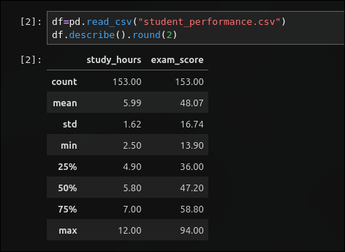
Solution:

Answer: study_hours has mean 5.99 and median 5.80 (mean above median by 0.19). exam_score has mean 48.07 and median 47.20 (mean above median by 0.87). exam_score shows the larger gap.

B2. Scatter Plot of Study Hours vs Exam Score
Task: Draw a scatter plot of study_hours (x) vs exam_score (y). Describe the visible trend and mark any points that look suspicious by eye — you will verify them numerically in B.3 and B.4.
Solution:
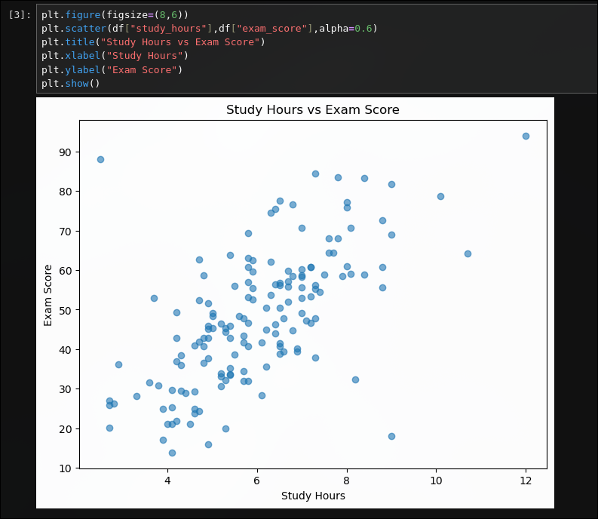
Answer: there is a clear positive, roughly linear trend - more study hours generally goes with a higher exam score. three points look suspicious by eye: one far right with unusually high study hours, one with ordinary study hours but a surprisingly high score, and one with high study hours but a surprisingly low score that breaks the trend line.
B.2 Univariate Outlier Detection
B3. IQR Fence Bounds and Box Plots
Task: Compute and print the IQR fence bounds for both columns. Print all rows that fall outside the fence in either column. Draw box plots of both columns side by side, noting the outlier dots.
Solution:
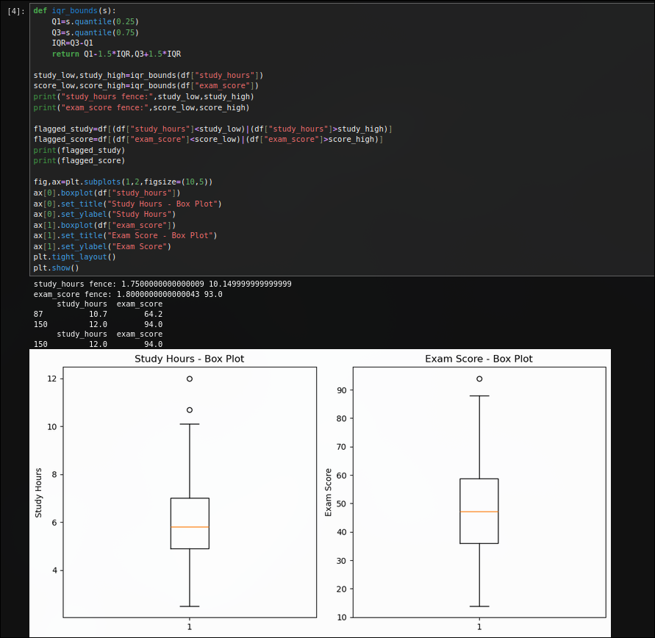

B4. Observation Table for Rows 150-152
Task: Fill in the observation table for rows 150, 151 and 152 stating whether each is flagged by study_hours, by exam_score, and a short interpretation phrase for each.
Solution:
Index | study_hours flagged? | exam_score flagged? | Interpretation
150 | Yes | Yes | univariate outlier in both columns
151 | No | No | not caught univariately
152 | No | No | not caught univariately

B.3 Euclidean Distance from Centroid
B5. Euclidean Distance and Three Thresholding Strategies
Task: Z-score both columns, then compute the Euclidean distance of each point from the origin. Apply top-10, scalar threshold (3.0), and IQR-based thresholding. For each strategy, print the number of rows flagged and their indices. Are indices 150, 151 and 152 all flagged by every strategy?
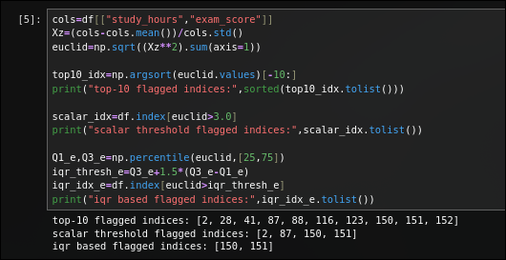
Solution:
Answer: no, not consistently. all three are only caught together by the fixed top-10 rule. the scalar threshold (z>3.0) catches 150 and 151 but misses 152. the iqr-based threshold also only catches 150 and 151, missing 152 as well.

B6. Scatter Plot with Euclidean IQR Flags
Task: Draw the scatter plot of the original (un-normalised) data. Colour points flagged by the IQR-based Euclidean threshold in red, all others in blue. Overlay the univariate IQR boundary lines as dashed lines. Compare which points are flagged here versus in B.2.
Solution:
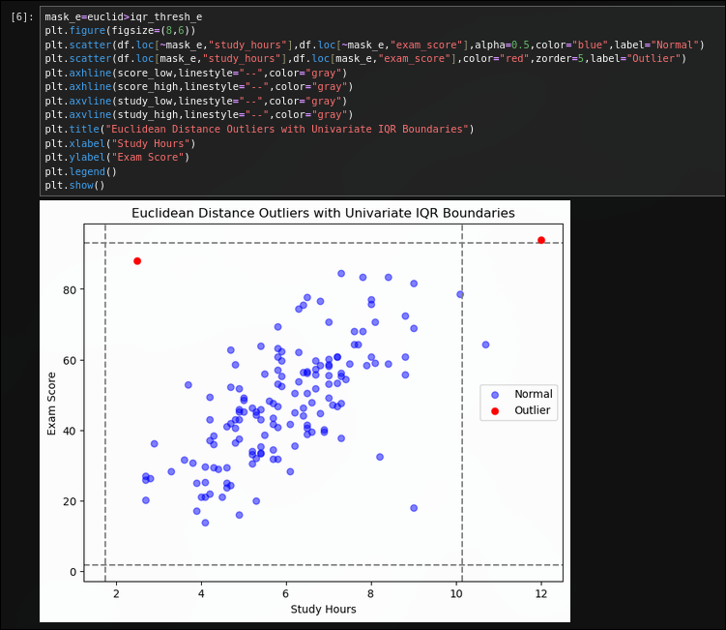
Answer: not the same points. univariate iqr (b.2/b.3) flags rows 87 and 150. euclidean iqr-based (b.6) flags rows 150 and 151. row 87 is caught only by the univariate check, row 151 is caught only by the euclidean check, and row 152 is missed by both.

B.4 Mahalanobis Distance
B7. Covariance Matrix and Mahalanobis Ranking
Task: Print the 2x2 covariance matrix and state what the off-diagonal value tells you about the relationship between the two columns. Compute Mahalanobis distances for all rows and print the top-5. Compare with the Euclidean top-5 from B.5 — which injected outlier moved up or down in rank, and why?
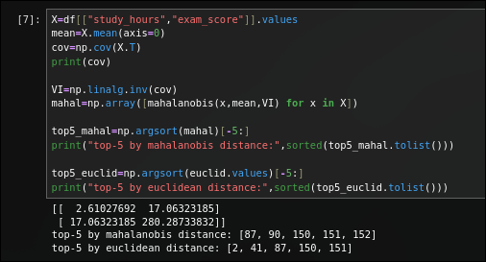
Solution:
Answer: the off-diagonal covariance value is 17.06, which is positive, confirming study_hours and exam_score move together. comparing top-5 rankings, rows 2 and 41 (high under euclidean) drop out of mahalanobis's top-5, while rows 90 and 152 enter it. row 152 jumps from not even appearing in euclidean's top-5 to 3rd-highest under mahalanobis, because it breaks the study-score correlation even though neither coordinate alone is extreme.

B8. Three Thresholding Strategies on Mahalanobis Distance
Task: Apply top-10, chi-square scalar threshold (chi2.ppf(0.975, df=2)), and IQR-based thresholding to the Mahalanobis distances. For each strategy print the number flagged and the row indices. Which strategy flags the fewest points?
Solution:
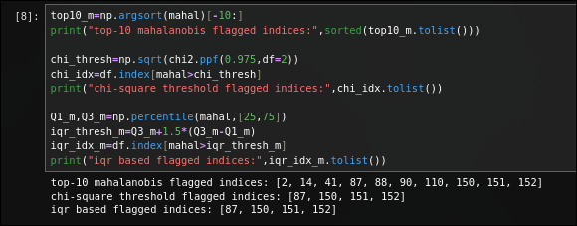
Answer:the chi-square threshold and the iqr-based threshold tie for fewest, each flagging exactly 4 points (the same set: 87, 150, 151, 152). top-10 always flags exactly 10 regardless of how many genuine outliers exist.

B9. Mahalanobis Scatter with 95% Ellipse and Distance Histogram
Task: Draw a scatter plot of the original data, colouring points flagged by the chi-square Mahalanobis threshold in red. Overlay the 95% Mahalanobis confidence ellipse. Label the axes, add a legend and a descriptive title. Also draw a histogram of the Mahalanobis distances with a vertical line at the chi-square
threshold.
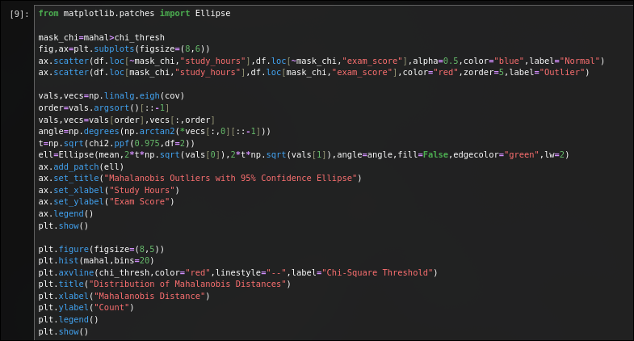
Solution:
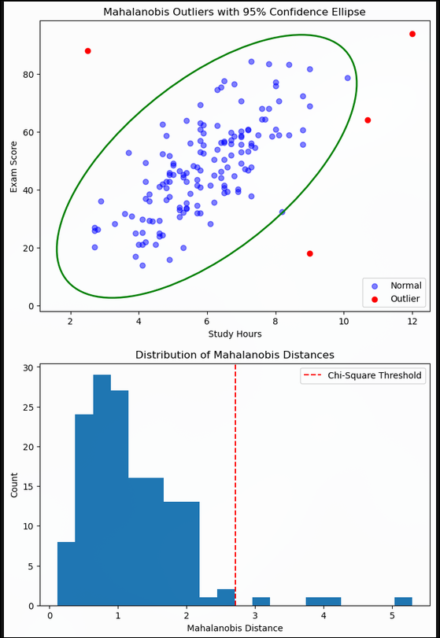

B.5 Comparing the Two Methods
B10. Side-by-Side Comparison of Euclidean vs Mahalanobis Flags
Task: Draw side-by-side scatter plots: (a) Euclidean IQR-flagged in red, (b) Mahalanobis chi-square-flagged in red, using the same axis scale. Write 3-4 sentences: why does Mahalanobis give a higher distance to Points B and C than Euclidean does? What property of the data does Mahalanobis capture that Euclidean ignores?
Solution:
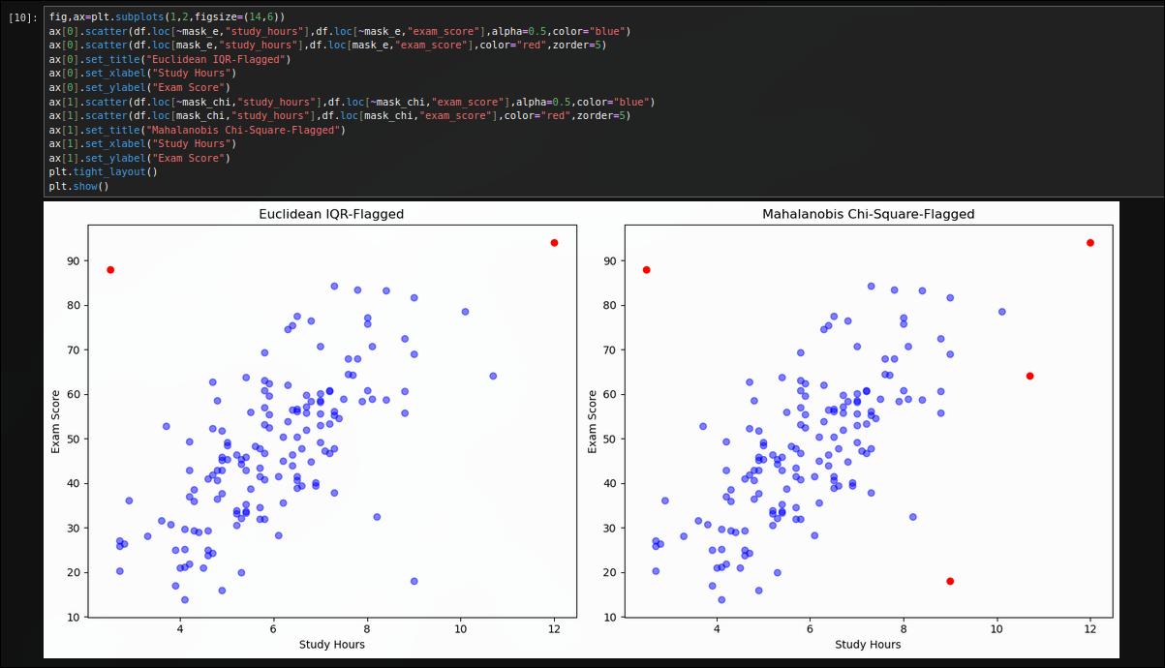
Answer: mahalanobis distance accounts for the correlation between the two columns, so it measures distance relative to the diagonal spread of the data cloud rather than treating every direction equally. points b and c don't have extreme values in either column alone, but they fall off the expected positive-correlation line, and mahalanobis stretches the distance metric in that off-diagonal direction, making them look far more unusual. euclidean distance, even after z-scoring, only reacts to how far a point's individual coordinates are from the mean, so it cannot notice that the combination of values is what is wrong - this is why row 152's euclidean distance (2.59, below every threshold) is so much lower than its mahalanobis distance (4.26, clearly flagged).

B11. Four-Category Outlier Comparison Plot
Task: Create a scatter plot with four colour categories: flagged by Mahalanobis only, flagged by Euclidean only, flagged by both, and flagged by neither, using IQR-based thresholds for both methods. Label each category in the legend.
Solution:
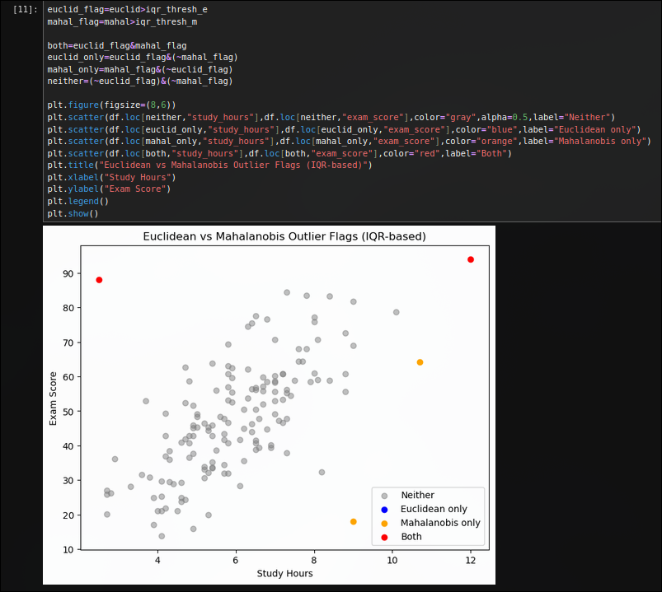

B.6 Take-Home (Submit with Notebook)
B12. Adding a Third Column and 3D Mahalanobis Distance
Task: Add a third column project_score = clip(0.7*exam_score + noise, 0, 100). Recompute Mahalanobis distances on all three columns (covariance is now 3x3; use chi2.ppf(0.975, df=3) for the threshold). Which rows are newly flagged that were not flagged in the 2-column version?
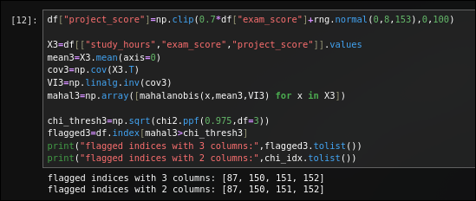
Solution:
Answer: none - the 3-column flagged set (87, 150, 151, 152) is identical to the 2-column flagged set. adding project_score, a noisy but correlated derivative of exam_score, did not surface any new joint-breaking outliers in this run.
B13. Mahalanobis Distance from Scratch
Task: Without using scipy.spatial.distance.mahalanobis, implement Mahalanobis distance from scratch using only NumPy: MD(x) = sqrt((x-mean)^T * inverse(covariance) * (x-mean)). Verify your result matches the scipy version for all 153 rows using np.allclose.
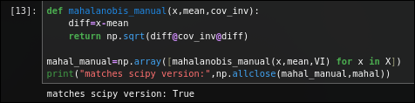
Solution:

