Walchand College of Engineering, Sangli
7CS353 Machine Learning Lab
Name - Atharv Vinayak Kulkarni
PRN - 245109074
Class - TY CSE(B)
7CS353 Machine Learning Lab — Assignment 7

PART B — Implementation Pipeline
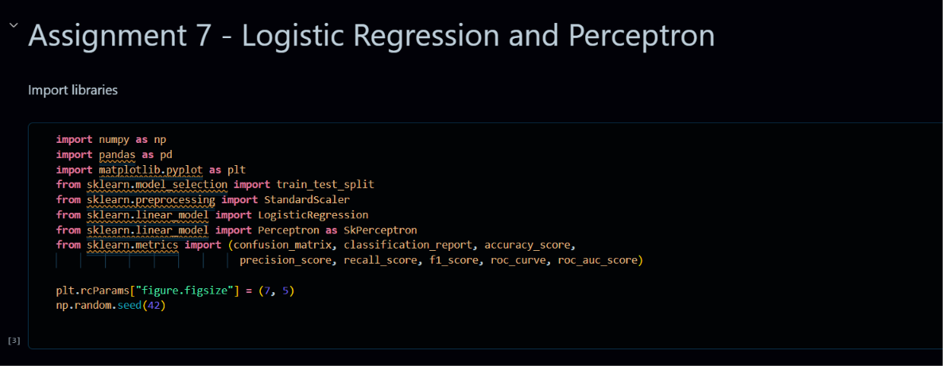
B1. Load and explore. Load student_pass.csv. Print shape and class distribution. Draw a scatter plot of study_hours vs attendance coloured by pass. Comment on whether the classes appear linearly separable.
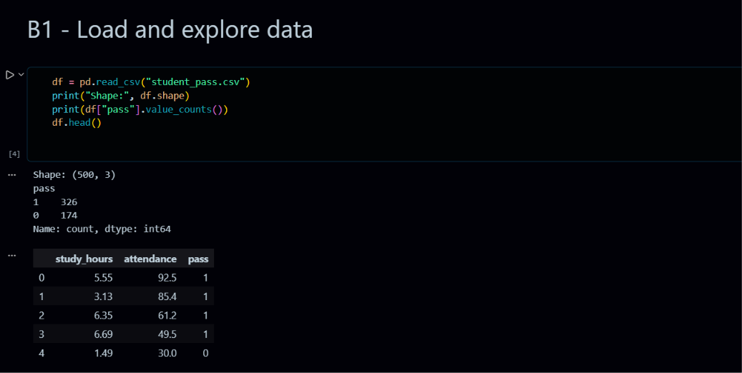

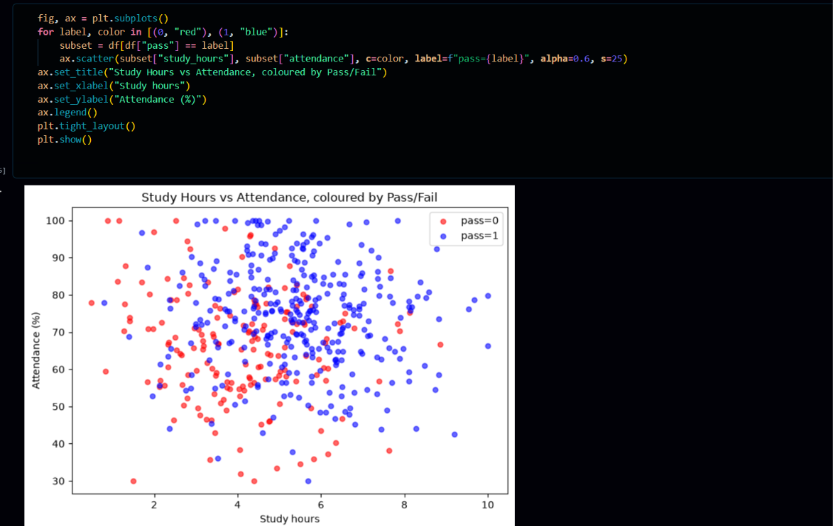
B2. Preprocessing. Perform an 80/20 train-test split (random_state=42) and standardise features.
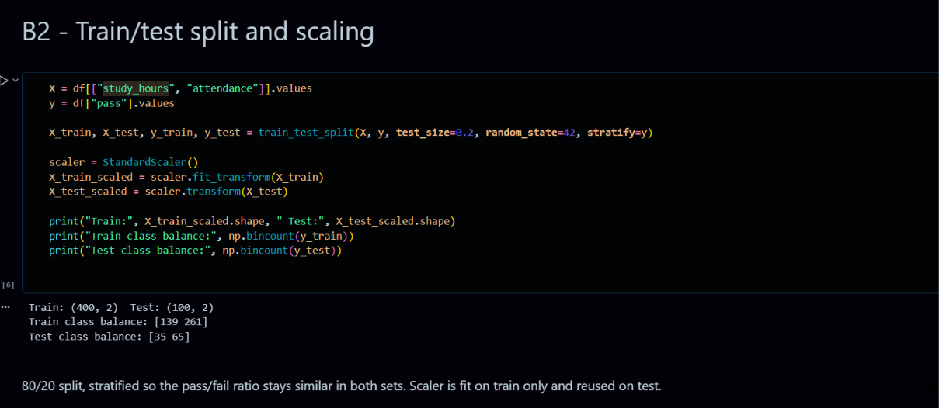

B3. Implement Logistic Regression from scratch. Plot the loss curve. Print the final w and b, and verify they are close to the coefficients of sklearn LogisticRegression fitted on the same data.
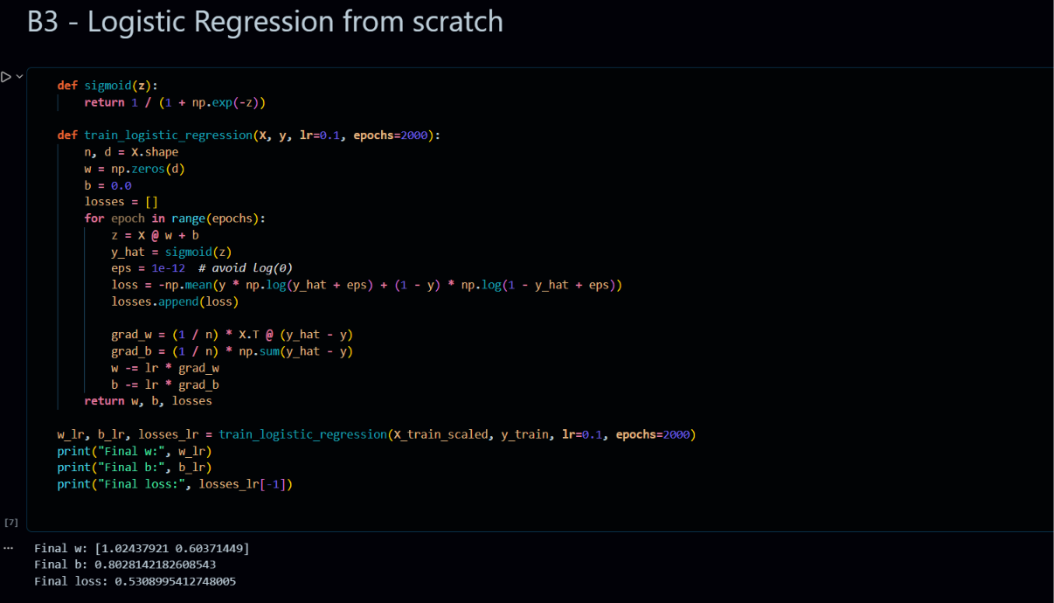
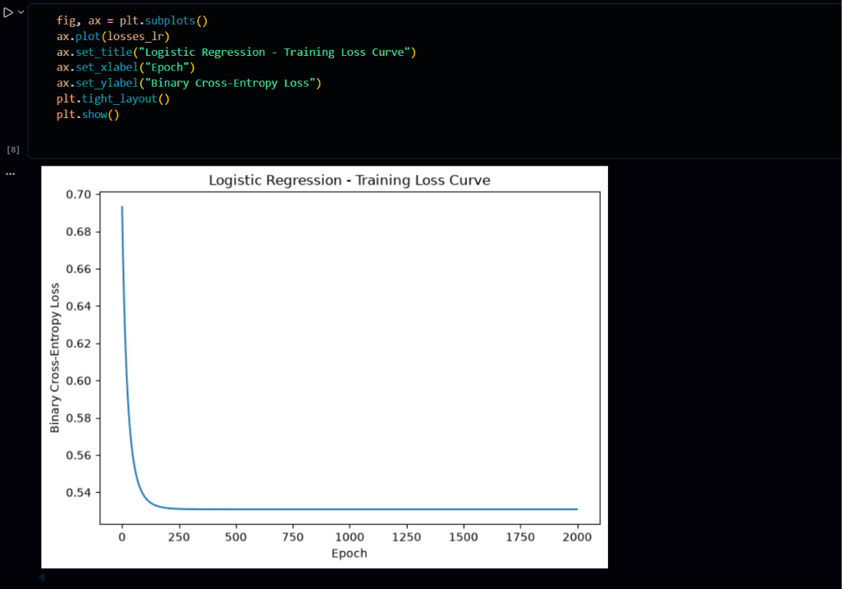
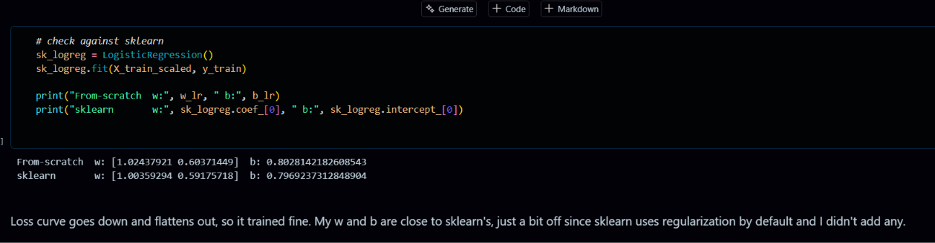
B4. Implement Perceptron from scratch. Track the number of misclassifications per epoch and plot it. Print the final w and b, and verify against sklearn Perceptron.
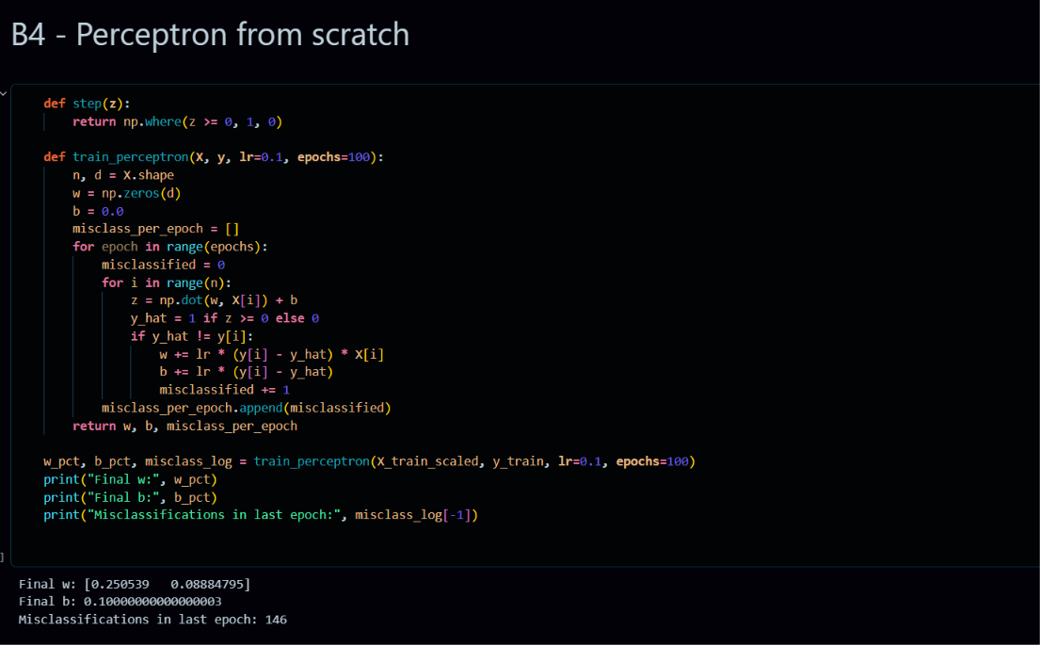
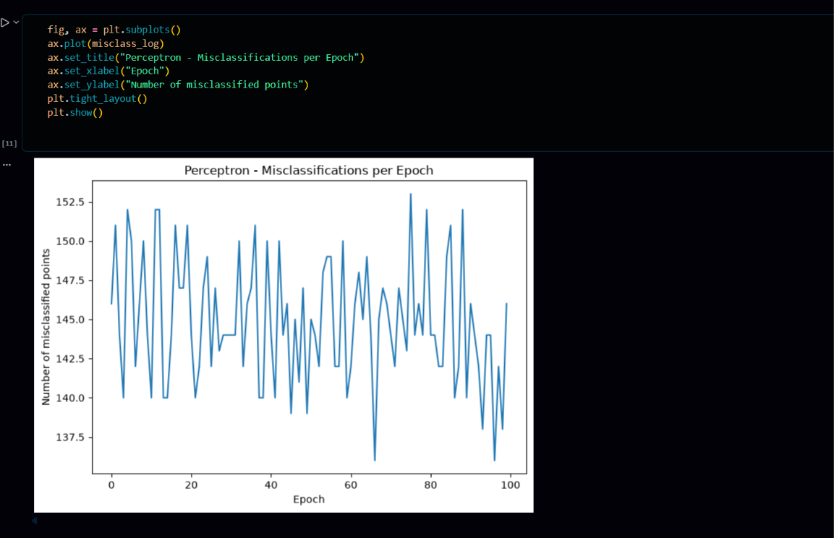
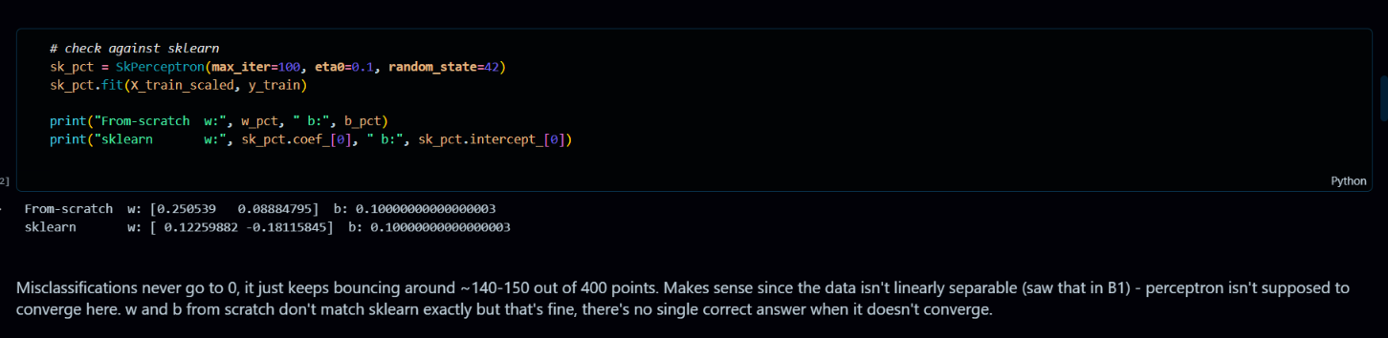
B5. Evaluate both models. For each model, generate predictions on the test set and produce: (a) a confusion matrix heatmap; (b) a full classification report (precision, recall, F1, accuracy). For logistic regression only, plot the ROC curve and compute AUC. Present a side-by-side markdown summary:
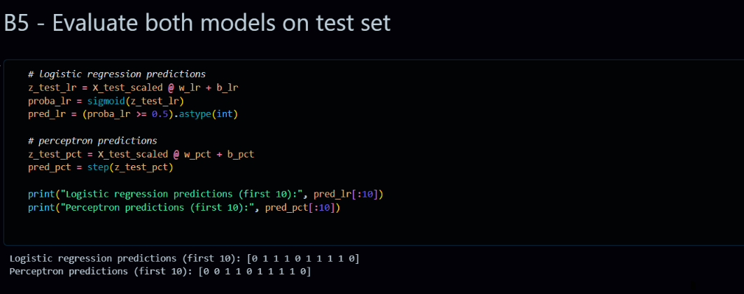

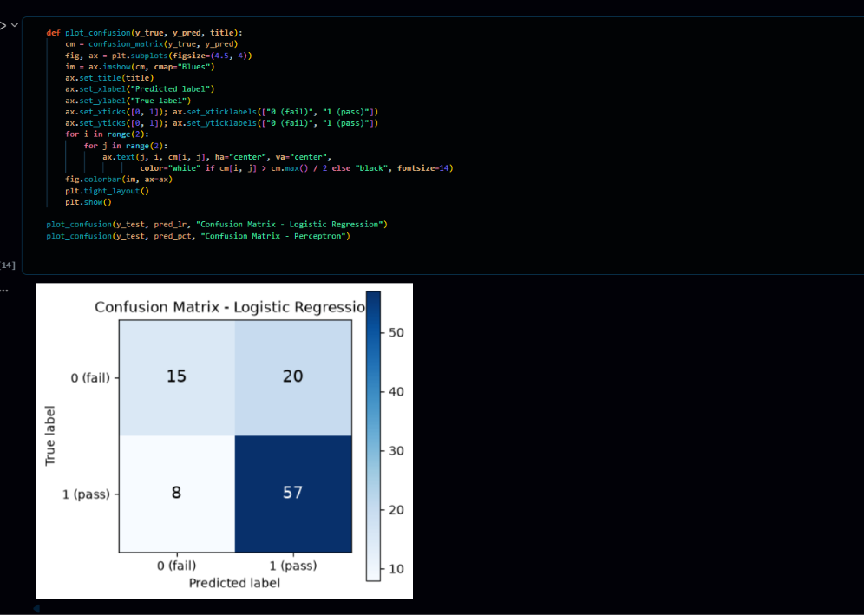
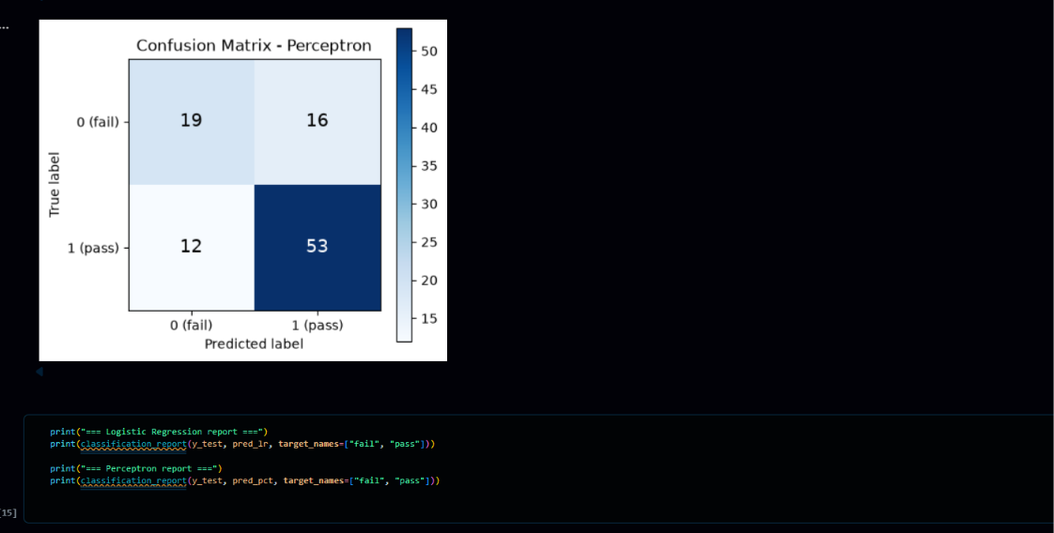
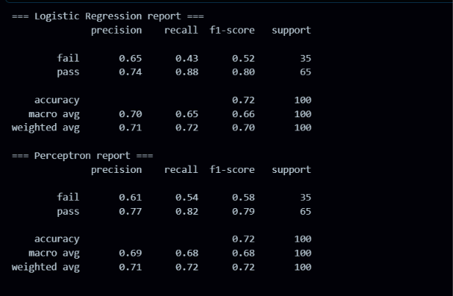
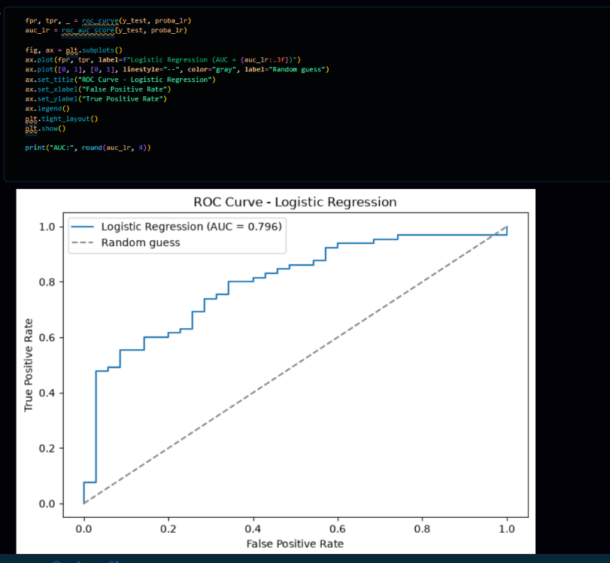

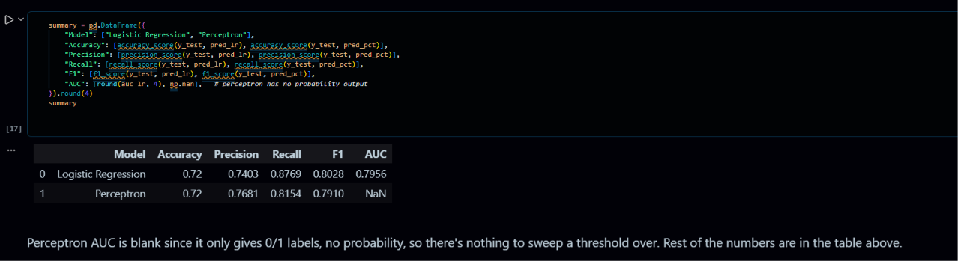

B6. Decision boundaries. Plot the decision boundary of each model over the scatter plot of the original (un-standardised) data, side by side. In a markdown cell, describe any region where the two boundaries differ and explain why.
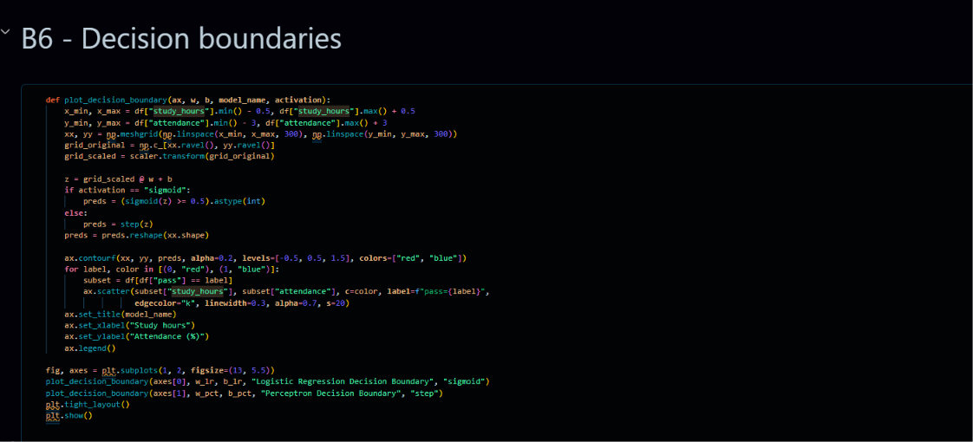
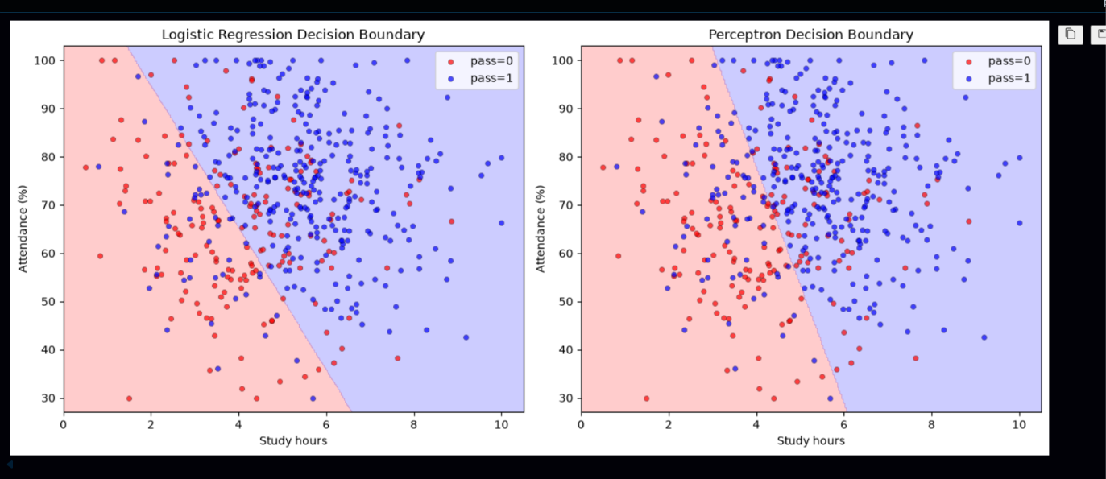
B7. Interpretation. In a final markdown cell, write a short paragraph (5–7 sentences) addressing: which model performed better and why; what the logistic regression coefficients reveal about the relative importance of study hours vs attendance; why the perceptron cannot produce an AUC score; and in what scenario you would prefer logistic regression over the perceptron


