Walchand College of Engineering, Sangli
Robotics Laboratory — Assignment 3
Installation of Blender
Name - Atharv Vinayak Kulkarni
PRN - 245109074
Class - TY CSE(B)

AIM
To install Blender 3D software on the system and get familiar with its interface for 3D modelling and animation applications in robotics.

OBJECTIVES
- To check the system requirements needed to run Blender.
- To download and install the correct version of Blender for the operating system in use.
- To verify that the installation was successful by launching the application.
- To identify the major panels and workspaces in Blender's default interface.
- To understand why a 3D tool like Blender is useful in a robotics workflow (modelling and visualising robot parts, simulating motion, and creating animations).

THEORY
Blender is a free and open-source 3D creation suite that supports the entire 3D pipeline: modelling, sculpting, rigging, animation, simulation, rendering, compositing, and even video editing. Because it is open-source, it is widely used in education, research, and small studios, and it also exposes a Python scripting API for automation.
In a robotics context, Blender is commonly used to build 3D models of robot parts or complete robots, visualise how a mechanism moves before building it physically, and produce animations that explain a robot's motion or a proposed design to others.
Blender is available for Windows, macOS, and Linux, and is distributed from the official Blender Foundation website. Installation typically involves downloading an installer (or a portable/archive build), running it, and following the on-screen setup steps.
I used this - https://en.wikipedia.org/wiki/Blender_(software)

EXPERIMENT STEPS WITH SCREENSHOT OF EACH STEP
Step 1: Open a web browser and navigate to the official Blender website (blender.org).
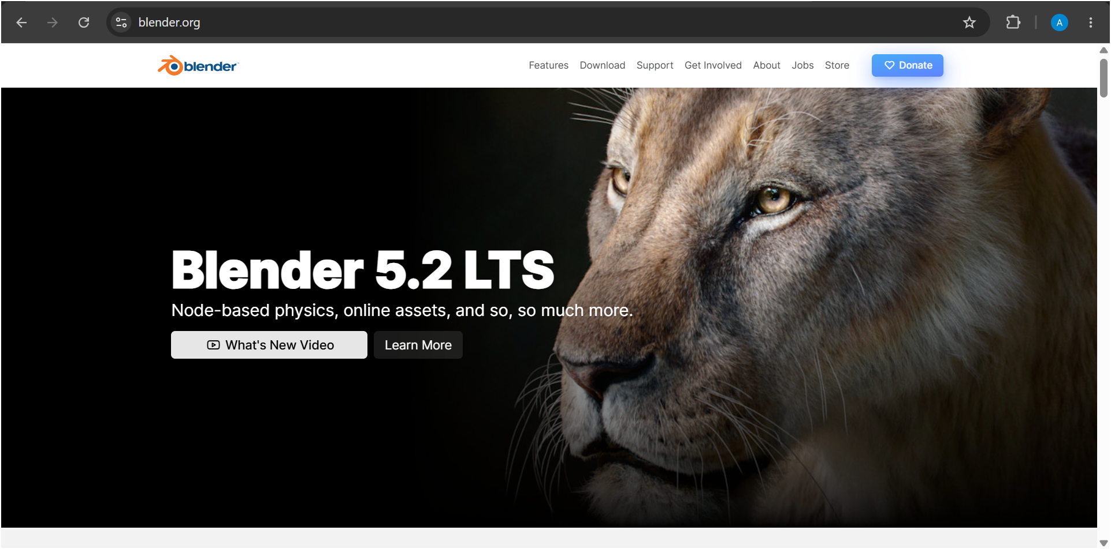
Step 2: Go to the Download section and check the listed system requirements against the system being used.
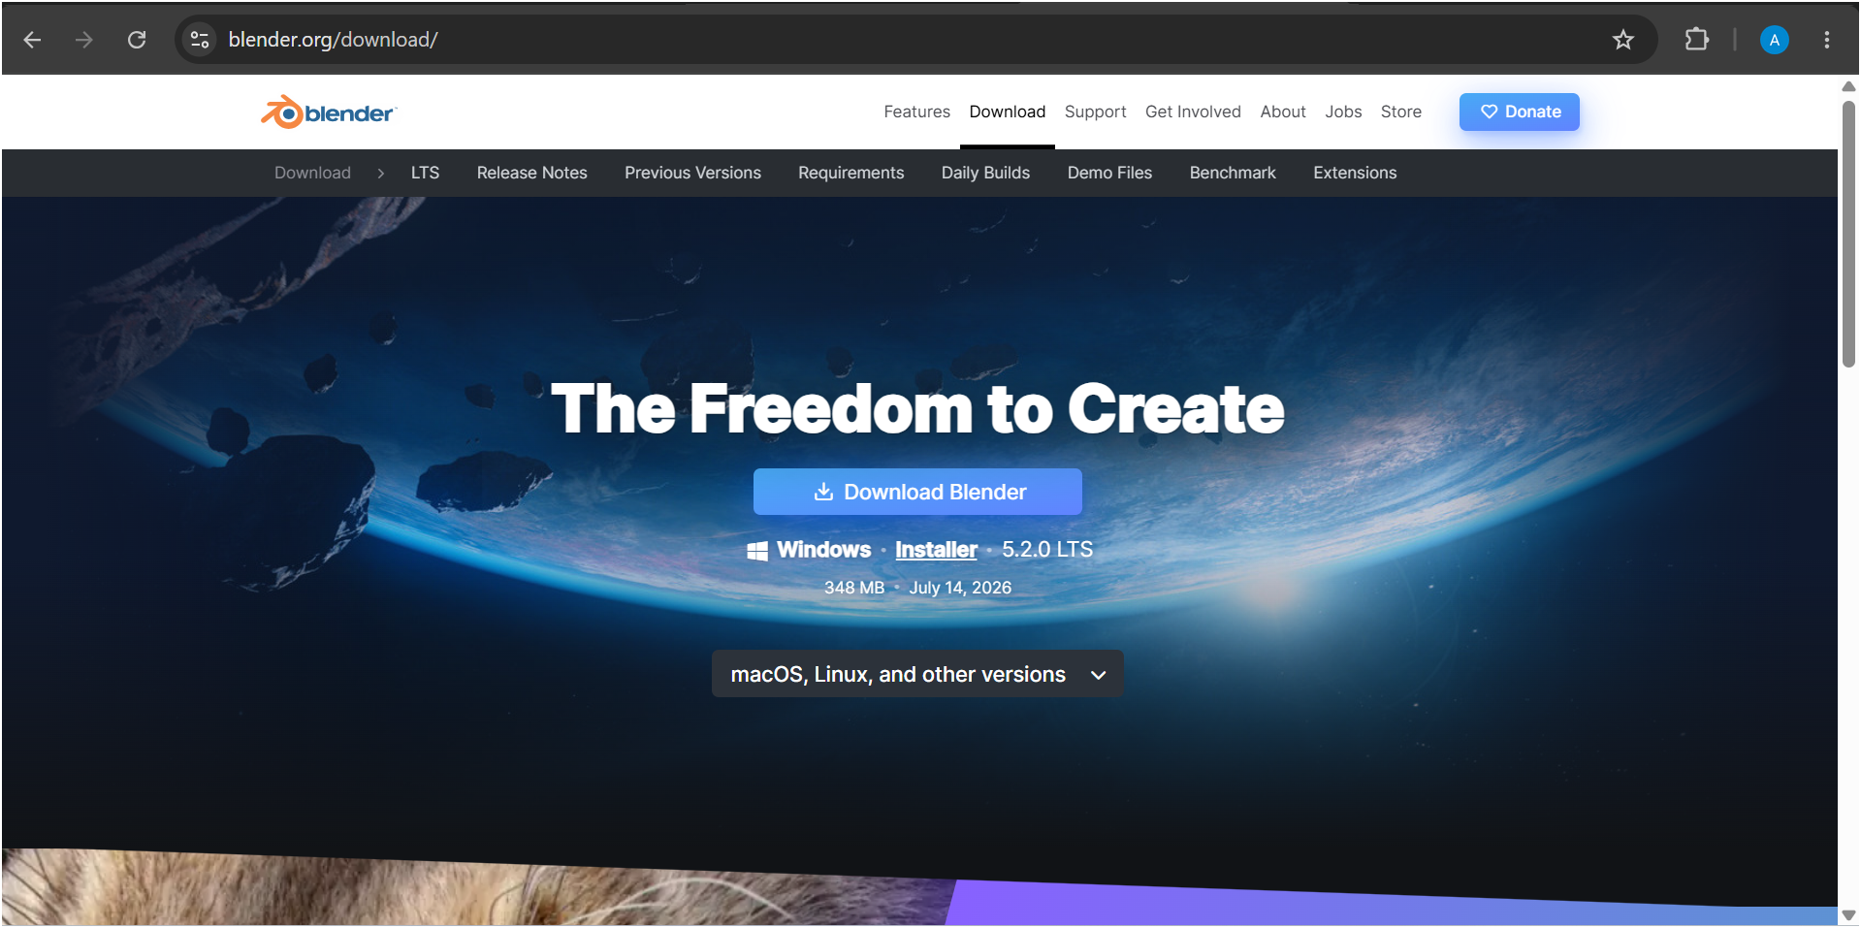
Step 3: Select the appropriate installer for the operating system (Windows, macOS, or Linux).
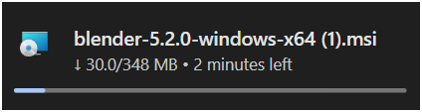
Step 4: Download the installer file to the system.
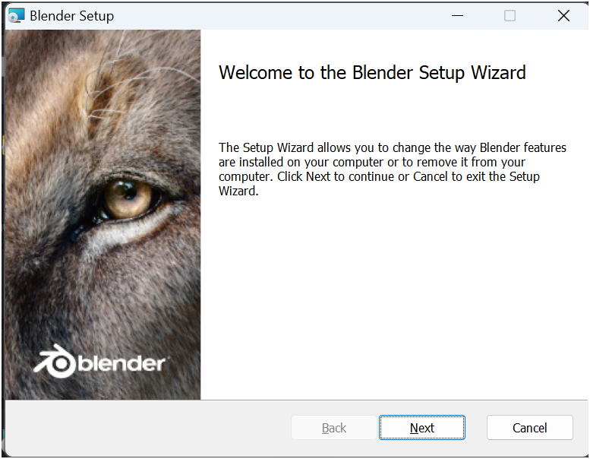

Step 5: Run the downloaded installer and accept the licence agreement.
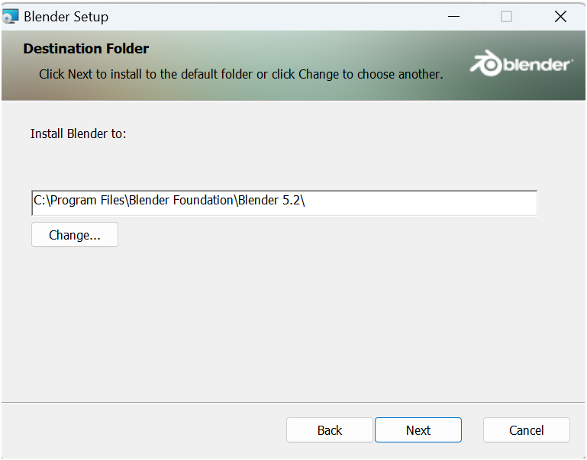

Step 6: Choose the installation location and complete the installation steps.
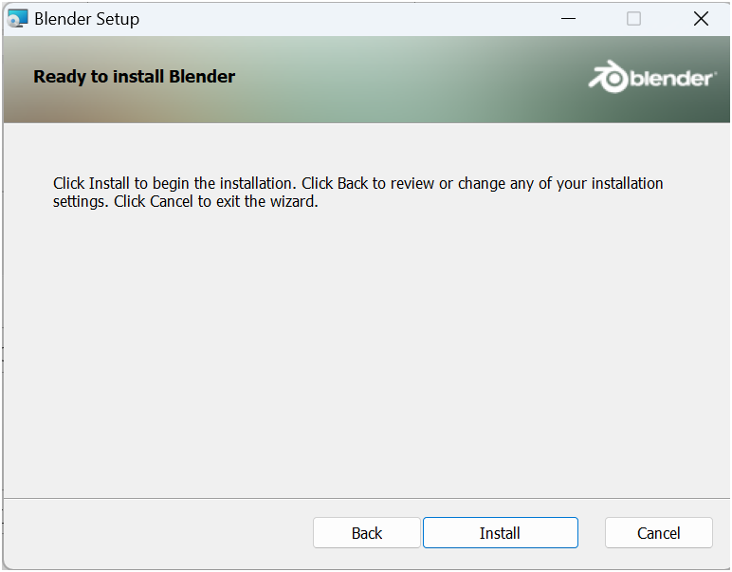
Step 7: Launch Blender once installation finishes.
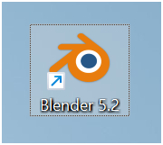

Step 8: Verify the installed version from the Splash Screen or under Help > About Blender.
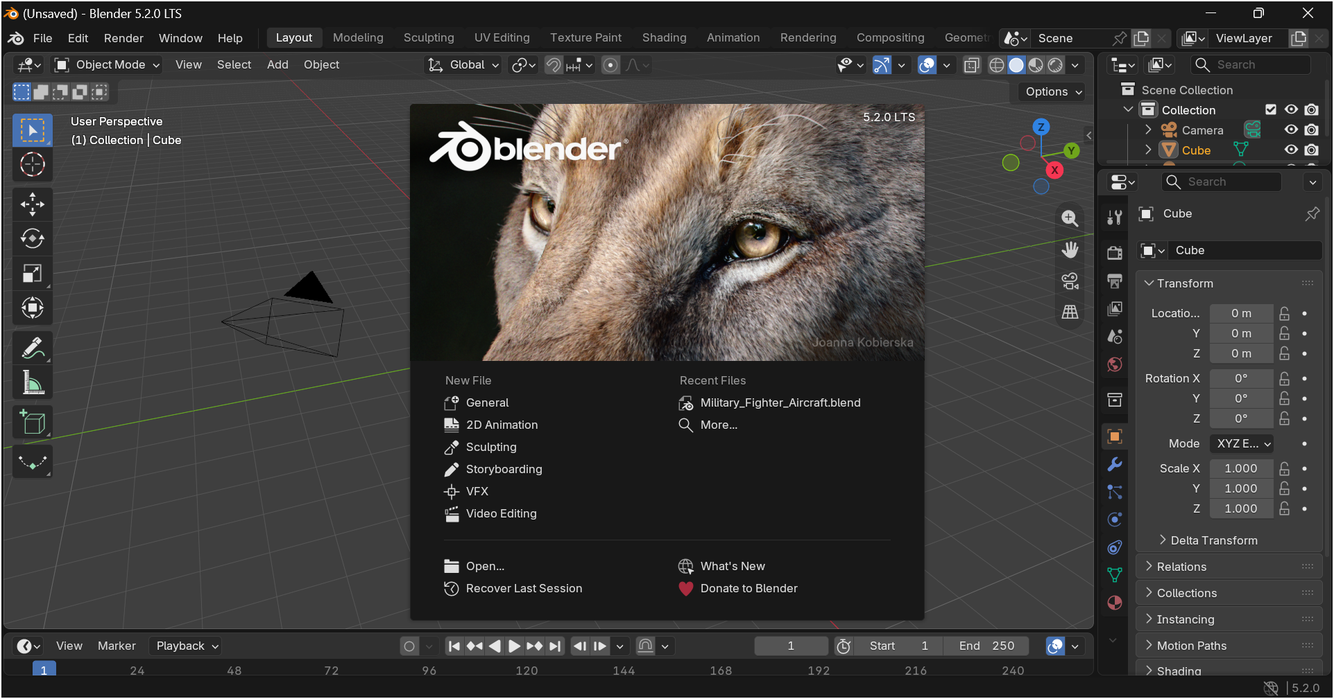Screenshot for Step 8 ]
Step 9: Explore the default interface: the 3D Viewport, Outliner, Properties panel, and Timeline.
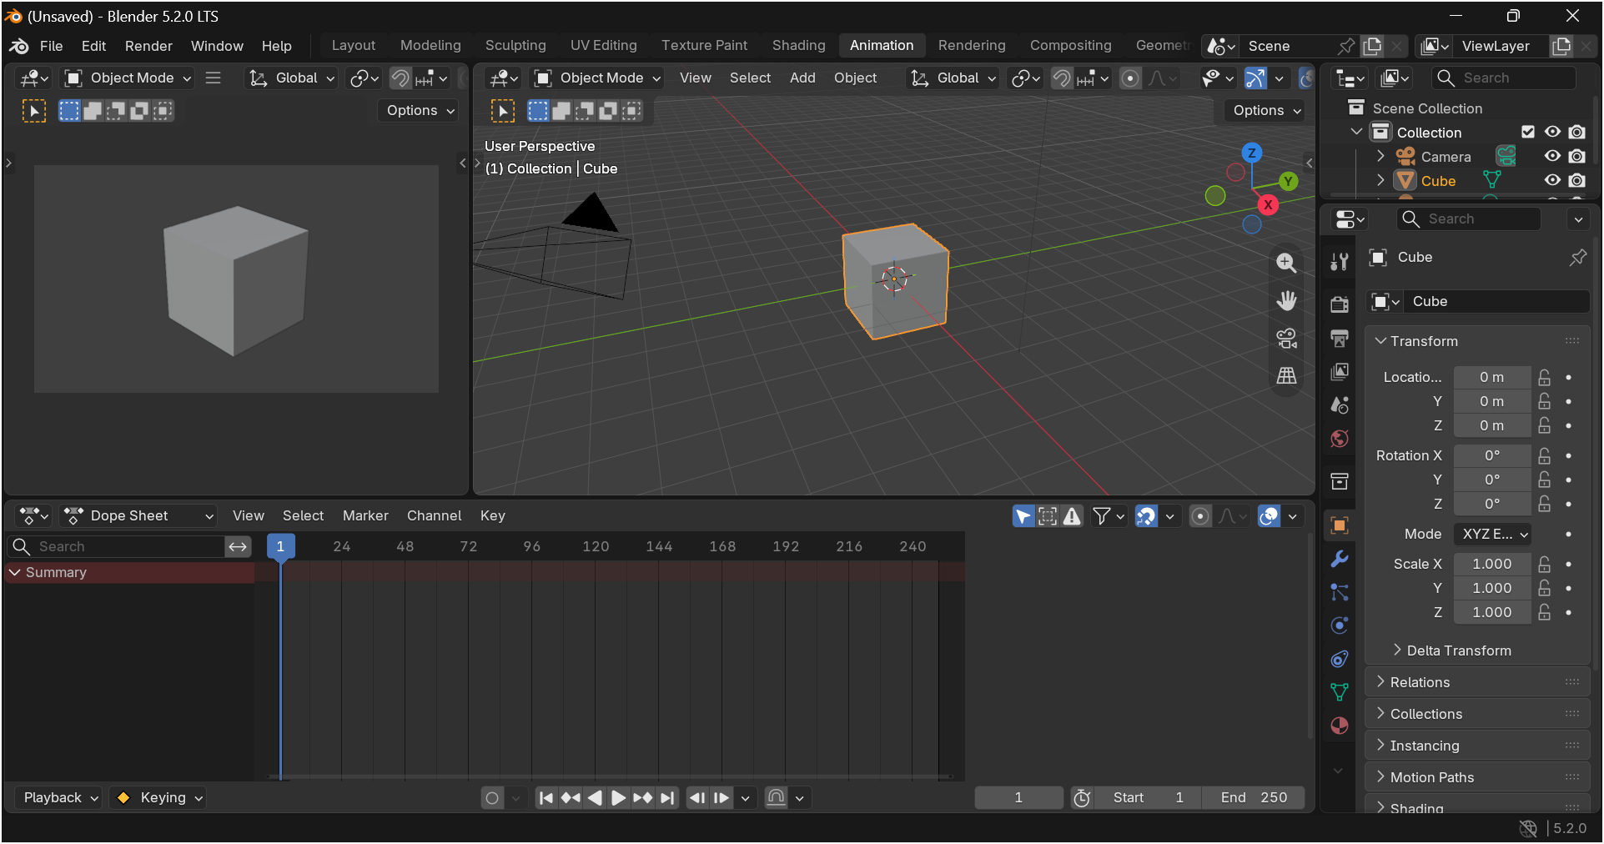
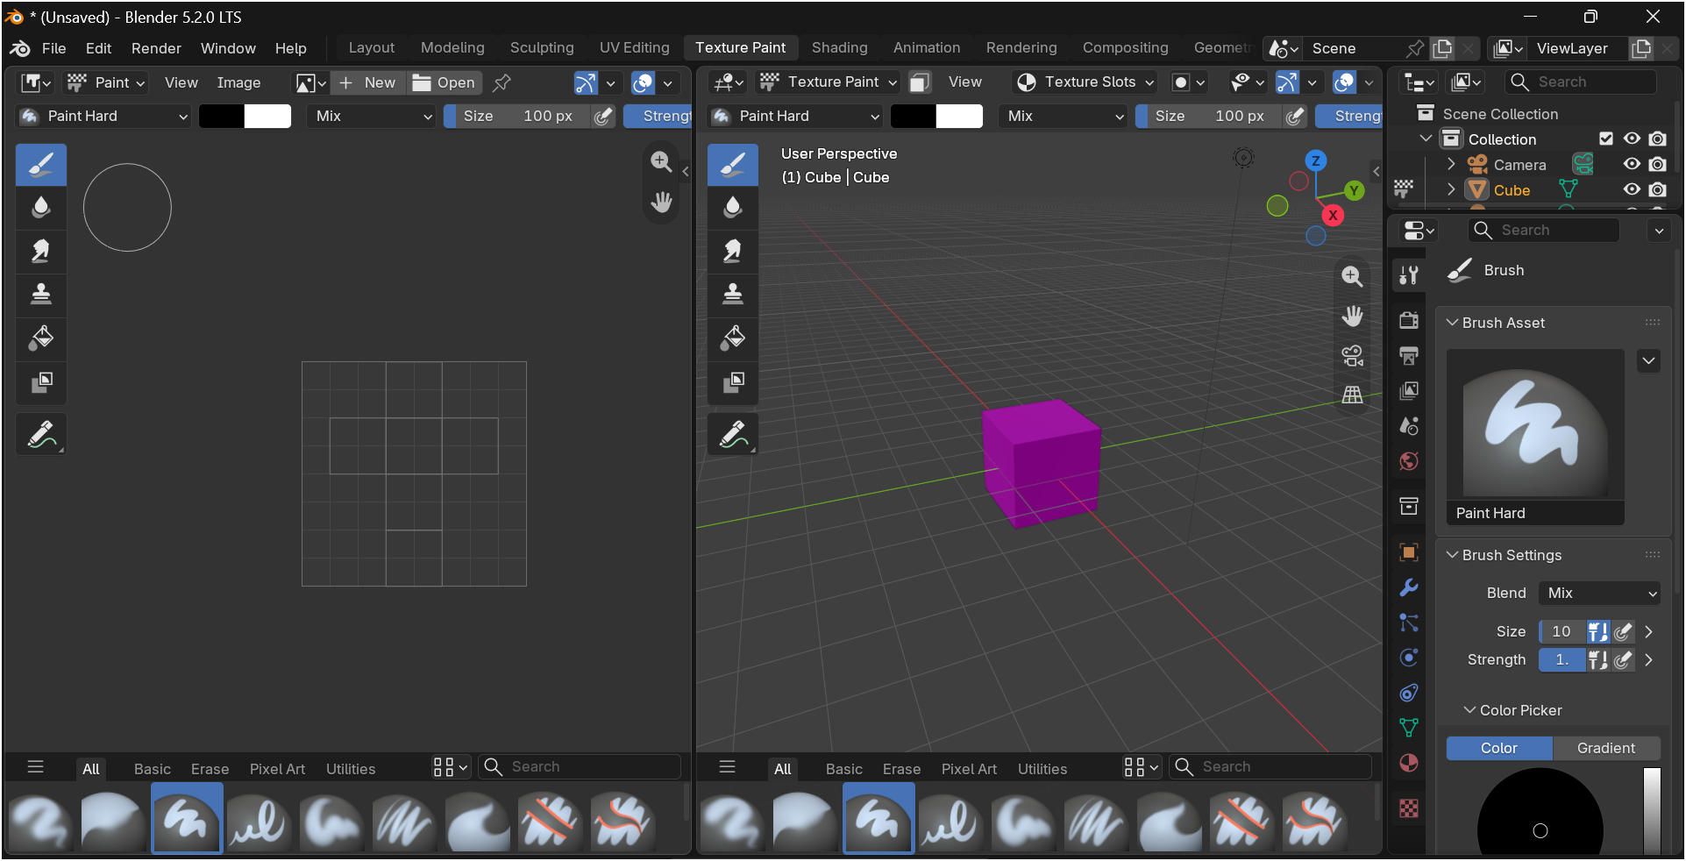

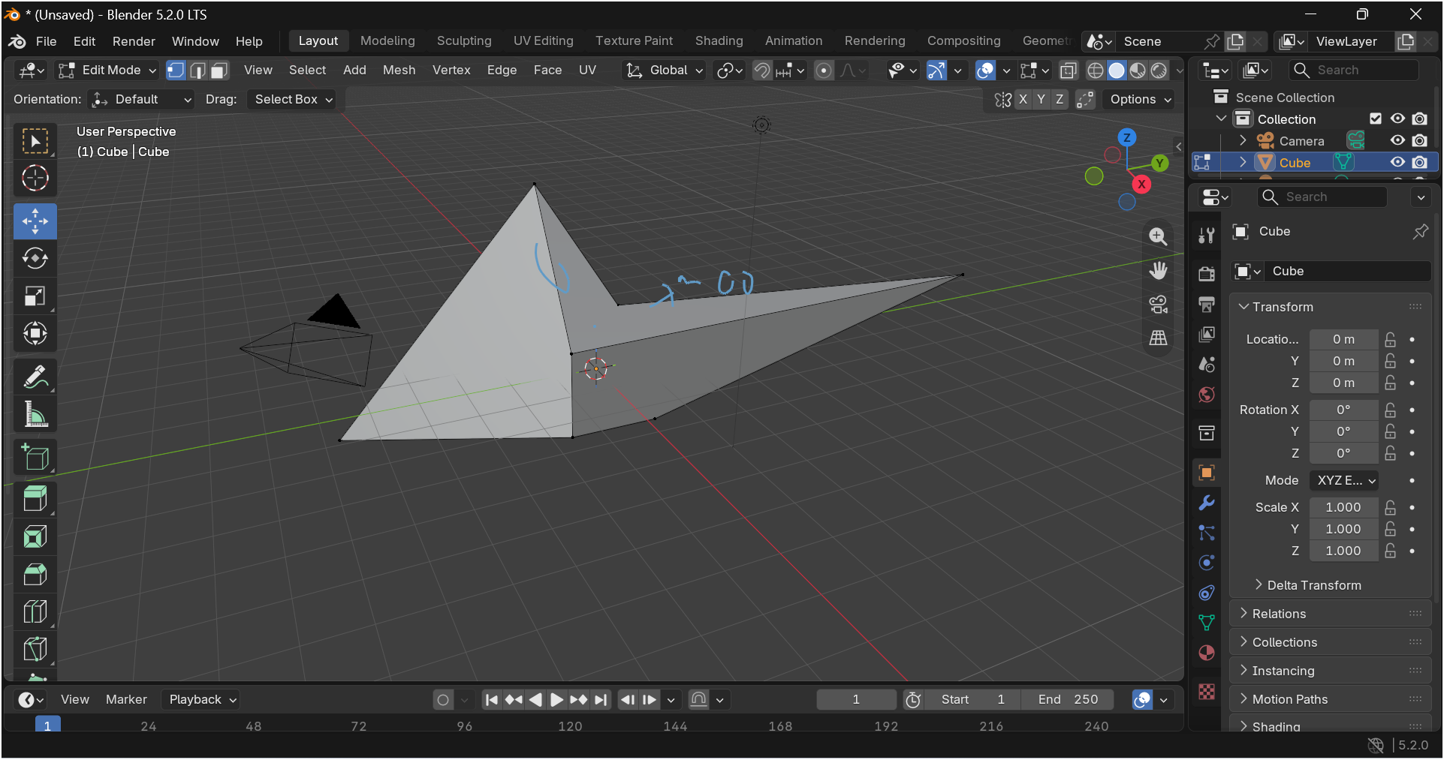

IMPLEMENTATION WITH OUTPUT
Blender was installed following the steps above and launched successfully. The default startup scene and interface panels were explored to confirm the installation is working correctly.
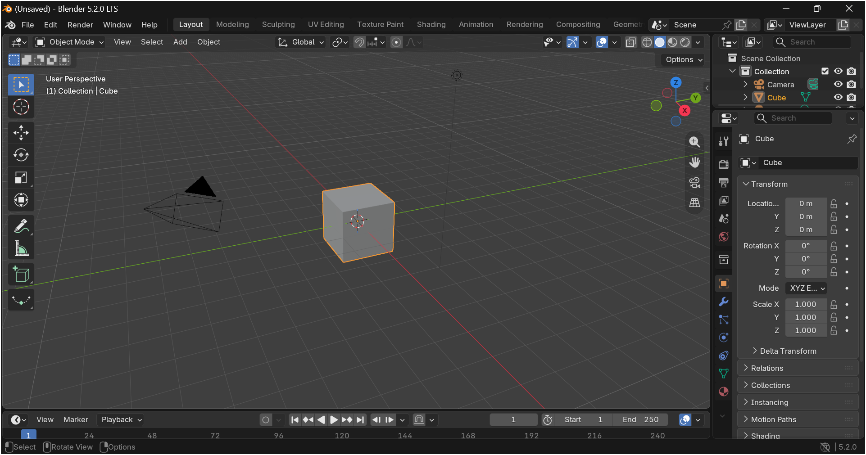

CONCLUSION
Blender was successfully downloaded and installed, and its default interface was explored. This installation forms the foundation for the 3D modelling and animation work carried out in the subsequent assignments, where Blender is used to build and animate 3D representations of robot components.

