Walchand College of Engineering, Sangli
Robotics Laboratory — Assignment 4
3D Modelling of a Computer/Robot using Blender
Name - Atharv Vinayak Kulkarni
PRN - 245109074
Class - TY CSE(B)

AIM
To create a 3D model of a computer/robot using Blender's mesh modelling tools.

OBJECTIVES
- To understand the basic building blocks of a 3D mesh: vertices, edges, and faces.
- To learn fundamental modelling operations such as extrude, scale, bevel, and loop cut.
- To combine multiple primitive shapes into a single recognisable object (a computer or robot).
- To apply basic materials/colours to distinguish different parts of the model.
- To render or view the completed 3D model from multiple angles.

THEORY
Every 3D object in Blender is a mesh made up of vertices (points), edges (lines connecting vertices), and faces (flat surfaces bounded by edges). Modelling is the process of manipulating these three elements to build up a desired shape.
Box modelling is a common approach: start from a simple primitive (cube, cylinder, sphere), and progressively extrude, scale, and reshape it into the target form. Extrusion creates new geometry by pulling a face, edge, or vertex outward; a bevel rounds off a sharp edge or corner; a loop cut adds an edge loop so a region can be reshaped independently.
Modifiers (such as Subdivision Surface, Mirror, or Boolean) can automate repetitive modelling tasks — for example, Mirror lets you model only one half of a symmetric object like a robot body, and Boolean can cut or combine shapes directly.
Once the shape is complete, materials are assigned to give different parts of the model distinct colours or surface properties, making the final model easier to interpret, whether it represents a desktop computer or a simplified robot arm.

EXPERIMENT STEPS WITH SCREENSHOT OF EACH STEP
Step 1: Open Blender and clear the default scene, keeping only the elements needed for the new model.
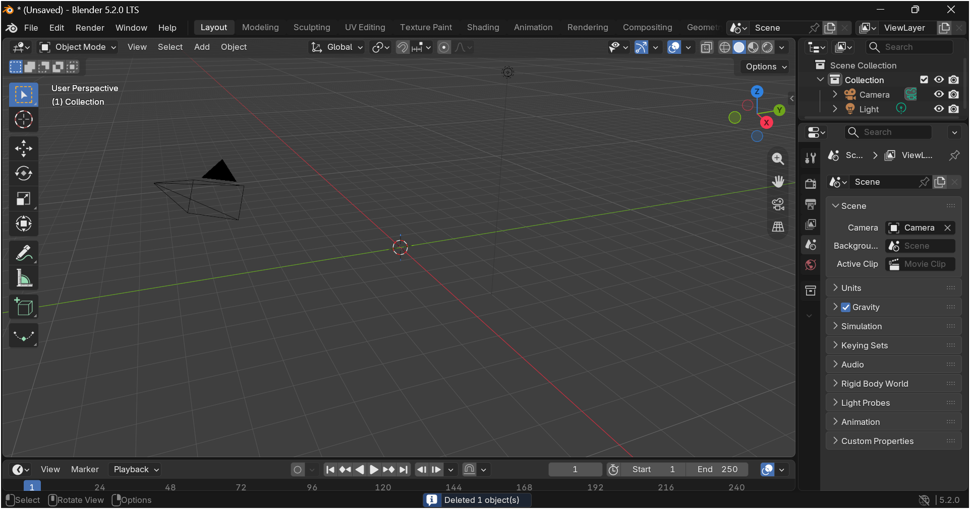

Step 2: Add a base primitive (e.g. a cube) to start modelling the main body of the computer/robot.
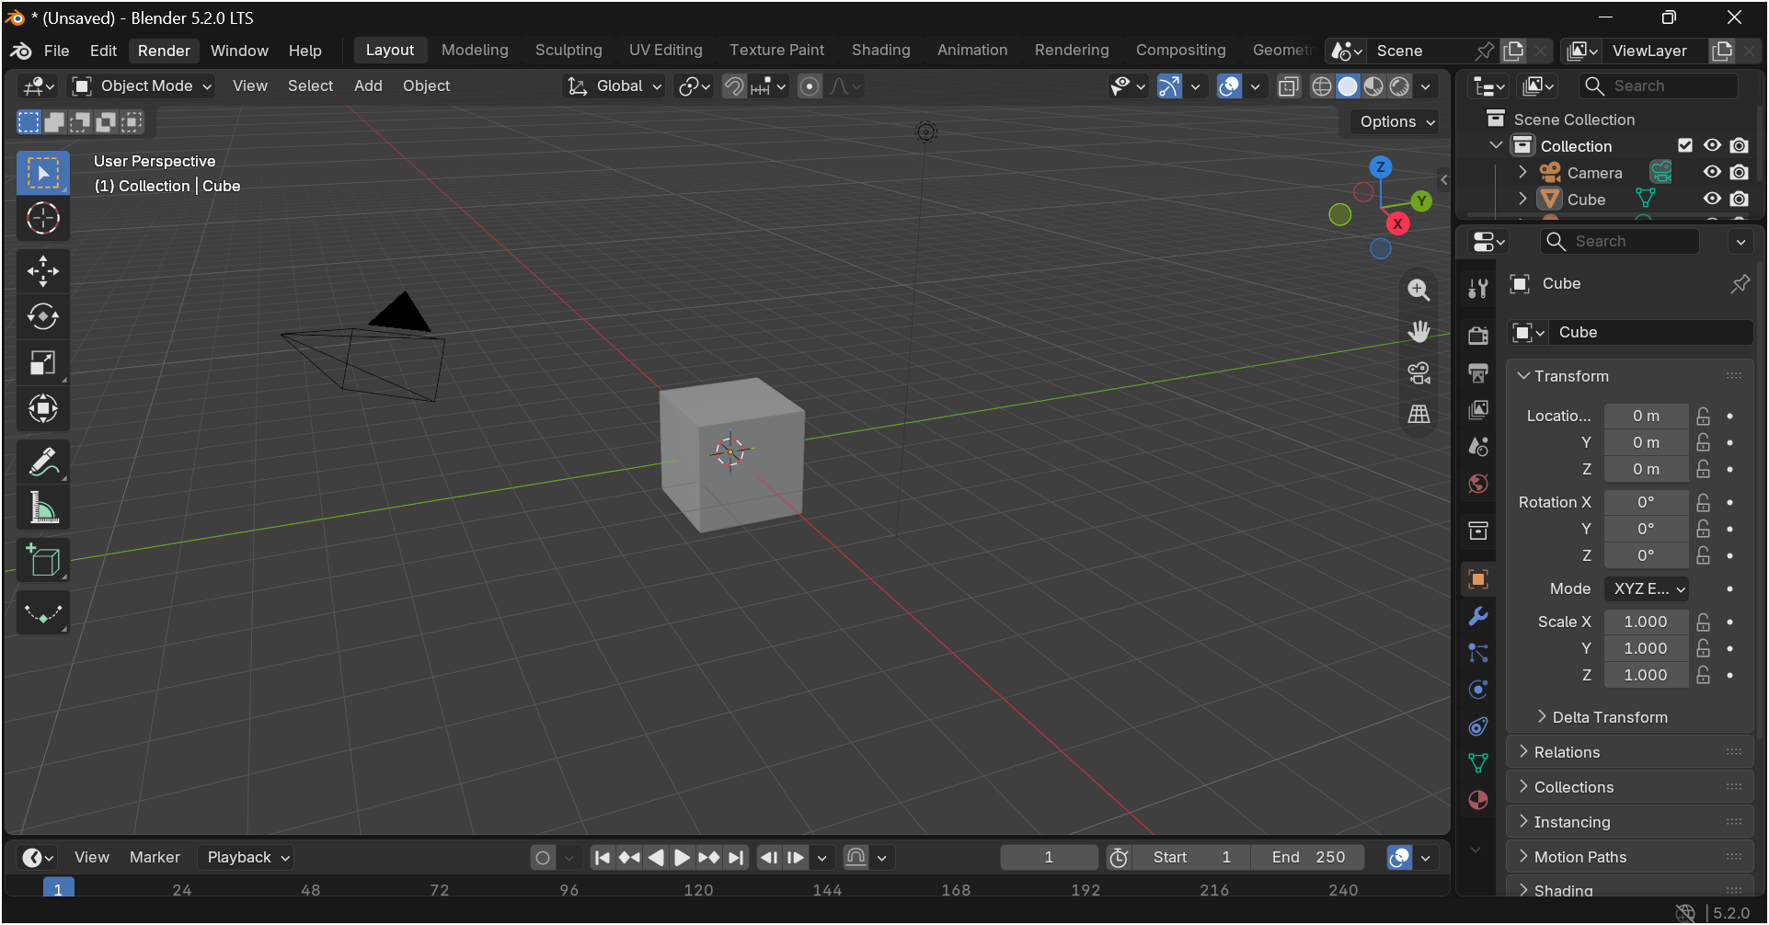

Step 3: Use Extrude and Scale to shape the main body (e.g. the monitor/screen or the robot's torso).
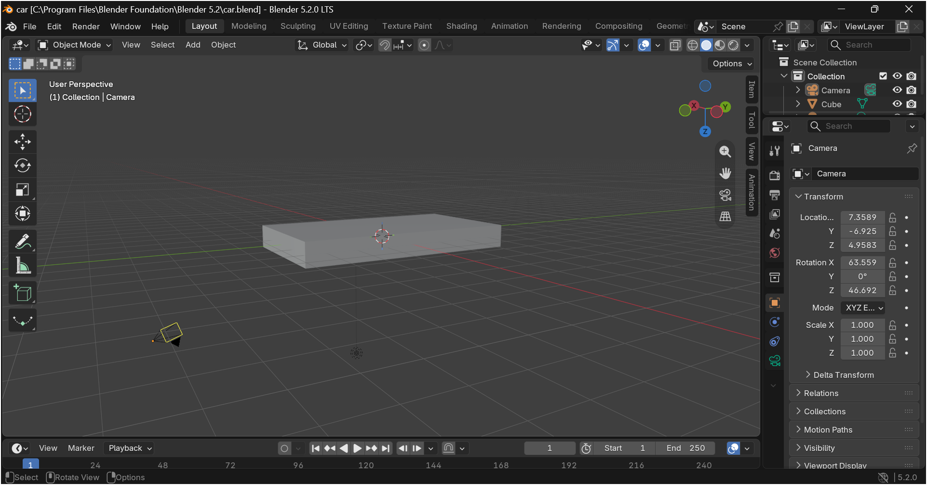
Step 4: Add further primitives for secondary parts (e.g. keyboard, stand, robot arm segments, or wheels).
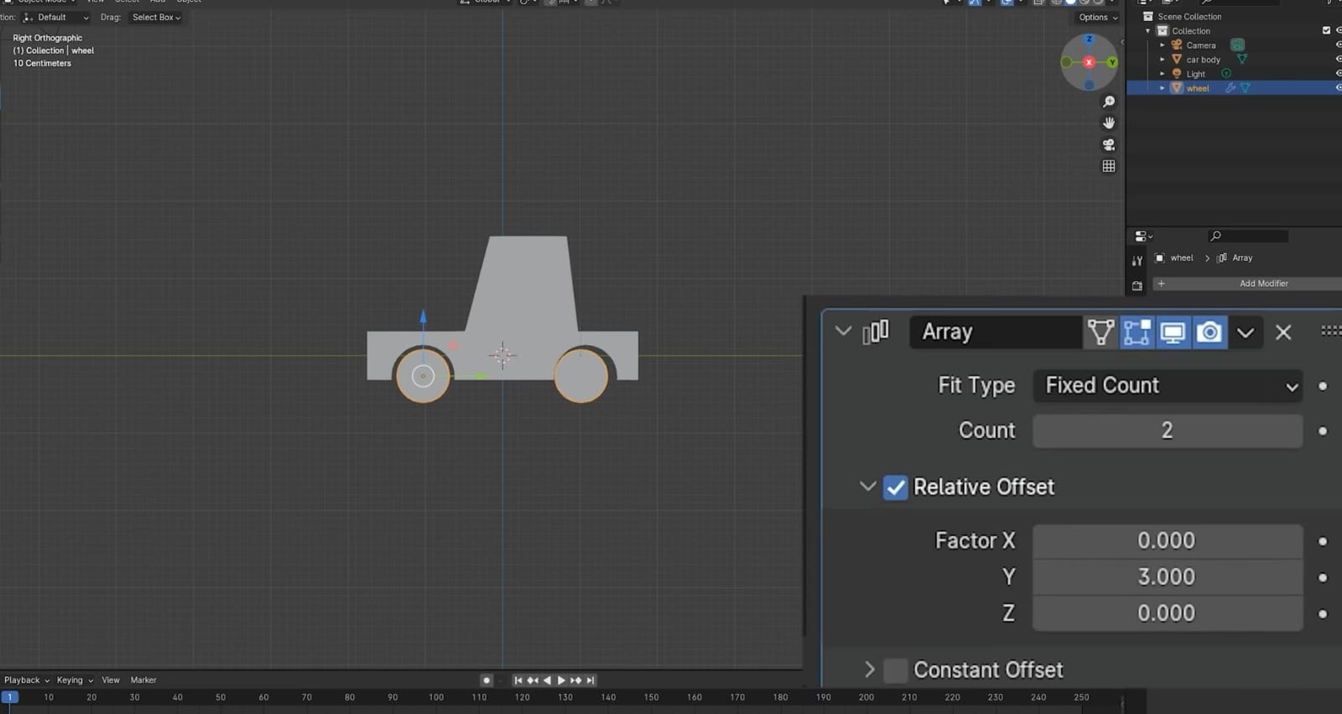

Step 5: Use Loop Cut and Bevel to refine edges and add detail where needed.
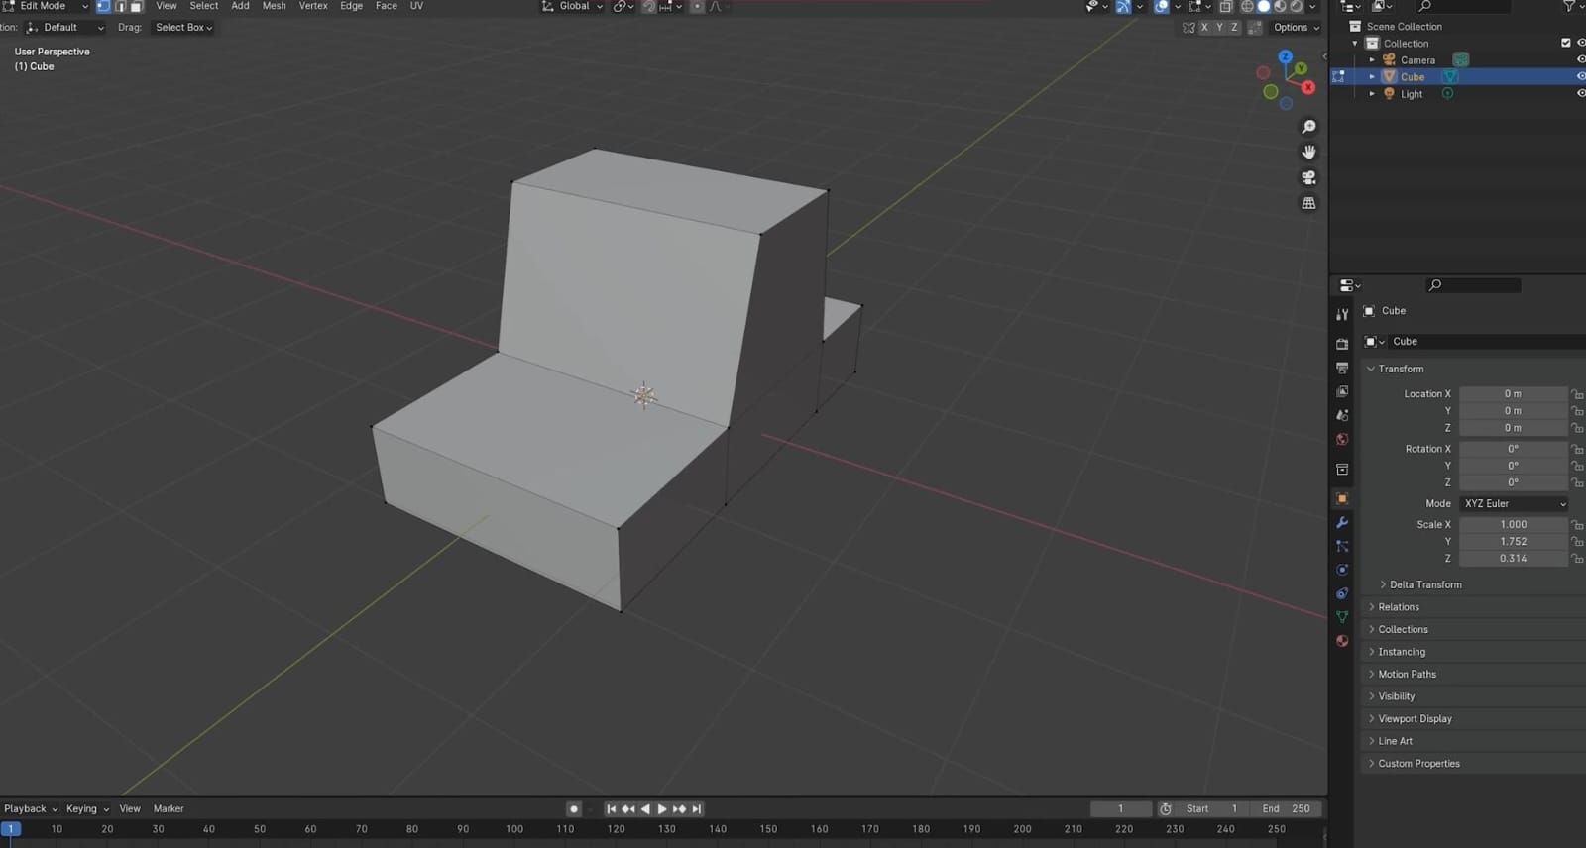
Step 6: Apply a Mirror modifier if the object is symmetric, to model only one half and mirror the rest.
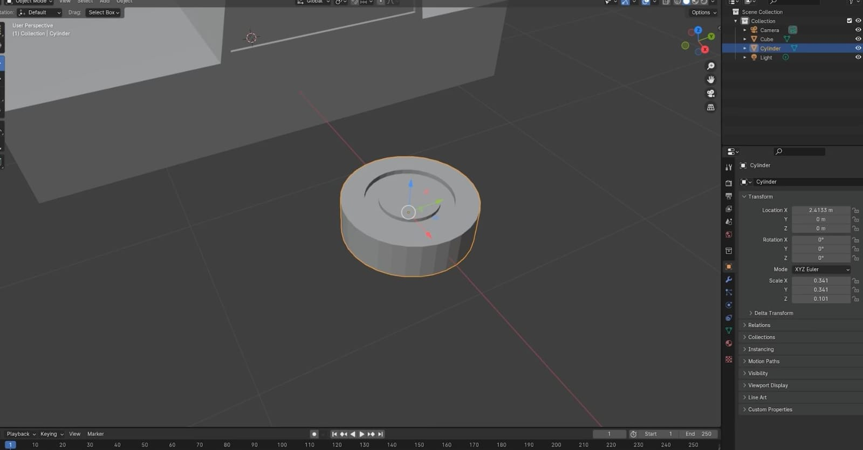
Step 7: Position and join all parts together into a single combined model.
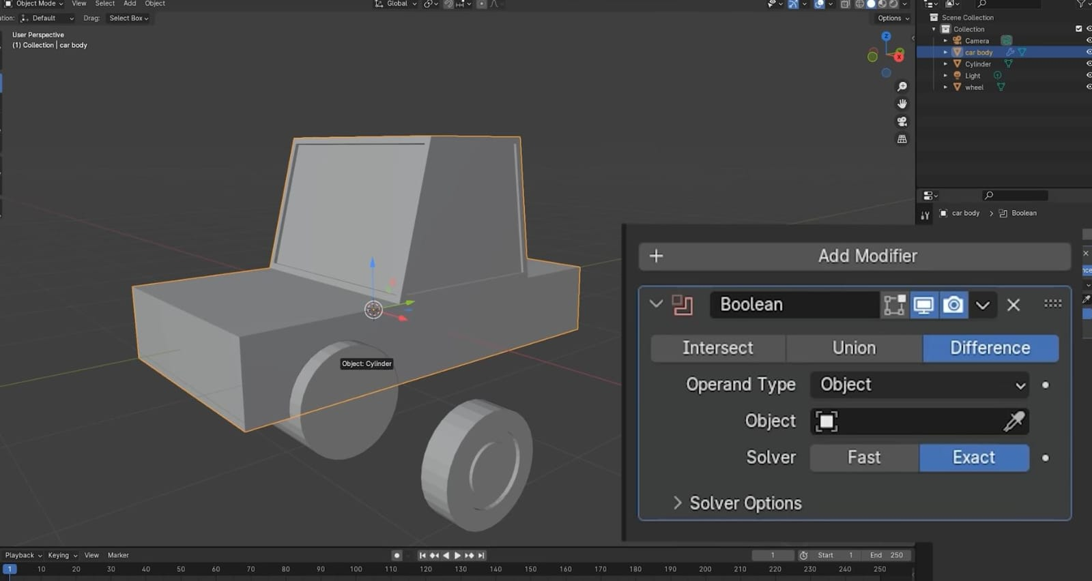
Step 8: Assign materials/colours to different parts of the model to distinguish them visually.
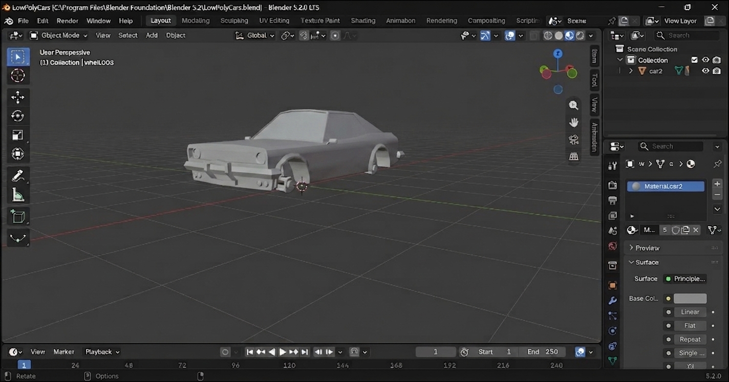

Step 9: Set up a camera and lighting, then render or screenshot the final model from multiple angles.
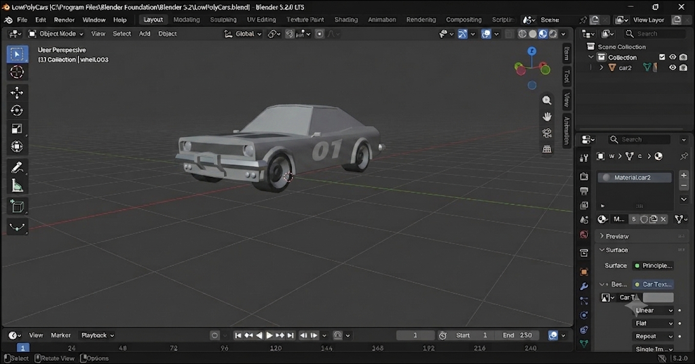

IMPLEMENTATION WITH OUTPUT
The steps above were used to build a 3D model of a computer/robot in Blender. The final model, along with renders from different viewing angles, is shown below.
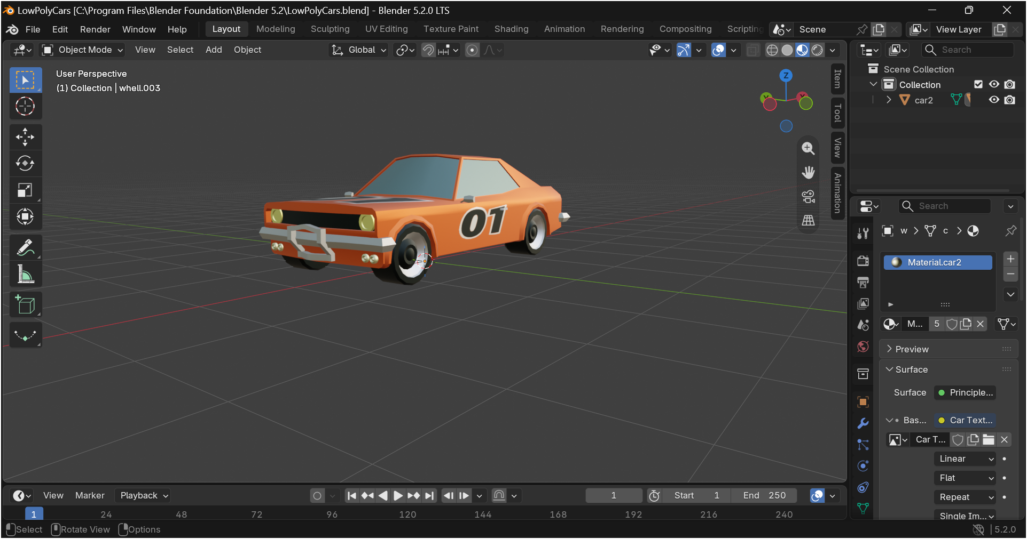

CONCLUSION
A 3D model of a Racing Car was successfully created in Blender using basic mesh modelling operations such as extrude, scale, bevel, and loop cut, along with modifiers to simplify symmetric parts. This exercise built familiarity with Blender's core modelling workflow, which is directly applicable to creating accurate 3D representations of real robot components for visualisation or simulation.

