Walchand College of Engineering, Sangli
Robotics Laboratory — Assignment 5
3D Animation of a Moving Object using Blender
Name - Atharv Vinayak Kulkarni
PRN - 245109074
Class - TY CSE(B)

AIM
To animate the movement of a 3D object in Blender using keyframes, and to render the animation as a video.

OBJECTIVES
- To understand the concept of keyframes and the timeline in Blender's animation workflow.
- To animate the location, rotation, and/or scale of an object over time.
- To understand interpolation between keyframes and how it affects the smoothness of motion.
- To preview the animation in the viewport before final rendering.
- To render the completed animation as a video file.

THEORY
Keyframe animation works by recording the state of an object's properties (such as location, rotation, or scale) at specific points in time, called keyframes. Blender automatically calculates, or interpolates, the values in between two keyframes, producing smooth motion from one recorded state to the next.
The Timeline (and the more detailed Graph Editor / Dope Sheet) shows all keyframes for the selected object across the animation's frame range. Frame rate (frames per second, FPS) determines how many of these interpolated frames are shown per second of playback, which affects how smooth or fast the final animation looks.
By default, Blender uses Bezier interpolation between keyframes, which eases motion in and out for a natural look; this can be changed to Linear (constant speed) or Constant (no interpolation, an instant jump) depending on the desired effect.
Once all keyframes are set, the animation can be previewed by scrubbing or playing the timeline in the viewport, and finally rendered frame-by-frame into a video file using Blender's render engine.

EXPERIMENT STEPS WITH SCREENSHOT OF EACH STEP
Step 1: Open Blender and select (or add) the object that needs to be animated.
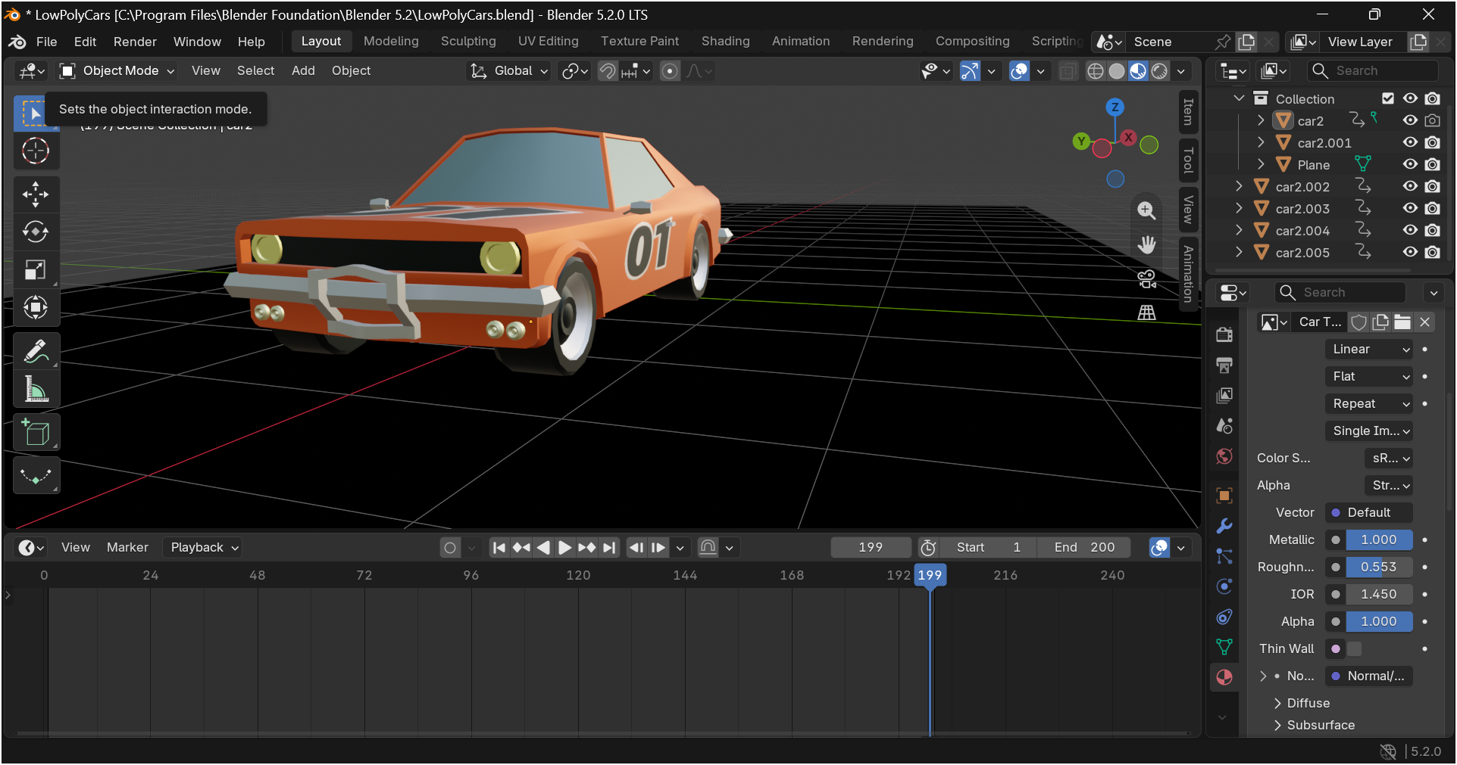

Step 2: Move the playhead to frame 1 on the Timeline and set the object's starting location/rotation.
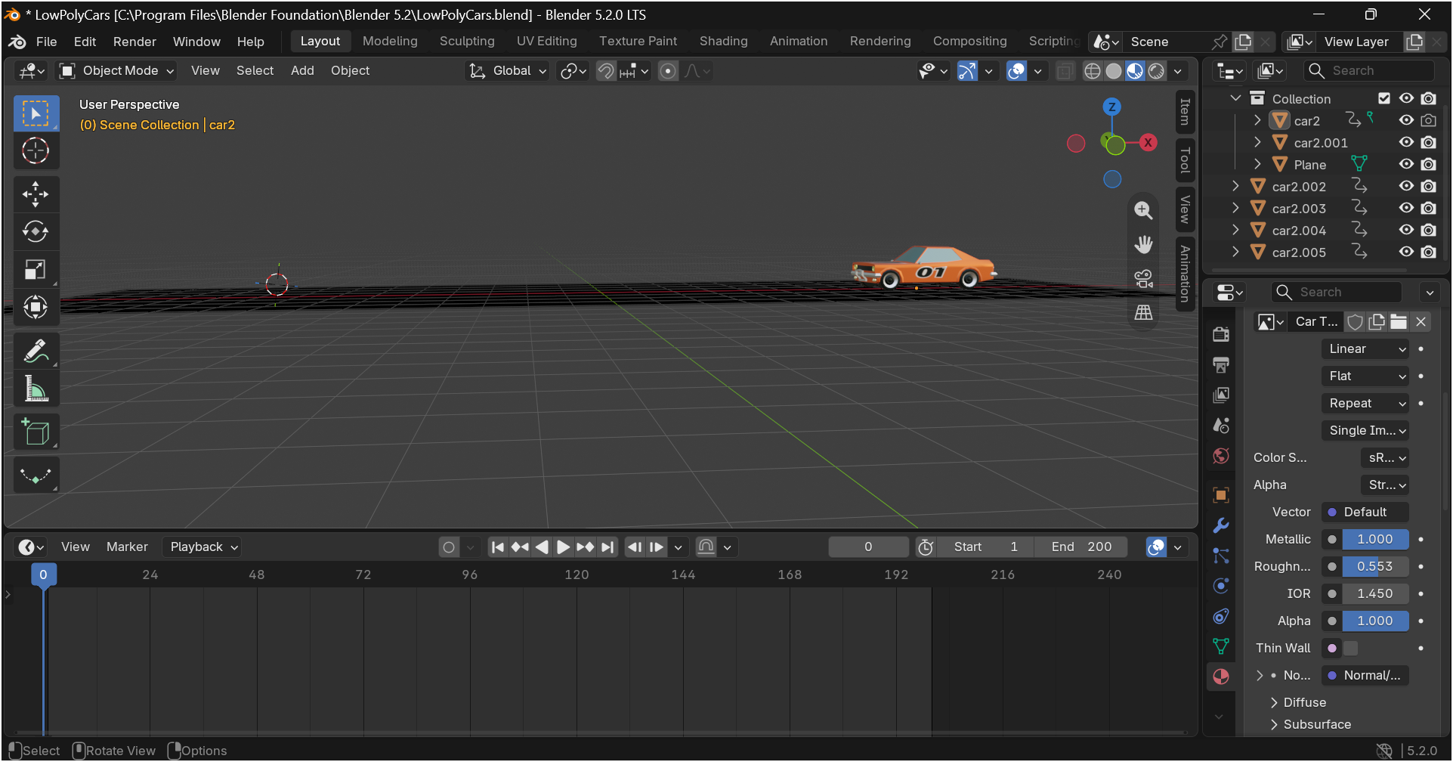
Step 3: Insert a keyframe for the object's location (and rotation, if needed) at frame 1.
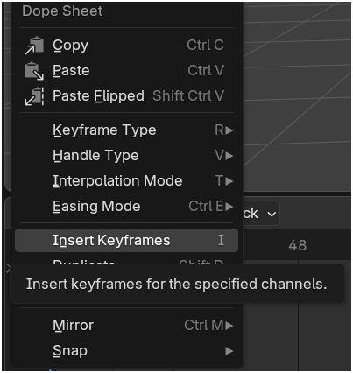

Step 4: Move the playhead further along the Timeline (e.g. to frame 50) and move/rotate the object to its next position.
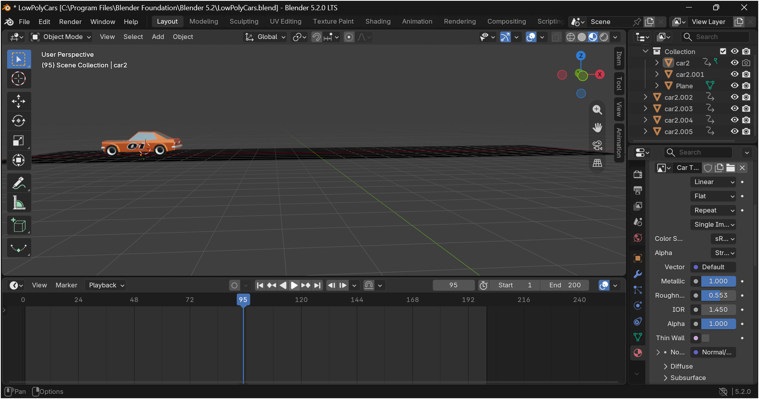
Step 5: Insert a new keyframe at this frame to record the updated state.
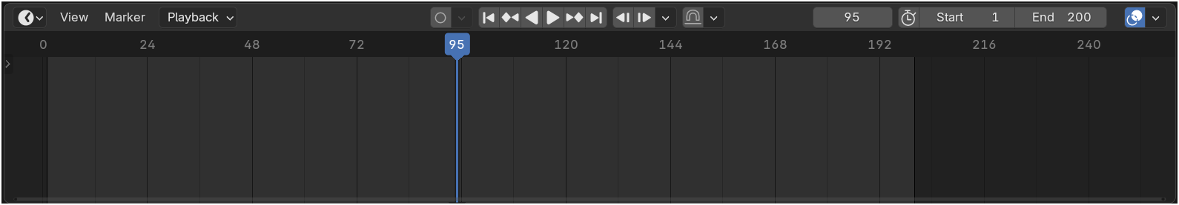

Step 6: Repeat the process for any additional positions needed to complete the motion path.
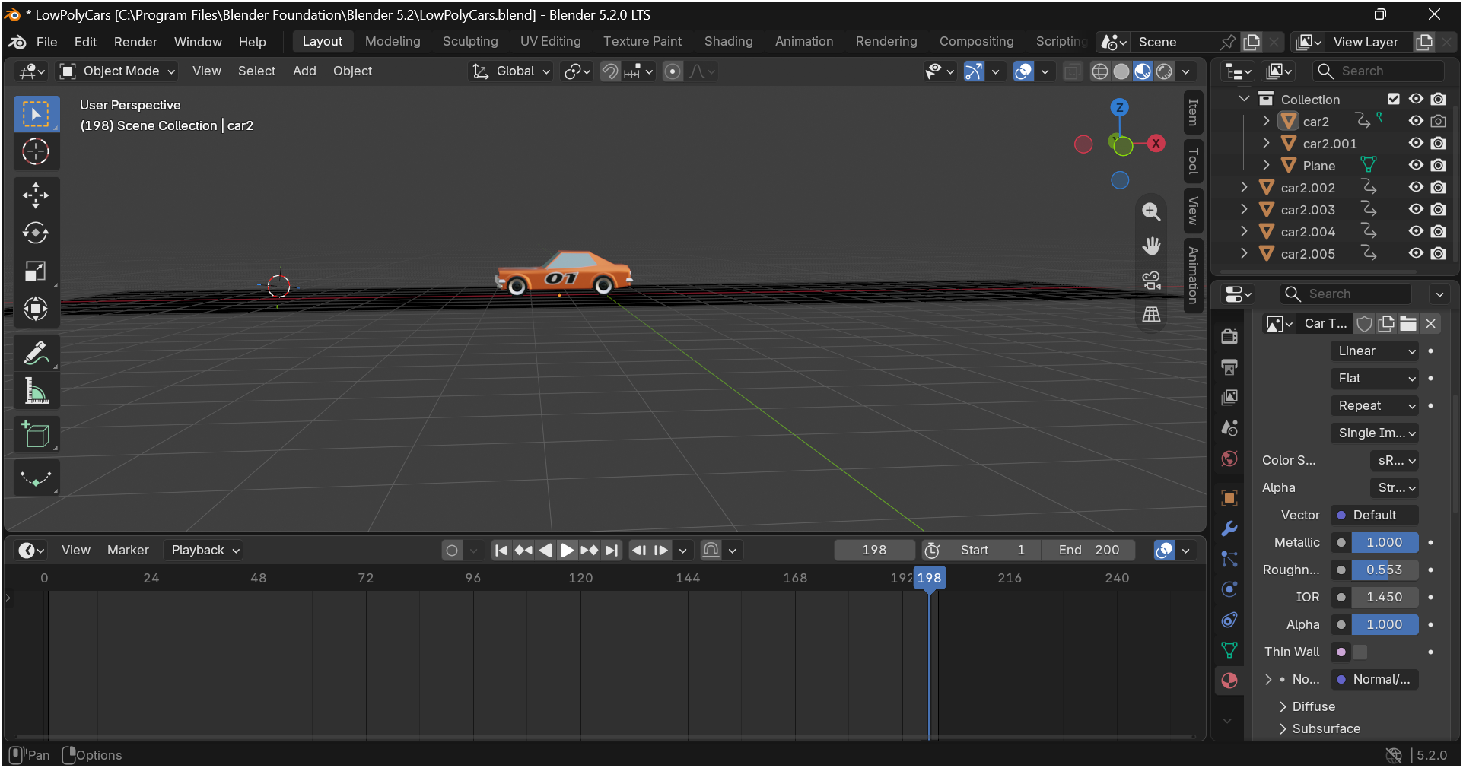
Step 7: Open the Graph Editor to check and adjust the interpolation curve between keyframes if the motion looks too abrupt or too slow.
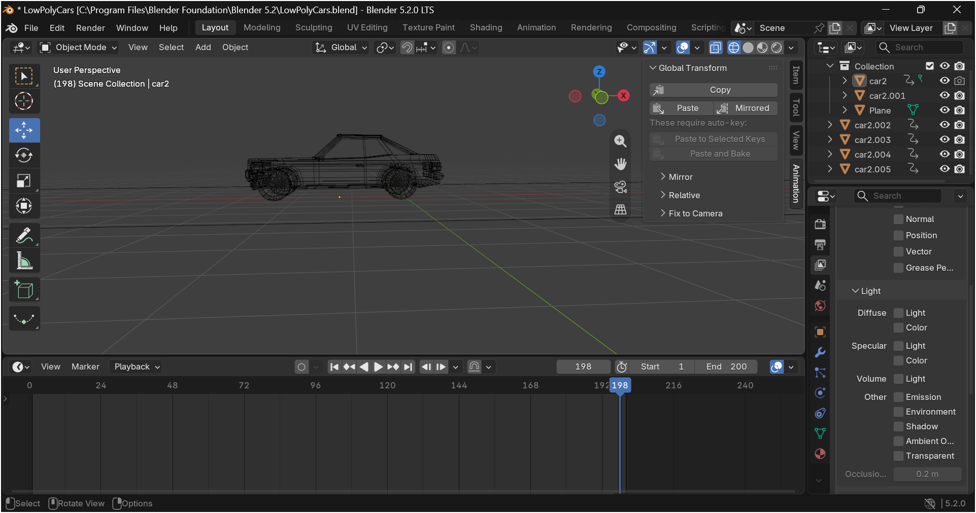
Step 8: Scrub through the Timeline or press Play to preview the full animation in the viewport.
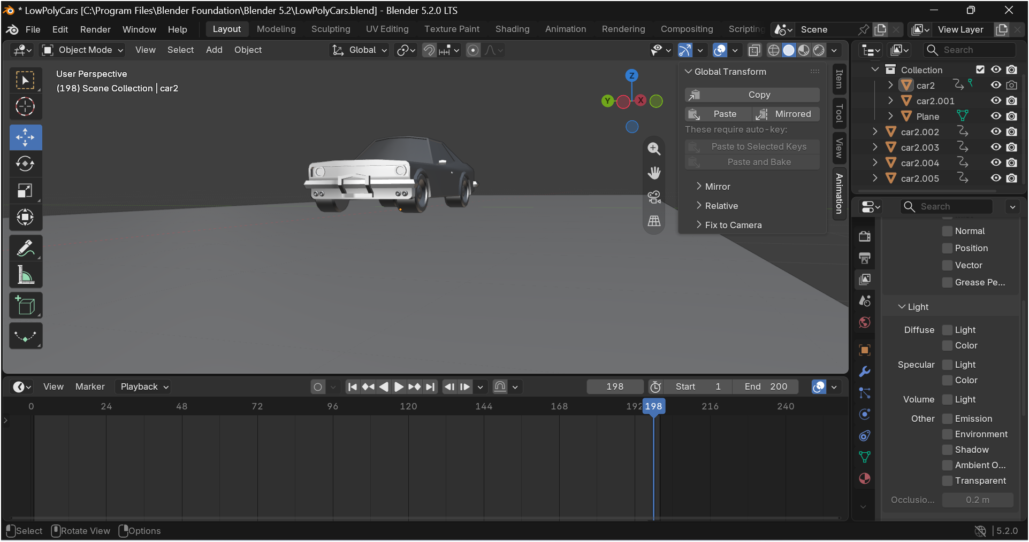
Step 9: Set the output format and frame range in the Output Properties, then render the animation as a video file.
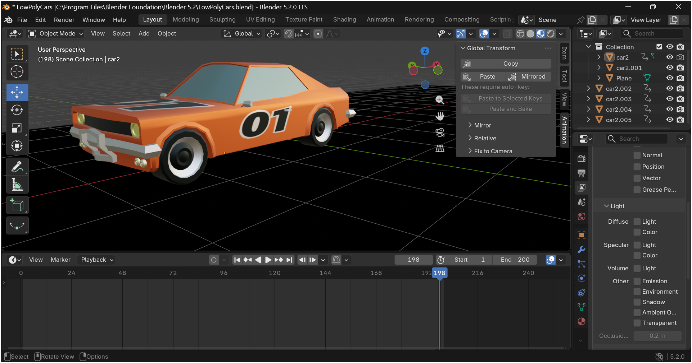

IMPLEMENTATION WITH OUTPUT
The object was animated using the keyframe workflow described above, moving from its starting position to its final position across the defined frame range. The rendered animation output is documented below.

Please Visit this Link for Animation Video of Whole Model

https://drive.google.com/file/d/1yMPmlbm2vvaUzKa041UF2izgnsfI_9RD/view?usp=sharing

CONCLUSION
A 3D object was successfully animated in Blender using keyframes to define its motion over time, with the interpolation between frames producing smooth movement. This exercise built familiarity with Blender's animation and rendering workflow, which extends directly to animating robot linkages or end-effector paths for visualisation and presentation purposes.

