Practical No. 9
Projects using MySQL, Node.Js and Express.Js, React.js

Name – Atharv Kulkarni

Prn – 245109074

Batch – S5

Perform following problem statements using Node.js

Problem Statement 3: Simple Blog Application
- Create a simple blog platform where users can sign up, log in, and write, edit, or delete their blog posts. Other users can view the blog posts but not edit or delete them.
- User authentication (JWT).
- Blog post CRUD operations.
- Display all blog posts on the homepage, with individual post details accessible through a unique URL.
- Add comment functionality where users can comment on blog posts.

Code Link (Github) - https://github.com/Atharv-K-979/WCE-Labs-Material/tree/main/Web-Dev-Design-Lab/Assignment9/BlogApplication

Deployed Website (Live) - https://wce-labs-material.onrender.com.

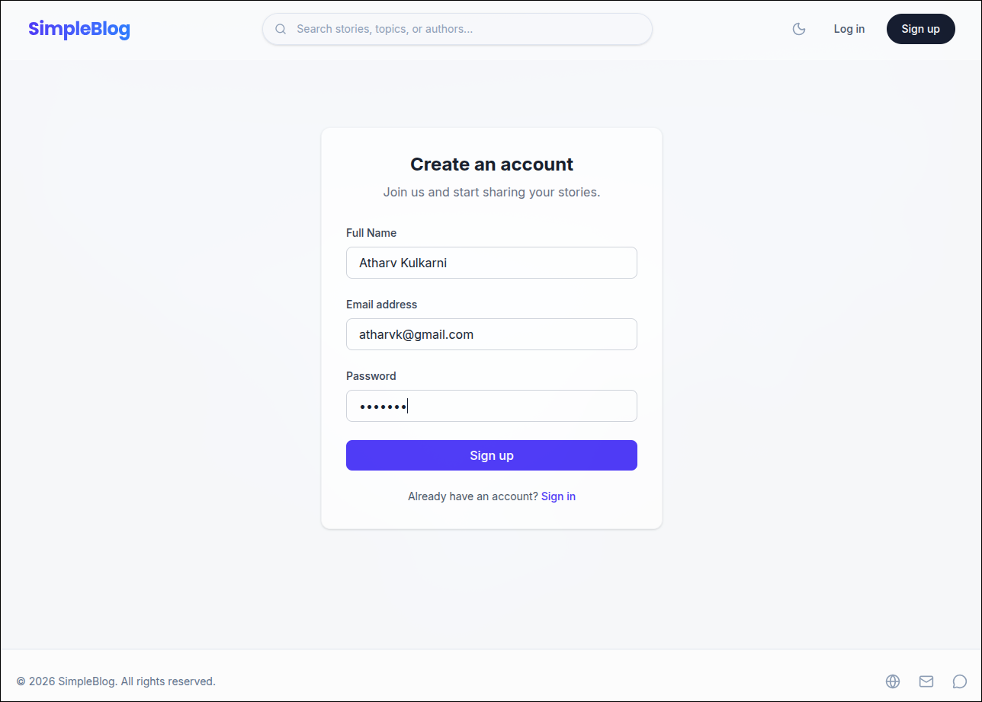

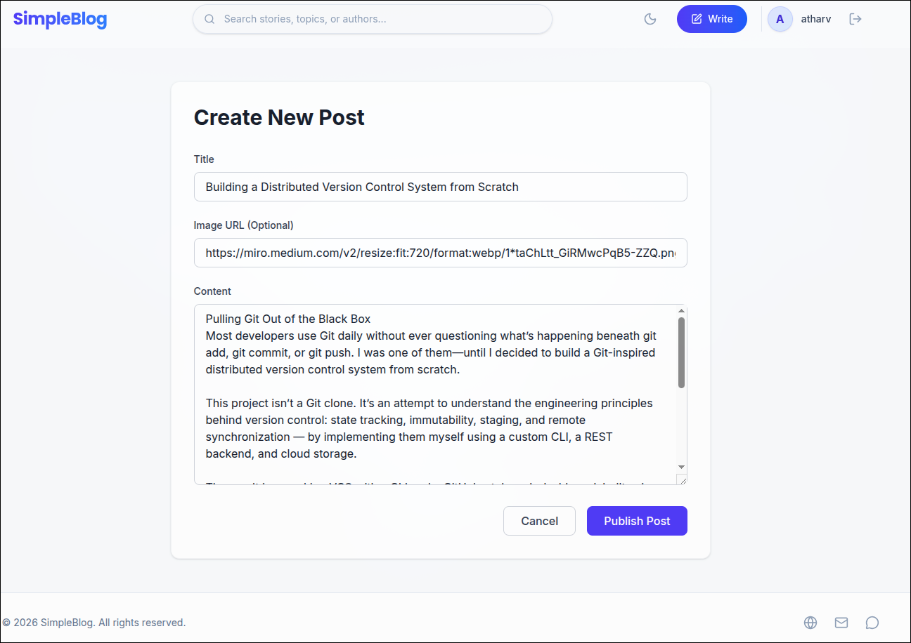

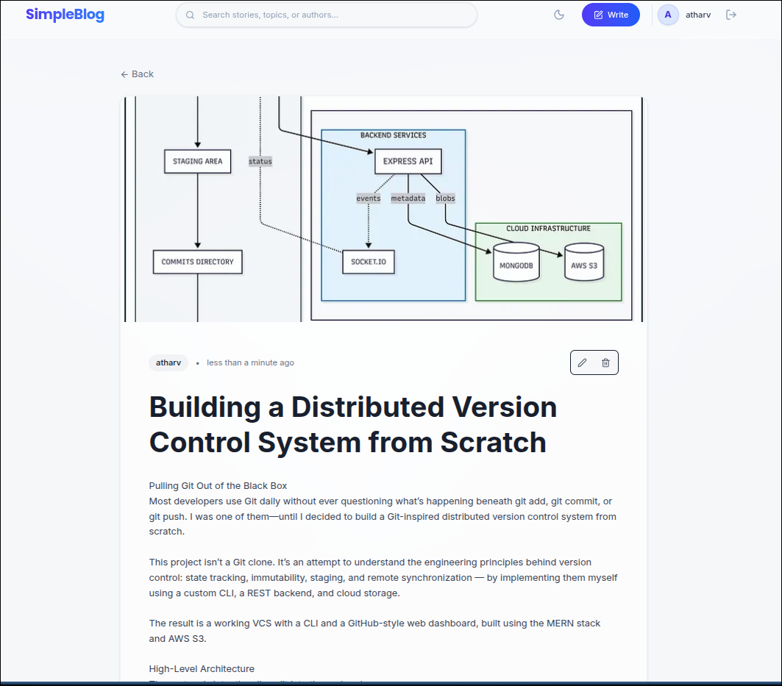

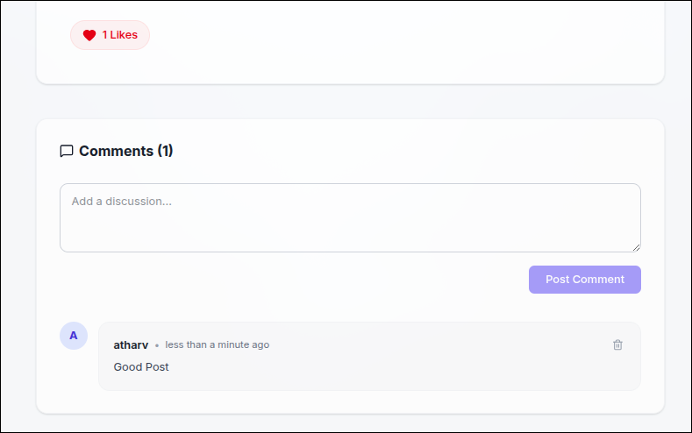

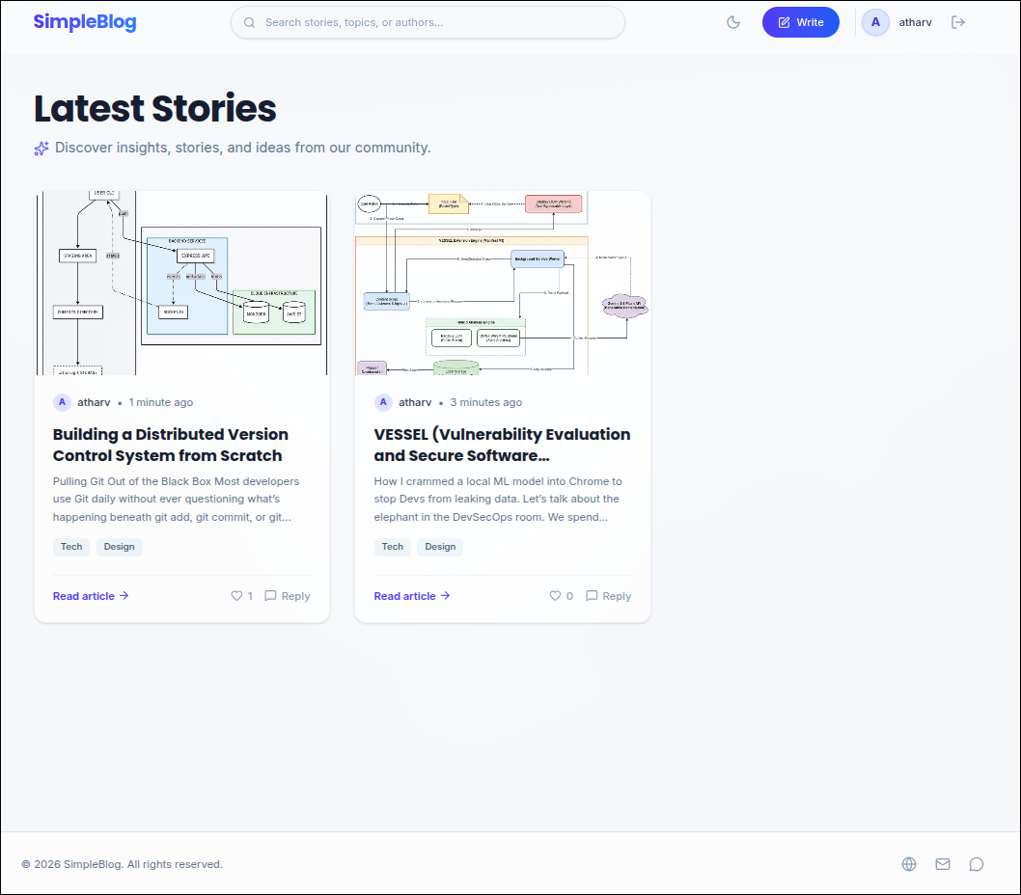

Problem Statement 5: Event Planner Application

Create an event planner app where users can organize events, including event details such as event name, date, location, and description.
- User authentication and role-based access (e.g., admin and user).
- CRUD operations for events (only admins can create, edit, or delete events).
- Display event details for all users.
- Implement event registration functionality, where users can register for events.
- Add email notifications when users register for an event.

Code Link (Github) - https://github.com/Atharv-K-979/event.ai.git
Deployed Website (Live) – event-ai-ak.vercel.app

Screenshots -

