WALCHAND COLLEGE OF ENGINEERING, SANGLI
Department of Computer Science & Engineering
LAB ASSIGNMENT 1 (LA-1)
Machine Learning Model for Robotics Perception
Real-Time Human Detection and Presence Monitoring System
Name - Atharv Kulkarni
PRN - 245109074
Class - TY CSE(B)
Academic Year: 2026–2027

Project Title
Real-Time Human Detection and Presence Monitoring using MobileNetV2, Haar Cascades, and Intel RealSense
GitHub Repository: https://github.com/Atharv-K-979/WCE-Labs-Material/blob/main/TY_Robotics_Lab/LA_1_ML_Model

AIM
To develop and evaluate a vision-based human-presence detection system combining a fine-tuned MobileNetV2 classifier, multi-pose Haar-cascade detection, and temporal filtering, with support for standard RGB cameras and Intel RealSense RGB/depth streams.

OBJECTIVES
- Set up the Python environment with PyTorch, Torchvision, OpenCV, and the optional Intel RealSense SDK.
- Prepare and evaluate an RGB dataset containing human and non-human examples.
- Fine-tune a pretrained MobileNetV2 model for binary human/non-human classification.
- Combine frontal-face, profile-face, and upper-body cues with neural-network predictions.
- Reduce false absence alerts during short occlusions using a temporal grace filter.
- Display live presence status, tracking cues, session time, FPS, and warning indicators in an OpenCV HUD.

THEORY

1. Human Detection and Robotics Perception
Robotics perception converts camera observations into information used by a system to make decisions. Human-presence detection classifies each image or video frame as containing a person or a non-human scene. Reliable operation must account for pose changes, partial occlusion, lighting variation, and movement.

2. MobileNetV2 and Transfer Learning
MobileNetV2 is a lightweight convolutional neural network designed for efficient inference. Transfer learning reuses visual features learned from a large dataset and adapts final layers to target classes. Here, early feature layers are frozen, the final feature block is fine-tuned, and a custom two-class classifier predicts HUMAN or NON_HUMAN.

3. Haar Cascades and Decision Fusion
OpenCV Haar cascades detect frontal faces, profile faces, and upper bodies. The implementation checks multiple pose cues, including a horizontally flipped frame for the opposite profile. These physical cues are combined with MobileNetV2 probabilities as a fallback when face or torso detection is ambiguous.

4. Temporal Absence Grace Filter
A single missed frame should not immediately mark a candidate absent. A 20-frame grace buffer (approximately 0.7–1.0 seconds depending on frame rate) retains the prior presence state during brief missed detections. A positive detection resets the absence counter.

5. Intel RealSense RGB and Depth
The Intel RealSense pipeline can provide synchronized color and depth frames. The included notebook demonstrates device discovery, stream capture, and depth colorization. The reported live classification uses the RGB frame; it should not be described as depth-based classification unless depth data is explicitly incorporated into the model input.

PROJECT FILE BREAKDOWN
File / Folder | Role and Functionality
train.py | Fine-tunes MobileNetV2 using augmentation, AdamW, label-smoothed cross-entropy, and cosine learning-rate scheduling.
test_images.py | Runs batch inference on the RGB dataset and reports per-image confidence and overall accuracy.
live_detection.py | Real-time camera monitoring using multi-pose Haar cascades, neural-network fallback, temporal filtering, and a HUD.
realsense_dataset/ | RGB and depth samples grouped into human and non_human classes.
Intel_Realsense_Cammera_Code.ipynb | Demonstrates RealSense device access, synchronized color/depth acquisition, and depth visualization.
human_detector.pth | Saved PyTorch model weights used for inference.

EXPERIMENT STEPS WITH SCREENSHOT OF EACH STEP
Step 1: Installation and Environment Setup
Set up the Anaconda/Python environment and install PyTorch, Torchvision, OpenCV, Pillow, NumPy, and Matplotlib. Install pyrealsense2 when testing the RealSense notebook. Confirm the dataset and scripts are available.
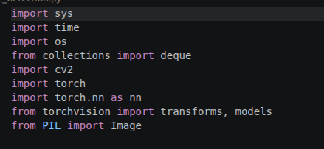

Step 2: RealSense Camera Integration
Run Intel_Realsense_Cammera_Code.ipynb to discover the device, configure RGB/depth streams, capture synchronized frames, and visualize colorized depth. Compatible RealSense hardware is required.
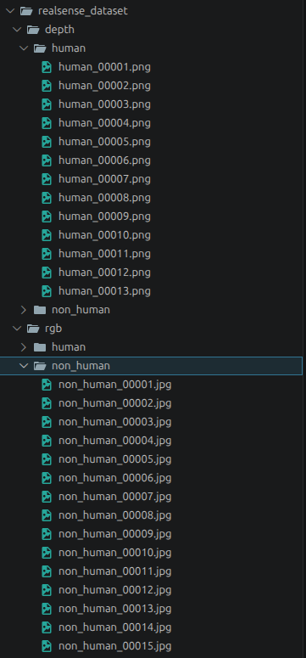

Step 3: Model Training (train.py)
Run train.py to load the RGB dataset, apply augmentation, fine-tune MobileNetV2 and its classifier, and save the weights as human_detector.pth.
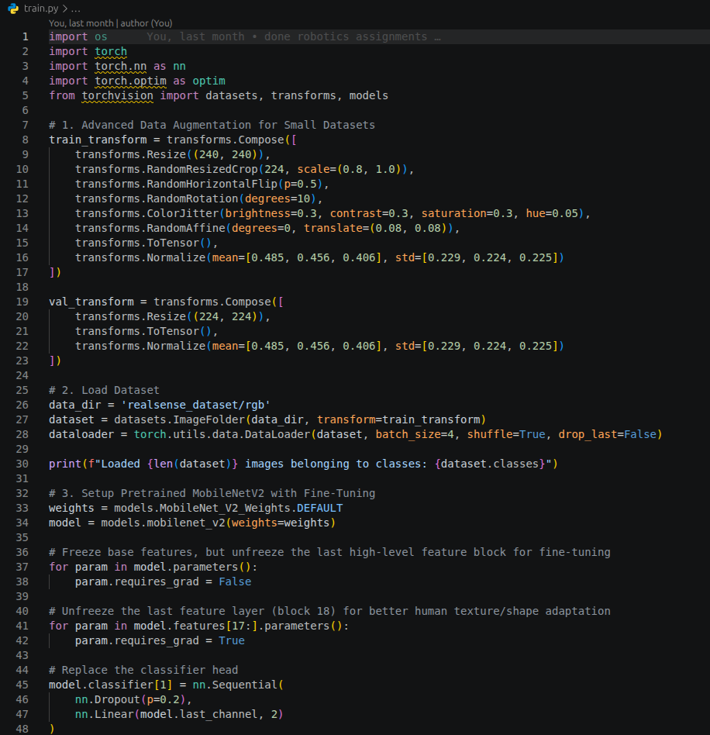

Step 4: Dataset Evaluation (test_images.py)
Run test_images.py against realsense_dataset/rgb/ and inspect predictions and confidence for human/non-human samples. Record correct predictions and overall accuracy.
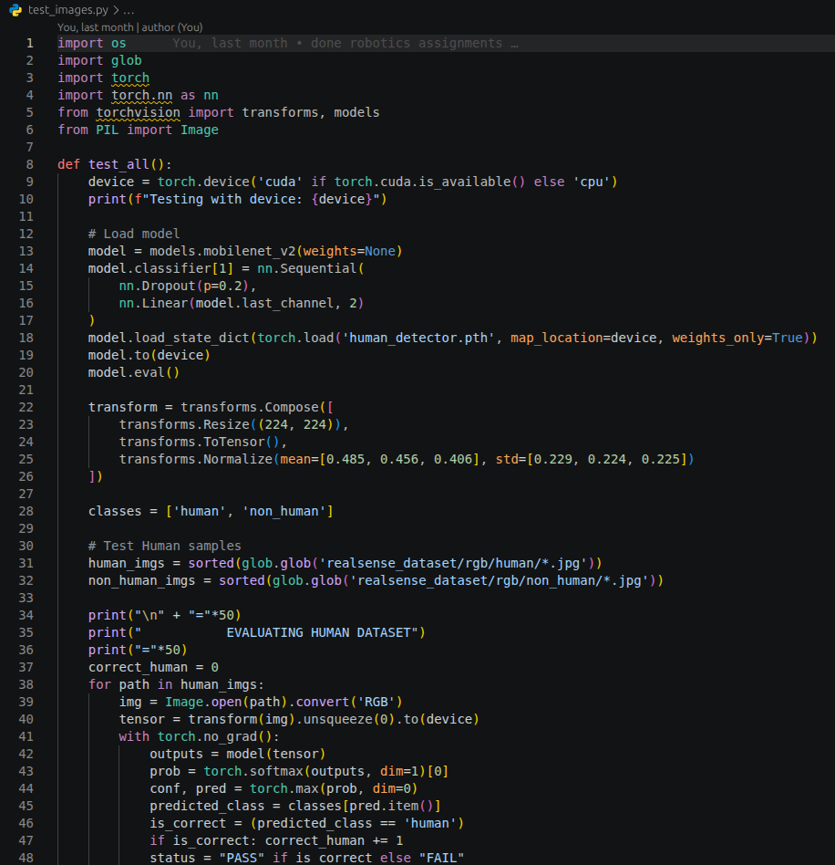

PROJECT EXECUTION & TEST RESULTS
The project dependencies were installed in the Anaconda environment and the training, evaluation, and live-inference scripts were executed. The following results reproduce the supplied run outputs.

1. Dataset Evaluation (test_images.py)
The model was evaluated on 28 RGB images: 13 human and 15 non-human samples. All samples were classified according to their listed ground-truth class in this run.
Dataset Class | Samples | Correct | Accuracy
Human | 13 | 13 | 100.0%
Non-human | 15 | 15 | 100.0%
Overall | 28 | 28 | 100.0%
Human confidence scores: 98.2%, 97.2%, 95.8%, 94.5%, 99.2%, 95.8%, 98.5%, 53.4%, 98.8%, 99.2%, 99.3%, 93.7%, 99.2%.
Non-human confidence scores: 87.3%, 91.9%, 70.2%, 74.1%, 94.5%, 91.6%, 88.1%, 91.9%, 90.9%, 94.7%, 97.2%, 90.5%, 95.5%, 85.8%, 96.8%.
Interpretation: The reported benchmark achieved 28/28 correct predictions on this small dataset. human_00008.jpg was classified correctly at 53.4% confidence, so its lower confidence merits review. This result applies only to the supplied test set and does not establish 100% accuracy on unseen real-world data.

2. Model Training Pipeline (train.py)
- Architecture: MobileNetV2 with final feature block (Block 18 / features[17:]) fine-tuned and a custom two-class classifier head.
- Augmentation: random resized crop, rotation, color jitter, affine translation, and horizontal flipping.
- Optimization: AdamW, cosine annealing over 30 epochs, and label smoothing.
- Output: weights saved to human_detector.pth.
Epoch | Training Loss | Training Accuracy
01/30 | 0.6971 | 50.0%
10/30 | 0.3397 | 89.3%
20/30 | 0.2201 | 96.4%
30/30 | 0.3157 | 89.3%
The final training loss and accuracy are worse than the reported epoch-20 values. Training variability or overfitting/instability may be involved; check validation metrics before drawing conclusions about generalization.

3. Live Hardware and Inference Verification
- Camera device: /dev/video0.
- Captured frame dimensions: 640 × 480.
- Live inference output: Human = 83.2%; Non-Human = 16.8%.
- The frame was reported as a candidate detected by the system.
Command used to launch the live monitor:
/home/atharv/anaconda3/bin/python live_detection.py
Press q in the video display window to stop the session.

KEY TECHNICAL HIGHLIGHTS
Lightweight model: MobileNetV2 uses inverted residual blocks and depthwise separable convolutions for efficient inference.
Multi-pose detection: Frontal/tilted face, left/right profile, and upper-body cascades cover common candidate poses.
Neural-network fallback: The classifier provides a secondary presence signal when classical cues are ambiguous.
Absence grace filter: A 20-frame buffer helps prevent brief missed detections from immediately switching the state to absent.
Proctoring HUD: Displays candidate presence, session timer, FPS, bounding-box tags, and an alert when the candidate leaves the frame.

CONCLUSION
The project implements a real-time human-presence monitoring pipeline combining a fine-tuned MobileNetV2 classifier, multi-pose Haar-cascade detection, and temporal filtering. In the reported evaluation, all 28 provided RGB samples were classified correctly, and a live camera test produced a human probability of 83.2%. The RealSense notebook supports synchronized RGB/depth stream inspection. Because the dataset is small and final training metrics fluctuate, the 100% test accuracy is a result on this particular dataset rather than a guarantee of real-world performance. Further evaluation on a larger independent dataset and validation of depth usage in the inference pipeline are recommended.

GitHub Repository
Project source code, setup instructions, architecture, and benchmark documentation:
https://github.com/Atharv-K-979/WCE-Labs-Material/blob/main/TY_Robotics_Lab/LA_1_ML_Model/

