Walchand College of Engineering, Sangli
7CS353 Machine Learning Lab — Assignment 1
Python Fundamentals Through Your First Dataset Class
Name - Atharv Vinayak Kulkarni
PRN - 245109074
Class - TY CSE(B)
Solutions for All Tasks from Assignment 1
A1. Variables and Printing
Task: Create variables for your own name and expected marks, and print a similar sentence. Explore output formatting in Python.
Solution:
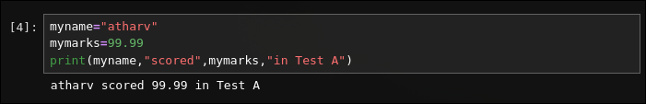
A2. Lists and Indexing
Task: Print the name and Test 1 marks of the 5th student in one line.
Solution:
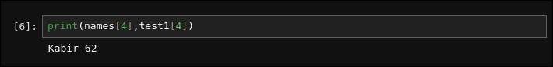

A3. Loops
Task: Modify the loop to print Test 2 marks and the improvement (Test2 − Test1) for each student. Explore enumerate().
Solution:
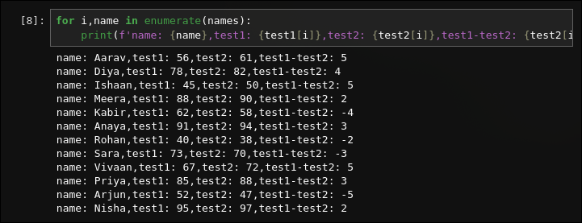
A4. Conditionals
Task: Print only the names of students scoring more than 80 in Test 1 and count how many such students there are.
Solution:
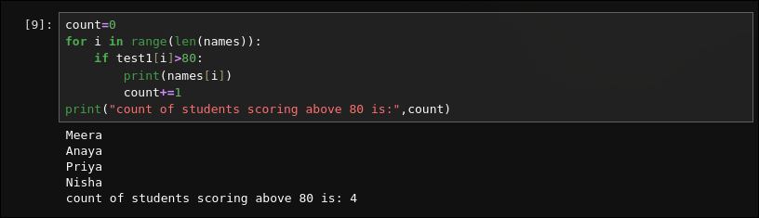

A5. Functions
Task: Complete average(values) to return the average of any list. Use it for Test1, Test2 and Attendance.
Solution:
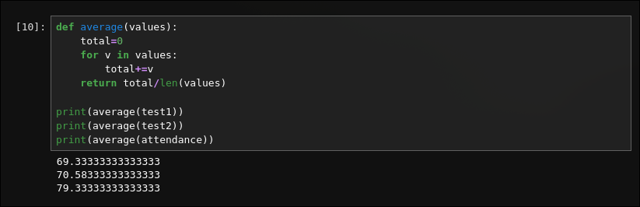

A5 Checkpoint
Task: Write whether Test 2 average being higher than Test 1 indicates overall class improvement. Can average alone prove every student improved?
Solution:
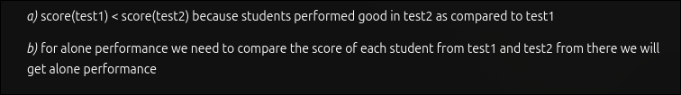
B1. NumPy Vectors
Task: Create NumPy arrays and compute improvement using vector subtraction.
Solution:
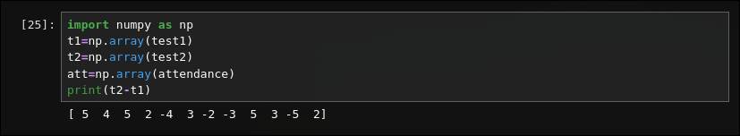

B2. Summary Statistics
Task: Compute mean, variance and standard deviation of Test 1. Verify mean with average() function.
Solution:
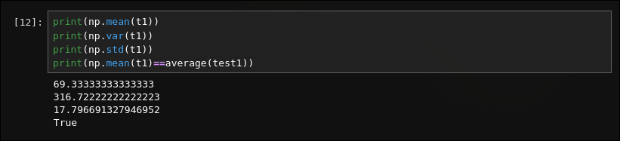
B3. Interpreting Spread
Task:Compare standard deviation of Test 1 and Attendance. State which is more spread out and what large standard deviation means.
Solution:
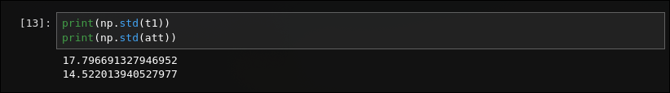

B4. Geometry
Task:Find the student closest to Nisha in 3D space using Euclidean distance.
Solution:
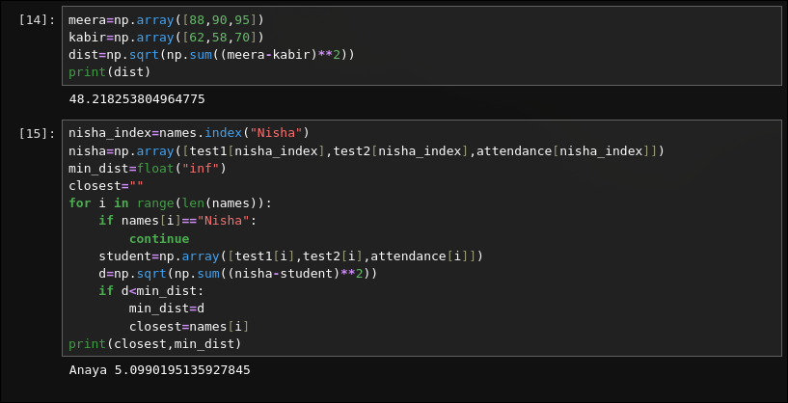
C1. Load and Inspect
Task:Load marks.csv. Use head(), shape and describe(). Explain count, mean, std, min, 25%, 50%, 75%, max.
Solution:
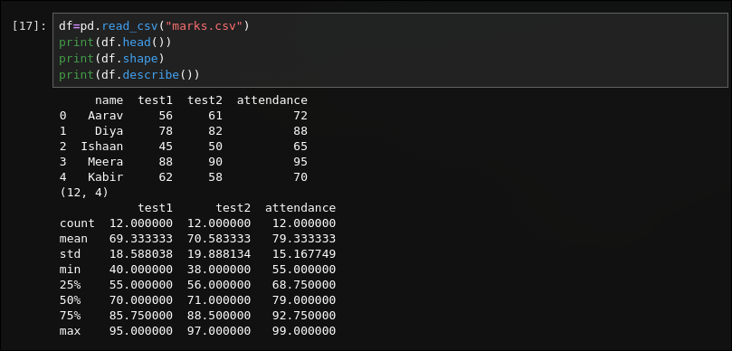

C2. Selecting and Filtering
Task:Print only name and test1 columns. Print rows with attendance > 85.
Solution:
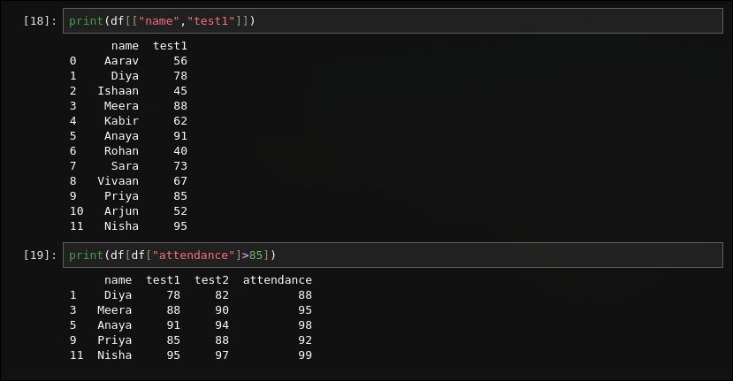

C3. Histogram
Task: Plot histogram of Test 1 marks. Comment on the distribution shape.
Solution:
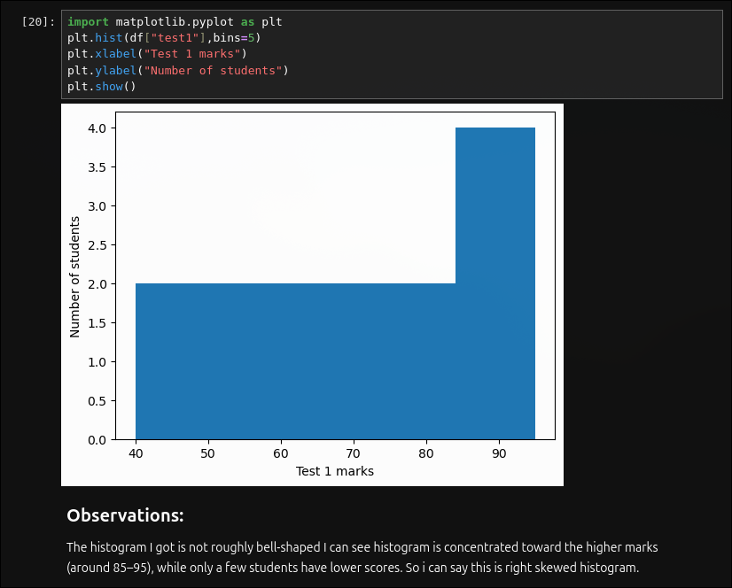

C4. Scatter Plot
Task: Plot attendance vs Test 1 marks. State whether higher attendance tends to relate to higher marks and whether a straight line fits.
Solution:
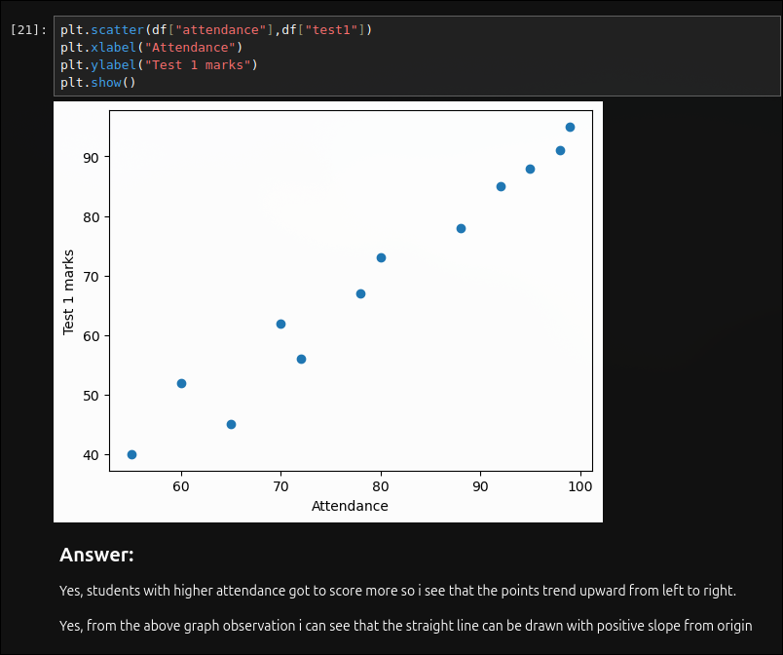

D1. Grade Function
Task: Create grade() function, add grade column for Test 2, print grade counts.
Solution:
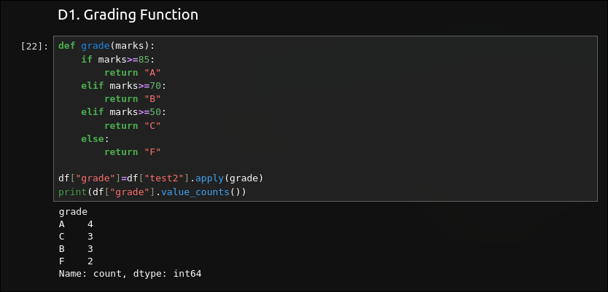
D2. Outlier Effect
Task: Change Rohan's Test 1 marks to 400. Recompute mean and standard deviation. Explain effect of outlier.
Solution:
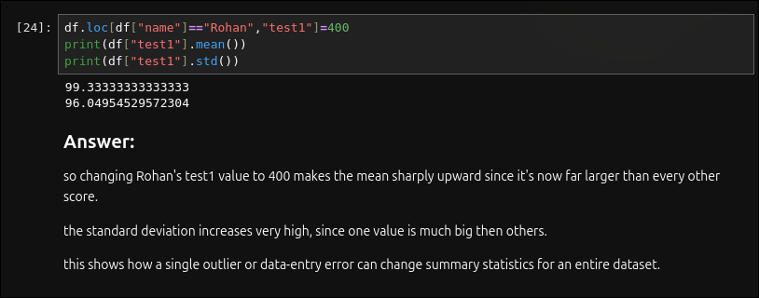

D3. Optional Stretch
Task: Compute variance manually using a loop without np.var and verify the result.
Solution:
