Practical No. 8
Introduction to MySQL

Name :Atharv Vinayak Kulkarni
PRN :245109074
Batch :CSE-S5

Problem Statement 1: Installing and Exploring MySQL
- Install MySQL on your system.
- Open the MySQL command-line client or GUI tool (e.g., MySQL Workbench).
- Create a new database named WebDB.
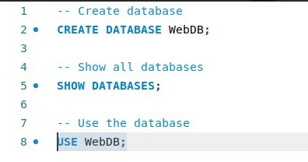

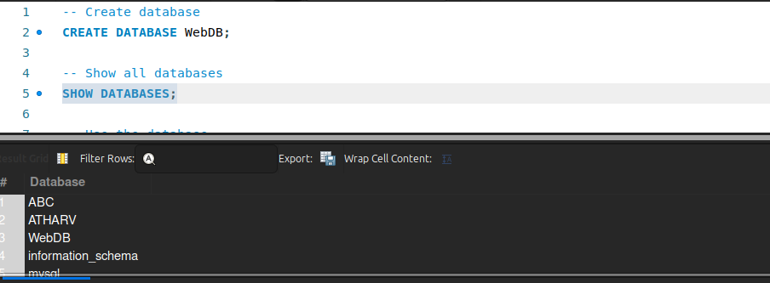
- List all databases available on your system.

Problem Statement 2: Creating a Simple Table
- Create a table Users with the following fields:
  - UserID (INT, Primary Key)
  - Username (VARCHAR(30))
  - Email (VARCHAR(50))

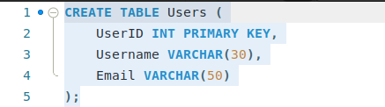

- Insert at least 3 sample records into the table.
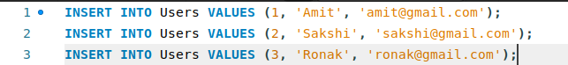

Problem Statement 3: Basic Data Retrieval
- Write queries to:

  - Display all records from the Users table.
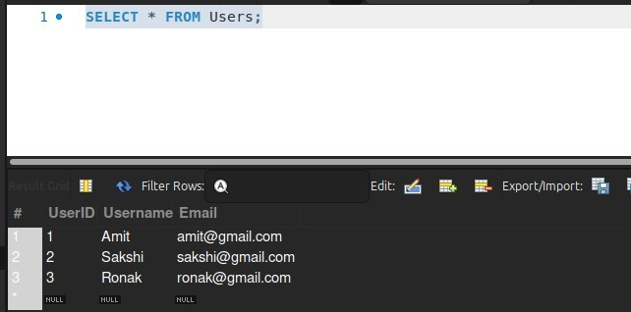

  - Retrieve only the Username and Email fields.
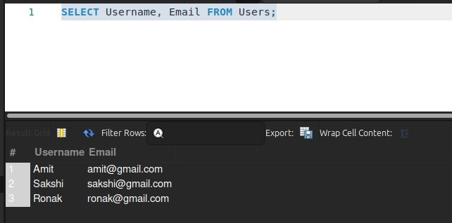

  - Display records where UserID is greater than 1.
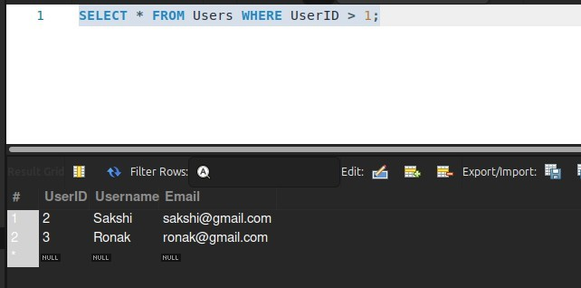

Problem Statement 4: Updating and Deleting Records
- Write queries to:

  - Update the email of a specific user.

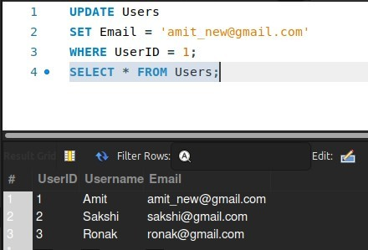
  - Delete a user record based on UserID.

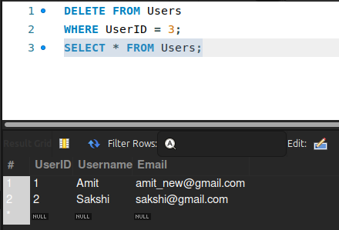

Problem Statement 5: Integration with Web Development

- Write a simple PHP/Node.js script to connect to the WebDB
database.
Connects PHP to MySQL database WebDB Retrieves data from Users table Displays records on the web page Handles error if connection

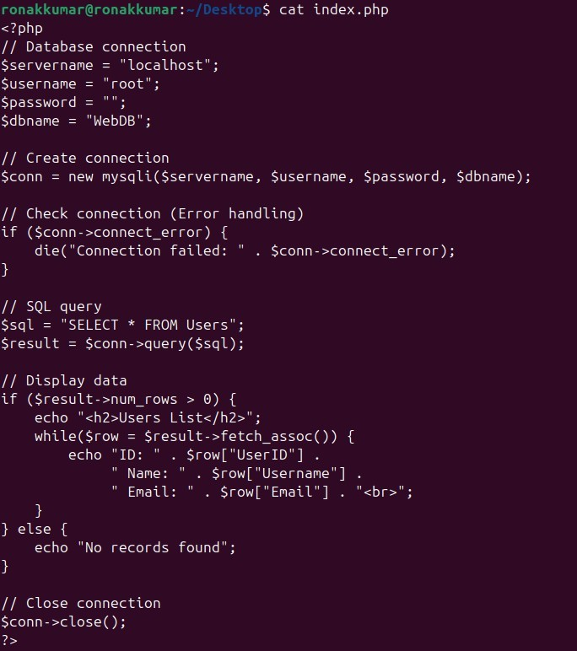

- Retrieve and display the records from the Users table on a web page.

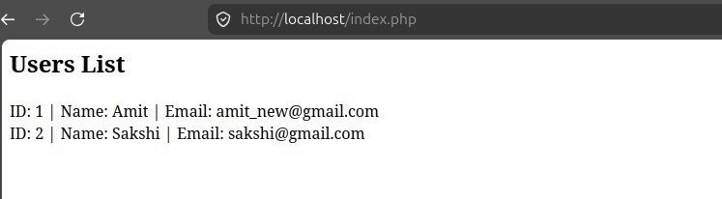

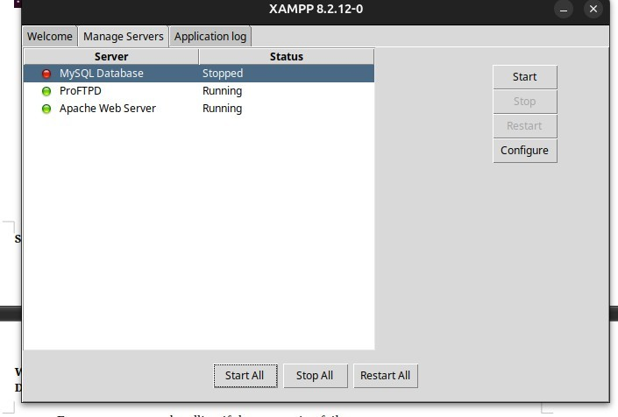
- Ensure proper error handling if the connection fail

