Practical No. 5
Study and implementation of Express.js

Name – Atharv Vinayak Kulkarni Batch – S5
PRN - 245109074

Perform following problem statements using Express.js

Problem Statement 1: Basics of Express.js
- What is Express.js and how does it differ from Node.js?
Ans –

Express.js
  - Express.js is a web framework for Node.js
  - It simplifies building web servers and APIs
  - Provides features like:
    - Routing
    - Middleware
    - Request handling

Node.js
  - Node.js is a runtime environment
  - It allows JavaScript to run outside the browser
  - Used for backend development

Difference
Feature | Node.js | Express.js
Type | Runtime | Framework
Level | Low-level | High-level
Routing | Manual | Built-in
Ease | Complex | Easy

- How do you create a simple Express.js server?
Ans –

Steps:
- Install express:
npm init -y
npm install express
- Create server file:
const express = require('express'); const app = express(); app.get('/', (req, res) => {
res.send('Hello World');
})
app.listen(3000, () => {
console.log('Server runn ing on port 3000');
});

- Explain the concept of routing in Express.js. How do you define routes?

Ans –
Definition:
  - Routing means handling different URLs (endpoints) Example:
app.get('/about', (req, res) => {
res.send('About Page');
});

Types of Routes:
  - GET → Fetch data
  - POST → Send data
  - PUT → Update
  - DELETE → Remove

- What is middleware in Express.js, and how does it work? Ans -

Definition:
  - Middleware is a function that runs between request and response

Flow:
Request → Middleware → Response

Example:

app.use((req, res, next) => {
console.log('Request received');
next();
});

- How do you create and use custom middleware in an Express.js application? Ans -

Definition:
  - Custom middleware is a user-defined function used in request-response cycle.

Steps:
- Create function (req, res, next)
- Write logic
- Call next()
- Use with app.use()

Example:
const logger = (req, res, next) => {
console.log(req.url);
next();
};
app.use(logger)

Key Points:
- Runs before route handler
- next() is compulsory
- Used for logging, authentication

- What is the difference between application-level middleware and router-level middleware?
Ans -
Type | Description
Application-level | Applied using app.use()
Router-level | Applied using express.Router()

- What are req and res in Express.js? Give examples of common properties and methods associated with each.
Ans –

req (Request):
  - Contains client data
  - Common properties:
- req.params - Route parameters
- req.query - Query strings
- req.body - POST data
- req.url - Current URL

res (Response):
  - Sends response to client
  - Common methods:
- res.send() - Send response
- res.json() - Send JSON
- res.status() - Set status code
- res.render() - Render views

Example:
JavaScript
app.get('/user', (req, res) => {
console.log(req.query.name); // Access query
res.send('Hello ' + req.query.name);
});

- How would you extract query parameters from a URL in an Express.js route? Ans –
Definition:
  - Query parameters come after ? in URL
  - Format: /search?name=John&age=25

Example:
JavaScript
app.get('/search', (req, res) => {
const name = req.query.name;
const age = req.query.age;
res.send(`Name: ${name}, Age: ${age}`);
});
URL: http://localhost:3000/search?name=John&age=25

- How does Express.js handle different HTTP methods (GET, POST, PUT, DELETE)? Ans –

Different Methods:
JavaScript
// GET - Retrieve data app.get('/data', (req, res) => {
res.send('GET request');
});

// POST - Create data app.post('/data', (req, res) => {
res.send('POST request');
});

// PUT - Update data app.put('/data', (req, res) => {
res.send('PUT request');
});

// DELETE - Remove data app.delete('/data', (req, res) => {
res.send('DELETE request');
});

- What are route parameters in Express.js? How do you use them in a route definition?
Ans –

Definition:
  - Dynamic values in URL path
  - Defined with : colon

Example:
JavaScript
app.get('/user/:id', (req, res) => {
const userId = req.params.id;
res.send(`User ID: ${userId}`);
});

app.get('/post/:id/:title', (req, res) => {
res.send(`ID: ${req.params.id}, Title: ${req.params.title}`);
});
URL: http://localhost:3000/user/123

Output: User ID: 123
Problem Statement 2: Basic Web Server with Express JS

Requirements
  - Create a basic Express.js server that listens on port 3000.
  - Define three routes:
    - GET / - Responds with "Welcome to the Home Page".
    - GET /about - Responds with "This is the About Page".
    - GET /contact - Responds with "Contact us at: email@example.com".
  - Include a 404 error handler that displays a "Page Not Found" message for unknown routes.

File: server.js
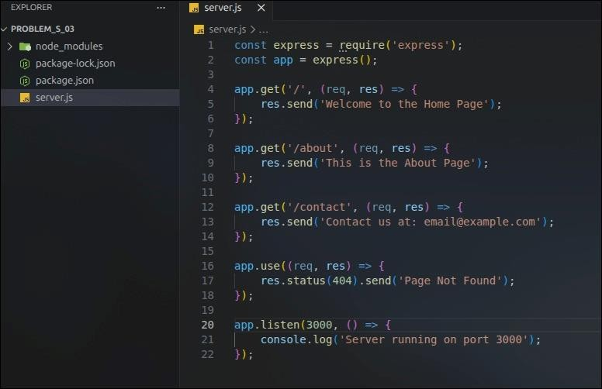

Steps to Run:
Bash
npm init -y
npm install express node server.js

Test URLs:
- http://localhost:3000/ → Welcome to the Home Page


- http://localhost:3000/about → This is the About Page
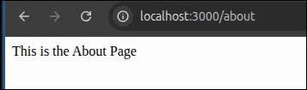

- http://localhost:3000/contact → Contact us at: email@example.com


- http://localhost:3000/random → Page Not Found


Problem Statement 3: Dynamic Route Parameters

Requirements
  - Modify the previous server to include the following route:
  - GET /users/:id - Responds with "User ID: [id]" where [id] is the dynamic value from the route.
  - Add another route:

    - GET /products/:category/:productId - Responds with "Category: [category], Product ID: [productId]".

File: server2.js
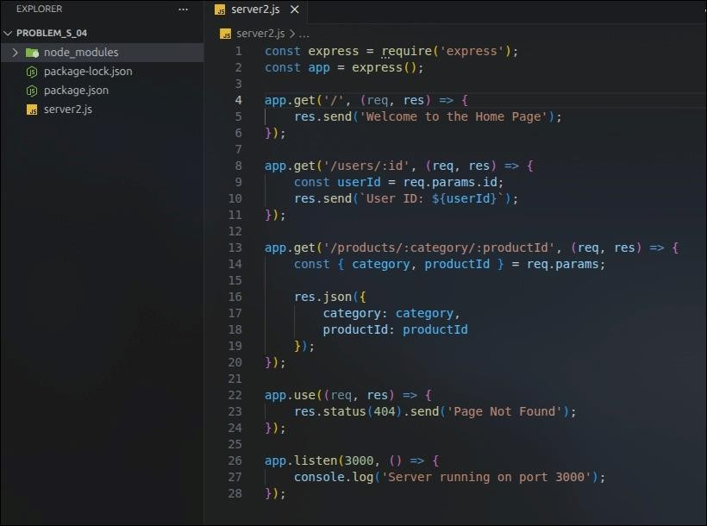

Test URLs:

- http://localhost:3000/users/101
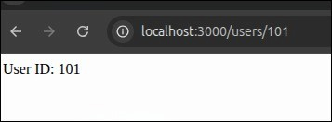
Output: User ID: 101

- http://localhost:3000/products/electronics/555

  - Output (JSON):
JSON
{
"category": "electronics", "productId": "555"
}
