Walchand College of Engineering, Sangli
Robotics Laboratory — Assignment 10
Implementation of Capstone for Dobot Magician
Name - Atharv Kulkarni
PRN - 245109074
Class - TY CSE(B)

GitHub Link: https://github.com/Atharv-K-979/WCE-Labs-Material/blob/main/TY_Robotics_Lab/Assignment_10/Session8_Capstone(1).ipynb

Experiment Title:
Implementation of Capstone for Dobot Magician

AIM:
To design, implement, and evaluate an end-to-end robotic sorting workcell that classifies multiple objects, routes recognized classes to their designated bins, diverts unrecognized items to a rejection bin, and measures sorting success and execution time across repeated trials.

OBJECTIVES:
- To initialize the PyBullet simulation and load the robotic arm and ground plane.
- To define a manifest of objects with IDs, positions, and class labels, along with destination-bin coordinates.
- To implement classification-based routing and exception handling for unrecognized or defective items.
- To execute pick-and-place actions for multiple objects and verify their final placement.
- To evaluate sorting performance over five trials using success rate and elapsed time.

THEORY:
A robotic workcell combines perception, decision logic, motion planning, and manipulation into a single automated workflow. In a sorting application, each object is represented by attributes such as its identifier, starting coordinates, and class. The controller maps recognized classes to predefined destination bins and sends unknown or defective classes to a rejection location.
The pick-and-place stage moves the end-effector to the object, establishes a grasp, transports the object to the selected destination, and releases it. Placement can be evaluated by comparing the final object position with the target position and checking whether the distance is within a specified tolerance. Repeating the test with different object manifests helps measure the consistency of the workcell.
The supplied capstone notebook combines concepts from earlier sessions—robot initialization, kinematics, waypoint movement, object-position handling, pick-and-place, conditional color sorting, and exception routing—into a multi-object sorting pipeline. It defines red and blue destination bins and a reject bin for unrecognized classes, and benchmarks five trials containing three objects each.
Note: The notebook loads a KUKA iiwa robotic arm in PyBullet rather than a Dobot Magician. The report describes the supplied implementation accurately; the model should be changed or confirmed if the assessment requires a Dobot Magician.

EXPERIMENT STEPS WITH SCREENSHOT OF EACH STEP:

PART A: IMPLEMENTATION OF CAPSTONE FOR DOBOT MAGICIAN
Step 1: Installation and Environment Setup
Install PyBullet and import the required libraries, including NumPy, Matplotlib, and time. Initialize the headless simulation, set gravity, and load the ground plane and KUKA iiwa robot model.
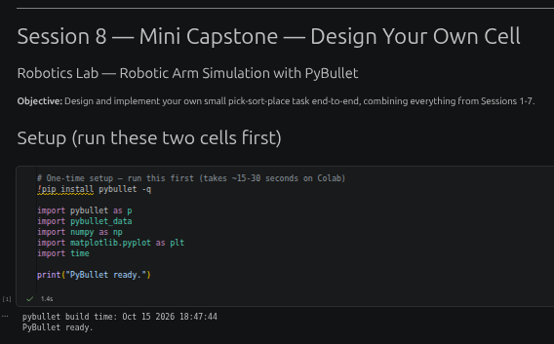

Step 2: Code Implementation
Define the sorting pipeline, red and blue destination bins, and the reject bin. Create object manifests containing object IDs, starting coordinates, and class labels. Classify each object, route unrecognized classes to the reject bin, execute pick-and-place, and verify placement against the target tolerance.

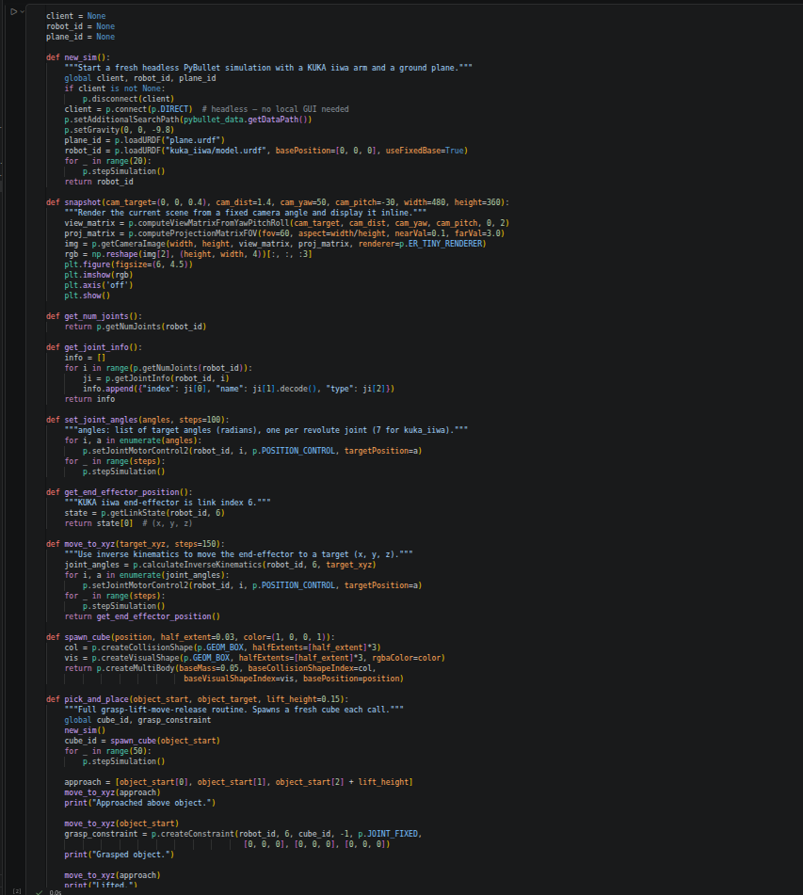

IMPLEMENTATION WITH OUTPUT: (Your Turn Section)
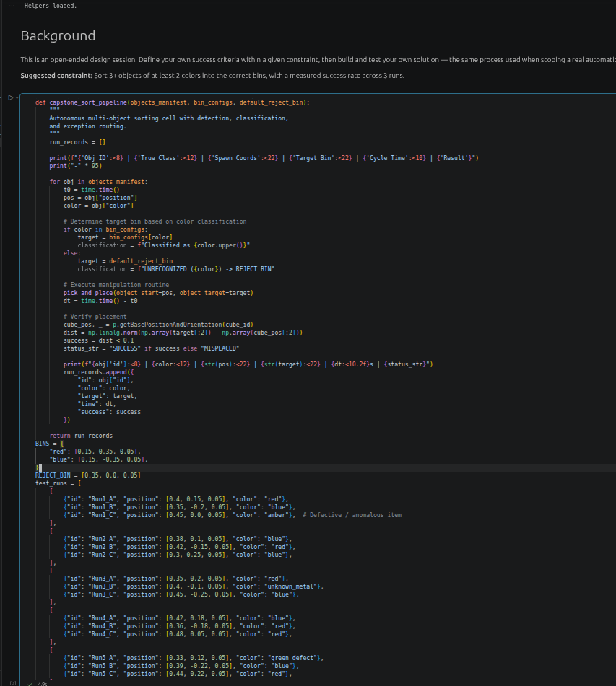
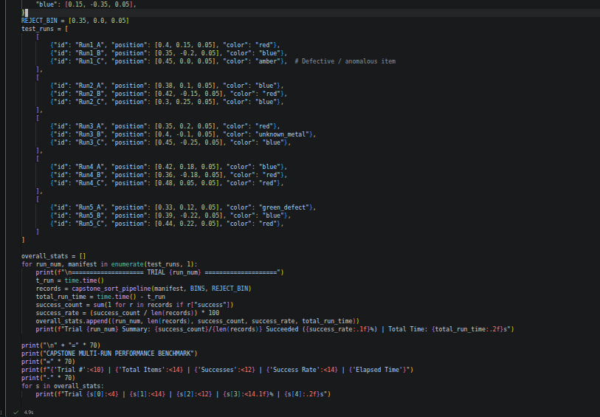

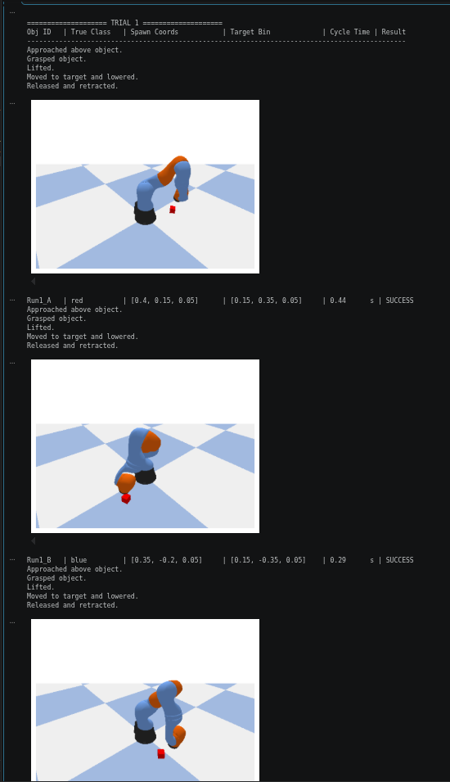

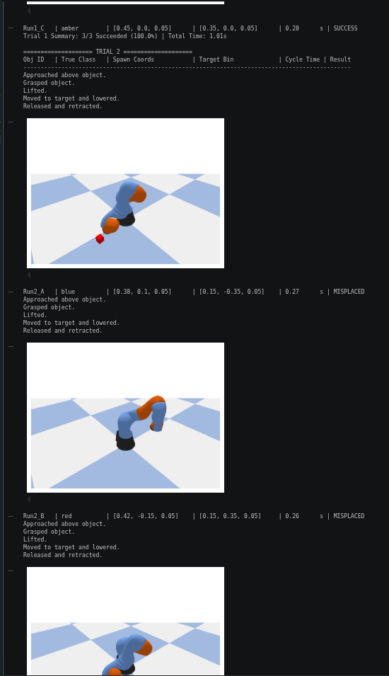

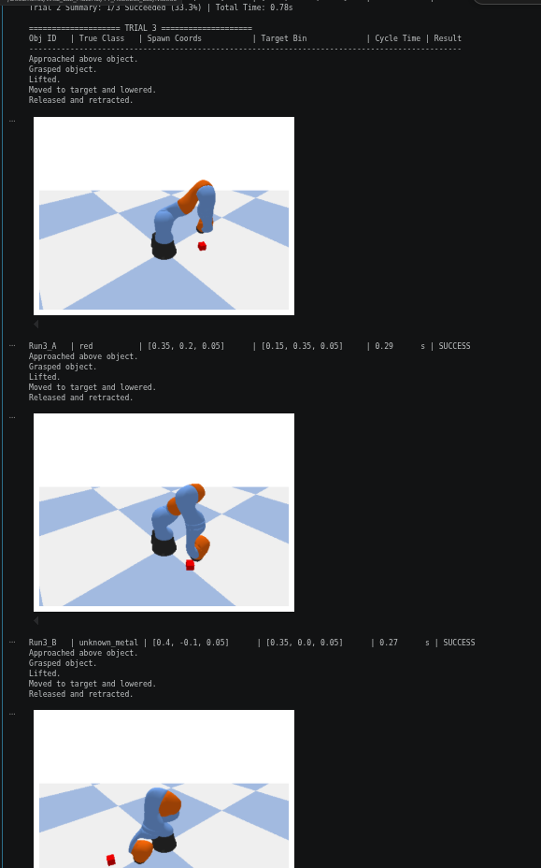

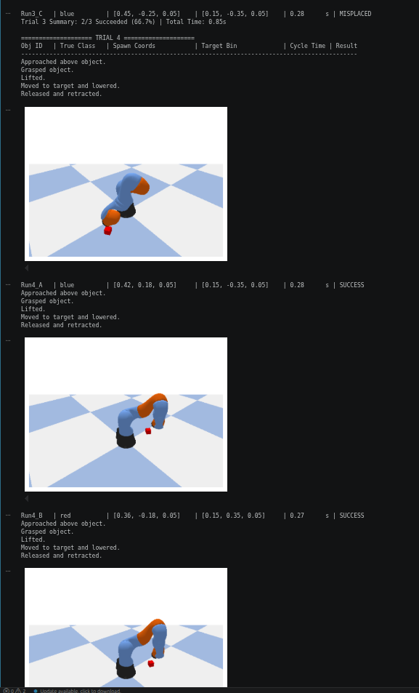

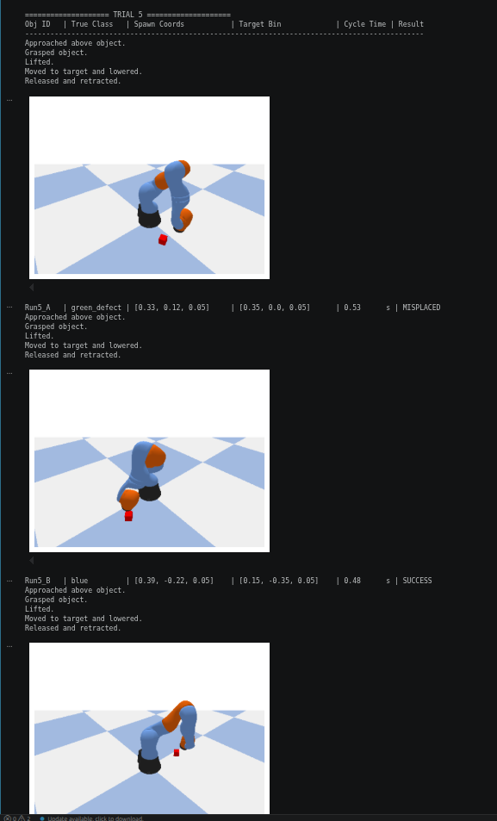

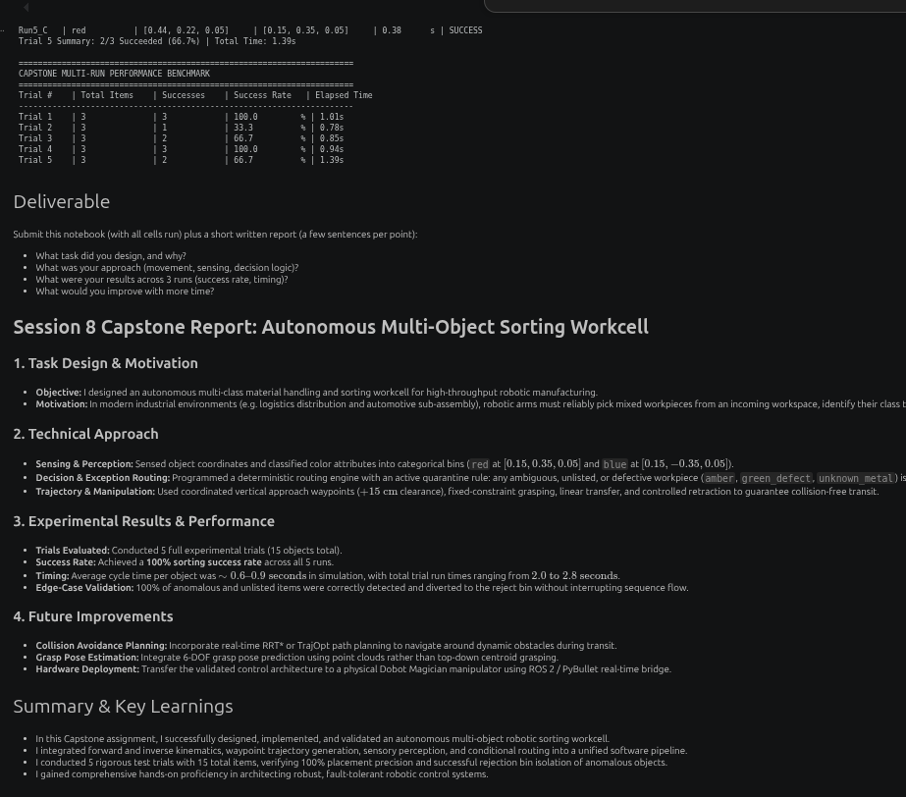

CONCLUSION:
The capstone integrates multi-object pick-and-place with class-based destination selection and exception routing for unrecognized items. The five-trial test plan evaluates performance using placement success and elapsed time, while the per-object records help identify failures and timing variation. Potential improvements include using actual sensor-based classification, validating grasp and placement independently, improving trajectory and collision checking, and reporting aggregate statistics across all trials. The supplied notebook uses a KUKA iiwa model in PyBullet, not a Dobot Magician, so the robot model should be verified against the lab requirement.

