Walchand College of Engineering, Sangli
Robotics Laboratory — Assignment 6
Implementation of Orientation and Forward Kinematics for Dobot Magician
Name - Atharv Kulkarni
PRN - 245109074
Class - TY CSE(B)

GitHub Link of My: Work:https://github.com/Atharv-K-979/WCE-Labs-Material/blob/main/TY_Robotics_Lab/Assignment_7/Session4_Pick_and_Place(1).ipynb
https://github.com/Atharv-K-979/WCE-Labs-Material/blob/main/TY_Robotics_Lab/Assignment_6/Session1_Orientation(1).ipynb
https://github.com/Atharv-K-979/WCE-Labs-Material/blob/main/TY_Robotics_Lab/Assignment_6/Session2_Forward_Kinematics.ipynb

Experiment Title:
Implementation of Orientation and Forward Kinematics for Dobot Magician

AIM:
To study robot orientation and forward kinematics by initializing a robotic-arm simulation, examining its joints and coordinate frames, and observing how joint-angle configurations affect the end-effector position.

OBJECTIVES:
- To set up the Python simulation environment using Google Colab and PyBullet.
- To load the robotic arm and ground plane in the simulation environment.
- To identify the robot joints and understand the world frame and tool/end-effector frame.
- To inspect the initial end-effector position and test different joint-angle configurations.
- To observe the relationship between joint angles and the resulting end-effector pose.

THEORY:
Robot orientation describes the direction in which a robot link or end-effector is pointing. A coordinate frame provides a reference for expressing position and orientation. The world frame is fixed relative to the simulation environment, whereas the tool frame moves with the robot's end-effector.
Forward kinematics calculates the end-effector position and orientation from the known joint variables and the robot's link geometry. For a serial manipulator, the transformations associated with successive joints and links are combined to obtain the end-effector pose relative to the world frame. Changing a joint angle changes the configuration of the arm and may change the end-effector position and orientation.

EXPERIMENT STEPS WITH SCREENSHOT OF EACH STEP:
Step 1: Install and import the required libraries
Install PyBullet and import the required Python libraries, including PyBullet, PyBullet data, NumPy, Matplotlib, and time.
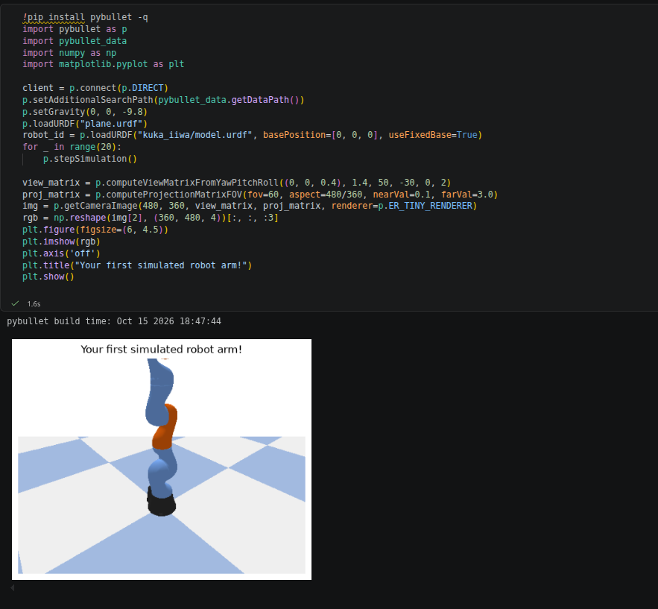
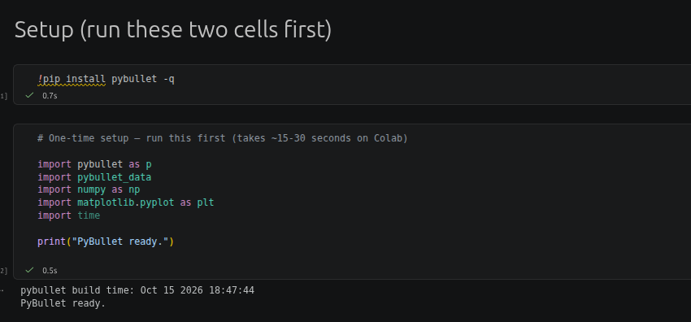
Step 2: Initialize the simulation environment
Create the simulation client, set the asset search path and gravity, and prepare the ground plane.
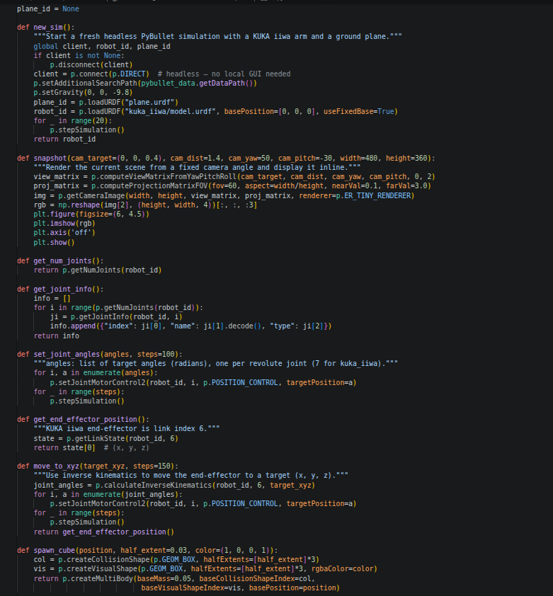

Step 3: Load the robotic arm and render the scene
Load the robot model into the simulation, advance the simulation, and capture a snapshot of the robot.

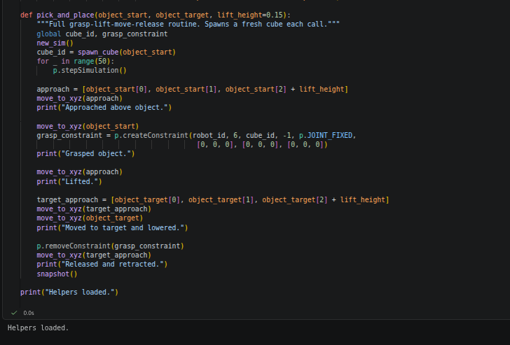

Step 4: Inspect the robot joints
Retrieve and display the joint information, including joint indices, names, and joint types.
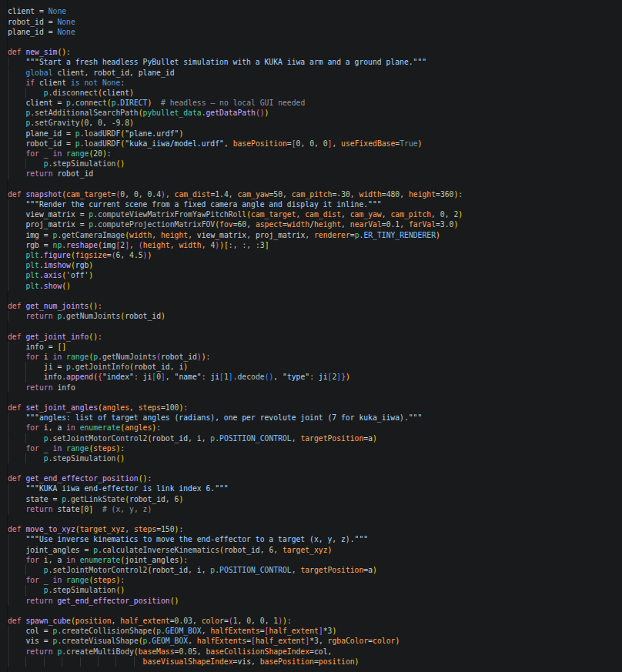

IMPLEMENTATION WITH OUTPUT:
Implementation Code Screenshot
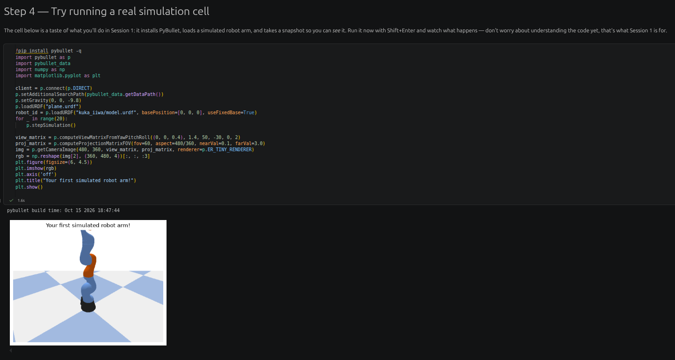
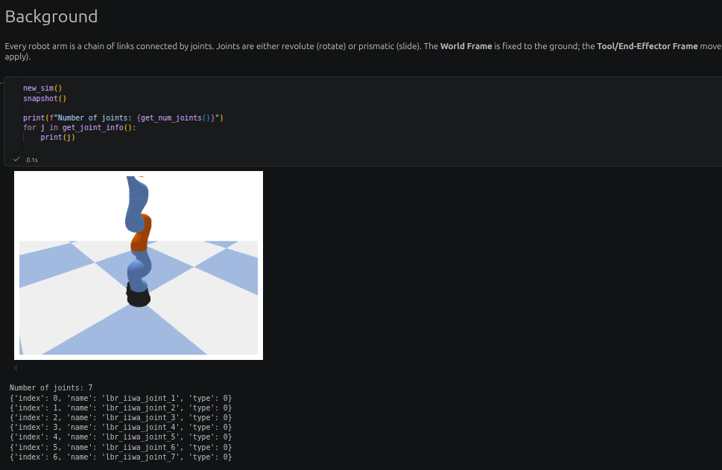
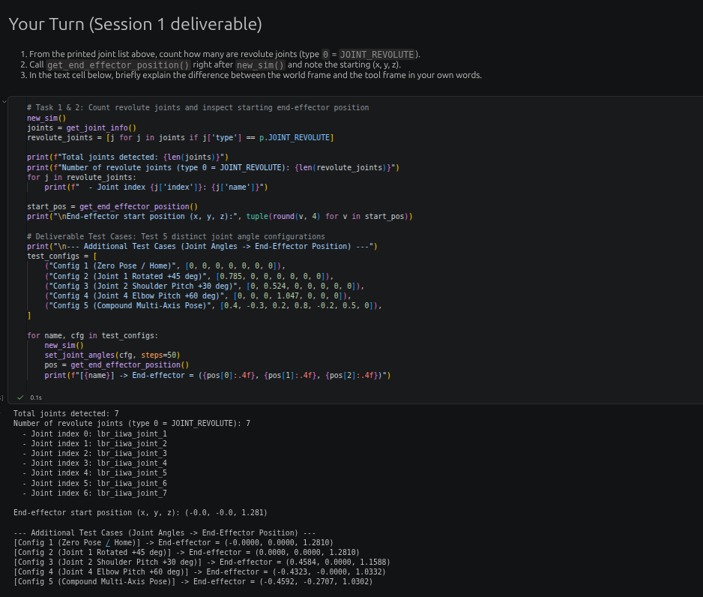
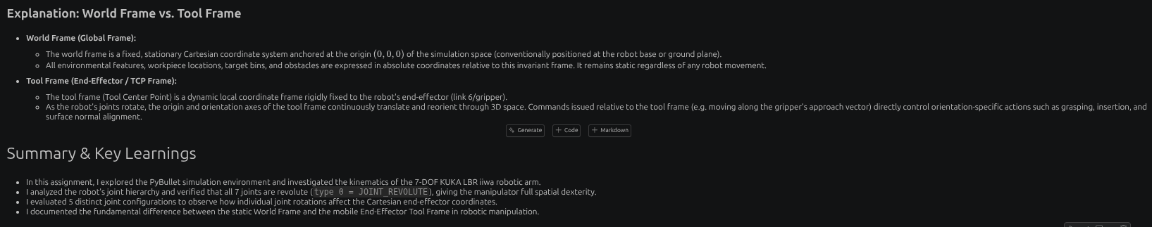

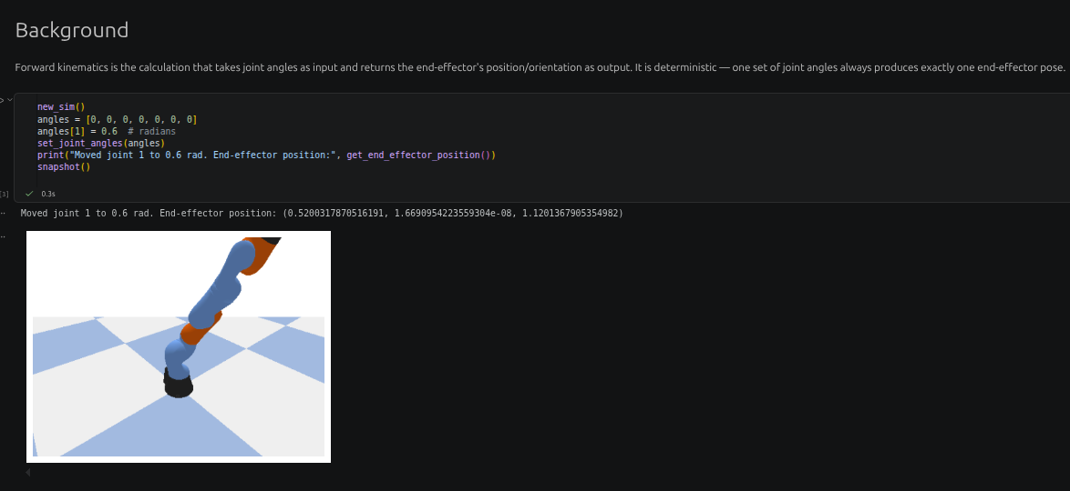
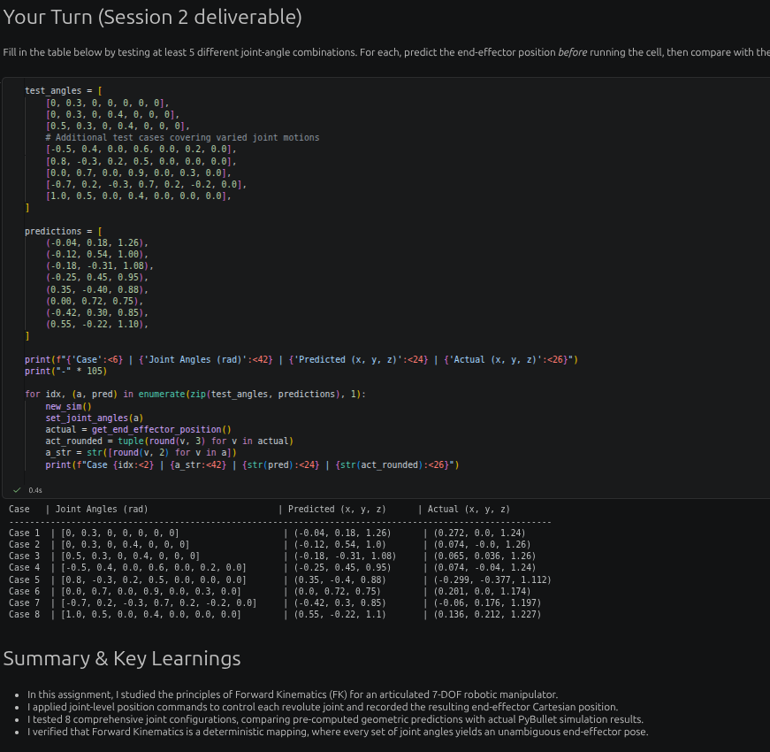

CONCLUSION:
The experiment introduces robotic orientation, coordinate frames, joint inspection, and forward kinematics through simulation. By changing joint-angle configurations and observing the resulting end-effector coordinates, the relationship between joint motion and the robot's pose can be studied. The supplied notebook uses a KUKA iiwa model in PyBullet; the model should be changed or the notebook verified if the assignment specifically requires the Dobot Magician.

