Walchand College of Engineering, Sangli
Robotics Laboratory — Assignment 8
Implementation of Dobot Magician with Waypoints and Sensor Guide
Name - Atharv Kulkarni
PRN - 245109074
Class - TY CSE(B)

GitHub Link: https://github.com/Atharv-K-979/WCE-Labs-Material/blob/main/TY_Robotics_Lab/Assignment_8/Session5_Waypoints(1).ipynb
https://github.com/Atharv-K-979/WCE-Labs-Material/blob/main/TY_Robotics_Lab/Assignment_8/Session6_Sensor_Guided(1).ipynb

Experiment Title:
Implementation of Dobot Magician with Waypoints and Sensor Guide

AIM:
To implement waypoint-based robotic motion and sensor-guided manipulation by planning a sequence of object pick-and-place actions and using detected object positions to guide the robot.

OBJECTIVES:
- To initialize the simulation environment and load the robotic arm.
- To program a sequence of pick-and-place actions using waypoints for multiple objects.
- To compare the original object order with a reordered sequence and analyze path distance and execution time.
- To simulate object-position detection and use the detected position instead of a manually hard-coded position.
- To test sensor-guided manipulation across multiple randomized object positions and consider the effects of inaccurate sensor readings.

THEORY:
Waypoint programming specifies a sequence of positions through which a robot moves while carrying out a task. A pick-and-place trajectory typically includes approach, grasp, lift, transfer, lower, and release stages. For multiple objects, the same routine can be reused in a loop. Reordering the objects may reduce total travel distance and cycle time, depending on the chosen sequence and the robot's motion.
Sensor-guided manipulation uses a perception step to estimate an object's location before planning the robot's action. Rather than relying on a fixed position entered manually, the manipulation routine receives the detected position and moves toward it. In a real robot, cameras or other sensors may provide this information; sensor calibration, noise filtering, and coordinate transformations are important for reliable grasping.

EXPERIMENT STEPS WITH SCREENSHOT OF EACH STEP:

PART A: IMPLEMENTATION OF DOBOT MAGICIAN WITH WAYPOINTS
Step 1: Installation and Environment Setup
Install PyBullet and import the required libraries. Initialize the simulation environment, load the ground plane and robotic arm, and prepare the helper functions for snapshots and pick-and-place actions.
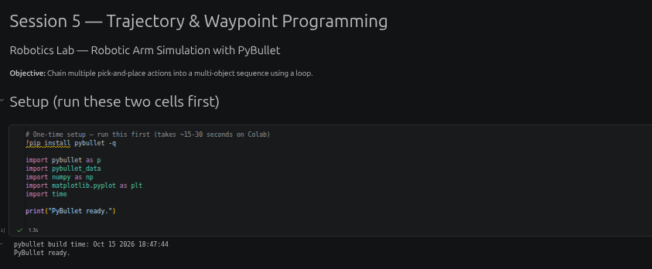
Step 2: Code Implementation
Define the list of objects with their start and target positions. Execute the pick-and-place routine for each object using a loop. Reorder the object list and calculate/compare the total path distance and elapsed time for the original and optimized sequences.
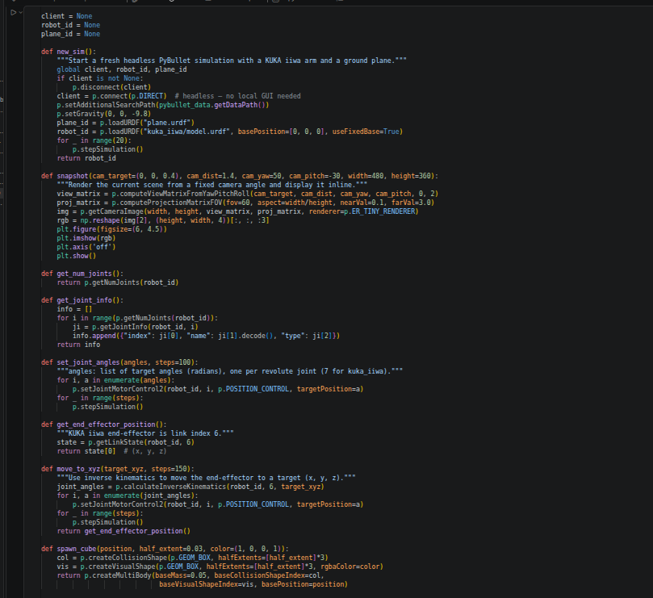

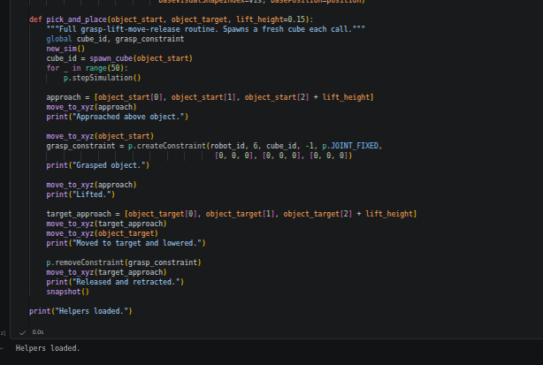

Step 3: Output
Run the original and reordered waypoint sequences. Capture the simulation snapshots and the printed path-distance and execution-time comparison.
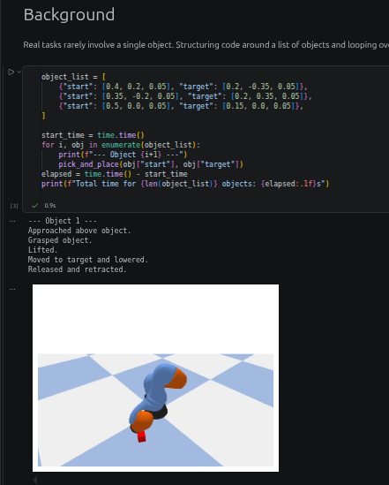

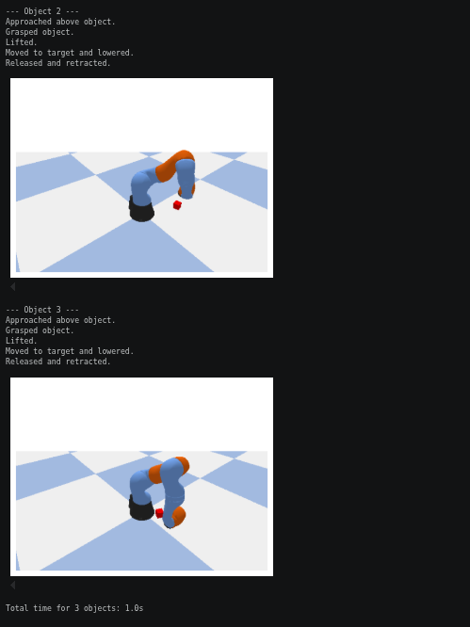

PART B: IMPLEMENTATION OF DOBOT MAGICIAN WITH SENSOR GUIDE
Step 1: Installation and Environment Setup
Install PyBullet and import the required libraries. Initialize the simulation, load the ground plane and robotic arm, and prepare the object-spawning and object-position detection functions.
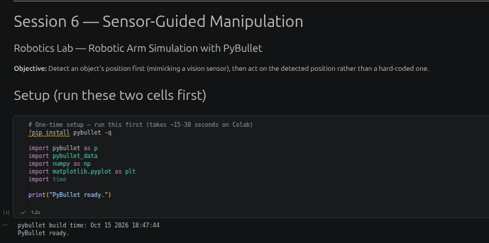
Step 2: Code Implementation
Spawn an object at a randomized position, detect and store its position using the perception function, and pass the detected coordinates to the pick-and-place routine. Repeat the process for multiple randomized trials and calculate the difference between the true and detected positions.
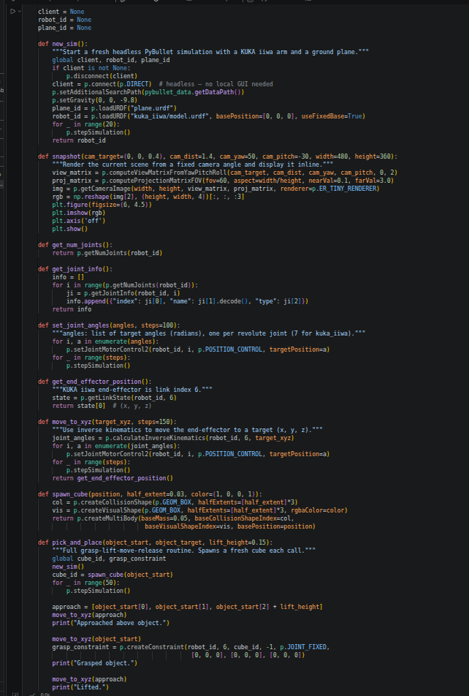
Step 3: Output
Run the sensor-guided trials and capture the simulation snapshots and printed results showing the true position, detected position, position error, and trial status. Review the effect that noisy or incorrect readings could have on grasping.
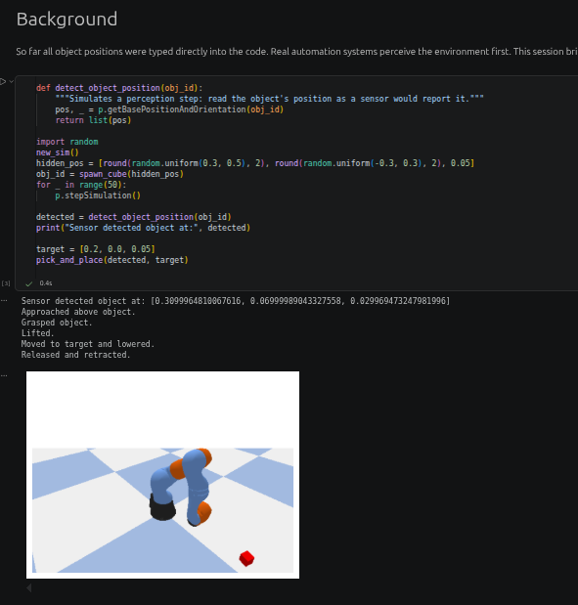

IMPLEMENTATION WITH OUTPUT: (Your Turn Section)
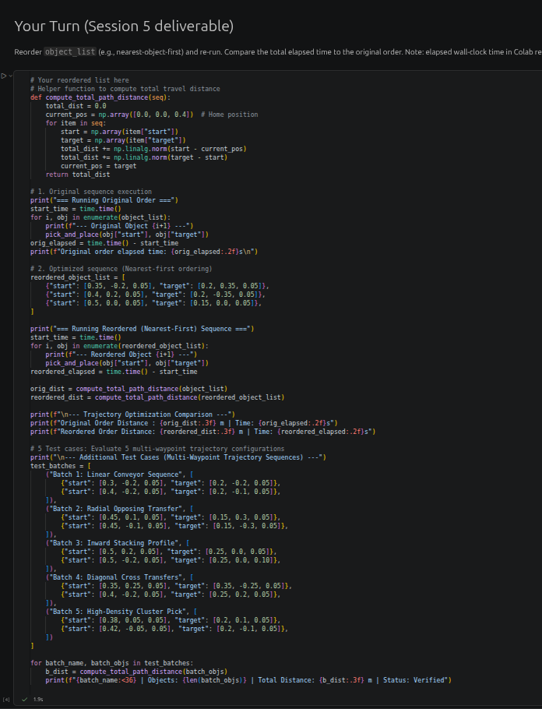
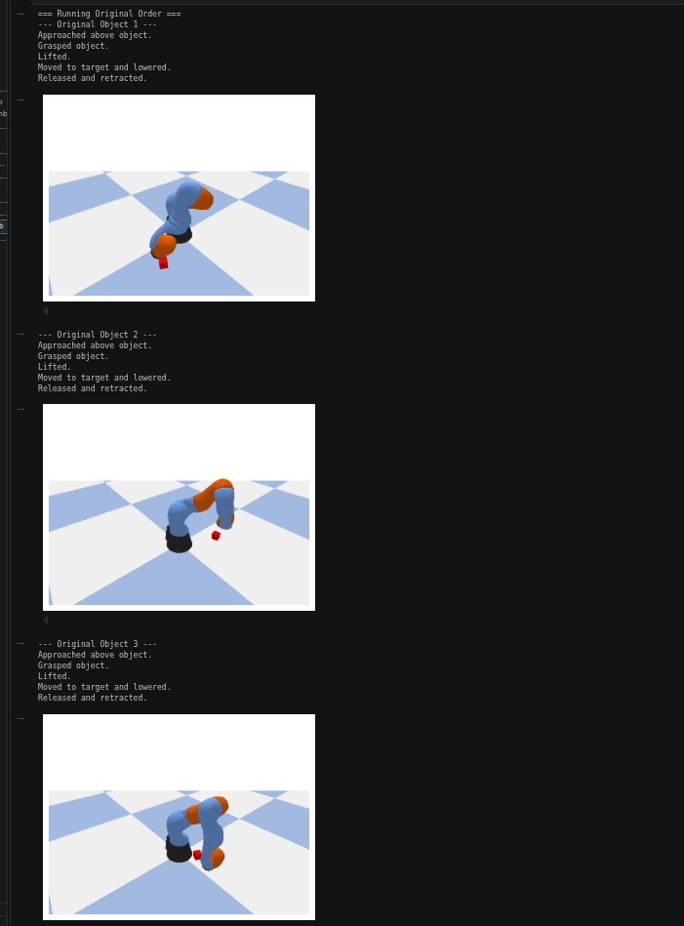
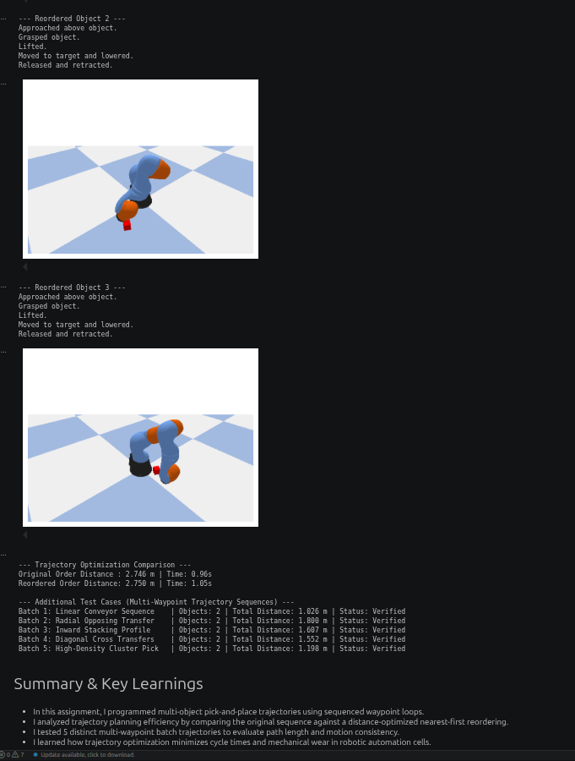

CONCLUSION:
The experiment demonstrates how waypoint sequences can automate pick-and-place actions for multiple objects and how reordering a sequence can affect path distance and execution time. It also demonstrates the sensor-guided workflow in which a detected object position is used to plan manipulation, with repeated trials helping assess position consistency. Reliable real-world operation requires accurate sensing and appropriate handling of measurement noise. The supplied notebooks use a KUKA iiwa model and simulated position sensing in PyBullet, so the robot model and sensing method should be verified if Dobot Magician hardware is required.

