Walchand College of Engineering, Sangli
Robotics Laboratory — Assignment 9
Implementation of Sorting for Dobot Magician
Name - Atharv Kulkarni
PRN - 245109074
Class - TY CSE(B)

GitHub Link: https://github.com/Atharv-K-979/WCE-Labs-Material/blob/main/TY_Robotics_Lab/Assignment_9/Session7_Sorting(1).ipynb

Experiment Title:
Implementation of Sorting for Dobot Magician

AIM:
To implement a conditional robotic sorting system that identifies an object's color and routes it to the corresponding destination bin, while safely handling unknown or unlisted colors.

OBJECTIVES:
- To initialize the PyBullet simulation environment and load the robotic arm.
- To define colored objects and destination bins for supported color classes.
- To implement conditional sorting based on the detected or assigned object color.
- To handle unknown or ambiguous colors using a dedicated rejection/inspection bin.
- To test the sorting pipeline with standard and unlisted-color objects and review the resulting actions.

THEORY:
Automated sorting is a robotic task in which workpieces are classified using a property such as color, size, shape, or barcode, and then placed into designated bins. The sorting logic maps each recognized class to a target location. A pick-and-place routine moves the robot to the object's pickup position, grasps it, transports it, and releases it at the selected destination.
A robust sorting system must also handle objects that do not match the supported classes. Possible strategies include stopping the process, skipping the object, or routing it to a separate rejection bin. A rejection bin is useful because it removes unknown items from the normal workflow while preserving traceability and allowing manual inspection.
Note: The supplied Session 7 notebook implements conditional color sorting in PyBullet using a KUKA iiwa robot model. The example recognizes red and blue objects and routes unlisted colors such as green or yellow to a rejection bin. It does not load a Dobot Magician model, so the robot model should be verified if the assignment specifically requires Dobot Magician.

EXPERIMENT STEPS WITH SCREENSHOT OF EACH STEP:

PART A: IMPLEMENTATION OF SORTING FOR DOBOT MAGICIAN
Step 1: Installation and Environment Setup
Install PyBullet and import the required libraries. Initialize a headless simulation, load the ground plane and robotic arm, and define the helper functions for snapshots, joint control, object creation, and pick-and-place movement.
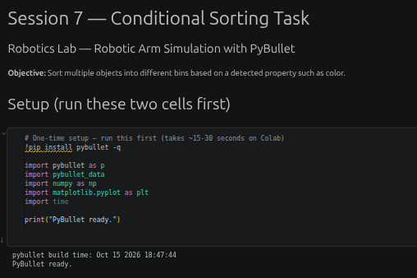

Step 2: Code Implementation
Define the color-to-bin mapping and implement the sorting function. For each object, identify its color, select the matching destination bin, and call the pick-and-place routine. Add edge-case handling for unknown colors by routing them to a dedicated rejection bin or skipping them with a warning.

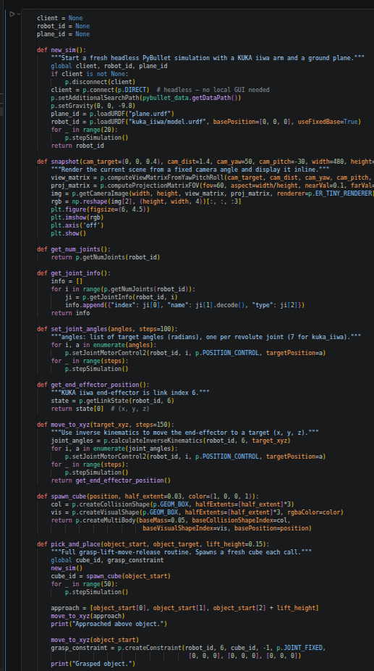

Step 3: Output
Run the sorting pipeline using the test objects, including standard red and blue objects and unlisted colors such as green and yellow. Capture the simulation and console output showing each object's detected color, target destination, and action taken.
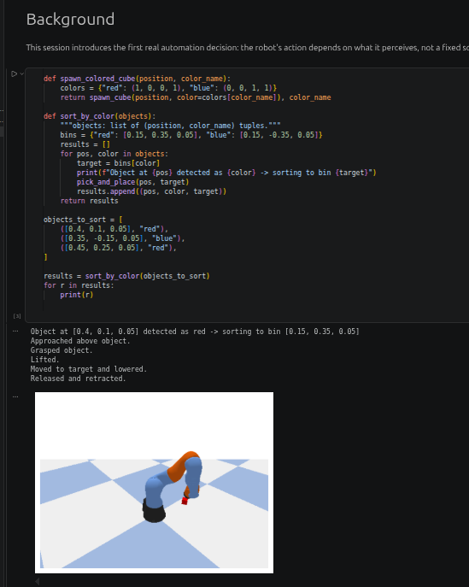

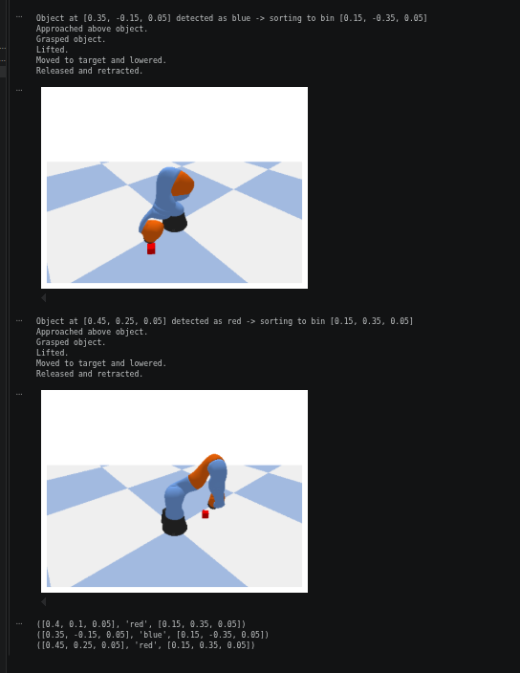

IMPLEMENTATION WITH OUTPUT:(Your Turn Section)
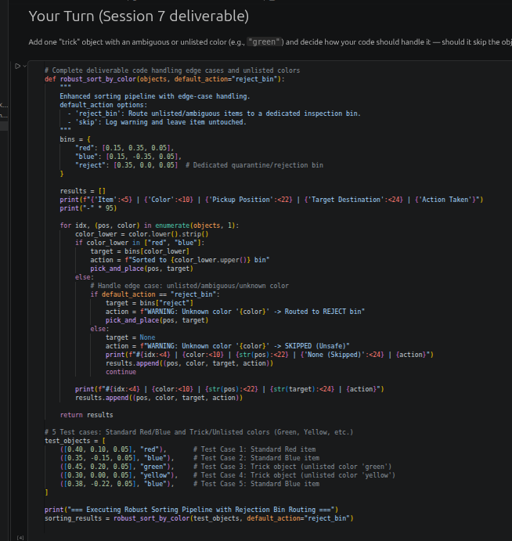
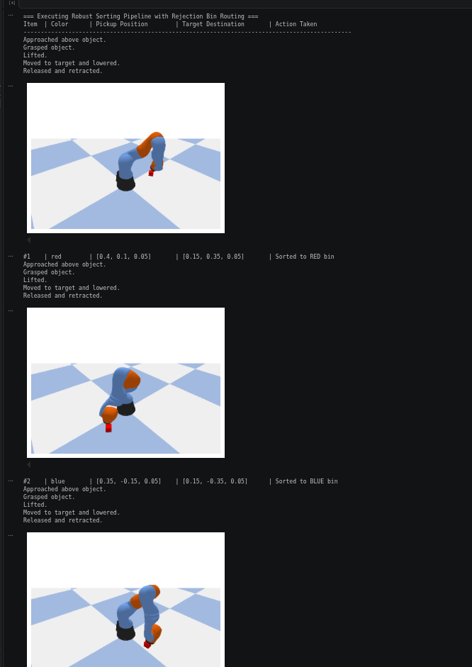
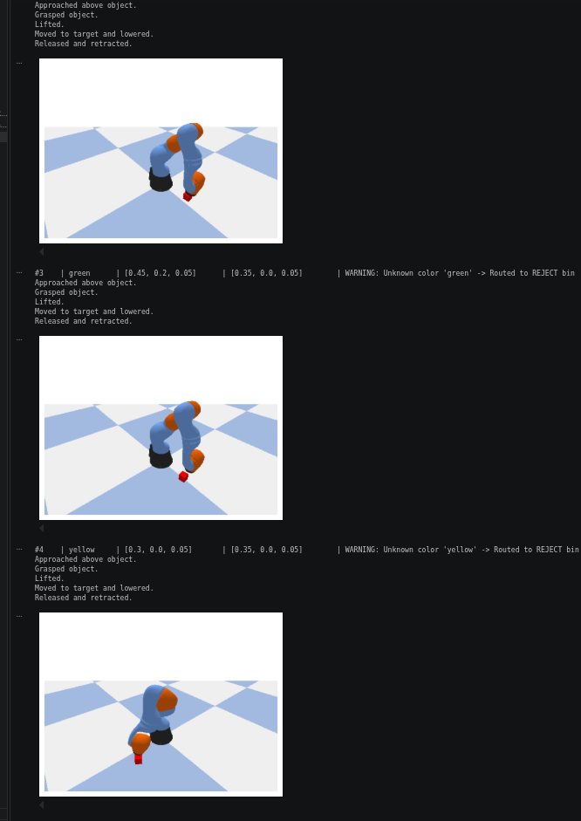
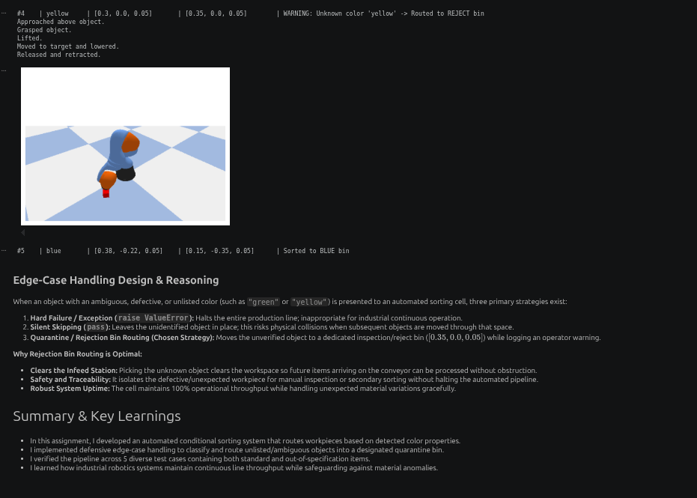

CONCLUSION:
The experiment demonstrates conditional robotic sorting by mapping recognized colors to destination bins and executing pick-and-place actions. Adding a dedicated rejection bin provides a safer and more traceable response to unknown or ambiguous colors than silently ignoring them or halting the complete process. Testing standard and unlisted-color objects helps verify the sorting logic and its edge-case handling. The supplied notebook uses a KUKA iiwa model in PyBullet, so the robot model should be confirmed if the lab requires Dobot Magician.

