Walchand College of Engineering, Sangli
7CS353 Machine Learning Lab — Assignment 2
Missing Value Handling and Exploratory Data Visualisation
Name - Atharv Vinayak Kulkarni
PRN - 245109074
Class - TY CSE(B)

7CS353 Machine Learning Lab — Assignment
PART B — Independent Tasks (10 Marks)
B1. Load Data and Establish a Baseline
- Load the dataset and perform the required preprocessing.
- Fit a default LogisticRegression(C=1.0, max_iter=1000) model on the training set.
- Report the following metrics on the test set:
  - Accuracy
  - F1-score
  - ROC-AUC
- In a Markdown cell, answer the following questions:
  - What does an AUC of 0.5 mean?
  - What does an AUC of 1.0 mean?
  - What does your baseline AUC tell you?
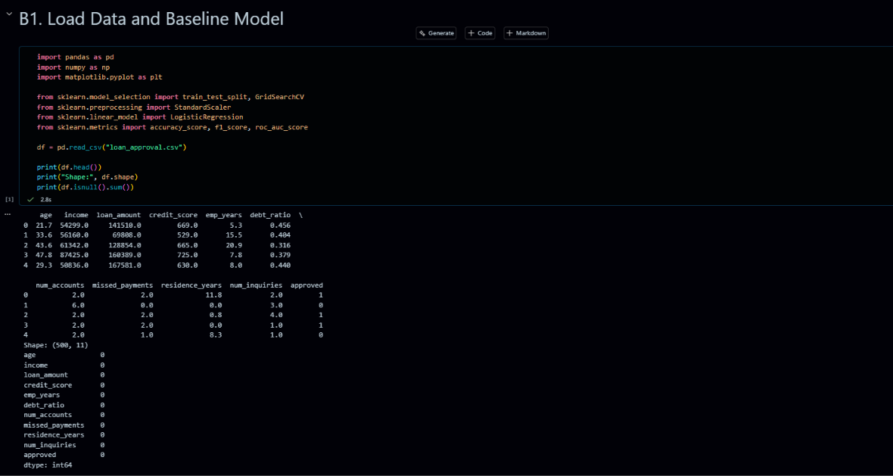
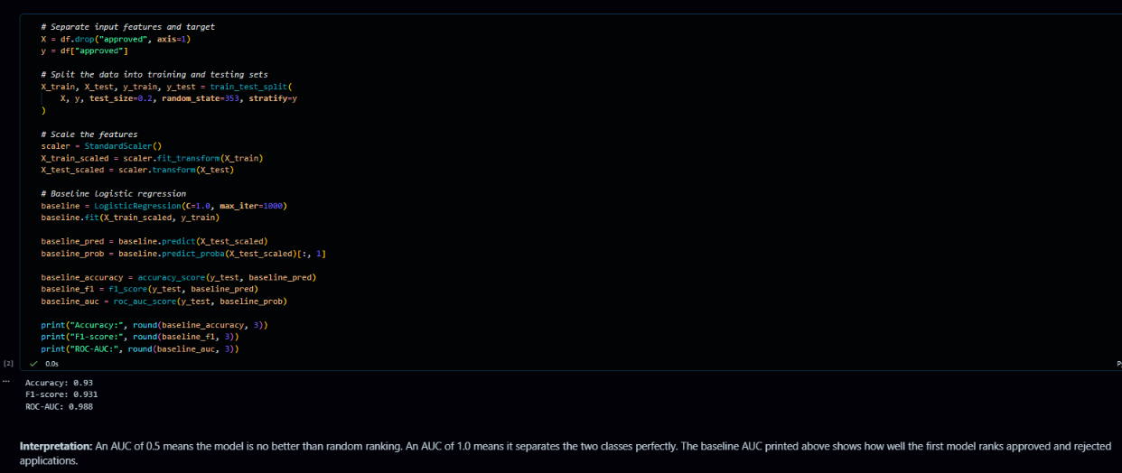

B2. Regularization — Ridge, Lasso, and ElasticNet
B2.1. Fit Three Regularization Models
Fit the following three models on the training set using C=0.1 for all models:
- Ridge (L2): LogisticRegression(penalty="l2")
- Lasso (L1): LogisticRegression(penalty="l1", solver="liblinear")
- ElasticNet: LogisticRegression(penalty="elasticnet", solver="saga", l1_ratio=0.5)
Report the test ROC-AUC for each model.
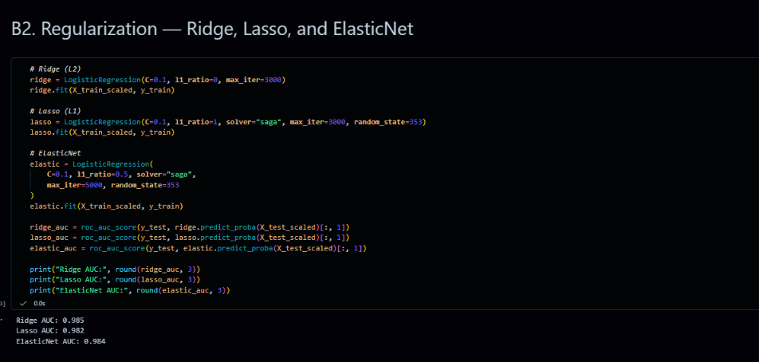
B2.2. Lasso Regularization Path
- Loop over the following values of C:
[0.001, 0.005, 0.01, 0.05, 0.1, 0.5, 1, 5, 10]
- For each value of C, fit a Lasso model and record all 10 coefficients.
- Plot the coefficient values against log(C), using one line per feature.
- Identify which features reach zero first as C decreases.
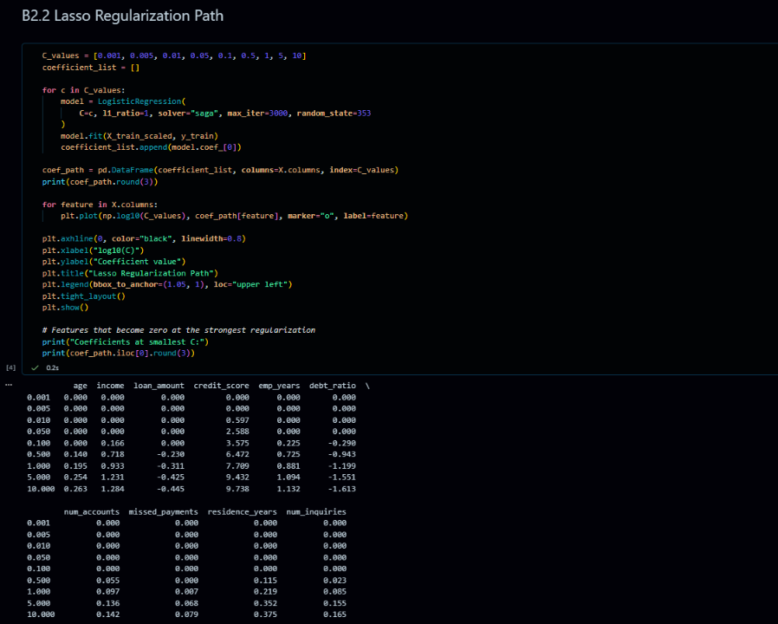
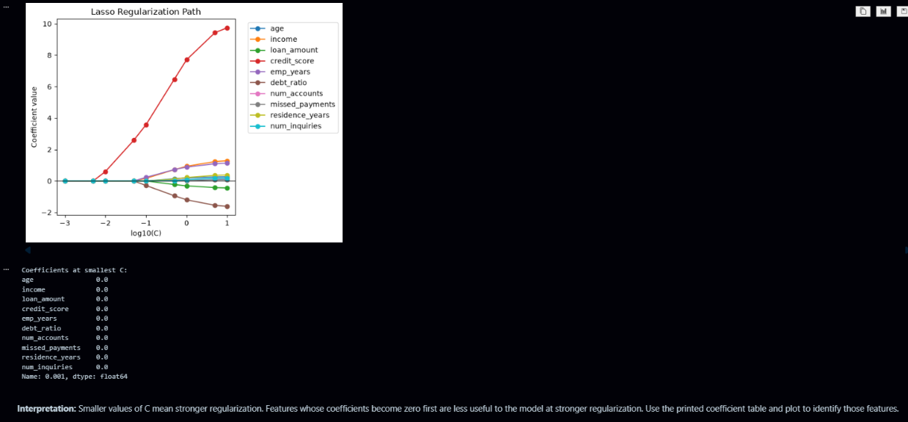
B2.3. Compare Ridge and Lasso Coefficients
Print a table containing the following columns:
- Feature
- Ridge coefficient (C=0.1)
- Lasso coefficient (C=0.1)
How many features does Lasso set to zero at C=0.1?
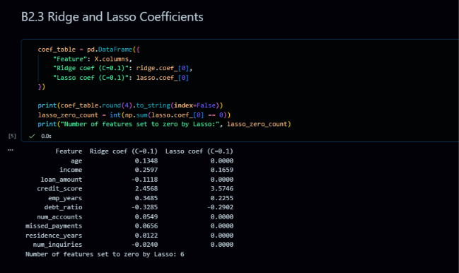

B2.4. Explain Ridge and Lasso
In a Markdown cell, explain in three sentences why Ridge keeps all features while Lasso can set some coefficients to zero. Relate your explanation to the geometry of the L1 and L2 penalties.
B3. Feature Importance and Hyperparameter Tuning
Use Lasso coefficients as the feature importance measure throughout this task.
B3.1. Feature Importance Using Lasso
- Fit a Lasso model with C=0.1.
- Extract the coefficients and sort the features by the absolute value of their coefficients.
- Plot a horizontal bar chart with feature names on the y-axis and absolute coefficient values on the x-axis.
- Display zero-coefficient features in a different colour.
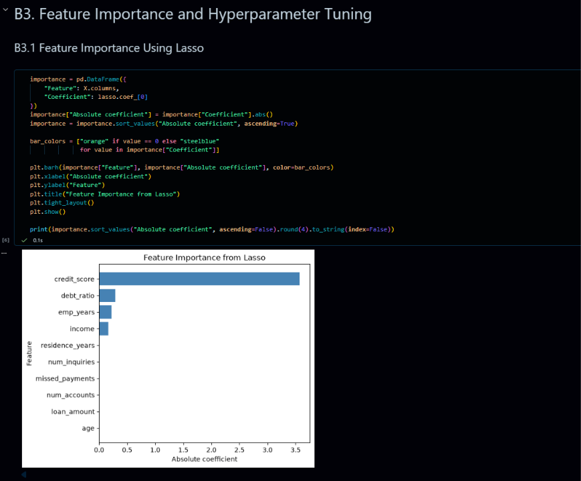
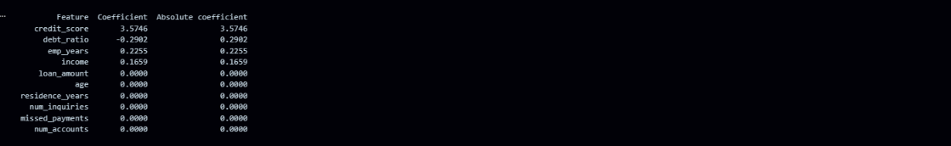
B3.2. Feature Selection
- Identify the features whose Lasso coefficients are zero.
- Remove these features from X_scaled and name the resulting dataset X_reduced.
- Retrain the baseline LogisticRegression(C=1.0) model using X_reduced.
- Report the test ROC-AUC.
- Did removing the weak features hurt the model's performance?

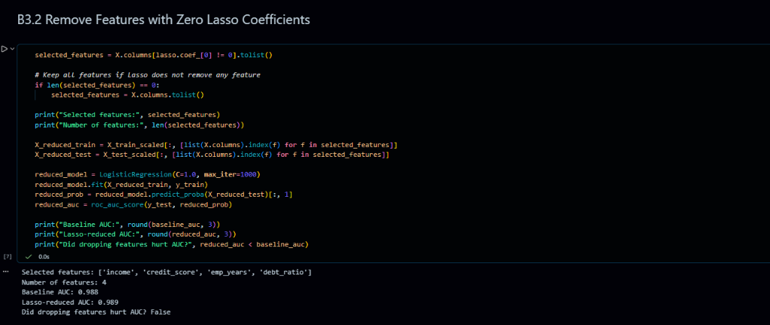

B3.3. Hyperparameter Tuning with GridSearchCV
On X_reduced, search for the best value of C using the following parameter grid:
[0.001, 0.01, 0.1, 1, 10, 100]
Use:
- cv=5
- scoring="roc_auc"
Print best_params_ and best_score_.
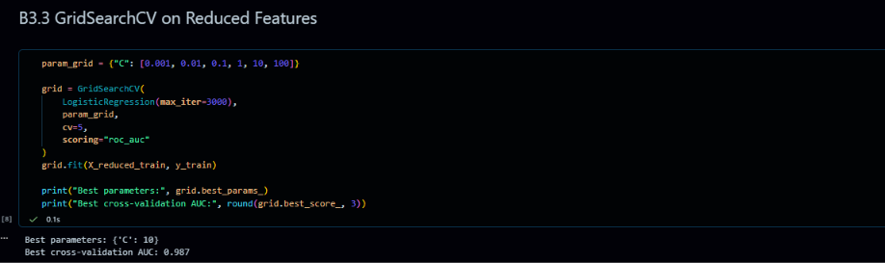
B3.4. Compare Model Performance
Evaluate grid.best_estimator_ on the test set and complete the following table:
Model | Features Used | Test AUC
Baseline (C=1, all features) | 10
Lasso-reduced (C=1)
Tuned (best C, reduced)
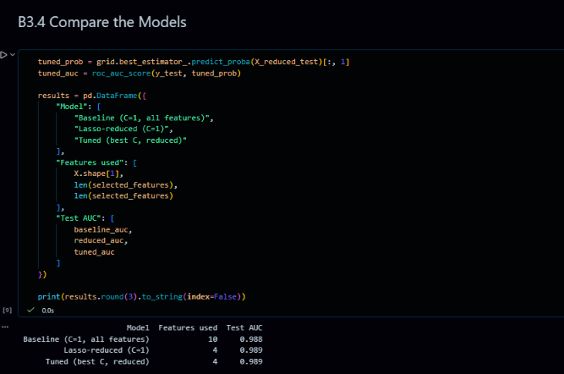
B4. Design Task — Real-World Adaptation (Take-Home)
Business Constraint
Your bank's compliance team issues the following requirement:
"The loan approval model must use at most 5 features, must be explainable to auditors in plain language, and must achieve at least 90% of the baseline AUC."
B4.1. Select Five Features
Select exactly five features and justify your choices using evidence from B2 (regularization path) and B3 (feature coefficient ranking).
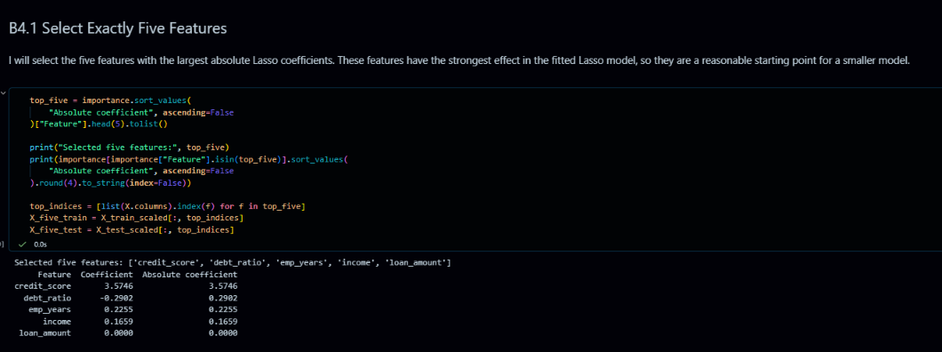
B4.2. Tune the Five-Feature Model
Tune the regularization strength of your five-feature model using GridSearchCV and the same parameter grid as in B3.3.
Report the best value of C and the test ROC-AUC.
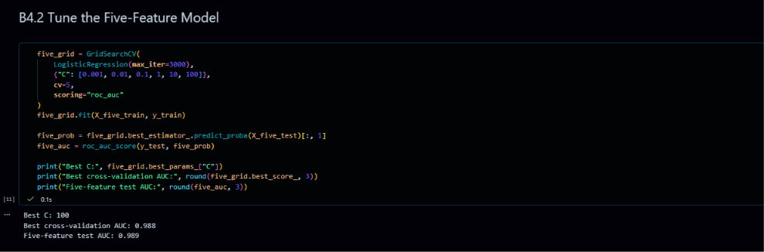
B4.3. Calculate the AUC Ratio
Calculate the AUC ratio using the following formula:
AUC Ratio = (Five-feature model AUC / Baseline AUC) × 100%
Does your model satisfy the requirement of achieving at least 90% of the baseline AUC?
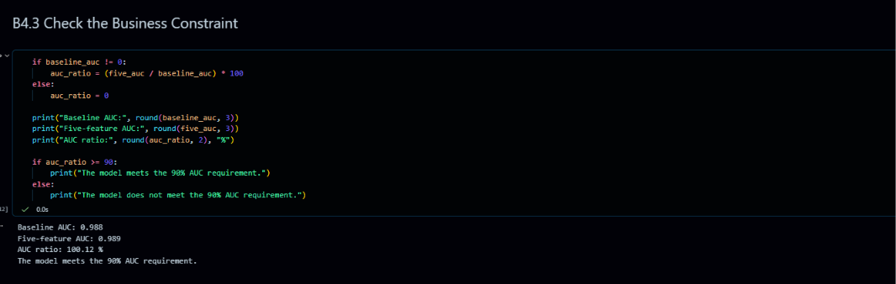
B4.4. Short Design Report
Write a design report of at least five sentences in a Markdown cell covering:
- Which five features you selected and why.
- Which regularization method you used and why.
- What you would do if the model did not meet the 90% AUC requirement.
- One potential fairness concern with this model in a real bank.


