Walchand College of Engineering, Sangli
7CS353 Machine Learning Lab — Assignment 2
Missing Value Handling and Exploratory Data Visualisation
Name - Atharv Vinayak Kulkarni
PRN - 245109074
Class - TY CSE(B)

7CS353 Machine Learning Lab — Assignment 8

PART B
B1. Load and explore: Load the Iris dataset. Print shape, class distribution, and feature statistics using describe(). Draw a pair plot (scatter matrix) using pd.plotting.scatter_matrix or seaborn pairplot, coloured by class. In a markdown cell, identify which pair of features appears to best separate the three classes.
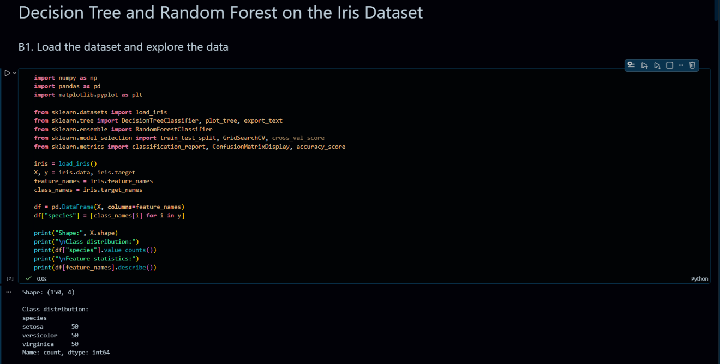
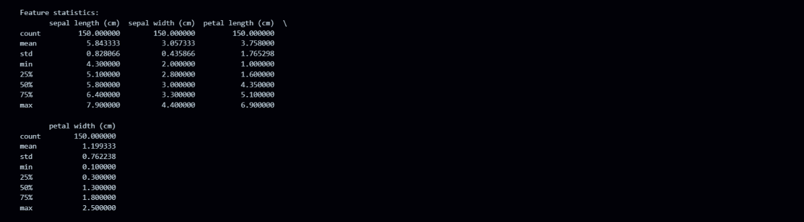

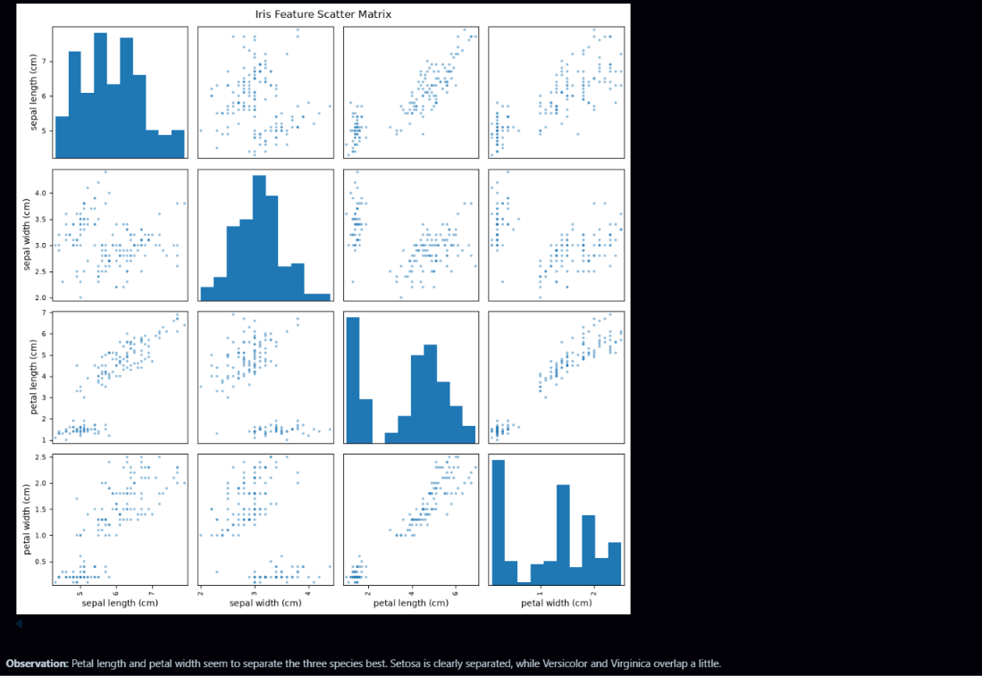

B2. Impurity from scratch: Using only NumPy, write two functions: entropy(y) that computes H = −Σ pₖlog₂(pₖ), and gini(y) that computes G = 1 − Σ pₖ². Apply both functions to the full label vector y, then to the subset of labels where petal_length ≤ 2.45, and to the complement. Compute the Information Gain for this split using entropy. In a markdown cell, confirm whether the split identified by petal_length ≤ 2.45 matches the root node of Figure 1 in Part A. Comment on split quality of IG.
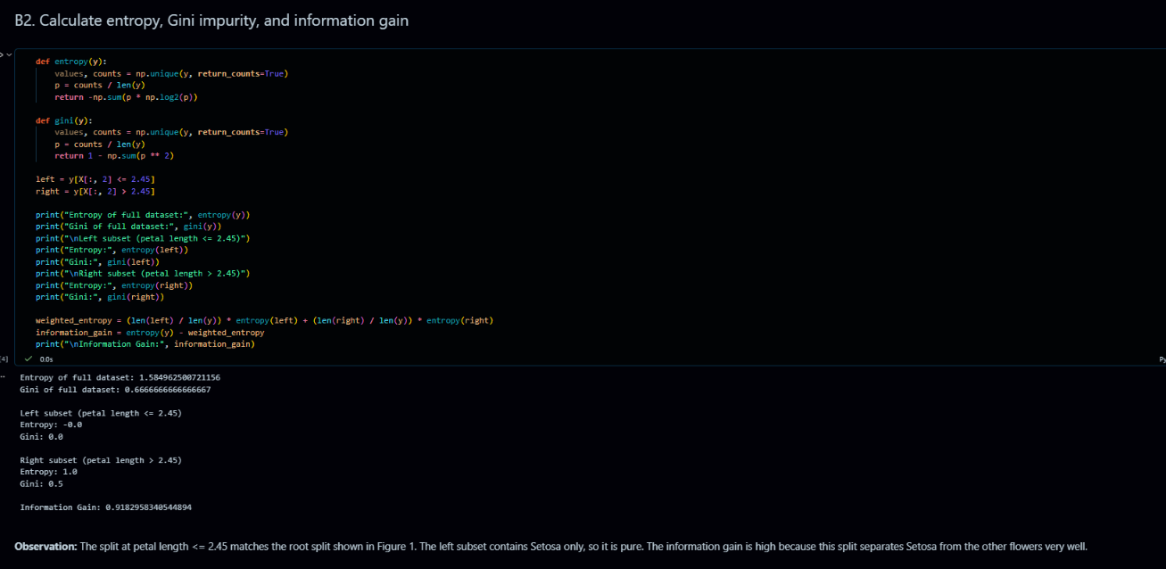
B3. Decision Tree — fit and visualise: Perform an 80/20 train-test split (random_state=42). Fit a Decision Tree with max_depth=3 and criterion="entropy". Use sklearn.tree.plot_tree to draw the full tree, showing the feature used, threshold, impurity, and sample counts at each node. Also print export_text(dt) for a text summary. Report classification report and confusion matrix heatmap on the test set.
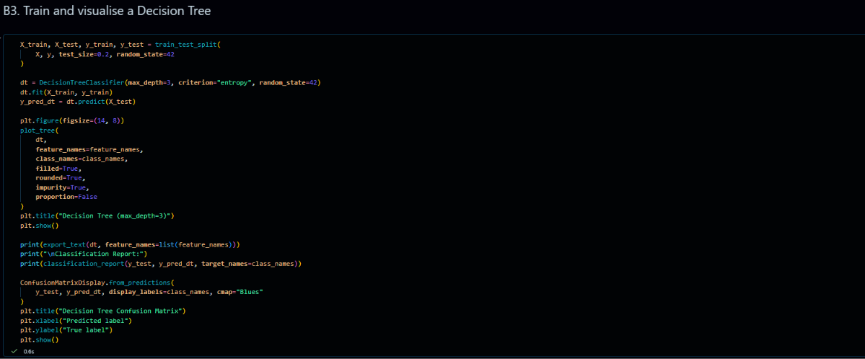

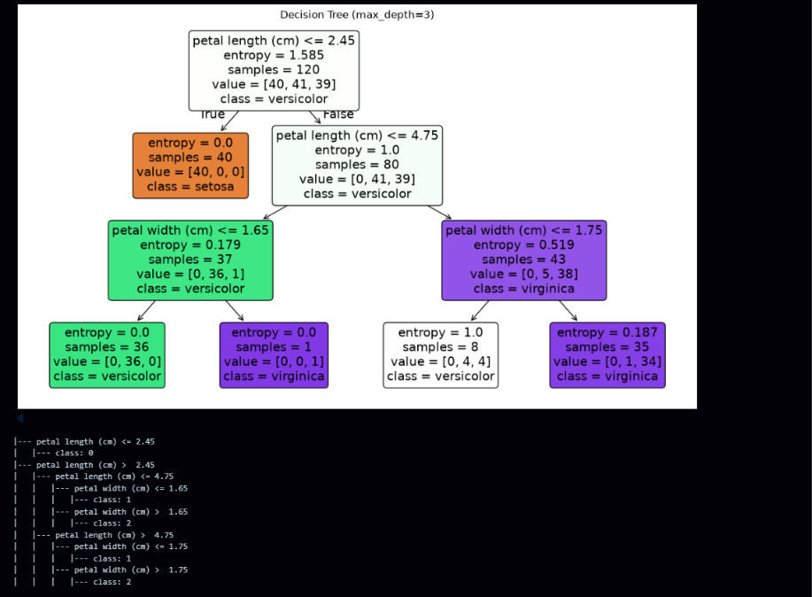
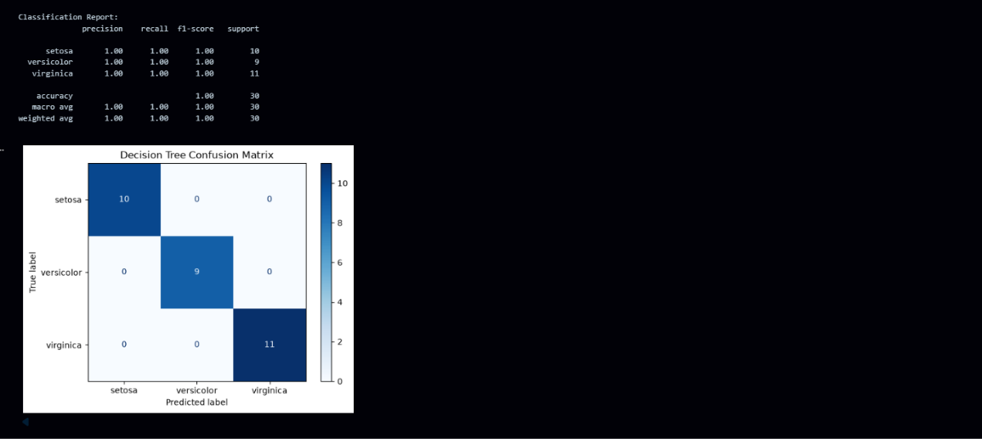

B4. Depth analysis: Train Decision Trees for max_depth = 1 through 10 and record training accuracy and test accuracy for each. Plot both curves on the same axes (depth on x-axis). In a markdown cell, identify the depth at which the model begins to overfit (training accuracy approaches 1.0 while test accuracy plateaus or drops), and choose an optimal depth with justification.
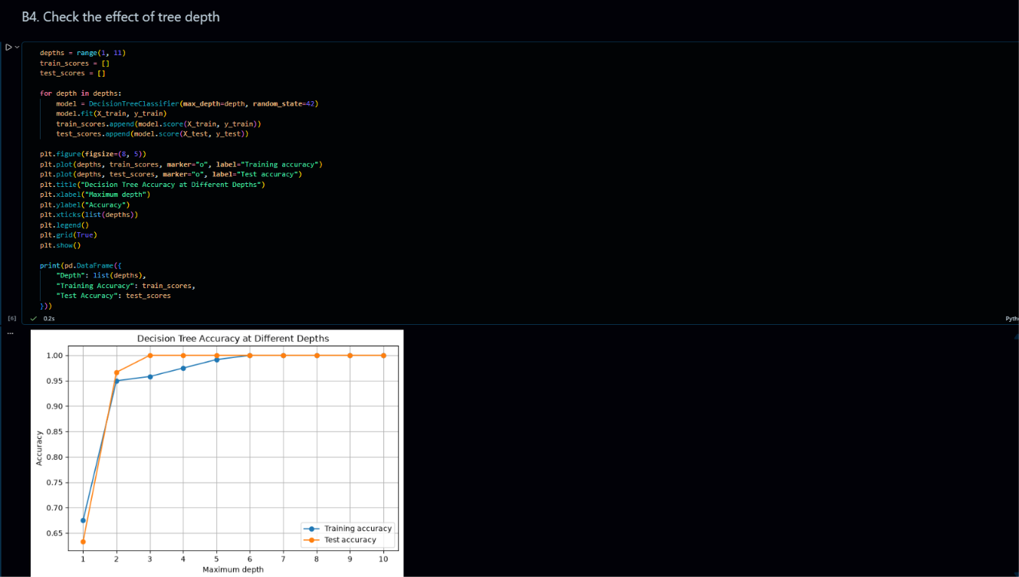
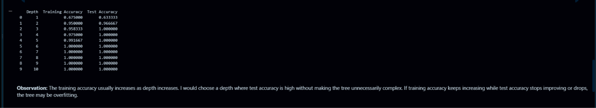

B5. Random Forest — fit and evaluate: Fit a Random Forest with n_estimators=100, oob_score=True, random_state=42. Print the OOB score and test-set classification report. Draw a horizontal bar chart of feature importances, sorted from highest to lowest. In a markdown cell, compare which features the Random Forest considers most important with what you observed in the pair plot (B1).
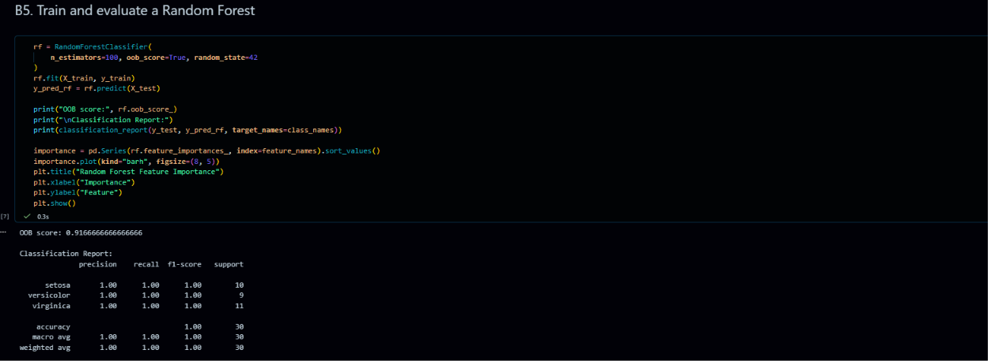
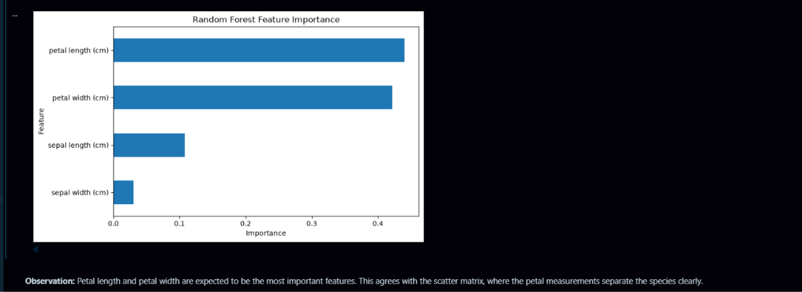

B6. Hyperparameter tuning: Use GridSearchCV (cv=5) to tune the Random Forest over: n_estimators ∈ {50,100,200} and max_depth ∈ {None,5,10,15}. Print the best parameter combination and the best crossvalidation accuracy. Refit with best parameters and report the final test-set metrics.
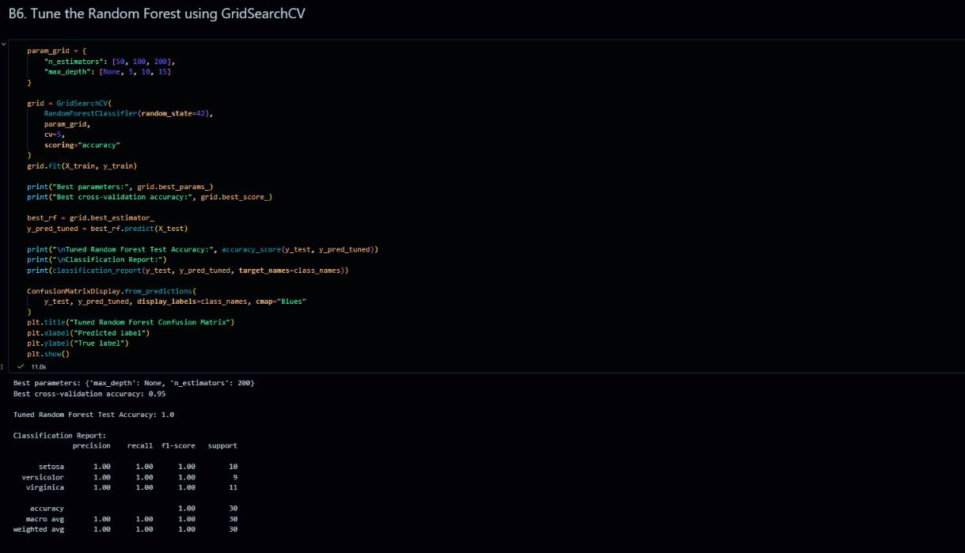
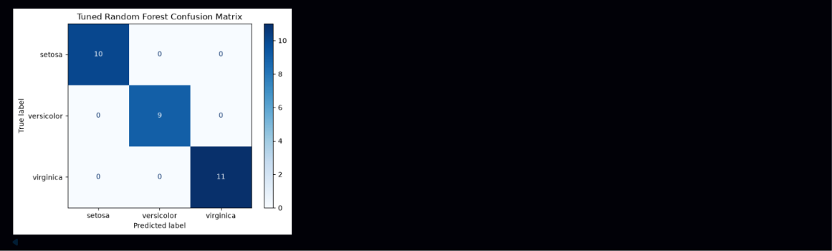

B7. Comparison and interpretation: Present a final summary table in markdown:


