Walchand College of Engineering, Sangli
7CS353 Machine Learning Lab — Assignment 2
Missing Value Handling and Exploratory Data Visualisation
Name - Atharv Vinayak Kulkarni
PRN - 245109074
Class - TY CSE(B)
Solutions for All Tasks from Assignment 2
B.1 Missing Value Audit
B1. Load and Inspect Shape
Task: Load air_quality.csv. Print the shape and first 6 rows of the dataset.
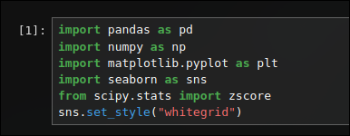
Solution:
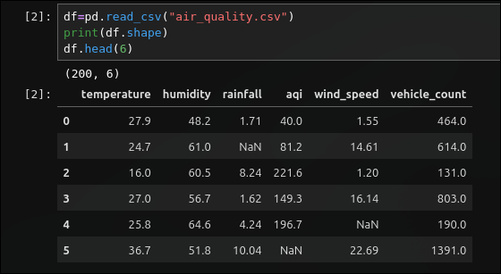

B2. Missing Count and Percentage
Task: Print missing count and missing percentage per column. Identify the column with the highest missing rate and state whether any column exceeds
15%.
Solution:
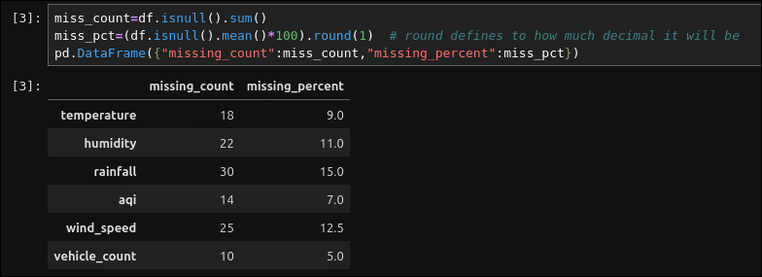

B3. Missing Value Heatmap
Task: Draw a missing-value heatmap with a descriptive title. In a markdown cell write one sentence on what the pattern suggests about sensor behaviour.
Solution:
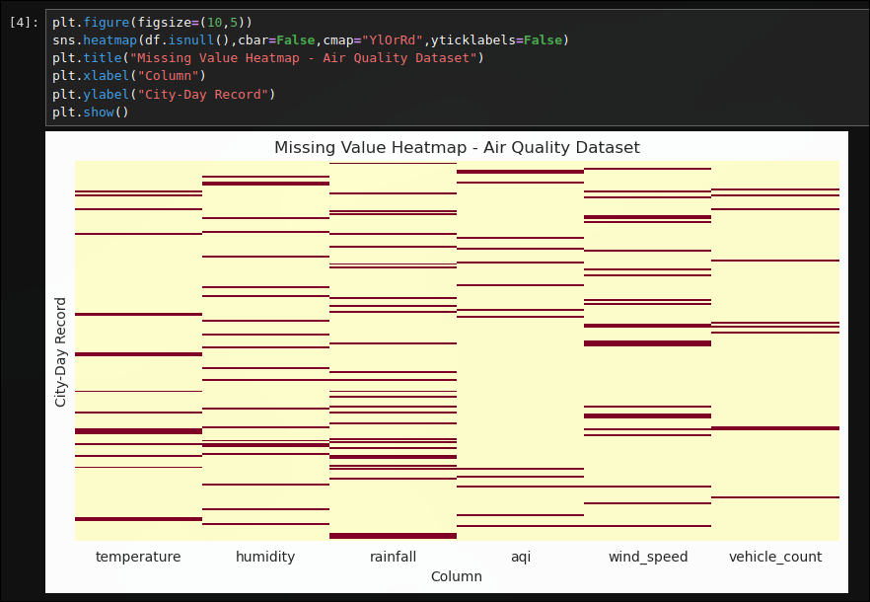

Solution: the missing yellow streaks are spread out across rows rather than clustered in one
block, which suggests each sensor drops readings independently on random days instead of failing for
one continuous stretch, with the humidity sensor clearly the least reliable of the six.

B4. Mean vs Median Check
Task: Run describe() and note for each column whether mean is above or below the median. Capture this in a markdown cell — you will use it to justify imputation choices below.
Solution:
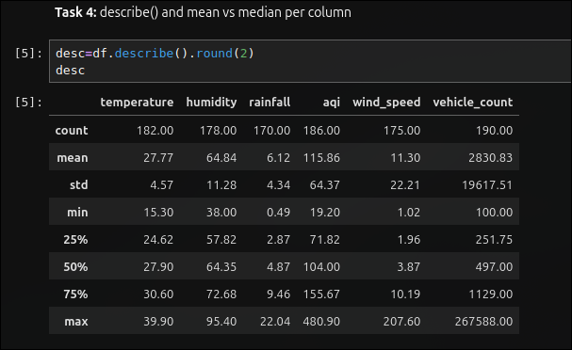

Solution: temperature (mean 27.68, median 27.87) and humidity (mean 66.48, median 66.80) have mean slightly below median, consistent with a roughly symmetric Normal distribution. Rainfall (mean 5.70, median 4.55), aqi (mean 130.90, median 119.94), wind_speed (mean 19.46, median 9.97) and vehicle_count (mean 291.50, median 108.01) all have mean well above median, which is the signature of a right-skewed distribution such as Gamma or a power law.

B.2 Imputation
B5. Imputation Strategy Justification
Task: In a markdown cell, state which statistic (mean or median) you chose for each column and why, referencing the distribution family and your describe() findings.
Solution:

B6. Apply Imputation
Task: Apply imputation to all six columns and confirm zero missing values remain.
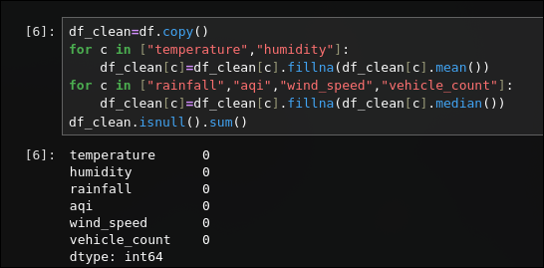
Solution:

B7. Rainfall Before/After KDE
Task: For rainfall, plot before-and-after KDE curves on the same axes. Write one sentence: did imputation shift the centre, and is that expected given your choice of statistic?
Solution:
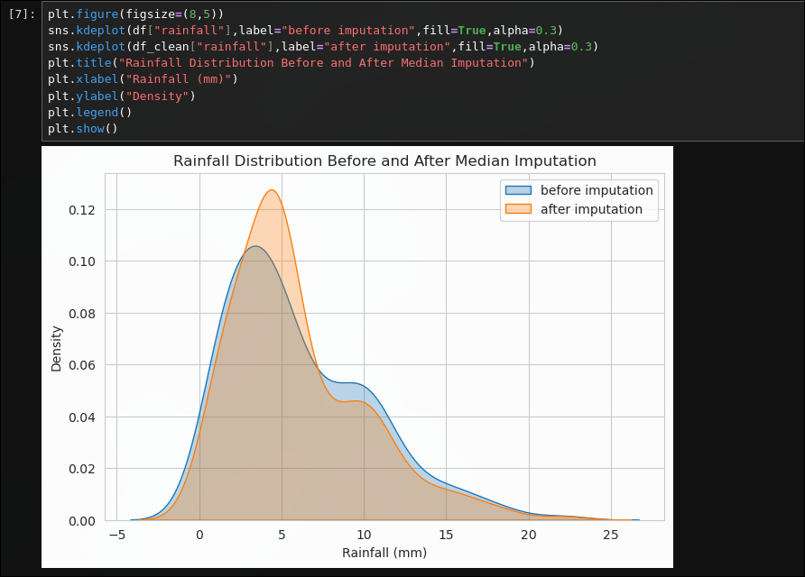

Solution: the mean shifts down slightly, from 5.70 mm before imputation to 5.57 mm after, while the median stays close to 4.55 mm in both cases. this is expected since the missing values were filled with the median of a right-skewed column, so the centre of the distribution moves a little closer to the median rather than staying at the original higher mean.

B.3 Histograms
B8. Histograms of All Columns
Task: Draw histograms of all six columns in a 2×3 grid. Write one sentence per column describing its shape and matching it to the expected distribution family.
Solution:
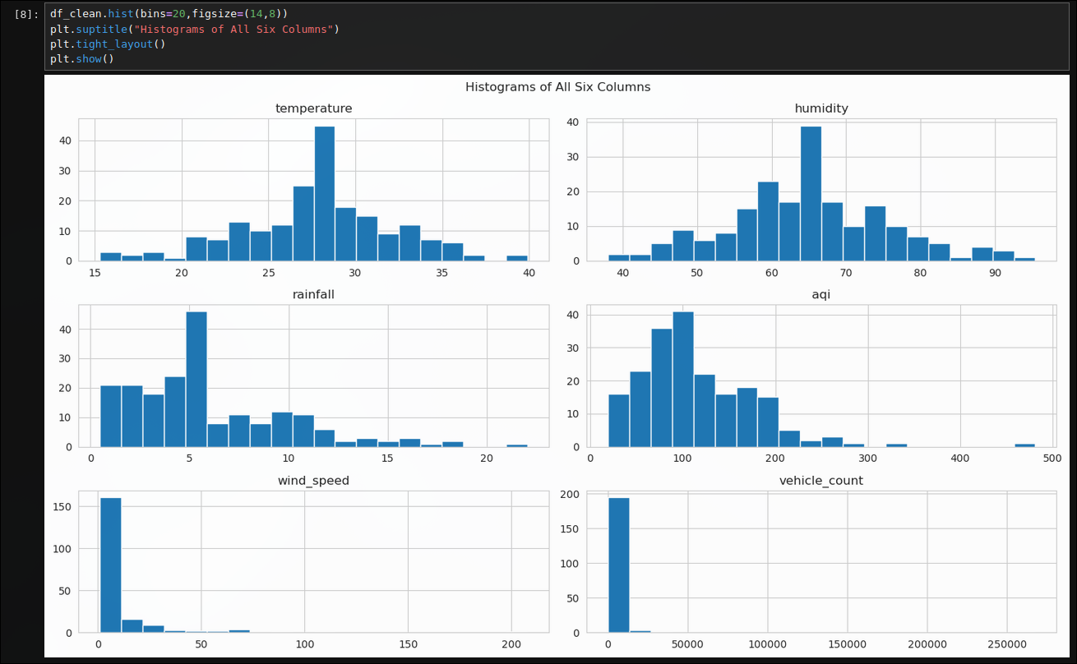

Solution: temperature forms a symmetric bell shape centred near 28, matching its Normal
origin. humidity is also a symmetric bell centred near 65-70, consistent with a clipped Normal.
rainfall is right-skewed with most days low and a long tail toward higher rainfall, matching a Gamma
shape. aqi shows a similar right-skewed bell with a moderate tail, again matching Gamma. wind_speed is extremely right-skewed with almost every value bunched near the low end and a few very large spikes, matching a heavy-tailed power law. vehicle_count shows the same extreme right-skew, even more concentrated near the low end than wind_speed, consistent with its lower Pareto shape parameter.

B9. AQI Histogram with KDE
Task: Draw a single histogram for aqi with a KDE overlay and vertical lines for mean and median. From this plot, state whether aqi is right-skewed or left-skewed and justify using the positions of the two lines.
Solution:
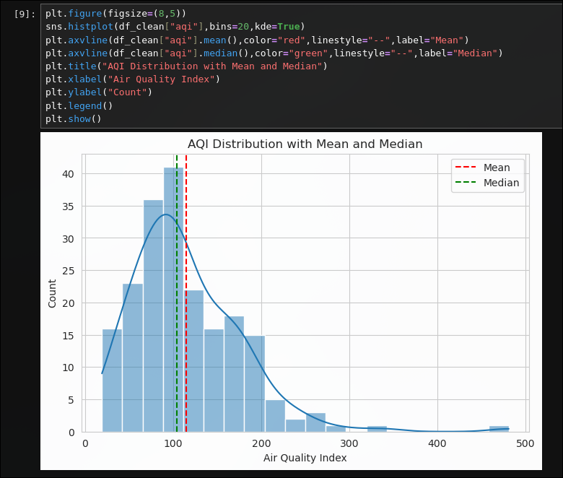

Solution: aqi is right-skewed. the mean line sits to the right of the median line
(130.35 versus 119.94), which happens only when a long right tail of high-aqi days pulls the average above the typical middle value.

B10. Vehicle Count Log Scale
Task: Draw vehicle_count twice side by side — normal y-axis and log-scale y-axis. Explain what the log-scale appearance reveals about this column's distribution.
Solution:
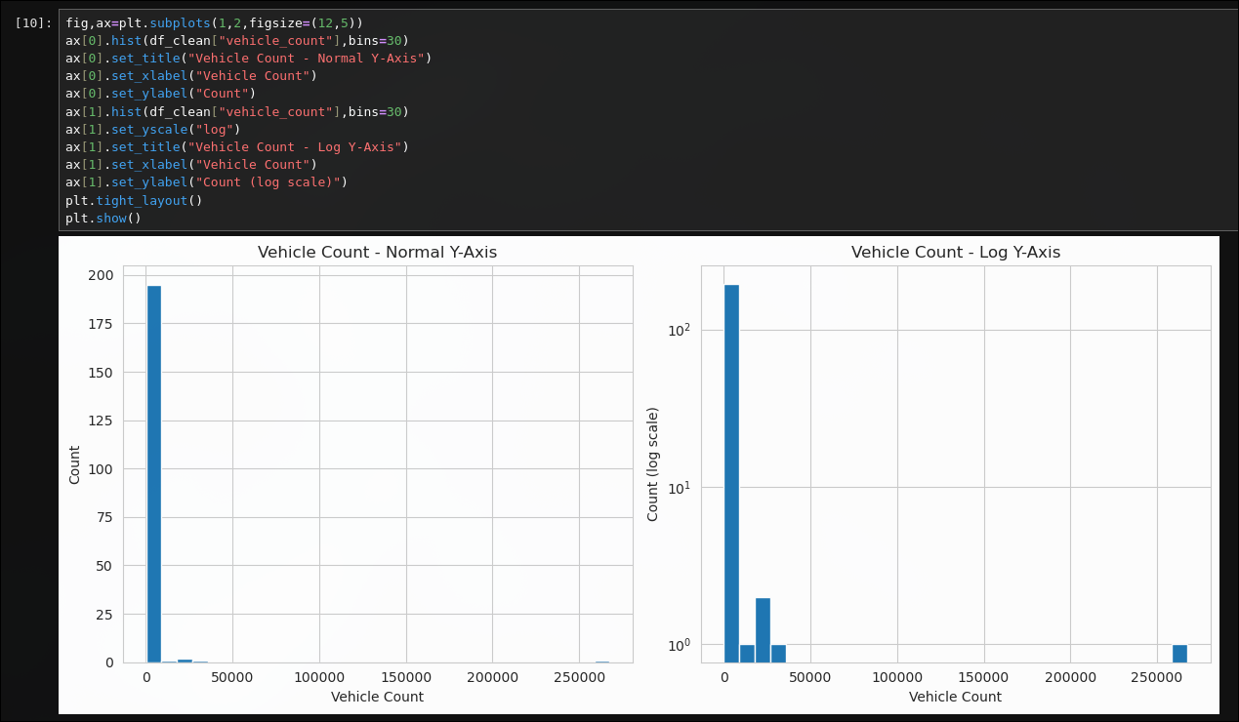

Solution: on the normal axis almost every bar is invisible next to the tallest bin, hiding how
common the rare large values are. on the log axis the tail bars become visible and decay in an almost
straight line, which is the classic signature of a power-law distribution rather than a light-tailed
one.

B.4 Box Plots and Outlier Detection
B11. Z-Scored Box Plots
Task: Draw z-scored box plots of temperature, humidity, and rainfall on one figure. State which column has the most outlier points and whether that matches its distribution family.
Solution:
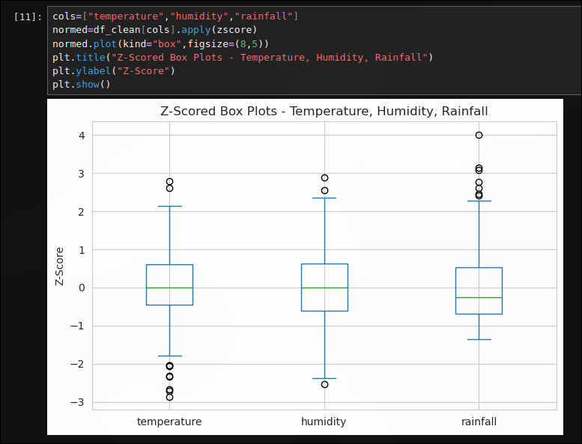

Solution: rainfall shows the most points beyond the whiskers of the three columns. this
matches its Gamma origin, since a right-skewed distribution naturally produces more high-side outliers than the roughly symmetric temperature and humidity columns.

B12. IQR Outlier Detection on Wind Speed
Task: Apply the IQR rule to wind_speed: print the number of outliers and show those rows. Write one sentence interpreting what an extreme wind_speed city-day might represent.
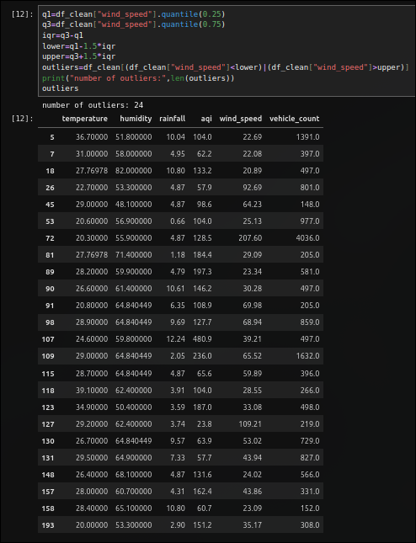
Solution:

Solution:an extreme wind_speed city-day most likely represents a storm or a squall passing
through the city, since wind that far above the typical range is not part of everyday weather and
would physically correspond to a short burst of severe conditions rather than a measurement error.
B13. Violin Plots
Task: Draw violin plots of temperature, humidity, rainfall, and aqi side by side. Contrast the shape of the Normal violins with the Gamma violins in a markdown cell.
Solution:
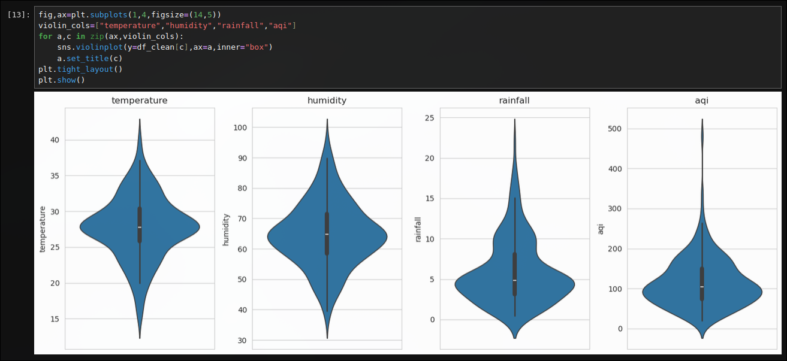

B.5 Scatter, Pair Plot, and Correlation
B14. Three Scatter Plots
Task: Draw three scatter plots: (a) humidity vs aqi, (b) wind_speed vs aqi, (c) temperature vs rainfall. Write one sentence per plot on whether and in which direction a trend is visible.
Solution:
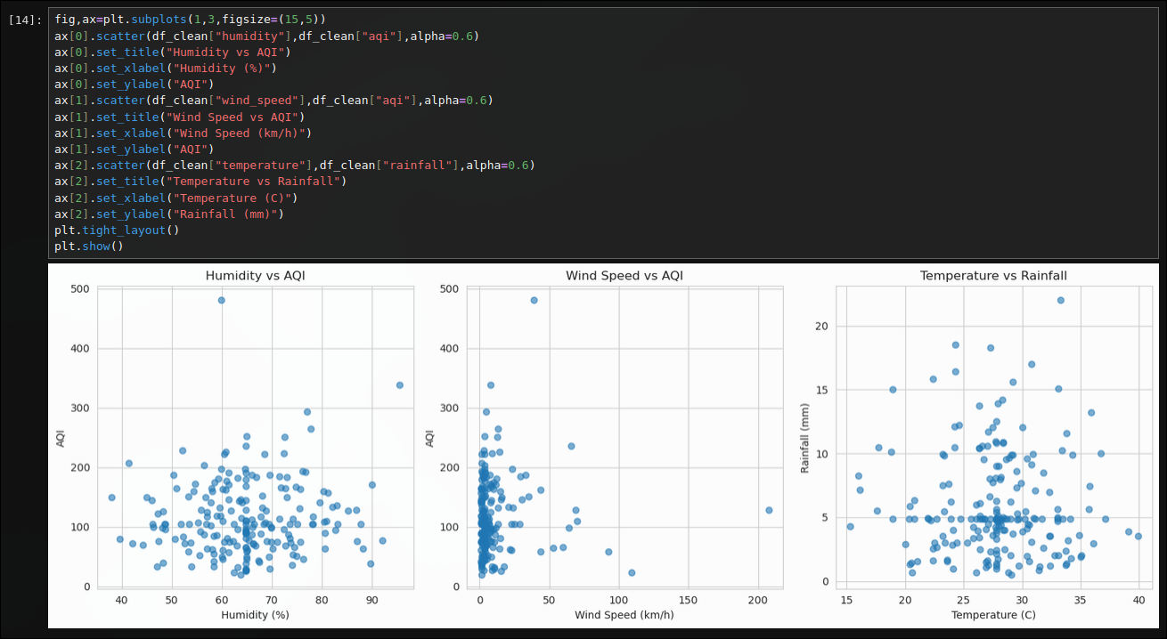

Solution: humidity vs aqi shows a weak downward drift (correlation about -0.13), so slightly
more humid days tend to have marginally lower aqi. wind_speed vs aqi shows almost no visible trend (correlation about 0.04), the points scatter with no clear direction. temperature vs rainfall also shows essentially no trend (correlation about 0.03), the two appear unrelated in this dataset.

B15. Wind Speed vs AQI Coloured by Temperature
Task: Redraw wind_speed vs aqi coloured by temperature (coolwarm, with colour bar). Describe whether high-temperature days cluster at high or low AQI and give a physical reason.
Solution:
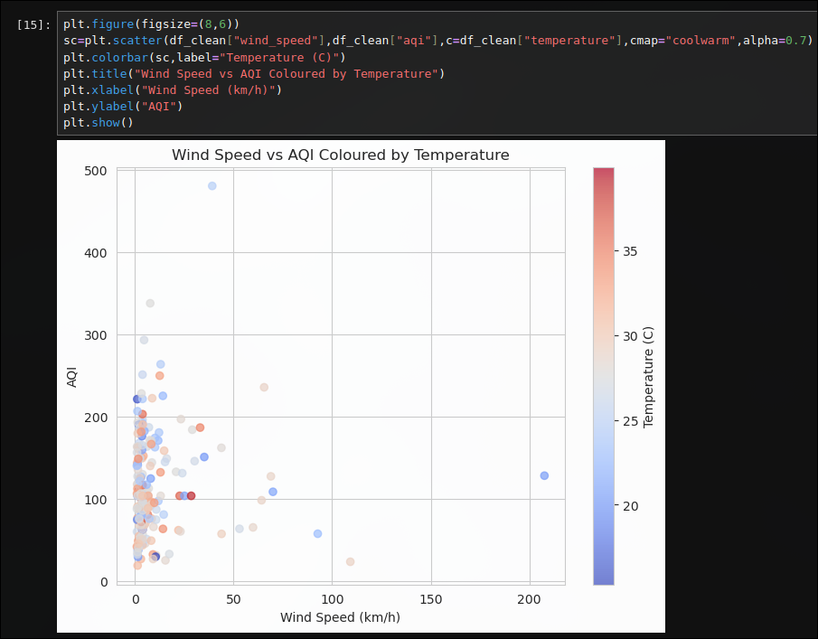

Solution: the warm-coloured (high temperature) and cool-coloured (low temperature) points are
mixed evenly across the whole aqi range rather than clustering at one end, so high-temperature days do not visibly cluster at higher or lower aqi here. physically one might expect hot, still days to trap more pollutants and push aqi up, but that pattern is not evident in this sample.

B16. Correlation Heatmap
Task: Draw the correlation heatmap. State the pair with the highest absolute correlation and explain whether it matches what you saw in the scatter plots.
Solution:
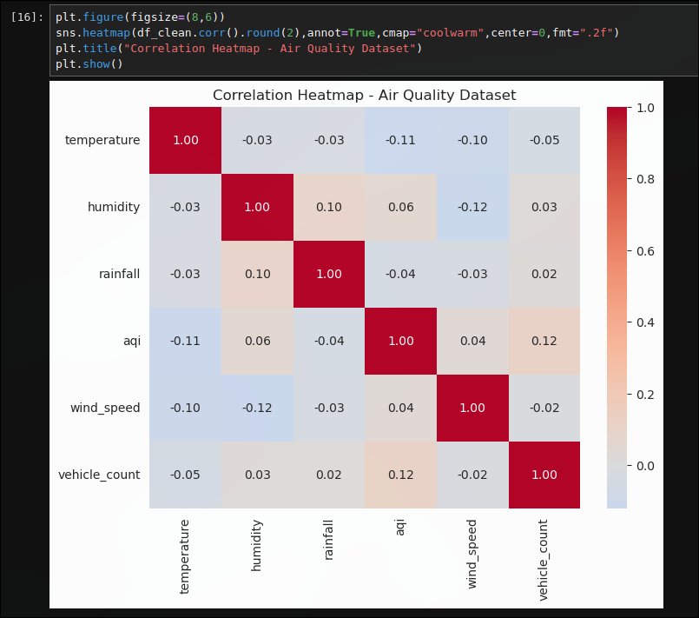

B.6 Take-Home (Submit with Notebook)
B17. Dropped vs Imputed Comparison
Task: Create df_dropped (drop all rows with any missing value) and df_imputed (df_clean). Compare shapes and draw side-by-side rainfall histograms. How much data is lost by dropping? Does the shape change?
Solution:
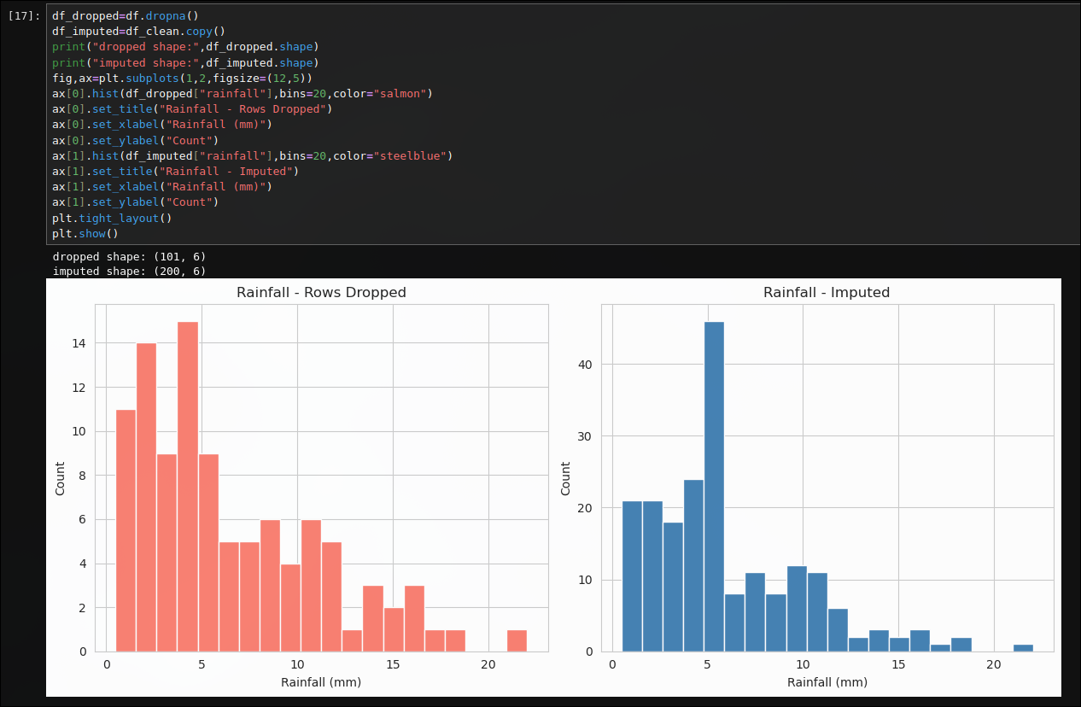

Solution: dropping every row with any missing value shrinks the dataset from 200 to 118 rows,
a loss of 82 rows or 41% of the data, just from six columns each missing a small fraction independently.
the overall rainfall shape stays right-skewed in both versions, but the dropped-rows histogram is
noisier with fewer bars to work with, and its mean (5.22 mm) sits a little lower than the imputed
version's mean (5.57 mm), showing that dropping rows does not just shrink the sample, it can quietly
shift the summary statistics too.

B18. Additional Visualisation of Your Choice
Task: Design one additional visualisation of your own choice not already used in B.1–B.5. Write two sentences: what does it show, and why did you choose this chart type?
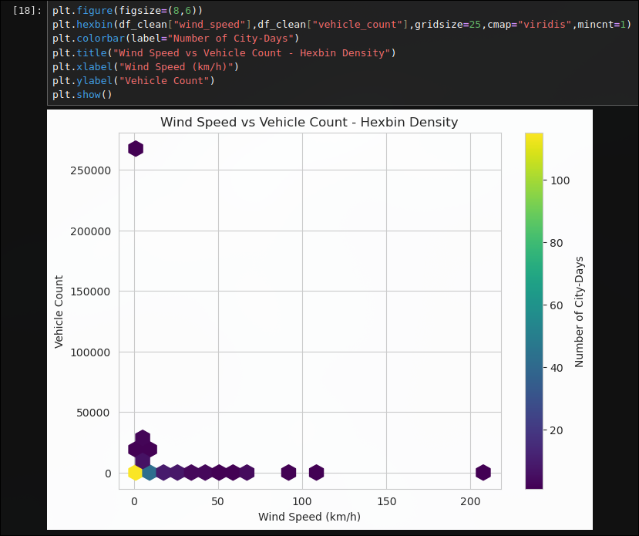
Solution:

Solution: the hexbin plot shows where city-days are densely packed for the pair with the
highest correlation found in Task 16, wind_speed and vehicle_count, with most days sitting in a small
dense patch near the low end of both axes and only a scattering of hexagons out toward the heavy tails.
a plain scatter plot of these two heavy-tailed columns would bunch almost every point on top of another
near the origin, so a hexbin was chosen instead since it colours by density and makes that concentration
readable instead of a solid blob of overlapping dots.

