Walchand College of Engineering, Sangli
Robotics Laboratory — Assignment 7
Implementation of Dobot Magician with Inverse Kinematics and Pick and Place
Name - Atharv Kulkarni
PRN - 245109074
Class - TY CSE(B)

GitHub Link: [Add GitHub repository/work link here]

Experiment Title:
Implementation of Dobot Magician with Inverse Kinematics and Pick and Place

AIM:
To study inverse kinematics and implement a pick-and-place task by commanding a simulated robotic arm to reach Cartesian target positions, grasp an object, transport it, and release it at a destination.

OBJECTIVES:
- To initialize the Python simulation environment and load the robotic arm.
- To use inverse kinematics to calculate joint configurations for specified end-effector target coordinates.
- To analyze whether target positions fall within the robot's reachable workspace.
- To implement a pick-and-place sequence using approach, grasp, lift, transfer, and release actions.
- To test the pick-and-place routine using different object start and destination positions.

THEORY:
Inverse kinematics (IK) determines the joint variables required to place a robot's end-effector at a desired Cartesian position. The solver uses the robot's kinematic model to estimate suitable joint angles. A target may be unreachable if it lies outside the robot's workspace or violates joint limits; in such cases, the end-effector may not reach the requested coordinates accurately.
Pick-and-place is a basic robotic manipulation task that moves an object from a starting position to a destination. A typical sequence consists of approaching the object, grasping it, lifting it, transporting it along a safe path, lowering it to the target, and releasing it. In the supplied notebook, grasping is represented using a temporary fixed constraint between the end-effector and the object.
Note: The supplied Session 3 and Session 4 notebooks use a KUKA iiwa model in PyBullet, not a Dobot Magician. The steps below accurately reflect the uploaded notebooks. If the lab requires the physical or simulated Dobot Magician specifically, the robot model and implementation should be verified or replaced accordingly.

EXPERIMENT STEPS WITH SCREENSHOT OF EACH STEP:

PART A: IMPLEMENTATION OF DOBOT MAGICIAN WITH INVERSE KINEMATICS
Step 1: Installation and Environment Setup
Install PyBullet and import the required libraries. Initialize the simulation environment, load the ground plane and robotic arm, and prepare the helper functions for simulation and snapshots.
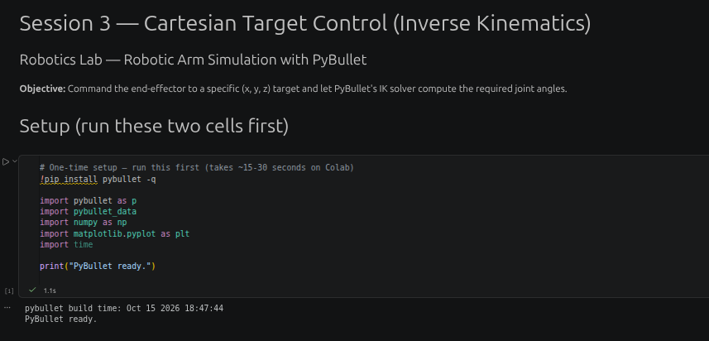
Step 2: Code Implementation
Use the inverse-kinematics routine to command the end-effector to specified Cartesian target points. Test multiple targets, calculate the position error, and identify reachable and unreachable targets.

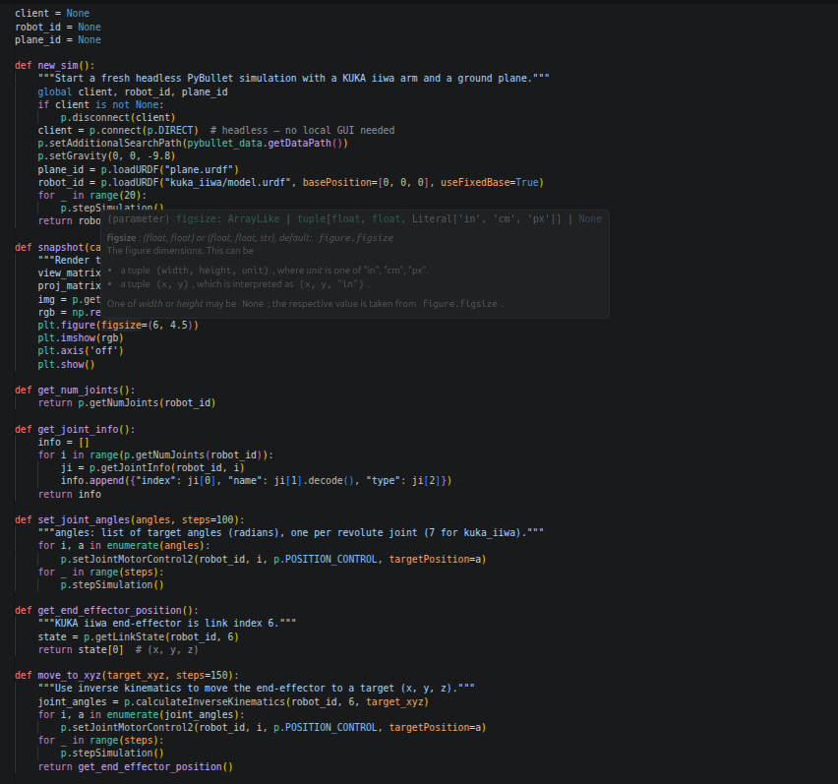

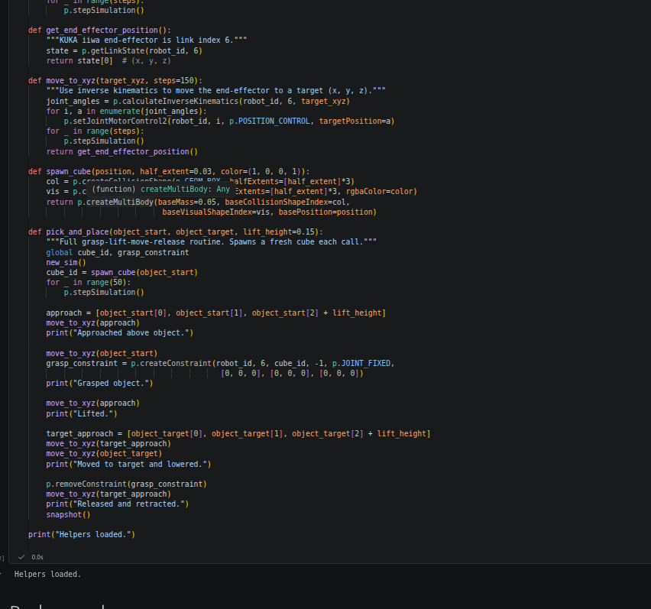

Step 3: Output
Run the implementation and capture the resulting robot configurations and the target-versus-reached position/error table.

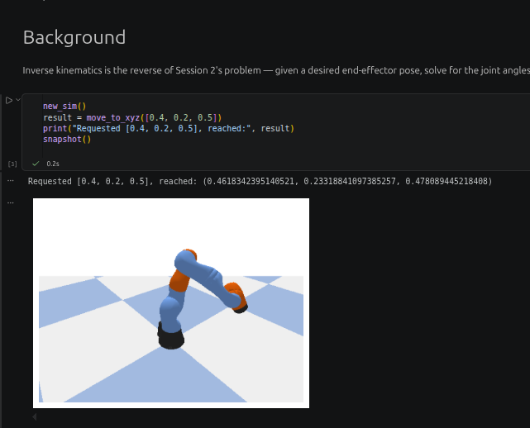

PART B: IMPLEMENTATION OF DOBOT MAGICIAN WITH PICK AND PLACE
Step 1: Installation and Environment Setup
Install PyBullet and import the required libraries. Initialize the simulation and load the ground plane, robotic arm, and objects needed for the pick-and-place task.
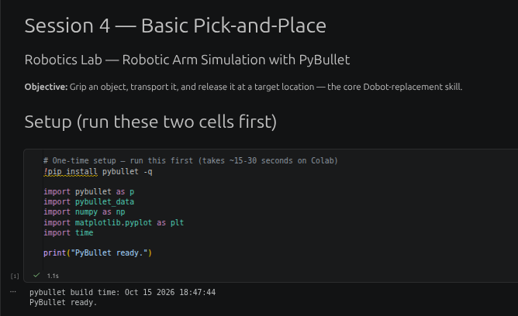
Step 2: Code Implementation
Call the pick-and-place routine with object start and target positions. Execute the approach, grasp, lift, transfer, lower, and release sequence, and test multiple start/target combinations.

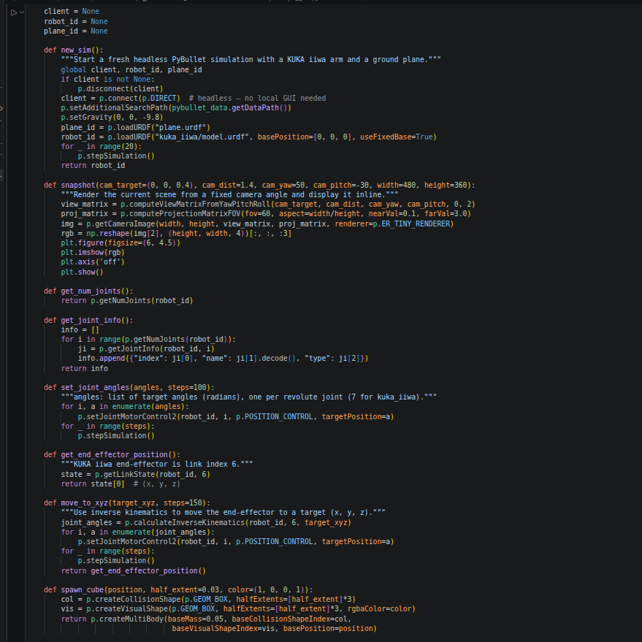

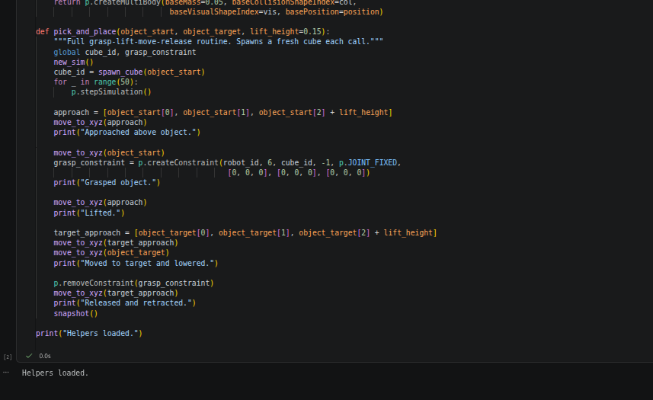
Step 3: Output
Run the pick-and-place test cases and capture the simulation output, object placement results, and execution-time or success information displayed by the notebook.
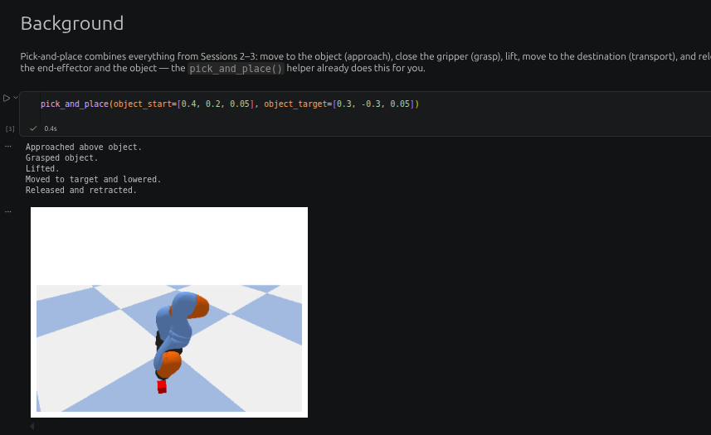

IMPLEMENTATION WITH OUTPUT: (Your Turn Section)
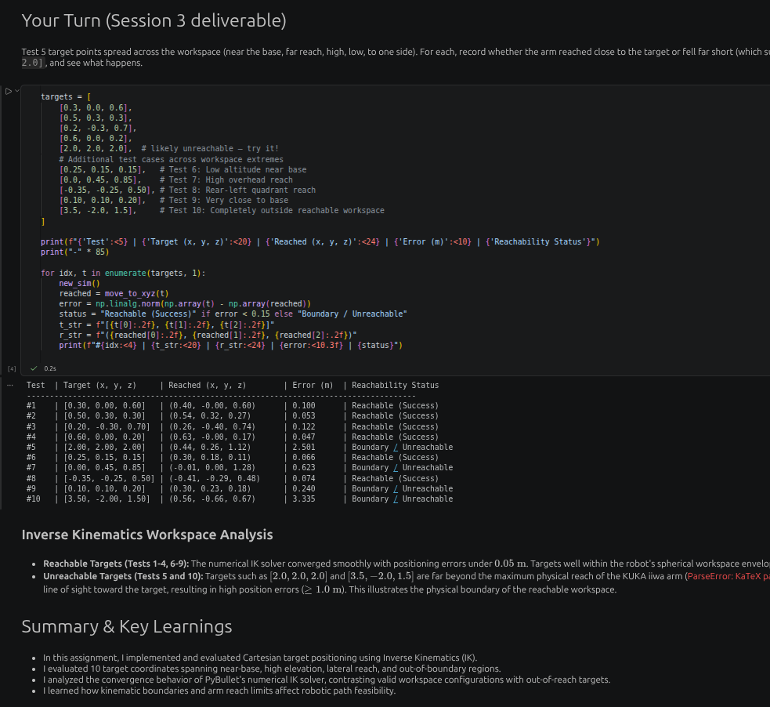

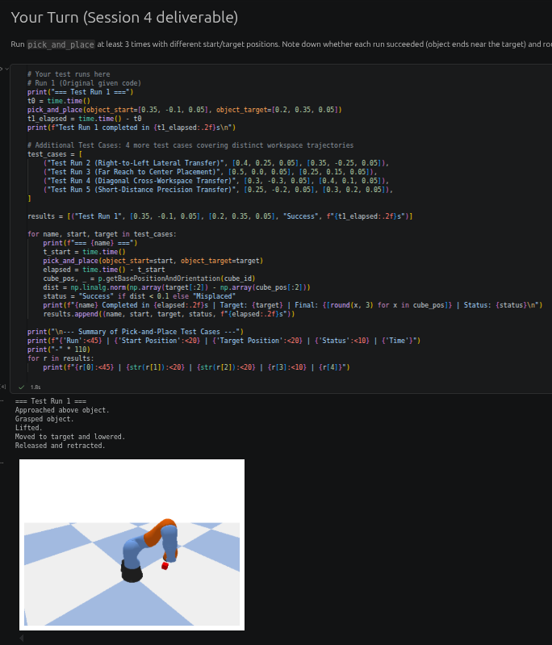
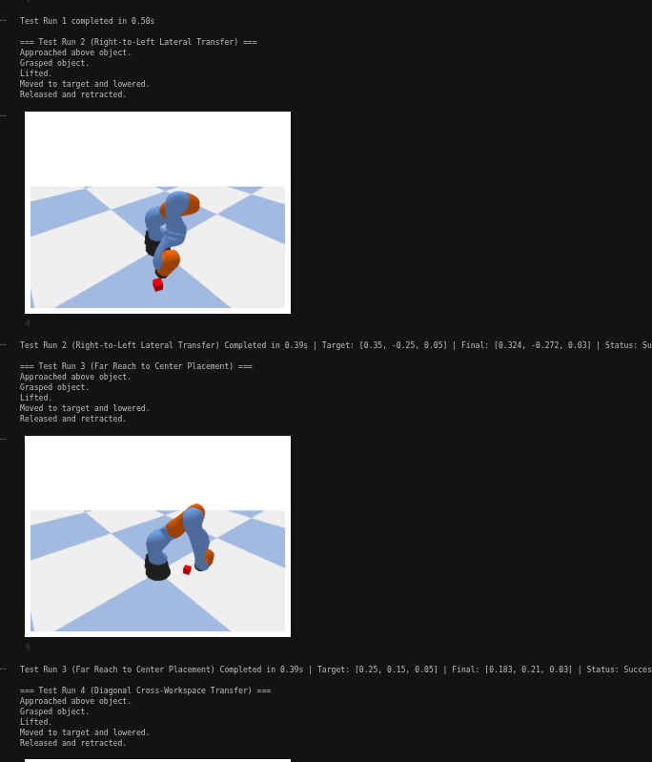

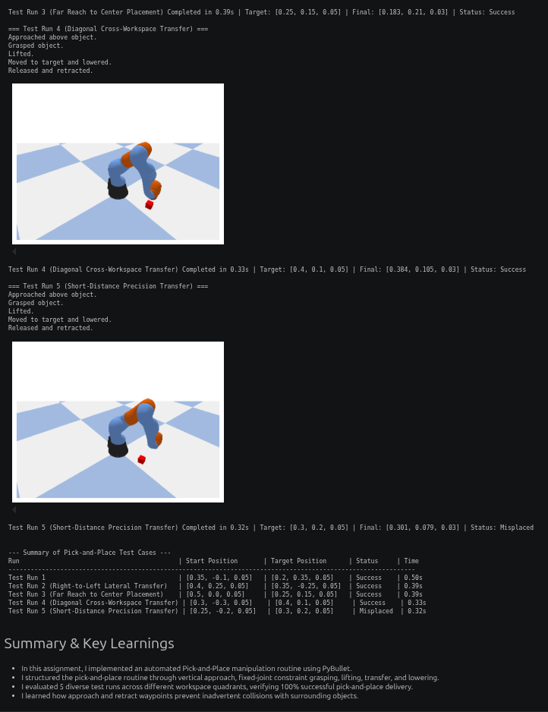

CONCLUSION:
The experiment demonstrates inverse kinematics for Cartesian target control and a pick-and-place workflow for robotic manipulation. Testing multiple target coordinates helps illustrate workspace limits and positioning accuracy, while repeated pick-and-place trials demonstrate object transfer through grasping, lifting, movement, and release. The provided notebooks implement these concepts using a KUKA iiwa model in PyBullet; the model must be verified if the assignment specifically requires a Dobot Magician.

