Walchand College of Engineering, Sangli
Department of Computer Science & Engineering
Computer Algorithm Laboratory
Assignment No. 5 — Greedy Method
Name : Atharv Vinayak Kulkarni
PRN : 245109074
Class : TY B.Tech CSE

Question 1: Network Signal Propagation – Shortest Delay Path (Dijkstra)
Problem Statement:
A telecom company models its relay network as a directed graph where each edge weight is the propagation delay (ms). Implement Dijkstra's algorithm to compute the minimum delay from source S to every other node.
Approach:
approach_1: relax edges repeatedly using Bellman-Ford style scanning. tc: o(v*e) sc: o(v)
approach_2 (optimal): use a min-priority queue; always expand the unvisited node with the smallest tentative distance and relax its outgoing edges (Dijkstra). tc: o((v+e) log v) sc: o(v+e)
Time Complexity:
o((V+E) log V) using a binary heap priority queue
Space Complexity:
o(V + E)
Code:
#include<iostream>
#include<vector>
#include<queue>
#include<climits>
#include<string>
using namespace std;
void dijkstra(vector<string>name, vector<vector<pair<int,int>>>adj, int src, int target){
int n=name.size();
vector<int>dist(n,INT_MAX);
vector<int>parent(n,-1);
dist[src]=0;
priority_queue<pair<int,int>,vector<pair<int,int>>,greater<pair<int,int>>>pq;
pq.push({0,src});
while(!pq.empty()){
auto [d,u]=pq.top();
pq.pop();
if(d>dist[u]) continue;
for(auto &[v,w]:adj[u]){
if(dist[u]!=INT_MAX && dist[u]+w<dist[v]){
dist[v]=dist[u]+w;
parent[v]=u;
pq.push({dist[v],v});
}
}
}
cout<<"Shortest distance from "<<name[src]<<" to "<<name[target]<<": ";
if(dist[target]==INT_MAX){
cout<<"unreachable\n";
return;
}
cout<<dist[target]<<" ms\n";
cout<<"Shortest path: ";
vector<int>path;
for(int v=target;v!=-1;v=parent[v]) path.push_back(v);
for(int i=path.size()-1;i>=0;i--){
cout<<name[path[i]];
if(i>0) cout<<"->";
}
cout<<"\n";
}
int main(){
//Test Case 1
{
vector<string>name={"S","A","B","C","D"};
vector<vector<pair<int,int>>>adj(5);
adj[0]={{1,4},{2,8}};
adj[1]={{2,2},{3,5}};
adj[2]={{3,1},{4,7}};
adj[3]={{4,3}};
cout<<"Test Case 1\n";
dijkstra(name,adj,0,4);
}
//Test Case 2
{
vector<string>name={"S","A","B","C"};
vector<vector<pair<int,int>>>adj(4);
adj[0]={{1,10},{2,3}};
adj[2]={{1,2},{3,8}};
adj[1]={{3,1}};
cout<<"\nTest Case 2\n";
dijkstra(name,adj,0,3);
}
//Test Case 3
{
vector<string>name={"S","A","B","C","D"};
vector<vector<pair<int,int>>>adj(5);
adj[0]={{1,5}};
adj[1]={{2,4}};
adj[2]={{3,2}};
adj[3]={{4,1}};
cout<<"\nTest Case 3\n";
dijkstra(name,adj,0,4);
}
//Test Case 4
{
vector<string>name={"S","A","B","C","D"};
vector<vector<pair<int,int>>>adj(5);
adj[0]={{1,2},{2,1}};
adj[1]={{3,2}};
adj[2]={{3,6}};
adj[3]={{4,3}};
cout<<"\nTest Case 4\n";
dijkstra(name,adj,0,4);
}
//Test Case 5-unreachable destination
{
vector<string>name={"S","A","B","C"};
vector<vector<pair<int,int>>>adj(4);
adj[0]={{1,4}};
adj[1]={{2,5}};
cout<<"\nTest Case 5\n";
dijkstra(name,adj,0,3);
}
return 0;
}
Output:
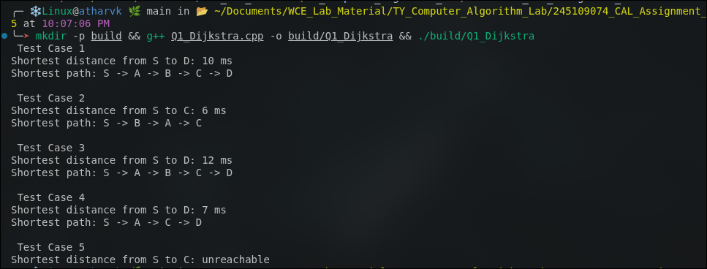

Question 2: Esports Arena – Match Scheduling (Activity Selection)
Problem Statement:
A single main stage receives match requests, each with a start and end time. Select the maximum number of non-overlapping matches using the greedy Activity Selection approach. The updated code demonstrates 5 independent test cases.
Approach:
approach_1: try all subsets of matches and check for overlaps. tc: o(2^n)
approach_2 (greedy): sort activities by finish time; greedily pick an activity if its start time is not before the finish time of the last selected activity. The code applies this to 5 test cases. tc: o(n log n) sc: o(n)
Time Complexity:
o(n log n) — dominated by the sort
Space Complexity:
o(n)
Code:
#include<iostream>
#include<vector>
#include<algorithm>
using namespace std;
void activitySelection(vector<pair<int,int>>matches){
sort(matches.begin(),matches.end(),[](const pair<int,int>&a,const pair<int,int>&b){
return a.second<b.second;
});
vector<pair<int,int>>selected;
int lastEnd=-1;
for(auto &m:matches){
if(m.first>=lastEnd){
selected.push_back(m);
lastEnd=m.second;
}
}
cout<<"Total activities: "<<matches.size()<<endl;
cout<<"Maximum non-overlapping activities: "<<selected.size()<<endl;
cout<<"Selected activities: ";
for(auto &m:selected)
cout<<"("<<m.first<<","<<m.second<<") ";
cout<<endl;
}
int main(){
//Test Case 1
cout<<"Test Case 1\n";
activitySelection({{1,3},{2,5},{4,7},{6,9},{8,10}});
//Test Case 2
cout<<"\nTest Case 2\n";
activitySelection({{0,6},{1,2},{3,4},{5,7},{8,9},{5,9}});
//Test Case 3
cout<<"\nTest Case 3\n";
activitySelection({{1,2},{2,3},{3,4},{4,5},{5,6}});
//Test Case 4
cout<<"\nTest Case 4\n";
activitySelection({{1,10},{2,3},{3,4},{5,7},{8,9},{10,12}});
//Test Case 5
cout<<"\nTest Case 5\n";
activitySelection({{1,4},{2,3},{3,5},{5,7},{6,8},{8,10},{9,11}});
return 0;
}

Output:
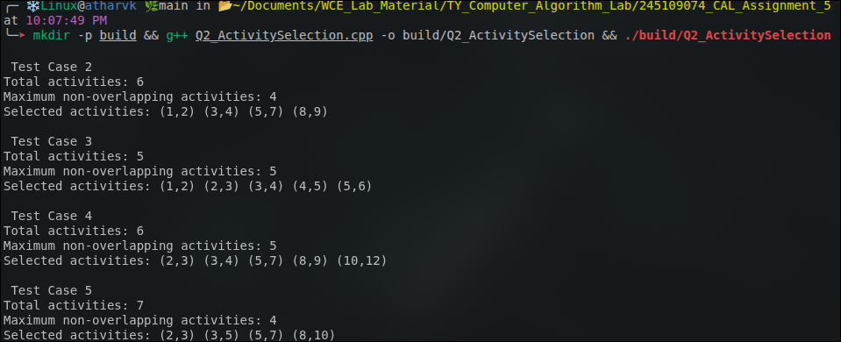

Question 3: Corporate Office – Minimum Meeting Rooms Required
Problem Statement:
Given meeting requests with start and end times, determine the minimum number of rooms required so that no two meetings in the same room overlap. The updated code demonstrates 5 independent test cases.
Approach:
approach_1: for every meeting, check all rooms currently in use to find a free one. tc: o(n^2)
approach_2 (greedy): separately sort all start times and all end times; sweep through with two pointers, incrementing the active-room counter on a start and decrementing on an end. The code applies this to 5 test cases. tc: o(n log n) sc: o(n)
Time Complexity:
o(n log n)
Space Complexity:
o(n)
Code:
#include<iostream>
#include<vector>
#include<algorithm>
using namespace std;
void minMeetingRooms(vector<pair<int,int>>meetings){
int n=meetings.size();
vector<int>start(n),end_(n);
for(int i=0;i<n;i++){
start[i]=meetings[i].first;
end_[i]=meetings[i].second;
}
sort(start.begin(),start.end());
sort(end_.begin(),end_.end());
int rooms=0,maxRooms=0;
int i=0,j=0;
while(i<n && j<n){
if(start[i]<end_[j]){
rooms++;
i++;
maxRooms=max(maxRooms,rooms);
}else{
rooms--;
j++;
}
}
cout<<"Total meetings: "<<n<<endl;
cout<<"Minimum meeting rooms required: "<<maxRooms<<endl;
}
int main(){
//Test Case 1
cout<<"Test Case 1\n";
minMeetingRooms({{900,1000},{930,1030},{1000,1100},{1030,1130}});
//Test Case 2
cout<<"\nTest Case 2\n";
minMeetingRooms({{900,1000},{1000,1100},{1100,1200}});
//Test Case 3
cout<<"\nTest Case 3\n";
minMeetingRooms({{900,1200},{930,1100},{1000,1130},{1030,1230}});
//Test Case 4
cout<<"\nTest Case 4\n";
minMeetingRooms({{800,900},{850,950},{900,1000},{920,1030},{1000,1100}});
//Test Case 5
cout<<"\nTest Case 5\n";
minMeetingRooms({{900,930},{930,1000},{1000,1030},{1030,1100},{1100,1130}});
return 0;
}

Output:
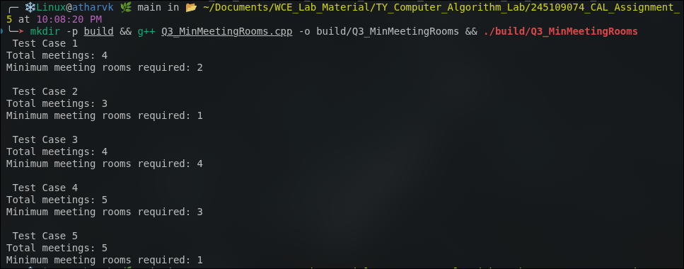

Question 4: Shared Office Printer – Minimizing Total Waiting Time
Problem Statement:
A printer has a queue of jobs with different durations. Decide the printing order that minimizes total (and average) waiting time. The updated code demonstrates 5 independent test cases.
Approach:
approach_1: process jobs in the order they were submitted (FCFS) and compute waiting times. Not optimal in general.
approach_2 (greedy): Shortest Job First — sort jobs by duration ascending and print in that order. This minimizes total/average waiting time in a single-server queue. The code applies this to 5 test cases. tc: o(n log n) sc: o(n)
Time Complexity:
o(n log n)
Space Complexity:
o(n)
Code:
#include<iostream>
#include<vector>
#include<algorithm>
using namespace std;
void minWaitingTime(vector<int>jobs){
int n=jobs.size();
sort(jobs.begin(),jobs.end());
vector<int>waitTime(n,0);
long long totalWait=0;
for(int i=1;i<n;i++){
waitTime[i]=waitTime[i-1]+jobs[i-1];
totalWait+=waitTime[i];
}
cout<<"Total jobs: "<<n<<endl;
cout<<"Order of printing: ";
for(int d:jobs) cout<<d<<" ";
cout<<endl;
cout<<"Waiting times: ";
for(int i=0;i<n;i++)
cout<<waitTime[i]<<" ";
cout<<endl;
cout<<"Total waiting time="<<totalWait<<" sec"<<endl;
cout<<"Average waiting time="<<(double)totalWait/n<<" sec"<<endl;
}
int main(){
//Test Case 1
cout<<"Test Case 1\n";
minWaitingTime({45,120,30,80,200});
//Test Case 2
cout<<"\nTest Case 2\n";
minWaitingTime({10,20,30,40});
//Test Case 3
cout<<"\nTest Case 3\n";
minWaitingTime({100,1,50,25,75});
//Test Case 4
cout<<"\nTest Case 4\n";
minWaitingTime({300,200,100,50,10,5});
//Test Case 5
cout<<"\nTest Case 5\n";
minWaitingTime({60,60,20,40,80});
return 0;
}

Output:
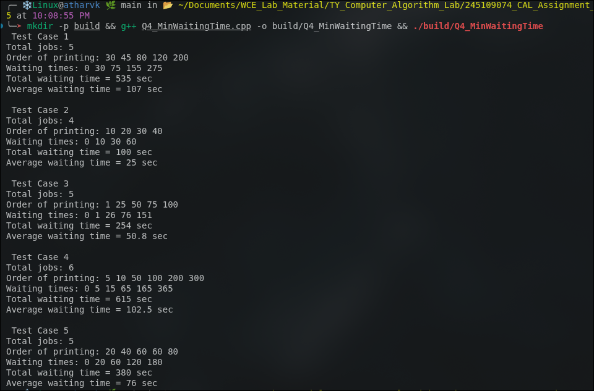

Question 5: Marketing Campaign – Minimum Channel Coverage (Set Cover)
Problem Statement:
Demographic segments must all be reached using as few advertising channels as possible, where each channel covers a fixed subset of segments. Use the greedy Set Cover approximation algorithm. The updated code demonstrates 5 independent test cases.
Approach:
approach_1 (exact): try all subsets of channels and check coverage. tc: o(2^m), NP-hard in general.
approach_2 (greedy approximation): repeatedly select the channel that covers the largest number of currently-uncovered segments until all segments are covered or no further progress is possible. The code applies this to 5 test cases, including an impossible-coverage case. tc: O(m^2 * s) in the straightforward implementation.
Time Complexity:
o(m^2 * s) for the greedy approximation (m = number of channels)
Space Complexity:
o(m * s)
Code:
#include<iostream>
#include<vector>
#include<set>
using namespace std;
void setCover(int totalSegments,vector<set<int>>channels){
set<int>universe;
for(int i=1;i<=totalSegments;i++)
universe.insert(i);
set<int>covered;
vector<int>chosenChannels;
while(covered.size()<universe.size()){
int bestChannel=-1;
int bestGain=0;
set<int>bestNew;
for(int i=0;i<(int)channels.size();i++){
set<int>newlyCovered;
for(int seg:channels[i])
if(covered.find(seg)==covered.end())
newlyCovered.insert(seg);
if((int)newlyCovered.size()>bestGain){
bestGain=newlyCovered.size();
bestChannel=i;
bestNew=newlyCovered;
}
}
if(bestChannel==-1) break;
chosenChannels.push_back(bestChannel+1);
for(int seg:bestNew)
covered.insert(seg);
}
cout<<"Universe size: "<<totalSegments<<endl;
cout<<"Channels selected: "<<chosenChannels.size()<<endl;
cout<<"Selected channels: ";
for(int c:chosenChannels)
cout<<"Channel"<<c<<" ";
cout<<endl;
if(covered.size()<universe.size())
cout<<"Warning: some segments could not be covered"<<endl;
else
cout<<"All segments covered"<<endl;
}
int main(){
//Test Case 1
cout<<"Test Case 1\n";
setCover(6,{
{1,2,3},{2,4},{3,5},{4,5,6},{1,6}
});
//Test Case 2
cout<<"\nTest Case 2\n";
setCover(8,{
{1,2,3},{3,4,5},{5,6},{6,7,8},{1,8}
});
//Test Case 3
cout<<"\nTest Case 3\n";
setCover(5,{
{1,2},{2,3},{3,4},{4,5},{1,5}
});
//Test Case 4
cout<<"\nTest Case 4\n";
setCover(10,{
{1,2,3,4},{4,5,6},{6,7,8},{8,9,10},{2,5,9}
});
//Test Case 5-impossible to cover all segments
cout<<"\nTest Case 5\n";
setCover(7,{
{1,2},{2,3},{4,5},{5,6}
});
return 0;
}
Output:
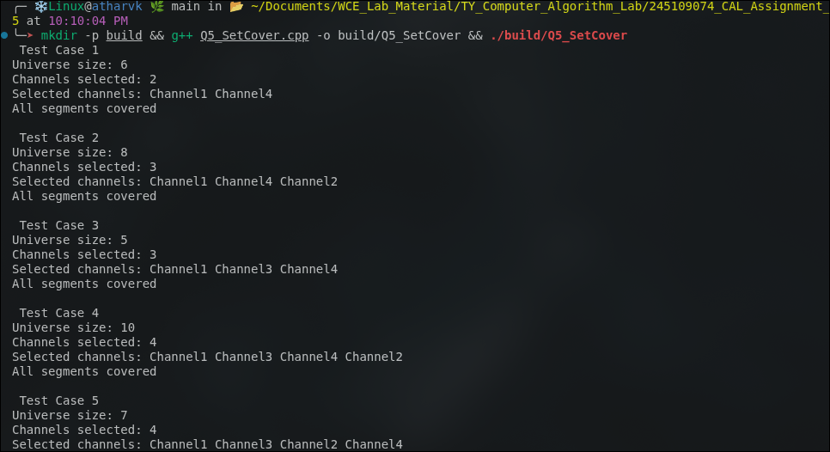

Question 6: ATM Cash Dispenser – Minimum Notes Problem
Problem Statement:
Dispense a requested withdrawal amount using the minimum number of currency notes chosen from the available denominations. The updated code demonstrates 5 test cases, including a counterexample where greedy is not optimal and a case where the exact amount cannot be formed.
Approach:
approach_1 (exact / DP): classic unbounded coin-change DP that tries every denomination for every amount. tc: o(amount * denominations)
approach_2 (greedy): sort denominations descending; repeatedly take as many notes of the largest usable denomination as possible. The code applies this to 5 test cases. It is optimal for canonical currency systems but not for arbitrary denomination sets. tc: O(d log d) sc: O(d) including the denomination copy and output storage.
Time Complexity:
o(d log d) for the greedy approach (d = number of denominations)
Space Complexity:
o(1) extra (excluding output storage)
Code:
#include<iostream>
#include<vector>
#include<algorithm>
using namespace std;
void minNotes(vector<int>denom,int amount){
sort(denom.rbegin(),denom.rend());
vector<pair<int,int>>used;
int totalNotes=0;
int remaining=amount;
for(int d:denom){
if(remaining<=0) break;
int count=remaining/d;
if(count>0){
used.push_back({d,count});
totalNotes+=count;
remaining-=d*count;
}
}
cout<<"Amount: "<<amount<<endl;
if(remaining!=0){
cout<<"Cannot form the exact amount with the given denominations.\n";
return;
}
cout<<"Notes used: ";
for(auto &p:used)
cout<<p.first<<"x"<<p.second<<" ";
cout<<endl;
cout<<"Total notes used: "<<totalNotes<<endl;
}
int main(){
//Test Case 1-standard denominations
cout<<"Test Case 1\n";
minNotes({1,2,5,10,20,50,100,200,500},1287);
//Test Case 2
cout<<"\nTest Case 2\n";
minNotes({1,5,10,20,50,100},275);
//Test Case 3
cout<<"\nTest Case 3\n";
minNotes({1,2,5,10,20},47);
//Test Case 4-greedy is not optimal for arbitrary denominations
cout<<"\nTest Case 4\n";
minNotes({1,3,4},6);
cout<<"Note: Greedy gives 4+1+1=3 notes, while optimal is 3+3=2 notes.\n";
//Test Case 5-exact amount cannot be formed
cout<<"\nTest Case 5\n";
minNotes({5,10,20},13);
return 0;
}

Output:
